CST8506 Assignment 2: CIFAR-10 Classification
  - CST8506 - Machine Learning
Peng Wang (041107730)
March 20, 2026
Table of Contents
Imports and Setup 3
Step 1: Data Understanding - Load CIFAR-10 Dataset 5
Step 2: Data Understanding - Visualize Sample Images 7
Step 3: Data Preparation - Normalize and Encode Labels 8
Step 4: MLP Classification (scikit-learn) 10
Step 5: NN with Dense Layers Only (Keras) 13
Step 6: CNN Model 1 - Conv + Dense (No Pooling) 16
Step 7: CNN Model 2 - Conv + MaxPool + Dense 19
Step 8: CNN Model 3 - Conv + AvgPool + Dense 22
Step 9: CNN Model 4 - Conv + MaxPool + AvgPool + Dense 25
Step 11: CNN Architecture Diagrams 28
Step 12: Results Summary 31
Step 13: Training History Visualization 33
Step 14: Prepare Subset Data for Parameter Study 35
Step 15: MLP Parameter Study (6 parameters) 38
Step 16: Dense NN Parameter Study (2 parameters) 45
Step 17: CNN Parameter Study — Conv2D (6 parameters) 49
Step 18: CNN Parameter Study — Compile (3 parameters) 56
Step 19: CNN Parameter Study — Fit (5 parameters) 61
Step 20: Parameter Study Summary 67

Imports and Setup

Code
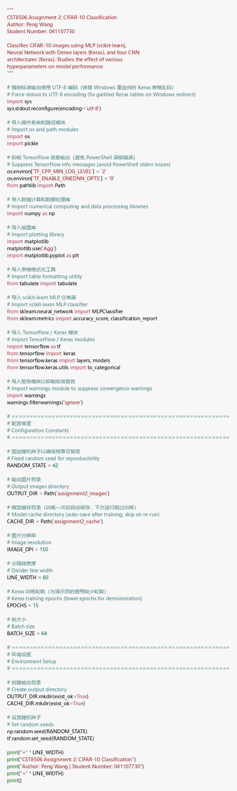

Explanation
I imported NumPy, Matplotlib, scikit-learn (for MLP), and TensorFlow/Keras (for NN and CNN models). I also set up caching to avoid retraining models on subsequent runs.

Step 1: Data Understanding - Load CIFAR-10 Dataset

Code
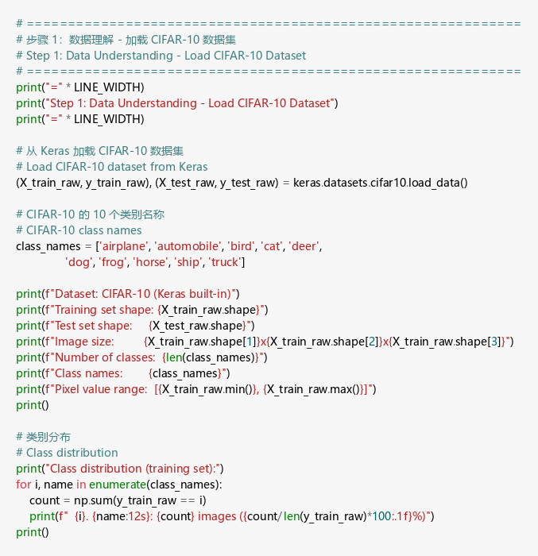

Output
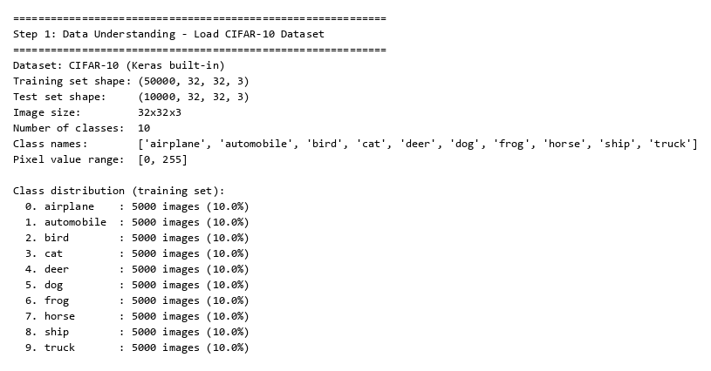

Explanation
I loaded the CIFAR-10 dataset from Keras. It has 50,000 training and 10,000 test images of size 32×32×3, evenly distributed across 10 classes (5,000 per class).

Step 2: Data Understanding - Visualize Sample Images

Code
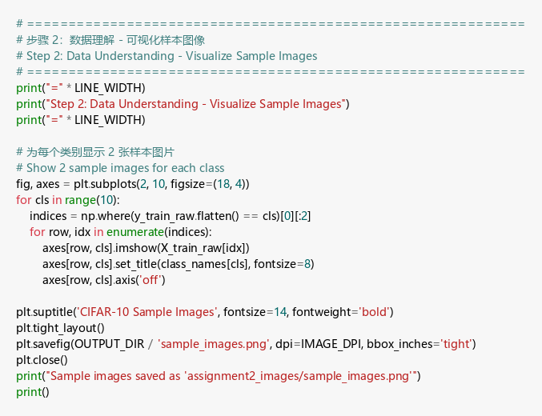

Output
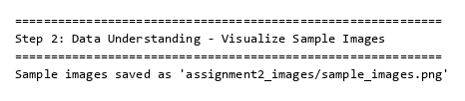

Sample Images
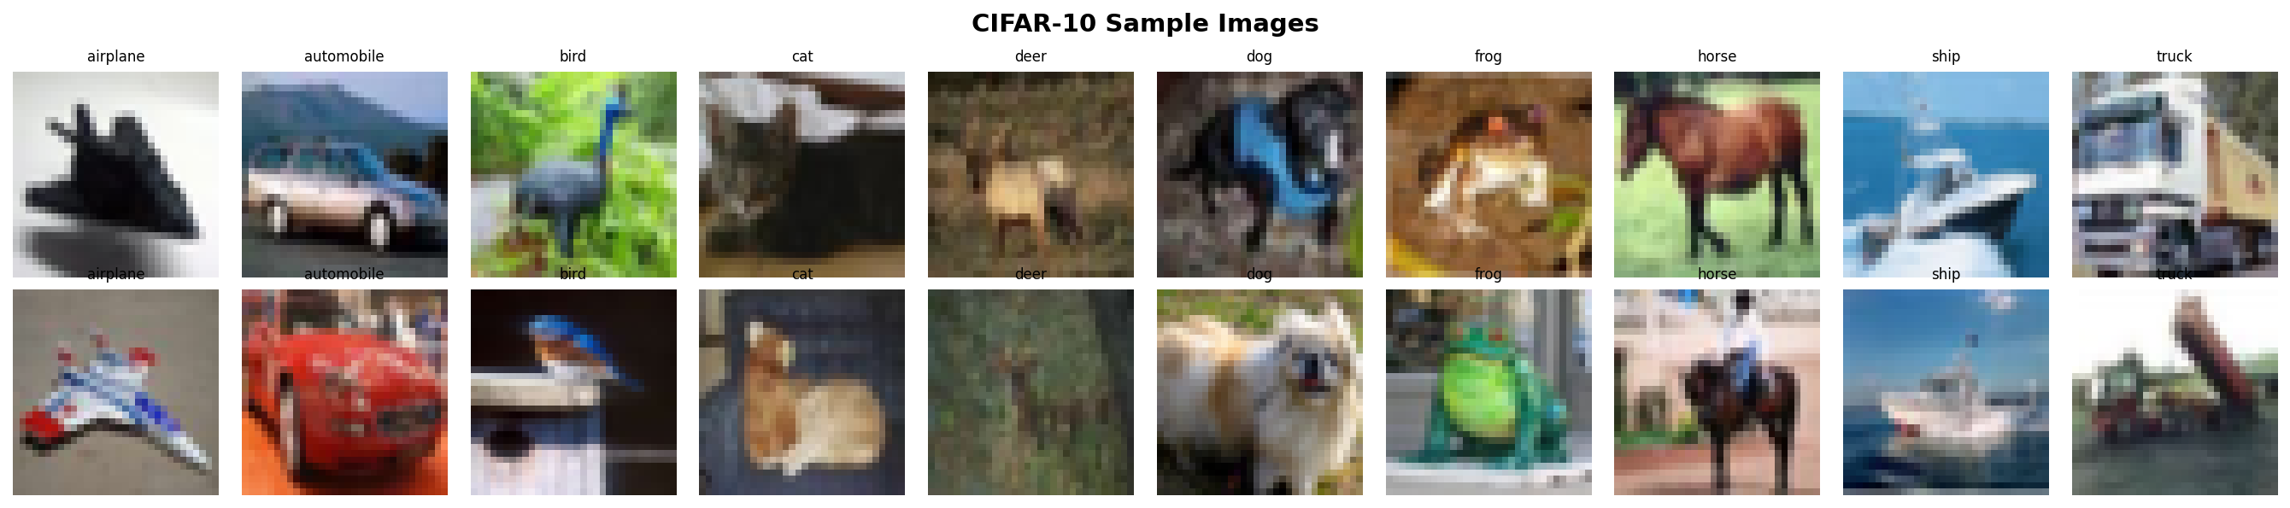

Explanation
I displayed 2 random samples per class to visually understand the dataset. Classes include airplane, automobile, bird, cat, deer, dog, frog, horse, ship, and truck.

Step 3: Data Preparation - Normalize and Encode Labels

Code
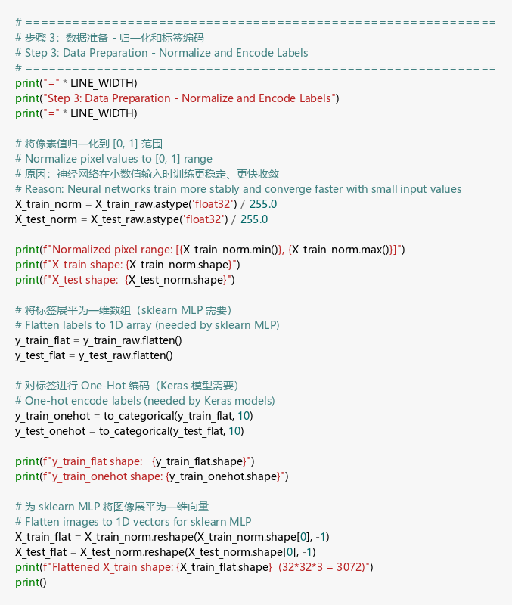

Output
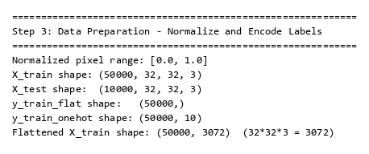

Explanation
I normalized pixel values from [0,255] to [0,1] for faster convergence. Labels are one-hot encoded for Keras models. Images are also flattened to 3,072 features for MLP.

Step 4: MLP Classification (scikit-learn)

Code
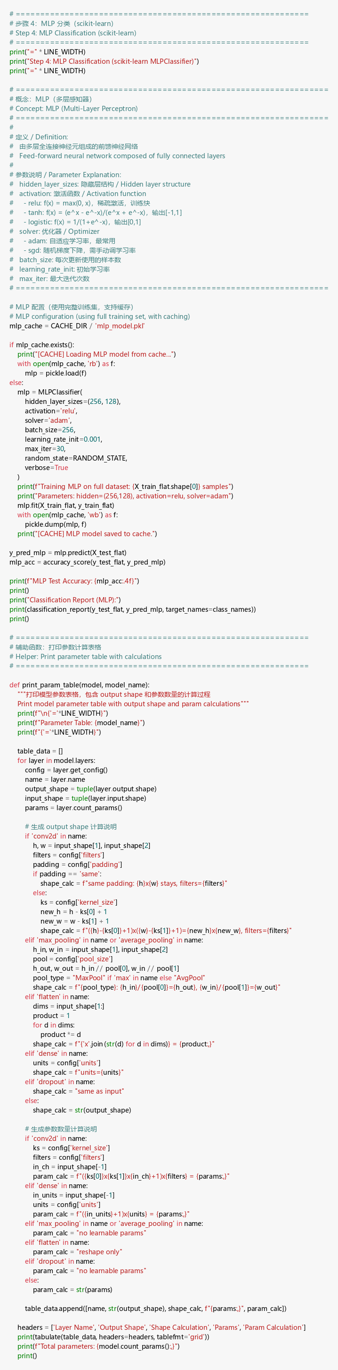

Output
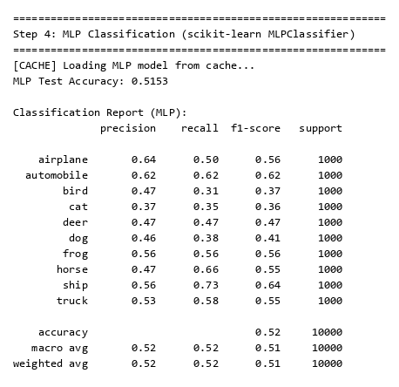

Explanation
I used scikit-learn’s MLPClassifier with hidden layers (256, 128), ReLU activation, and Adam optimizer. It achieved 51.53% accuracy. Ship and automobile had the highest F1 scores; cat and bird were hardest to classify.

Step 5: NN with Dense Layers Only (Keras)

Code
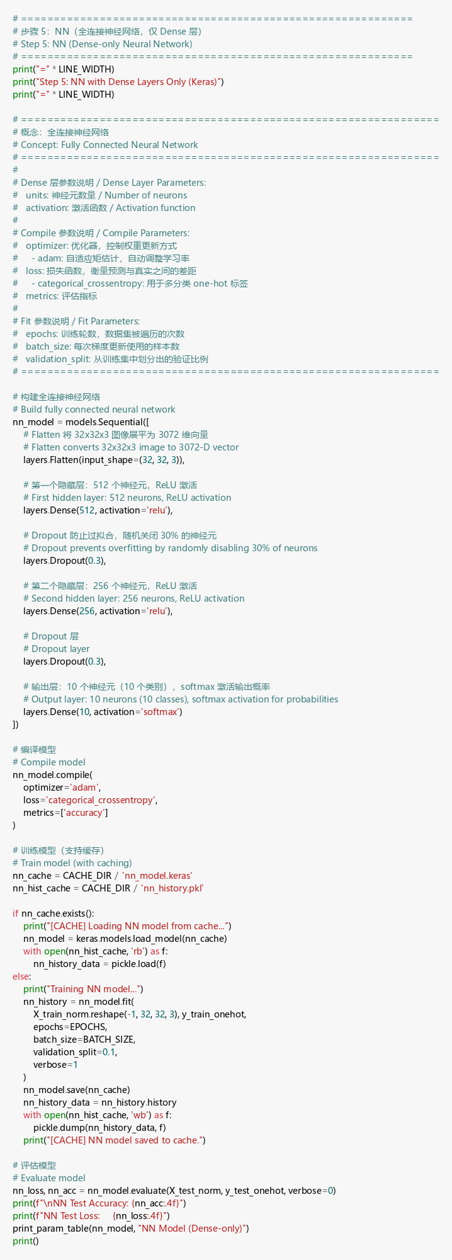

Output
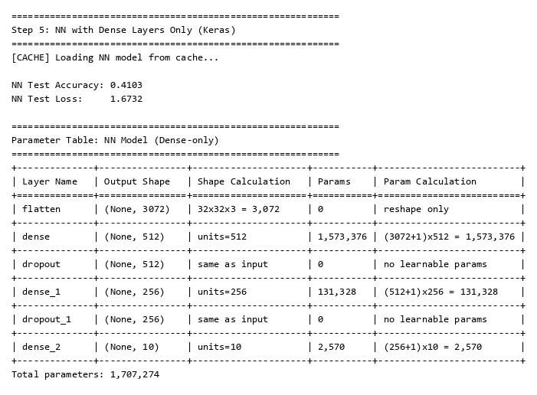

Explanation
I built a Dense-only NN: Flatten → Dense(512,relu) → Dropout(0.3) → Dense(256,relu) → Dropout(0.3) → Dense(10,softmax). It achieved 41.03% accuracy with 1,707,274 total parameters. The parameter table shows calculations like (3072+1)×512 = 1,573,376 for the first Dense layer.

Step 6: CNN Model 1 - Conv + Dense (No Pooling)

Code
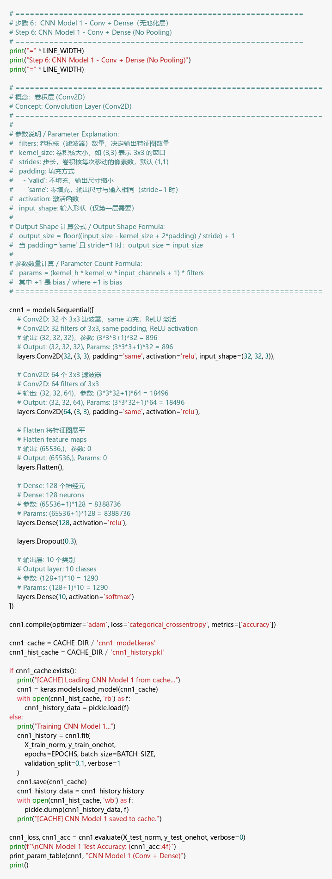

Output
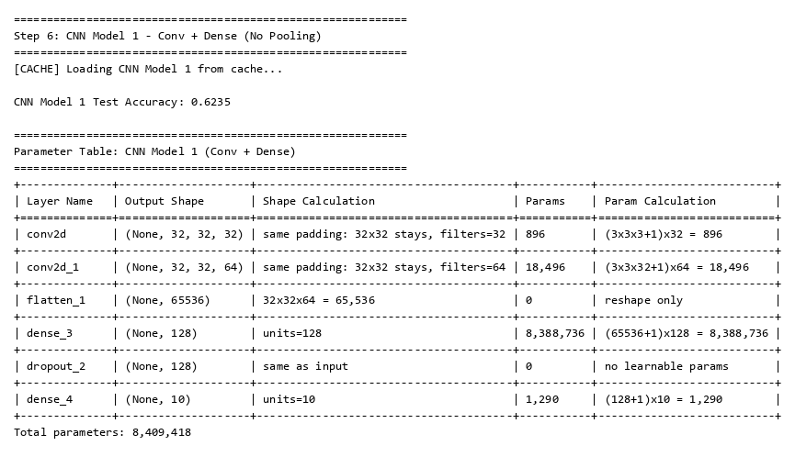

Explanation
CNN Model 1 uses Conv2D and Dense layers without pooling. Without pooling, the feature map stays at 32×32, producing a huge flatten output (65,536) and 8.4M parameters. It achieved 62.35% accuracy but is memory-intensive.

Step 7: CNN Model 2 - Conv + MaxPool + Dense

Code
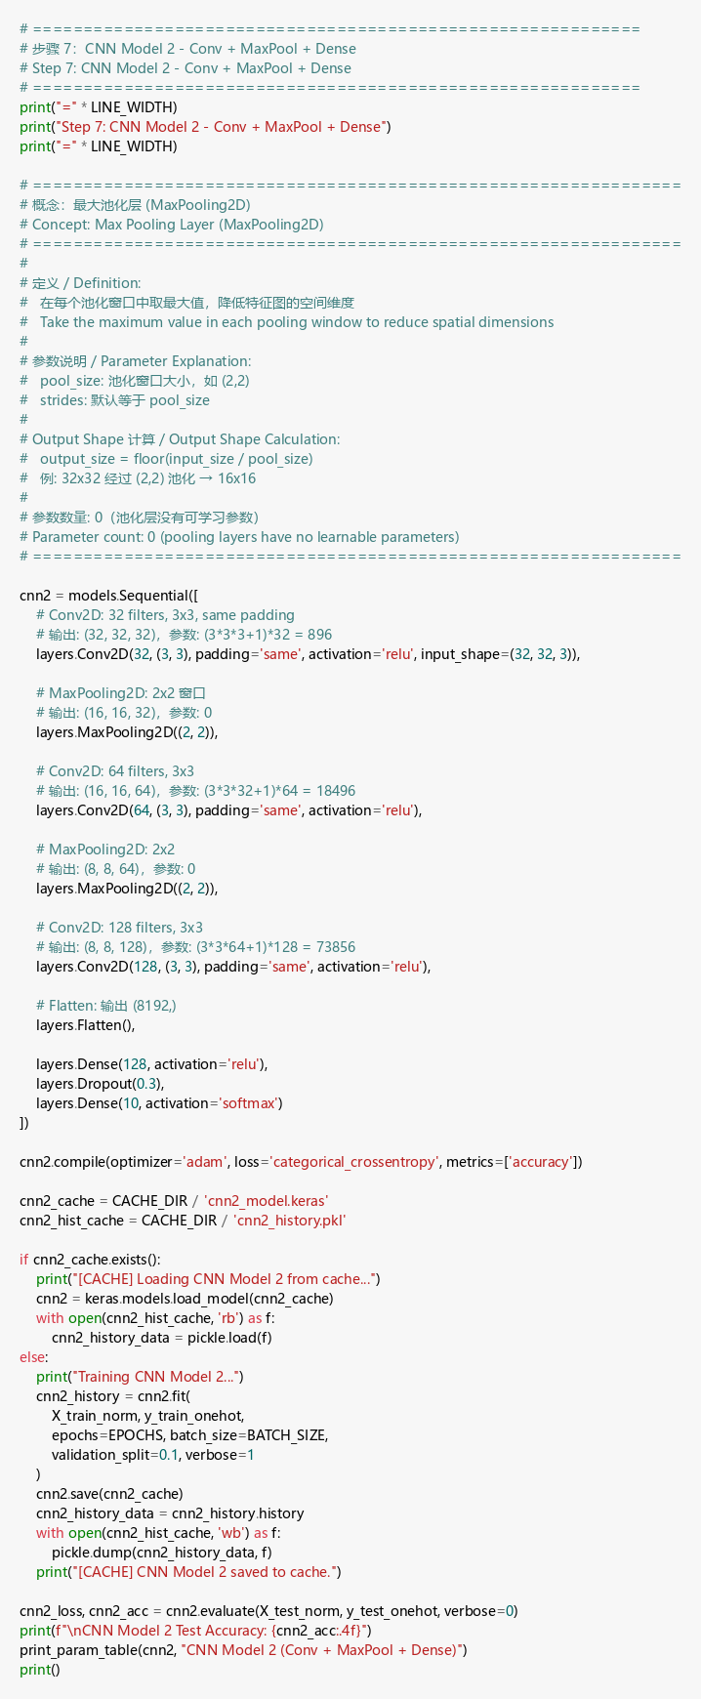

Output
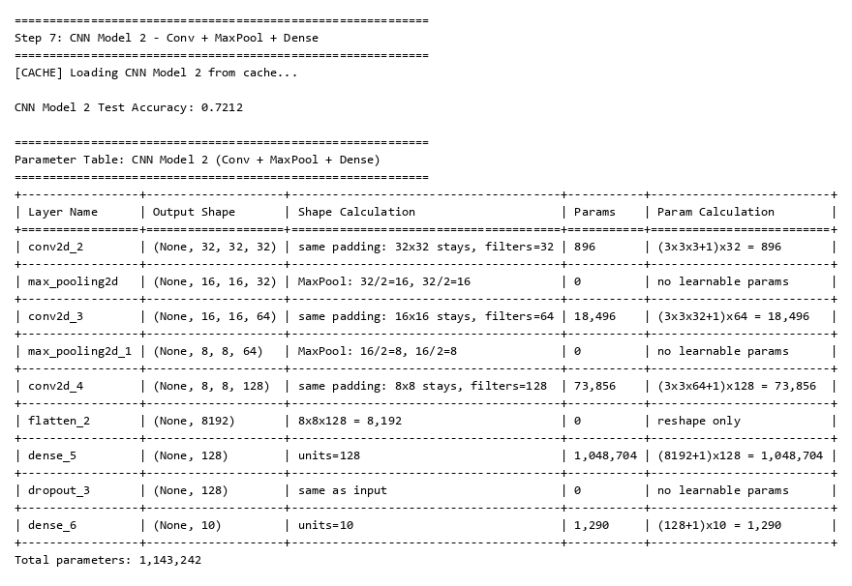

Explanation
I added MaxPooling2D layers which take the max in each 2×2 window, reducing dimensions from 32→16→8. This cuts parameters to 1.14M and improves accuracy to 72.12% — a big improvement over no-pooling Model 1.

Step 8: CNN Model 3 - Conv + AvgPool + Dense

Code
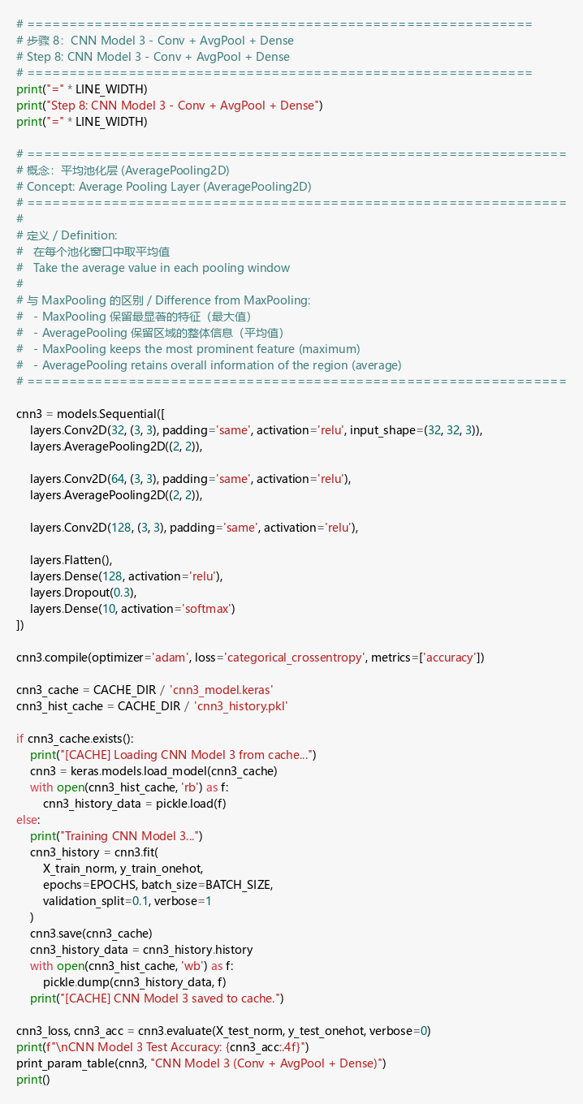

Output
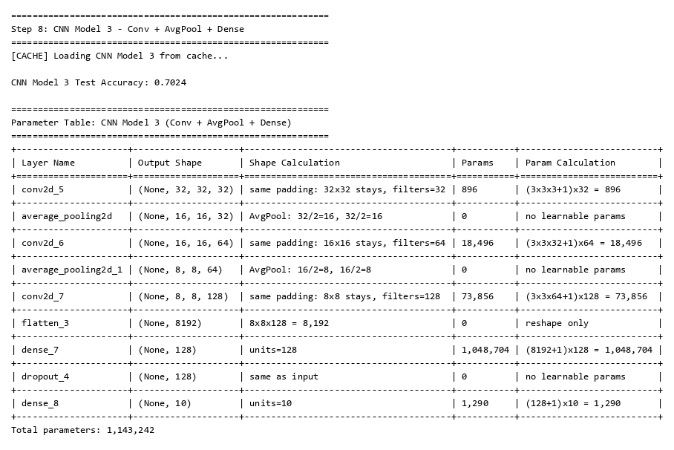

Explanation
I replaced MaxPool with AveragePooling2D which takes the average instead of maximum. Same parameter count (1.14M) but slightly lower accuracy (70.24%). MaxPool usually wins in classification because it preserves the strongest features.

Step 9: CNN Model 4 - Conv + MaxPool + AvgPool + Dense

Code
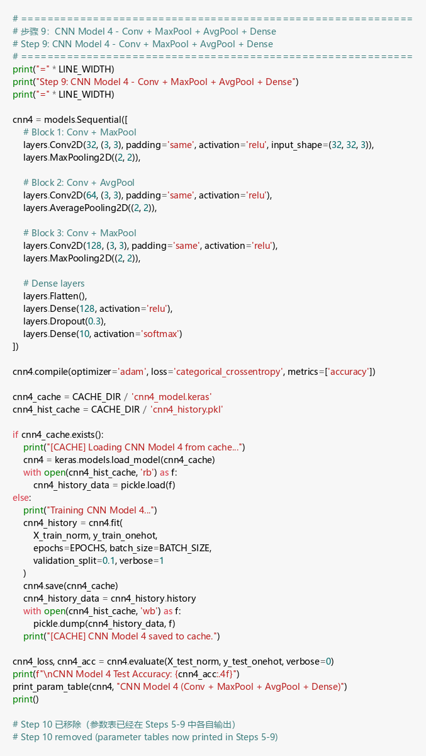

Output
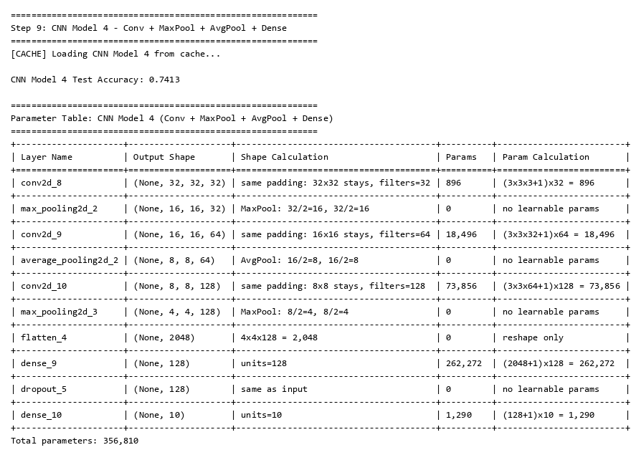

Explanation
Model 4 combines both MaxPool and AvgPool with 3 pooling layers total, reducing to 4×4 with only 356,810 parameters — the smallest model. It achieved the best accuracy at 74.13%, showing that combining pooling types captures both strong and averaged features.

Step 11: CNN Architecture Diagrams

Code
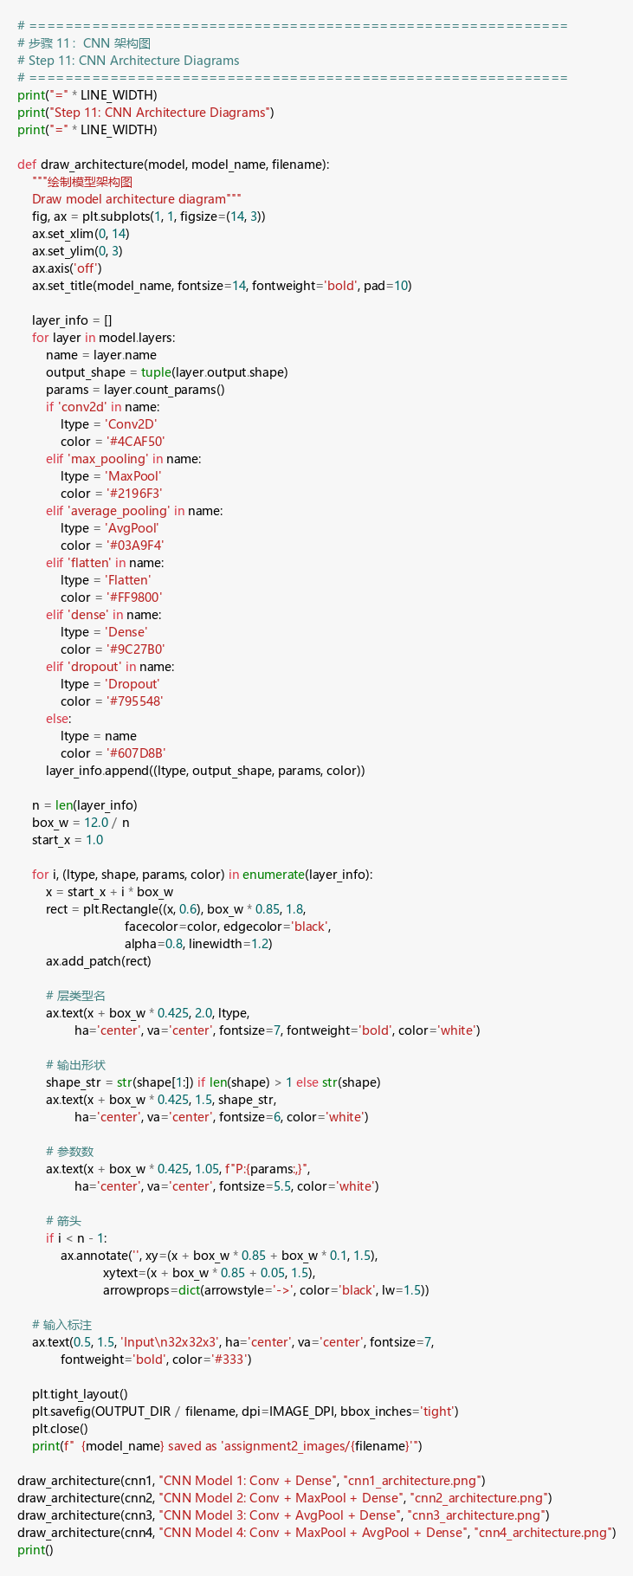

Output
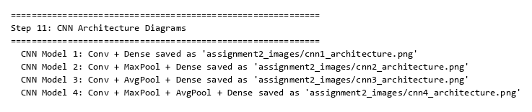

CNN Model 1 Architecture
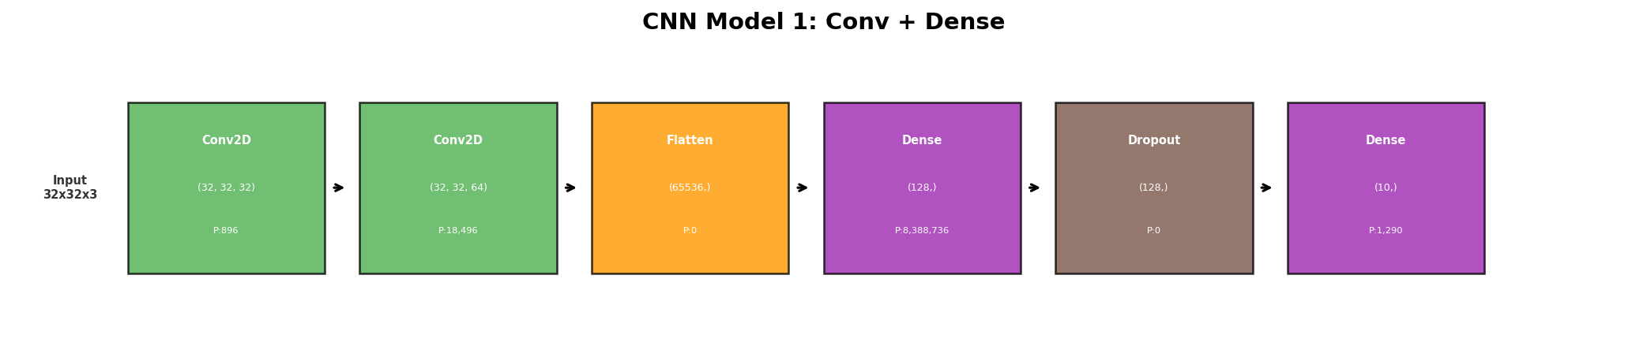

CNN Model 2 Architecture
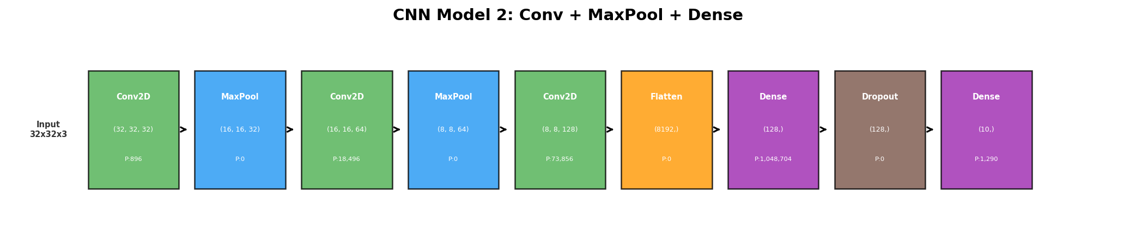

CNN Model 3 Architecture
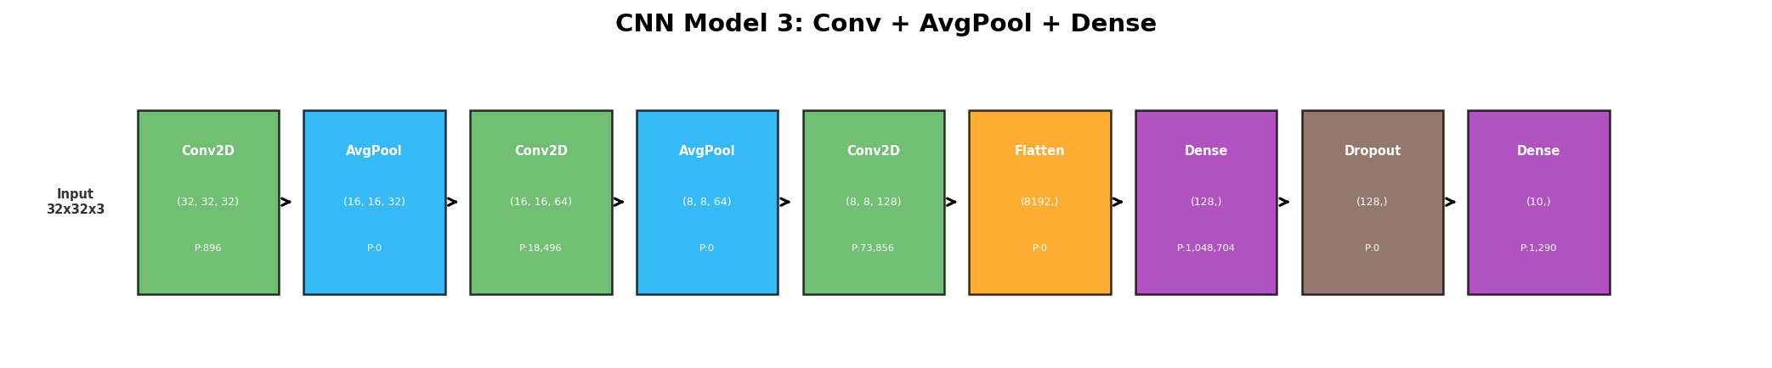

CNN Model 4 Architecture
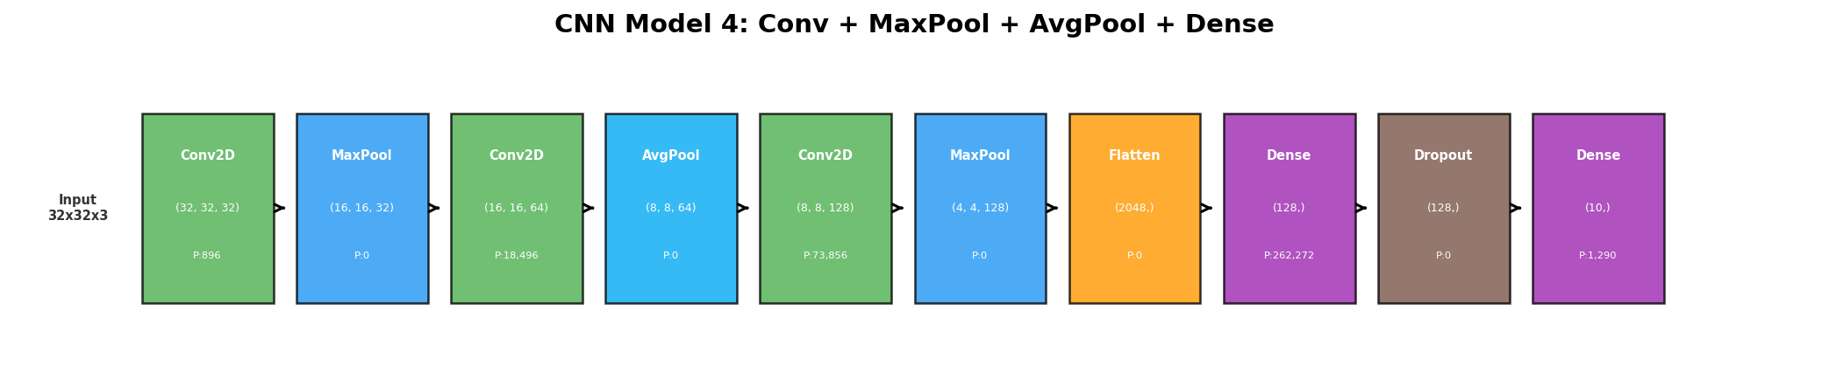

Explanation
These pictorial representations show how data flows through each CNN model, with layer types, output shapes, and parameter counts labeled at each stage.

Step 12: Results Summary

Code
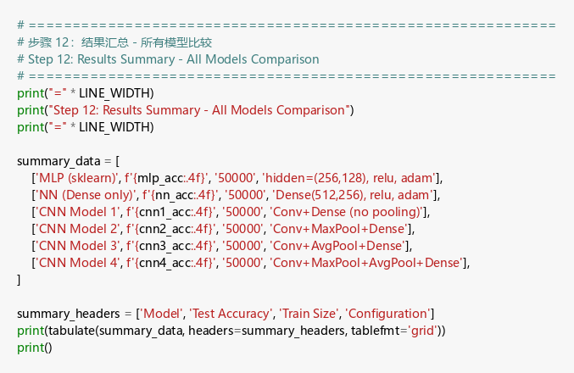

Output
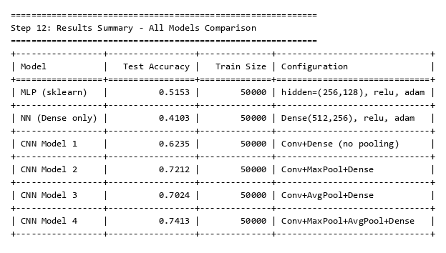

Explanation
CNN Model 4 is the best (74.13%) and NN Dense-only is the worst (41.03%). CNNs outperform flat models because convolution extracts spatial features that are lost when images are flattened.

Step 13: Training History Visualization

Code
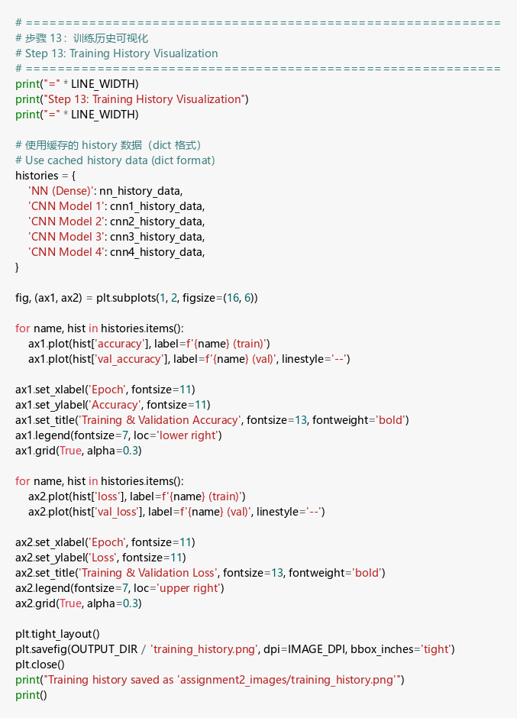

Training History
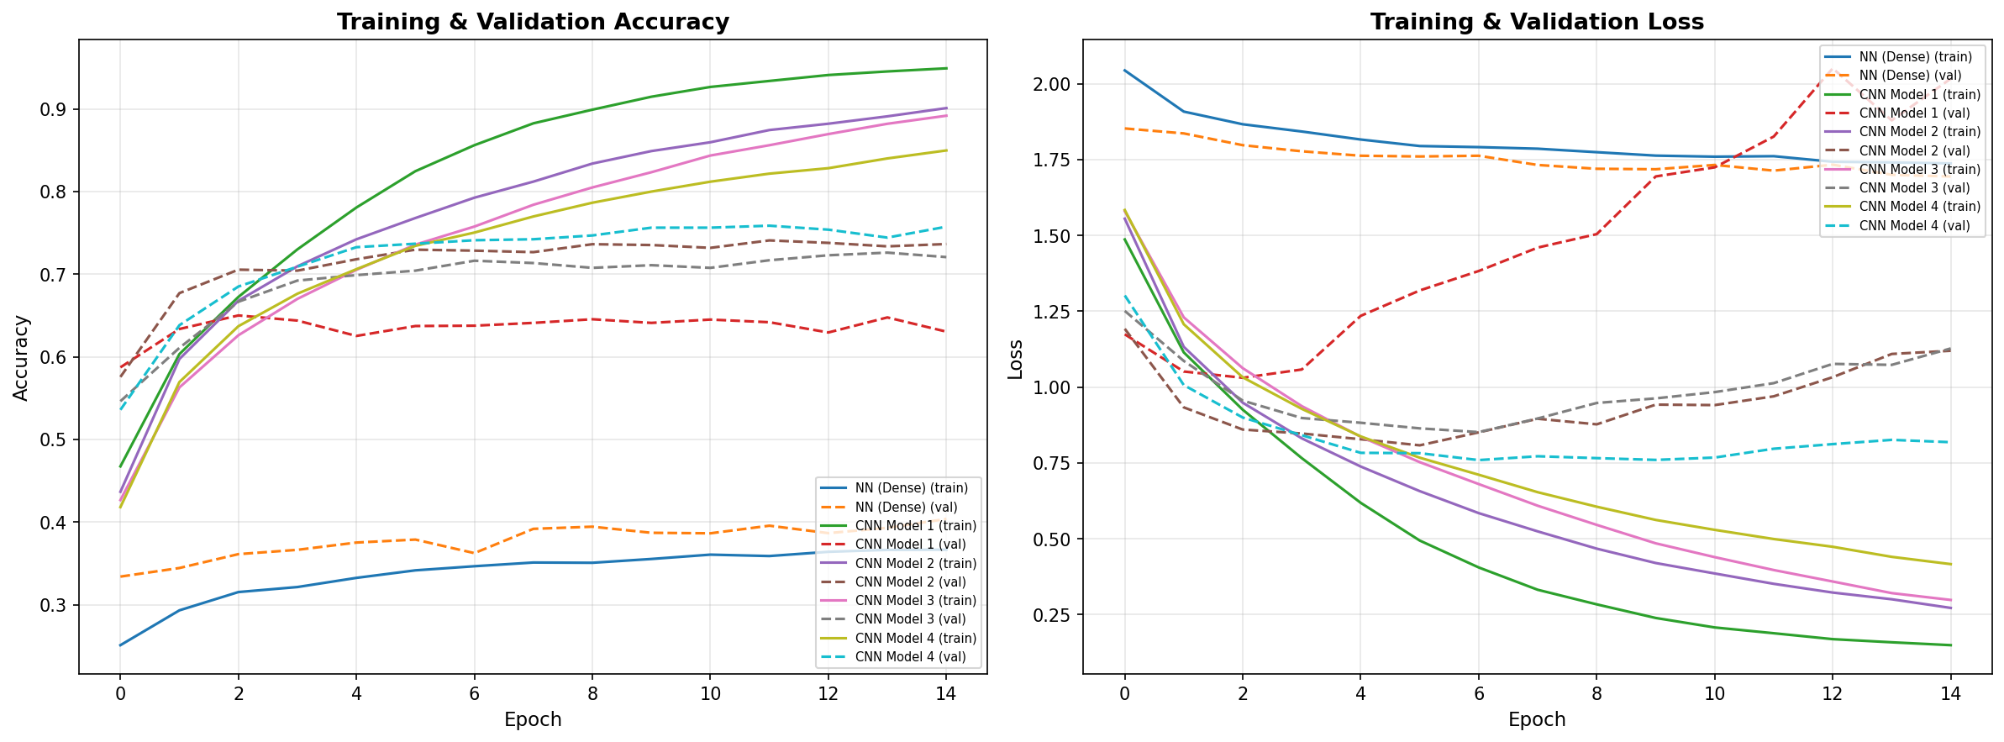

Explanation
The training curves show CNN models converge faster and reach higher accuracy than the Dense-only NN. Model 4 has the most stable learning curve.

Step 14: Prepare Subset Data for Parameter Study

Code
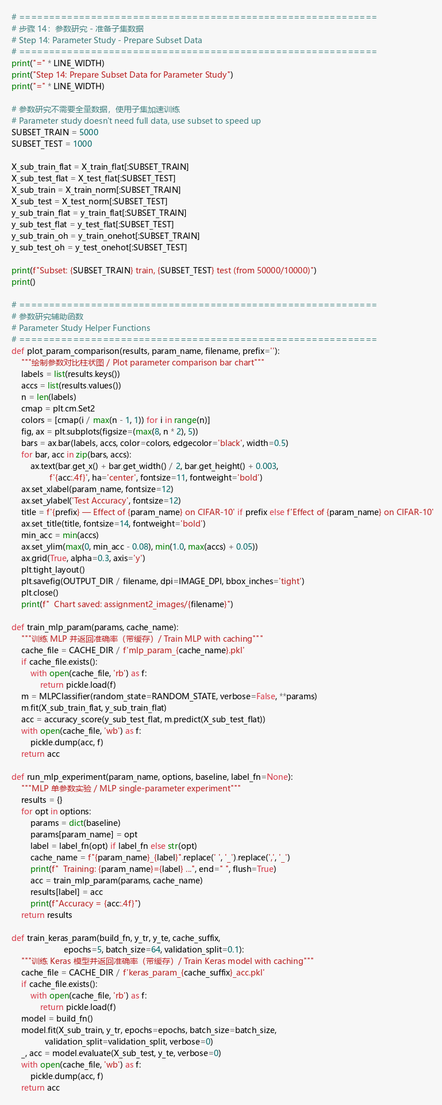

Output
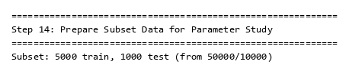

Explanation
I created a subset of 5,000 training and 1,000 test samples to speed up parameter experiments. Relative performance differences stay consistent on subsets.

Step 15: MLP Parameter Study (6 parameters)

Code
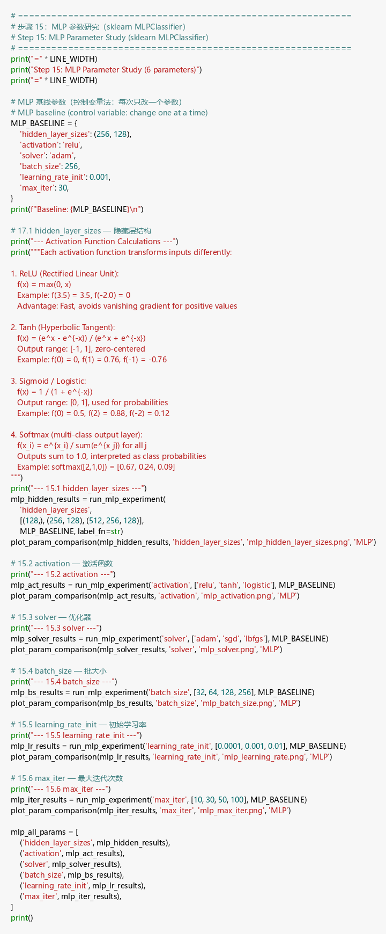

Output
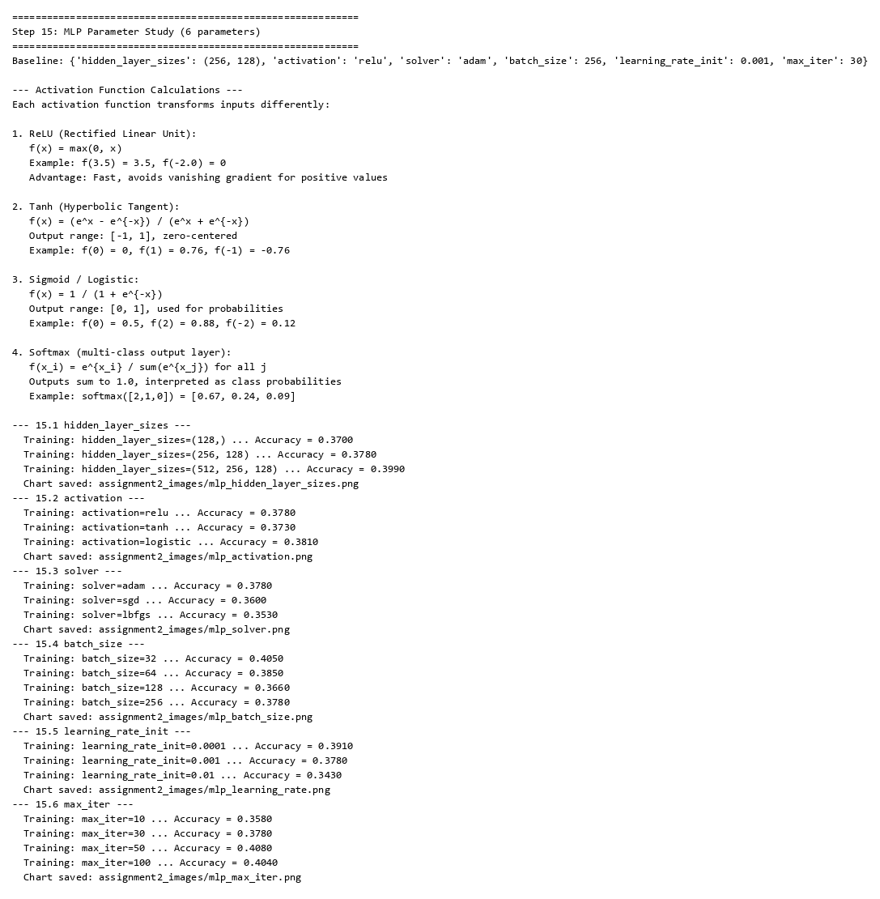

Activation Function Calculations
Each activation function transforms inputs differently:
- ReLU: f(x) = max(0, x). Example: f(3.5) = 3.5, f(-2.0) = 0. Fast, avoids vanishing gradient.
- Tanh: f(x) = (e^x - e^{-x}) / (e^x + e^{-x}). Output [-1, 1], zero-centered.
- Sigmoid: f(x) = 1 / (1 + e^{-x}). Output [0, 1], for probabilities.
- Softmax: f(x_i) = e^{x_i} / Σe^{x_j}. Outputs sum to 1, for multi-class problems.

Parameter Charts
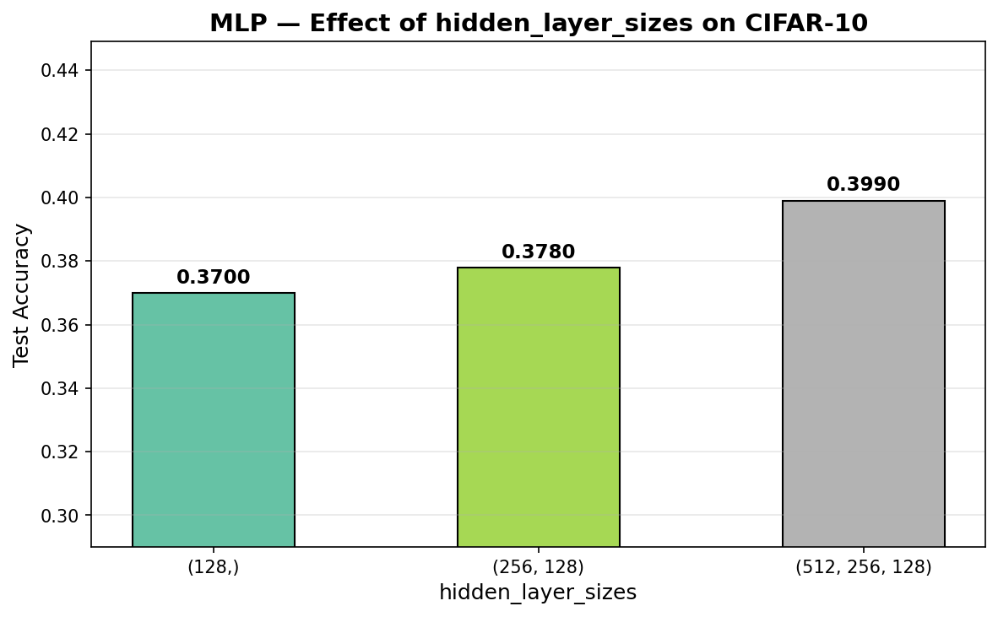
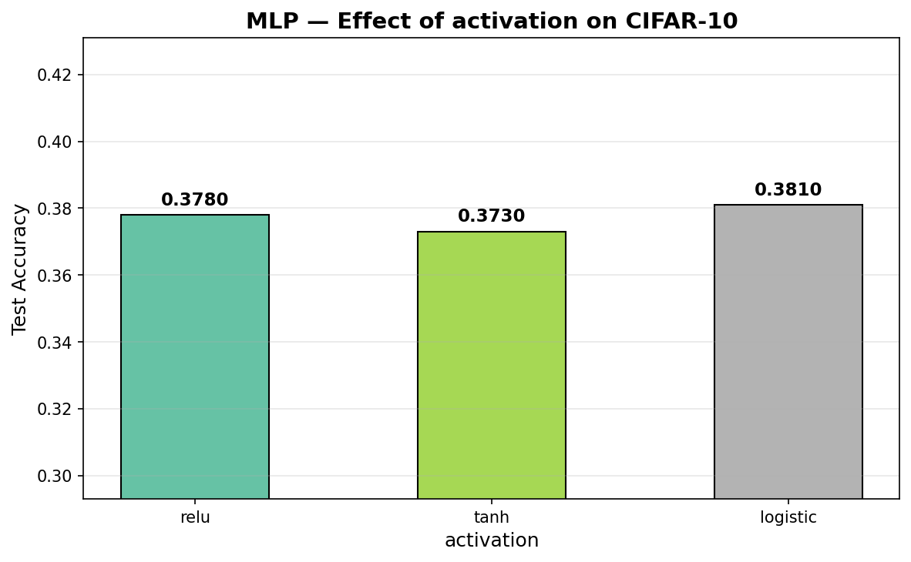
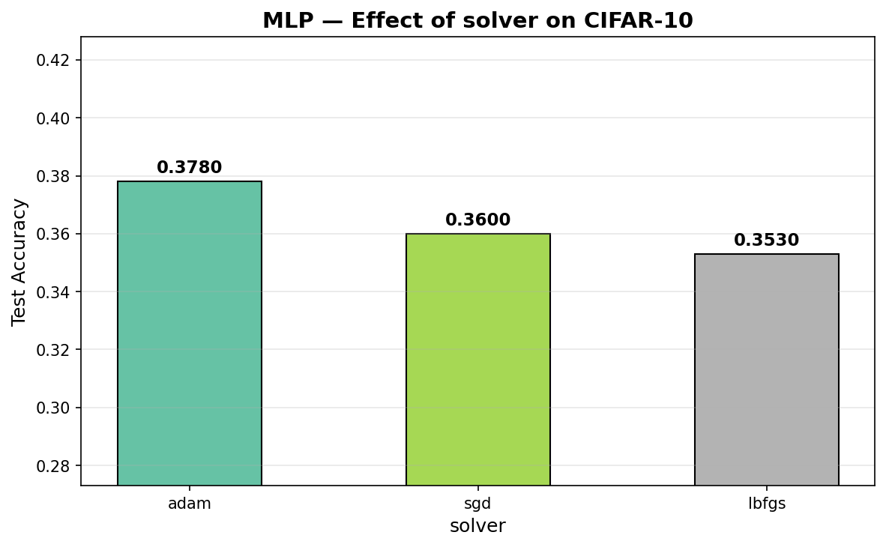
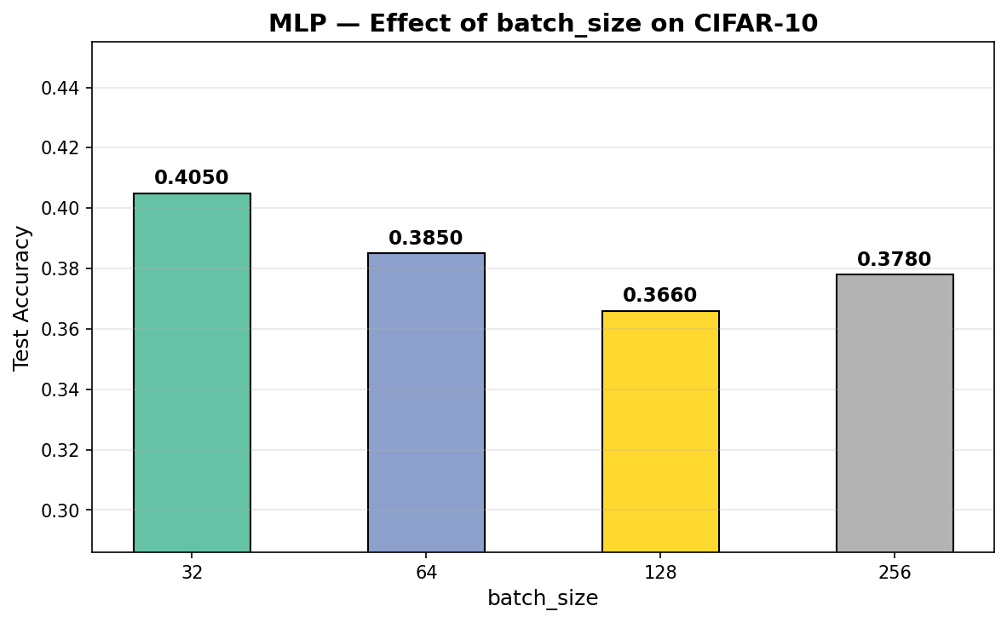
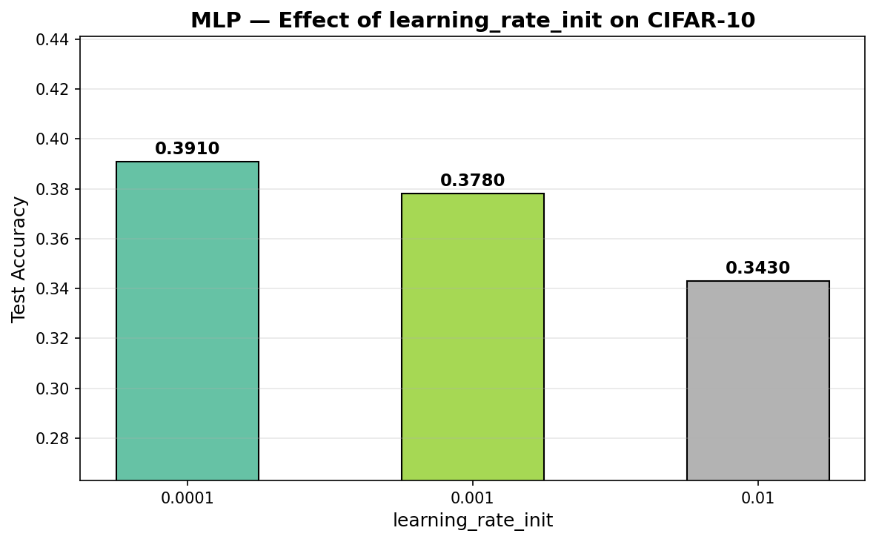
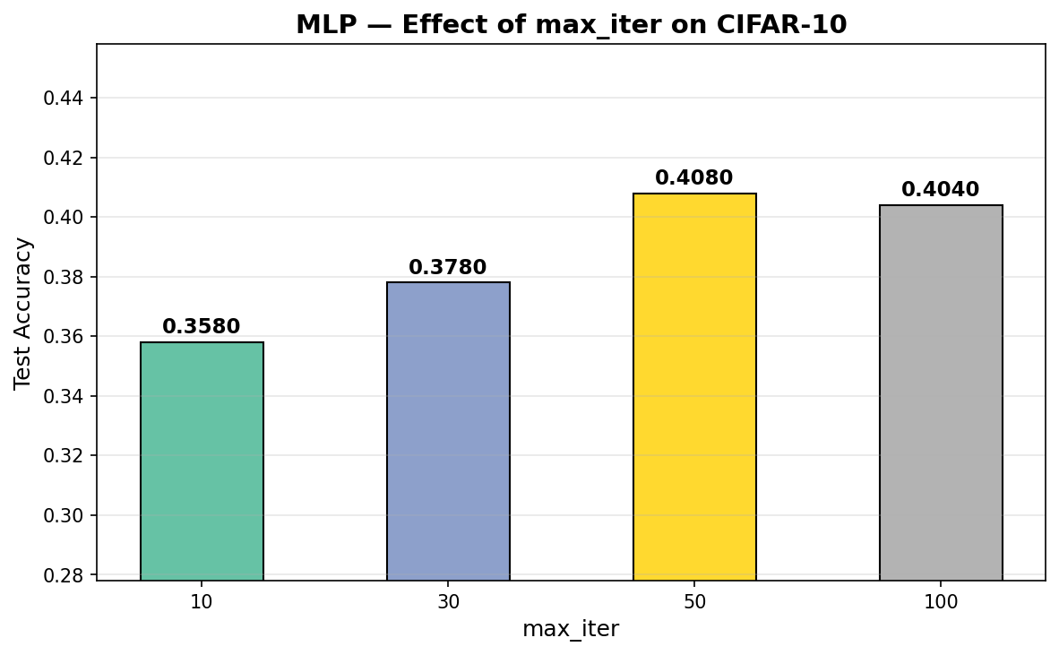

Explanation
- hidden_layer_sizes: (512,256,128) got 39.9% vs (128,) at 37.0%. Bigger networks learn more complex patterns.
- activation: All similar (~37-38%). Logistic slightly best at 38.1%.
- solver: Adam (37.8%) beats SGD (36.0%) and LBFGS (35.3%) because it adapts learning rates per parameter.
- batch_size: Smaller batches (32 → 40.5%) give more frequent gradient updates than larger ones (256 → 37.8%).
- learning_rate: 0.0001 (39.1%) is best. Too high (0.01 → 34.3%) causes overshooting.
- max_iter: 50 iterations (40.8%) is optimal; after that, performance plateaus.

Step 16: Dense NN Parameter Study (2 parameters)

Code
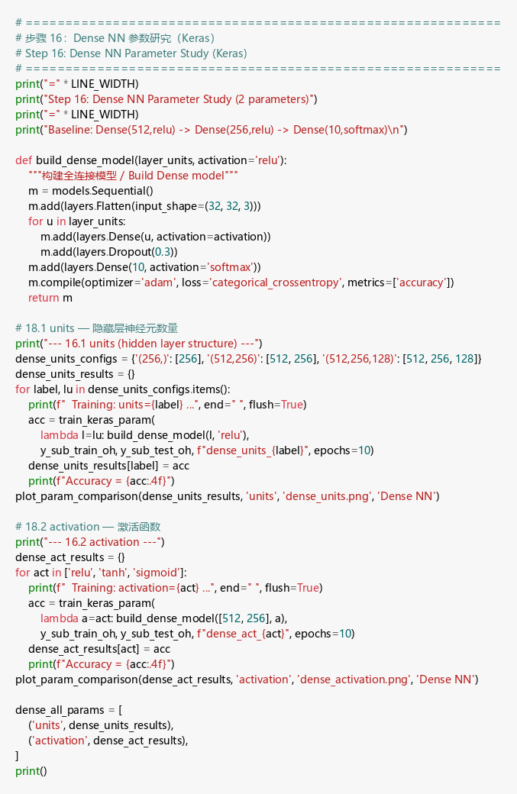

Output
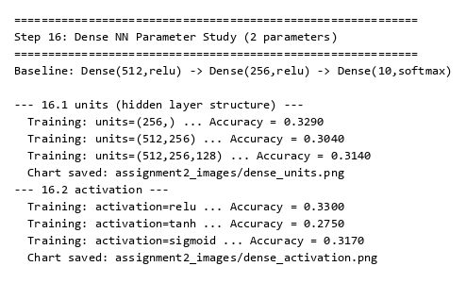
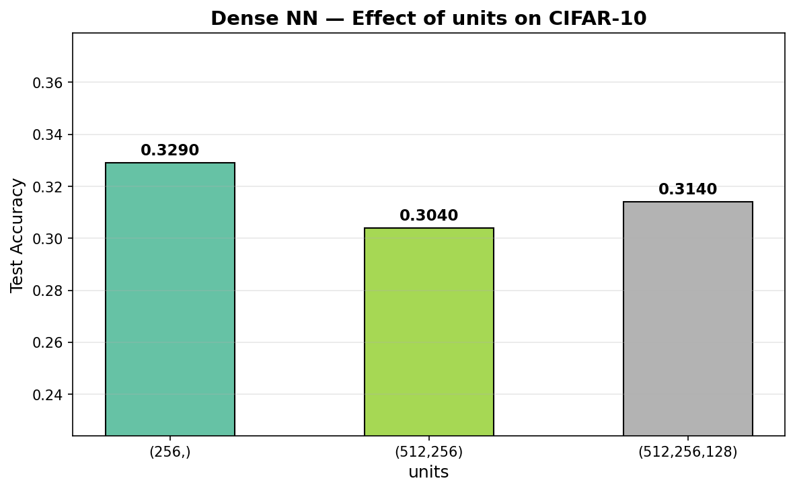
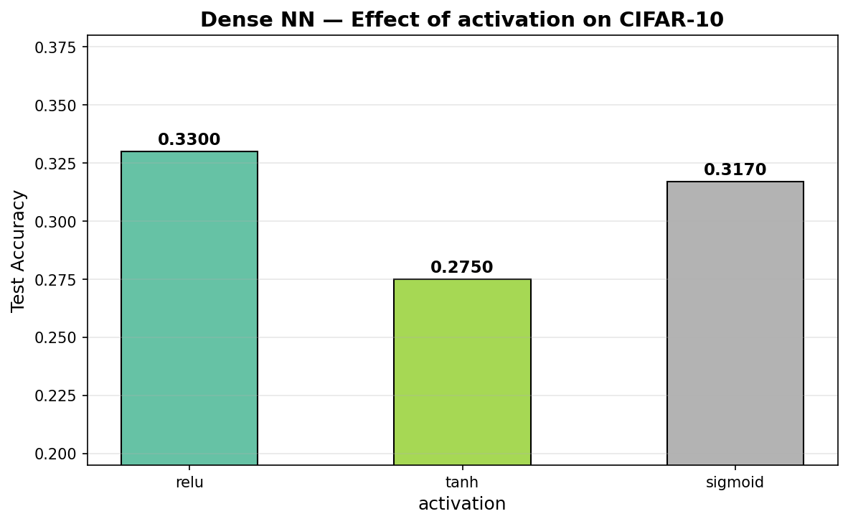

Explanation
- units: Single layer (256,) at 32.9% beat deeper (512,256 → 30.4%) on this small subset — deeper networks need more data and epochs.
- activation: ReLU (33.0%) > sigmoid (31.7%) > tanh (27.5%). ReLU avoids vanishing gradient and computes faster.

Step 17: CNN Parameter Study — Conv2D (6 parameters)

Code
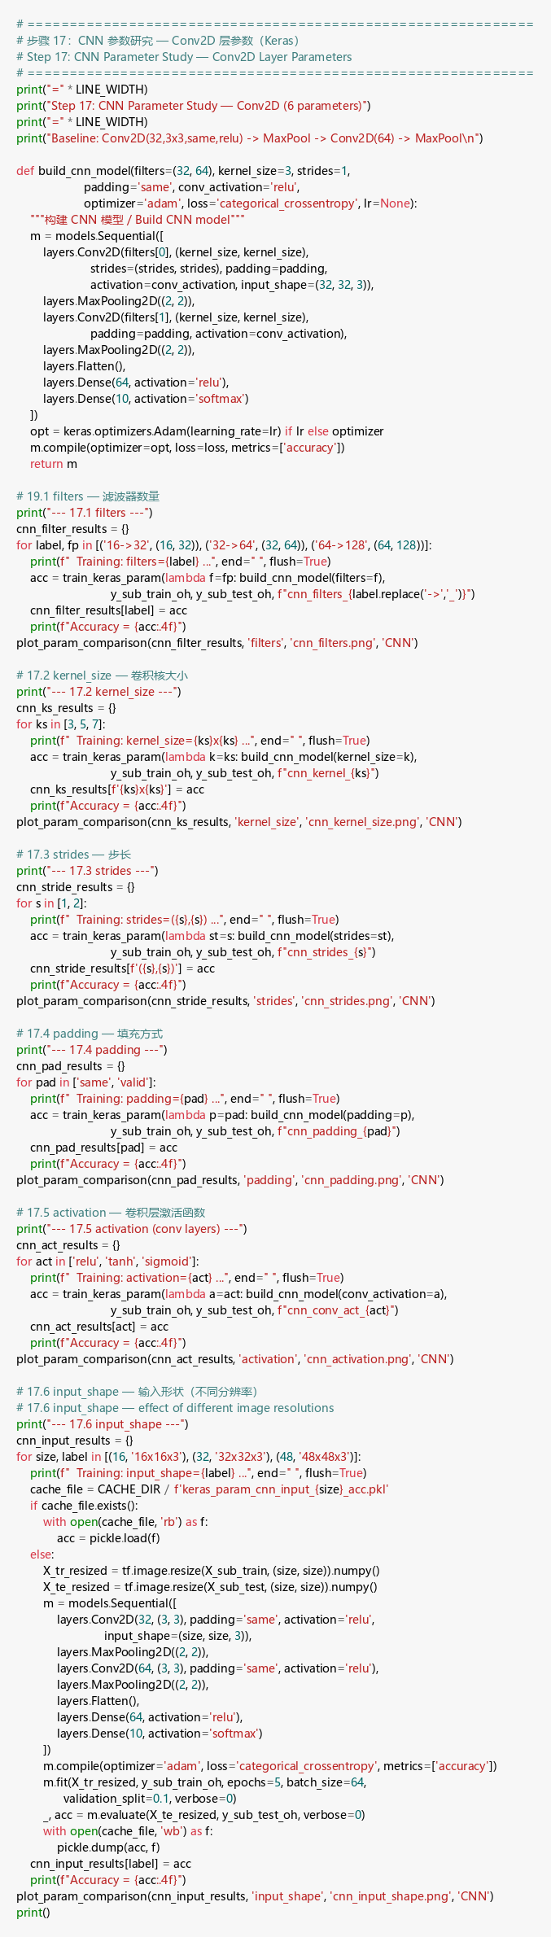

Output
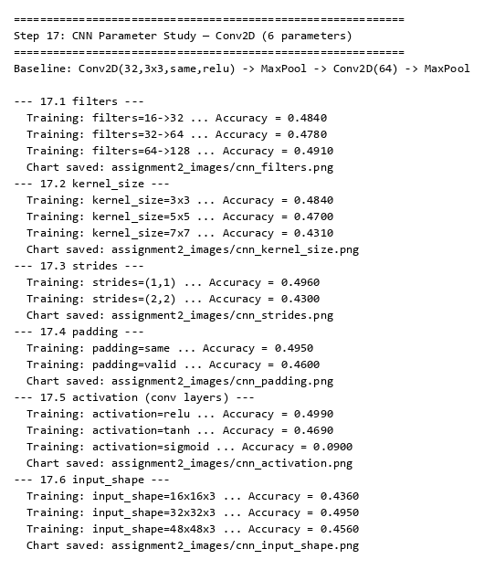
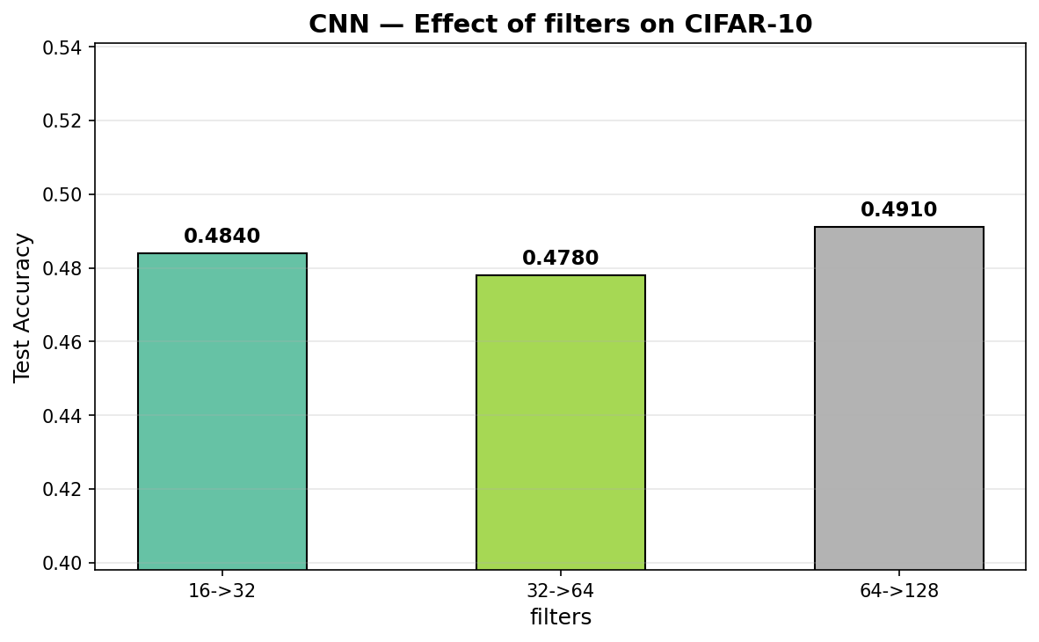
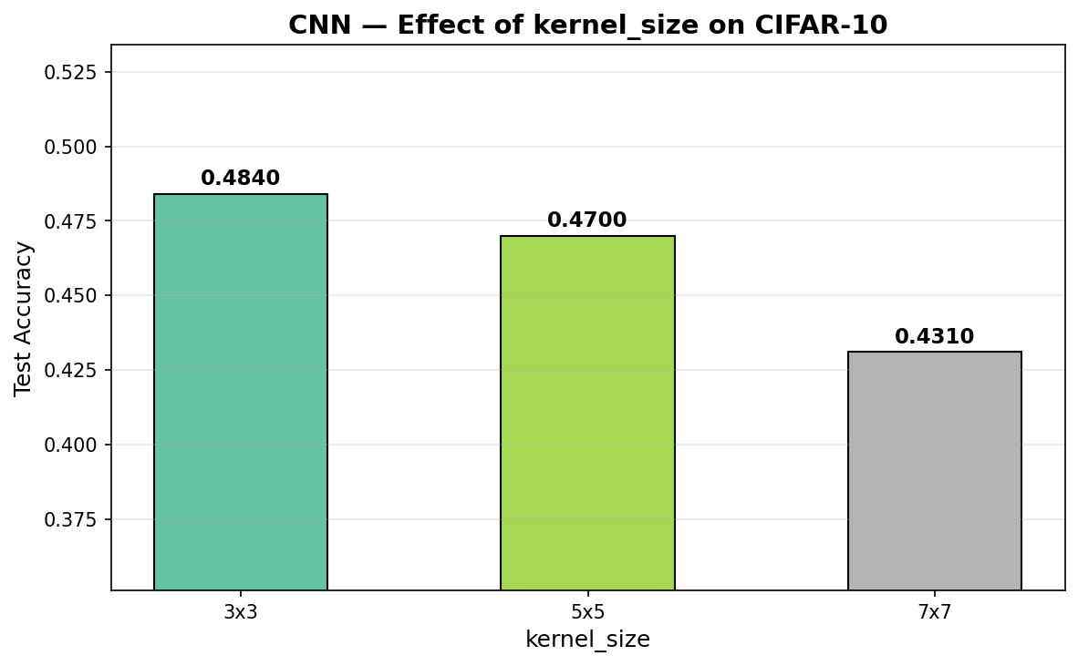
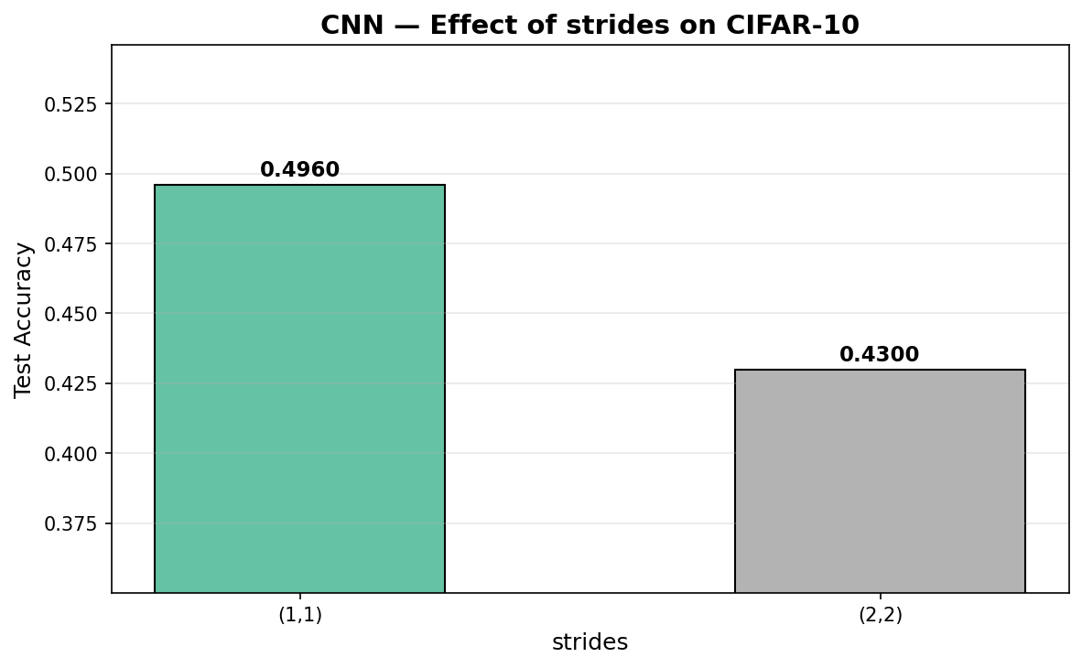
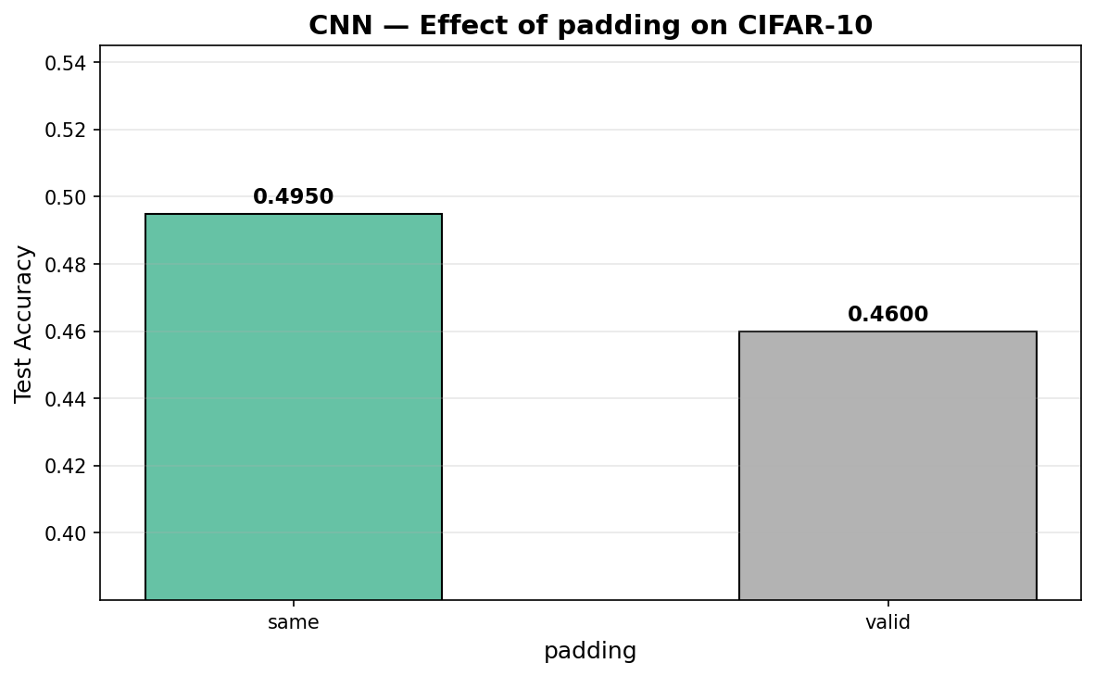
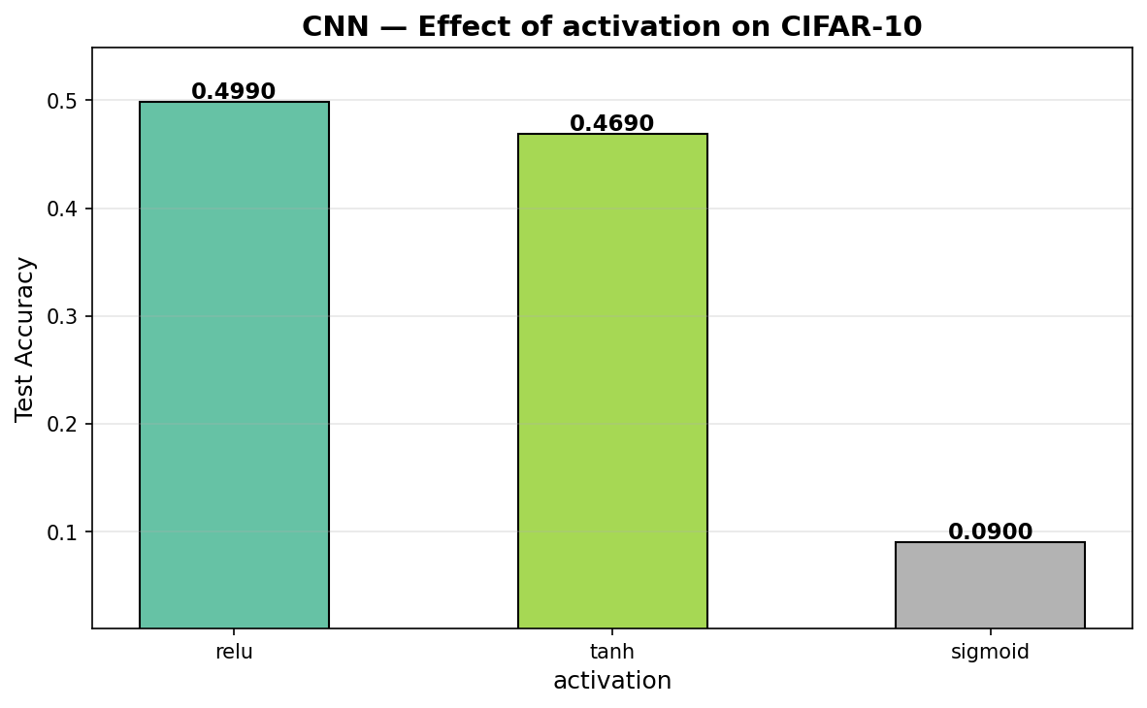
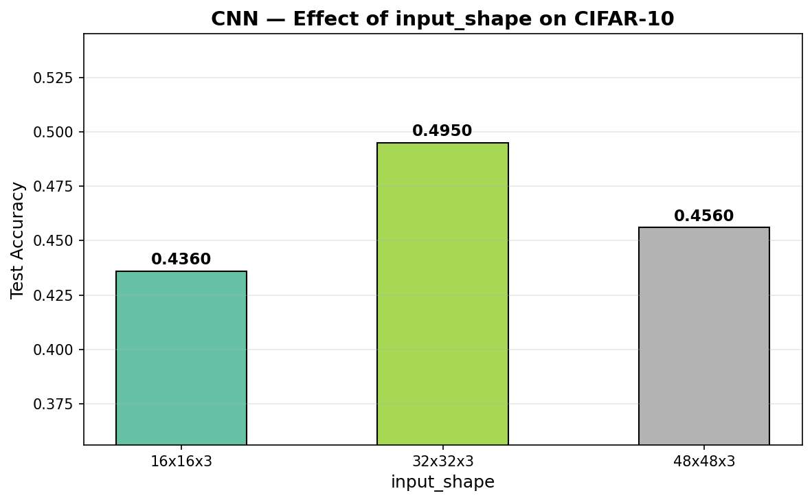

Explanation
- filters: 64→128 (49.1%) slightly better. More filters detect more feature patterns.
- kernel_size: 3×3 (48.4%) > 7×7 (43.1%). Smaller kernels capture finer details.
- strides: (1,1) (49.6%) >> (2,2) (43.0%). Stride 2 skips pixels and loses information.
- padding: same (49.5%) > valid (46.0%). Same padding preserves spatial dimensions.
- activation: ReLU (49.9%) >> sigmoid (9.0%). Sigmoid causes severe vanishing gradient in deep CNNs.
- input_shape: 32×32 (49.5%) is the original CIFAR-10 resolution and works best. 16×16 loses detail, 48×48 adds noise from upscaling.

Step 18: CNN Parameter Study — Compile (3 parameters)

Code
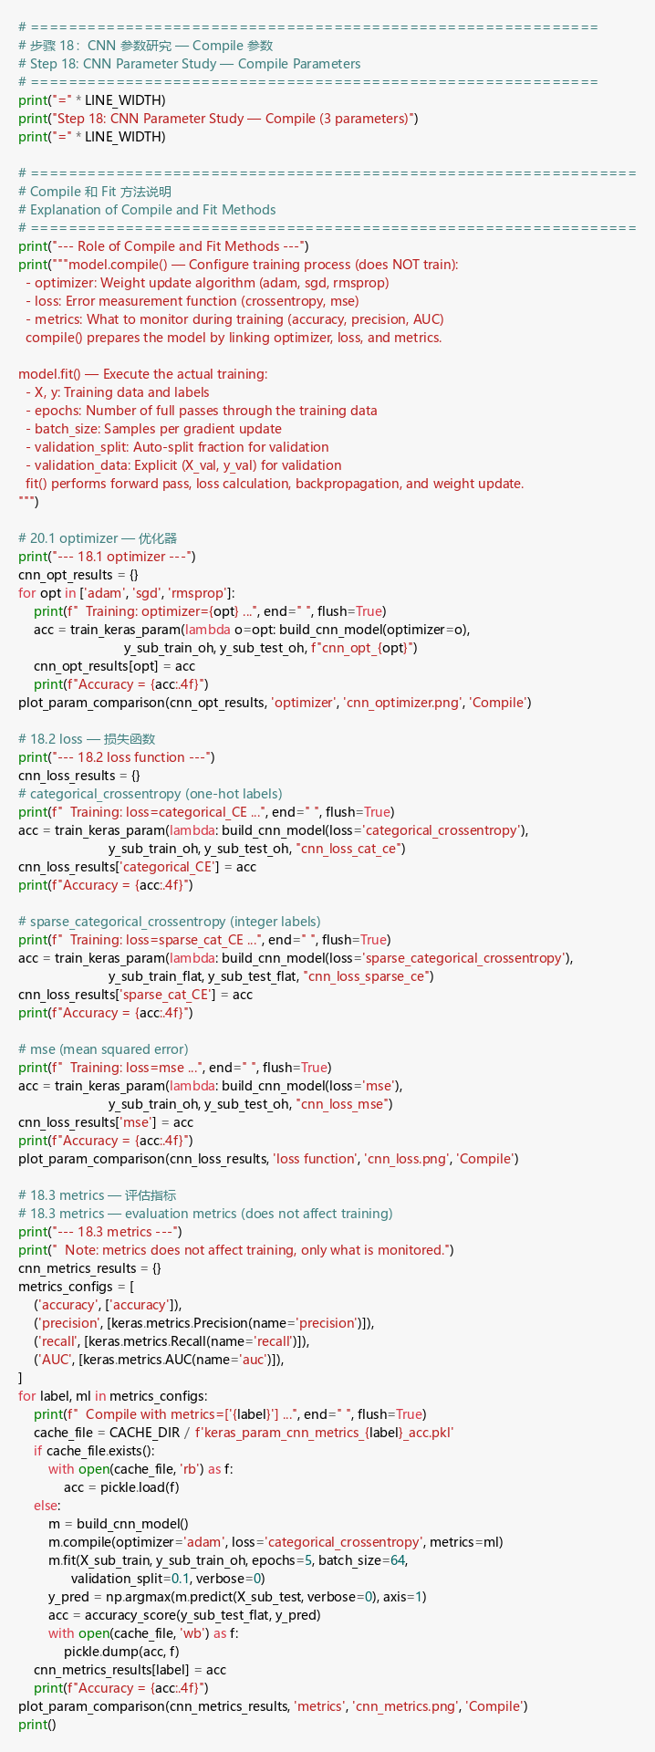

Output
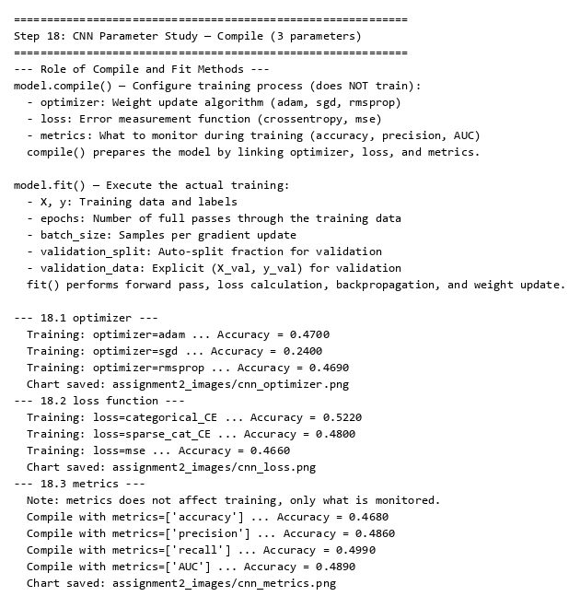

Role of Compile and Fit Methods
model.compile() configures training (does NOT train): sets the optimizer (weight update algorithm), loss function (error measurement), and metrics (monitoring).
model.fit() executes training: performs forward pass, calculates loss, runs backpropagation, and updates weights over specified epochs with given batch size.
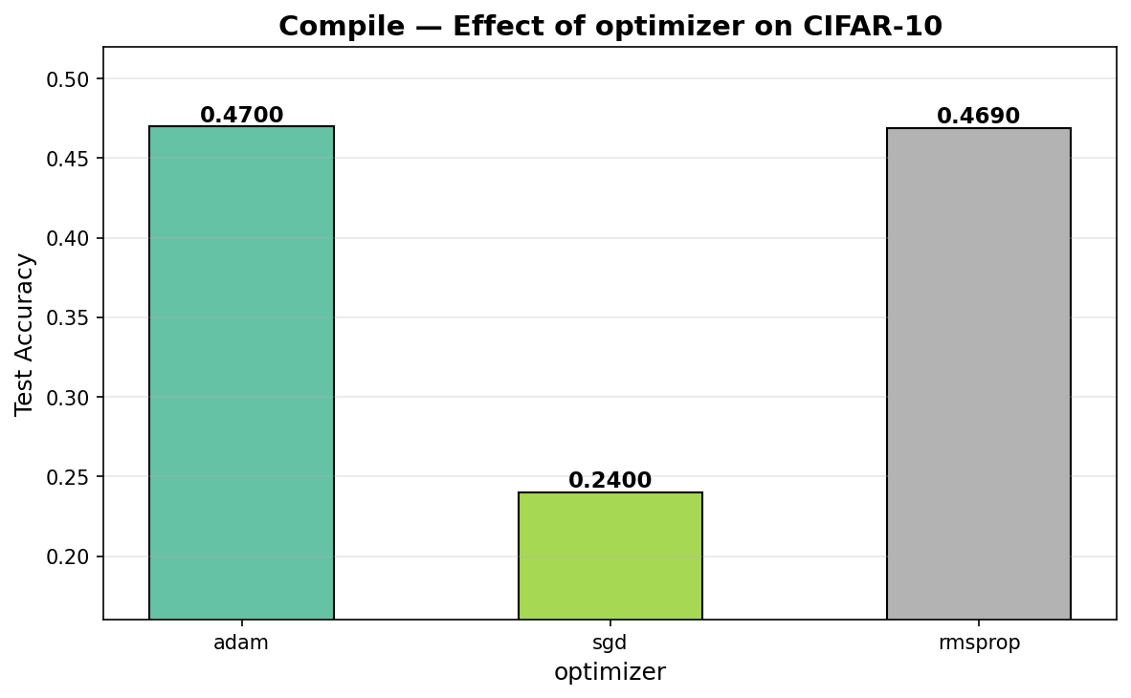
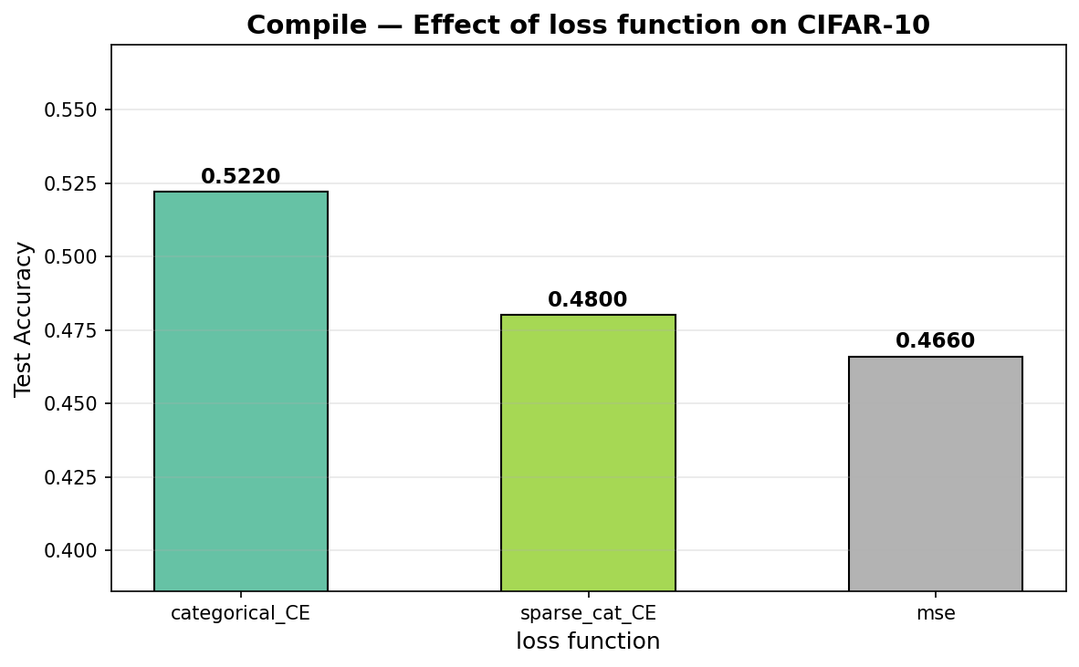
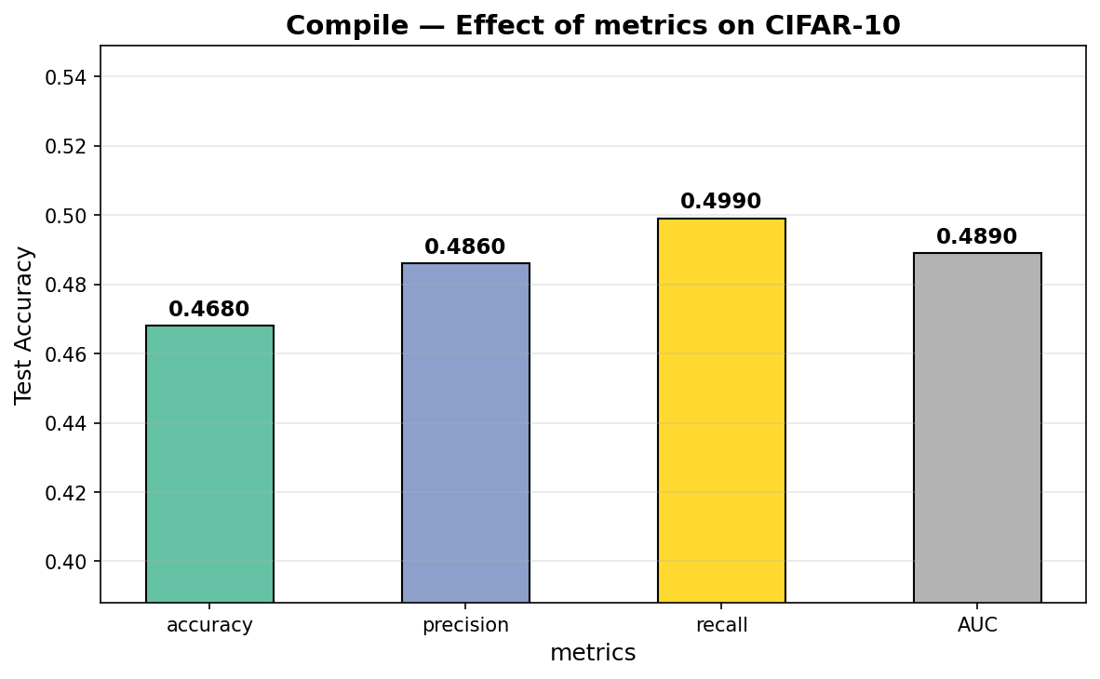

Explanation
- optimizer: Adam (47.0%) ≈ RMSprop (46.9%) >> SGD (24.0%). SGD without momentum struggles with complex loss landscapes.
- loss: categorical_crossentropy (52.2%) is best for classification. MSE (46.6%) is designed for regression, not classification.
- metrics: All produce similar accuracy (~47-50%) because metrics only monitor training — they don’t affect weight updates.

Step 19: CNN Parameter Study — Fit (5 parameters)

Code
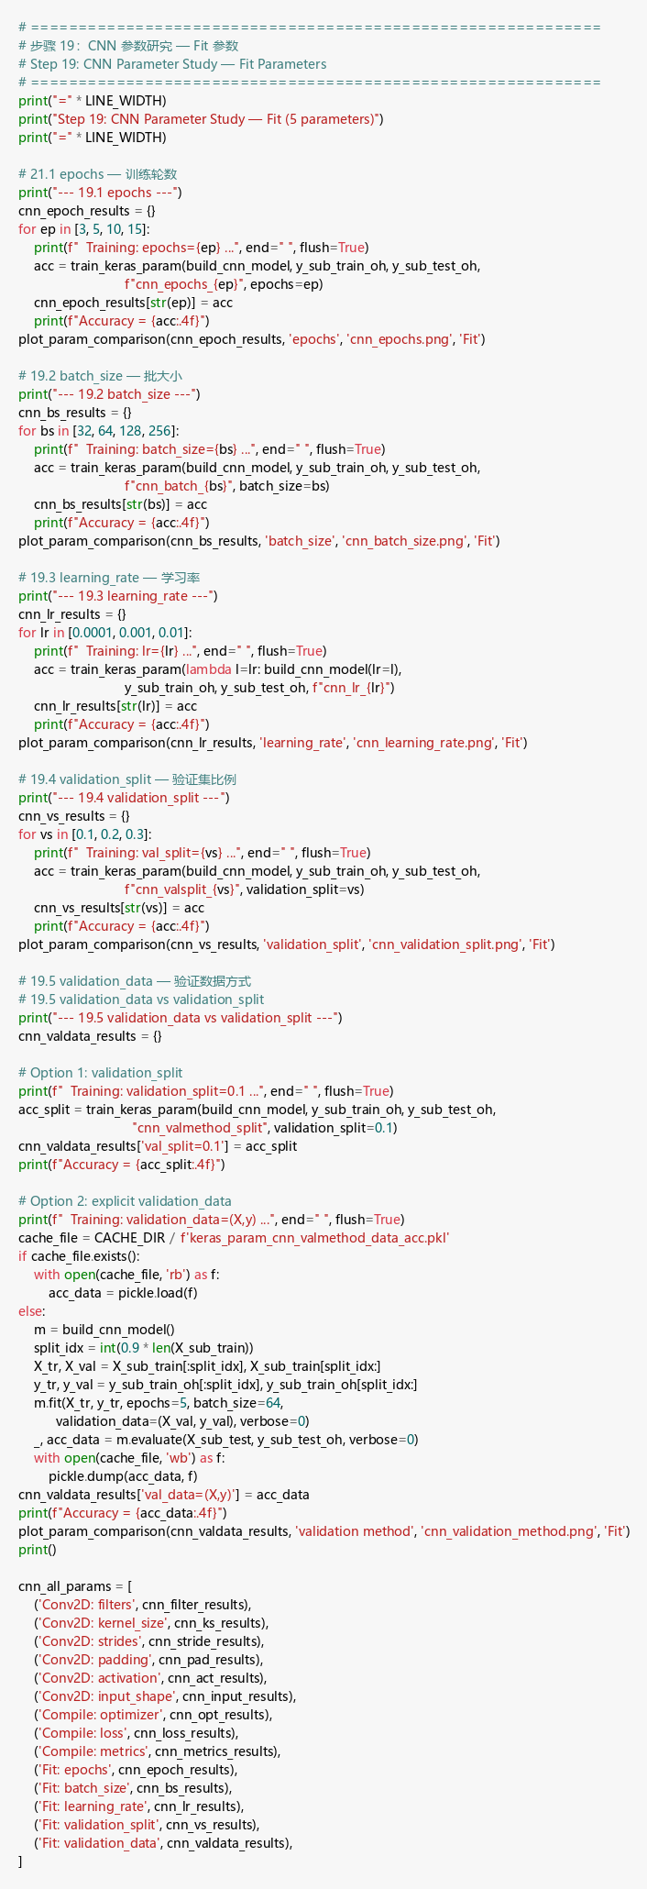

Output
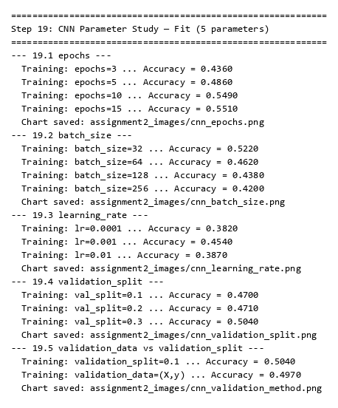
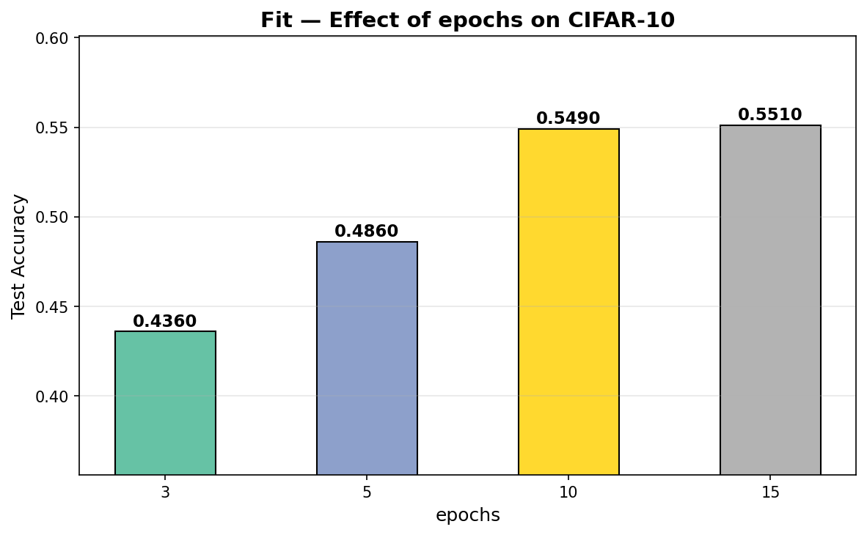
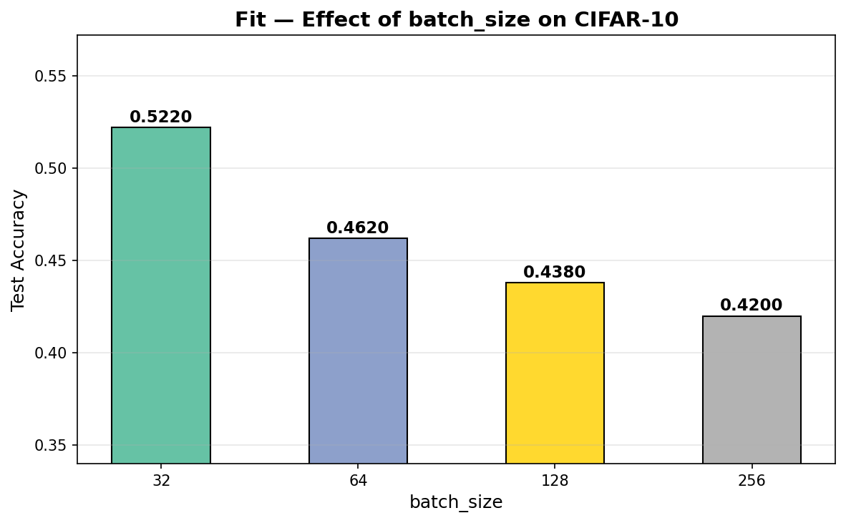
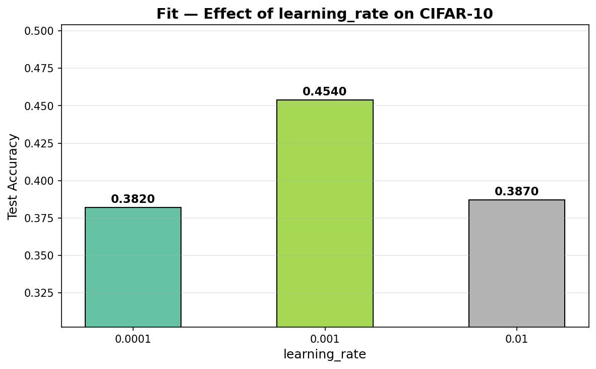
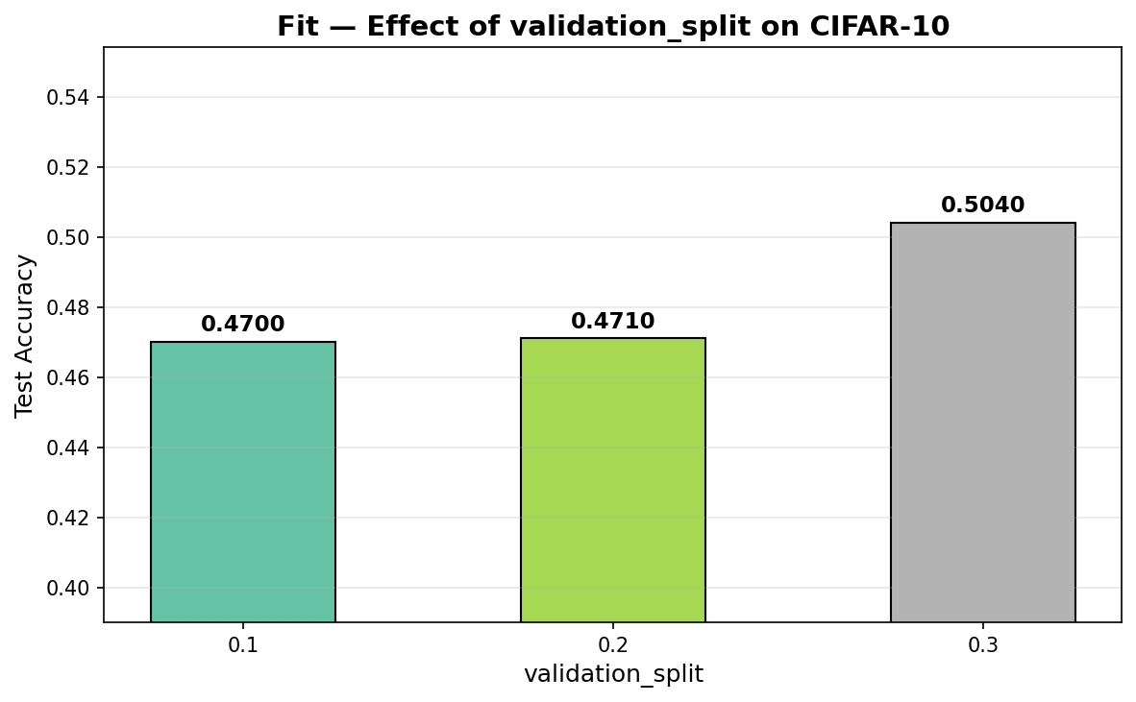
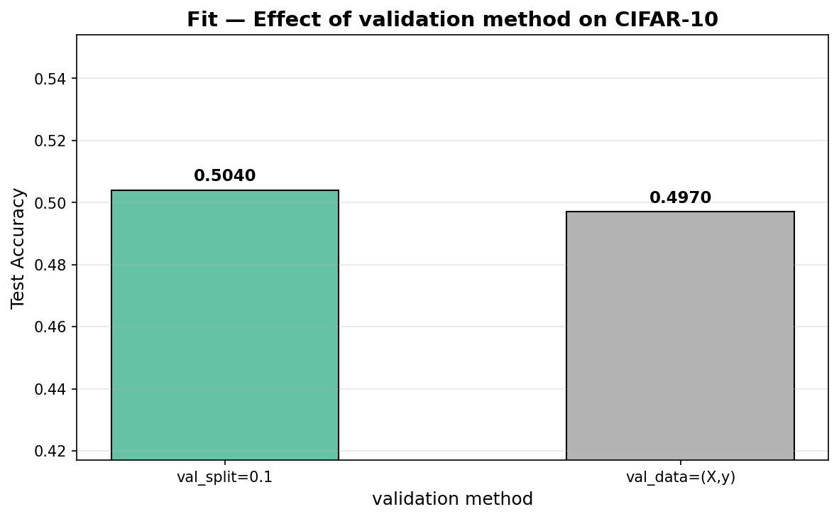

Explanation
- epochs: 15 (55.1%) > 3 (43.6%). More epochs allow better convergence but risk overfitting.
- batch_size: 32 (52.2%) > 256 (42.0%). Smaller batches give noisier but more frequent gradient updates.
- learning_rate: 0.001 (45.4%) is optimal. 0.0001 converges too slowly; 0.01 overshoots.
- validation_split: 0.3 (50.4%) slightly better than 0.1 (47.0%), but uses fewer training samples.
- validation_data: Using explicit validation_data (49.7%) vs validation_split (50.4%) gives similar results. validation_data provides more control over which samples are used.

Step 20: Parameter Study Summary

Code
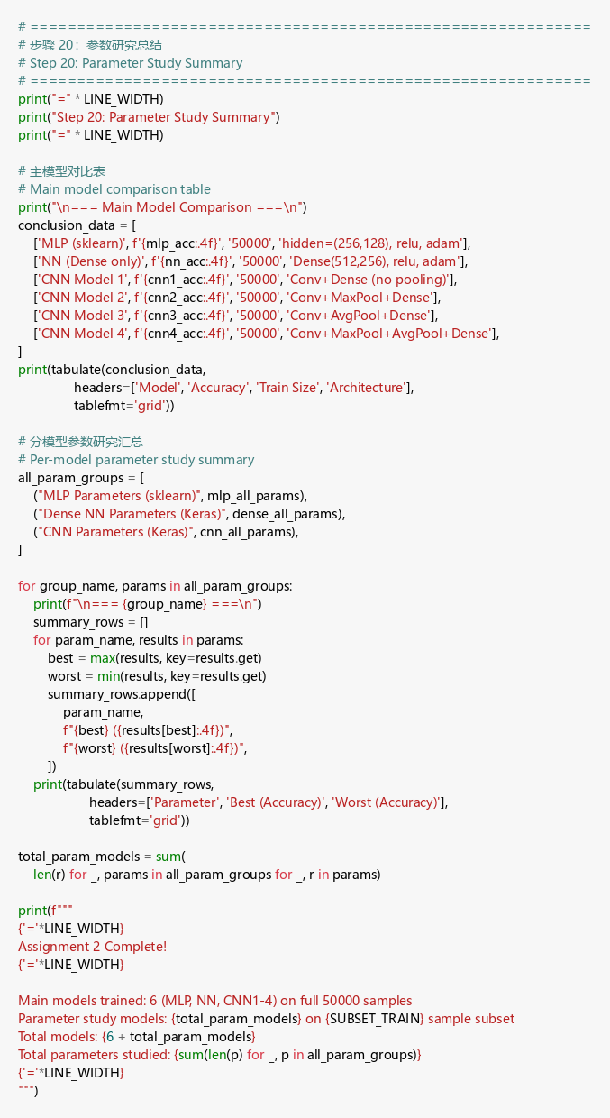

Output
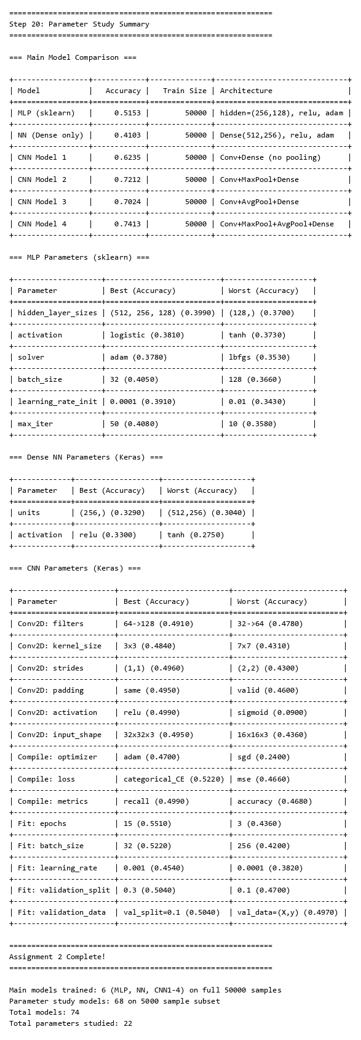

Explanation
I studied 22 parameters across 74 models total. Key findings: (1) CNN outperforms MLP/NN for image classification. (2) Pooling layers are essential — they reduce parameters and improve accuracy. (3) Adam optimizer, ReLU activation, and categorical_crossentropy are the best default choices. (4) Smaller batch sizes and moderate learning rates (0.001) yield the best results.

