CST8508 Machine Vision - Assignment 1 Report
Author: Peng Wang
Student Number: 041107730
Date: February 2026

1. Introduction
This assignment involves training deep learning models for image classification using the mmpretrain framework from OpenMMLab. The Oxford Flowers 17 dataset was used, containing 17 categories of flowers with approximately 80 images each.
Two models were selected for comparison:
- ResNet-18 — A residual network with 18 layers, using SGD optimizer
- MobileNet V2 — A lightweight network using depthwise separable convolutions, with Adam optimizer

Training Environment
Component | Version
OS | Ubuntu 22.04 (WSL2)
GPU | NVIDIA RTX 4060 (8GB)
Python | 3.8 (conda)
PyTorch | 2.4.1 + CUDA 12.1
mmengine | 0.10.7
mmcv | 2.2.0
mmpretrain | 1.2.0

2. Dataset Preparation (20%)

2.1 Dataset Overview
The Oxford Flowers 17 dataset contains 1,360 images across 17 flower categories: Bluebell, Buttercup, Coltsfoot, Cowslip, Crocus, Daffodil, Daisy, Dandelion, Fritillary, Iris, LilyValley, Pansy, Snowdrop, Sunflower, TigerLily, Tulip, Windflower.

2.2 SubFolder Format
The dataset was organized into the SubFolder format as required by mmpretrain’s CustomDataset:
data/flowers17/
├── train/
│ ├── Bluebell/ (62 images)
│ ├── Buttercup/ (62 images)
│ ├── ...
│ └── Windflower/ (62 images)
└── val/
├── Bluebell/ (16 images)
├── Buttercup/ (16 images)
├── ...
└── Windflower/ (16 images)
- Training set: ~1,054 images (62 per category)
- Validation set: ~272 images (16 per category)
- Split was performed using the provided train_set.json and val_set.json files.

2.3 Why SubFolder Format?
The SubFolder format was chosen because:
- No annotation files need to be created
- Class names are automatically inferred from subfolder names
- It is the simplest format compatible with mmpretrain

3. Model Training (50%)

3.1 Model 1: ResNet-18
Parameter | Value
Architecture | ResNet-18 (4 stages, 512-dim output)
Optimizer | SGD (lr=0.01, momentum=0.9)
LR Scheduler | Cosine Annealing (T_max=100)
Batch Size | 32
Epochs | 100
Input Size | 224×224
Data Augmentation | RandomResizedCrop, RandomFlip

3.2 Model 2: MobileNet V2
Parameter | Value
Architecture | MobileNet V2 (widen_factor=1.0, 1280-dim output)
Optimizer | Adam (lr=0.001)
LR Scheduler | Cosine Annealing (T_max=100)
Batch Size | 32
Epochs | 100
Input Size | 224×224
Data Augmentation | RandomResizedCrop, RandomFlip

3.3 Key Differences
Aspect | ResNet-18 | MobileNet V2
Parameters | ~11.7M | ~3.4M
Architecture | Standard convolutions | Depthwise separable convolutions
Optimizer | SGD | Adam
Feature Dim | 512 | 1280
Design Goal | Accuracy | Efficiency

4. Evaluation Analysis (20%)

4.1 Metrics Used
- Top-1 Accuracy: Percentage of correct predictions
- Top-5 Accuracy: Percentage where correct class is in top 5 predictions
- Per-class Accuracy: Accuracy breakdown by flower category
- Confusion Matrix: Visual analysis of classification errors

4.2 Training Progress
ResNet-18 Validation Accuracy (Top-1) by Epoch:
Epoch | Top-1 (%) | Top-5 (%)
10 | 38.97 | 80.51
20 | 52.57 | 91.54
30 | 60.66 | 95.96
40 | 65.07 | 93.75
50 | 69.49 | 95.96
60 | 72.43 | 97.43
70 | 72.79 | 97.43
80 | 74.63 | 97.43
90 | 77.21 | 97.79
100 | 76.47 | 98.16
MobileNet V2 Validation Accuracy (Top-1) by Epoch:
Epoch | Top-1 (%) | Top-5 (%)
10 | 55.88 | 92.65
20 | 63.60 | 95.22
30 | 70.22 | 95.96
40 | 75.00 | 97.06
50 | 84.93 | 98.90
60 | 85.29 | 98.53
70 | 88.24 | 98.90
80 | 89.71 | 98.90
90 | 90.07 | 98.53
100 | 89.71 | 98.90

4.3 Final Results (Best Checkpoint — Epoch 90)
Metric | ResNet-18 | MobileNet V2
Top-1 Accuracy | 77.21% | 90.07%
Top-5 Accuracy | 97.79% | 98.53%
Macro Avg Precision | 0.78 | 0.91
Macro Avg Recall | 0.77 | 0.90
Macro Avg F1-Score | 0.77 | 0.90
MobileNet V2 outperformed ResNet-18 by approximately 13 percentage points in Top-1 accuracy.

4.4 Per-Category Analysis
Figure 1: Per-Category Accuracy Comparison
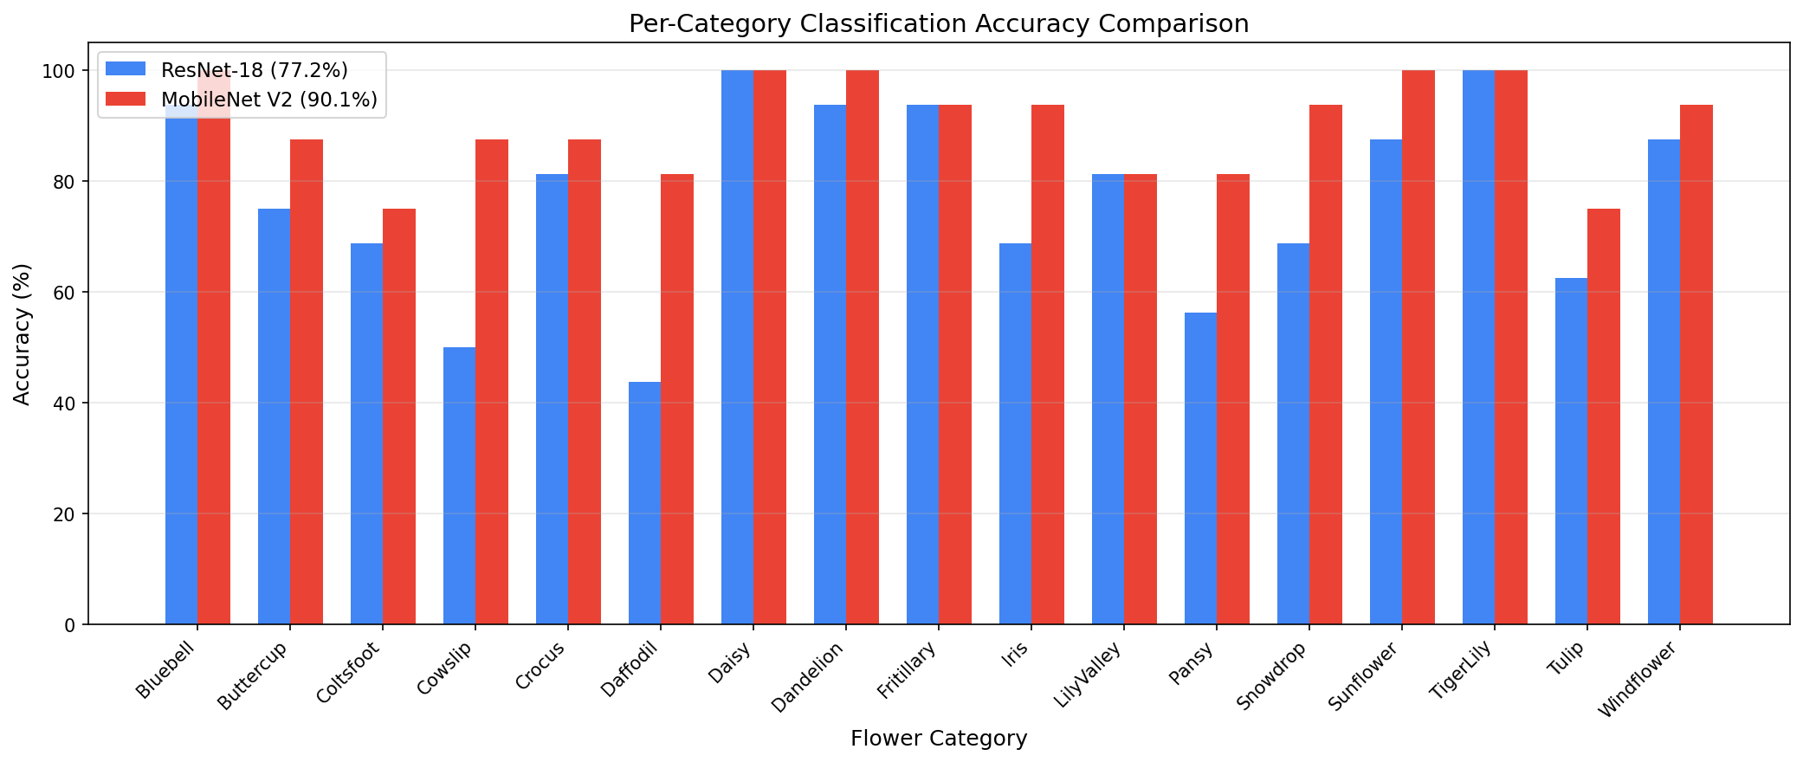
Figure 2: Confusion Matrices
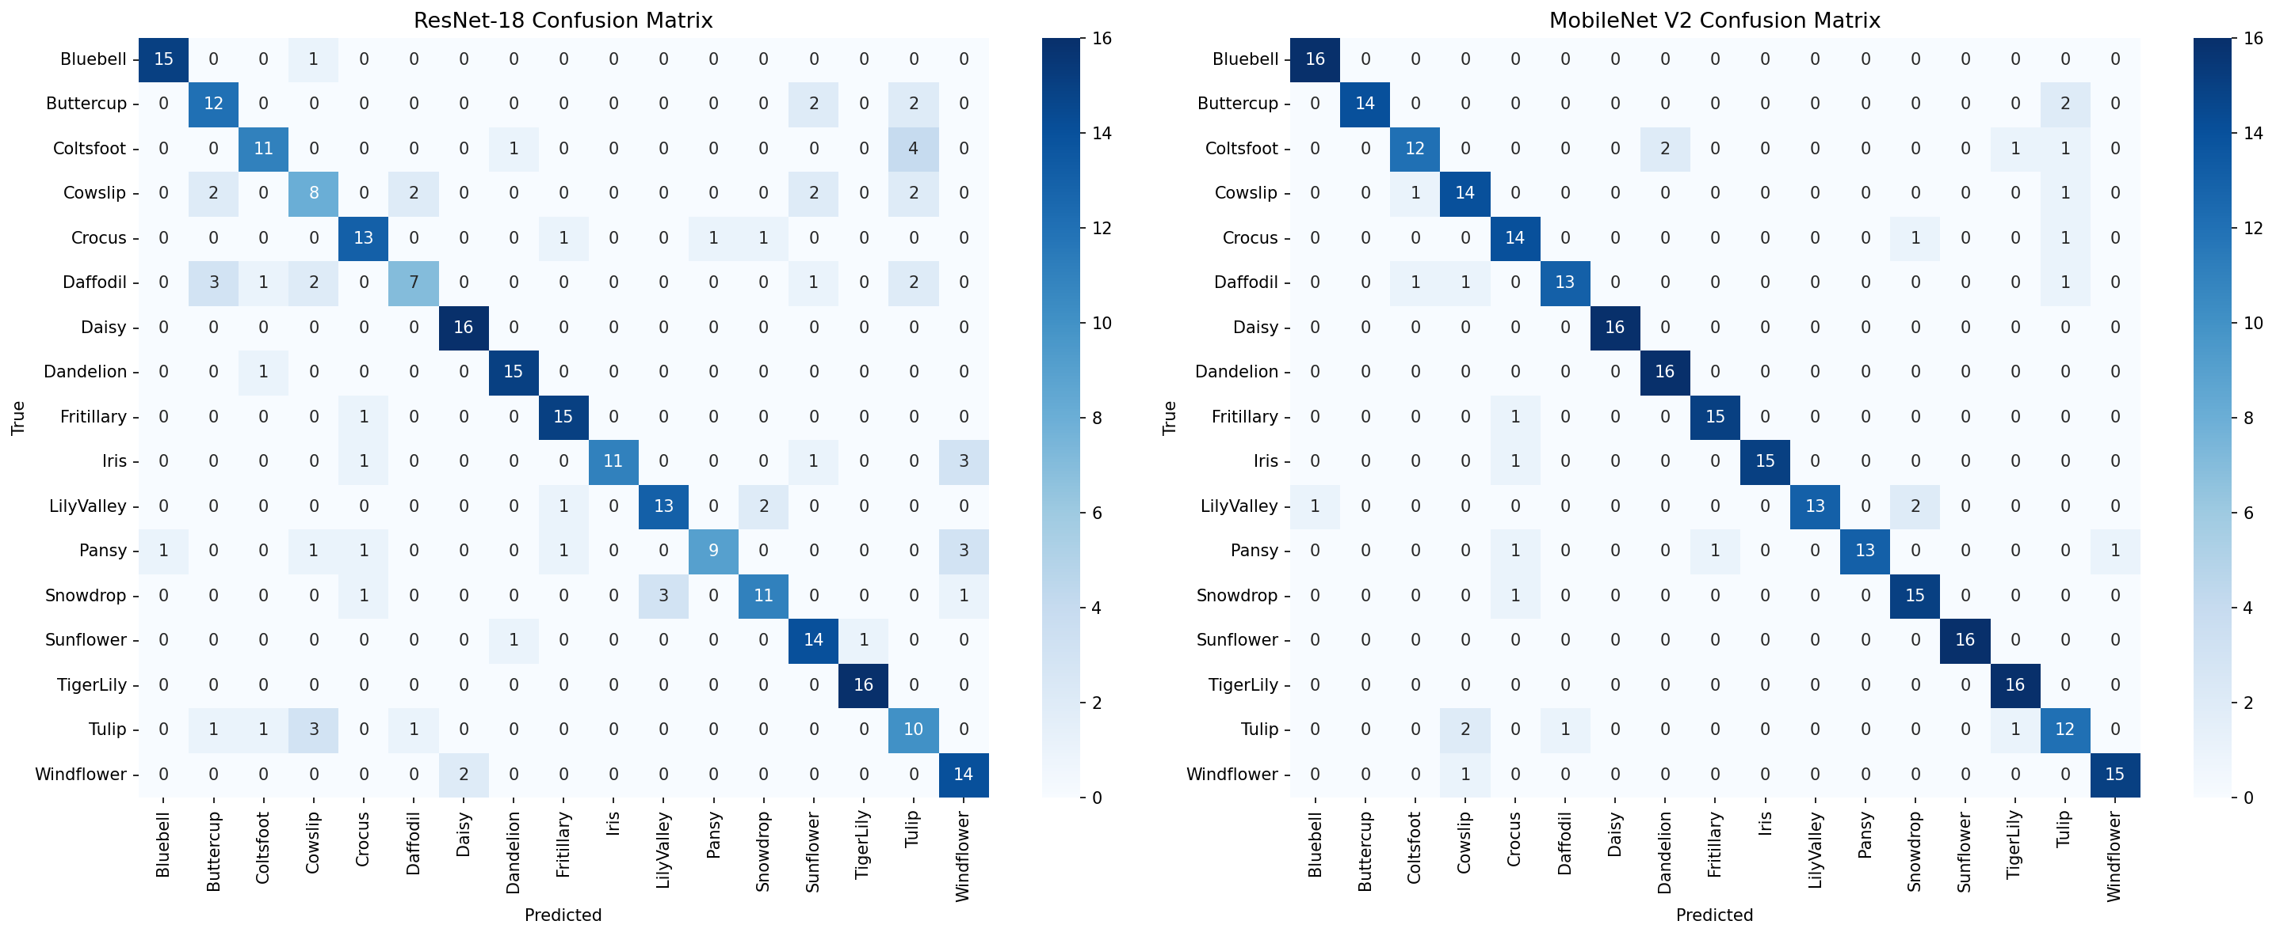
ResNet-18 — Best/Worst Categories:
Category | Precision | Recall | F1
TigerLily | 0.94 | 1.00 | 0.97
Daisy | 0.89 | 1.00 | 0.94
Dandelion | 0.88 | 0.94 | 0.91
Cowslip | 0.53 | 0.50 | 0.52
Daffodil | 0.70 | 0.44 | 0.54
Tulip | 0.50 | 0.62 | 0.56
MobileNet V2 — Best/Worst Categories:
Category | Precision | Recall | F1
Daisy | 1.00 | 1.00 | 1.00
Sunflower | 1.00 | 1.00 | 1.00
Bluebell | 0.94 | 1.00 | 0.97
Tulip | 0.67 | 0.75 | 0.71
Coltsfoot | 0.86 | 0.75 | 0.80
Cowslip | 0.78 | 0.88 | 0.82
Key Observations:
- Categories with distinctive visual features (Sunflower, Daisy, TigerLily) achieve high accuracy in both models
- Visually similar categories (Cowslip vs Coltsfoot, Buttercup vs Dandelion) are more challenging
- MobileNet V2 shows significantly better performance on difficult categories like Daffodil (0.87 vs 0.54 F1) and Pansy (0.90 vs 0.69 F1)
- The Adam optimizer with MobileNet V2 appears to converge faster and more effectively than SGD with ResNet-18 on this small dataset

5. Lessons Learned (10%)

5.1 Challenges Faced
- Environment Setup Complexity: OpenMMLab requires specific compatible versions of PyTorch, mmcv, and mmengine. Initial attempts on Google Colab failed because PyTorch 2.10+cu128 had no pre-built mmcv wheel. Attempts to build from source also failed due to Python 3.12 incompatibility with pkg_resources. The solution was to use a local WSL (Ubuntu 22.04) environment with conda, following the official mmpretrain tutorial exactly: conda + Python 3.8 + PyTorch 2.4.1 + CUDA 12.1.
- NumPy Version Conflicts: In the WSL venv environment, NumPy 2.x caused segfaults with PyTorch 2.1.2. Downgrading NumPy did not resolve the issue. Switching to conda (which manages binary compatibility automatically) solved this completely.
- Dataset Organization: The Oxford Flowers 17 dataset provides raw images without a predefined folder structure. A custom prepare_dataset.py script was written to download, extract, and organize images into the SubFolder format using predefined train/val split JSON files.
- Config File Structure: The ImageClassificationInferencer requires a test_dataloader in the config, but our configs only defined train_dataloader and val_dataloader. Adding test_dataloader = val_dataloader resolved this.
- Small Dataset Considerations: With only ~62 training images per class, overfitting is a concern. Data augmentation (RandomResizedCrop, RandomFlip) and cosine annealing LR schedule helped. Both models showed continued improvement up to epoch 90, with slight fluctuation at epoch 100.

5.2 Key Takeaways
- Environment Matters: The biggest lesson was that environment setup is half the battle. Conda with the official tutorial versions (Python 3.8, PyTorch + CUDA via conda, mim for OpenMMLab packages) is the most reliable path. Avoid mixing pip/conda or using bleeding-edge Python versions.
- MobileNet V2 Surprised Me: Despite having only ~3.4M parameters (vs ResNet-18’s ~11.7M), MobileNet V2 achieved 90% accuracy compared to ResNet-18’s 77%. The Adam optimizer likely helped MobileNet V2 converge better on this small dataset, while SGD with ResNet-18 may have needed more careful hyperparameter tuning.
- Config-Based Training: The config-driven approach makes experiments highly reproducible. Changing models, datasets, or hyperparameters only requires editing config files, not rewriting training loops.
- OpenMMLab Ecosystem: Once you learn the structure of one OpenMMLab project (config system, registry, runner), all others become much easier to use.
- Automation Saves Time: Writing assignment1.sh as an all-in-one script (setup → check → train → evaluate → copy results) made the workflow reproducible and eliminated manual steps.

5.3 Future Improvements
- Use pretrained ImageNet weights for transfer learning — this would significantly boost accuracy on this small dataset by leveraging features learned from 1.2M images
- Experiment with stronger data augmentation (ColorJitter, RandomRotation, CutOut) to further combat overfitting with limited training data
- Try fine-tuning (freezing early layers) vs training from scratch to compare convergence speed and final accuracy
- Explore more advanced architectures (EfficientNet, Vision Transformer) to understand how modern architectures perform on small-scale classification tasks
- Implement learning rate warmup to stabilize early training phases

