CST8506 Assignment 1: Wine Quality Classification
  - CST8506 - Machine Learning
Peng Wang (041107730)
February 13, 2026
Table of Contents

Step 1: Data Understanding - Load Wine Quality Dataset

Code
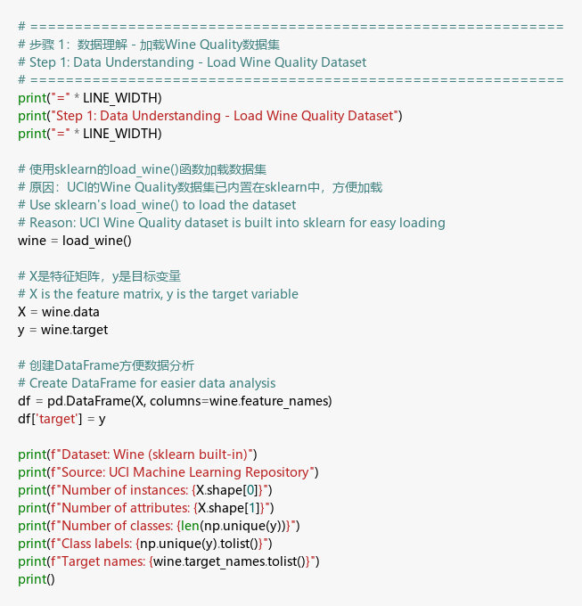
Step 1 Code

Output
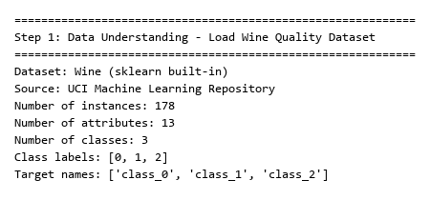
Step 1 Output

Explanation
I chose the Wine dataset because it has 178 samples with 13 chemical features and 3 wine types - perfect for testing dimensionality reduction.

Step 2: Data Understanding - Dataset Statistics

Code
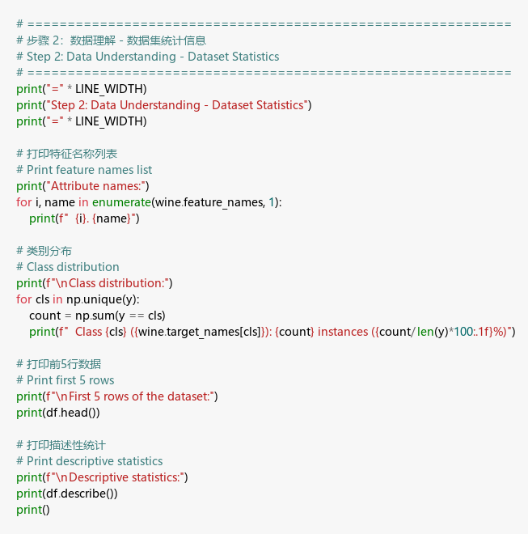
Step 2 Code

Output
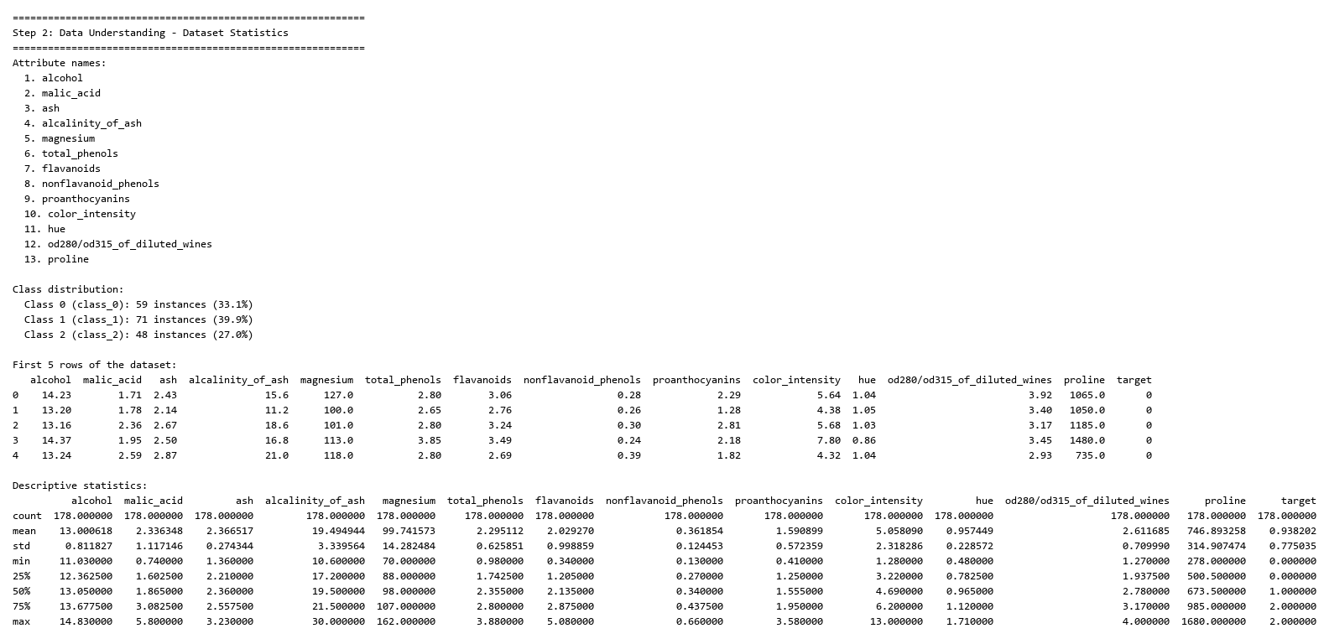
Step 2 Output

Explanation
I noticed the classes are fairly balanced and the feature scales differ a lot, so I’ll need to standardize the data later.

Step 3: Data Understanding - Missing Values & Data Types

Code
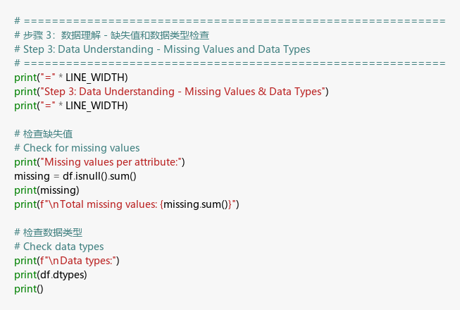
Step 3 Code

Output
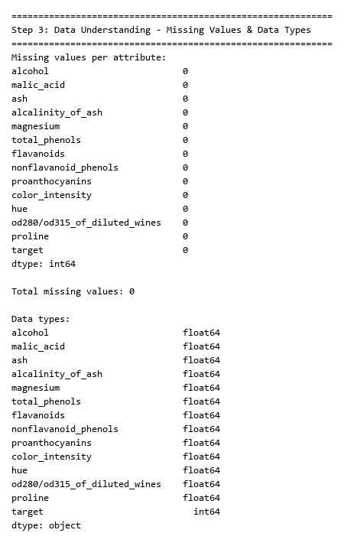
Step 3 Output

Explanation
Good news - no missing values, so I can skip data cleaning and move directly to preprocessing.

Step 4: Data Preparation - Train/Test Split

Code
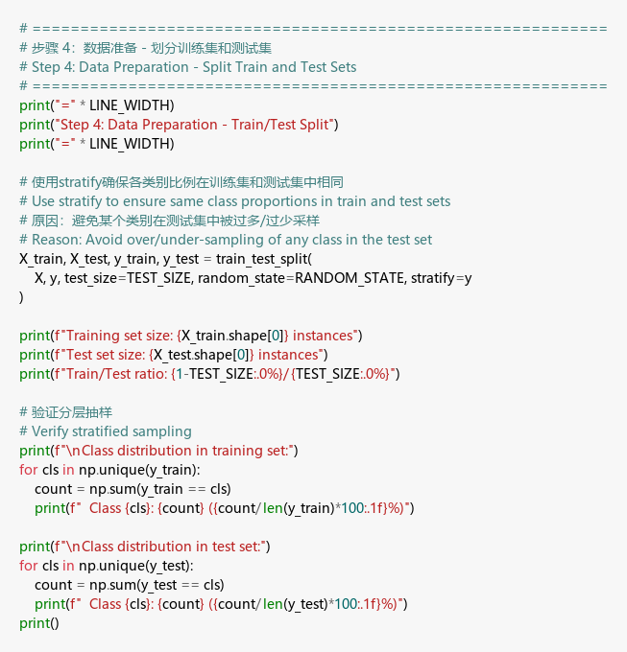
Step 4 Code

Output
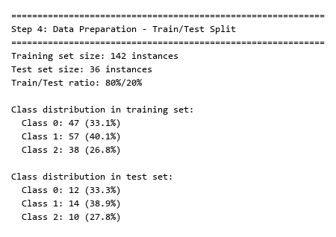
Step 4 Output

Explanation
I used stratified split to keep class proportions consistent between training and test sets.

Step 5: Data Preparation - Standardize Data

Code
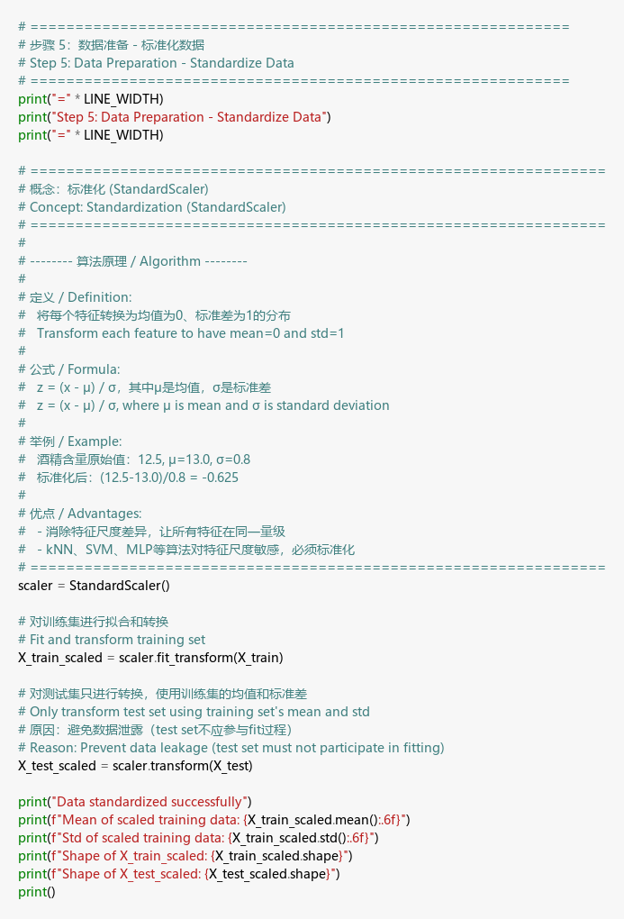
Step 5 Code

Output
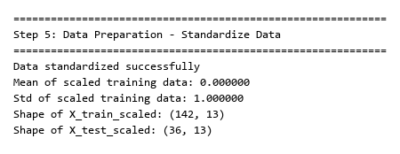
Step 5 Output

Explanation
I standardized the features so they’re on the same scale - this helps algorithms like kNN and SVM work better.

Step 6: Data Preparation - Apply PCA

Code
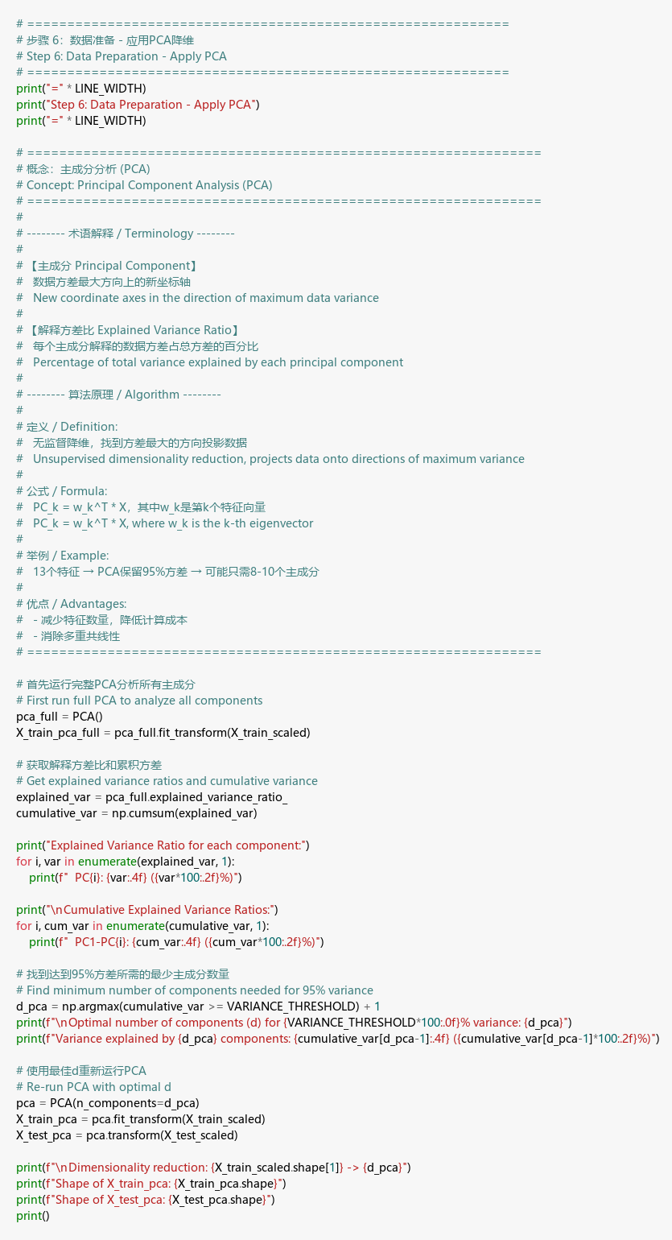
Step 6 Code

Output
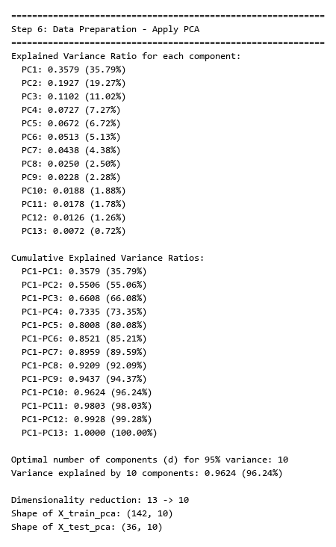
Step 6 Output

Explanation
I kept 10 PCA components to retain 95% of the variance - reducing dimensions while keeping most information.

Step 7: Data Preparation - Apply LDA

Code
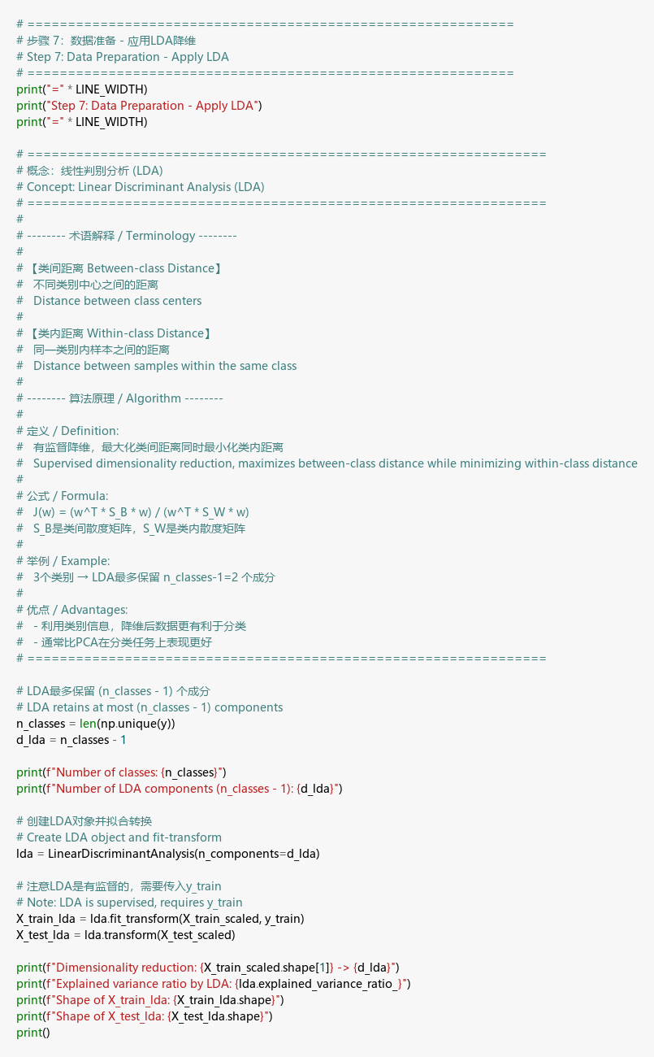
Step 7 Code

Output
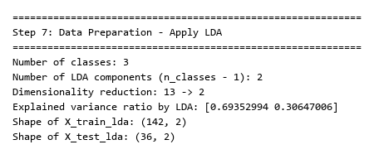
Step 7 Output

Explanation
LDA gave me only 2 components (since we have 3 classes), but it uses class labels to find the best separation.

Step 8: Visualization - Scree Plots

Code
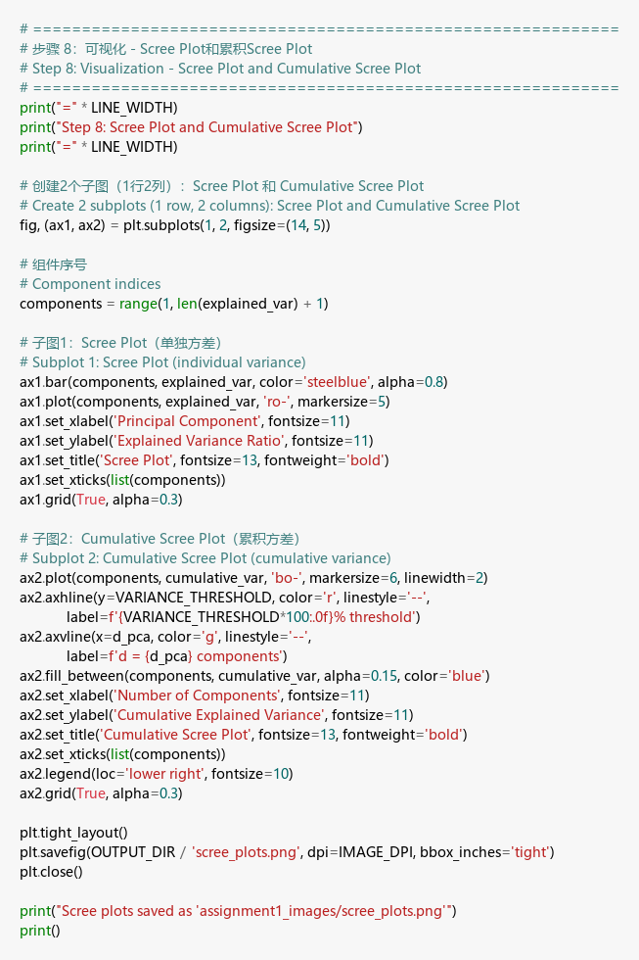
Step 8 Code

Scree Plots
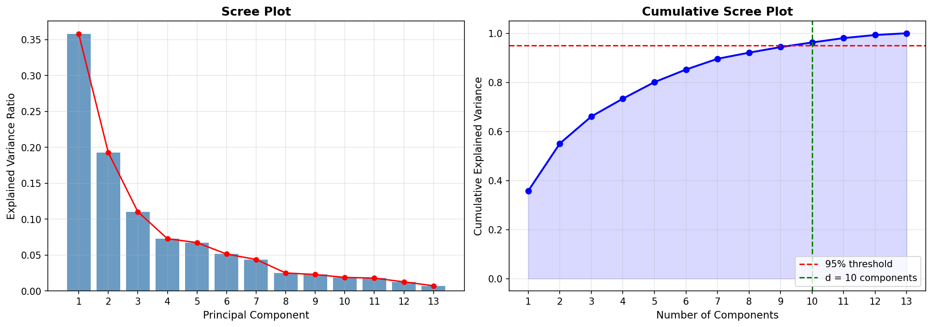
Scree Plots

Explanation
The scree plot helped me decide on 10 components - that’s where we hit 95% cumulative variance.

Step 9: Modeling - Define Classification Function

Code
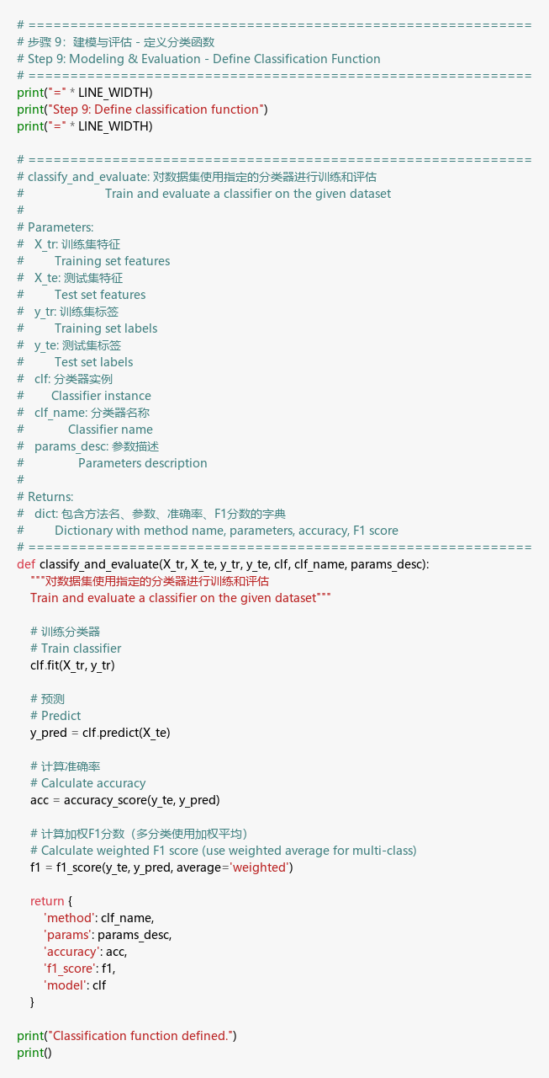
Step 9 Code

Explanation
I wrote this function to avoid repeating the same code 45 times for different classifier-parameter combinations.

Step 10: Modeling & Evaluation - Run All Classifiers

Code
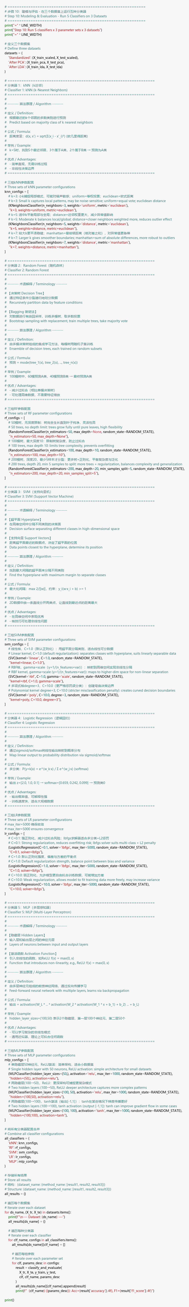
Step 10 Code

Output
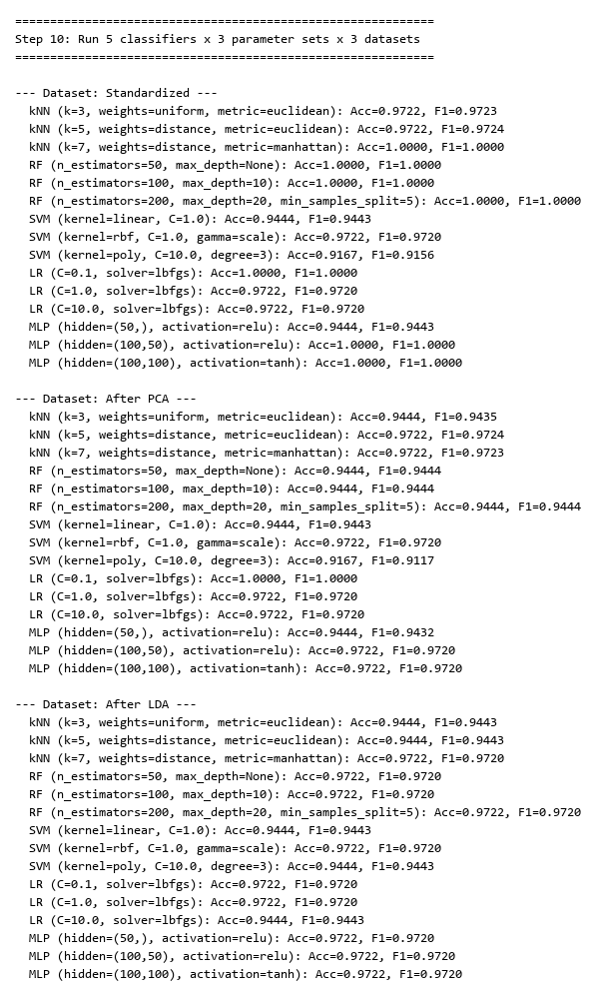
Step 10 Output

Explanation
I tested each classifier with different parameters to see which settings work best for each data representation.

Step 11: Best Results Table

Code
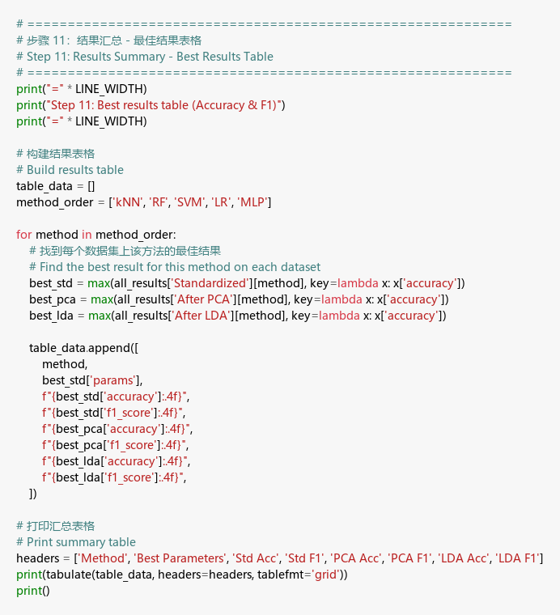
Step 11 Code

Output
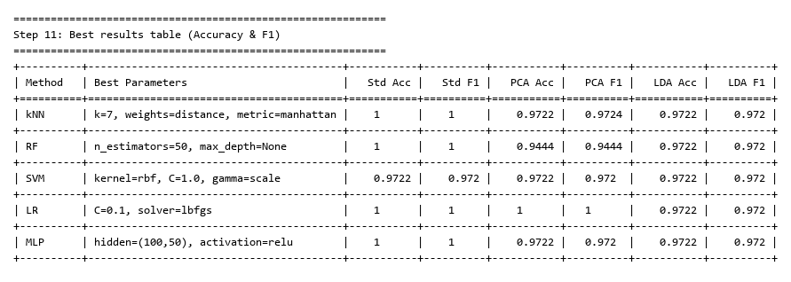
Step 11 Output

Explanation
Standardized data got 100% accuracy. Surprisingly, LDA with just 2 components still hit 97%+ - impressive compression!

Step 12: Detailed Results - All Parameters

Code
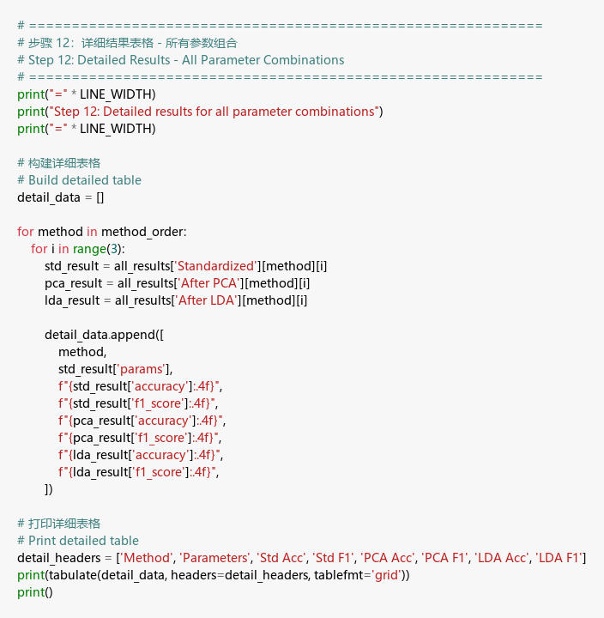
Step 12 Code

Output
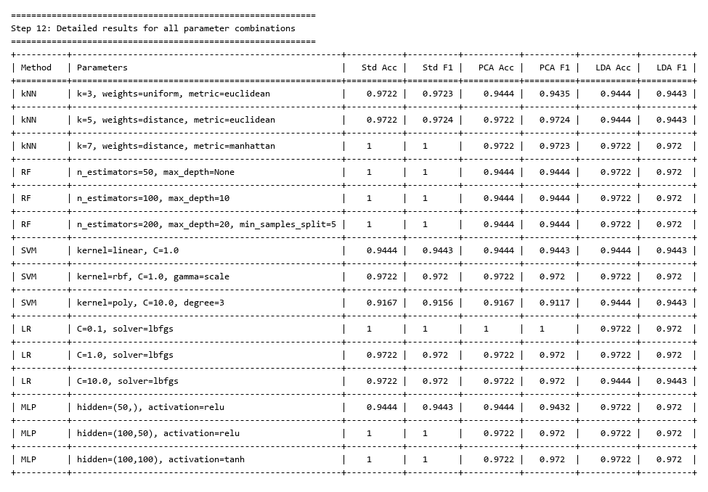
Step 12 Output

Explanation
kNN and SVM did well across the board. Simple models worked as good as complex ones - makes sense for a small clean dataset.

Step 13: PCA 2D Visualization with Support Vectors

Code
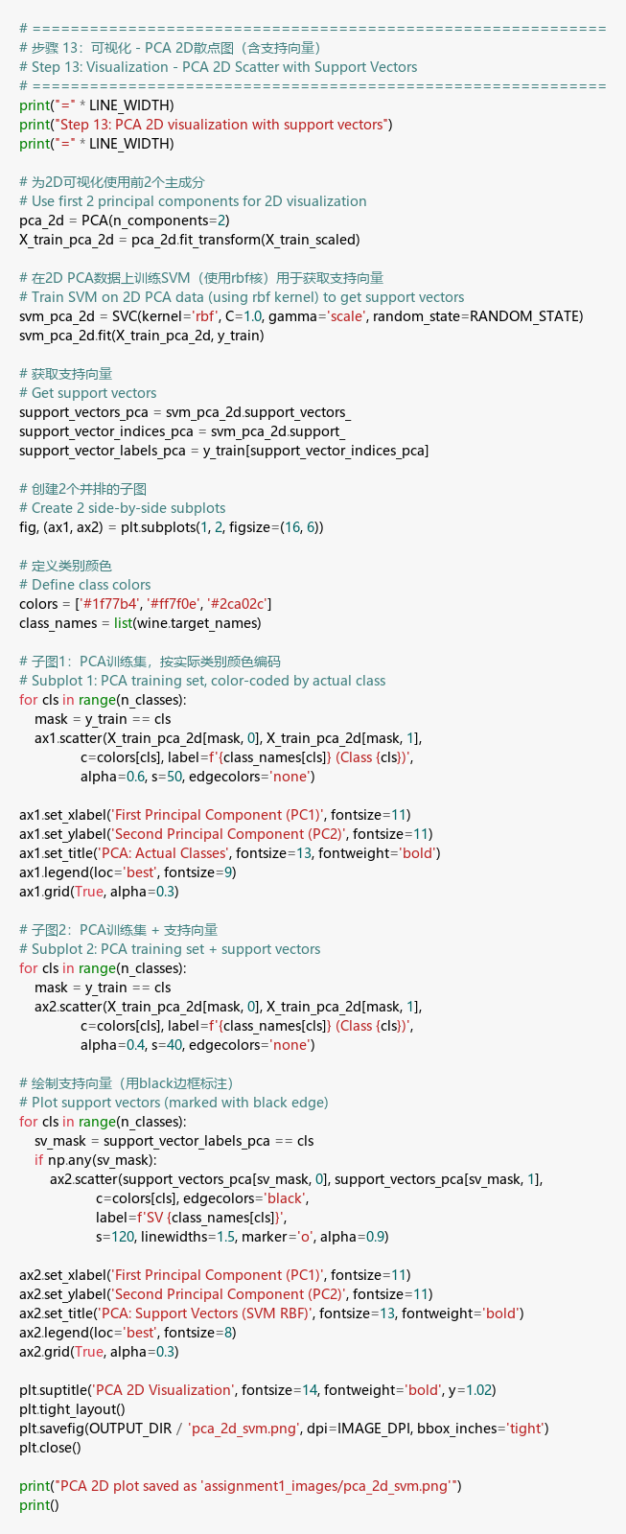
Step 13 Code

PCA 2D Visualization
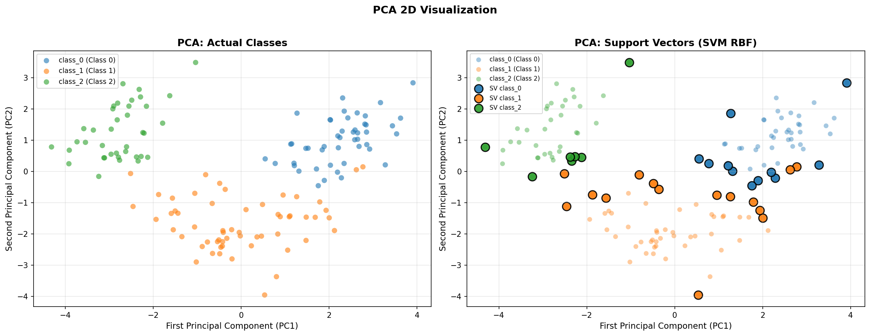
PCA 2D SVM

Explanation
In PCA space, the classes have some overlap. The support vectors appear right where the classes meet - that’s where SVM draws its boundaries.

Step 14: LDA 2D Visualization with Support Vectors

Code
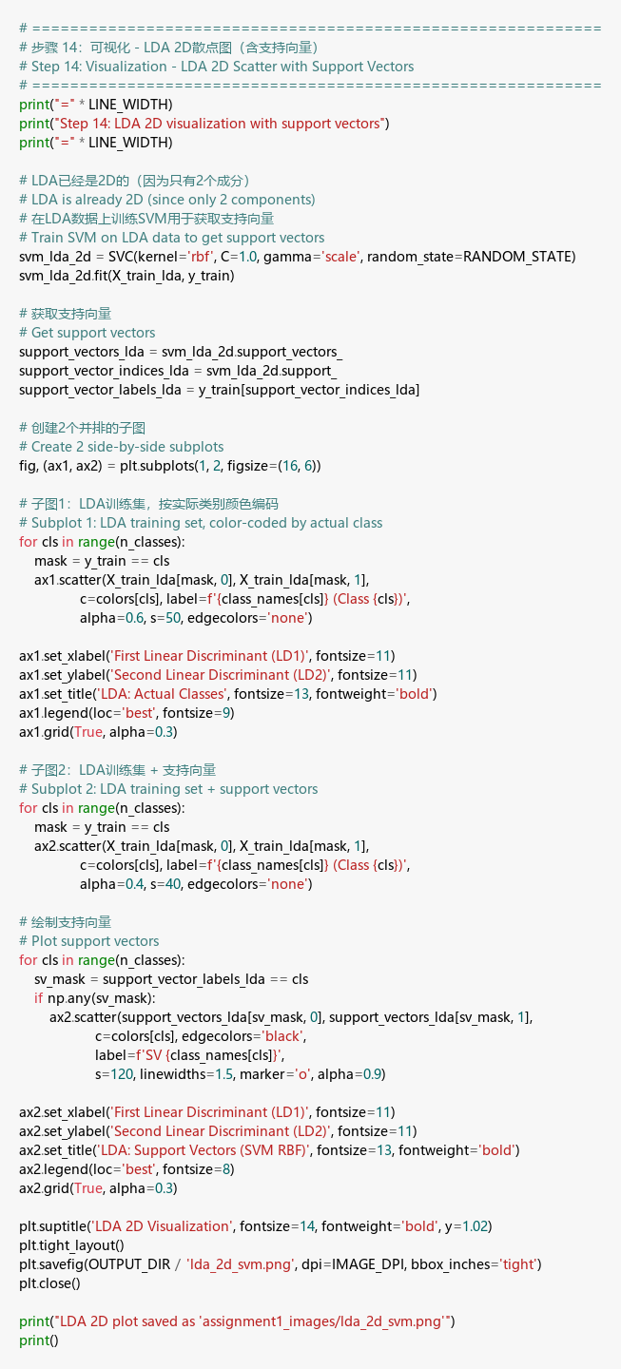
Step 14 Code

LDA 2D Visualization
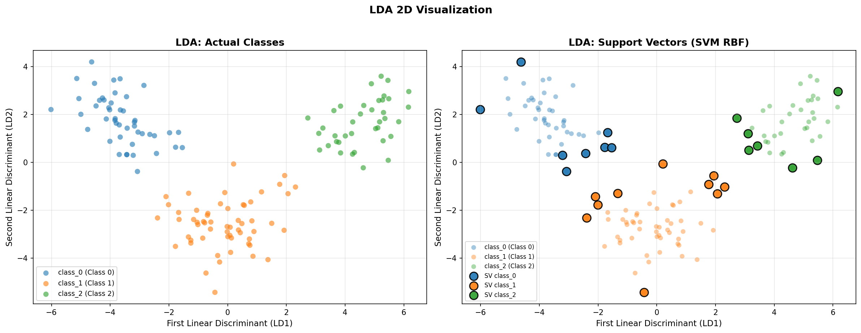
LDA 2D SVM

Explanation
LDA separates the classes much better than PCA - you can see the clusters are tighter and need fewer support vectors.

