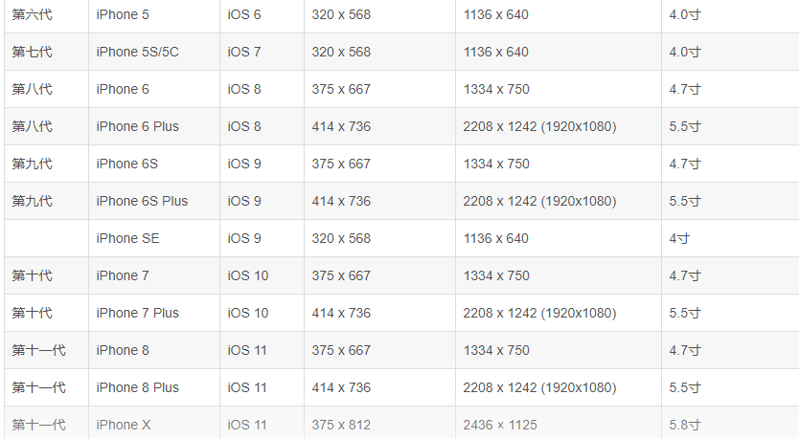

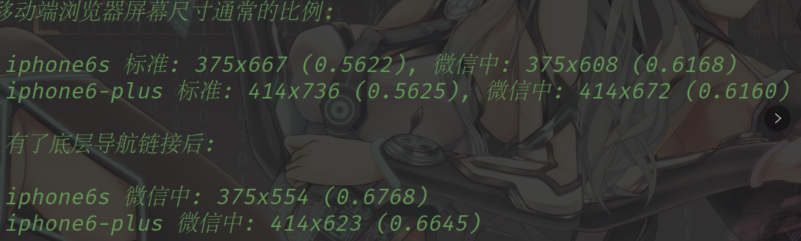

苹果8 672 626 苹果x 724 641

苹果8p带按键 414 626 苹果5带按键 320 458

/\*苹果5s的适配\*/

@media only screen and (device-width : 320px) and (max-height : 510px){

/\*苹果x的适配\*/

@media only screen and (device-width : 375px) and (height : 724px){

/\*苹果x带虚拟按键的适配\*/

@media only screen and (device-width : 375px) and (height : 641px){

/\*苹果6带虚拟按键的适配\*/

@media only screen and (device-width : 375px) and (max-height : 555px){

/\*苹果6plus带虚拟按键的适配\*/

@media only screen and (device-width : 414px) and (max-height : 627px){