SUPPLEMENTARY MATERIALS
Multi-kernel feature extraction with dynamic fusion and downsampled residual feature embedding for predicting rice RNA N⁶-methyladenine sites

Mengya Liu¹, Zhan-Li Sun^{2, *}, Zhigang Zeng³, Kin-Man Lam⁴
- School of Computer Science and Technology, Anhui University, Hefei, 230601, China
- School of Electrical Engineering and Automation, Anhui University, Hefei, 230601, China
- School of Artificial Intelligence and Automation, Huazhong University of Science and Technology, Wuhan, 430074, China
- Department of Electronic and Information Engineering, The Hong Kong Polytechnic University, Hong Kong, China

Corresponding author:
Zhan-Li Sun, Email: zhlsun2006@126.com

Algorithm S1: MFDm⁶ARice for rice m⁶A sites prediction.
Input: Rice m⁶A sequences: $S$, numerical representation: $match_dict$={A=1, T=2, G=3, C=4, P (pad)=0}
Output: Probability of a sample containing a m⁶A site: $\hat{y}$
1: function $fea_encoding(S)$
2: $F←[]$ # [] means list
3: for $k←1$ to $length(S)$ do
4: $F_{k}←[]$
5: $F_{k}←match_dict(S_{k})$
6: $F=F+F_{k}$
7: end for
8: return $F$
9: end function
10: function $MKFF(F)$
11: $F_{MKFF}←[]$
12: for $i←1$ to $length(S)$ do
13: $F_{MKFF}^{i}←[]$
14: $MK_{i}←MK(F_{i}))$
15: $F_{MKFF}^{i}←GLDF(MK_{i})$
16: $F_{MKFF}= F_{MKFF}+ F_{MKFF}^{i}$
17: end for
18: return $F_{MKFF}$
19: end function
20: function $DRFE(F_{MKFF})$
21: $F_{DRFE}←[]$
22: for $j←1$ to $length(S)$ do
23: $F_{DRFE}^{j}←[]$
24: $F_{down}^{j}= {MaxPool(Pad(F}_{DRFE}^{j}))$
25: $F_{DRFE}^{j}=Conv(Pad(Conv(Pad(F_{down}^{j})))) +F_{down}^{j}$
26: optimization about $F_{DRFE}^{j}$ by contrastive learning loss function
27: $F_{DRFE}= F_{DRFE}+ F_{DRFE}^{j}$
28: end for
29: return $F_{DRFE}$
30: end function
31: function $Output(F_{DRFE})$
32: $\hat{y}←[]$
33: for $l←1$ to $length(S)$ do
34: ${\hat{y}}_{l}←[]$
35: ${\hat{y}}_{l}←MLP(F_{DRFE}^{l})$
36: optimization about ${\hat{y}}_{l}$ by binary cross-entropy loss function
37: $\hat{y}= \hat{y}+ {\hat{y}}_{l}$
38: end for
39: return $\hat{y}$
40: end function
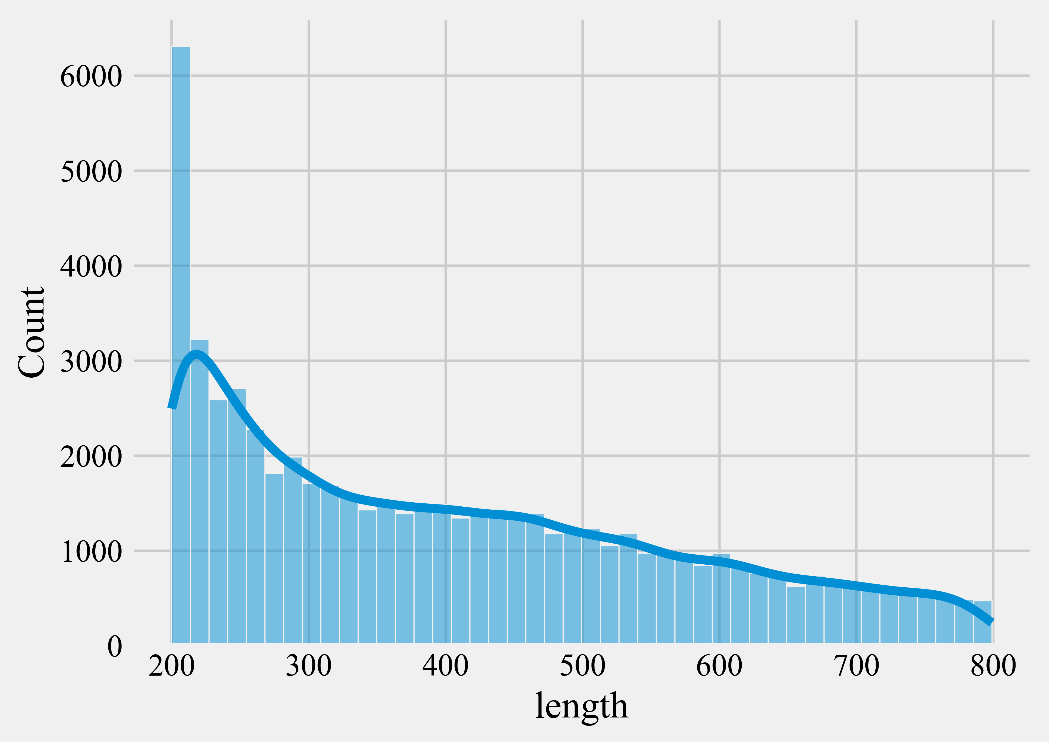
Figure S1. Sequence length distribution.

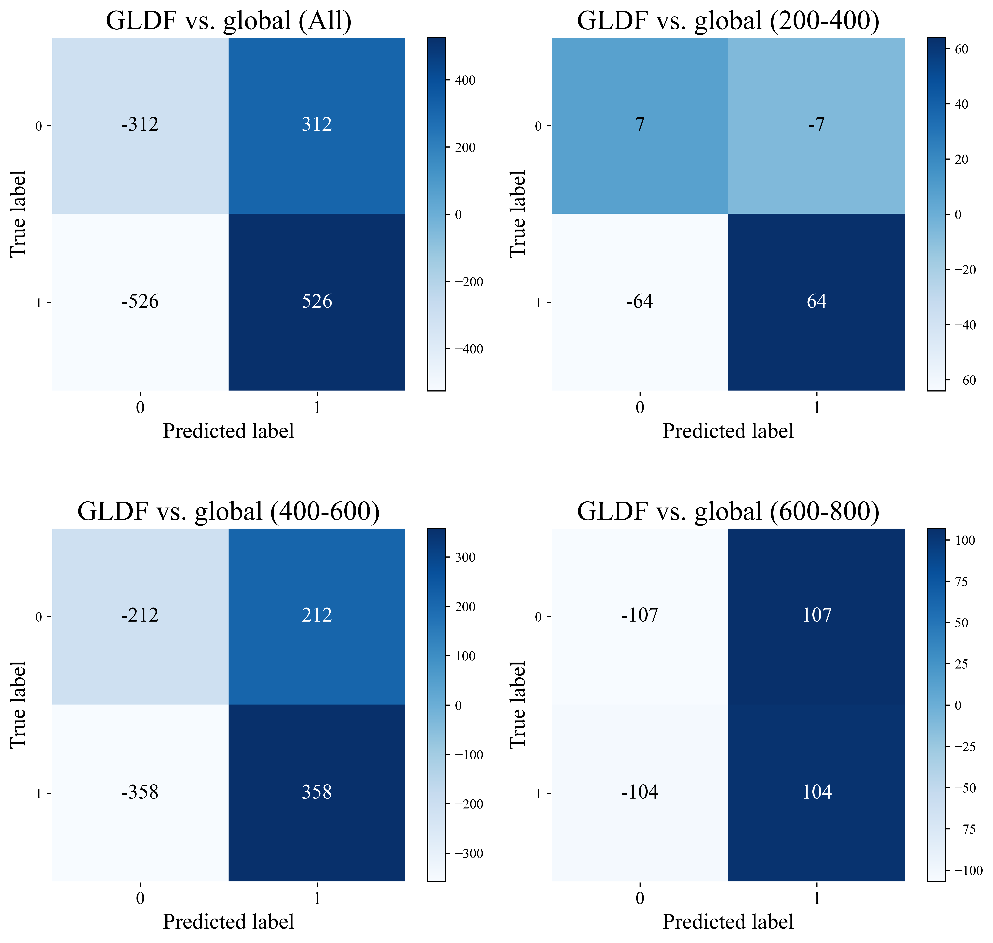
Figure S2. The difference between the confusion matrices of GLDF and global variants under different sequence length distributions.
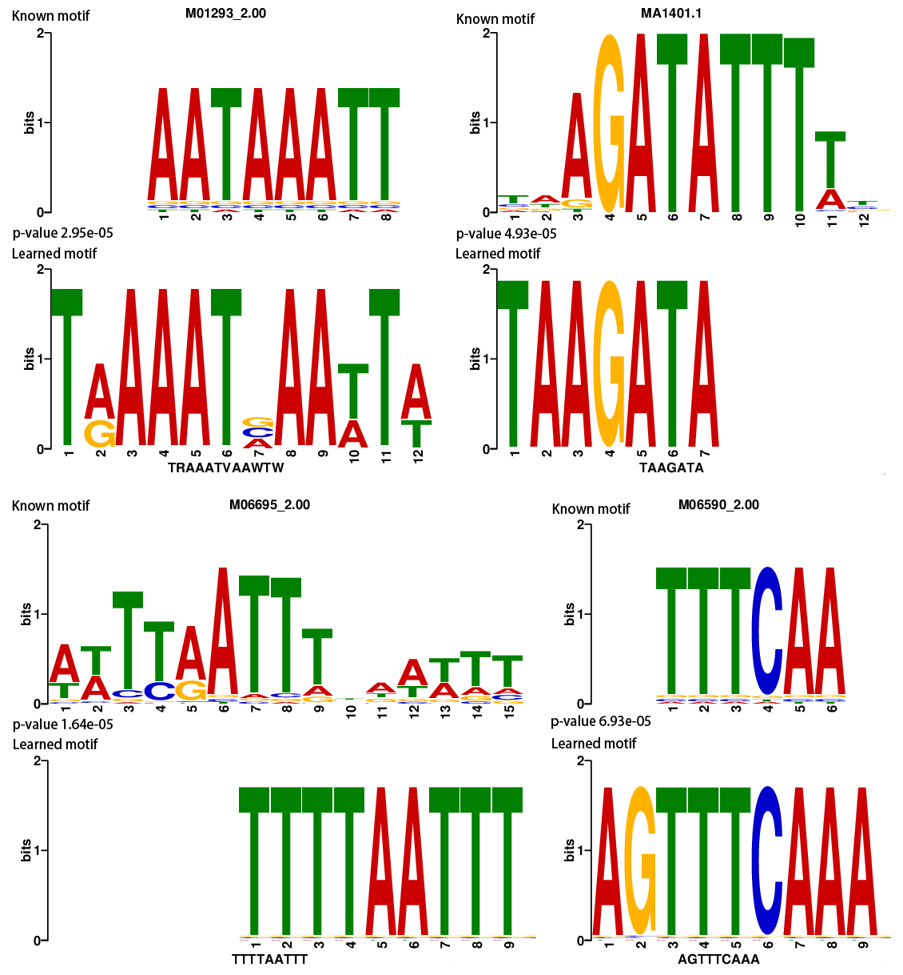
Figure S3. Visualization of some significant motifs learned by MFDm⁶ARice.

