*******转发：**********************
request.getRequestDispatcher("").forward(request, response);
*****重定向：*********
response.sendRedirect("");
*****编码格式：*******
（从服务器向页面）
response.setContentType("text/html;charset=utf-8");
（从页面向服务器）
request.setCharacterEncoding("utf-8");
******创建session：******
HttpSession session = request.getSession();
******创建输出out：******
PrintWriter out = response.getWriter();
输出到页面：out.println("---------------------");
输出到控制台：System.out.print("---------------");
*****ServletRequest转HttpServletRequest********
HttpServletRequest request=(HttpServletRequest)arg0;
******JNDI在tomcat中的配置******
<Resource name="jdbc/restrant" auth="Container"
type="javax.sql.DataSource" maxActive="100"
maxIdle="30" maxWait="10000" username="sa" password="sa"
driverClassName="com.microsoft.sqlserver.jdbc.SQLServerDriver"
url="jdbc:sqlserver://localhost:1433;databaseName=restrant"
/>
*******MySql自增***********
id int auto_increment primary key
********struts2得到内置对象******************
HttpServletRequest request = ServletActionContext.getRequest() ;
HttpServletResponse response = ServletActionContext.getResponse();
HttpSession session=request.getSession();
*********struts2跟这个效果一样request.setAttribute("users", udao.search());存东西*********
ActionContext.getContext().put(key, value);/相当于往request中放
ActionContext.getContext().getSession();
----------------------------------------
ActionContext ctx=ActionContext.getContext();
ctx.getApplication().put("键","值");//相当于往application中放
ctx.getSession().put("键","值");//相当于往session中放
ctx.put("键","值"); //相当于往request中放
---
取出用${"键"}
************************hibernate得到session*************************************
Session session=new Configuration().configure().buildSessionFactory().openSession();
***************struts2头*********************
<%@ taglib prefix="s" uri="/struts-tags"%>
****************整合的update更新方法*************
public void updateEmployee(final Employee employee) {
getHibernateTemplate().executeFind(new HibernateCallback(){

public Object doInHibernate(Session session)
throws HibernateException, SQLException {
Query query=session.createQuery("update Employee set ename=?,etel=?,eaddress=? where eid=? ");
query.setString(0,employee.getEname());
query.setInteger(1,employee.getEtel());
query.setString(2,employee.getEaddress());
query.setInteger(3,employee.getEid());
query.executeUpdate();
return null;
}
}
);
}

****************struts2部分常量***********************************************
<!-- 开发模式true时显示友好的出错提示 -->
<constant name="struts.devMode" value="true"></constant>
<!-- 默认编码集 -->
<constant name="struts.i18n.encoding" value="utf-8"></constant>
<!-- 请求的后缀请求时加后缀 -->
<constant name="struts.action.extension" value="do,action"></constant>
<!-- struts.xml改变时，自动重新加载该文件 -->
<constant name="struts.configuration.xml.reload" value="true"></constant>

***

<!-- 指定另一个配置文件 -->
<include file="user-struts.xml"></include>
*****************************编码解码****************************
public static void main(String[] args) throws UnsupportedEncodingException {
//编码
String reslut=URLEncoder.encode("炸炉","utf-8").toString();
System.out.println(reslut);
//解码
String res=URLDecoder.decode("%E7%82%B8%E7%82%89","utf-8").toString();
System.out.println(res);
}
******************struts2的iterator *****************
<s:iterator value="#session.list">
<tr align="center">
<td><s:property value="orderId"/></td>
<td><s:property value="name"/></td>
<td><s:property value="proName"/></td>
<td><s:property value="orderCount"/></td>
<td><s:date name="datetime" format="yyyy-MM-dd"/></td>
<s:if test="status==1">
<td>未处理</td>
<td><a href="orders/orders!updateOrders?id=<s:property value="orderId"/>">处理</a></td>
</s:if>
<s:else>
<td>历史订单</td>
</s:else>
</tr>
</s:iterator>
**************************struts2防止重复提交token*****************

1.页面中使用<s:token></s:token>

<form action="user" method="post">
name:<input type="text" name="name"><br>
age: <input type="text" name="age"><br>
<input type="submit" value="SUBMIT">
<s:token></s:token>
</form>
- struts.xml中发配置
<interceptor-ref name="token"></interceptor-ref>
<result name="invalid.token">/error.jsp</result>

<action name="user" class="com.luchao.tokenintercept.UserAction">
<result>/ok.jsp</result>
<interceptor-ref name="defaultStack"></interceptor-ref>
<interceptor-ref name="token"></interceptor-ref>
<result name="invalid.token">/error.jsp</result>
</action>
***************************无提示*******************************
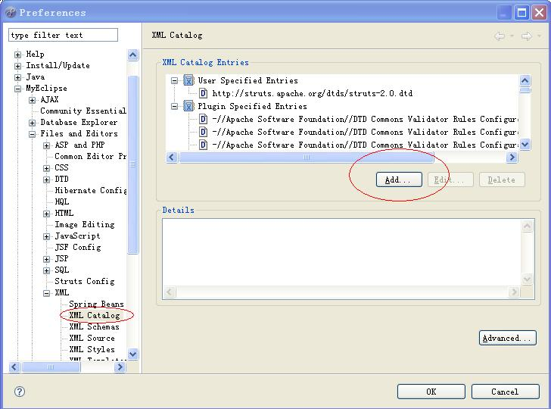

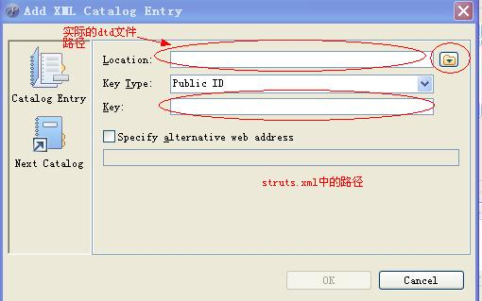
其中key type 选择URI
*************************调用存储过程*****************************
User.hbm.xml中配置：
<sql-query name="selall" callable="true">
<return alias="stu" class="User">
<return-property name="id" column="id"></return-property>
<return-property name="name" column="name"></return-property>
</return>
{call selbyid()}
//selbyid()为实际存储过程名字
</sql-query>

Dao的接口中：
public List<User> getAllUser() {
Session session =sessionFacory.getCurrentSession();
List<User> list=(List<User>)session.getNamedQuery("selall").list();
return list;
//return (List<User>)getHibernateTemplate().find("from User");
}
************ibatas的like关键字***********
<isNotEmpty prepend="and" property="staffername">
s.name like '%$staffername$%'
</isNotEmpty>
或者 '%'||$staffername$||'%'

