A double-blind, randomised, placebo-controlled Phase II trial of pirfenidone in patients with unclassifiable progressive fibrosing interstitial lung disease
Professor Toby M Maher, MD,^{1,2} Tamera J Corte, PhD,^{3,4} Aryeh Fischer, MD,⁵ Professor Michael Kreuter, MD,⁶ David J Lederer, MD,⁷* Maria Molina-Molina, MD,^{8,9} Judit Axmann, PhD,¹⁰ Klaus-Uwe Kirchgaessler, MD,¹⁰ Katerina Samara, MD,¹¹ Frank Gilberg, PhD,¹⁰ Professor Vincent Cottin, MD,^{12,13}
¹National Heart and Lung Institute, Imperial College London, London, UK. ²NIHR Respiratory Clinical Research Facility, Royal Brompton Hospital, London, UK. ³Department of Respiratory Medicine, Royal Prince Alfred Hospital, Camperdown, New South Wales, Australia. ⁴Medical School, University of Sydney, Camperdown, New South Wales, Australia. ⁵University of Colorado School of Medicine, Denver, CO, USA. ⁶Center for Interstitial and Rare Lung Diseases and Department of Pulmonology and Critical Care Medicine, Thoraxklinik, Member of the German Center for Lung Research, University of Heidelberg, Heidelberg, Germany. ⁷Divison of Pulmonary, Allergy, and Critical Care Medicine, Columbia University Medical Center, New York, NY, USA. ⁸ILD Unit, Respiratory Department, University Hospital of Bellvitge, Institut d'Investigació Biomèdica de Bellvitge (IDIBELL), L'Hospitalet de Llobregat, Barcelona, Spain. ⁹Centro de Investigación Biomédica en Red Enfermedades Respiratorias (CIBERES), Madrid, Spain. ¹⁰F. Hoffmann-La Roche, Ltd., Basel, Switzerland. ¹¹F. Hoffmann-La Roche, Ltd./Roche (Hellas) S.A., Maroussi, Greece. ¹²National Reference Coordinating Center for Rare Pulmonary Diseases, Louis Pradel Hospital, Lyon, France. ¹³Hospices Civils de Lyon, Université Claude Bernard Lyon 1, UMR754, Lyon, France.
*Current affiliation: Regeneron Pharmaceuticals, Tarrytown, NY, USA

Correspondence to: Toby M Maher, Fibrosis Research Group, Inflammation, Repair & Development Section, NHLI, Sir Alexander Fleming Building, Imperial College London, London, SW7 2AZ, UK; Tel: +44 207 351 8951; Email: t.maher@rbht.nhs.uk
Running title: Pirfenidone in progressive fibrosing uILD
Target journal: Lancet Respiratory Medicine
Word count: 4690
Tables/figures: 7 (plus 3 supplementary tables/figures)
References: 23/30
Summary (623/300 words)
Background: Unclassifiable interstitial lung disease (uILD), characterised by progressive fibrosis of the lung, currently lacks any proven pharmacotherapies. The efficacy and safety of pirfenidone was evaluated in progressive fibrosing uILD.
Methods: This was a multicentre, international, double-blind, randomised, placebo-controlled Phase II trial. Eligible patients (aged ≥18–85 years) had progressive fibrosing uILD. Patients were randomised 1:1 to 2403 mg/day pirfenidone or placebo using a validated interactive voice or web-based response system. Randomisation was stratified by use of concomitant mycophenolate mofetil and presence/absence of interstitial pneumonia with autoimmune features. The primary endpoint was mean change in forced vital capacity (FVC) measured by daily home spirometry over 24 weeks. Secondary endpoints were change in FVC (site spirometry), percent predicted carbon monoxide diffusing capacity (DLco), 6-minute walk distance (6MWD), University of California San Diego Shortness of Breath Questionnaire (UCSD-SOBQ) score, cough visual analogue scale (VAS), and St. George's Respiratory Questionnaire (SGRQ) total score. The percentage of patients who experienced non-elective hospitalisation (respiratory and all-cause), acute exacerbations, and progression-free survival (PFS) were also reported. The primary analysis population for all efficacy analyses was the intent-to-treat (ITT) population. Safety was also assessed. This trial is registered with ClinicalTrials.gov (identifier: NCT03099187) and is no longer recruiting.
Findings: 253 patients were randomised (ITT population: n=127 pirfenidone; n=126 placebo). Analysis of the primary endpoint was impacted by intra-individual variability in home spirometry values, which prevented application of the prespecified statistical model. Predicted median (Q1, Q3) FVC change over 24 weeks measured using home spirometry was –87·7 (–338·1, 148·6) mL and –157·1 (–370·9, 70·1) mL with pirfenidone and placebo, respectively. For traditional site spirometry, pirfenidone reduced predicted mean FVC change vs placebo (treatment difference 95·3 mL; 95% confidence interval [CI] 35·9–154·6, p=0·002) and reduced the likelihood of a >5% or >10% decline in FVC (odds ratio 0·42, 95% CI 0·25–0·69, p=0·001 and odds ratio 0·44, 95% CI 0·23–0·84, p=0·011, respectively). Mean change in DLco from baseline to Week 24 was –0·7% for pirfenidone and –2·5% for placebo, and mean change in 6MWD from baseline to Week 24 was –2·0 m for pirfenidone and –26·7 m for placebo. Changes from baseline to Week 24 in UCSD-SOBQ, cough VAS, and SGRQ scores were similar in the pirfenidone and placebo groups. Analysis of acute exacerbation or hospitalisation events throughout the study period yielded no meaningful results due to a small frequency of events. A treatment difference was not observed between the pirfenidone and placebo groups, irrespective of the definition of PFS used (>10% absolute decline in percent predicted FVC, >50 m decline in 6MWD, or death [hazard ratio (HR) 0·84, 95% CI 0·56–1·24]; or >10% relative decline in FVC, non-elective respiratory hospitalisation, or death [HR 0·79, 95% CI 0·52–1·20]. Treatment-emergent adverse events (TEAEs) were reported in 120 of 127 (94·5%) and 101 of 124 (81·5%) patients in the pirfenidone and placebo groups, respectively. A serious TEAE was reported in 18 of 127 (14·2%) and 20 of 124 (16·1%) patients in the pirfenidone and placebo groups, respectively. The most common treatment-related TEAEs were gastrointestinal disorders (60 of 127 [47·2%] and 32 of 124 [25·8%] patients in the pirfenidone and placebo groups, respectively), fatigue (16 of 127 [12·6%] and 12 of 124 [9·7%] patients in the pirfenidone and placebo groups, respectively), and rash (13 of 127 [10·2%] and nine of 124 [7·3%] patients in the pirfenidone and placebo groups, respectively).
Interpretation: Although the planned statistical model could not be applied to the primary endpoint data, results of key secondary endpoints suggest that patients with progressive fibrosing uILD benefit from pirfenidone treatment, with an acceptable safety/tolerability profile. These findings support further investigation of pirfenidone as an effective treatment for patients with progressive fibrotic uILD.
Funding: Funded by F. Hoffmann-La Roche, Ltd.

Research in context
Evidence before this study
We searched PubMed for reports published in any language before 31 May 2019 using the search terms (“uILD” OR “unclassifiable interstitial lung disease” OR “unclassifiable ILD” OR ("unclassifiable" AND ("interstitial lung disease" OR "ILD"))), which yielded 57 papers. We excluded papers that were not in English or not related to uILD, which left 48 papers. To focus on the treatment of uILD, we then excluded case studies and papers that dealt with prevalence or incidence, diagnosis, disease classification, natural history, or prognosis, which left 11 papers. To focus on pharmacological treatments, we excluded two papers investigating lung transplant as a treatment for uILD. Of the remaining papers, seven were review articles or opinion pieces, one was a retrospective review of medical records that included only three patients with uILD, and one was a study design manuscript (describing the design of the study presented in the current paper). Thus, we identified no randomised controlled trials investigating a pharmacological treatment in patients with uILD.
Added value of this study
To our knowledge, our study represents the first randomised controlled trial to exclusively enrol patients with uILD, a type of ILD for which there are currently no approved pharmacological treatments. Pirfenidone is an antifibrotic shown to slow disease progression in patients with IPF, a form of ILD that shows mechanistic and clinical similarities to progressive fibrotic uILD. This study investigated the efficacy and safety of pirfenidone vs placebo over 24 weeks in patients with progressive fibrotic uILD. Due to unanticipated technical and analytical issues with home spirometry, it was not possible to apply the planned statistical model to the primary endpoint data. However, results from the key secondary and exploratory endpoints measured at site visits, including FVC, DLco, and 6MWD, suggested that pirfenidone is effective vs placebo in patients with progressive fibrosing uILD over 24 weeks. The safety and tolerability profile of pirfenidone was comparable with that observed in the Phase III trials in IPF, and no new safety signals were identified.
Implications of all the available evidence
There is currently no direct evidence to guide the treatment of patients with uILD and no approved pharmacological treatments; therefore, the results of this study are important for patients with progressive fibrosing uILD and the clinicians involved in their treatment. This study found that pirfenidone was associated with benefits to lung function and exercise capacity vs placebo over 24 weeks, thus supporting future studies investigating the benefits of pirfenidone in this patient population over a longer time period. Furthermore, the technical and analytical issues encountered with home spirometry in this study also have important implications for the design of future clinical trials. It is clear from our results that further analyses are needed before daily home spirometry can be used as primary outcome measure in future clinical trials.

Introduction
Interstitial lung diseases (ILDs) are a large, heterogeneous group of diseases characterised by abnormalities of the pulmonary interstitium and/or alveoli, including fibrosis.¹ Patients with ILD experience limitations to daily activities, shortness of breath, tiredness, and muscle fatigue.² ILDs may be associated with environmental exposures or may be secondary to another condition, such as a connective tissue disease, but in many cases, a cause is not established, and these patients are diagnosed as having ‘idiopathic interstitial pneumonias’ (IIP).¹
Whereas some ILDs display a progressive fibrosing phenotype similar to idiopathic pulmonary fibrosis (IPF; the most common form of IIP³), others vary in their clinical course.^{1,4,5} Diagnosis of a specific ILD is important for identifying the most appropriate management strategy and informing disease prognosis.^{1,4,5} However, as recognised in current international IIP diagnostic guidelines,⁶ despite thorough investigation by a multidisciplinary team (MDT; including pulmonologists, radiologists, and lung pathologists), a final diagnosis is not always possible,⁴ leading to a diagnosis of unclassifiable ILD, or ‘uILD’.⁷
The management of patients with ILD can be considered as divided between those with IPF and all others with progressive forms of fibrotic ILD. For IPF, there are two antifibrotic drugs, pirfenidone and nintedanib, proven to slow disease progression.⁸⁻¹⁰ In the absence of clinical evidence guiding the treatment of other fibrosing ILDs (eg, uILD, hypersensitivity pneumonitis, connective tissue disease-ILD), options include treatment with short-term immunosuppression followed by an evaluation of treatment response, or continued observation without pharmacotherapy.^{3,5,11}
Although these treatments may be used in practice, there are currently no approved treatments for uILD.¹² Due to the mechanistic and clinical similarities between IPF and other ILDs with a progressive fibrosing phenotype, it is reasonable to hypothesise that antifibrotics may be beneficial in patients with progressive uILDs characterised by fibrosis.^{12,13}
This randomised controlled trial aimed to evaluate the efficacy and safety of pirfenidone vs placebo in patients with progressive fibrosing uILD over 24 weeks.¹²
Methods
Trial design
This was a multicentre, international, double-blind, randomised, placebo-controlled Phase II trial, the methods of which have been previously described.¹²
The trial was conducted in accordance with the International Conference on Harmonisation E6 guideline for Good Clinical Practice, the Declaration of Helsinki, and local laws for countries in which the research was conducted. Informed consent was obtained from each participant by the study investigator before any trial-specific screening procedure was performed. An independent Data Monitoring Committee (iDMC) reviewed the safety data and advised on trial conduct a minimum of three times during the trial. The iDMC are an independent body who recommended to continue, modify, or stop the trial at each meeting.
Randomisation and masking
After a screening period, patients were randomised 1:1, using a validated interactive voice or web-based response system (IxRS; implemented and conducted by the Roche vendor: Bracket Global LLC, San Francisco, CA, USA) using permuted block randomisation, to receive 2403 mg/day pirfenidone via oral administration of three 267 mg capsules three times a day or placebo for 24 weeks. Randomisation was stratified by use of concomitant mycophenolate mofetil (MMF) and presence or absence of interstitial pneumonia with autoimmune features (IPAF; a research classification for patients with clinical, serologic, and/or lung morphologic features suggesting underlying autoimmunity who do not fulfil criteria for connective tissue disease).¹⁴ Investigational and site personnel and patients were blinded to treatment assignment. To ensure blinding of the treatment group to investigators, study participants, and the sponsor, study participants randomised to the placebo group were administered placebo capsules with identical appearance, size, and taste to pirfenidone capsules. Treatment codes could only be broken in emergency situations, for example, occurrence of a serious adverse event, when the study investigator would be able to determine a patient’s allocated intervention by contacting the IxRS vendor. The success of masking was evaluated by continuous monitoring at the investigational site. The database was locked and kept by the IxRS vendor until it was time to perform statistical analyses of the data.
Patients
Eligible patients were aged ≥18–85 years and had fibrosing uILD, defined as fibrosing ILD that could not be classified with moderate or high confidence to any category of ILD after MDT discussion at each centre. Patients had percent predicted forced vital capacity (FVC) ≥45% and carbon monoxide diffusing capacity (DLco) ≥30%, as well as >10% fibrosis on high-resolution computed tomography within the previous 12 months. Patients were also required to have progressive disease, defined as either >5% absolute decline in percent predicted FVC¹⁵ or significant symptomatic worsening not due to cardiac, pulmonary (except worsening of underlying uILD), vascular, or other causes (as determined by the investigator) within the previous 6 months. Exclusion criteria have been previously described.¹² Patients were randomised between May 15, 2017 and June 5, 2018.
Endpoints
The primary objective was to evaluate the efficacy of pirfenidone vs placebo using change in FVC (mL) measured by daily home spirometry over 24 weeks (primary endpoint). Patients performed a single spirometry reading using a portable handheld Micro spirometer (Vyaire Medical, Basingstoke, England; previously CareFusion, Kent, England) at approximately the same time each day. Blows were categorised by a spirometer-based algorithm as ‘rejected’, ‘borderline accepted’, or ‘accepted’, with only ‘accepted’ manoeuvres retained for analysis. Blows that were shorter than 6 seconds but had a flow-change of 100 mL in the last 0.5 seconds were classified as acceptable blows. These parameters were set based on those used for clinic-based measurements; however, a blow less than 6 seconds was deemed to be acceptable in this study, provided it had a good flow difference in the final 0.5 seconds. These criteria were recommended by the device manufacturer and enabled the capture of data that would have been discarded using site spirometry. Coughing during the blow rendered a warning message of bad blow, which allowed the patient to perform another blow the same day. The handheld spirometry device had several built-in features to control for a good blow. Most of these controls measured intra-blow differences of blows performed on the same day. As only one blow was requested per day in this study, these controls could not be activated, enabling undetected day-to-day variability and physiologically impossible values. Training on how to use the device was provided at the screening visit, and refresher training offered after Month 1, between Months 2 and 3, and between Months 4 and 5. Data were downloaded by site staff at each site visit (every 4 weeks). Patients were blinded to daily spirometry values.
Secondary endpoints included change in FVC and the percentage of patients who experienced a >5% or >10% absolute or relative decline in percent predicted FVC measured by centrally over-read clinic-based spirometry, DLco, 6-minute walk distance (6MWD), University of California San Diego Shortness of Breath Questionnaire (UCSD-SOBQ) score, cough visual analogue scale (VAS), and St. George's Respiratory Questionnaire (SGRQ) total score.
Further prespecified secondary endpoints included: the percentage of patients who experienced non-elective hospitalisation (respiratory and all-cause); the incidence of, and time to first, investigator-reported acute exacerbation; and progression-free survival (PFS), defined as time to first occurrence of a >10% absolute decline in percent predicted FVC (clinic-based spirometry), a >50 m decline in 6MWD, or death, or alternatively defined as time to first occurrence of a >10% relative decline in FVC, non-elective respiratory hospitalisation, or death.
Exploratory prespecified endpoints included the percentage of patients experiencing a >15% absolute decline in percent predicted DLco and the percentage of patients experiencing a >50 m decline in 6MWD. A subgroup analysis of mean change in FVC from baseline to Week 24 measured using site spirometry was also performed to evaluate treatment response in subgroups defined by age, sex, lung function, weight, MMF treatment, and the presence/absence of IPAF.
The safety and tolerability of pirfenidone was assessed from the date of first randomised treatment intake until 28 days after the last dose taken during the double-blind treatment period. The nature and severity of treatment-emergent adverse events (TEAEs) and withdrawals from study treatment or study discontinuations were recorded.
Statistical analysis
A sample size of 250 patients was planned for inclusion, based on the statistical hypothesis of the primary endpoint, and assumed 80% power and a two-sided α of 5% using a Student’s t-test. Following inspection of historical data, it was assumed that, over the course of the trial, FVC decline in the placebo arm would be 85 mL with a common standard deviation of 70 mL, which could be reduced to 60 mL with a common standard deviation of 70 mL in the pirfenidone arm. In this scenario, 125 patients per treatment arm were needed to detect this treatment effect with 80% power.¹²
All statistical analyses were performed using SAS Version 9.4 (SAS, Cary, NC, USA).
The primary analysis population for all efficacy analyses was the intent-to-treat (ITT) population, defined as all randomised patients. For the prespecified primary endpoint analysis, it was planned that the estimated FVC change would be calculated for each individual patient by applying a linear regression model to available daily home spirometry measurements collected during the 24-week treatment period. The mean 24-week FVC change (mL) predicted from these linear models would be compared between treatment arms using a Student’s t-test with a two-sided significance level of 5%. However, the planned statistical model could not be applied to the primary endpoint data because the test on the normality (ie, Shapiro-Wilks) of the data in each arm suggested that the statistical assumptions for applying a Student’s t-test were not fulfilled. A non-parametric test was not considered for use because it would be unable to estimate a difference between the two treatment arms in predicted FVC decline at 24 weeks, eg, a rank analysis of covariance (ANCOVA) would only consider the last observed FVC values while all other daily measurements would be disregarded. Therefore, the primary endpoint data are presented descriptively, with median selected as the most appropriate statistic given the skewed nature of the data. Patients who discontinued treatment prematurely were analysed based on all available data, and no imputation method was applied for missing data, ie, an algorithm was not used to calculate values beyond the discontinuation date of a patient.
For the secondary endpoints, all data from baseline to Week 24 were used without imputation of values for patients who discontinued early. P-values were reported with no adjustment for multiplicity and are for descriptive purposes only. The predicted FVC change from baseline to Week 24 measured by site spirometry (mL) was compared between the treatment arms using the same method as described for the primary endpoint. Changes in percent predicted FVC and percent predicted DLco were compared between treatment arms using a rank ANCOVA model, with change from baseline used as an outcome variable and standardised rank baseline value used as covariate. Categorical changes in FVC (>5% and >10%) were compared between treatment arms using a Cochran-Mantel-Haenszel test. Changes in 6MWD, UCSD-SOBQ, cough VAS, and total and subscores of the SGRQ were analysed using a rank ANCOVA model, with the recorded value at 24 weeks used as an outcome variable and the standardised rank baseline value used as a covariate. All-cause and respiratory non-elective hospitalisation, PFS, and time to death from any cause were analysed using Kaplan–Meier, and the two treatment arms were compared with a log rank test; hazard ratios (HR) and corresponding 95% confidence intervals (CI) were calculated by applying Cox proportional hazard models. The incidence of investigator-reported acute exacerbations in the two treatment arms was compared with Fisher’s exact test.¹²
For the prespecified exploratory endpoints, categorical changes in DLco (>15%) and 6MWD (>50 m) were compared between treatment arms using a logistic regression. For the subgroup analysis of FVC change measured using site spirometry, patients were stratified into subgroups based on age, sex, lung function, weight, MMF treatment, and the presence/absence of IPAF, and mean change in FVC from baseline to Week 24 measured using site spirometry was calculated as described above.
The population for the safety analyses was the safety population, defined as all randomised patients who received at least one dose of study drug.
This study is registered as an International Standard Randomised Controlled Trial with ClinicalTrials.gov (identifier: NCT03099187).
Role of the funding source
The funder, F. Hoffmann-La Roche, Ltd., and its designees, designed and performed this analysis, and were involved in data interpretation and the writing of the manuscript, in collaboration with the academic authors. The corresponding author had full access to all data in the study and had final responsibility for the decision to submit for publication.
Results
Patients
Between May 15, 2017 and June 5, 2018, 253 patients were randomised from 70 centres in Australia, Belgium, Canada, Czech Republic, Denmark, Germany, Greece, Ireland, Israel, Italy, Poland, Portugal, Spain, and the UK. A total of 127 patients were randomised to, and received, pirfenidone. Of the 126 patients randomised to placebo, 124 received treatment as there were two randomisation errors. All randomised patients were included in the ITT population (N=253; figure 1) and all randomised patients who received at least one dose of study drug were included in the safety population (N=251; figure 1).
Baseline characteristics did not differ substantially between the treatment groups (table 1). The majority of patients in the pirfenidone and placebo arms had a diagnosis of uILD without any features suggestive of another form of ILD (93 of 127 [73·2%] and 93 of 126 [73·8%], respectively; table 1).
The median daily dose was 2281·62 mg/day for pirfenidone and 2299·80 mg/day for placebo (the median number of placebo capsules was translated into a theoretical pirfenidone dose, eg, nine placebo capsules = 2403 mg/day). Mean (standard deviation) treatment duration (excluding dose interruptions) was 20·7 (6·8) weeks for pirfenidone and 22·8 (4·7) weeks for placebo. Treatment durations for pirfenidone and placebo remained similar when dose interruptions were included.
Primary outcome
Analysis of the primary endpoint, as prespecified in the statistical analysis plan, was rendered impossible due to unforeseen issues with the recorded home spirometry values. There were two problems that led to this failure; the first was the technical reliability of the readings recorded and the second was the issue of applying a linear regression model to patients with a small number of readings collected within a short time window. In both cases, the values obtained were physiologically implausible, eg, daily home FVC values of 0 L or >6 L and predicted 24-week changes in FVC as extreme as +33 L. These outliers meant that the planned statistical model could not be applied to the primary endpoint data, because the statistical assumptions (requiring continuous data with independent observations in each sample that are normally distributed with equal variances) for applying a Student’s t-test were not fulfilled. The group mean (range) predicted 24-week changes from baseline in FVC were –17·9 (–5799 to 16 411) mL in the pirfenidone group and 116·6 (–7256 to 33 794) mL in the placebo group. Group median values of the predicted 24-week change are presented in figure 2 (as a more appropriate parameter less affected by outliers). The median (Q1, Q3) predicted 24-week change from baseline in daily home FVC was –87·7 (–338·1, 148·6) mL in the pirfenidone group and –157·1 (–370·9, 70·1) mL in the placebo group (figure 2).
Secondary outcomes
When measured using hospital site spirometry (and analysed using the Student’s t-test [assumptions worked and the statistical model was appropriate for the secondary endpoint in contrast to the primary endpoint]), mean decline in FVC was lower in patients randomised to pirfenidone as compared with placebo at Week 24 (–17·8 mL [n=118] and –113·0 mL [n=119], respectively; between-group difference, 95·3 mL; 95% CI 35·9–154·6, p=0·002; table 2).
Absolute declines of >5% and >10% in percent predicted FVC were reported less frequently in patients receiving pirfenidone vs placebo (47 of 127 [37·0%] vs 74 of 126 [58·7%] and 18 of 127 [14·2%] vs 34 of 126 [27·0%], respectively; odds ratio [OR] 0·42, 95% CI 0·25–0·69, p=0·001 for >5% decline and OR 0·44, 95% CI 0·23–0·84, p=0·011 for >10% decline; table 2). A >5% relative decline in percent predicted FVC was reported less frequently in patients treated with pirfenidone vs placebo (66 of 127 [52·0%] vs 84 of 126 [66·7%], respectively; OR 0·55, 95% CI 0·33–0·91, p=0·018), but no treatment difference was observed for >10% relative decline in percent predicted FVC (36 of 127 [28·3%] vs 49 of 126 [38·9%], respectively; OR 0·62, 95% CI 0·37–1·05, p=0·08). A rank ANCOVA model for percent predicted FVC for absolute change from baseline to last observed measurement yielded a p-value of 0·038.
The mean change in percent predicted DLco from baseline at Week 24 was –0·7% for pirfenidone (n=97) and –2·5% for placebo (n=110; table 3). The mean change in 6MWD from baseline at Week 24 was –2·0 m for pirfenidone (n=99) and –26·7 m for placebo (n=108; table 3). Rank ANCOVA models for percent predicted DLco and 6MWD for change from baseline to last observed measurement yielded p-values of 0·09 and 0·040, respectively.
Time-to-event analyses for PFS, defined as >10% absolute decline in percent predicted FVC, >50 m decline in 6MWD, or death (HR 0·84, 95% CI 0·56–1·24), or defined as >10% relative decline in FVC, non-elective respiratory hospitalisation, or death (HR 0·79, 95% CI 0·52–1·20), are presented in supplementary figure S1 (page 5 of Supplementary Appendix). A treatment difference was not observed between the pirfenidone and placebo groups, irrespective of the definition of PFS used.
Changes in UCSD-SOBQ, SGRQ, and cough VAS scores were similar between the pirfenidone and placebo groups (supplementary table S1; page 2 of Supplementary Appendix).
Analysis of acute exacerbation or hospitalisation events throughout the study period yielded no meaningful results due to a small frequency of events.
Exploratory outcomes
The proportion of patients who experienced a >15% absolute decline in percent predicted DLco was three of 127 (2·4%) and 11 of 126 (8·7%) in the pirfenidone and placebo groups, respectively (OR 0·25, 95% CI 0·07–0·93, p=0·039). A >50 m decline in 6MWD was reported in 36 of 127 (28·3%) and 35 of 126 (27·8%) patients in the pirfenidone and placebo groups, respectively (OR 1·03, 95% CI 0·59–1·78, p=0·92; table 2).
In an exploratory prespecified subgroup analysis of mean change in FVC from baseline to Week 24 measured using site spirometry, a treatment benefit was generally observed regardless of age, gender, lung function, and presence/absence of IPAF. Subgroup analyses stratified by body weight and MMF treatment appeared to suggest a differential treatment effect, but the small sample sizes prevent meaningful interpretation of these data (figure 3).
Safety
TEAEs were reported in 120 of 127 (94·5%) and 101 of 124 (81·5%) patients in the pirfenidone and placebo groups, respectively (table 4). A total of 90 of 127 (70·9%) and 57 of 124 (46·0%) TEAEs in the pirfenidone and placebo groups, respectively, were judged by investigators to be treatment-related. The proportion of patients who experienced a serious TEAE was 18 of 127 (14·2%) and 20 of 124 (16·1%) in the pirfenidone and placebo groups, respectively. The percentages of patients with treatment-related photosensitivity, rash, weight decrease, and fatigue (adverse reactions known to be associated with pirfenidone) were similar (<10% difference) between treatment groups; however, treatment-related gastrointestinal disorders were more frequent with pirfenidone, reported in 60 of 127 (47·2%) and 32 of 124 (25·8%) patients in the pirfenidone and placebo groups, respectively. No new safety signals concerning pirfenidone were identified. The proportion of patients who experienced a TEAE leading to treatment discontinuation was 19 of 127 (15·0%) and five of 124 (4·0%) in the pirfenidone and placebo groups, respectively. During the study period, there were two deaths (one in each treatment group), which were not judged to be treatment-related. TEAEs by System Organ Class are available in supplementary table S2 (page 4 of Supplementary Appendix).
Discussion
In this randomised controlled trial evaluating the efficacy and safety of pirfenidone in patients with progressive fibrosing uILD, the planned statistical model could not be applied to the primary endpoint data. However, results for the key secondary endpoints support the conclusion that pirfenidone slows disease progression vs placebo in patients with progressive fibrosing uILD over 24 weeks. The safety and tolerability profile of pirfenidone was comparable with that in patients with IPF,¹⁶ and no new safety signals were identified.
The analysis of the primary endpoint in this study was affected by unanticipated technical and analytical issues with home spirometry. In some patients with short observation periods, the application of linear regression to predict 24-week rate of FVC change generated extreme outliers that led to physiologically implausible values; the most extreme being a 33 L increase in FVC over 24 weeks. Technical problems with the algorithm that determined recording of daily spirometry readings also contributed to these outliers, with spirometers recording implausibly low (below 0·5 L) or high (above 6 L) readings approximately 10% of the time. Of importance, many of the problems were due to the fact that the spirometers were set up to only record one acceptable blow per day (intended to improve patient compliance and minimise the intrusiveness of performing readings), but many of the quality control checks that were built into devices, including measurement of intra-blow differences, could only be used if three blows were permitted per day. Daily home spirometry has been previously studied in IPF,¹⁷⁻¹⁹ and although the data collected can be variable,¹⁹ the issues encountered during this study could not have been predicted. The technical issues experienced with home spirometry meant that the planned statistical model could not be applied to the primary endpoint data, and it is now clear that further analyses, including an assessment of how to conduct clinical trials using home spirometry and the application of various analytical approaches to determine which is the most appropriate, are needed before this method can be used in future trials.
In this study, results favouring pirfenidone vs placebo were observed across a number of secondary efficacy endpoints, suggesting that pirfenidone is effective in patients with progressive fibrosing uILD. Using site spirometry to monitor FVC, which is the accepted regulatory standard in IPF clinical trials,²⁰ pirfenidone reduced FVC decline by 95·3 mL compared with placebo at Week 24. Although not directly comparable, this result is similar to the treatment benefit observed in a prespecified pooled analysis of the Phase III trials of pirfenidone in IPF, where an absolute treatment difference of 104 mL was observed for pirfenidone vs placebo by Week 24, increasing to 148 mL by Week 52.²¹ Furthermore, in the current study, patients treated with pirfenidone were less likely to undergo a >5% (absolute or relative) and >10% (absolute) categorical decline in percent predicted FVC vs placebo. No treatment difference was observed for >10% relative decline in percent predicted FVC. Mean FVC change from baseline to Week 24 measured using site spirometry was also evaluated in an exploratory subgroup analysis, which found that a treatment benefit was generally observed regardless of age, gender, lung function, and presence/absence of IPAF. Whereas the recently published SENSCIS study of nintedanib in ILD associated with systemic sclerosis reported that the treatment effect of nintedanib on FVC change was affected by MMF,²² we are unable to remark on any impact on pirfenidone in this study, due to the small sample sizes. Similarly, the small number of patients in the low–body-weight subgroup prevents any meaningful conclusions being drawn from this analysis.
Other key endpoints included DLco, 6MWD, and PFS. Although the rank ANCOVA results for DLco did not favour pirfenidone, the prespecified exploratory analysis of >15% categorical decline in percent predicted DLco did demonstrate a treatment benefit. Results for 6MWD demonstrated the opposite, with results in favour of pirfenidone observed for the rank ANCOVA analysis, but not for the prespecified exploratory analysis of a >50 m categorical decline. Results for both definitions of PFS used in this study (>10% absolute decline in percent predicted FVC, >50 m decline in 6MWD, or death; >10% absolute decline in percent predicted FVC, non-elective respiratory hospitalisation, or death) did not show a treatment difference. Finally, secondary outcomes also included patient-reported outcomes, and in keeping with IPF studies, changes from baseline were similar between the pirfenidone and placebo groups.^{8,9}
The safety outcomes from this study were consistent with the established safety profile of pirfenidone in patients with IPF, with the nature and frequency of TEAEs identified in this study similar to the Phase III IPF trials.¹⁶ The proportions of patients treated with pirfenidone who experienced treatment-related serious (one of 127 [0·8%]) or severe (six of 127 [4·7%]) TEAEs were low, and no new safety signals were identified.
The results of this study are important because there is currently no direct evidence to guide the treatment of patients with uILD, and no approved pharmacological treatments. In clinical practice, management is often based on the most probable diagnosis.^{5,7} Several parallels in disease behaviour can be drawn between progressive fibrotic uILD and IPF³ based on similarities in disease progression and prognosis. Looking at available data for both patient populations, placebo patients with IPF in the ASCEND Phase III trial of pirfenidone demonstrated a linear slope of decline in FVC of 280 mL at Week 52, whereas placebo patients with uILD in this study experienced a mean decline of 113·0 mL at Week 24 measured using site spirometry.⁸ Although not directly comparable, because during ASCEND, patients who died had their FVC imputed as 0 mL and therefore the decline was larger,⁸ these data illustrate the progressive nature and decline in lung function shared by both patients with IPF and progressive fibrosing uILD. The results of this study show that the similarities in disease behaviour between IPF and progressive fibrosing uILD may extend into treatment response, with pirfenidone demonstrating efficacy in this subgroup of patients with uILD.
There are several limitations that should be considered when interpreting the results of this study. In addition to the problems associated with home spirometry, patients with uILD are a heterogeneous population, which may mean that the effect of treatment varies on a case-by-case basis. Although the majority of patients in this study had a diagnosis of uILD without any features suggestive of another form of ILD, we cannot exclude the possibility that some patients who did not have a biopsy and were considered to have uILD in this study may have had an underlying pathological pattern of usual interstitial pneumonia typical of IPF. However, it should be noted that patients with even a low-confidence diagnosis of IPF were excluded from this study. In this study, patients had to receive a diagnosis of uILD based on the consensus of a multidisciplinary board. Investigators received training on the inclusion and exclusion criteria of this study, which were developed based on the available literature on uILD,⁷ and they were provided with a number of case studies, which can be viewed online.¹² A further limitation related to diagnosis is that high-resolution computed tomography images were not collected, which means that although investigators had to confirm that patients had >10% fibrosis to be eligible for the study, this cannot be independently verified, and more detailed profiling of fibrotic and inflammatory changes cannot be performed. Similarly, although investigators were asked to evaluate the presence or absence of IPAF using the published research criteria,¹⁴ the individual components of the IPAF score were not recorded. The short treatment duration was another limitation, with patients only treated for 24 weeks; however, the difference in FVC between groups measured by hospital site spirometry was highly differentiated at 24 weeks and the study length limited the length of time during which patients would receive placebo.
Results from this study support the conclusion that pirfenidone was effective in patients with progressive fibrotic uILD over 24 weeks, with an acceptable safety and tolerability profile. This study identified a number of important methodological challenges associated with home spirometry, which ultimately meant that the prespecified statistical model could not be applied to the primary endpoint data. However, consistent benefits for pirfenidone vs placebo were observed across a number of key secondary and exploratory endpoints, including lung function and exercise capacity. Although further research is needed to address the challenges encountered with home handheld spirometry as an outcome measure, results from this study support further investigation of pirfenidone as an effective treatment for patients with progressive fibrotic uILD.

Contributors
All authors were involved in the conception and/or design of the work and interpretation of study results, contributed to the manuscript from the outset, and read and approved the final draft. All authors vouch for the accuracy of the content included in the final manuscript.
Declaration of interests
TMM has, via his institution, received industry-academic funding from GlaxoSmithKline R&D and UCB, and has received consultancy or speakers fees from Apellis, AstraZeneca, Bayer, Blade Therapeutics, Boehringer Ingelheim, Bristol-Myers Squibb, Celgene, Galapagos, GlaxoSmithKline R&D, Indalo, Novartis, Pliant, ProMetic, Respivant, F. Hoffmann-La Roche, Ltd., Samumed, and UCB.
TJC has received unrestricted educational grants, travel assistance, and speaker fees, and served on advisory boards for Boehringer Ingelheim, has received unrestricted educational grants and speaker fees, and served on advisory boards for F. Hoffmann-La Roche, Ltd., has received unrestricted educational grants from Actelion, Ltd., Bayer, Galapagos, and Sanofi, and has served on advisory boards for AstraZeneca, Bristol-Myers Squibb, and Promedior.
AF serves as a consultant and clinical trial steering committee member for Boehringer Ingelheim and F. Hoffmann-La Roche, Ltd., and as a consultant for Bristol-Myers Squibb and Pfizer.
MK, or his institution, has received unrestricted educational grants, speaker fees, and research grants from, and has served on advisory boards for, Boehringer Ingelheim, Galapagos, and Roche.
DJL is a steering committee member for this study and has received consulting fees from, and has served on advisory boards for, Galapagos, Genentech-Roche, and Veracyte, and has received consulting fees from FibroGen, Global Blood Therapeutics, ImmuneWorks, and Philips Respironics. DJL's institution, Columbia University, has received funding for clinical trials in IPF from Boehringer Ingelheim, FibroGen, and Global Blood Therapeutics, and has received consulting fees from the Pulmonary Fibrosis Foundation. As of May 2018, DJL no longer accepts or receives consulting fees.
MM-M, or her institution, has received grants from AstraZeneca, Boehringer Ingelheim, BRN, Chiesi, GlaxoSmithKline, InterMune (a wholly owned subsidiary of F. Hoffmann-La Roche, Ltd. since 2014), and F. Hoffmann-La Roche, Ltd., and personal fees from Esteve-Teijin Healthcare (ETH) outside the submitted work.
JA and K-UK are employees and shareholders of F. Hoffmann-La Roche, Ltd.
KS is an employee of F. Hoffmann-La Roche Ltd./Roche (Hellas) S.A.
FG is an employee of F. Hoffmann-La Roche, Ltd.
VC reports personal fees and non-financial support from Actelion, grants, personal fees, and non-financial support from Boehringer Ingelheim, personal fees from Bayer/MSD, personal fees from Gilead, personal fees from Novartis, grants, personal fees, and non-financial support from Roche, grants from Sanofi, personal fees from Promedior, personal fees from Celgene, personal fees from Galapagos, and personal fees from Galecto, outside the submitted work.
Data sharing
Qualified researchers may request access to individual patient level data through the clinical study data request platform (www.clinicalstudydatarequest.com). Further details on Roche's criteria for eligible studies are available here (https://clinicalstudydatarequest.com/Study-Sponsors/Study-Sponsors-Roche.aspx). For further details on Roche's Global Policy on the Sharing of Clinical Information and how to request access to related clinical study documents, see here (https://www.roche.com/research_and_development/who_we_are_how_we_work/clinical_trials/our_commitment_to_data_sharing.htm).
Acknowledgements
Medical writing support was provided by Rebekah Waters, PhD, of CMC AFFINITY, a division of McCann Health Medical Communications, Ltd., Manchester, UK, and Ceilidh McConnachie of CMC AFFINITY, a division of McCann Health Medical Communications, Ltd., Glasgow, UK, funded by F. Hoffmann-La Roche, Ltd. Toby M Maher is supported by a NIHR-funded Clinician Scientist Fellowship (NIHR Ref: CS-2013-13-017) and British Lung Foundation Chair in Respiratory Research (C17-3).
We would like to thank the patients, their family members, and participating staff at all of the study centres.
Funding
This study is sponsored by F. Hoffmann-La Roche, Ltd. This trial was initially developed as part of an NIHR-funded Clinician Scientist Fellowship awarded to Toby M Maher (NIHR Ref: CS-2013-13-017) and subsequently adapted following discussions with F. Hoffmann-La Roche, Ltd.

References
1. Ryerson CJ, Collard HR. Update on the diagnosis and classification of ILD. Curr Opin Pulm Med 2013; 19: 453-9.
2. Tonelli R, Cocconcelli E, Lanini B, et al. Effectiveness of pulmonary rehabilitation in patients with interstitial lung disease of different etiology: a multicenter prospective study. BMC Pulm Med 2017; 17: 130.
3. Cottin V, Hirani NA, Hotchkin DL, et al. Presentation, diagnosis and clinical course of the spectrum of progressive-fibrosing interstitial lung diseases. Eur Respir Rev 2018; 27.
4. Guler SA, Ellison K, Algamdi M, Collard HR, Ryerson CJ. Heterogeneity in Unclassifiable Interstitial Lung Disease. A Systematic Review and Meta-Analysis. Ann Am Thorac Soc 2018; 15: 854-63.
5. Skolnik K, Ryerson CJ. Unclassifiable interstitial lung disease: A review. Respirology 2016; 21: 51-6.
6. Travis WD, Costabel U, Hansell DM, et al. An official American Thoracic Society/European Respiratory Society statement: Update of the international multidisciplinary classification of the idiopathic interstitial pneumonias. Am J Respir Crit Care Med 2013; 188: 733-48.
7. Ryerson CJ, Urbania TH, Richeldi L, et al. Prevalence and prognosis of unclassifiable interstitial lung disease. Eur Respir J 2013; 42: 750-7.
8. King TE, Jr., Bradford WZ, Castro-Bernardini S, et al. A phase 3 trial of pirfenidone in patients with idiopathic pulmonary fibrosis. N Engl J Med 2014; 370: 2083-92.
9. Noble PW, Albera C, Bradford WZ, et al. Pirfenidone in patients with idiopathic pulmonary fibrosis (CAPACITY): two randomised trials. Lancet 2011; 377: 1760-9.
10. Richeldi L, du Bois RM, Raghu G, et al. Efficacy and safety of nintedanib in idiopathic pulmonary fibrosis. N Engl J Med 2014; 370: 2071-82.
11. Guler SA, Ryerson CJ. Unclassifiable interstitial lung disease: from phenotyping to possible treatments. Curr Opin Pulm Med 2018; 24: 461-8.
12. Maher TM, Corte TJ, Fischer A, et al. Pirfenidone in patients with unclassifiable progressive fibrosing interstitial lung disease: design of a double-blind, randomised, placebo-controlled phase II trial. BMJ Open Respir Res 2018; 5: e000289.
13. Richeldi L, Varone F, Bergna M, et al. Pharmacological management of progressive-fibrosing interstitial lung diseases: a review of the current evidence. Eur Respir Rev 2018; 27: 180084.
14. Fischer A, Antoniou KM, Brown KK, et al. An official European Respiratory Society/American Thoracic Society research statement: interstitial pneumonia with autoimmune features. Eur Respir J 2015; 46: 976-87.
15. Richeldi L, Ryerson CJ, Lee JS, et al. Relative versus absolute change in forced vital capacity in idiopathic pulmonary fibrosis. Thorax 2012; 67: 407-11.
16. Lancaster L, Albera C, Bradford WZ, et al. Safety of pirfenidone in patients with idiopathic pulmonary fibrosis: integrated analysis of cumulative data from 5 clinical trials. BMJ Open Respir Res 2016; 3: e000105.
17. Russell AM, Adamali H, Molyneaux PL, et al. Daily Home Spirometry: An Effective Tool for Detecting Progression in Idiopathic Pulmonary Fibrosis. Am J Respir Crit Care Med 2016; 194: 989-97.
18. Moor CC, Wapenaar M, Miedema JR, Geelhoed JJM, Chandoesing PP, Wijsenbeek MS. A home monitoring program including real-time wireless home spirometry in idiopathic pulmonary fibrosis: a pilot study on experiences and barriers. Respir Res 2018; 19: 105.
19. Johannson KA, Vittinghoff E, Morisset J, Lee JS, Balmes JR, Collard HR. Home monitoring improves endpoint efficiency in idiopathic pulmonary fibrosis. Eur Respir J 2017; 50: 1602406.
20. Karimi-Shah BA, Chowdhury BA. Forced vital capacity in idiopathic pulmonary fibrosis--FDA review of pirfenidone and nintedanib. N Engl J Med 2015; 372: 1189-91.
21. Noble PW, Albera C, Bradford WZ, et al. Pirfenidone for idiopathic pulmonary fibrosis: analysis of pooled data from three multinational phase 3 trials. Eur Respir J 2016; 47: 243-53.
22. Distler O, Highland KB, Gahlemann M, et al. Nintedanib for Systemic Sclerosis-Associated Interstitial Lung Disease. N Engl J Med 2019; 380: 2518-28.

Table 1: Demographic and baseline characteristics of study participants (ITT population)
Characteristic | Treatment group
Characteristic | Pirfenidone (n=127) | Placebo (n=126)
Median age at screening, years (Q1, Q3) | 70·0 (61·0, 76·0) | 69·0 (63·0, 74·0)
Male, n (%) | 70 (55·1) | 69 (54·8)
White, n (%) | 120 (94·5) | 123 (97·6)
Median BMI, kg/m² (Q1, Q3) | 28·6 (26·5, 32·9) | 29·3 (26·2, 32·7)
Historical surgical lung biopsy, n (%) | 40 (31·5) | 48 (38·1)
Median percent predicted FVC (Q1, Q3) | 71·0 (59·0, 87·3) | 71·5 (58·0, 88·0)
Median percent predicted DLco (Q1, Q3) | 44·6 (36·9, 53·5) | 48·0 (38·4, 59·0)
Median percent predicted FEV₁ (Q1, Q3) | 75·0 (62·0, 88·0) | 76·0 (62·0, 92·7)
Median FEV₁:FVC (Q1, Q3) | 0·82 (0·78, 0·86) | 0·84 (0·78, 0·87)
Median 6MWD, m (Q1, Q3) | 372·0 (303·0, 487·0) | 395·0 (325·0, 472·0)
Patients taking concomitant MMF, n (%) | 23 (18·1) | 22 (17·5)
Patients with a diagnosis of IPAF, n (%)  Taking concomitant MMF, n (%) | 15 (11·8)  6 (4.7) | 18 (14·3)  6 (4.8)
Diagnosis of uILD, n (%)  Low-confidence RA-ILD  Low-confidence SSc-ILD  Low-confidence undifferentiated CTD-ILD  Low-confidence cHP-ILD  Low-confidence idiopathic NSIP-ILD  Low-confidence sarcoidosis-ILD  Low-confidence myositis-ILD  Low-confidence other defined ILD  uILD | 0  0  3 (2·4)  10 (7·9)  4 (3·1)  0  0  1 (0·8)  93 (73·2) | 0  1 (0·8)  2 (1·6)  9 (7·1)  3 (2·4)  0  0  0  93 (73·8)
6MWD=6-minute walk distance. BMI=body mass index. cHP=chronic hypersensitivity pneumonitis. CTD=connective tissue disease. DLco=carbon monoxide diffusing capacity. FEV₁=forced expiratory volume in 1 second. FVC=forced vital capacity. ILD=interstitial lung disease. IPAF=interstitial pneumonia with autoimmune features. ITT=intent-to-treat. MMF=mycophenolate mofetil. NSIP=non-specific interstitial pneumonia. Q1=quartile 1. Q3=quartile 3. RA=rheumatoid arthritis. SSc=systemic sclerosis. uILD=unclassifiable ILD.
Table 2: Summary of secondary outcomes* (ITT population)
Parameter | Pirfenidone (n=127) | Placebo (n=126) | Pirfenidone vs placebo
Predicted FVC change from baseline to Week 24 measured by site spirometry, mL
Mean (95% CI) | –17·8† (–62·6 to 27·0) | –113·0‡ (–152·5 to –73·6) | 95·3 (35·9 to 154·6)
Median (Q1, Q3) | –7·5 (–185·4, 112·3) | –125·8 (–238·2, 2·2) | 118·3
p-value | – | – | 0·002
FVC change from baseline to Week 24 measured by site spirometry, % predicted
p-value (rank ANCOVA) | – | – | 0·038
Patients with >5% decline, n (%) | 47 (37·0%) | 74 (58·7%) | –
Odds ratio (95% CI) | – | – | 0·42 (0·25–0·69)
p-value | – | – | 0·001
Patients with >10% decline, n (%) | 18 (14·2%) | 34 (27·0%) | –
Odds ratio (95% CI) | – | – | 0·44 (0·23–0·84)
p-value | – | – | 0·011
DLco change from baseline to Week 24, % predicted
p-value (rank ANCOVA) | – | – | 0·09
Patients with >15% decline, n (%)§ | 3 (2·4) | 11 (8·7) | –
Odds ratio (95% CI) | – | – | 0·25 (0·07–0·93)
p-value | – | – | 0·039
6MWD change from baseline to Week 24, m
p-value (rank ANCOVA) | – | – | 0·040
Patients with decline >50 m, n (%)§ | 36 (28·3) | 35 (27·8) | –
Odds ratio (95% CI) | – | – | 1·03 (0·59–1·78)
p-value | – | – | 0·92
6MWD=6-minute walk distance. ANCOVA=analysis of covariance. CI=confidence interval. DLco=carbon monoxide diffusing capacity. FVC=forced vital capacity. ITT=intent-to-treat. Q1=quartile 1. Q3=quartile 3. *p-values for secondary endpoints are not adjusted for multiplicity and are provided for descriptive purposes only. †n=118. ‡n=119. §Prespecified exploratory outcome.

Table 3: Summary of descriptive secondary outcome variables (ITT population)
Parameter | Pirfenidone (n=127) | Placebo (n=126)
FVC change from baseline to Week 24 measured by site spirometry, mL
Mean (SD) | 20·0* (7·6) | –80·0† (7·6)
Median (Q1, Q3) | 0·0 (–160·0, 120·0) | –90·0 (–210·0, 30·0)
FVC change from baseline to Week 24 measured by site spirometry, % predicted
Mean (SD) | –0·4* (6·9) | –2·5† (9·2)
Median (Q1, Q3) | 0·0 (–4·8, 4·0) | –2·0 (–7·0, 1·5)
DLco change from baseline to Week 24, % predicted
Mean (SD) | –0·7‡ (7·1) | –2·5§ (8·8)
Median (Q1, Q3) | –1·0 (–4·1, 3·2) | –2·0 (–6·0, 1·7)
6MWD change from baseline to Week 24, m
Mean (SD) | –2·0¶ (68·1) | –26·7‖ (79·3)
Median (Q1, Q3) | 0·0 (–39·0, 40·0) | –12·0 (–53·5, 10·5)
6MWD=6-minute walk distance. DLco=carbon monoxide diffusing capacity. FVC=forced vital capacity. ITT=intent-to-treat. Q1=quartile 1. Q3=quartile 3. SD=standard deviation. *n=101. †n=112. ‡n=97. §n=110. ¶n=99. ‖n=108.

Table 4: Summary of TEAEs (safety population)
Event, n (%) | Pirfenidone (n=127) | Placebo (n=124)
Any TEAEs | 120 (94·5) | 101 (81·5)
Any treatment-related TEAEs | 90 (70·9) | 57 (46·0)
Any serious TEAEs* | 18 (14·2) | 20 (16·1)
Any severe TEAEs | 29 (22·8) | 28 (22·6)
Any treatment-related severe TEAEs | 6 (4·7) | 2 (1·6)
TEAEs of special interest† | 0 (0·0) | 0 (0·0)
TEAEs leading to death | 1 (0·8) | 1 (0·8)
Treatment-related TEAEs leading to death | 0 (0·0) | 0 (0·0)
TEAEs leading to treatment discontinuation | 19 (15·0) | 5 (4·0)
Treatment-related TEAEs leading to treatment discontinuation | 16 (12·6) | 1 (0·8)
Summary of treatment-related TEAEs known to be associated with pirfenidone
GI disorder‡ | 60 (47·2) | 32 (25·8)
Photosensitivity§ | 10 (7·9) | 2 (1·6)
Rash‖ | 13 (10·2) | 9 (7·3)
Dizziness | 10 (7·9) | 4 (3·2)
Weight decrease | 10 (7·9) | 1 (0·8)
Fatigue | 16 (12·6) | 12 (9·7)
ALT=alanine aminotransferase. AST=aspartate aminotransferase. GI=gastrointestinal. PT=Medical Dictionary for Regulatory Activities Preferred Term. SOC=System Organ Class. TEAE=treatment-emergent adverse event. ULN=upper limit of normal. *Only one TEAE in each treatment group was considered to be treatment-related. †Cases of potential drug-induced liver injury that include an elevated ALT or AST in combination with either an elevated bilirubin or clinical jaundice, as defined by Hy’s law: (ALT or AST >3 × ULN + total bilirubin >2 × ULN). ‡SOC GI disorders. §PTs photodermatosis, photosensitivity reaction, pruritus, pruritus allergic, pruritus generalised. ‖PTs nodular rash, rash, rash erythematous, rash generalised, rash macular, rash maculo-papular, rash papular, rash pruritic, rash follicular, exfoliative rash, solar dermatitis, solar urticarial, sunburn, erythema, dry skin.

Figure 1: Patient enrolment and outcomes

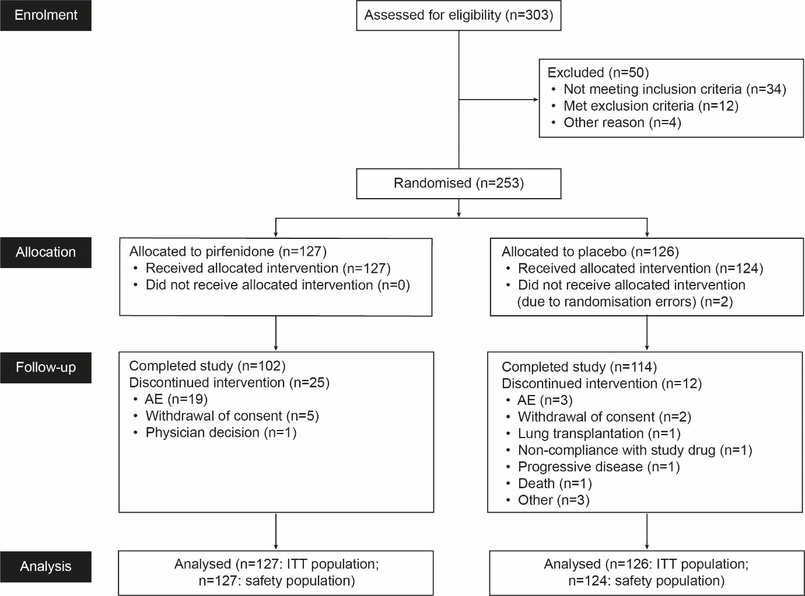
AE=adverse event. ITT=intent-to-treat.

Figure 2: Boxplot of median predicted FVC change (mL) from baseline to Week 24 measured using daily home spirometry (ITT population)
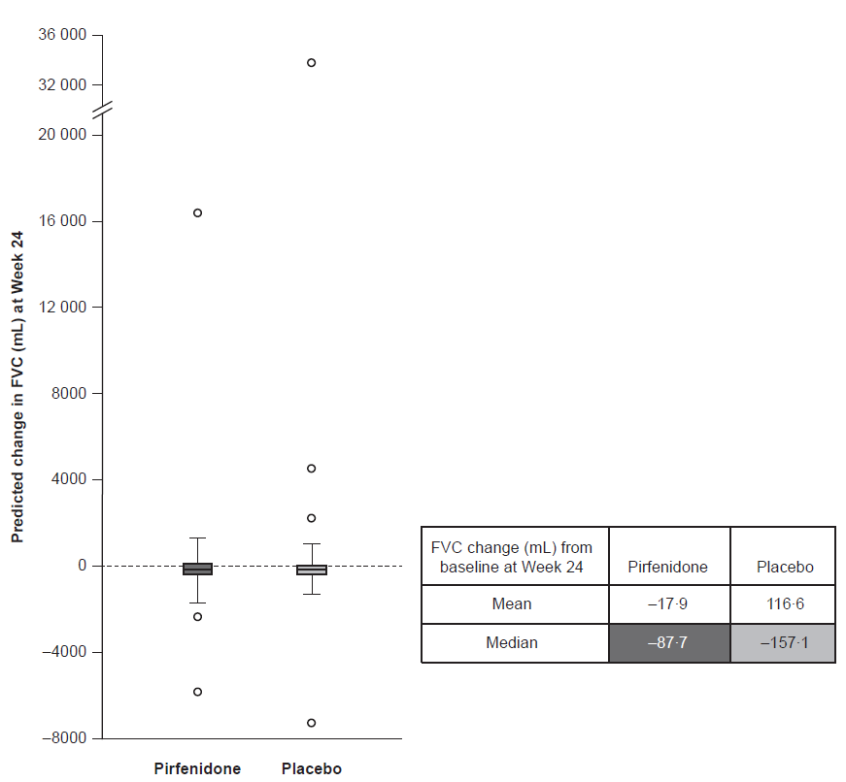
FVC=forced vital capacity. ITT=intent-to-treat.

Figure 3: Subgroup analysis of mean change in FVC from baseline to Week 24 measured using site spirometry (ITT population*)
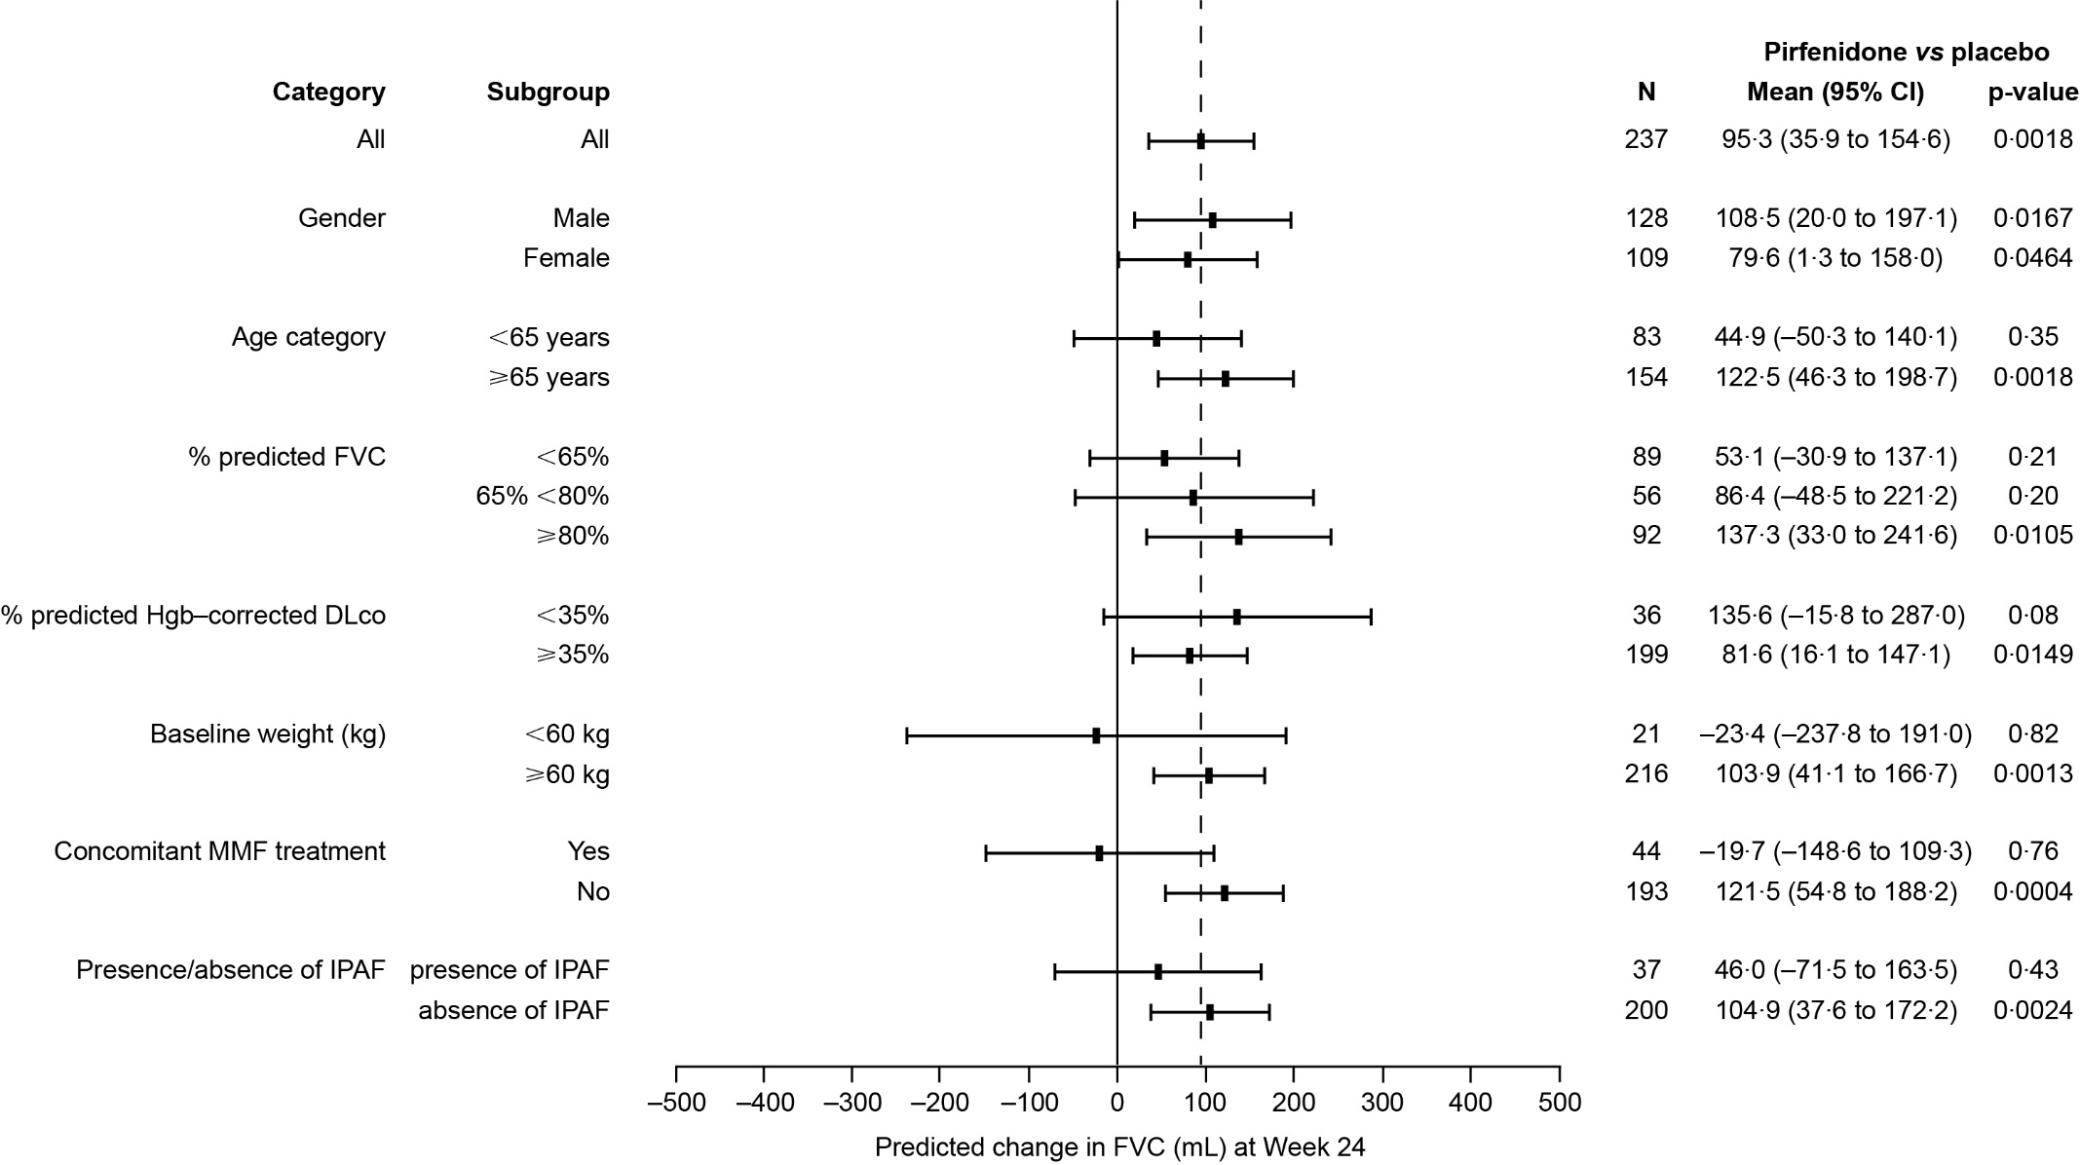
CI=confidence interval. DLco=carbon monoxide diffusing capacity. FVC=forced vital capacity. Hgb=haemoglobin. IPAF=interstitial pneumonia with autoimmune features. ITT=intent-to-treat. MMF=mycophenolate mofetil. *Analysis excluded patients who did not reach Week 8 site spirometry.

Supplementary Appendix
for
A double-blind, randomised, placebo-controlled Phase II trial of pirfenidone in patients with unclassifiable progressive fibrosing interstitial lung disease
Professor Toby M Maher,^{1,2} Tamera J Corte,^{3,4} Aryeh Fischer,⁵ Professor Michael Kreuter,⁶ David J Lederer,⁷* Maria Molina-Molina,^{8,9} Judit Axmann,¹⁰ Klaus-Uwe Kirchgaessler,¹⁰ Katerina Samara,¹¹ Frank Gilberg,¹⁰ Professor Vincent Cottin^{12,13}
¹National Heart and Lung Institute, Imperial College London, London, UK. ² NIHR Respiratory Clinical Research Facility, Royal Brompton Hospital, London, UK. ³Department of Respiratory Medicine, Royal Prince Alfred Hospital, Camperdown, New South Wales, Australia. ⁴Medical School, University of Sydney, Camperdown, New South Wales, Australia. ⁵University of Colorado School of Medicine, Denver, CO, USA. ⁶Center for Interstitial and Rare Lung Diseases and Department of Pulmonology and Critical Care Medicine, Thoraxklinik, Member of the German Center for Lung Research, University of Heidelberg, Heidelberg, Germany. ⁷Divison of Pulmonary, Allergy, and Critical Care Medicine, Columbia University Medical Center, New York, NY, USA. ⁸University Hospital of Bellvitge, Institut d'Investigació Biomèdica de Bellvitge (IDIBELL), L'Hospitalet de Llobregat, Barcelona, Spain. ⁹Centro de Investigación Biomédica en Red Enfermedades Respiratorias (CIBERES), Madrid, Spain. ¹⁰F. Hoffmann-La Roche, Ltd., Basel, Switzerland. ¹¹F. Hoffmann-La Roche, Ltd./Roche (Hellas) S.A., Maroussi, Greece. ¹²National Coordinating Reference Center for Rare Pulmonary Diseases, Louis Pradel Hospital, Lyon, France. ¹³Hospices Civils de Lyon, Université Claude Bernard Lyon 1, UMR754, Lyon, France.
*Current affiliation: Regeneron Pharmaceuticals, Tarrytown, NY, USA
Supplementary table S1: Summary of patient-reported outcomes (ITT population)
Parameter | Pirfenidone | Placebo | Pirfenidone vs placebo
Change from baseline to Week 24 in SGRQ score
Total score
Mean (SD) | 0·05 (12·5)* | 0·85 (13·4)† | –
Median (Q1, Q3) | –0·37 (–7·6, 7·0) | 0·60 (–7·0, 9·4) | –
Rank ANCOVA | – | – | 0·16
Symptoms component
Mean (SD) | –1·69 (19·2)‡ | –0·66 (15·4)§ | –
Median (Q1, Q3) | 0 (–15·4, 9·7) | 0·41 (–9·9, 9·4) | –
Activities component
Mean (SD) | 1·25 (14·6)* | 2·22 (13·1)† | –
Median (Q1, Q3) | 0 (–6·7, 6·7) | 0·05 (–6·7, 12·1) | –
Impacts component
Mean (SD) | –0·18 (13·9)* | 1·07 (17·5)† | –
Median (Q1, Q3) | –1·24 (–7·6, 8·0) | –0·22 (–8·3, 11·7) | –
Change from baseline to Week 24 in UCSD-SOBQ score
Mean (SD) | 5·21 (18·7)¶ | 5·30 (22·1)‖ | –
Median (Q1, Q3) | 4·00 (–7·5, 14·5) | 1·00 (–8·0, 20·0) | –
Rank ANCOVA | – | – | 0·78
Change from baseline to Week 24 in cough VAS score, mm
Mean (SD) | –2·52 (26·7)** | 0·78 (30·1)†† | –
Median (Q1, Q3) | 0 (–15·5, 10·0) | 0 (–15·0, 20·0) | –
Rank ANCOVA | – | – | 0·30
ANCOVA=analysis of covariance. ITT=intent-to-treat. Q1=quartile 1. Q3=quartile 3. SD=standard deviation. SGRQ=St. George’s Respiratory Questionnaire. UCSD-SOBQ=University of California San Diego Shortness of Breath Questionnaire. VAS=visual analogue scale. *n=97. †n=112. ‡n=99. §n=113. ¶n=84. ‖n=102. **n=100. ††n=114.
Supplementary table S2: TEAEs by System Organ Class (safety population)
Patients with at least one TEAE within System Organ Class, n (%) | Pirfenidone (n=127) | Placebo (n=124)
Gastrointestinal disorders | 71 (55·9) | 50 (40·3)
Infections and infestations | 59 (46·5) | 53 (42·7)
Respiratory, thoracic, and mediastinal disorders | 36 (28·3) | 44 (35·5)
General disorders and administration-site conditions | 34 (26·8) | 29 (23·4)
Skin and subcutaneous tissue disorders | 34 (26·8) | 22 (17·7)
Metabolism and nutrition disorders | 32 (25·2) | 20 (16·1)
Nervous system disorders | 31 (24·4) | 27 (21·8)
Investigations | 27 (21·3) | 13 (10·5)
Musculoskeletal and connective tissue disorders | 20 (15·7) | 26 (21·0)
Psychiatric disorders | 17 (13·4) | 6 (4·8)
Injury, poisoning, and procedural complications | 11 (8·7) | 9 (7·3)
Eye disorders | 10 (7·9) | 2 (1·6)
Cardiac disorders | 9 (7·1) | 9 (7·3)
Vascular disorders | 8 (6·3) | 10 (8·1)
Blood and lymphatic system disorders | 5 (3·9) | 0 (0·0)
Reproductive system and breast disorders | 5 (3·9) | 0 (0·0)
Renal and urinary disorders | 4 (3·1) | 5 (4·0)
Neoplasms benign, malignant, and unspecified (including cysts and polyps) | 4 (3·1) | 3 (2·4)
Endocrine disorders | 1 (0·8) | 1 (0·8)
Immune system disorders | 1 (0·8) | 1 (0·8)
Ear and labyrinth disorders | 0 (0·0) | 2 (1·6)
Surgical and medical procedures | 0 (0·0) | 2 (1·6)
Hepatobiliary disorders | 0 (0·0) | 1 (0·8)
TEAE=treatment-emergent adverse event.

Supplementary figure S1: Time-to-event analyses, from baseline, for patients who experienced PFS defined as (A) >10% absolute decline in percent predicted FVC, >50 m decline in 6MWD, or death, or defined as (B) >10% relative decline in percent predicted FVC, non-elective respiratory hospitalisation, or death (ITT population)
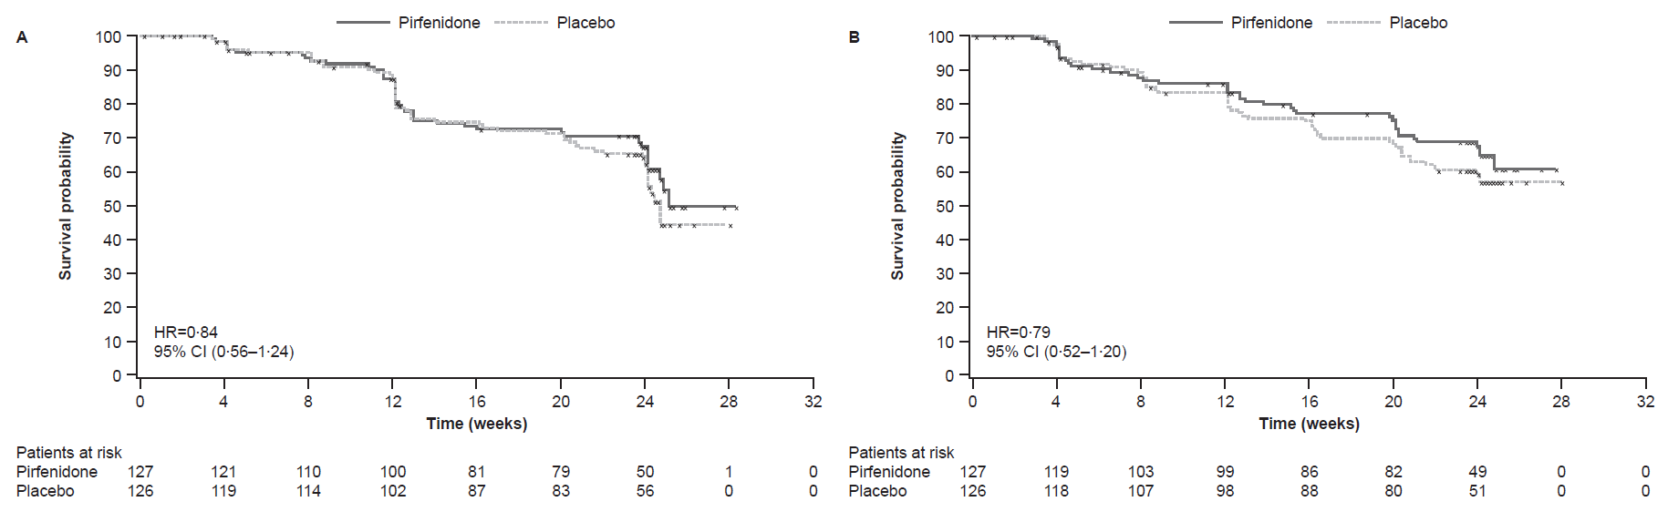
6MWD=6-minute walk distance. CI=confidence interval. FVC=forced vital capacity. HR=hazard ratio. ITT=intent-to-treat. PFS=progression-free survival.
List of investigators

Australia: Lauren Troy, Royal Prince Alfred Hospital, Camperdown; Ian Glaspole, The Alfred Hospital, Melbourne; Chris Grainge, John Hunter Hospital, New Lambton Heights; Nicole Goh, Austin Health, Melbourne; Jeremy Wrobel, Fiona Stanley Hospital, Murdoch; Gregory Keir, Princess Alexandra Hospital, Woolloongabba; Dan Chambers, Prince Charles Hospital, Brisbane; Mark Holmes, Royal Adelaide Hospital, Adelaide. Belgium: Wim Wuyts, UZ Leuven Gasthuisberg, Leuven; Antoine Froidure, Cliniques Universitaires St-Luc, Woluwe-Saint-Lambert; Benjamin Bondue, ULB Hôpital Erasme, Anderlecht. Canada: Chris Ryerson, St. Paul’s Hospital University of British Columbia, Vancouver; Martin Kolb, St. Joseph’s Healthcare, Hamilton. Czech Republic: Vitezslav Kolek, Fakultni Nemocnice Olomouc, Olomouc; Martina Doubkova, Fakultni Nemocnice Brno-Bohunice, Brno; Tomas Snizek, Nemocnice Jihlava, Jihlava. Denmark: Saher B Shaker, Gentofte Hospital, Hellerup; Elisabeth Bendstrup, Aarhus Universitetshospital, Aarhus; Helle Dall Madsen, Odense Universitetshospital, Odense. Germany: Christian Grohé, Evangelische Lungenklinik Berlin, Berlin; Andreas Günther, Klinik der Justus-Liebig-Universität, Giessen; Michael Kreuter, Thoraxklinik Heidelberg gGmbH, Heidelberg; Jürgen Behr, Klinikum der Universität München, München; Irmhild Mäder, Zentralklinik Bad Berka GmbH, Bad Berka. Greece: Demosthenes Bouros, Sotiria Hospital for Diseases of the Chest, Athens; Spyridon Papiris, University General Hospital of Athens, Athens; Katerina Antoniou, University General Hospital of Heraklion, Heraklion. Ireland: Katherine O’Reilly, Mater Misericordiae University Hospital, Dublin; Michael Keane, St. Vincent’s University Hospital, Dublin. Israel: Gabriel Izbicki, Shaare Zedek Medical Center, Jerusalem; Yochai Adir, Carmel Medical Center, Haifa; Neville Berkman, Hadassah Medical Center, Jerusalem; David Shitrit, Meir Medical Center, Kfar Saba; Mordechai Kramer, Beilinson Medical Center, Petah Tikva; Gershon Fink, Kaplan Medical Center, Rehovot; Yael Raviv, Soroka Medical Center, Be’er Sheva. Italy: Carlo Albera, Azienda Ospedaliero-Universitaria San Luigi Gonzaga di Orbassano, Orbassano; Sergio Harari, Ospedale San Giuseppe, Mailand; Sara Tomassetti, Ospedale Morgagni-Pierantoni, Forlì; Stefano Gasparini, Azienda Ospedaliero-Universitaria Ospedali Riuniti di Ancona, Ancona; Federico Lavorini, Azienda Ospedaliero-Universitaria Careggi, Firenze. Poland: Wojciech Piotrowski, Uniwersytecki Szpital Kliniczny Nr 1 im. N. Barlickiego Uniwersytetu Medycznego, Łódź; Ewa Jassem, Uniwersyteckie Centrum Kliniczne, Gdańsk; Jan Kus, Instytut Gruźlicy i Chorób Płuc, Warsaw. Portugal: Antonio Morais, Hospital de Sao Joao, Porto; Carlos Robalo Cordeiro, Hospitais da Universidade de Coimbra, Lisbon; Sofia Neves, Centro Hospitalar de Vila Nova de Gaia/Espinho, Vila Nova de Gaia; Pedro Ferreira, Hospital Infante D. Pedro, Aveiro. Spain: Asunción Nieto Barbero, Hospital Clínico San Carlos, Madrid; Victoria Villena, Hospital Universitario 12 de Octubre, Madrid; Claudia Valenzuela, Hospital Universitario La Princesa, Madrid; María Molina-Molina, Hospital Universitari de Bellvitge, Bellvitge/Barcelona; Jose Cifrian, Hospital Universitario Marqués de Valdecilla, Santander. United Kingdom: Helen Parfrey, Papworth Hospital NHS Foundation Trust, Cambridge; Huzaifa Adamali, Southmead Hospital, Bristol; Nik Hirani, Edinburgh Royal Infirmary, Edinburgh; Toby Maher, Royal Brompton Hospital, London; Nazia Chaudhuri, Wythenshawe Hospital, Manchester; Stephen Bianchi, Northern General Hospital, Sheffield; Felix Woodhead, Glenfield Hospital, Leicester; Michael Gibbons, Royal Devon and Exeter Hospital, Exeter; Joanna Porter, University College London Hospital, London; Sophie Fletcher, Southampton University Hospitals NHS Trust, Southampton; David Thickett, University Hospital Birmingham Queen Elizabeth Hospital, Birmingham; Helen Stone, Royal Stoke University Hospital, Stoke-on-Trent.

