DCEC for Robust Image Text Retrieval under Visual Corruptions
Authors and contact details: [To be completed]
Ningxia University

Abstract
Visual corruptions can shift image embeddings and disrupt image-text retrieval. We propose DCEC, a lightweight correction module that uses image quality statistics to predict a gated residual while keeping CLIP frozen. Clean CLIP similarity distributions supervise bidirectional ranking preservation during training; inference requires no parameter updates. On Flickr30K, DCEC improves the mean bidirectional Recall@1 over Frozen CLIP by 1.435 percentage points across 21 validation corruption conditions and by 1.513 points across 22 final-test conditions, with positive gains in every condition. Comparisons with DN and TCR show condition-dependent advantages rather than uniform superiority. Mechanism analyses support the importance of correction direction, magnitude and image-specific matching. DCEC provides fixed-parameter robustness gains, with limitations under mild corruption and motion blur and a descriptor-related latency cost.
Keywords: image-text retrieval; visual corruption; frozen CLIP; embedding correction; robustness

1 Introduction
Vision-language models map images and texts into a shared embedding space, enabling retrieval by similarity [1,2]. This correspondence can deteriorate when images are blurred, compressed, noisy or poorly illuminated. Distribution-shift evaluations motivate explicit robustness analysis [3]. Retrieval is particularly sensitive to changes in relative similarity: an embedding need not become entirely uninformative for the order of nearby candidates to change.
Deployment adaptation includes parameter updates, prompt adaptation and target-distribution calibration [4–10]. DN estimates statistics from unlabeled target samples [6], whereas TCR addresses cross-modal query shift through test-time adaptation [8]. Recent work further studies generative query refinement and confidence calibration [11,12]. We consider a deployment constraint in which model parameters remain fixed during inference and target-batch statistics are unavailable, while offline training of a small image-side module is permitted.
DCEC uses statistics computed from the current image to condition a residual correction of its frozen CLIP embedding. The corrected image embedding is compared with unchanged text embeddings. During offline training, paired clean images provide teacher similarity distributions. Our question is whether this correction can consistently improve a frozen retrieval model, and which geometric properties of the correction explain the gain.
The contributions are a sample-conditioned correction architecture with identity initialization, a clean-teacher bidirectional distribution objective for the selected configuration, and controlled robustness evidence supported by mechanism interventions. These are evaluated contributions; we do not claim that residual learning, quality statistics or distillation are individually new, or that DCEC uniformly outperforms existing adaptation methods.

2 Method

2.1 Inputs outputs and processing flow
Figure 1 separates deployment from training. At deployment, the inputs are a corrupted image and candidate text descriptions. The outputs are image-to-text and text-to-image rankings derived from the corrected image embedding and frozen text embeddings. Clean images enter only the training teacher branch. Only the green modules are learned; both CLIP encoders remain frozen.
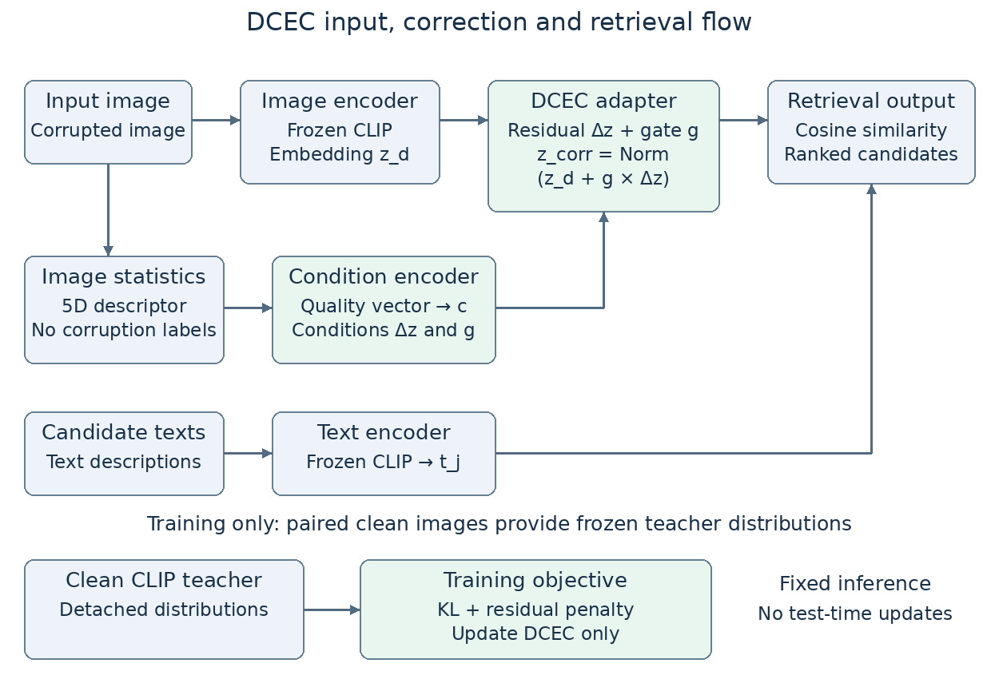
Figure 1. DCEC inference and training flow. Quality statistics condition the image-side residual and its auxiliary gate. The clean teacher supplies detached training distributions and is absent from inference.

2.2 Frozen representations and conditional correction
We use OpenAI CLIP ViT-B/32 with 512-dimensional image and text projections. For corrupted image x_d and caption y_j, normalized embeddings are z_d = Norm(f_I(x_d)) and t_j = Norm(f_T(y_j)), where Norm denotes L2 normalization. DCEC changes only the image embedding. Image and text embeddings have dimension 512; q has dimension 5 and c has dimension 64. Norm(v) denotes v divided by its L2 norm. The symbol s_j denotes cosine similarity, whereas the separate scalar s below denotes the frozen CLIP logit scale.
$c = φ(q(x_{d})); Δz = ψ([z_{d}; c]); g = σ(η(c)) (1)$
$z_{corr} = Norm(z_{d} + gΔz); s_{j} = {z_{corr}}^{T}t_{j} (2)$
The five-dimensional descriptor contains luminance mean, luminance standard deviation, mean absolute four-neighbor Laplacian response, high-frequency residual magnitude relative to a radius-1 Gaussian blur, and discontinuity at internal 8-pixel boundaries. RGB luminance uses coefficients 0.2126, 0.7152 and 0.0722. The descriptor uses neither corruption-type nor severity labels.

2.3 Architecture and learning objective
The condition encoder is a 5→32→64 MLP with ReLU activations. Concatenating the 64-dimensional condition with z_d gives a 576-dimensional input to a 576→256→512 residual network with a hidden ReLU. Its final weights and biases are initialized to zero, making the initial correction exactly zero. A 64→32→1 network with hidden ReLU and output sigmoid produces the scalar gate. The complete adapter has 283,713 trainable parameters. Here φ is the condition encoder, ψ is the residual network, η is the gate network before sigmoid, and σ is the sigmoid function.
The gate bounds its scaling coefficient, not the residual norm itself. Residual magnitude is regularized separately. We therefore describe the gate as auxiliary scaling rather than assuming that its variation drives robustness.
For a batch of B images and 5B captions, let Z_c denote detached clean-image teacher embeddings, Z_corr the corrected image embeddings and T the frozen text embeddings. With frozen CLIP scale s, teacher and student similarity matrices are S_c = sZ_cTᵀ and S_corr = sZ_corrTᵀ. Softmax along each retrieval direction gives teacher and student distributions.
$L_{rank} = \frac{1}{2} [KL(p_{c, I→T} || p_{corr, I→T}) + KL(p_{c, T→I} || p_{corr, T→I})] (3)$
$L_{res} = \frac{1}{Bd}{{‖ΔZ‖}_{F}}^{2}; L_{A3} = L_{rank} + 0.001 L_{res} (4)$
The selected A3/no_sem configuration retains the complete architecture but sets the direct semantic anchoring weight to zero. The residual penalty acts on the raw Δz, before gating. Ranking preservation is distribution distillation; no additional positive-negative mining objective is implied. Gradients update DCEC only; clean teacher outputs are detached and CLIP parameters are excluded from the optimizer. In Eq. (4), ΔZ stacks the B raw residual vectors, d = 512, and the Frobenius norm sums squared entries over both batch and feature dimensions.

3 Experimental Protocol

3.1 Data and corruption conditions
Flickr30K training uses 29,000 images and 145,000 captions. The local validation protocol contains 1,014 images and 5,070 captions. The frozen Karpathy test uses 1,000 images and 5,000 captions. The validation count differs from the conventional 1,000-image split; exact manifest provenance and membership verification remain necessary before submission (Appendix A).
Table 1. Recorded corruption settings. Seen means available during training; unseen means withheld from training.
Degradation | Role | S1 | S2 | S3
JPEG | Seen | quality=75 | quality=50 | quality=25
Gaussian Blur | Seen | radius=1.0 | radius=2.0 | radius=4.0
Gaussian Noise | Seen | σ=0.02 | σ=0.05 | σ=0.10
Low Light | Seen | brightness=0.75 | brightness=0.50 | brightness=0.25
Motion Blur | Unseen | kernel=3 | kernel=7 | kernel=15
Contrast | Unseen | factor=0.75 | factor=0.50 | factor=0.25
Pixelate | Unseen | block=2 | block=4 | block=8

Training includes clean images, JPEG, Gaussian blur, Gaussian noise and low light. Motion blur, contrast and pixelation are withheld corruption families used for validation and testing. Gaussian noise is generated reproducibly using the protocol seed and image index. The evaluation averages 21 corrupted conditions, or 22 conditions when clean is included.

3.2 Training selection and evaluation
AdamW trains only the adapter for five epochs with batch size 32, learning rate 0.001 and weight decay 0.0001. The learning rate is fixed. At each epoch, checkpoint selection averages Primary across clean-S0, JPEG-S2, Gaussian Blur-S2, Gaussian Noise-S2 and Low Light-S2. The validation perturbation seed is fixed to 2026. Three independent training seeds, 2026, 2027 and 2028, use the same selection rule.
Primary is the arithmetic mean of image-to-text and text-to-image Recall@1, expressed as a percentage. Improvements are percentage-point differences. R@5 and R@10 belong to the evaluation protocol, but their numerical summaries are not available in the present manuscript evidence and are not invented here.
$Primary = \frac{1}{2} ({R@1}_{I→T} + {R@1}_{T→I}) (5)$
The architecture, weights and selected checkpoints were frozen before the final test. Subsequent DN/TCR comparisons, interventions and profiling use validation and do not feed back into those checkpoints. Final-test results in this paper compare DCEC with Frozen only; DN and TCR results are validation comparisons.

3.3 What the comparative experiment compares
Table 2. Baselines and the role of each comparison.
Method | Mechanism | Comparison purpose
Frozen CLIP | Unchanged image and text embeddings | Does the learned correction improve the unadapted backbone?
DN [6] | Unlabeled target-statistics normalization | How does DCEC compare with distribution calibration?
TCR [8] | Online adaptation for retrieval query shift | How does fixed inference compare with test-time adaptation?
DCEC | Offline learned image-side correction | Proposed method; no test-time update

All four methods are evaluated on the same local validation images, captions, corruption implementation, CLIP ViT-B/32 backbone and Primary metric. DN estimates statistics using 100 unlabeled samples with five statistical repetitions per condition. TCR has one controlled run per condition; DCEC has three training repetitions. The numbers are controlled local evaluations recorded in the study, not scores copied from the original baseline papers.
This is a matched evaluation setting, but it does not equalize every method’s information access or offline training budget: DCEC learns from paired clean/corrupted training data, DN uses target samples, and TCR adapts online. The performance table should be read together with these differences. Exact baseline configurations and output provenance require a reproducible supplement before submission.

3.4 Statistical interpretation
DCEC mean ± SD summarizes variation across three training seeds. Seed-level 95% t intervals describe training randomness conditional on fixed evaluation images. DN repetitions concern target-statistics estimation, while TCR lacks repeated runs. These different repetition structures do not support a symmetric cross-method significance test. Image-level mechanism correlations use 500 image-cluster bootstrap repetitions, retaining each image’s dependence across corruption conditions. Reported gains retain the archived differences; some differ from subtraction of displayed rounded means by up to 0.001 point. Consistency with unrounded exports remains to be verified.

4 Results

4.1 Frozen final test
Table 3. Frozen final-test performance. W/T/L counts condition-level wins, ties and losses against Frozen.
Subset | Frozen | DCEC | Gain | W/T/L
All 22 conditions | 63.5109 | 65.0241 ± 0.0570 | +1.5132 | 22/0/0
Clean | 69.0500 | 69.5600 ± 0.0638 | +0.5100 | —
Seen 12 conditions | 65.6992 | 67.3983 | +1.6992 | 12/0/0
Unseen 9 conditions | 59.9778 | 61.3544 | +1.3767 | 9/0/0

DCEC reaches 65.0241 ± 0.0570 across 22 final-test conditions, improving Frozen by 1.5132 points with positive gains in all conditions. The clean score increases by 0.5100 points. Gains also occur for the 12 seen and nine unseen corrupted conditions, supporting generalization beyond the training corruption families in this setting.
The three-seed t interval for the overall DCEC score is [64.8825, 65.1657]; the conditional gain interval against fixed Frozen is [1.3716, 1.6548]. These are not image-resampling intervals and do not establish generalization to arbitrary populations or other benchmarks.

4.2 Controlled baseline comparison
Table 4. Validation mean across 21 corrupted conditions.
Method | Primary | Repetition source | Available uncertainty
Frozen | 65.286 | Deterministic evaluation | Not applicable
DN | 66.849 | 5 statistics estimates per condition | Condition-wise SD; no aggregate paired CI
TCR | 66.553 | 1 controlled run per condition | No repeated-run CI
DCEC | 66.721 ± 0.033 | 3 training seeds | Seed-level 95% CI [66.640, 66.802]

DCEC improves Frozen by 1.435 points and wins on all 21 corrupted conditions. It is 0.169 points above TCR, winning on 16 of 21 conditions, but 0.128 points below DN, winning on six of 21 conditions. Thus the comparative evidence supports stable gains over Frozen and conditional competitiveness with adapted baselines, not uniform superiority. Neither difference against DN or TCR is presented as statistically significant.

4.3 Severity dependence
Table 5. Mean validation performance by severity.
Severity | Frozen | DN | TCR | DCEC mean ± SD
S1 | 69.670 | 70.957 | 70.201 | 70.463 ± 0.139
S2 | 67.530 | 69.070 | 68.439 | 68.812 ± 0.026
S3 | 58.659 | 60.520 | 61.017 | 60.889 ± 0.193

The DCEC−DN gap changes from −0.494 at S1 to −0.259 at S2 and +0.370 at S3. However, DCEC remains 0.128 points below TCR at S3. The supported trend concerns relative competitiveness with DN; it is not a universal increase in advantage over all baselines.

4.4 Corruption dependence and failure analysis
Table 6. Mean validation performance over three severities per corruption.
Corruption | Frozen | DN | TCR | DCEC mean ± SD
jpeg | 69.987 | 71.425 | 70.325 | 71.069 ± 0.172
gaussian_blur | 61.755 | 64.252 | 62.821 | 64.821 ± 0.087
gaussian_noise | 69.609 | 71.001 | 70.168 | 70.462 ± 0.013
low_light | 68.918 | 69.718 | 69.632 | 69.975 ± 0.072
motion_blur | 64.727 | 66.074 | 66.315 | 65.311 ± 0.111
contrast | 68.600 | 69.976 | 69.241 | 70.179 ± 0.129
pixelate | 53.409 | 55.496 | 57.367 | 55.231 ± 0.202

DCEC exceeds DN on Gaussian blur, low light and contrast in the three-severity means. Gaussian Blur S3 yields a 2.585-point gain over DN. Motion blur is a clear boundary: DCEC is 0.762 points below DN and 1.004 below TCR on average. Pixelation is also weaker than both baselines on average, particularly against TCR.
The average gate stays near 0.117 across severities, whereas correction norm rises from 0.0934 at S1 to 0.1809 at S3. The archived semantic-recovery statistic changes from approximately zero to +0.0199. Gaussian blur produces larger correction and recovery than motion blur. Because the descriptor contains no explicit directional-blur statistic and the motion-blur implementation uses a horizontal kernel, the observations are consistent with limited directional-blur sensitivity. This is a plausible structural explanation, not a unique causal identification.

4.5 Image level mechanism evidence
Table 7. Condition-demeaned image-level correlations with 95% image-cluster bootstrap intervals.
关联 | Pearson r | 95% image-cluster bootstrap CI
Drift → margin gain | 0.197 | [0.173, 0.221]
Recovery → margin gain | 0.286 | [0.256, 0.313]
Correction norm → margin gain | 0.363 | [0.341, 0.390]
Gate → margin gain | 0.009 | [-0.026, 0.039]
Drift → correction norm | 0.425 | [0.400, 0.449]
Drift → recovery | 0.534 | [0.492, 0.571]

After removing each corruption-severity condition mean, drift is positively associated with correction norm and recovery. Correction norm and recovery are also positively associated with retrieval-margin gain. In contrast, the gate–gain interval includes zero. The results support correction geometry and magnitude as useful explanatory variables; they do not support a strong claim that gate variation controls the observed gain. Correlation is descriptive and does not establish causality. Formal archived definitions of drift, recovery and per-image margin remain to be supplied in the reproducibility supplement.

4.6 Ablations and functional interventions
Table 8. Recorded controlled ablations. Scores use the five-condition checkpoint-selection metric, not the 21-condition comparison mean.
Variant | Parameters | Selected epoch | Seed | Selection Primary
A1 | 262,912 | 3 | 2026 | 69.700
A2 | 281,600 | 3 | 2026 | 69.714
A3 | 283,713 | 3 | 2026 | 70.168
A4 | 283,713 | 1 | 2026 | 69.464

A1 removes quality conditioning and gating; A2 retains quality conditioning with g fixed to one; A3 uses the complete architecture without semantic anchoring; A4 removes the ranking objective. A3 has the highest recorded selection score. A2→A3 also changes the semantic-loss configuration, so its difference cannot isolate the causal contribution of the gate. The recorded ablations therefore validate configurations rather than every component individually.
On Gaussian Blur S1, reversed correction (α = −1) reduces Primary to 67.702 versus 69.408 without correction (α = 0). Moderate positive scaling reaches 70.385 near α = 2, whereas α = 4 and 6 reduce performance to 67.604 and 63.679. Pixelate S3 shows the same qualitative reversal/overcorrection pattern but reaches its best tested value at α = 1. These interventions demonstrate condition-dependent correction scale.
Matched-norm random directions underperform learned correction by 1.613 points on Gaussian Blur S1 and 6.049 on Pixelate S3, averaged over five and three random directions, respectively. Globally shuffling corrections lowers Gaussian Blur S1 performance by 1.426 points. Descriptor replacement or shuffling has little effect in that condition. The interventions support direction and image–correction matching, while limiting claims about precise descriptor matching.

4.7 Efficiency and computational cost
Table 9. Recorded RTX 4090 D profiling at batch size 32.
Configuration | Latency ms/image | Peak GPU MB
Adapter only | 0.0146 | 13.71
Frozen CLIP, serial profile | 2.554 | 679.66
Frozen + DCEC, serial descriptor | 7.658 | 679.66
Frozen + DCEC, 4 CPU workers | 6.227 | 679.66

The adapter uses approximately 0.284 M parameters and 0.283 MMAC per image. Its small cost does not make the full pipeline latency-free. Serial end-to-end latency increases by 199.8%; four-worker profiling still records a 141.6% increase relative to its corresponding Frozen measurement. Serial and parallel profiles were measured separately, so their baseline latencies should not be assumed identical. Neither profile detects additional peak GPU memory, which is a measurement result rather than proof of zero memory overhead.
The CPU/PIL descriptor is the bottleneck. Gaussian blur and luminance conversion account for about 43.6% and 28.7% of its recorded batch time. Four-worker extraction reduces descriptor time from 227.6 to 82.6 ms per batch, with zero maximum absolute output difference. A tensor or GPU implementation is a future optimization, not an achieved result.

5 Discussion and Limitations
DCEC establishes a fixed-inference route to improving a frozen backbone under controlled image corruption. Its distinguishing design choice is to learn a sample-conditioned image-embedding correction offline and preserve clean-teacher similarity distributions, while keeping text embeddings and deployed parameters fixed. This positioning must be compared against related methods at the level of information access, training supervision, online state and cost, not just aggregate accuracy.
Recent ReEx work addresses query noise using generative semantic refinement and exclusion-guided adaptation [11]. Unified Confidence Adjustment studies confidence calibration while accounting for semantic proximity among retrieval candidates [12]. These studies motivate updated related-work coverage and assessment of additional baselines. They are cited as related work only: no ReEx or Unified Confidence Adjustment experiment has been performed in the present evidence, and no numerical comparison with them is claimed.
The current study is limited to Flickr30K and CLIP ViT-B/32. The local 1,014-image validation manifest needs provenance checking. Baseline information access and training budgets differ, and repeated-run structures are not comparable. Paired image/query predictions and suitable repetition designs are needed before cross-method significance can be assessed. Seed intervals should not be treated as population uncertainty.
Mild corruption and motion blur expose limitations of the current correction. The descriptor has no explicit directional feature, and the gate alone does not explain gains. Single synthetic corruptions do not cover compound artifacts, real sensor shifts, corrupted text queries or large retrieval galleries. The descriptor also creates a substantial end-to-end latency cost. Additional datasets, backbones, fair baseline repetitions and deployment profiling are needed before broader claims are justified.

6 Conclusion
DCEC uses image statistics and a learned residual to correct frozen CLIP image embeddings. Clean-teacher bidirectional distribution distillation trains the module offline; deployment uses fixed parameters. In the recorded Flickr30K setting, the method improves Frozen across all validation corruption conditions and all clean/corrupted final-test conditions. Comparisons and interventions identify condition-dependent performance and the functional importance of correction geometry, while retaining statistical, corruption-specific and latency limitations.

References
[1] Radford A, Kim J W, Hallacy C, et al. Learning Transferable Visual Models From Natural Language Supervision[C]//Proceedings of the 38th International Conference on Machine Learning. PMLR, 2021, 139: 8748–8763.
[2] Li J, Li D, Xiong C, Hoi S. BLIP: Bootstrapping Language-Image Pre-training for Unified Vision-Language Understanding and Generation[C]//Proceedings of the 39th International Conference on Machine Learning. PMLR, 2022, 162: 12888–12900.
[3] Qiu J, Zhu Y, Shi X, et al. Benchmarking Robustness of Multimodal Image-Text Models under Distribution Shift[J]. Journal of Data-centric Machine Learning Research, 2024, 1(2): 1–56.
[4] Wang D, Shelhamer E, Liu S, Olshausen B, Darrell T. Tent: Fully Test-Time Adaptation by Entropy Minimization[C]//International Conference on Learning Representations. 2021.
[5] Shu M, Nie W, Huang D-A, et al. Test-Time Prompt Tuning for Zero-Shot Generalization in Vision-Language Models[C]//Advances in Neural Information Processing Systems. 2022, 35: 14274–14289.
[6] Zhou Y, Ren J, Li F, Zabih R, Lim S-N. Test-Time Distribution Normalization for Contrastively Learned Vision-language Models[C]//Advances in Neural Information Processing Systems. 2023, 36.
[7] Karmanov A, Guan D, Lu S, El Saddik A, Xing E. Efficient Test-Time Adaptation of Vision-Language Models[C]//Proceedings of the IEEE/CVF Conference on Computer Vision and Pattern Recognition. 2024: 14162–14171.
[8] Li H, Hu P, Zhang Q, Peng X, Liu X, Yang M. Test-time Adaptation for Cross-modal Retrieval with Query Shift[C]//International Conference on Learning Representations. 2025.
[9] Vargas Hakim G A, Osowiechi D, Noori M, et al. CLIPArTT: Adaptation of CLIP to New Domains at Test Time[C]//Proceedings of the IEEE/CVF Winter Conference on Applications of Computer Vision. 2025: 7092–7101.
[10] Zanella M, Fuchs C, De Vleeschouwer C, Ben Ayed I. Realistic Test-Time Adaptation of Vision-Language Models[C]//Proceedings of the IEEE/CVF Conference on Computer Vision and Pattern Recognition. 2025: 25103–25112.
[11] Yang Q, Wei X, Li Y, et al. Robust Cross-Modal Retrieval via Generative Semantic Refinement and Exclusion-Guided Adaptation. Proceedings of the 43rd International Conference on Machine Learning. PMLR, 2026, 306: 146369–146382. https://proceedings.mlr.press/v306/yang26ci.html
[12] Zhou R, Hao Y, Zuo H, et al. Unified Confidence Adjustment for Robust Cross-Modal Retrieval under Test-Time Distribution Shifts. Proceedings of the 42nd Conference on Uncertainty in Artificial Intelligence. PMLR, 2026, 337: 8292–8311. https://proceedings.mlr.press/v337/zhou26b.html

Appendix A Research Status and Evidence to Complete
The method and all numerical results above correspond to the recorded September 30 evidence. This appendix distinguishes completed analyses from prospective work so that the research status can be assessed separately from the inference architecture.
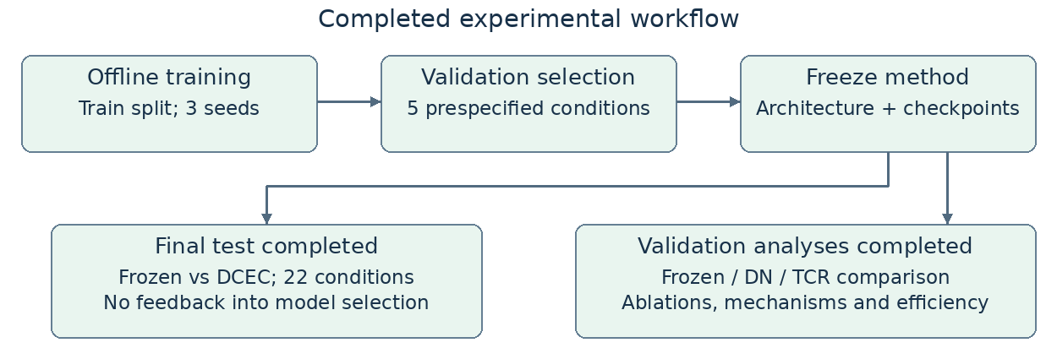
Figure A1. Completed workflow and analysis branches. Both branches use the frozen method; external baseline results do not alter the selected DCEC model.
Table A1. Status of experimental evidence.
Item | Status | Evidence or remaining work
Inputs and outputs | Specified | Corrupted images and captions → bidirectional rankings; clean images are training only.
Main method | Completed | A3/no_sem; three training seeds; frozen CLIP.
Baseline comparisons | Completed on validation | Frozen, DN and TCR under the shared local evaluation protocol.
Final test | Completed | Frozen and DCEC; 1,000 images and 5,000 captions.
Ablations and interventions | Completed with limits | A1–A4; direction, scaling and matching; gate effect is not isolated.
Mechanism and efficiency | Completed with limits | Bootstrap correlations and profiling; exact metric definitions require documentation.
2026 research coverage | Updated in text | ReEx and Unified Confidence Adjustment cited; no new baseline scores.
Additional validation | Pending | Comparable baseline repetitions, paired predictions, other datasets and backbones.

Reproducibility details requiring completion: validation manifest origin and membership audit; exact baseline commits, configurations and output paths; formal mechanism-metric definitions; complete bidirectional R@1/R@5/R@10 tables; target venue and author metadata. Missing details: [To be completed]. No unobserved values are inferred from the reported Primary scores.
If new experiments are undertaken, they should constitute a clearly identified extension with prespecified settings. The frozen final test must not become a feedback source for tuning the existing DCEC model. Submission readiness remains subject to evidence completion and assessment of novelty against directly related work.

