Zabbix item installation

In folder C:\Program Files\Zabbix Agent 2 is configuration file: zabbix_agent2.conf
Open it with "C:\Users\jelinek\AppData\Local\Programs\Microsoft VS Code\Code.exe"
Copy line with inspection item:
UserParameter=frontstage.duplicext,"C:\Program Files\Microsoft SQL Server"\110\Tools\Binn\sqlcmd -Q "set nocount on; select fs_custom.dbo.duplicext()" -h -1

It is possible to use parameters ($1,$2…) UserParameter=frontstage.duplicext(*)
select $1.dbo. $2()
Change name of item and name of SQL function
Save it
Restart Zabbix Service:
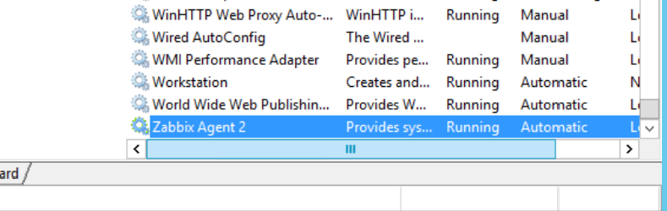
Add new item into Zabbix application:
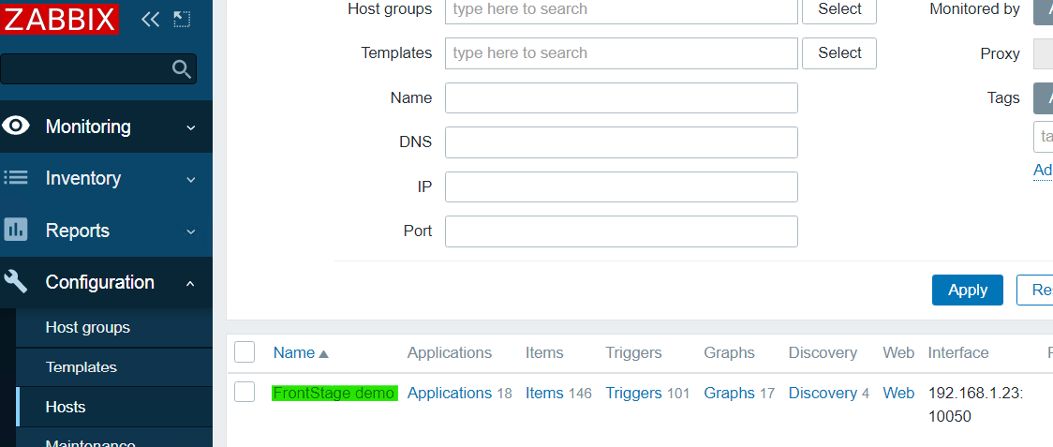
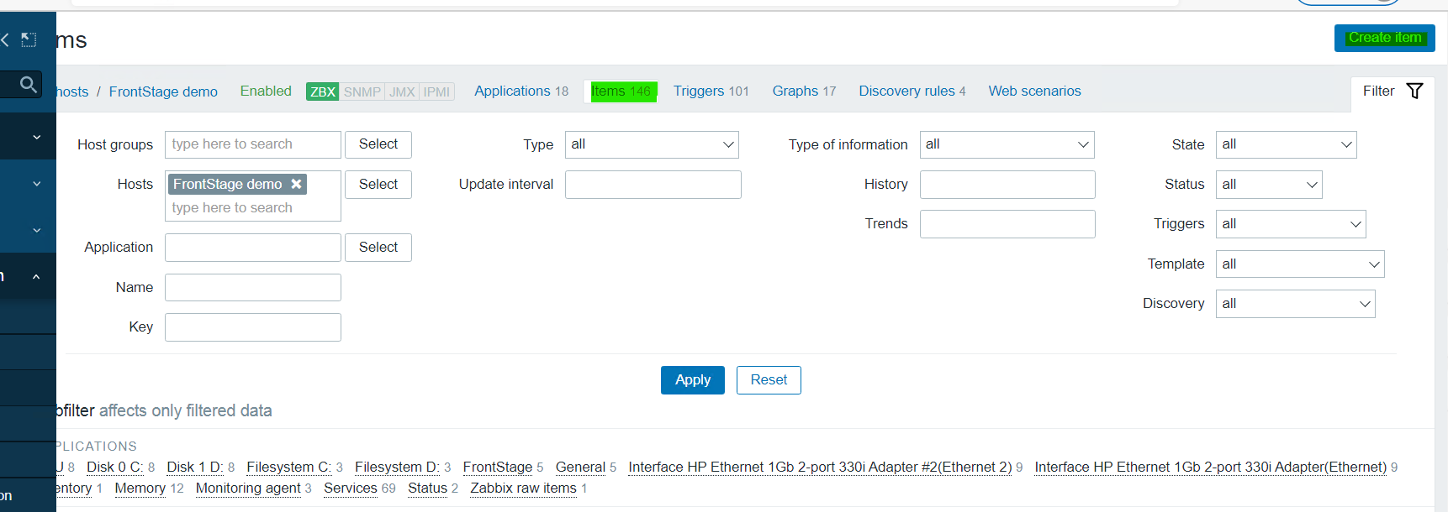
Fill Form:
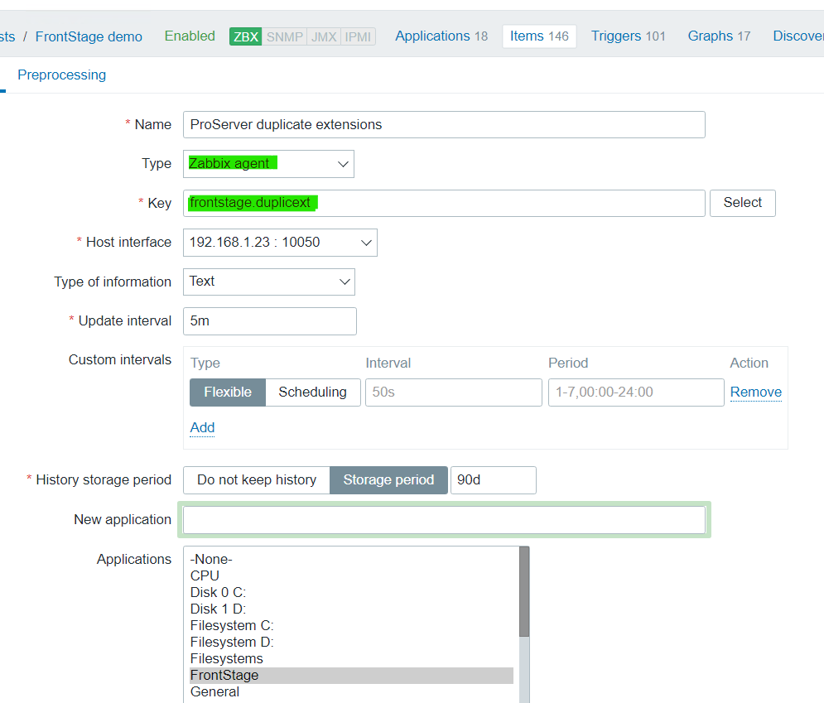

Test item by command prompt:
zabbix_agent2 -c .\zabbix_agent2.conf -t frontstage.RecordingLessCallsS

Calling Item with parameter: Frontstage.DuplicExt[String]

