SET STATISTICS TIME ON – zobrazuje přesné časy vykonávání
SELECT ContactID
FROM Person.Contact WITH (INDEX(AK_Contact_rowguid),NOLOCK)

Velikost transakčního logu:
DBCC SQLPERF(LOGSPACE)
SELECT (size/1024/1024)*8 FROM sys.master_files WHERE Type=1 AND database_id = DB_ID('Frontstage');

FrontStage Support - SQL školení - Optimalizace, ladění a monitorování T-SQL dotazů - Všechny dokumenty (sharepoint.com)

QUERY STORE – nástroj pro sledování kvality dotazů
PŘEJMENOVÁNÍ DATABÁZE:
EXEC sp_renamedb N'Accounting', N'Financial';
GO
BACKUP DATABASE @DB_Name TO DISK = @fileNameindex
RESTORE DATABASE CloneDB FROM DISK='c:\Test\clone.bak'
Načtení proměnných pro SQLCMD:
:r C:\\TEMP\\setvar.txt

BACKUP TABLE:
select * into PCS.dbo.SnapshotSL_backup from PCS.dbo.SnapshotSL
select * into DataQuery_backup from DataQuery

DELETE PN FROM iCC.dbo.PhoneNumber PN
LEFT JOIN InboundCall IC ON IC.PhoneNumberId=PN.PhoneNumberId
where deleted=0 and rank=2 AND IC.InboundCallId IS NULL

VarBinary:
convert(varchar(max),EML) AS EML,

IF EXISTS(
SELECT * FROM INFORMATION_SCHEMA.TABLES
WHERE TABLE_NAME = 'Album'
)
IF EXISTS(
SELECT * FROM INFORMATION_SCHEMA.COLUMNS
WHERE COLUMN_NAME = 'Title'
)
ALTER TABLE table_name
ADD column_name column-definition

SELECT
IvrStep.*,
v.Status
FROM
IvrStep
CROSS APPLY
(VALUES
(CASE WHEN Rank = 30 THEN 'Eingeschaltet' ELSE 'Ausgeschaltet' END),
(CASE WHEN FileName = 'Announcement 1_x' AND Rank = 30 THEN 'Ansage 1 Eingeschaltet' ELSE 'Ansage 1 Ausgeschaltet' END),
(CASE WHEN FileName = 'Announcement 2_x' AND Rank = 30 THEN 'Ansage 2 Eingeschaltet' ELSE 'Ansage 2 Ausgeschaltet' END),
(CASE WHEN FileName = 'Announcement 3_x' AND Rank = 30 THEN 'Ansage 3 Eingeschaltet' ELSE 'Ansage 3 Ausgeschaltet' END),
(CASE WHEN FileName = 'Announcement 4_x' AND Rank = 30 THEN 'Ansage 4 Eingeschaltet' ELSE 'Ansage 4 Ausgeschaltet' END)
) v(Status)
WHERE

How to move SQL database files (MDF and LDF) to another location (sqlshack.com)

ALTER TABLE <table_name>(
ADD column1 data_type[(size)],
ADD column2 data_type[(size)],
...);

Přidělení práv pro Update, jednu tabulku a Username
GRANT UPDATE ON .dbo.Holiday TO digitalonedb

-- Nebo načtěte obsah souboru do tabulky
SELECT BulkColumn INTO #temp
FROM OPENROWSET(BULK 'C:\\JSON\\Books\\book.json', SINGLE_CLOB) as j;

INSERT INTO table2
SELECT * FROM table1;

Podmíněný (překlad/běh):
IF DB_NAME()<>@FS_CUSTOM
BEGIN
PRINT 'Zvolte si prosím DB '+@FS_CUSTOM
SET NOEXEC ON
END
GO
ALTER PROCEDURE [dbo].[CheckRecAndEmlActivity2]
AS
BEGIN
…..
END
SET NOEXEC OFF

Každý s každým = CROSS JOIN
- Change Database Collation https://youtu.be/eRepsuw2pBU
- Building Infinite Loop https://youtu.be/U6DHGvVGPps
- Single Installer for SSMS & ADS https://youtu.be/RU464-KoxY0
- Arrow in Execution Plan https://youtu.be/bdi_vsVbBuA
- OUTPUT Clause 5 FAQs https://youtu.be/mXGCoQOMbjE

Logování:
EXEC xp_logevent 60000, @@MESSAGE, informational;

Povolení spouštět proceduru komukoliv:
GRANT Execute on dbo.gettargetcolumntext to [public]

Předání parametru výčet z SSRS do funkce (v DPD):
Parameter: @Teams as varchar(8000),
Filtrování v proceduře:AND (@Teams IS NULL OR M.TeamName IN (select * from FS_Custom.dbo. SplitStringToTable (@Teams, ','))) - Musí tam být vždy toto
Tento řetězec patří do zažlucené Parameter Value:
=join(Parameters!<your param name>.Value,",")
Properties DataSetu, který funkci s parametry volá:
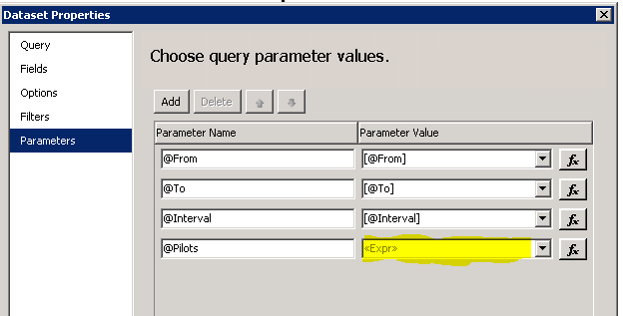
In your query, you can then reference the value like so:
where yourColumn in (@<your param name>)
´´´´´´´´´´´´´´´´´´´´´´´´´´´´´´´´´´´´´´´´´´´´´´´´

SSRS Calling Stored Procedure from Custom Code:

https://social.msdn.microsoft.com/Forums/sqlserver/en-US/cdf290fb-153d-4bc2-8964-8b550df7a087/calling-stored-procedure-from-custom-code?forum=sqlreportingservices

-----------------------
COLLATE – CODEPAGE:
COLLATE DATABASE_DEFAULT

Příklad nápravy relace:
LEFT JOIN iCC_H.dbo.Agent AS A ON WB.Rada COLLATE DATABASE_DEFAULT =SUBSTRING(A.SystemPin,1,1) COLLATE DATABASE_DEFAULT

-------------------------------
SELECT
CONVERT(varchar(50), N'æøåáäĺćçčéđńőöřůýţžš')
COLLATE Cyrillic_General_CI_AI
Current collation:
SELECT CONVERT (varchar, SERVERPROPERTY('collation')) -- SQL_Czech_CP1250_CI_AS
SET Language CZECH
SELECT @@LANGUAGE -– Current Language

Zrychlení dotazů:
http://dev.mysql.com/doc/refman/5.0/en/using-explain.html

SELECT title, excerpt, author FROM wp_posts LIMIT 10;

Změna jména sloupce:
EXEC sp_RENAME 'issue.servicedate' , 'xServiceDate', 'COLUMN'

Spuštění commandu z SQL:
DECLARE @COMMAND nvarchar(4000)
SET @COMMAND = 'net stop <servicename>'
exec master.dbo.xp_cmdshell @COMMAND
https://learn.microsoft.com/en-us/sql/powershell/run-windows-powershell-steps-in-sql-server-agent?view=sql-server-ver16

Příklad MultiStatement function je v CEWE WallBoard_ZC_SL

CREATE FUNCTION [dbo].Multistatement (@type varchar(100))
RETURNS @results TABLE (name sysname)
AS
BEGIN
INSERT @results (name)
SELECT distinct name
FROM sysobjects
WHERE type = @type

RETURN
END
Příklad deklarací, které jsou použity ve výsledném výpočtu:
DECLARE @Redirectors TABLE (Number NVARCHAR(16))
INSERT INTO @Redirectors SELECT Number FROM [iCC].[dbo].[Redirector]
WHERE (DisplayName LIKE 'LE%' AND (@Linky IS NULL OR 'L' IN (select * from FS_Custom.dbo. SplitStringToTable (@Linky, ','))))
OR (DisplayName LIKE 'GAS%'AND (@Linky IS NULL OR 'G' IN (select * from FS_Custom.dbo. SplitStringToTable (@Linky, ','))))

UPDATE table_name
SET column1=value1,column2=value2,...
WHERE some_column=some_value;
Příklad úpravy daty z jiné tabulky:
update icc.dbo.Contact
set Correlation = n.newContactId
from (select jmeno,prijmeni, CisloSmlouvy,Okres,RodneCislo,NewContactId from fs_custom.dbo.NewContact where aktualizace='A') n
where contact.CompanyName=CONVERT(nvarchar(120),n.CisloSmlouvy) /**/

Parametrický list:
DECLARE @list TABLE (Id INT)

INSERT INTO @list(Id)
SELECT 1 UNION ALL SELECT 2 UNION ALL SELECT 3 UNION ALL SELECT 4

SELECT
*
FROM
myTable
JOIN @list l ON myTable.myColumn = l.Id

SELECT
*
FROM
myTable
WHERE
myColumn IN (SELECT Id FROM @list)
DECLARE Employee_Cursor CURSOR FOR
SELECT EmployeeID, Title FROM AdventureWorks2012.HumanResources.Employee;
OPEN Employee_Cursor;
FETCH NEXT FROM Employee_Cursor;
WHILE @@FETCH_STATUS = 0
BEGIN
FETCH NEXT FROM Employee_Cursor;
END;
CLOSE Employee_Cursor;
DEALLOCATE Employee_Cursor;

Export výsledku do txt:
sqlcmd -i c:\sql\myquery.sql -o c:\sql\myoutput.txt
PS:
Invoke-Sqlcmd -InputFile "C:\sql\myquery.sql" | Out-File -filePath "C:\sql\powershelloutput.txt"

Práce se subscription na SSRS:
create view [dbo].[vw_scheduled_Reports]
as
select
Schedule.ScheduleID as SQLAgent_Job_Name, [Catalog].Name as reportname,
Subscriptions.Description as sub_desc,
Subscriptions.DeliveryExtension as sub_delExt,
[catalog].path as reportpath
from reportserver.dbo.reportschedule inner join reportserver.dbo.Schedule
on ReportSchedule.ScheduleID = Schedule.ScheduleID
inner join reportserver.dbo.Subscriptions
on ReportSchedule.SubscriptionID = Subscriptions.SubscriptionID
inner join reportserver.dbo.[Catalog]
on ReportSchedule.ReportID = [Catalog].ItemID
and Subscriptions.Report_OID = [Catalog].ItemID
GO
Third, scheduled a SQL job to run on the desired schedule (in my case M-F 8am-5pm) which executes the following TSQL:
declare @counter int
Set @counter=1
declare @sqlagentjobname uniqueidentifier
declare @reportstable table (sqlagentjobname uniqueidentifier,row int)
insert @reportstable
SELECT SQLAgent_Job_Name, ROW_NUMBER() over (order by reportname) as row
FROM [ReportServer].[dbo].[vw_scheduled_Reports] a
where reportname in
(
'MYREPORTNAME',
'MYOTHERREORTNAME'
)
While @counter <= (select COUNT (*) from @reportstable)
begin
select @sqlagentjobname=sqlagentjobname from @reportstable where row=@counter
exec msdb.dbo.sp_start_job @job_name=@sqlagentjobname
set @counter=@counter+1
end
Seznam uživatelů:
Select UserID, UserName
from ReportServer.dbo.Users
where UserName = 'Domain\DeletedUserID'
Generování příkazů (MAKRO):
SET @QRY ='ALTER DATABASE '+@DBNAME+' SET READ_ONLY WITH NO_WAIT'
EXEC (@QRY)
Tvorba dočasných pracovních tabulek: TEMP
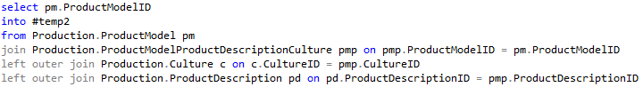
select RecordFileId, OutboundCallId, Max(Score) as Score, Max(CallRecordId) as CallRecordId
into #Candidates
from iCC.dbo.CallRecord
where OutboundCallId IS NOT NULL
group by OutboundCallId, RecordFileId having count(*)>1
select CR.CallRecordId
into #Deleters
from iCC.dbo.CallRecord as CR
inner join #Candidates as C on CR.CallRecordId=C.CallRecordId
where CR.Score=C.Score
drop table #Candidates

Zjišťování stavu SQL Serveru:
- sys.dm_exec_requests
  - Session level only
- sys.dm_os_waiting_tasks
  - Task level
  - Very accurate
  - Transient data
- sys.dm_os_wait_stats
  - Cumulative waits by wait type
  - Persistent data
- Použití: SELECT * FROM sys.dm_exec_requests

TRANSACTIONS:
BEGIN TRY
BEGIN TRANSACTION
INSERT INTO sales.orders…
INSERT INTO sales.orderdetails…
COMMIT TRANSACTION
END TRY
BEGIN CATCH
ROLLBACK TRANSACTION
SELECT ERROR_NUMBER()…
END CATCH
GO
SELECT ContactID
FROM Person.Contact WITH (INDEX(AK_Contact_rowguid),NOLOCK)

Zjištění, který dotaz používá který index:
SELECT
SUBSTRING(sqltext.text, (deqs.statement_start_offset / 2) + 1,
(CASE deqs.statement_end_offset
WHEN -1 THEN DATALENGTH(sqltext.text)
ELSE deqs.statement_end_offset
END - deqs.statement_start_offset) / 2 + 1) AS sqltext,
deqs.execution_count,
deqs.total_logical_reads/execution_count AS avg_logical_reads,
deqs.total_logical_writes/execution_count AS avg_logical_writes,
deqs.total_worker_time/execution_count AS avg_cpu_time,
deqs.last_elapsed_time/execution_count AS avg_elapsed_time,
deqs.total_rows/execution_count AS avg_rows,
deqs.creation_time,
deqs.last_execution_time,
CAST(query_plan AS xml) as plan_xml
FROM
sys.dm_exec_query_stats as deqs
CROSS APPLY
sys.dm_exec_text_query_plan (deqs.plan_handle, deqs.statement_start_offset, deqs.statement_end_offset) as detqp
CROSS APPLY
sys.dm_exec_sql_text(deqs.sql_handle) AS sqltext
WHERE
detqp.query_plan like '%Name of Your Index Here%'
ORDER BY
deqs.last_execution_time DESC
OPTION (MAXDOP 1, RECOMPILE);
V podmínce WHERE nahraďte 'Name of Your Index Here' názvem vašeho indexu

REINDEX DATABASE
USE MyDatabase
GO
EXEC sp_MSforeachtable @command1="print '?' DBCC DBREINDEX ('?', ' ', 80)"
GO
EXEC sp_updatestats
GO
SELECT TOP 1 [ResultData] FROM ICC.[dbo].[MessageEvent] WITH (INDEX(CX_Timelocal)) WHERE TimeLocal>@OneHourAgo AND ResultData='NoTemplate'
Kaskádové volání:
DECLARE @isHol as integer = 0
IF EXISTS((SELECT * FROM
(SELECT TimeFrom AS Start, TimeTo AS MyEnd FROM iCC.dbo.Holiday WHERE HolidayGroupName='OUT_OF_OFFICE' and TimeMode='SingleDay'
UNION
SELECT DATEADD(YEAR,YEAR(GETDATE()) - YEAR(TimeFrom),TimeFrom) AS Start, DATEADD(YEAR,YEAR(GETDATE()) - YEAR(TimeTo),TimeTo) AS MyEnd
FROM iCC.dbo.Holiday WHERE HolidayGroupName='OUT_OF_OFFICE' and TimeMode='DayInYear') AS Holidays
WHERE @MyDatime>=Start and @MyDatime<=MyEnd))
BEGIN
SET @isHol = 1
END
RETURN @isHol
IIF/CASE:
CASE WHEN Podmínka THEN 'Ano' ELSE 'Ne' END
ISDIGIT: ResultText LIKE '%[0-9]%'
SQL Backup:
Novou úlohu je potřeba zakládat přes Wizard:
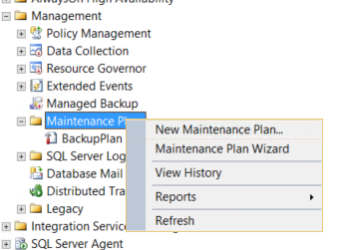

Editaci je možno provádět zde:
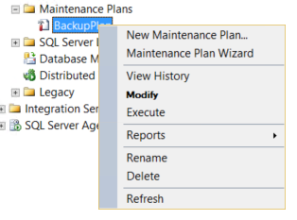
SubPlány je možno kopírovat takto:
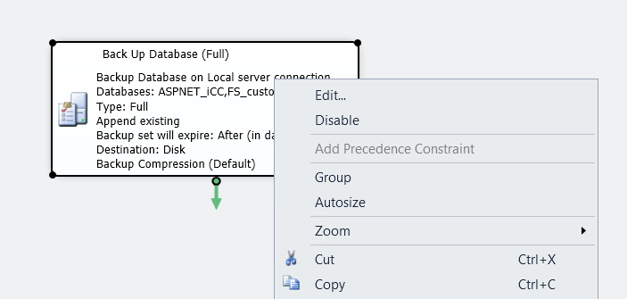

Fulltext indexy (pro FullText vyhledávání):
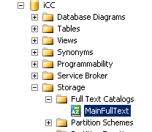
ALTER FULLTEXT CATALOG catalog_name REBUILD
DROP FULLTEXT INDEX ON iCC.dbo.Issue
GO
CREATE FULLTEXT INDEX ON iCC.[dbo].[Issue]
([ResultText] LANGUAGE 0)
KEY INDEX [PK_Issue]
ON [MainFullText];
GO
Použití Fulltext:
SELECT Name, ListPrice
FROM Production.Product
WHERE ListPrice = 80.99
AND CONTAINS(Name, 'Mountain')

SELECT Title
FROM Production.Document
WHERE FREETEXT (Document, 'vital safety components')

Jak zrušit běžící indexaci:
KILL session_ID
Session Id zjistí:
SELECT
r.session_id as SessionID,
r.start_time as StartTime,
r.[status] as Status,
r.wait_type as WaitType,
r.blocking_session_id as BlockedBySessionID,
sessions.login_name as BlockedByUser,
SUBSTRING(qt.[text],r.statement_start_offset / 2,
(CASE
WHEN r.statement_end_offset = -1
THEN LEN(CONVERT(NVARCHAR(MAX), qt.[text])) * 2
ELSE r.statement_end_offset
END - r.statement_start_offset) / 2) AS SQLStatement,
DB_NAME(qt.[dbid]) AS DatabaseName,
r.cpu_time as CPUTime,
r.total_elapsed_time as TotalElapsedTime,
Round(r.total_elapsed_time / 1000.0 / 60.0,1) as TotalElapsedTimeInMinutes,
r.reads as Reads,
r.writes as Write,
r.logical_reads as LogicalReads
FROM sys.dm_exec_requests AS r
OUTER APPLY sys.dm_exec_sql_text(sql_handle) AS qt
LEFT OUTER JOIN sys.dm_exec_sessions sessions ON sessions.session_id = r.blocking_session_id
WHERE r.session_id > 50 -- This eliminates system requests
ORDER BY r.start_time
------------------------------------------------------

Řádky – sloupce (otočí) dělá PIVOT
Test na existenci tabulky:
IF EXISTS (SELECT 1
FROM INFORMATION_SCHEMA.TABLES
WHERE TABLE_TYPE='BASE TABLE'
AND TABLE_NAME='mytablename')

Otevřené případy – dokáže zjišťovat historii otevřenosti
-- OTEVŘENO -----------------------------------------------------------------------
-- Pro otevřené případy musím vygenerovat ještě časovou základnu
-- Případy, u kterých se měnil agent v průběhu kontrolního období
select
--MONTH(e.timeutc) as Cas
ie.timelocal as Cas
--,e.agentid
,AG.displayname as Agent
,0 AS Vytvoreno
,1 AS Otevreno
,0 AS Vraceno
,0 AS Zavreno
--,h.DisplayName as Faze
from
icc.dbo.IssueEvent ie with(nolock)
left join icc.dbo.Issue E with(nolock) on ie.Issueid=e.IssueId
left join icc.dbo.agent AG with(nolock) on AG.agentid=ie.agentid
where (convert(date,ie.timelocal)>=convert(date,@from) and convert(date,ie.timelocal)<=convert(date,@to) and EventType IN ('AgentChange','NewIssue', 'OpenIssue'))
UNION ALL
-- Případy, u kterých se neměnil agent v průběhu kontrolního období, ale byly již otevřené
select
--MONTH(e.timeutc) as Cas
ISNULL(e.closetime,@FROM) as Cas
--,e.agentid
,ISNULL((SELECT TOP 1 AG.displayname FROM icc.dbo.IssueEvent IE2 with(nolock)
left join icc.dbo.agent AG with(nolock) on AG.agentid=ie2.agentid
WHERE ie2.Issueid=e.IssueId and
(convert(date,ie2.timelocal)<=convert(date,@from) and IE2.EventType IN ('AgentChange','NewIssue', 'OpenIssue')) ORDER BY TimeLocal),AG.displayname) as Agent
,0 AS Vytvoreno
,1 AS Otevreno
,0 AS Vraceno
,0 AS Zavreno
--,h.DisplayName as Faze
from
icc.dbo.Issue E with(nolock)
left join icc.dbo.IssueEvent IE with(nolock) on ie.Issueid=e.IssueId and (convert(date,ie.timelocal)>=convert(date,@from) and convert(date,ie.timelocal)<=convert(date,@to) and IE.EventType IN ('AgentChange','NewIssue', 'OpenIssue'))
left join icc.dbo.IssueEvent IE2 with(nolock) on ie2.Issueid=e.IssueId and (convert(date,ie.timelocal)<=convert(date,@from) and IE2.EventType IN ('AgentChange','NewIssue', 'OpenIssue'))
left join icc.dbo.agent AG2 with(nolock) on AG2.agentid=ie2.agentid
left join icc.dbo.agent AG with(nolock) on AG.agentid=e.agentid
where (convert(date,e.timeUTC)<=convert(date,@FROM) and convert(date,e.Closetime)>=convert(date,@FROM)) and ie.TimeLocal IS NULL

245 044 490
Toto vrací dbo:
SELECT USER_NAME()
SELECT CURRENT_USER
SELECT SESSION_USER
Toto vrací Windows Logon: SUSER_NAME()

Správný test na existenci ##TEMP Table:
IF OBJECT_ID(N'tempdb..##TEMP', N'U') IS NOT NULL
DROP TABLE ##TEMP

Načtení ze souboru:
BULK INSERT FS_custom.dbo.Whitelist FROM 'C:\Atlantis-install\VYVOJ\vkladani-kontaktu.csv' WITH (
FIRSTROW = 2,
FIELDTERMINATOR = ';',
ROWTERMINATOR = '\n',
TABLOCK,
CODEPAGE = '1250',
ERRORFILE = 'C:\Atlantis-install\Vyvoj\vkladani-kontaktu.err')

