SELECT DB_NAME(database_id) , is_read_committed_snapshot_on , snapshot_isolation_state_desc ,* FROM sys.databases --WHERE database_id = DB_ID();

Např. na našem demu, to na ICC máme
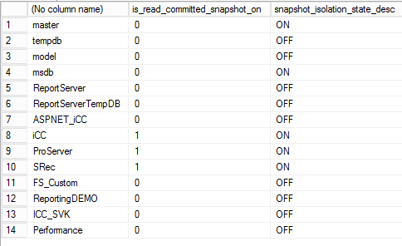

Tohle když spustíš nad tempdb, tak ti zjistí kolik místa to verzování (version_store, co děla snaphost isolation, zabírá. Ale časem se mění

SELECT SUM(user_object_reserved_page_count) * 8 / 1024.0 / 1024.0 AS user_obj_GB
, SUM(internal_object_reserved_page_count) * 8 / 1024.0 / 1024.0 AS internal_obj_GB
, SUM(version_store_reserved_page_count) * 8 / 1024.0 / 1024.0 AS version_store_GB
, SUM(unallocated_extent_page_count) * 8 / 1024.0 / 1024.0 AS freespace_GB
, SUM(mixed_extent_page_count) * 8 / 1024.0 / 1024.0 AS mixedextent_GB
FROM sys.dm_db_file_space_usage

