Rady jak na SQL: https://ola.hallengren.com/
------------
If you tried to shrink the temps db with DBCC freeprocahce() or DBCC dropcleanbuffer(), then this will clear the cache and might be showing the some buffer pool , but this will impact your application performance because its will clear the cache.

DBCC FREEPROCCACHE
DBCC DROPCLEANBUFFERS

DBCC FREEPROCCACHE

USE [tempdb]
GO
DBCC SHRINKFILE (N'tempdev' , 2048)
GO
Microsoft:
I don’t recommend running the below scripts on the production server. please refer the below articles for your reference.

https://docs.microsoft.com/en-us/sql/t-sql/database-console-commands/dbcc-freeproccache-transact-sql?view=sql-server-2017
https://docs.microsoft.com/en-us/sql/t-sql/database-console-commands/dbcc-dropcleanbuffers-transact-sql?view=sql-server-2017
https://www.sqlshack.com/handling-excessive-sql-server-pageiolatch_sh-wait-types/

----------------
Pomáhá shodit zavazbený proces
Takhle je v současnosti využíván podle systémového pohledu : sys.dm_os_buffer_descriptors

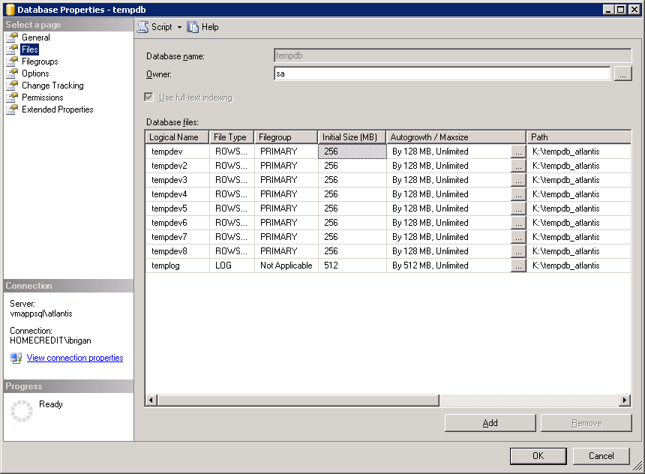

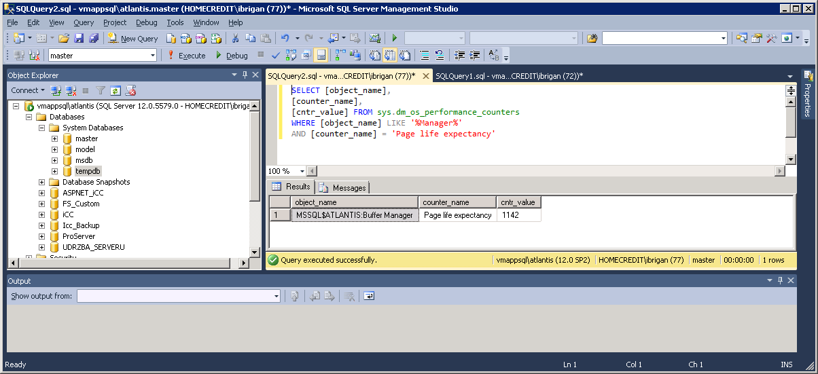
SELECT Object_name, counter_Name, cntr_value FROM sys.dm_os_performance_counters
WHERE counter_name='page life expectancy'
PLE < 300 je asi špatně.

Podle počtu procesorů nastavit:
