Compartment-Specific miR-98-5p Biology and Potential TNFAIP3/A20 Regulatory Decoupling in IgA Nephropathy

An Evidence-Constrained Conditional Mechanistic Hypothesis

Abstract
IgA nephropathy (IgAN) includes peripheral IgA source biology and renal resident-cell injury, which need not share the same miR-98-5p behavior. Peripheral IgAN evidence indicates that miR-98-5p is increased in peripheral blood mononuclear cells and participates in a CCL3/IL-6/C1GALT1-associated glycosylation pathway; it therefore does not justify indiscriminate systemic miR-98-5p augmentation. Conversely, a lupus-nephritis-context study combining human renal-tissue observations with functional experiments in a human mesangial IP15 cell line shows that miR-98-5p can suppress BACH1, BACH1-associated NF-kappaB/p65 activity, proliferation, and IL-6/TNF-alpha output. This does not establish an IgAN renal miR-98-5p deficiency or a renal benefit. Gate 0A maps phenotype and Gate 0C explores biogenesis, but Gate 0B is the actual go/no-go actionability test: whether increasing mature miR-98-5p produces a reproducible desired effect in an IgAN-relevant human renal context. A negative Gate 0B terminates the augmentation strategy. Only after a positive Gate 0B do Gates A-C address the unresolved miR-98-5p to TNFAIP3/A20 interaction, the functional consequence of A20 loss, and selective target-site protection. The renal rationale is cross-disease and context-limited; no therapeutic efficacy is established.
Keywords: IgA nephropathy; miR-98-5p; TNFAIP3; A20; mesangial cell; compartment-specific biology; regulatory decoupling; hypothesis.

1. Introduction
Human in-vitro studies retained in the frozen record show that aberrantly glycosylated IgA1 can induce mesangial platelet-activating-factor production and that mesangial-derived TNF-alpha can activate tubular epithelial cells in IgA nephropathy [1,2]. The aberrantly glycosylated-IgA1 study also supports a constrained mesangial-to-podocyte injury bridge, although mediator certainty remains specific to the reported experimental system [1]. These observations establish renal inflammatory relevance but do not show that inflammation persists after source control or identify a patient-specific therapeutic niche.
miRNAs are attractive but difficult regulatory candidates because one mature miRNA can affect multiple transcripts. In DAKIKI cells, a human IgAN B-lymphoblast surrogate, miR-98-5p directly regulates C1GALT1 and is associated with an IgA1 glycosylation phenotype [3]. This observation does not establish mature plasma-cell biology, a renal miR-98 phenotype, or a renal therapeutic effect.
The rationale for examining miR-98-5p is compartment-specific rather than based on an established systemic deficiency. In IgAN peripheral blood mononuclear cells (PBMCs), miR-98-5p was reported to be higher than in controls and was directly linked by reporter and perturbation evidence to CCL3; the study reported a CCL3-associated IL-6/C1GALT1 pathway [7]. These PBMC findings caution against assuming that systemic augmentation is beneficial. They must not be transferred to renal resident cells.
In contrast, a lupus-nephritis-context study reported lower miR-98-5p in human lupus-nephritis renal tissue and performed functional experiments in the human mesangial IP15 cell line. In IP15 cells, miR-98-5p mimic/inhibitor perturbations changed BACH1, proliferation, and secretion of IL-6 and TNF-alpha; a wild-type/mutant reporter supported BACH1 targeting. BACH1 gain/loss altered p-p65, and the NF-kappaB inhibitor BAY11-7082 functionally reduced BACH1-overexpression-associated responses [8]. This is human mesangial cell-line evidence from a different disease context, not primary IgAN mesangial cells or IgAN immune-complex stimulation. It provides a reason to test a renal-localized effect, not evidence that IgAN kidneys are deficient in miR-98-5p or that augmentation is beneficial.
TNFAIP3/A20 is an endogenous, context-dependent inflammatory brake. In LPS-stimulated mouse macrophages, miR-98-5p perturbation was linked to TNFAIP3 and NF-kappaB readouts [4]. In IL-1-stimulated human mesangial cells, A20 overexpression reduced ERK, JNK, and p38 phosphorylation, but this stimulus-specific observation does not establish A20 function during IgAN-related immune-complex stimulation [5]. The potential miR-98-5p to A20 interaction remains unresolved in relevant human renal cells.
The resulting architecture has two nested forms of regulatory decoupling. First, peripheral/systemic miR-98-5p biology is separated from renal resident-cell biology. Second, only if a desired renal miR-98-5p program is demonstrated and simultaneously suppresses A20 should selective TNFAIP3 target-site protection be tested. No validated protector, sequence, delivery method, or treatment is proposed.

2. Methods

2.1 Study design and scope
This study is a directed mechanistic evidence synthesis and context-aware multicellular reconstruction. It is not a systematic review, a validated digital twin, a pharmacologic simulation, or a clinical prediction study. The objective was to assess mechanistic compatibility, expose context gaps, and define experiments that can discriminate among the central hypotheses.

2.2 Evidence provenance and V1.7 targeted audit
The V1.0 frozen evidence library was retained, and the V1.7 update added a targeted primary-literature audit of IgAN PBMC miR-98-5p evidence, lupus nephritis renal/human mesangial evidence, SLE PBMC IL-6/STAT3 evidence, and Lin28/miR-98 biogenesis evidence. Primary-source metadata and full text where accessible were checked for disease, species, cell type, perturbation, endpoint, directness, DOI, and PMID. Reviews were not used to upgrade causal evidence.

2.3 Evidence grades, transfer rules, and Gate 0
Direct denotes experimental support in the specified source context. Cross-context denotes direct or functional support in a different disease, cell type, species, or stimulus. Hypothesis denotes a proposed but untested relation or design. Unresolved denotes absent qualifying evidence in the required context. Peripheral immune cell is not renal resident cell; lupus nephritis renal evidence is not IgAN renal evidence; a human mesangial IP15 cell line is not a primary IgAN mesangial cell; mouse macrophage is not human mesangial cell; IL-1-stimulated mesangial cell is not IgAN immune-complex-stimulated mesangial cell; DAKIKI is not a mature plasma cell; and mesangial biology is not copied to podocytes. Gate 0A maps phenotype and Gate 0C explores upstream biogenesis; neither is required for Gate 0 passage. Gate 0B is the proposed experimental go/no-go discrimination step.

2.4 Negative evidence, modularity, and reconstruction output
Failure to locate qualifying exact-context evidence was recorded as unresolved rather than biological absence. Separate modules were retained for Lin28/miR-98 processing, miR-98/BACH1, miR-98/IL-6/STAT3, and miR-98/A20; they were not combined into one established IgAN pathway. The reconstruction is an evidence-constrained multicellular mechanistic reconstruction, referred to here as a digital-cell framework. It is not a calibrated dynamical system, a patient-specific digital twin, or an efficacy estimator.

2.5 Claim freeze and availability
Supporting evidence matrices, context-grading rules, methodological provenance, conceptual figures, and reproducibility materials associated with this work are publicly available on Zenodo at https://doi.org/10.5281/zenodo.22686376 and on GitHub at https://github.com/zhongguozhang/IgAN-miR98-A20-regulatory-decoupling. The repository does not claim verified execution provenance for historical development-stage analysis scripts; such scripts are therefore not presented as code used to generate the manuscript results. OpenAI ChatGPT and OpenAI Codex assisted evidence organization, computational workflow scaffolding, manuscript structuring, drafting, and language refinement. The author reviewed and edited outputs, verified the primary-source evidence supporting manuscript claims, approved evidence classifications and interpretations, and takes responsibility for the final manuscript.

3. Results

3.1 Evidence-constrained renal architecture
The frozen human literature supports a constrained mesangial-to-podocyte bridge after aberrantly glycosylated IgA1 stimulation [1] and mesangial-derived TNF-alpha communication with tubular epithelial cells in IgA nephropathy [2]. This establishes downstream multicellular relevance only. No podocyte miR-98-5p or A20 mechanism is proposed here.

3.2 Compartment-specific miR-98-5p evidence supports testing, not assuming, a renal augmentation strategy
The literature supports compartment divergence, not systemic miR-98-5p deficiency. Exact-disease peripheral evidence places increased miR-98-5p in IgAN PBMCs within a CCL3/IL-6/C1GALT1-associated pathway [7]. A lupus-nephritis-context study combined lower miR-98-5p in human renal tissue with functional experiments in a human mesangial IP15 cell line, where miR-98-5p perturbation inhibited BACH1-associated p65 activity, proliferation, and inflammatory outputs [8]. The two observations cannot be merged into a unified causal chain. IgAN renal mature miR-98-5p level is unresolved.

3.3 Gate 0: renal miR-98-5p actionability
Gate 0A asks whether mature miR-98-5p is altered in IgAN glomerular tissue with glomerular or mesangial localization where possible; whole-kidney averages alone are insufficient. Gate 0A is informative but is not required to be positive: a normal endogenous level does not establish that additional mature miR-98-5p lacks pharmacological activity. Gate 0B is the true go/no-go criterion and asks whether experimentally increasing mature miR-98-5p produces a reproducible desired effect in primary human mesangial cells under an IgAN-relevant immune-complex stimulus. Pre-specified readouts can include BACH1, p65-related activity, IL-6, TNF-alpha, proliferation, and other injury readouts. They need not move together. Gate 0C is exploratory: LIN28-mediated processing is not required for Gate 0 passage. Lin28 is an established inhibitor of let-7-family biogenesis [10]. In a neural differentiation system, Lin28 was further shown to bind pri- and pre-miR-98 and inhibit miR-98 processing at the cropping step [11]. Whether an analogous mechanism occurs in IgAN renal cells is unknown. Measurements of pri-, pre-, and mature miR-98 alongside LIN28A/B would refine interpretation but are not prerequisites for Gate 0 passage.

3.4 What is supported for A20
Mouse macrophage data support miR-98-5p-associated TNFAIP3 and NF-kappaB regulation in that cross-context system [4]. Human mesangial evidence supports reduced ERK, JNK, and p38 phosphorylation after A20 overexpression under IL-1 stimulation [5]. These observations justify testing, but do not establish, whether A20 functionally constrains IgAN-relevant immune-complex-induced signaling in primary human mesangial cells. A20 is not presumed to regulate NF-kappaB and all MAPK branches simultaneously.

3.5 The critical unresolved miR-98-5p-A20 edge
Mouse RAW264.7 macrophage data report miR-98-5p perturbation, TNFAIP3 direction, and a dual-luciferase test [4]. A separate HEK293T reporter record concerns let-7a/e rather than miR-98-5p and cannot fill that identity gap [6]. Thus, miR-98-5p-TNFAIP3/A20 is direct cross-context partial support and remains unresolved in human IgAN mesangial cells. It is not presented as an established IgAN mechanism.

3.6 Conditional regulatory trade-off and hypothesis discriminability
The target-protection rationale requires a conditional sequence. Gate 0 passes only with a positive Gate 0B: a reproducible desired renal miR-98-5p effect in an IgAN-relevant context. Gate 0A and Gate 0C are auxiliary phenotype-mapping and biogenesis modules. After positive Gate 0B, Gate A asks whether mature miR-98-5p directly regulates TNFAIP3/A20 there using mimic/inhibitor perturbation, wild-type and mutant 3-prime UTR reporters, and RNA/protein readouts. If Gate A is positive, Gate B asks whether A20 functionally constrains IgAN-relevant immune-complex-induced signaling in primary human mesangial cells using gain, loss, and rescue. Testing target-site protection at Gate C is justified only after positive Gates 0B, A, and B. A positive Gate C may support further proof-of-concept development; a negative Gate C ends the decoupling implementation. A negative Gate 0B terminates the renal augmentation strategy, a negative Gate A removes the protector rationale, and a negative Gate B removes functional justification. No negative outcome may be reinterpreted merely to preserve the hypothesis.

4. Discussion
This manuscript identifies a conditional regulatory conflict rather than an effective therapy. The premise is not that IgAN has a proven renal miR-98-5p deficiency. It is that miR-98-5p may behave differently across peripheral and renal compartments, and this difference can be experimentally tested.
Why consider renal rather than systemic miR-98-5p augmentation? There is no established systemic or renal miR-98-5p deficiency in IgAN. Peripheral IgAN PBMC evidence makes indiscriminate systemic augmentation biologically questionable [7]. In contrast, the lupus-nephritis-context study combines human renal-tissue observation with a human mesangial IP15 cell-line functional rationale: miR-98-5p perturbation changed BACH1-associated p65 activity and inflammatory outputs [8]. This transfer is provisional and is not a therapeutic claim. Gate 0B, not Gate 0A, determines whether there is an actionable renal phenotype in IgAN. A negative Gate 0B terminates the entire renal augmentation design; a normal or negative Gate 0A does not by itself do so.
Why protect A20 rather than not use miR-98-5p? A20 protection is downstream of Gate 0B, not an independent justification to augment miR-98-5p. There is no rationale for a protector unless a desired renal miR-98 effect exists, miR-98 directly lowers A20 in that context, and A20 loss is functionally unfavorable. Thus, positive Gates 0B, A, and B are prerequisites to testing target-site protection at Gate C. If Gate 0B is positive and Gate A is negative, renal miR-98 may remain of interest but TNFAIP3-specific protection is unnecessary. If Gate A is positive and Gate B is negative, an interaction may exist but protection lacks functional justification. If Gate C is negative, the decoupling implementation fails.
LIN28-mediated suppression of miR-98/let-7-family biogenesis is a biologically plausible upstream mechanism, not a confirmed IgAN mechanism. Lin28 is an established inhibitor of let-7-family biogenesis [10]. In a neural differentiation system, Lin28 was further shown to bind pri- and pre-miR-98 and inhibit miR-98 processing at the cropping step [11]. Whether an analogous mechanism occurs in IgAN renal cells is unknown. Pri-, pre-, and mature miR-98 measurements together with LIN28A/B, followed by perturbation and rescue if warranted, are required before attributing an IgAN renal phenotype to altered processing.
The SLE PBMC study provides a separate cross-context module in which miR-98 directly targets IL-6 and changes STAT3 phosphorylation through IL-6; it does not support STAT3 as a direct miR-98 target [9]. The Lin28, BACH1, IL-6/STAT3, and A20 modules must remain separately graded. Combining them as an exact IgAN renal pathway would exceed the evidence.
The reconstruction contributes by recording context, preventing automatic cross-compartment copying, and defining stop rules before resources are invested in an unvalidated target-site protector. It does not predict efficacy. The S-I-R framework remains conceptual and unvalidated; source, intrarenal inflammatory activity, and recoverable structural reserve cannot currently be linked at the patient level. No claim is made that inflammation persists after source control, that fibrosis can be reversed, or that glucocorticoids can be replaced.

5. Conclusion
miR-98-5p biology may differ between peripheral and renal compartments in IgAN. Available evidence does not establish renal miR-98-5p deficiency in IgAN. Gate 0 passes only if Gate 0B demonstrates a reproducible desired renal effect in an IgAN-relevant human context; Gate 0A and Gate 0C are not required prerequisites. Testing TNFAIP3 target-site protection at Gate C is justified only after positive Gates 0B, A, and B; further development of the regulatory-decoupling strategy requires a positive Gate C. This work does not establish therapeutic efficacy, fibrosis reversal, clinical benefit, or a validated target protector.

Figure 1. Compartment-specific gate architecture
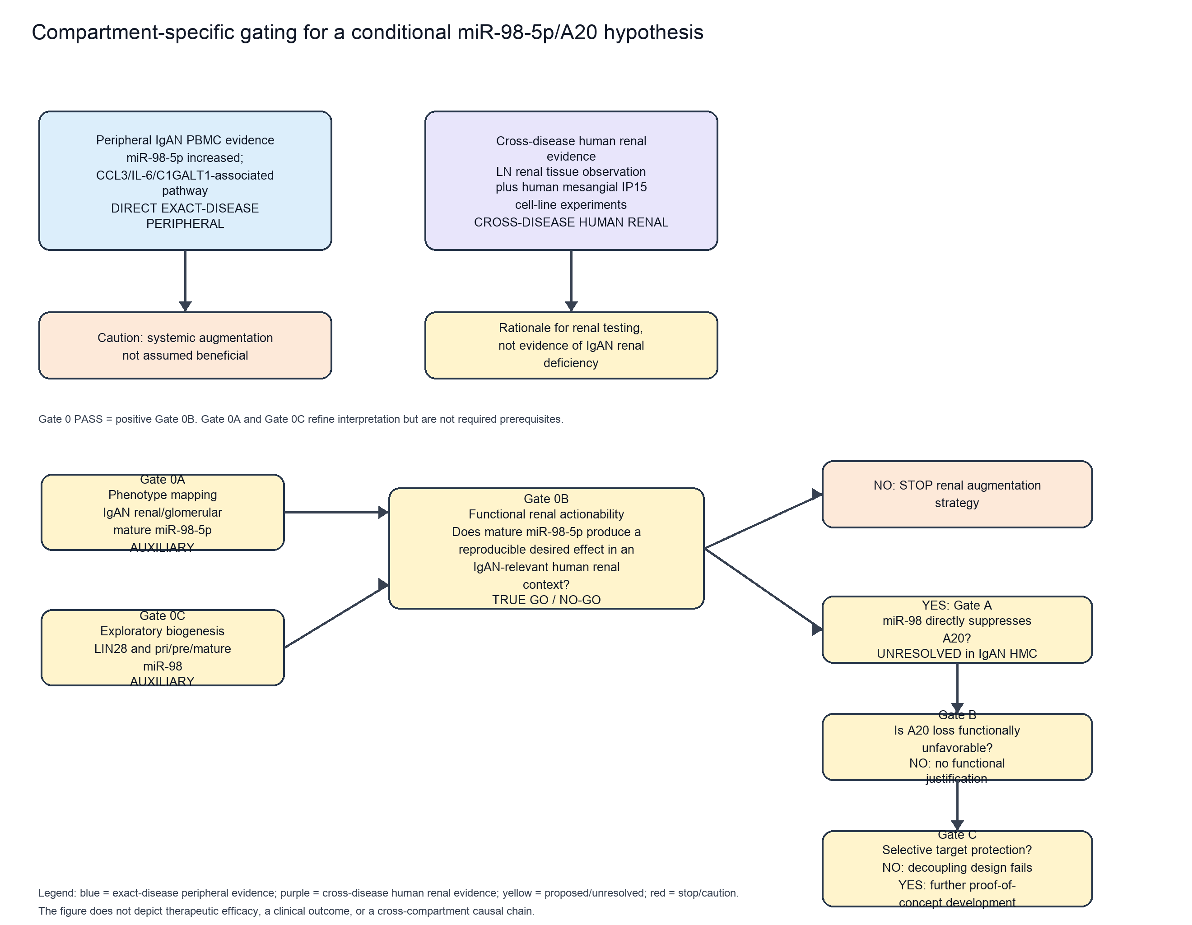
Figure 1. Exact-disease peripheral IgAN PBMC evidence and cross-disease human renal evidence are presented as separate contexts. Gate 0A maps renal phenotype and Gate 0C explores biogenesis; both are auxiliary to Gate 0B, the true functional go/no-go actionability test. Positive Gates 0B, A, and B justify testing target-site protection at Gate C. Gate C is a separate selective-decoupling test. Colors distinguish direct exact-disease peripheral evidence, cross-disease human renal evidence, and unresolved/proposed steps. The figure does not depict efficacy or clinical prediction.

Declaration of generative AI and AI-assisted technologies in the manuscript preparation process
During the preparation of this work, the author used OpenAI ChatGPT and OpenAI Codex to assist with evidence organization, computational workflow scaffolding, manuscript structuring, drafting, and language refinement. The author reviewed and edited the outputs, verified the primary-source evidence used to support manuscript claims, approved the final evidence classifications and interpretations, and takes full responsibility for the content of the publication.

References
Coppo R, Fonsato V, Balegno S, Ricotti E, Loiacono E, Camilla R, Peruzzi L, Amore A, Bussolati B, Camussi G. Aberrantly glycosylated IgA1 induces mesangial cells to produce platelet-activating factor that mediates nephrin loss in cultured podocytes. Kidney International. 2010;77(5):417-427. doi:10.1038/ki.2009.473. PMID:20016469.
Chan LYY, Leung JCK, Tsang AWL, Tang SCW, Lai KN. Activation of tubular epithelial cells by mesangial-derived TNF-alpha: Glomerulotubular communication in IgA nephropathy. Kidney International. 2005;67(2):602-612. doi:10.1111/j.1523-1755.2005.67116.x. PMID:15673307.
Liu C, Li X, Shuai L, Dang X, Peng F, Zhao M, Xiong S, Liu Y, He Q. Astragaloside IV inhibits galactose-deficient IgA1 secretion via miR-98-5p in pediatric IgA nephropathy. Frontiers in Pharmacology. 2021;12:658236. doi:10.3389/fphar.2021.658236. PMID:33935780.
Wu J, Chen X, Pan N, Chen B, Zhang J, Liu Z. 3beta-Hydroxycholest-5-en-7-one from seahorse alleviates lipopolysaccharide-induced inflammatory responses by downregulating miR-98-5p. Life Sciences. 2020;258:118176. doi:10.1016/j.lfs.2020.118176. PMID:32771556.
Luo H, Liu Y, Li Q, Liao L, Sun R, Liu X, Jiang M, Hu J. A20 regulates IL-1-induced tolerant production of CXC chemokines in human mesangial cells via inhibition of MAPK signaling. Scientific Reports. 2015;5:18007. doi:10.1038/srep18007. PMID:26648169.
Liu J, Zhu L, Xie GL, Bao JF, Yu Q. Let-7 miRNAs modulate the activation of NF-kappaB by targeting TNFAIP3 and are involved in the pathogenesis of lupus nephritis. PLOS ONE. 2015;10(6):e0121256. doi:10.1371/journal.pone.0121256. PMID:26110642.
Liu D, Xia M, Liu Y, Tan X, He L, Liu Y, Chen G, Liu H. The upregulation of miR-98-5p affects the glycosylation of IgA1 through cytokines in IgA nephropathy. International Immunopharmacology. 2020;82:106362. doi:10.1016/j.intimp.2020.106362. PMID:32126510.
Du Y, Shi X, Li J, Jia Y. MicroRNA-98-5p inhibits human mesangial cell proliferation and TNF-alpha and IL-6 secretion by targeting BTB and CNC homology 1. Experimental and Therapeutic Medicine. 2021;22(6):1436. doi:10.3892/etm.2021.10871. PMID:34721678.
Yuan S, Tang C, Chen D, Li F, Huang M, Ye J, He Z, Li W, Chen Y, Lin X, Wang X, Cai X. miR-98 modulates cytokine production from human PBMCs in systemic lupus erythematosus by targeting IL-6 mRNA. Journal of Immunology Research. 2019;2019:9827574. doi:10.1155/2019/9827574. PMID:31886314.
Viswanathan SR, Daley GQ, Gregory RI. Selective blockade of microRNA processing by Lin28. Science. 2008;320(5872):97-100. doi:10.1126/science.1154040. PMID:18292307.
Kawahara H, Okada Y, Imai T, Iwanami A, Mischel PS, Okano H. Musashi1 cooperates in abnormal cell lineage protein 28 (Lin28)-mediated let-7 family microRNA biogenesis in early neural differentiation. Journal of Biological Chemistry. 2011;286(18):16121-16130. doi:10.1074/jbc.M110.199166. PMID:21378162.

