

Answer:

If no setter or getter for an instance variable in a class, you can’t get access or modify instance values when you call this class



Answer:

We can “new” the scanner function with its fully qualified name (java.util.Scanner), and then we can use it same as we import it



Answer:

withDraw method

public void withDraw(double *withDrawAmount*) {  
  
 if (*withDrawAmount* > balance) {  
 System.*out*.println(**"Withdrawal amount exceeded account balance"**);  
  
 }  
 else {  
 balance = balance - *withDrawAmount*;  
 }  
}

test code:

public class Test {  
 public static void main(String[] *args*) {  
 Account account1 = new Account(**"Zhonghua Zhang"**, 100.01);  
  
 *// display initial balance of account 1* System.*out*.printf(**"%s balance: $%.2f%n"**,  
 account1.getName(), account1.getBalance());  
  
 *// create a Scanner to obtain input from the command window* Scanner input = new Scanner(System.*in*);  
  
 System.*out*.print(**"Enter withdraw amount for account1: "**); *// prompt* double withDrwaAmount = input.nextDouble(); *// obtain user input* System.*out*.printf(**"%nremoving %.2f from account1 balance%n%n"**,  
 withDrwaAmount);  
  
  
 account1.withDraw(withDrwaAmount);  
 *// minus withdraw amount from balance  
  
  
 // display balances* System.*out*.printf(**"%s balance: $%.2f%n"**,  
 account1.getName(), account1.getBalance());  
 }  
}

Result:

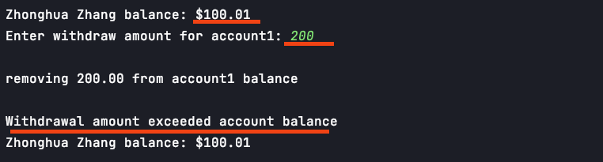



**Question 4:**

Display an account’s information code:

public static void displayAccount(Account *AccountToDisplay*){  
 System.*out*.printf(**"%s balance: $%.2f%n"**,  
 *AccountToDisplay*.getName(),*AccountToDisplay*.getBalance());  
}

call the method code:

*displayAccount*(account1);  
*displayAccount*(account2);

result:

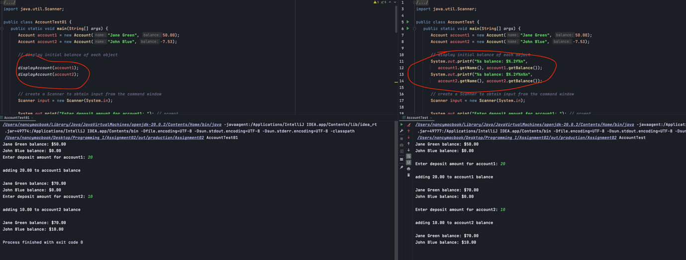

**Question 5**

Car class

public class Car {  
 String model;  
 int year;  
 double price;  
  
  
 public void discount(double *discount*){  
  
 price = price * (1 - *discount*/100);  
  
 }  
  
 public Car(String *model*, int *year*, double *price*) {  
 this.model = *model*;  
 this.year = *year*;  
 if (*price* > 0.0) {  
 this.price = *price*;  
 } else {  
 System.*out*.println(**"Car:"** + this.model + **"---invalid car price"**);  
 }  
  
 }  
  
  
 public String getModel() {  
 return model;  
 }  
  
 public void setModel(String *model*) {  
 this.model = *model*;  
 }  
  
 public int getYear() {  
 return year;  
 }  
  
 public void setYear(int *year*) {  
 this.year = *year*;  
 }  
  
 public double getPrice() {  
 return price;  
 }  
  
 public void setPrice(double *price*) {  
 this.price = *price*;  
 }  
}

**test code:**

public class CarTest {  
 public static void main(String[] *args*) {  
 Car car1 = new Car (**"ToyotaCamry"**, 2020, 30000);  
 Car car2 = new Car(**"HondaCivic"**, 2019, 25000);  
 *displayCarInfo*(car1);  
 *displayCarInfo*(car2);  
  
 System.*out*.println(**"Applying discounts..."**);  
  
 car1.discount(5);  
 System.*out*.printf(**"Car1 - New Price: $%.2f%n"**, car1.getPrice());  
  
 car2.discount(7);  
 System.*out*.printf(**"Car2 - New Price: $%.2f%n"**, car2.getPrice());  
 }  
  
 public static void displayCarInfo(Car *displayCar*){  
 System.*out*.printf(**"Model:%s Year:%s Price:$%.2f%n"**,  
 *displayCar*.getModel(),*displayCar*.getYear(),*displayCar*.getPrice());  
 }  
}

**result :**

