Question 1

if (x > 5) **{**  
  
 if (y > 5) **{**  
 System.*out*.println(**"x and y are > 5"**);  
 **}**  
}   
else   
 System.*out*.println(**"x is <= 5"**);

Question 2

Part a

if (x < 10){  
 if (y > 10)  
 System.*out*.println(**"*****"**);  
 else  
 System.*out*.println(**"#####"**);  
}  
System.*out*.println(**"$$$$$"**);

Part b

if (x < 10) {  
 if (y > 10)  
 System.*out*.println(**"*****"**);  
}  
else {  
 System.*out*.println(**"#####"**);  
 System.*out*.println(**"$$$$$"**);  
}

Question 3

Main class

public class question03 {  
 public static void main(String[] *args*) {  
  
*// Mosis Abhenry, earning 150,000 Euros,  
// Marium Essa, earning 70,000 Euros,  
// Abrahim Rai, earning 30,000 Euros* Scanner scanner = new Scanner(System.*in*);  
  
 System.*out*.println(**"Enter citizen-1 name:"**);  
 String name1 = scanner.nextLine();  
 System.*out*.println(**"Enter citizen-1 earning:"**);  
 int earning1 = scanner.nextInt();  
 scanner.nextLine();  
*// get citizen1's information: name & earning* System.*out*.println(**"Enter citizen-2 name:"**);  
 String name2 = scanner.nextLine();  
 System.*out*.println(**"Enter citizen-2 earning:"**);  
 int earning2 = scanner.nextInt();  
 scanner.nextLine();  
*// get citizen2's information: name & earning* System.*out*.println(**"Enter citizen-3 name:"**);  
 String name3 = scanner.nextLine();  
 System.*out*.println(**"Enter citizen-3 earning:"**);  
 int earning3 = scanner.nextInt();  
 scanner.nextLine();  
*// get citizen3's information: name & earning* Account account1 = new Account(name1, earning1);  
 Account account2 = new Account(name2, earning2);  
 Account account3 = new Account(name3, earning3);  
*// create 3 account instances* double tax1 = *taxCalculation*(account1.getEarnings());  
 double tax2 = *taxCalculation*(account2.getEarnings());  
 double tax3 = *taxCalculation*(account3.getEarnings());  
  
  
 System.*out*.printf(**" Name: %s Earning: %s Tax:%s%n "**,  
 account1.getName(), account1.getEarnings(), tax1);  
 System.*out*.printf(**"Name: %s Earning: %s Tax:%s%n "**,  
 account2.getName(), account2.getEarnings(), tax2);  
 System.*out*.printf(**"Name: %s Earning: %s Tax:%s%n"**,  
 account3.getName(), account3.getEarnings(), tax3);  
 }  
  
 public static double taxCalculation(double *earnings*) {  
  
 if (*earnings* < 30000){  
 return *earnings* * 0.15;  
 }  
 else {  
 return (30000 * 0.15) + ((*earnings* - 30000) * 0.2);  
 }  
  
*// earnings < 30000 ?  
// return earnings * 0.15;  
// return (earnings * 0.15) + ((earnings - 30000) * 0.2);* }  
}

Account class

public class Account {  
  
 String name;  
 double earnings;  
  
 public Account(String *name*, double *earnings*) {  
 this.name = *name*;  
 this.earnings = *earnings*;  
  
 }  
  
  
 public String getName() {  
 return name;  
 }  
  
 public void setName(String *name*) {  
 this.name = *name*;  
 }  
  
 public double getEarnings() {  
 return earnings;  
 }  
  
 public void setEarnings(double *earnings*) {  
 this.earnings = *earnings*;  
 }  
}

Result

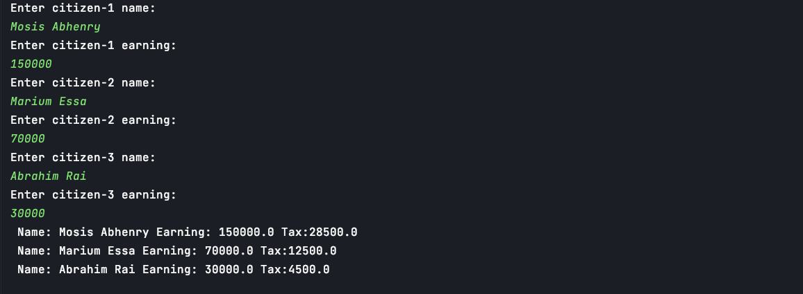

Question 4

Main class

public class CreditLimitCalculator {  
 public static void main(String[] *args*) {  
 Scanner input = new Scanner(System.*in*);  
  
 int newBalance;  
  
 System.*out*.println(**"Enter account number:"**);  
 int accountNumber = input.nextInt();  
 input.nextLine();  
*// input account number* System.*out*.println(**"Enter balance at the beginning of the month: "**);  
 int startBalance = input.nextInt();  
 input.nextLine();  
*// balance at the beginning of the month* System.*out*.println(**"Enter total of all items charges by the customers this month: "**);  
 int totalCharges = input.nextInt();  
 input.nextLine();  
*// total of all items charges by the customers this month* System.*out*.println(**"Enter total of all credits applied to the customer’s account this month: "**);  
 int allCredits = input.nextInt();  
 input.nextLine();  
*// total of all items charges by the customers this month* System.*out*.println(**"Enter allowed credit limit.: "**);  
 int allowedCredit = input.nextInt();  
 input.nextLine();  
*// total of all items charges by the customers this month* Account account1 = new Account(accountNumber, startBalance, totalCharges, allCredits, allowedCredit);  
*//  
  
// newBalance = startBalance - totalCharges - allCredits;  
//  
// if (newBalance >= allowedCredit){  
// System.out.println("Account :" + account1.getAccountNumber() + "---new balance:" + newBalance);  
// }  
// else {  
// System.out.println("Credit limit exceeded");  
// }* if (*balance*(startBalance,totalCharges,allCredits,allowedCredit) != -1){  
 System.*out*.println(**"Account :"** + account1.getAccountNumber() + **"--- new balance: "** + *balance*(startBalance,totalCharges,allCredits,allowedCredit));  
 }  
 else {  
 System.*out*.println(**"Credit limit exceeded"**);  
  
 }  
  
 }  
  
  
 public static int balance(int *startBalance*, int *totalCharges*, int *allCredits*, int *allowedCredit*){  
  
 if (*startBalance* - *totalCharges* - *allCredits* >= *allowedCredit*)  
 return *startBalance* - *totalCharges* - *allCredits*;  
 else  
 return -1 ;  
  
  
 }  
}

class Account

public class Account {  
 int accountNumber;  
 int startBalance;  
 int totalCharges;  
 int allCredits;  
 int allowedCredit;  
  
  
  
 public int getAccountNumber() {  
 return accountNumber;  
 }  
  
 public void setAccountNumber(int *accountNumber*) {  
 this.accountNumber = *accountNumber*;  
 }  
  
 public int getStartBalance() {  
 return startBalance;  
 }  
  
 public void setStartBalance(int *startBalance*) {  
 this.startBalance = *startBalance*;  
 }  
  
 public int getTotalCharges() {  
 return totalCharges;  
 }  
  
 public void setTotalCharges(int *totalCharges*) {  
 this.totalCharges = *totalCharges*;  
 }  
  
 public int getAllCredits() {  
 return allCredits;  
 }  
  
 public void setAllCredits(int *allCredits*) {  
 this.allCredits = *allCredits*;  
 }  
  
 public int getAllowedCredit() {  
 return allowedCredit;  
 }  
  
 public void setAllowedCredit(int *allowedCredit*) {  
 this.allowedCredit = *allowedCredit*;  
 }  
  
 public Account(int *accountNumber*, int *startBalance*, int *totalCharges*, int *allCredits*, int *allowedCredit*) {  
 this.accountNumber = *accountNumber*;  
 this.startBalance = *startBalance*;  
 this.totalCharges = *totalCharges*;  
 this.allCredits = *allCredits*;  
 this.allowedCredit = *allowedCredit*;  
 }  
}

result

Scenario 1



Scenario 2

