Vehicle

public class Vehicle {  
 String name;  
 int value;  
 int seats;  
  
 public Vehicle(String *name*, int *value*, int *seats*) {  
 this.name = *name*;  
 this.value = *value*;  
 this.seats = *seats*;  
 }  
  
 public String getName() {  
 return name;  
 }  
  
 public void setName(String *name*) {  
 this.name = *name*;  
 }  
  
 public int getValue() {  
 return value;  
 }  
  
 public void setValue(int *value*) {  
 this.value = *value*;  
 }  
  
 public int getSeats() {  
 return seats;  
 }  
  
 public void setSeats(int *seats*) {  
 this.seats = *seats*;  
 }  
  
 public void print() {  
 System.*out*.println(  
 **"Vehicle : name "** + name + **", value $"** + value + **", with "** + seats + **" seats"**);  
 }  
}

WheeledVehicle

public class WheeledVehicle extends Vehicle {  
  
  
 public WheeledVehicle(String *name*, int *value*, int *seats*) {  
 super(*name*, *value*, *seats*);  
 }  
  
 int wheels;  
  
 public int getWheels() {  
 return wheels;  
 }  
  
 public void setWheels(int *wheels*) {  
 this.wheels = *wheels*;  
 }  
  
 public WheeledVehicle(String *name*, int *value*, int *seats*, int *wheels*) {  
 super(*name*, *value*, *seats*);  
 this.wheels = *wheels*;  
 }  
  
 @Override  
 public void print(){  
 System.*out*.println(**"WheeledVehicle : name "** + name + **", value $"** +  
 value + **", with "** + seats + **" seats and "** + wheels + **" wheels"**);  
 }  
}

MotorisedWheeledVehicle

public class MotorisedWheeledVehicle extends WheeledVehicle{  
 public MotorisedWheeledVehicle(String *name*, int *value*, int *seats*, int *wheels*) {  
 super(*name*, *value*, *seats*, *wheels*);  
 }  
  
 int engineSize;  
  
 public int getEngineSize() {  
 return engineSize;  
 }  
  
 public void setEngineSize(int *engineSize*) {  
 this.engineSize = *engineSize*;  
 }  
  
 public MotorisedWheeledVehicle(String *name*, int *value*, int *seats*, int *wheels*, int *engineSize*) {  
 super(*name*, *value*, *seats*, *wheels*);  
 this.engineSize = *engineSize*;  
 }  
 @Override  
 public void print(){  
 System.*out*.println(**"MotorisedWheeledVehicle : name "** + name + **", value $"** + value + **", with "** + seats + **" "** +  
 **"seats and "** + wheels + **" wheels and "** + **"engine size "** + engineSize );  
 }  
}

FlyingVehicle

public class FlyingVehicle extends Vehicle{  
 public FlyingVehicle(String *name*, int *value*, int *seats*) {  
 super(*name*, *value*, *seats*);  
  
 }  
 int wings;  
  
 public int getWings() {  
 return wings;  
 }  
  
 public void setWings(int *wings*) {  
 this.wings = *wings*;  
 }  
  
 public FlyingVehicle(String *name*, int *value*, int *seats*, int *wings*) {  
 super(*name*, *value*, *seats*);  
 this.wings = *wings*;  
 }  
 @Override  
 public void print(){  
 System.*out*.println(**"FlyingVehicle : name "** + name + **", value $"** +  
 value + **", with "** + seats + **" seats and "** + wings + **" wings"**);  
 }  
}

MotorisedFlyingVehicle

public class MotorisedFlyingVehicle extends FlyingVehicle{  
 public MotorisedFlyingVehicle(String *name*, int *value*, int *seats*, int *wings*) {  
 super(*name*, *value*, *seats*, *wings*);  
 }  
 int engineSize;  
  
 public MotorisedFlyingVehicle(String *name*, int *value*, int *seats*, int *wings*, int *engineSize*) {  
 super(*name*, *value*, *seats*, *wings*);  
 this.engineSize = *engineSize*;  
 }  
  
 public int getEngineSize() {  
 return engineSize;  
 }  
  
 public void setEngineSize(int *engineSize*) {  
 this.engineSize = *engineSize*;  
 }  
  
 @Override  
 public void print(){  
 System.*out*.println(**"MotorisedWheeledVehicle : name "** + name + **", value $"** + value + **", with "** + seats + **" "** +  
 **"seats and "** + wings + **" wings and "** + **"engine size "** + engineSize );  
 }  
}

output:

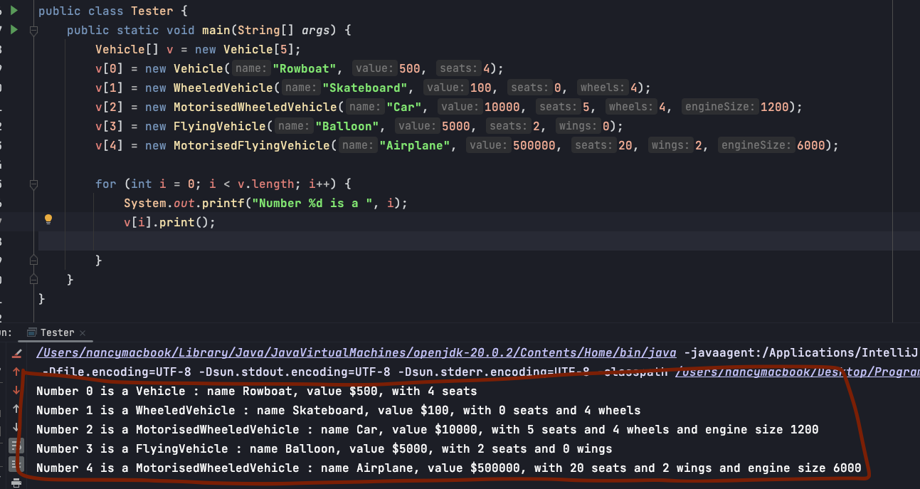

Requirement

