学 号 20337270 姓 名 钟海财
【实验题目】流水线CPU设计(1)
【实验目的】用FPGA芯片实现不处理数据冒险和控制冒险的流水线CPU（MIPS）。
【实验工具】
BASYS3实验板，Vivado软件
【实验目标】
设计流水线CPU，不考虑数据冒险与控制冒险，可以正确运行程序“file1pipe.asm”。
【参考代码】
module ExMemRegister(clk, memRead,memWrite, pc,aluResult,
exmemMemRead,exmemMemWrite,exmemPc,exmemAluResult);
input clk, memRead,memWrite;
output reg exmemMemRead,exmemMemWrite;
input [31:0] pc,aluResult;
output reg [31:0] exmemPc,exmemAluResult;

always @(posedge clk) begin
{exmemMemRead,exmemMemWrite,exmemPc,exmemAluResult }
<= { memRead,memWrite,pc,aluResult };
end
end module
【实验建议步骤】
步骤1、按照参考图“fig-4.51.jpg”改进单周期CPU设计，为设计流水线CPU做好准备。注意每次修改一部分之后都要运行仿真,仿真采用“file1pipe.asm”（机器码为file1pipe.txt），看是否有错：
- 修改模块名和变量名，采用驼峰命名规范，模块名字第一个字母大写，其他名字的第一个字母小写，例如：DataMemory, readData1，branchNot。
* 替换：编辑窗口，鼠标右键菜单“Replace”。
- 图中有名字可以直接采用，例如, add2Result, aluResult，没有的建议加Out，例如，add1Out。只定义输出线，使图中的线与程序中的名很容易对应。
- 下一条指令地址的处理部分全部分模块定义，见参考图。
- 可以定义一个二路转换器模块Mux32，所有32位多路转换可以统一使用它。
- file1pipe.asm把“addi $zero,$zero,x”用作空指令。

参考运行file1pipe.asm的仿真图：
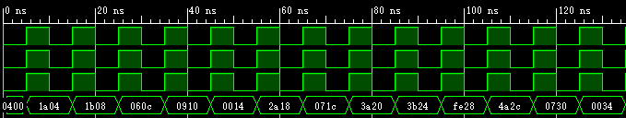
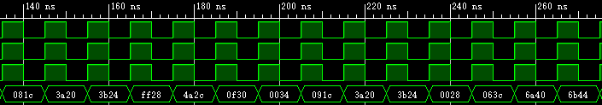
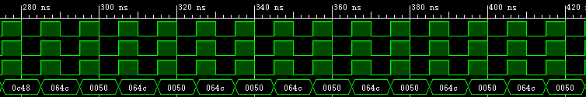
* 仿真的输出数据在file1pipe.asm的末尾。
步骤2（if/id和id/ex）按照参考图“fig-4.51.jpg”，实现两级流水线寄存器if/id和id/ex。此步骤只是建议完成，也可以直接完成四级流水线寄存器。
- 下一条指令地址的形成处理都是在id阶段完成。
- PC贯穿每级流水，使每级流水完成后都可以得到与单周期CPU相同的结果。
- 流水线寄存器参考命名：IfIdRegister；只命名输出参数，例如，ifidPcOut,idexReadData2Out。
- 初始化流水线寄存器为0。
- 寄存器组要使用下降沿，否则消除数据冒险要使用三条nop指令。
完成后的仿真图： 由于我直接实现了四级流水，所以步骤2，3的仿真图在一起
步骤3（ex/mem和mem/wb）按照参考图“fig-4.51.jpg”，实现两级流水线寄存器ex/mem和mem/wb。
完成后的仿真图：
说明：
- 由于我直接实现了四级流水，所以步骤2，3的仿真图在一起
- 实现了在beq和bne执行时在ifidRegister流水线寄存器插入两个气泡（无论转移不转移）和PC暂停1个时钟，以及j指令不用插入气泡可直接跳转。所以在执行j指令和会跳转的beq，bne指令时不用读取顺序执行下一条指令。所以我的输出结果如下：（0000表示气泡/空指令）
#0400 1a04 1b08 060c 0910 0014 2a18
#071c 3a20 3b24 fe28 0000 0000 4a2c 0730 0034 //5a38，j指令直接跳转，不会读该条指令
#081c 3a20 3b24 ff28 0000 0000 4a2c 0f30 0034 //5a38，j指令直接跳转，不会读该条指令
#091c 3a20 3b24 0028 0000 0000 //4a2c，会跳转的beq指令，不会读该条指令
#063c 6a40 6b44 0c48
#064c 0050 //7a54，j指令直接跳转，不会读该条指令
#064c 0050 //7a54，j指令直接跳转，不会读该条指令
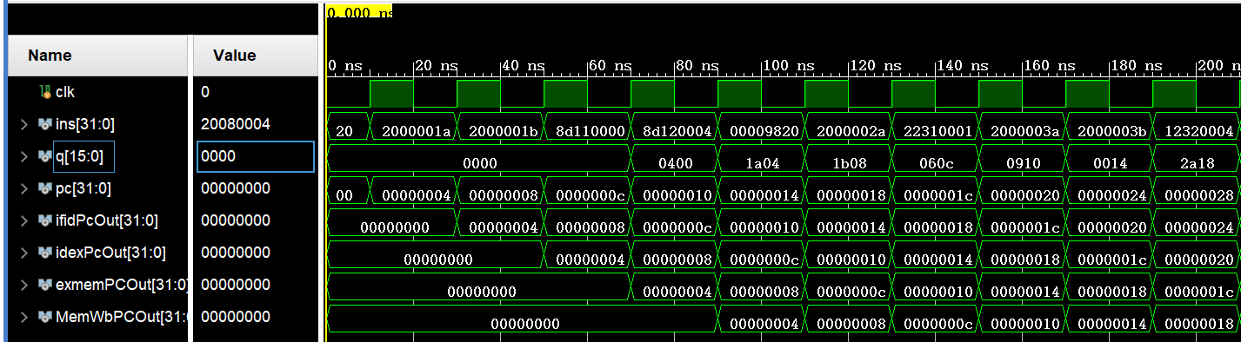
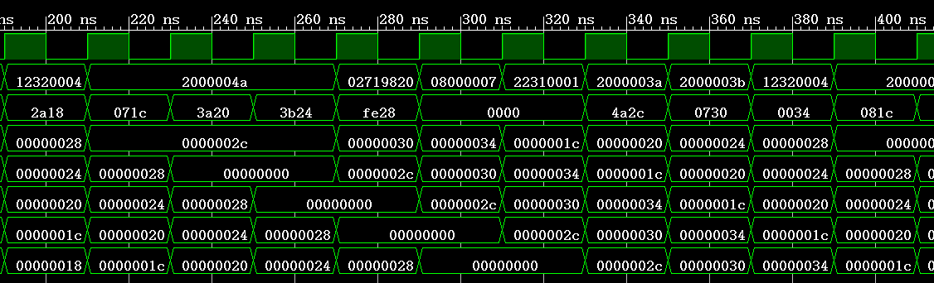
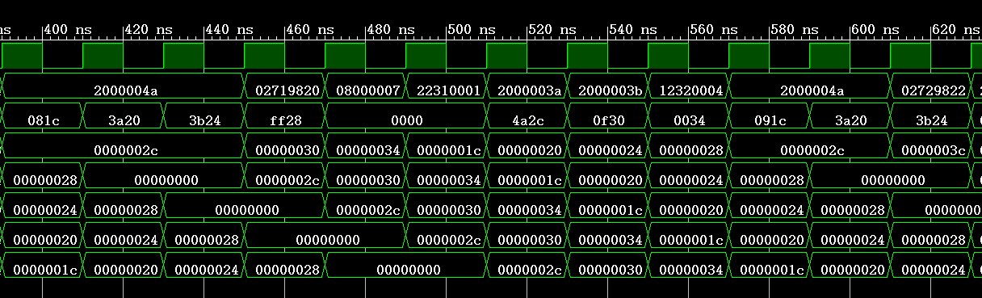
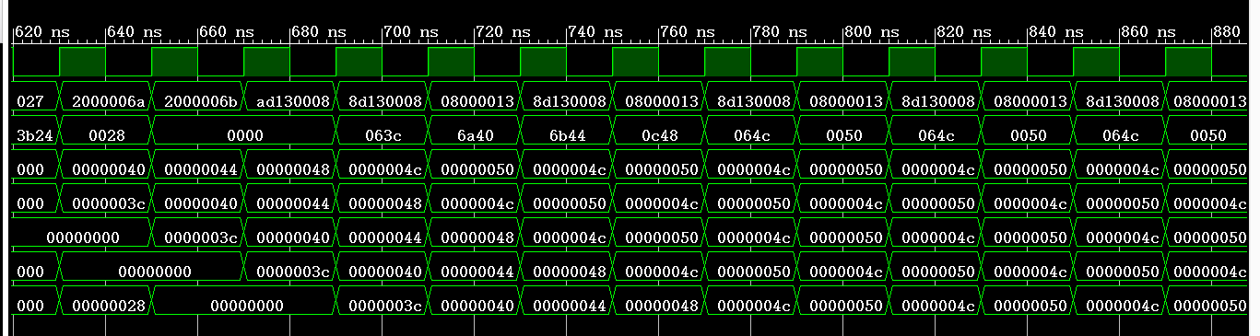
全部完成后的模块源码（名字可变，也可增减）：
[PC]
- `timescale 1ns / 1ps
- module PC(
- input clk,
- input Branch,
- input [1:0] PCSrc,
- input [31:0] immediate,//立即数
- input [25:0] addr,//j指令的跳转地址
- input [31:0] ra,
- output reg[31:0] pc
- );
- reg [31:0] pc0;
- integer i;
- initial
- begin
- i=0;
- pc0=0;
- pc=0;
- end

- always@(negedge clk)
- begin
- if(i>=0) i=i-1;
- end

- always@(posedge clk)
- begin
- if(Branch==1)
- begin
- i=2;
- //pc0=pc+4;//这里在i=2时pc=pc+4,所以可以不用pc0，
- end
- if(i==1) //pc暂停1个时钟
- begin
- //pc=pc;
- end
- else if(i==0)
- begin
- //pc=pc0;
- if(PCSrc==2'b01) pc=pc+immediate*4;//beq,bne
- end
- else
- case(PCSrc)
- 2'b00: pc=pc+4;//下一条指令
- 2'b01: pc=pc+4+immediate*4;//加指令低16扩展后左移两位,beq,bne
- 2'b10:// j ,jal
- begin
- pc=pc+4;
- pc={pc[31:28],addr[25:0],2'b00};
- end
- 2'b11: //jr
- begin
- pc = ra;
- end
- default: pc=pc+4;
- endcase

- end

- endmodule

[CPU]
- `timescale 1ns / 1ps

- module CPU(
- input clk,
- output [31:0] ins,
- output [15:0] q,
- output [31:0] pc,ifidPcOut,idexPcOut,exmemPCOut,MemWbPCOut
- );
- wire[31:0] data;
- wire[31:0] pc;
- wire[31:0] ins;
- wire[31:0] ra;

- wire [5:0] opcode,func;
- wire [4:0] rs,rt,rd,shamt;
- wire [31:0] immediate,immediate0;//立即数
- wire [25:0] addr;//j,jal指令跳转到的地址

- wire[1:0] PCSrc;//控制转移信号
- wire Jal,Branch,RegDst,MemRead,MemtoReg,MemWrite,ALUSrc,RegWrite;
- //Control控制信号,去除了Branch,Jump(在PcControl里生成)
- wire [1:0] ALUOP;
- wire zero;

- wire[31:0] ReadData1,ReadData2;//寄存器组输出: rs,rt的值
- wire[31:0] aluResult;//ALU
- wire[31:0] ReadData;//DataMem
- //wire [31:0] WriteData;//由Result与ReadData二选一生成

- wire[31:0] ifidPcOut;
- wire[5:0] ifid_opcode,ifid_func;
- wire[4:0] ifid_rs,ifid_rt,ifid_rd,ifid_shamt;
- wire[31:0] ifid_immediate;
- wire[25:0] ifid_addr;
- wire ifid_Jal,ifid_Branch;

- wire[31:0] idexPcOut;
- wire[5:0] idex_opcode;
- wire[1:0] idex_ALUOP;
- wire idex_Branch,idex_MemRead,idex_MemtoReg,idex_MemWrite,idex_ALUSrc,idex_RegWrite;
- wire [31:0] idexReadData1Out,idexReadData2Out,idex_immediate;
- wire [4:0] idex_WriteRegister;

- wire exmemMemRead,exmemMemtoReg,exmemMemWrite,exmemRegWrite;
- wire [31:0]exmemPCOut,exmemAluResult,exmemReadData2Out;
- wire exmemZero;
- wire [4:0] exmem_WriteRegister;

- wire [4:0]MemWb_WriteRegister;
- wire MemWb_RegWrite;
- wire [31:0] MemWbPCOut,MemWb_WriteData;

- assign q[15:8] = MemWb_WriteData[7:0];
- assign q[7:0] = MemWbPCOut[7:0];

- PCControl uPCControl(opcode,func,idex_opcode,zero,PCSrc,Branch,Jal);

- PC uPC(clk,Branch,PCSrc,immediate0,addr,ra,pc);
- InsMemory uInsMemory(pc,ins,opcode,func,rs,rt,rd,shamt,immediate,immediate0,addr);
- Control uControl(ifid_opcode,ifid_func,RegDst,MemRead,MemtoReg,ALUOP,MemWrite,ALUSrc,RegWrite);
- Registers uRegisters(clk,MemWb_RegWrite,MemWb_WriteRegister,MemWb_WriteData,ifid_rs,ifid_rt,ReadData1,ReadData2,ifid_Jal,ifidPcOut,ra);
- ALU uALU(idexReadData1Out,idexReadData2Out,idex_immediate,idex_ALUSrc,idex_ALUOP,zero,aluResult);
- DataMemory uDataMemory(clk,exmemAluResult,exmemReadData2Out,exmemMemWrite,exmemMemRead,ReadData);

- ifidRegister uifidRegister(clk,pc,ins,Jal,Branch,
- ifidPcOut,ifid_opcode,ifid_func,ifid_rs,ifid_rt,ifid_rd,
- ifid_shamt,ifid_immediate,ifid_addr,ifid_Jal,ifid_Branch);

- idexRegister uidexRegister(clk,ifidPcOut,ifid_opcode,ALUOP,
- ifid_Branch,RegDst,MemRead,MemtoReg,MemWrite,ALUSrc,
- RegWrite,ReadData1,ReadData2,ifid_immediate,ifid_rt,ifid_rd,
- idexPcOut,idex_opcode,idex_ALUOP,idex_Branch,idex_MemRead,
- idex_MemtoReg,idex_MemWrite,idex_RegWrite,idex_ALUSrc,
- idexReadData1Out,idexReadData2Out,idex_immediate,idex_WriteRegister);

- ExMemRegister uExMemRegister(clk, idex_MemRead,idex_MemtoReg,idex_MemWrite,idex_RegWrite,
- idexPcOut,aluResult,idexReadData2Out,zero,idex_WriteRegister,
- exmemMemRead,exmemMemtoReg,exmemMemWrite,exmemRegWrite,exmemPCOut,
- exmemAluResult,exmemReadData2Out,exmemZero,exmem_WriteRegister);

- MemWbRegister uMemWbRegister(clk,exmemMemtoReg,exmemRegWrite,exmem_WriteRegister, exmemAluResult,ReadData,exmemPCOut,
- MemWb_WriteRegister,MemWb_RegWrite,MemWb_WriteData,MemWbPCOut);
- endmodule

[CPU_sim]
- `timescale 1ns / 1ps
- module CPU_sim();
- reg clk;
- wire[31:0] ins;
- wire[15:0] q;
- wire[31:0] pc,ifidPcOut,idexPcOut,exmemPCOut,MemWbPCOut;
- CPU uCPU(clk,ins,q,pc,ifidPcOut,idexPcOut,exmemPCOut,MemWbPCOut);
- initial begin
- clk = 0;
- end
- always #10 clk = ~clk;
- endmodule

[DataMemory]
- `timescale 1ns / 1ps
- module DataMemory(
- input clk,
- input [31:0] address,//ALU的Result
- input [31:0] WriteData,//Registers的ReadData2
- input MemWrite,
- input MemRead,
- output reg[31:0] ReadData
- );

- reg[31:0] mem[127:0];
- integer i;
- initial
- begin
- for(i=0;i<128;i=i+1) mem[i]=0;
- $readmemh("data1.txt",mem);//读文件
- end

- always@(*)//读操作无需时钟信号
- if(MemRead)
- begin
- //ReadData=mem[(address-32'b00000000000000000010000000000000)>>2];
- //使数据段在数据存储器中的位置从0开始
- ReadData=mem[address>>2];//
- end

- always@(posedge clk)//写操作
- if(MemWrite)
- begin
- //mem[(address-32'b00000000000000000010000000000000)>>2]=WriteData;
- mem[address>>2]=WriteData;
- end

- endmodule

[InsMemory]
- `timescale 1ns / 1ps
- module InsMemory(
- input [31:0] pc,
- output [31:0] ins0,
- output [5:0] opcode,func,
- output [4:0] rs,
- output [4:0] rt,
- output [4:0] rd,
- output [4:0] shamt,
- output [31:0] immediate,immediate0,
- output [25:0] addr
- );
- reg [31:0] ins;
- reg [25:0] addr0;
- reg[31:0] mem[127:0];
- integer i;
- initial begin
- ins=0;
- addr0=0;
- for(i=0;i<128;i=i+1) mem[i]=0;
- $readmemh("file1pipe.txt", mem);
- //$readmemh("bsort2.txt", mem);
- end

- always@(*)
- begin
- ins = mem[pc>>2];
- addr0 = (opcode==6'b000010||opcode==6'b000011)?ins[25:0]:addr0;
- end
- assign ins0 = ins;
- assign opcode = ins[31:26];
- assign rs = ins[25:21];
- assign rt = ins[20:16];
- assign rd = ins[15:11];
- assign shamt = ins[10:6];
- assign immediate[15:0] = ins[15:0];
- assign immediate[31:16] = ins[15]?16'hffff:16'h0000;
- assign immediate0 = ((opcode==6'b000100)||(opcode==6'b000101))?immediate:immediate0;
- assign addr = addr0;
- assign func= ins[5:0];

- endmodule

[Control]
- `timescale 1ns / 1ps
- module Control(
- input [5:0] opcode,func,
- //input zero,
- //output reg[1:0] PCSrc,
- //output Jal,
- output RegDst,
- //output Jump,
- //output Branch,
- output MemRead,
- output MemtoReg,
- output reg [1:0] ALUOP,
- output MemWrite,
- output ALUSrc,
- output RegWrite
- );
- //Jal
- //assign Jal=(opcode==6'b000011)?1:0;
- //addi lw addiu
- assign RegDst=(opcode==6'b001000||opcode==6'b100011 ||opcode==6'b001001)?0:1;
- //j jal
- //assign Jump=(opcode==6'b000010||opcode==6'b000011)?1:0;
- //beq
- //assign Branch=(opcode==6'b000100)?1:0;//去除Branch和Jump，转移都用PCSrc判断
- //lw
- assign MemRead=(opcode==6'b100011)?1:0;
- //lw
- assign MemtoReg=(opcode==6'b100011)?1:0;
- //sw
- assign MemWrite=(opcode==6'b101011)?1:0;
- //lw sw addi addiu
- assign ALUSrc=(opcode==6'b100011||opcode==6'b101011||opcode==6'b001000 ||opcode==6'b001001)?1:0;
- //add sub slt addi lw addiu
- assign RegWrite=(opcode==6'b000000||opcode==6'b101010||opcode==6'b001000||opcode==6'b100011||opcode==6'b001001)?1:0;

- always@(*)
- begin
- if(opcode == 6'b000000)begin
- case(func)
- //add
- 6'b100000 : ALUOP=2'b00;
- //sub
- 6'b100010: ALUOP=2'b01;
- //slt
- 6'b101010: ALUOP=2'b11;
- default: ALUOP=2'b00;
- endcase
- end

- else begin
- case(opcode)
- //addi
- 6'b001000: ALUOP=2'b00;
- //addiu
- 6'b001001: ALUOP=2'b00;
- //sw
- 6'b101011: ALUOP=2'b00;
- //lw
- 6'b100011: ALUOP=2'b00;
- //beq
- 6'b000100: ALUOP=2'b01;
- //bne
- 6'b000101: ALUOP=2'b01;
- default:ALUOP=2'b00;
- endcase
- end
- end
- endmodule

[Registers]
- `timescale 1ns / 1ps
- module Registers(
- input clk,
- //input RegDst,
- input RegWrite,
- input [4:0] WriteRegister,
- input [31:0] WriteData,
- //input MemtoReg,
- input [4:0] rs,
- input [4:0] rt,
- //input [4:0] rd,
- //input [31:0] Result,
- //input [31:0] ReadData,
- output [31:0] ReadData1,
- output [31:0] ReadData2,
- input Jal,
- input [31:0] pc,
- output [31:0] ra
- );

- reg [31:0] register[0:31];//寄存器组
- integer i;
- initial
- begin
- for(i=0;i<32;i=i+1) register[i]=0;
- end

- //wire [4:0] WriteRegister;//实现MUX（1）
- //assign WriteRegister=RegDst?rd:rt;//实现MUX（1）
- //assign WriteData=MemtoReg?ReadData:Result;//实现MUX（3）

- assign ReadData1=register[rs];
- assign ReadData2=register[rt];
- assign ra = register[31];

- always @(negedge clk)//写操作
- begin
- if(Jal==1) register[31] = pc+4;//jal指令保存pc+4(下一条指令pc))到$ra
- if(RegWrite&&WriteRegister!=0)begin
- register[WriteRegister]=WriteData;
- end
- end

- endmodule

[PCControl]
- `timescale 1ns / 1ps
- module PCControl(
- input [5:0] opcode,func,
- input [5:0] opcode_Branch,
- input zero,
- output reg[1:0] PCSrc,
- output Branch,
- output Jal
- );
- assign Branch = ((opcode==6'b000100)||(opcode==6'b000101))?1:0;//插入2条nop指令
- assign Jal=(opcode==6'b000011)?1:0;
- always@(*)
- begin
- if((opcode_Branch==6'b000100&&zero==1'b1)||(opcode_Branch==6'b000101&&zero==0))
- begin
- PCSrc = 2'b01;//beq,bne
- end
- else if(opcode==6'b000010||opcode==6'b000011)
- begin
- PCSrc = 2'b10;//j jal
- end
- else if(opcode==6'b000000&&func==6'b001000)
- begin
- PCSrc = 2'b11;//jr
- end
- else
- begin
- PCSrc = 2'b00;
- end
- end
- endmodule

[ALU]
- `timescale 1ns / 1ps
- module ALU(
- input [31:0] ReadData1,
- input [31:0] ReadData2,
- input [31:0] immediate,
- input ALUSrc,
- input [1:0] ALUOP,
- output zero,
- output reg [31:0]Result
- );
- initial
- begin
- Result=0;
- end
- wire [31:0] a,b;
- assign a=ReadData1;
- assign b=ALUSrc?immediate:ReadData2;//MUX（2）
- assign zero=(Result==0)?1:0;

- always@(*)
- begin
- case(ALUOP)
- 2'b00://加法
- begin
- Result=a+b;
- end
- 2'b01://减法
- begin
- Result=a-b;
- end
- 2'b11://slt
- begin
- Result=(a<b)?1:0;
- end
- default:
- Result=0;
- endcase
- end

- endmodule

四个流水线寄存器：
[ifidRegister]
- `timescale 1ns / 1ps

- module ifidRegister(
- input clk1,
- input [31:0]pc,
- input [31:0]ins,
- input Jal,Branch,
- output reg[31:0] ifidPcOut,
- output reg[5:0] ifid_opcode,ifid_func,
- output reg[4:0] ifid_rs,
- output reg[4:0] ifid_rt,
- output reg[4:0] ifid_rd,
- output reg[4:0] ifid_shamt,
- output reg[31:0] ifid_immediate,
- output reg[25:0] ifid_addr,
- output reg ifid_Jal,ifid_Branch
- );
- integer i;

- initial
- begin
- i=0;
- ifidPcOut = 0;
- ifid_opcode = 0;
- ifid_rs = 0;
- ifid_rt = 0;
- ifid_rd = 0;
- ifid_shamt = 0;
- ifid_immediate[15:0] = 0;
- ifid_immediate[31:16] = 0;
- ifid_addr = 0;
- ifid_func= 0;
- ifid_Jal=0;
- ifid_Branch=0;
- end

- always@(negedge clk1)
- begin
- if(i>0) i=i-1;
- end

- always @(posedge clk1)
- begin
- if(Branch==1)
- begin
- i=3;
- end
- if(i==2||i==1)
- begin
- ifidPcOut = 0;
- ifid_opcode = 0;
- ifid_rs = 0;
- ifid_rt = 0;
- ifid_rd = 0;
- ifid_shamt = 0;
- ifid_immediate[15:0] = 0;
- ifid_immediate[31:16] = 0;
- ifid_addr = 0;
- ifid_func= 0;
- ifid_Jal=0;
- ifid_Branch=0;
- end
- else
- begin
- ifidPcOut = pc;
- ifid_opcode = ins[31:26];
- ifid_rs = ins[25:21];
- ifid_rt = ins[20:16];
- ifid_rd = ins[15:11];
- ifid_shamt = ins[10:6];
- ifid_immediate[15:0] = ins[15:0];
- ifid_immediate[31:16] = ins[15]?16'hffff:16'h0000;
- ifid_addr = ins[25:0];
- ifid_func= ins[5:0];
- ifid_Jal= Jal;
- ifid_Branch=Branch;
- end
- end
- endmodule

[idexRegister]
- module idexRegister(
- input clk2,
- input [31:0] ifidPcOut,
- input [5:0] ifid_opcode,
- input [1:0] ALUOP,
- input Branch,RegDst,MemRead,MemtoReg,MemWrite,ALUSrc,RegWrite,
- input [31:0] ReadData1,ReadData2,ifid_immediate,
- input [4:0]rt,rd,
- output reg[31:0] idexPcOut,
- output reg[5:0] idex_opcode,
- output reg[1:0] idex_ALUOP,
- output reg idex_Branch,idex_MemRead,idex_MemtoReg,idex_MemWrite,idex_RegWrite,idex_ALUSrc,
- output reg[31:0] idexReadData1Out,idexReadData2Out,idex_immediate,
- output reg[4:0] idex_WriteRegister
- );
- initial
- begin
- idexPcOut <= 0;
- idex_ALUOP<=0;
- idex_opcode<= 0 ;
- {idex_Branch,idex_MemRead,idex_MemtoReg,idex_MemWrite,idex_ALUSrc,idex_RegWrite}
- <= 0;
- idexReadData1Out<=0;
- idexReadData2Out<=0;
- idex_immediate<=0;
- end
- always @(posedge clk2) begin
- idexPcOut <= ifidPcOut;
- idex_ALUOP <= ALUOP;
- {idex_Branch,idex_MemRead,idex_MemtoReg,idex_MemWrite,idex_ALUSrc,idex_RegWrite}
- <= {Branch,RegDst,MemRead,MemtoReg,MemWrite,ALUSrc,RegWrite};
- idex_opcode<= ifid_opcode ;
- idexReadData1Out <=ReadData1;
- idexReadData2Out <=ReadData2;
- idex_immediate <= ifid_immediate;
- idex_WriteRegister=RegDst?rd:rt;//实现MUX（1）
- end

- endmodule

[ExMemRegister]
- module ExMemRegister(
- clk, idex_MemRead,idex_MemtoReg,idex_MemWrite,idex_RegWrite,
- pc,aluResult,idexReadData2Out,Zero,WriteRegister,
- exmemMemRead,exmemMemtoReg,exmemMemWrite,exmemRegWrite,
- exmemPCOut,exmemAluResult,exmemReadData2Out,exmemZero,
- exmem_WriteRegister);
- input clk, idex_MemRead,idex_MemtoReg,idex_MemWrite,idex_RegWrite;
- output reg exmemMemRead,exmemMemtoReg,exmemMemWrite,exmemRegWrite;
- input [31:0] pc,aluResult,idexReadData2Out;
- output reg [31:0] exmemPCOut,exmemAluResult,exmemReadData2Out;

- input Zero;
- output reg exmemZero;

- input [4:0] WriteRegister;
- output reg[4:0] exmem_WriteRegister;

- initial begin
- {exmemMemRead,exmemMemtoReg,exmemMemWrite,exmemRegWrite,exmemPCOut,exmemAluResult }<=0;
- exmemReadData2Out<=0;
- exmemZero<=0;
- exmem_WriteRegister<=0;
- end
- always @(posedge clk) begin
- {exmemMemRead,exmemMemtoReg,exmemMemWrite,exmemRegWrite,exmemPCOut,exmemAluResult}
- <= { idex_MemRead,idex_MemtoReg,idex_MemWrite,idex_RegWrite,pc,aluResult};
- exmemReadData2Out<= idexReadData2Out;
- exmemZero <= Zero;
- exmem_WriteRegister <= WriteRegister;
- end
- endmodule

[MemWbRegister]
- module MemWbRegister(
- input clk,
- input MemtoReg,RegWrite,
- input [4:0] WriteRegister,
- input [31:0] AluResult,ReadData,pc,
- output reg[4:0]MemWb_WriteRegister,
- output reg MemWb_RegWrite,
- output reg [31:0] MemWb_WriteData,MemWbPCOut
- );
- initial
- begin
- MemWb_WriteData<=0;
- MemWb_RegWrite<=0;
- MemWb_WriteRegister<=0;
- MemWbPCOut<=0;
- end

- always @(posedge clk)
- begin
- MemWb_WriteData<=MemtoReg?ReadData:AluResult;//实现MUX（3）
- MemWb_RegWrite<=RegWrite;
- MemWb_WriteRegister<=WriteRegister;
- MemWbPCOut<= pc;
- end
- endmodule

…

【完成情况】
是否完成？(√完成 ×未做)
[√]

【实验体会】
写出实验过程中遇到的问题，解决方法和自己的思考;并简述实验体会（如果有的话）。

问题1）刚开始把流水线寄存器加入时，仿真总是不能运行，出现程序性错误。
解决方法：先逐个对照各个流水线寄存器的输入输出关系是否正确，以及每个输入输出变量是否定义过；再修改仿真模块，使其适应流水线CPU。

问题2）beq指令不能跳转或者跳转错误。
解决方法：修改pc和ifidRegister，在执行beq/bne指令时，把beq/bne指令的立即数immediate保存为immediate0，pc暂停1个时钟周期（pc=pc+4），ifidRegister插入2条nop指令（全0的空指令），等beq/bne的Ex执行完得到zero时判断是否转移，如果转移令pc=pc+ immediate0*4.

问题3）通过设计使j指令不用插入nop指令。
解决方法：由于我的生成转移信号PCSrc的模块PCControl是在ifidRegister之前，所以j指令不用插入nop指令，可直接跳转。

【交实验报告】
每位同学单独完成本实验内容并填写实验报告。
交作业地点：http://172.18.187.251/netdisk/default.aspx?vm=20org
FPGA实验/06、流水线CPU设计(1)
截止日期：2021年12月25日23:00（周六）
上传文件：学号_姓名_流水线CPU设计1.doc
学号_姓名_流水线CPU设计1.rar （包含源代码的工程）

