学 号 20337270 姓 名 钟海财
【实验题目】流水线CPU设计(3)
【实验目的】用FPGA芯片实现流水线CPU。
【实验工具】
BASYS3实验板，Vivado软件

【实验要求】
设计基于MIPS的流水线CPU，可以正确运行课本中的冒泡排序程序。

【实验要求】
1、（仿真）实现执行冒泡排序并仿真，仿真执行包含最后读取数据区数据的8条语句的WriteData的低8位和PC的低8位。
参考仿真图：052c，0630，…,3948 (排序结果输出，下图划红线部分)
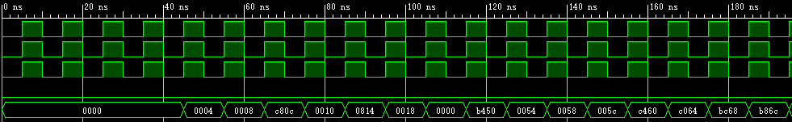
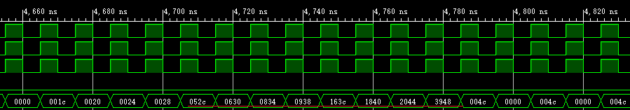
问题：与单周期仿真图的地址不同的原因是什么？
在解决控制冒险和数据冒险中的load-use插入了nop指令和气泡。
你的仿真图（要截图排序部分，并用红线标出）：
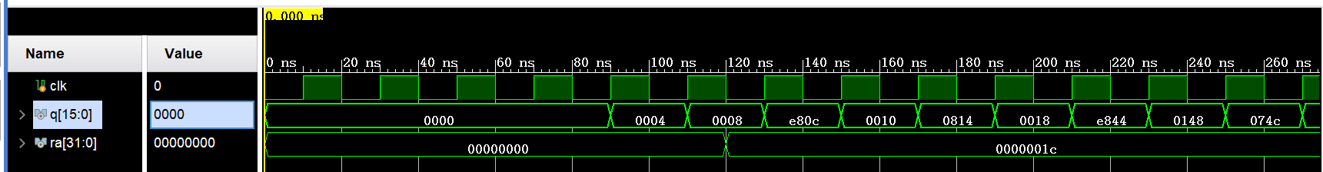
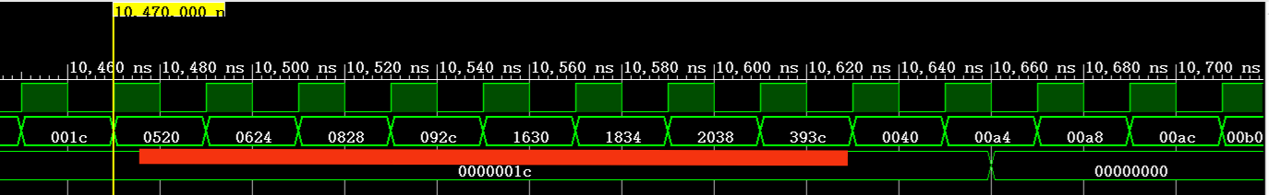
2、（写板）实现写板，每次按BtnL键在数码管上输出数据存储器中的内容，输出的第一个数字是序号，后三个数字是内容，循环输出。一开始没有排序，在按下按BtnC键后，才开始排序，然后按BtnL键可以看到排序结果。
完成后拍照8个数据排序前的结果，拼在一张图上(最好不要超过300KB)：
[1] [2] [3] [4]
[5] [6] [7] [8]
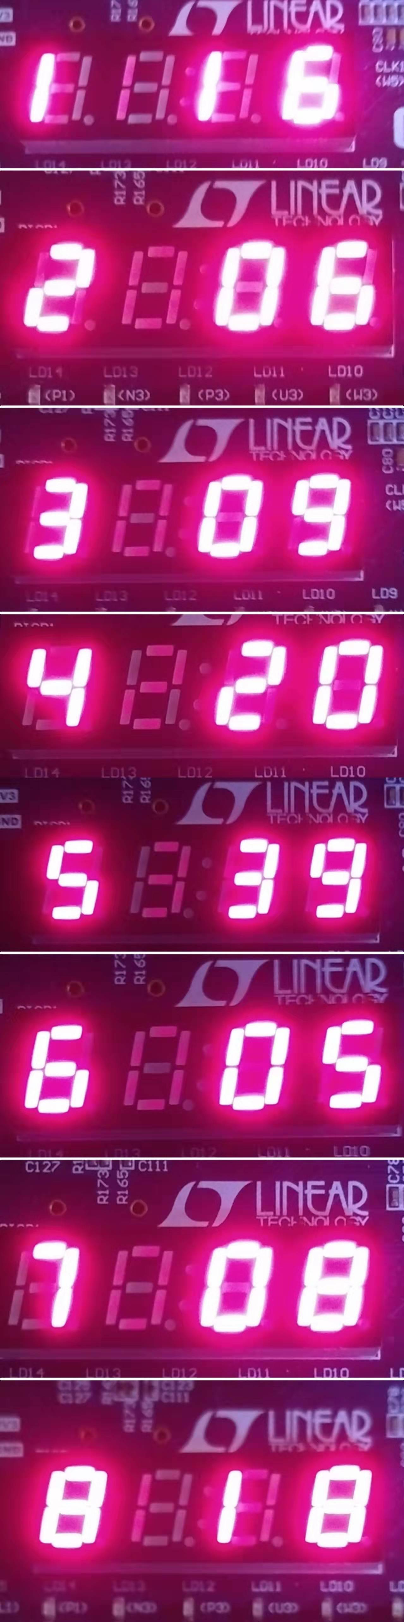
拍照8个数据排序后的结果，拼在一张图上(最好不要超过300KB)：
[1] [2] [3] [4]
[5] [6] [7] [8]
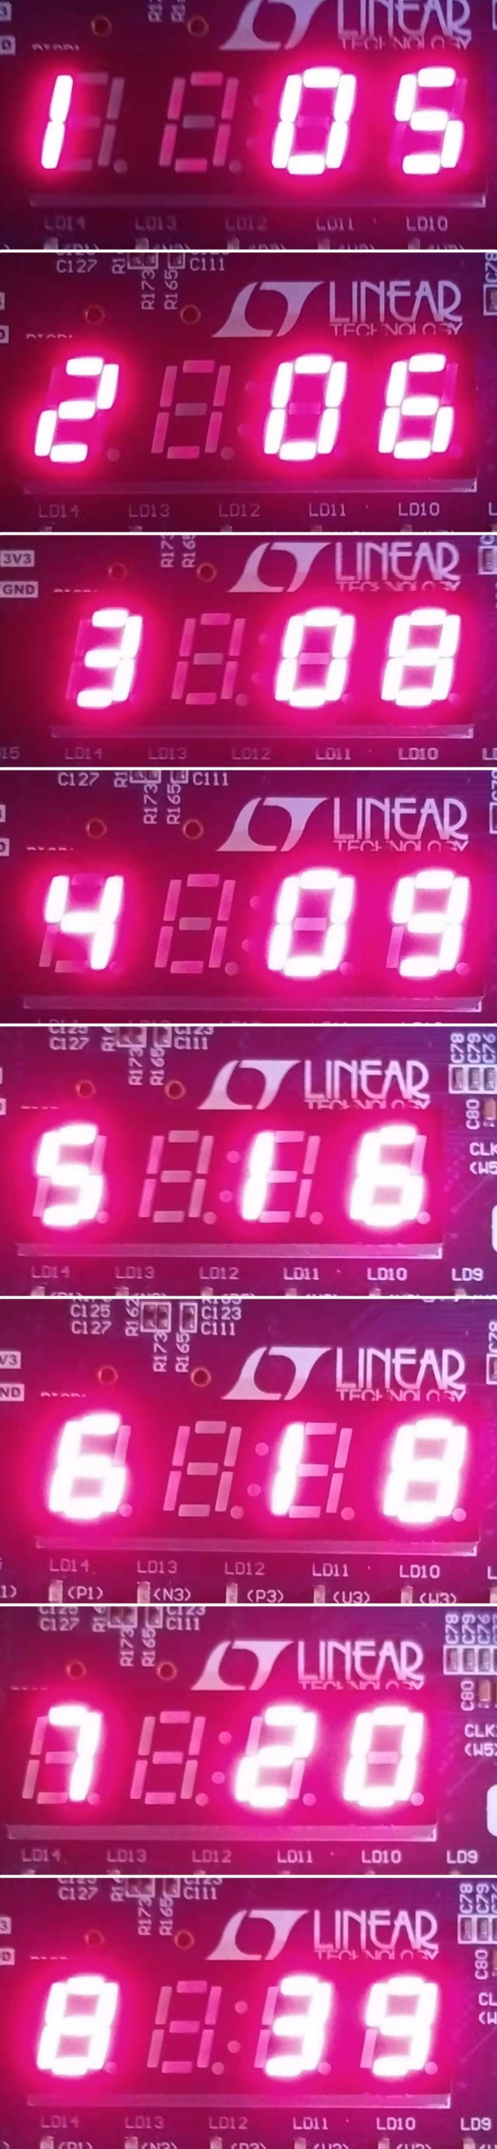
3、模块源码（名字可变，也可增减）：
如果是在 “流水线CPU设计(2)”的基础上修改的，只需要给出顶层模块(CPU)和列出修改过的模块。
是在 “流水线CPU设计(2)”的基础上修改的，新增部分用于写板的模块，并对一些模块的输入输出进行修改以用来写板。
[smg]顶层模块（用于写板）
- `timescale 1ns / 1ps

- module smg(
- output reg[7:0]y,
- output reg[3:0]d,
- input clk2,//内置时钟，100MHz
- input Btnc,
- input Btnl
- );
- // reg[3:0] d;
- // reg[7:0] y;//序号
- wire[7:0] y1;
- wire[7:0] y2;
- wire[31:0] data1 ;
- wire[31:0] data2;
- wire[31:0] data3 ;
- wire[31:0] data4;
- wire[31:0] data5;
- wire[31:0] data6 ;
- wire[31:0] data7 ;
- wire[31:0] data8 ;

- parameter state_A=2'b00,state_B=2'b01,state_C=2'b10,state_D=2'b11;
- parameter n0=8'b00000011,n1=8'b11110011,n2=8'b00100101,n3=8'b00001101,n4=8'b10011001,n5=8'b01001001,n6=8'b01000001,n7=8'b00011111,n8=8'b00000001,n9=8'b00001001;
- //n0~n9为数字0-9

- reg [1:0] state=state_A;
- reg[7:0] tail=n8;//序号的数字

- reg[31:0] divclk_cnt = 0;//时钟分频1，用于数码管显示
- reg divclk=0;
- always@(posedge clk2)
- begin
- if(divclk_cnt==2500) //2500
- begin
- divclk =~ divclk;
- divclk_cnt = 0;
- end
- else
- begin
- divclk_cnt = divclk_cnt+1'b1;
- end
- end

- reg[31:0] divclk_cnt2 = 0; //分频2,作为CPU的时钟
- reg divclk2=0;
- always@(posedge clk2)
- begin
- if(divclk_cnt2==150000) //150000
- begin
- divclk2 =~ divclk2;
- divclk_cnt2 = 0;
- end
- else
- begin
- divclk_cnt2 = divclk_cnt2+1'b1;
- end
- end

- //消抖模块
- reg sysclk;
- reg [18:0]cnt_20ms;
- //用于Btnl和Btnc按键消抖
- always @(posedge clk2)
- begin
- cnt_20ms <= cnt_20ms + 1;
- if(cnt_20ms == 19'd500000 )
- sysclk <= ~sysclk;
- end
- reg bl_low=0;
- reg bc_low=0;

- reg bl_low_r=0; //按键值锁存一个时钟周期，以判断按键是否按下
- reg bc_low_r=0;
- always @( posedge sysclk)
- begin
- bl_low <= Btnl;
- bc_low <= Btnc;
- end

- always @( posedge clk2) //用于Btnl和Btnc按键消抖
- begin
- bl_low_r <= bl_low;
- bc_low_r <= bc_low;
- end
- wire bl_ctr;
- wire bc_ctr;
- assign bl_ctr = bl_low_r & (!bl_low);
- assign bc_ctr= bc_low_r & (!bc_low);//Btnl和Btnc按下后对应的为1

- wire clk; //CPU时钟
- reg En = 0;//CPU时钟的使能，为1时有效
- always @(posedge clk2)
- begin
- if(bc_ctr==1) En=1;//当按下Btnc时CPU时钟的使能En=1
- end

- assign clk = En&divclk2 ;//将divclk2和En取与作为CPU的时钟
- CPU2 uCpu2(clk,data1,data2,data3,data4,data5,data6,data7,data8);
- reg [31:0] data;//数码管要输出的数据
- datatosmg(data,y1,y2);//将对应的数据转化为对应的数码管控制信号，y1为十位，y2为个位

- always @(posedge clk2) //循环显示8个数
- begin
- if(bl_ctr==1)
- case (tail)
- n8:
- begin
- tail=n1; //序号变化
- data=data1;//数据变化
- end
- n1:
- begin
- tail=n2;
- data=data2;
- end
- n2:
- begin
- tail=n3;
- data=data3;
- end
- n3:
- begin
- tail=n4;
- data=data4;
- end
- n4:
- begin
- tail=n5;
- data=data5;
- end
- n5:
- begin
- tail=n6;
- data=data6;
- end
- n6:
- begin
- tail=n7;
- data=data7;
- end
- n7:
- begin
- tail=n8;
- data=data8;
- end
- endcase
- end

- //扫描显示数码管
- always@(posedge divclk)
- begin
- case (state)
- state_A: //第1个数码管
- begin
- state=state_B;
- d=4'b0111;
- y=tail; //序号
- end

- state_B://第2个数码管
- begin
- state=state_C;
- d=4'b1011;
- y=8'b11111111;
- end

- state_C: //第3个数码管
- begin
- state=state_D;
- d=4'b1101;
- y=y1;//十位
- end

- default: //第4个数码管
- begin
- state=state_A;
- d=4'b1110;
- y=y2;//个位
- end
- endcase
- end

- endmodule

[CPU]（用于仿真）
- `timescale 1ns / 1ps

- module CPU(
- input clk,
- output [15:0] q,
- output [31:0] ra
- );
- wire[31:0] pc;
- wire[31:0] ins;
- wire[31:0] ra;

- wire [5:0] opcode,func;
- wire [4:0] rs,rt,rd,shamt;
- wire [31:0] immediate,immediate0;//立即数
- wire [25:0] addr;//j,jal指令跳转到的地址

- wire[1:0] PCSrc;//控制转移信号
- wire Jal,Branch;
- wire RegDst,MemRead,MemtoReg,MemWrite,ALUSrc,RegWrite;//Control控制信号,去除了Branch,Jump
- wire [1:0] ALUOP;
- wire zero;

- wire zero0;//Registers的输出，判断rs==rt的结果
- wire[31:0] ReadData1,ReadData2;//寄存器组输出: rs,rt的值
- wire[31:0] aluResult;//ALU
- wire[31:0] ReadData;//DataMem
- //wire [31:0] WriteData;//由Result与ReadData二选一生成

- wire[31:0] ifidPcOut;
- wire[5:0] ifid_opcode,ifid_func;
- wire[4:0] ifid_rs,ifid_rt,ifid_rd,ifid_shamt;
- wire[31:0] ifid_immediate;
- wire[25:0] ifid_addr;
- wire ifid_Branch;

- wire[31:0] idexPcOut;
- wire[5:0] idex_opcode;
- wire[1:0] idex_ALUOP;
- wire idex_Branch,idex_MemRead,idex_MemtoReg,idex_MemWrite,idex_ALUSrc,idex_RegWrite;
- wire [31:0] idexReadData1Out,idexReadData2Out,idex_immediate;
- wire [4:0] idex_WriteRegister,idex_rs,idex_rt;

- wire exmemMemRead,exmemMemtoReg,exmemMemWrite,exmemRegWrite;
- wire [31:0]exmemPCOut,exmemAluResult,exmemReadData2Out;
- wire exmemZero;
- wire [4:0] exmem_WriteRegister;

- wire [4:0]MemWb_WriteRegister;
- wire MemWb_RegWrite;
- wire [31:0] MemWbPCOut,MemWb_WriteData;

- wire[31:0] _ReadData1,_ReadData2;
- wire stall;

- assign q[15:8] = MemWb_WriteData[7:0];
- assign q[7:0] = MemWbPCOut[7:0];

- PCControl uPCControl(opcode,func,idex_opcode,zero,PCSrc,Branch,Jal);//只用插入1条nop指令

- PC uPC(clk,Branch,PCSrc,immediate0,addr,ra,pc,stall);
- InsMemory uInsMemory(pc,ins,opcode,func,rs,rt,rd,shamt,immediate,immediate0,addr);
- Control uControl(ifid_opcode,ifid_func,RegDst,MemRead,MemtoReg,ALUOP,MemWrite,ALUSrc,RegWrite);
- Registers uRegisters(clk,MemWb_RegWrite,MemWb_WriteRegister,MemWb_WriteData,ifid_rs,ifid_rt,ReadData1,ReadData2,Jal,pc,ra,zero0);
- ALU uALU(_ReadData1,_ReadData2,idex_immediate,idex_ALUSrc,idex_ALUOP,zero,aluResult);
- DataMemory uDataMemory(clk,exmemAluResult,exmemReadData2Out,exmemMemWrite,exmemMemRead,ReadData);

- ifidRegister uifidRegister(clk,pc,ins,Branch,stall,
- ifidPcOut,ifid_opcode,ifid_func,ifid_rs,ifid_rt,ifid_rd,ifid_shamt,ifid_immediate,ifid_addr,ifid_Branch);

- idexRegister uidexRegister(clk,stall,ifidPcOut,ifid_opcode,ALUOP,ifid_Branch,RegDst,MemRead,MemtoReg,MemWrite,ALUSrc,
- RegWrite,ReadData1,ReadData2,ifid_immediate,ifid_rs,ifid_rt,ifid_rd,
- idexPcOut,idex_opcode,idex_ALUOP,idex_Branch,idex_MemRead,idex_MemtoReg,idex_MemWrite,idex_RegWrite,idex_ALUSrc,
- idexReadData1Out,idexReadData2Out,idex_immediate,idex_WriteRegister,idex_rs,idex_rt);

- ExMemRegister uExMemRegister(clk, idex_MemRead,idex_MemtoReg,idex_MemWrite,idex_RegWrite,
- idexPcOut,aluResult,_ReadData2,zero,idex_WriteRegister,
- exmemMemRead,exmemMemtoReg,exmemMemWrite,exmemRegWrite,exmemPCOut,
- exmemAluResult,exmemReadData2Out,exmemZero,exmem_WriteRegister);

- MemWbRegister uMemWbRegister(clk,exmemMemtoReg,exmemRegWrite,exmem_WriteRegister,
- exmemAluResult,ReadData,exmemPCOut,
- MemWb_WriteRegister,MemWb_RegWrite,MemWb_WriteData,MemWbPCOut);

- ForwardUnit uForwardUnit(exmemRegWrite,MemWb_RegWrite,MemWb_WriteRegister,exmem_WriteRegister,idex_rs,idex_rt,
- idexReadData1Out,idexReadData2Out,exmemAluResult,MemWb_WriteData,
- _ReadData1,_ReadData2);

- StallUnit uStallUnit(ifid_rs,ifid_rt,idex_WriteRegister,idex_MemRead,MemRead,stall);

- endmodule

[CPU_sim]
- `timescale 1ns / 1ps

- module CPU_sim();
- reg clk;
- wire[15:0] q;
- wire[31:0] ra;
- //wire[31:0] data1,data2,data3,data4,data5,data6,data7,data8;
- CPU uCPU(clk,q,ra);
- //CPU2 uCPU2(clk,data1,data2,data3,data4,data5,data6,data7,data8);
- initial begin
- clk = 0;
- end
- always #10 clk = ~clk;
- endmodule

[DataMemory] （用于仿真）
- `timescale 1ns / 1ps

- module DataMemory(
- input clk,
- input [31:0] address,//ALU的Result
- input [31:0] WriteData,//Registers的ReadData2，前推后的
- input MemWrite,
- input MemRead,
- output reg[31:0] ReadData
- );

- reg[31:0] mem[127:0];
- integer i;
- initial
- begin
- for(i=0;i<128;i=i+1) mem[i]=0;
- $readmemh("data2.txt",mem);//读文件
- end

- always@(*)//读操作无需时钟信号
- begin
- if(MemRead)
- begin
- ReadData=mem[(address-32'b00000000000000000010000000000000)>>2];
- //使数据段在数据存储器中的位置从0开始
- //ReadData=mem[address>>2];//
- end
- end

- always@(posedge clk)//写操作
- if(MemWrite)
- begin
- mem[(address-32'b00000000000000000010000000000000)>>2]=WriteData;
- //mem[address>>2]=WriteData;
- end

- endmodule

[CPU2]（用于写板）
- `timescale 1ns / 1ps

- module CPU2(
- input clk,
- output [31:0] data1,data2,data3,data4,data5,data6,data7,data8
- );
- wire[31:0] pc;
- wire[31:0] ins;
- wire[31:0] ra;

- wire [5:0] opcode,func;
- wire [4:0] rs,rt,rd,shamt;
- wire [31:0] immediate,immediate0;//立即数
- wire [25:0] addr;//j,jal指令跳转到的地址

- wire[1:0] PCSrc;//控制转移信号
- wire Jal,Branch;
- wire RegDst,MemRead,MemtoReg,MemWrite,ALUSrc,RegWrite;//Control控制信号,去除了Branch,Jump
- wire [1:0] ALUOP;
- wire zero;

- wire zero0;//Registers的输出，判断rs==rt的结果
- wire[31:0] ReadData1,ReadData2;//寄存器组输出: rs,rt的值
- wire[31:0] aluResult;//ALU
- wire[31:0] ReadData;//DataMem
- //wire [31:0] WriteData;//由Result与ReadData二选一生成

- wire[31:0] ifidPcOut;
- wire[5:0] ifid_opcode,ifid_func;
- wire[4:0] ifid_rs,ifid_rt,ifid_rd,ifid_shamt;
- wire[31:0] ifid_immediate;
- wire[25:0] ifid_addr;
- wire ifid_Branch;

- wire[31:0] idexPcOut;
- wire[5:0] idex_opcode;
- wire[1:0] idex_ALUOP;
- wire idex_Branch,idex_MemRead,idex_MemtoReg,idex_MemWrite,idex_ALUSrc,idex_RegWrite;
- wire [31:0] idexReadData1Out,idexReadData2Out,idex_immediate;
- wire [4:0] idex_WriteRegister,idex_rs,idex_rt;

- wire exmemMemRead,exmemMemtoReg,exmemMemWrite,exmemRegWrite;
- wire [31:0]exmemPCOut,exmemAluResult,exmemReadData2Out;
- wire exmemZero;
- wire [4:0] exmem_WriteRegister;

- wire [4:0]MemWb_WriteRegister;
- wire MemWb_RegWrite;
- wire [31:0] MemWbPCOut,MemWb_WriteData;

- wire[31:0] _ReadData1,_ReadData2;
- wire stall;

- //assign q[15:8] = MemWb_WriteData[7:0];
- //assign q[7:0] = MemWbPCOut[7:0];

- PCControl uPCControl(opcode,func,idex_opcode,zero,PCSrc,Branch,Jal);//只用插入1条nop指令

- PC uPC(clk,Branch,PCSrc,immediate0,addr,ra,pc,stall);
- InsMemory uInsMemory(pc,ins,opcode,func,rs,rt,rd,shamt,immediate,immediate0,addr);
- Control uControl(ifid_opcode,ifid_func,RegDst,MemRead,MemtoReg,ALUOP,MemWrite,ALUSrc,RegWrite);
- Registers uRegisters(clk,MemWb_RegWrite,MemWb_WriteRegister,MemWb_WriteData,ifid_rs,ifid_rt,ReadData1,ReadData2,Jal,pc,ra,zero0);
- ALU uALU(_ReadData1,_ReadData2,idex_immediate,idex_ALUSrc,idex_ALUOP,zero,aluResult);
- DataMemory2 uDataMemory2(clk,exmemAluResult,exmemReadData2Out,exmemMemWrite,exmemMemRead,ReadData,data1,data2,data3,data4,data5,data6,data7,data8);

- ifidRegister uifidRegister(clk,pc,ins,Branch,stall,
- ifidPcOut,ifid_opcode,ifid_func,ifid_rs,ifid_rt,ifid_rd,ifid_shamt,ifid_immediate,ifid_addr,ifid_Branch);

- idexRegister uidexRegister(clk,stall,ifidPcOut,ifid_opcode,ALUOP,ifid_Branch,RegDst,MemRead,MemtoReg,MemWrite,ALUSrc,
- RegWrite,ReadData1,ReadData2,ifid_immediate,ifid_rs,ifid_rt,ifid_rd,
- idexPcOut,idex_opcode,idex_ALUOP,idex_Branch,idex_MemRead,idex_MemtoReg,idex_MemWrite,idex_RegWrite,idex_ALUSrc,
- idexReadData1Out,idexReadData2Out,idex_immediate,idex_WriteRegister,idex_rs,idex_rt);

- ExMemRegister uExMemRegister(clk, idex_MemRead,idex_MemtoReg,idex_MemWrite,idex_RegWrite,
- idexPcOut,aluResult,_ReadData2,zero,idex_WriteRegister,
- exmemMemRead,exmemMemtoReg,exmemMemWrite,exmemRegWrite,exmemPCOut,
- exmemAluResult,exmemReadData2Out,exmemZero,exmem_WriteRegister);

- MemWbRegister uMemWbRegister(clk,exmemMemtoReg,exmemRegWrite,exmem_WriteRegister,
- exmemAluResult,ReadData,exmemPCOut,
- MemWb_WriteRegister,MemWb_RegWrite,MemWb_WriteData,MemWbPCOut);

- ForwardUnit uForwardUnit(exmemRegWrite,MemWb_RegWrite,MemWb_WriteRegister,exmem_WriteRegister,idex_rs,idex_rt,
- idexReadData1Out,idexReadData2Out,exmemAluResult,MemWb_WriteData,
- _ReadData1,_ReadData2);

- StallUnit uStallUnit(ifid_rs,ifid_rt,idex_WriteRegister,idex_MemRead,MemRead,stall);

- endmodule

[DataMemory2] （用于写板）
- `timescale 1ns / 1ps

- module DataMemory2(
- input clk,
- input [31:0] address,//ALU的Result
- input [31:0] WriteData,//Registers的ReadData2，前推后的
- input MemWrite,
- input MemRead,
- output reg[31:0] ReadData,
- output [31:0] data1,data2,data3,data4,data5,data6,data7,data8
- );

- reg[31:0] mem2[127:0];
- integer i;
- initial
- begin
- for(i=0;i<128;i=i+1) mem2[i]=0;
- $readmemh("data2.txt",mem2);//读文件,在综合实现时为什么读不了？
- mem2[0]= 32'b00000000000000000000000000010110;
- mem2[1] = 32'b00000000000000000000000000000110;
- mem2[2]= 32'b00000000000000000000000000001001;
- mem2[3] = 32'b00000000000000000000000000100000;
- mem2[4] = 32'b00000000000000000000000000111001;
- mem2[5]= 32'b00000000000000000000000000000101;
- mem2[6]= 32'b00000000000000000000000000001000;
- mem2[7] = 32'b00000000000000000000000000011000;
- end
- assign data1 = mem2[0];
- assign data2 = mem2[1];
- assign data3 = mem2[2];
- assign data4 = mem2[3];
- assign data5 = mem2[4];
- assign data6 = mem2[5];
- assign data7 = mem2[6];
- assign data8 = mem2[7];

- always@(*)//读操作无需时钟信号
- begin
- if(MemRead)
- begin
- ReadData=mem2[(address-32'b00000000000000000010000000000000)>>2];
- //使数据段在数据存储器中的位置从0开始
- //ReadData=mem[address>>2];//
- end
- end

- always@(posedge clk)//写操作
- if(MemWrite)
- begin
- mem2[(address-32'b00000000000000000010000000000000)>>2]=WriteData;
- //mem[address>>2]=WriteData;
- end

- endmodule

[InsMemory]
- `timescale 1ns / 1ps
- module InsMemory(
- input [31:0] pc,
- output [31:0] ins0,
- output [5:0] opcode,func,
- output [4:0] rs,
- output [4:0] rt,
- output [4:0] rd,
- output [4:0] shamt,
- output [31:0] immediate,
- output reg[31:0] immediate0,
- output [25:0] addr
- );
- reg [31:0] ins;
- reg[31:0] mem[127:0];
- integer i;
- initial begin
- immediate0=0;
- ins=0;
- for(i=0;i<128;i=i+1) mem[i]=0;
- $readmemh("bsort1.txt", mem);
- end

- always@(*)
- begin
- ins = mem[pc>>2];
- if((opcode==6'b000100)||(opcode==6'b000101)) immediate0=immediate;
- end
- assign ins0 = ins;
- assign opcode = ins[31:26];
- assign rs = ins[25:21];
- assign rt = ins[20:16];
- assign rd = ins[15:11];
- assign shamt = ins[10:6];
- assign immediate[15:0] = ins[15:0];
- assign immediate[31:16] = ins[15]?16'hffff:16'h0000;
- assign addr = ins[25:0];
- assign func= ins[5:0];

- endmodule

[PC]（只修改1个integer类型变量i变为reg类型）
- `timescale 1ns / 1ps

- module PC(
- input clk,
- input Branch,
- input [1:0] PCSrc,
- input [31:0] immediate,//立即数
- input [25:0] addr,//j指令的跳转地址
- input [31:0] ra,
- output reg[31:0] pc,
- input stall
- );

- reg[1:0] i;
- initial
- begin
- i=0;
- pc=0;
- end

- always@(negedge clk)
- begin
- if(i>0&&stall==0) i=i-1;
- end

- always@(posedge clk)
- begin
- if(stall==1)
- begin
- end

- else begin
- if(Branch==1) i=2'b11;
- //pc=pc+4;//这里在i=2时pc=pc+4,所以可以不用pc0，

- if(i>0&&i<2'b11)
- begin
- //pc=pc0;
- if(PCSrc==2'b01) pc=pc+immediate*4;//beq,bne
- end
- else
- case(PCSrc)
- 2'b00: pc=pc+4;//下一条指令
- 2'b01: pc=pc+4+immediate*4;//加指令低16扩展后左移两位,beq,bne
- 2'b10:// j ,jal
- begin
- pc=pc+4;
- pc={pc[31:28],addr[25:0],2'b00};
- end
- 2'b11: //jr
- begin
- pc = ra;
- end
- default: pc=pc+4;
- endcase
- end

- end

- endmodule

[ifidRegister] （只修改1个integer类型变量i变为reg类型）
- `timescale 1ns / 1ps

- module ifidRegister(
- input clk1,
- input [31:0]pc,
- input [31:0]ins,
- input Branch,stall,
- output reg[31:0] ifidPcOut,
- output reg[5:0] ifid_opcode,ifid_func,
- output reg[4:0] ifid_rs,
- output reg[4:0] ifid_rt,
- output reg[4:0] ifid_rd,
- output reg[4:0] ifid_shamt,
- output reg[31:0] ifid_immediate,
- output reg[25:0] ifid_addr,
- output reg ifid_Branch
- );

- reg[1:0] i;

- initial
- begin
- i=0;
- ifidPcOut = 0;
- ifid_opcode = 0;
- ifid_rs = 0;
- ifid_rt = 0;
- ifid_rd = 0;
- ifid_shamt = 0;
- ifid_immediate[15:0] = 0;
- ifid_immediate[31:16] = 0;
- ifid_addr = 0;
- ifid_func= 0;
- ifid_Branch=0;
- end

- always@(negedge clk1)
- begin
- if(i>0&&stall==0) i=i-1;
- end

- always @(posedge clk1)
- begin
- if(stall==1)
- begin
- end
- else begin
- if(Branch==1)i=2'b11; //插入i条nop指令
- if(i>0&&i<2'b11)
- begin
- ifidPcOut = 0;
- ifid_opcode = 0;
- ifid_rs = 0;
- ifid_rt = 0;
- ifid_rd = 0;
- ifid_shamt = 0;
- ifid_immediate[15:0] = 0;
- ifid_immediate[31:16] = 0;
- ifid_addr = 0;
- ifid_func= 0;
- ifid_Branch=0;
- end
- else
- begin
- ifidPcOut = pc;
- ifid_opcode = ins[31:26];
- ifid_rs = ins[25:21];
- ifid_rt = ins[20:16];
- ifid_rd = ins[15:11];
- ifid_shamt = ins[10:6];
- ifid_immediate[15:0] = ins[15:0];
- ifid_immediate[31:16] = ins[15]?16'hffff:16'h0000;
- ifid_addr = ins[25:0];
- ifid_func= ins[5:0];
- ifid_Branch=Branch;
- end

- end

- end
- endmodule

[datatosmg](新增模块用于写板)
- `timescale 1ns / 1ps

- module datatosmg(//将对应的数据转化为对应的数码管控制信号，y1为十位，y2为个位
- input [31:0]data0,
- output reg[7:0]y1,
- output reg[7:0]y2
- );

- parameter n0=8'b00000011,n1=8'b11110011,n2=8'b00100101,n3=8'b00001101,n4=8'b10011001,n5=8'b01001001,n6=8'b01000001,n7=8'b00011111,n8=8'b00000001,n9=8'b00001001;
- //n0~n9为数字0-9
- always @(*)
- begin
- case(data0[7:4])
- 4'b0000: y1=n0;
- 4'b0001: y1=n1;
- 4'b0010: y1=n2;
- 4'b0011: y1=n3;
- 4'b0100: y1=n4;
- 4'b0101: y1=n5;
- 4'b0110: y1=n6;
- 4'b0111: y1=n7;
- 4'b1000: y1=n8;
- 4'b1001: y1=n9;
- default : y1=8'b11111111;
- endcase
- case(data0[3:0])
- 4'b0000: y2=n0;
- 4'b0001: y2=n1;
- 4'b0010: y2=n2;
- 4'b0011: y2=n3;
- 4'b0100: y2=n4;
- 4'b0101: y2=n5;
- 4'b0110: y2=n6;
- 4'b0111: y2=n7;
- 4'b1000: y2=n8;
- 4'b1001: y2=n9;
- default : y2=8'b11111111;
- endcase
- end
- endmodule

…

【完成情况】
是否完成以下步骤？(√完成 ×未做)
1 [√] 2[√]

【实验体会】
写出实验过程中遇到的问题，解决方法和自己的思考;并简述实验体会（如果有的话）。

问题1）仿真正确但在实现过程中出现错误：因为beq/bne插入气泡时我使用了一个integer类型的变量i（在[PC]和[ifidRegister]里使用了），开始时令i=-1，通过i来计数，但实现过程中出现报错，推测integer类型变量必须大于0？或者FPGA芯片中integer类型的原件有限或不能用。
解决方法，使用2位reg类型变量来计数。

问题2）写板成功后但是按下Btnc键并没有排序。
解决方法：用单周期CPU的写板，发现单周期CPU的板上运行正确，推测可能是时钟分频出现问题，于是调整时钟分频，再重新写板，结果正确。

本次实验基本没遇到什么问题，程序性问题在流水线2实验中基本完全解决，写板问题在单周期3实验中基本完全解决。

【交实验报告】
每位同学单独完成本实验内容并填写实验报告。
交作业地点：http://172.18.187.251/netdisk/default.aspx?vm=20org
FPGA实验/08、流水线CPU设计(3)
截止日期：2022年1月4日23:00（周二）
上传文件：学号_姓名_流水线CPU设计3.doc
学号_姓名_流水线CPU设计3.rar （包含源代码的工程）

