学 号 20337270 姓 名 钟海财
【实验题目】流水线CPU设计(2)
【实验目的】用FPGA芯片实现可以处理数据冒险和控制冒险的流水线CPU（MIPS）。
【实验工具】
BASYS3实验板，Vivado软件
【实验要求】
设计流水线CPU，处理数据冒险与控制冒险，正确运行程序“file1pipe5.asm”。

【实验建议步骤】
每一步都在原来的基础上拷贝一个新的FPGA工程，这样做就可以在下一步查不出错误时可以重做一遍。新的FPGA工程先运行这个步骤的测试程序试一下并截屏，填写修改前的仿真图，然后再进行修改。

步骤1、“流水线CPU设计(1)”要求增加四个流水线寄存器，并可以正确运行file1pipe.asm，现在用该设计运行file1pipe1.asm和file1pipe5.asm，再回答问题后完成步骤2~步骤5
运行file1pipe1.asm的仿真图（正确的计算结果为06）：
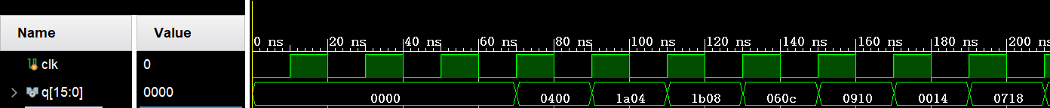
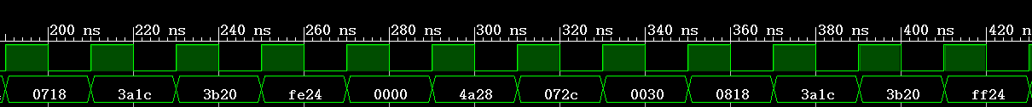
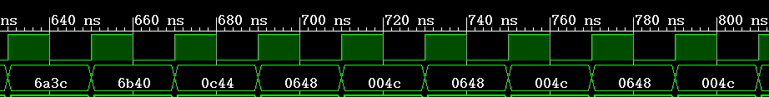
结果0648正确

运行file1pipe5.asm的仿真图（正确的计算结果为06，由于没有处理冒险，结果不正确）：
由于没有处理数据冒险，导致lw $s1,0($t0)从0608变为1108，即s1的值为11，所以程序不会跳出
beq $s1,$s2,exit循环，陷入死循环，结果错误。

阅读程序file1pipe1.asm，其中目的寄存器为$zero的指令为nop指令， 找出所有在删除nop指令后会出现的数据冒险，把相关联的寄存器用不同颜色标注。
addi $t0,$zero,4
//addi $zero,$zero,0x1a
//addi $zero,$zero,0x1b
lw $s1,0($t0) 数据冒险 EX/MEM.RegisterRd = ID/EX.RegisterRs
lw $s2,4($t0) 数据冒险 MEM/WB.RegisterRd = ID/EX.RegisterRs
add $s3,$zero,$zero
loop:
addi $s1,$s1,1
//addi $zero,$zero,0x3a
//addi $zero,$zero,0x3b
beq $s1,$s2,exit EX/MEM.RegisterRd = ID/EX.RegisterRs
//addi $zero,$zero,0x4a
add $s3,$s3,$s1 MEM/WB.RegisterRd = ID/EX.RegisterRt
j loop
//addi $zero,$zero,0x5a
exit:
sub $s3,$s3,$s2
//addi $zero,$zero,0x6a
//addi $zero,$zero,0x6b
sw $s3,8($t0) MEM/WB.RegisterRd = ID/EX.RegisterRt
ll:
lw $s3,8($t0) MEM/WB.RegisterRd = ID/EX.RegisterRt
j ll
//addi $zero,$zero,0x7a

阅读程序file1pipe5.asm，找出所有的load-use冒险和load-beq冒险，把相关联的寄存器用不同颜色标注。如果分支和转移时继续执行其后的一条指令而不将其作废，则可能会出现控制冒险（除非故意安排一条可以执行的语句），把具有控制冒险的语句用黑体标注。
addi $t0,$zero,4
add $s3,$zero,$zero
lw $s1,0($t0)
loop:
addi $s1,$s1,1 load-use冒险
lw $s2,4($t0)
beq $s1,$s2,exit load-beq冒险
add $s3,$s3,$s1
j loop
exit:
sub $s3,$s3,$s2
sw $s3,8($t0)
ll:
lw $s3,8($t0)
j ll
步骤2、参考“fig-4.60.jpg”增加ForwardUnit处理数据冒险（beq和bne指令除外），可以正确运行file1pipe2.asm。
(a) ForwardUnit可以处理ex与mem和wb之间的数据冒险，beq和bne的数据冒险属于id与ex和mem之间的数据冒险。
(b) Mux8和Mux9加在Mux7之前,Mux10和Mux11加在Mux2之前，Mux11作为ReadData2接入ExMemRegister (考虑sw和上一条指令的相关性)
(c) 数据冒险要考虑指令rs和rt是否真的在指令中使用了，因此，Control要增加输出rsUsed和rtUsed并通过IdExRegister输入到ForwardUnit。* sw指令同时使用了rs和rt。
运行file1pipe2.asm的参考仿真图：
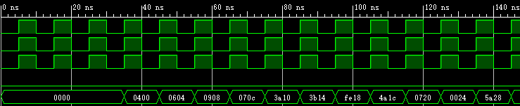
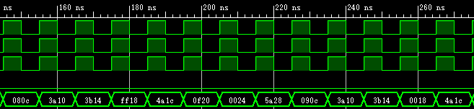
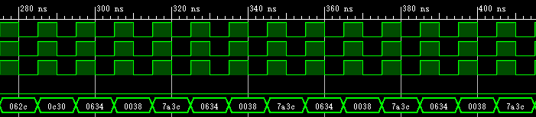

* 仿真的输出数据在file1pipe2.asm的末尾。
修改前的仿真图：
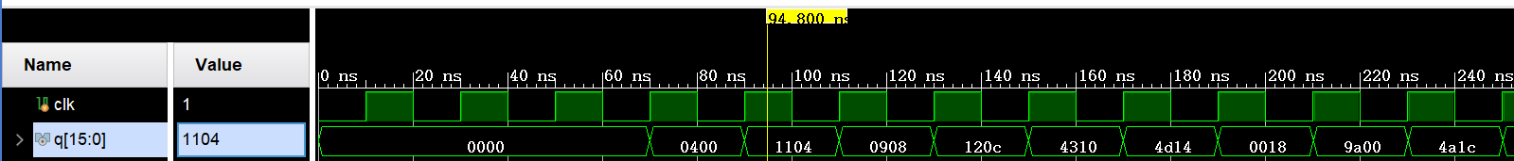
指出其中问题：
指令lw $s1,0($t0)存在数据冒险，EX/MEM.RegisterRd = ID/EX.RegisterRs，t0的值还未写回寄存器组，导致$s1的值取到了11而非6，从而陷入死循环。
修改成功后的仿真图：
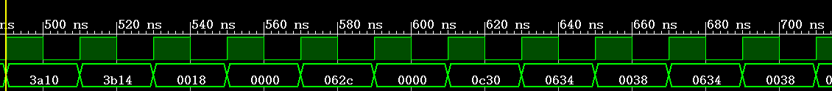

步骤3、 参考“fig-4.60.jpg”增加ForwardUnit2处理beq和bne的数据冒险，可以正确运行file1pipe3.asm。 ForwardUnit2与ForwardUnit类似，只是beq的rs和rt的前推数据来源于EX.writeRegister和Mem. writeRegister。
运行file1pipe3.asm的参考仿真图：

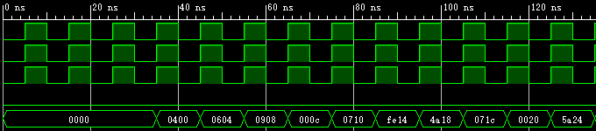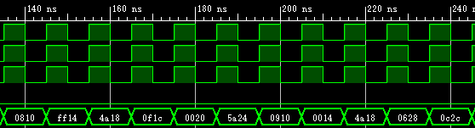
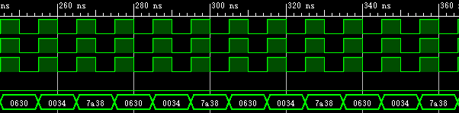
* 仿真的输出数据在file1pipe3.asm的末尾。

修改前的仿真图：
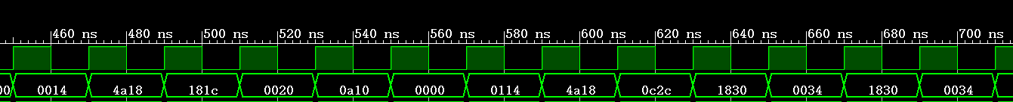
指出其中问题：
存在控制冒险load-beq冒险：
addi $s1,$s1,1
beq $s1,$s2,exit
$s1还未写回寄存器就将$s1,$s2进行比较
修改成功后的仿真图：
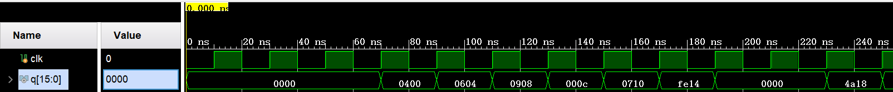
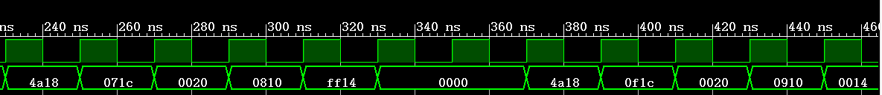
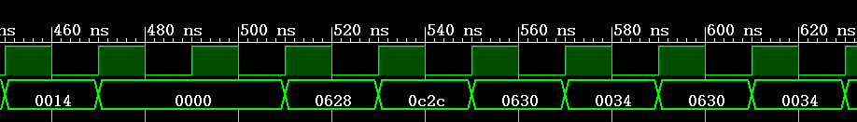
步骤4、处理load-use和load-beq/bne。参考“fig-4.60.jpg”增加HazardDetectUnit，使一条处于id阶段的指令如果后面紧跟有数据冒险的lw指令需要在lw指令之前插入一条nop指令，即该指令暂停（stall）一个时钟周期，如果该指令是beq/bne指令，则要在后面有数据冒险的lw指令之前插入两条nop指令，即需要暂停2个时钟周期。stall的方法是保持pc和IfIdRegister的内容不变，IdExRegister中的Control信号清0（实际只需要清除idexRegWrite和idexMemWrite），并且所有其他内容也清0（便于观察）。测试程序为file1pipe4.asm。
* 暂停应采用always内部处理，不建议使用屏蔽clk的方法。
file1pipe4.asm在不影响基本流程和结果的情况下调整了几条指令的次序，形成了load-use和load-beq：
lw $s1,0($t0) # 0604
addi $s1,$s1,1 # 0710 0810 0910
lw $s2,4($t0)
beq $s1,$s2,exit # fe1c ff1c 001c
运行file1pipe4.asm的参考仿真图：
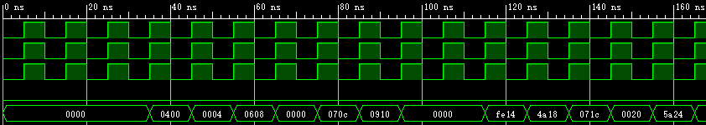
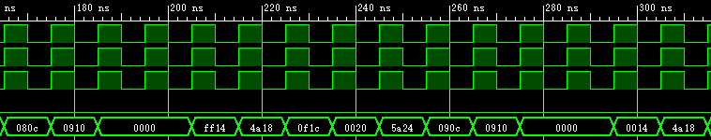
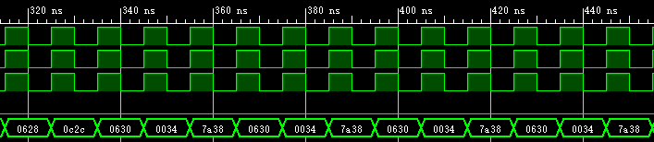
* 其中的0000为nop指令。仿真的输出数据在file1pipe4.asm的末尾。
修改前的仿真图：

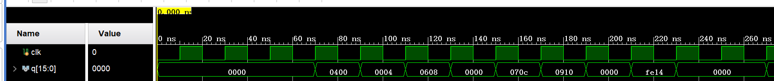
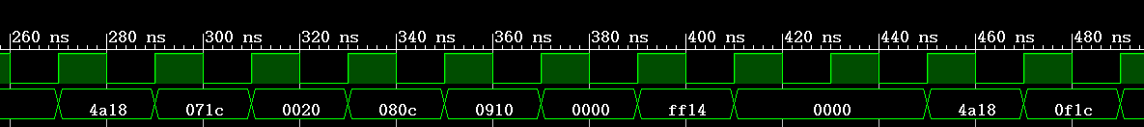
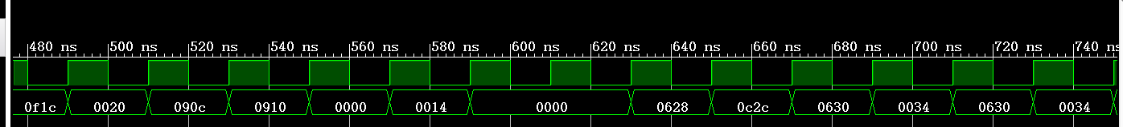

指出其中问题：由于在前面处理数据冒险的时候顺便处理了load-use和load-beq/bne（加一条nop指令），所以我的仿真没有问题，不用修改。

修改成功后的仿真图：（和修改前相同，没有问题）

步骤5、参考“fig-4.60.jpg”，当beq/bne/j/jr/jal指令分支时，其后的一条指令将被清空，也就是将一条全0指令(sll $zero,$zero,0)保存到IfIdRegister,这样就不需要在这些指令之后跟一条nop指令。测试程序为file1pipe5.asm。
运行file1pipe5.asm的参考仿真图：
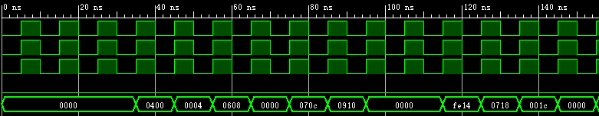
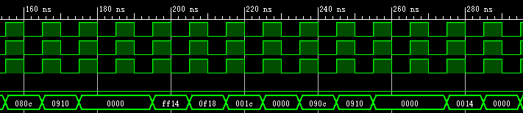
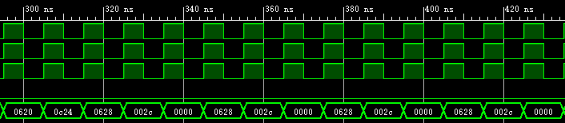
* 其中的0000为nop指令。仿真的输出数据在file1pipe4.asm的末尾。
修改前的仿真图：
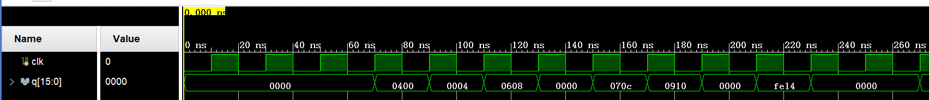
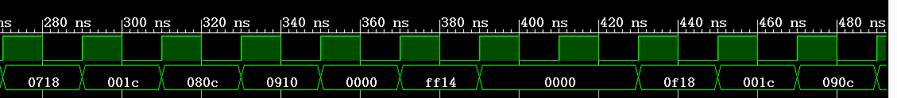
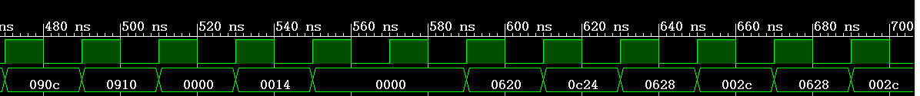
指出其中问题：由于我的设计中beq，bne是通过插入两个气泡处理，执行的下一条指令是理论上的目的指令（不转移时执行顺序执行的那条指令，转移时执行要转移的那条指令），不会额外取到下一条指令；j，jal，jr指令是直接转到目的指令，也不会额外取到下一条指令。所以我的仿真没有问题，不用修改。
修改成功后的仿真图：（和修改前相同，没有问题）

最后成功仿真步骤的模块源码（名字可变，也可增减，字体和行距最小，能看清就行，也可截屏）：
[PC]
- `timescale 1ns / 1ps

- module PC(
- input clk,
- input Branch,
- input [1:0] PCSrc,
- input [31:0] immediate,//立即数
- input [25:0] addr,//j指令的跳转地址
- input [31:0] ra,
- output reg[31:0] pc,
- input stall
- );

- integer i;
- initial
- begin
- i=-1;
- pc=0;
- end

- always@(negedge clk)
- begin
- if(i>=0&&stall==0) i=i-1;
- end

- always@(posedge clk)
- begin
- if(stall==1)
- begin
- end

- else begin
- if(Branch==1) i=2;
- //pc=pc+4;//这里在i=2时pc=pc+4,所以可以不用pc0，

- if(i>=0&&i<2)
- begin
- //pc=pc0;
- if(PCSrc==2'b01) pc=pc+immediate*4;//beq,bne
- end
- else
- case(PCSrc)
- 2'b00: pc=pc+4;//下一条指令
- 2'b01: pc=pc+4+immediate*4;//加指令低16扩展后左移两位,beq,bne
- 2'b10:// j ,jal
- begin
- pc=pc+4;
- pc={pc[31:28],addr[25:0],2'b00};
- end
- 2'b11: //jr
- begin
- pc = ra;
- end
- default: pc=pc+4;
- endcase
- end

- end

- endmodule

[CPU]
- `timescale 1ns / 1ps

- module CPU(
- input clk,
- output [15:0] q
- );
- wire[31:0] pc;
- wire[31:0] ins;
- wire[31:0] ra;

- wire [5:0] opcode,func;
- wire [4:0] rs,rt,rd,shamt;
- wire [31:0] immediate,immediate0;//立即数
- wire [25:0] addr;//j,jal指令跳转到的地址

- wire[1:0] PCSrc;//控制转移信号
- wire Jal,Branch;
- wire RegDst,MemRead,MemtoReg,MemWrite,ALUSrc,RegWrite;//Control控制信号,去除了Branch,Jump
- wire [1:0] ALUOP;
- wire zero;

- wire zero0;//Registers的输出，判断rs==rt的结果
- wire[31:0] ReadData1,ReadData2;//寄存器组输出: rs,rt的值
- wire[31:0] aluResult;//ALU
- wire[31:0] ReadData;//DataMem
- //wire [31:0] WriteData;//由Result与ReadData二选一生成

- wire[31:0] ifidPcOut;
- wire[5:0] ifid_opcode,ifid_func;
- wire[4:0] ifid_rs,ifid_rt,ifid_rd,ifid_shamt;
- wire[31:0] ifid_immediate;
- wire[25:0] ifid_addr;
- wire ifid_Branch;

- wire[31:0] idexPcOut;
- wire[5:0] idex_opcode;
- wire[1:0] idex_ALUOP;
- wire idex_Branch,idex_MemRead,idex_MemtoReg,idex_MemWrite,idex_ALUSrc,idex_RegWrite;
- wire [31:0] idexReadData1Out,idexReadData2Out,idex_immediate;
- wire [4:0] idex_WriteRegister,idex_rs,idex_rt;

- wire exmemMemRead,exmemMemtoReg,exmemMemWrite,exmemRegWrite;
- wire [31:0]exmemPCOut,exmemAluResult,exmemReadData2Out;
- wire exmemZero;
- wire [4:0] exmem_WriteRegister;

- wire [4:0]MemWb_WriteRegister;
- wire MemWb_RegWrite;
- wire [31:0] MemWbPCOut,MemWb_WriteData;

- wire[31:0] _ReadData1,_ReadData2;
- wire stall;

- assign q[15:8] = MemWb_WriteData[7:0];
- assign q[7:0] = MemWbPCOut[7:0];

- PCControl uPCControl(opcode,func,idex_opcode,zero,PCSrc,Branch,Jal);//只用插入1条nop指令

- PC uPC(clk,Branch,PCSrc,immediate0,addr,ra,pc,stall);
- InsMemory uInsMemory(pc,ins,opcode,func,rs,rt,rd,shamt,immediate,immediate0,addr);
- Control uControl(ifid_opcode,ifid_func,RegDst,MemRead,MemtoReg,ALUOP,MemWrite,ALUSrc,RegWrite);
- Registers uRegisters(clk,MemWb_RegWrite,MemWb_WriteRegister,MemWb_WriteData,ifid_rs,ifid_rt,ReadData1,ReadData2,Jal,pc,ra,zero0);
- ALU uALU(_ReadData1,_ReadData2,idex_immediate,idex_ALUSrc,idex_ALUOP,zero,aluResult);
- DataMemory uDataMemory(clk,exmemAluResult,exmemReadData2Out,exmemMemWrite,exmemMemRead,ReadData);

- ifidRegister uifidRegister(clk,pc,ins,Branch,stall,
- ifidPcOut,ifid_opcode,ifid_func,ifid_rs,ifid_rt,ifid_rd,ifid_shamt,ifid_immediate,ifid_addr,ifid_Branch);

- idexRegister uidexRegister(clk,stall,ifidPcOut,ifid_opcode,ALUOP,ifid_Branch,RegDst,MemRead,MemtoReg,MemWrite,ALUSrc,
- RegWrite,ReadData1,ReadData2,ifid_immediate,ifid_rs,ifid_rt,ifid_rd,
- idexPcOut,idex_opcode,idex_ALUOP,idex_Branch,idex_MemRead,idex_MemtoReg,idex_MemWrite,idex_RegWrite,idex_ALUSrc,
- idexReadData1Out,idexReadData2Out,idex_immediate,idex_WriteRegister,idex_rs,idex_rt);

- ExMemRegister uExMemRegister(clk, idex_MemRead,idex_MemtoReg,idex_MemWrite,idex_RegWrite,
- idexPcOut,aluResult,_ReadData2,zero,idex_WriteRegister,
- exmemMemRead,exmemMemtoReg,exmemMemWrite,exmemRegWrite,exmemPCOut,
- exmemAluResult,exmemReadData2Out,exmemZero,exmem_WriteRegister);

- MemWbRegister uMemWbRegister(clk,exmemMemtoReg,exmemRegWrite,exmem_WriteRegister,
- exmemAluResult,ReadData,exmemPCOut,
- MemWb_WriteRegister,MemWb_RegWrite,MemWb_WriteData,MemWbPCOut);

- ForwardUnit uForwardUnit(exmemRegWrite,MemWb_RegWrite,MemWb_WriteRegister,exmem_WriteRegister,idex_rs,idex_rt,
- idexReadData1Out,idexReadData2Out,exmemAluResult,MemWb_WriteData,
- _ReadData1,_ReadData2);

- StallUnit uStallUnit(ifid_rs,ifid_rt,idex_WriteRegister,idex_MemRead,MemRead,stall);

- endmodule

[CPU_sim]
- `timescale 1ns / 1ps

- module CPU_sim();
- reg clk;
- wire[15:0] q;
- CPU uCPU(clk,q);
- initial begin
- clk = 0;
- end
- always #10 clk = ~clk;
- endmodule

[DataMemory]
- `timescale 1ns / 1ps

- module DataMemory(
- input clk,
- input [31:0] address,//ALU的Result
- input [31:0] WriteData,//Registers的ReadData2，前推后的
- input MemWrite,
- input MemRead,
- output reg[31:0] ReadData
- );

- reg[31:0] mem[127:0];
- integer i;
- initial
- begin
- for(i=0;i<128;i=i+1) mem[i]=0;
- $readmemh("data1.txt",mem);//读文件
- end

- always@(*)//读操作无需时钟信号
- begin
- if(MemRead)
- begin
- //ReadData=mem[(address-32'b00000000000000000010000000000000)>>2];
- //使数据段在数据存储器中的位置从0开始
- ReadData=mem[address>>2];//
- end
- end

- always@(posedge clk)//写操作
- if(MemWrite)
- begin
- //mem[(address-32'b00000000000000000010000000000000)>>2]=WriteData;
- mem[address>>2]=WriteData;
- end

- endmodule

[InsMemory]
- `timescale 1ns / 1ps
- module InsMemory(
- input [31:0] pc,
- output [31:0] ins0,
- output [5:0] opcode,func,
- output [4:0] rs,
- output [4:0] rt,
- output [4:0] rd,
- output [4:0] shamt,
- output [31:0] immediate,immediate0,
- output [25:0] addr
- );
- reg [31:0] ins;
- reg [25:0] addr0;
- reg[31:0] mem[127:0];
- integer i;
- initial begin
- ins=0;
- addr0=0;
- for(i=0;i<128;i=i+1) mem[i]=0;
- $readmemh("file1pipe5.txt", mem);
- end

- always@(*)
- begin
- ins = mem[pc>>2];
- addr0 = (opcode==6'b000010||opcode==6'b000011)?ins[25:0]:addr0;
- end
- assign ins0 = ins;
- assign opcode = ins[31:26];
- assign rs = ins[25:21];
- assign rt = ins[20:16];
- assign rd = ins[15:11];
- assign shamt = ins[10:6];
- assign immediate[15:0] = ins[15:0];
- assign immediate[31:16] = ins[15]?16'hffff:16'h0000;
- assign immediate0 = ((opcode==6'b000100)||(opcode==6'b000101))?immediate:immediate0;
- assign addr = addr0;
- assign func= ins[5:0];

- endmodule

[PCControl]
- `timescale 1ns / 1ps
- module PCControl(
- input [5:0] opcode,func,
- input [5:0] idex_opcode,
- input zero,
- output reg[1:0] PCSrc,
- output Branch,
- output Jal
- );
- //assign Sw = (opcode==6'b101011)?1:0;
- assign Branch = ((opcode==6'b000100)||(opcode==6'b000101))?1:0;//插入1条nop指令
- assign Jal=(opcode==6'b000011)?1:0;
- always@(*)
- begin
- if((idex_opcode==6'b000100&&zero==1'b1)||(idex_opcode==6'b000101&&zero==0))
- begin
- PCSrc = 2'b01;//beq,bne
- end
- else if(opcode==6'b000010||opcode==6'b000011)
- begin
- PCSrc = 2'b10;//j jal
- end
- else if(opcode==6'b000000&&func==6'b001000)
- begin
- PCSrc = 2'b11;//jr
- end
- else
- begin
- PCSrc = 2'b00;
- end
- end
- endmodule

[Control]
- `timescale 1ns / 1ps
- module Control(
- input [5:0] opcode,func,
- //input zero,
- //output reg[1:0] PCSrc,
- //output Jal,
- output RegDst,
- //output Jump,
- //output Branch,
- output MemRead,
- output MemtoReg,
- output reg [1:0] ALUOP,
- output MemWrite,
- output ALUSrc,
- output RegWrite
- );
- //Jal
- //assign Jal=(opcode==6'b000011)?1:0;
- //addi lw addiu
- assign RegDst=(opcode==6'b001000||opcode==6'b100011 ||opcode==6'b001001)?0:1;
- //j jal
- //assign Jump=(opcode==6'b000010||opcode==6'b000011)?1:0;
- //beq
- //assign Branch=(opcode==6'b000100)?1:0;//去除Branch和Jump，转移都用PCSrc判断
- //lw
- assign MemRead=(opcode==6'b100011)?1:0;
- //lw
- assign MemtoReg=(opcode==6'b100011)?1:0;
- //sw
- assign MemWrite=(opcode==6'b101011)?1:0;
- //lw sw addi addiu
- assign ALUSrc=(opcode==6'b100011||opcode==6'b101011||opcode==6'b001000 ||opcode==6'b001001)?1:0;
- //add sub slt addi lw addiu
- assign RegWrite=(opcode==6'b000000||opcode==6'b101010||opcode==6'b001000||opcode==6'b100011||opcode==6'b001001)?1:0;

- always@(*)
- begin
- if(opcode == 6'b000000)begin
- case(func)
- //add
- 6'b100000 : ALUOP=2'b00;
- //sub
- 6'b100010: ALUOP=2'b01;
- //slt
- 6'b101010: ALUOP=2'b11;
- default: ALUOP=2'b00;
- endcase
- end

- else begin
- case(opcode)
- //addi
- 6'b001000: ALUOP=2'b00;
- //addiu
- 6'b001001: ALUOP=2'b00;
- //sw
- 6'b101011: ALUOP=2'b00;
- //lw
- 6'b100011: ALUOP=2'b00;
- //beq
- 6'b000100: ALUOP=2'b01;
- //bne
- 6'b000101: ALUOP=2'b01;
- default:ALUOP=2'b00;
- endcase
- end
- end
- endmodule

[Registers]
- `timescale 1ns / 1ps

- module Registers(
- input clk,
- //input RegDst,
- input RegWrite,
- input [4:0] WriteRegister,
- input [31:0] WriteData,
- //input MemtoReg,
- input [4:0] rs,
- input [4:0] rt,
- //input [4:0] rd,
- //input [31:0] Result,
- //input [31:0] ReadData,
- output [31:0] ReadData1,
- output [31:0] ReadData2,
- input Jal,
- input [31:0] pc,
- output [31:0] ra,
- output zero
- );

- reg [31:0] register[0:31];//寄存器组
- integer i;
- initial
- begin
- for(i=0;i<32;i=i+1) register[i]=0;
- end

- //wire [4:0] WriteRegister;//实现MUX（1）
- //assign WriteRegister=RegDst?rd:rt;//实现MUX（1）
- //assign WriteData=MemtoReg?ReadData:Result;//实现MUX（3）

- assign ReadData1=register[rs];
- assign ReadData2=register[rt];
- assign zero=(ReadData1==ReadData2)?1:0;
- assign ra = register[31];

- always @(negedge clk)//写操作
- begin
- if(Jal==1) register[31] = pc+4;//jal指令保存pc+4(下一条指令pc))到$ra
- if(RegWrite&&WriteRegister!=0)begin
- register[WriteRegister]=WriteData;
- end
- end

- endmodule

[ALU]
- `timescale 1ns / 1ps

- module ALU(
- input [31:0] ReadData1,
- input [31:0] ReadData2,
- input [31:0] immediate,
- input ALUSrc,
- input [1:0] ALUOP,
- output zero,
- output reg [31:0]Result
- );
- initial
- begin
- Result=0;
- end
- wire [31:0] a,b;
- assign a=ReadData1;
- assign b=ALUSrc?immediate:ReadData2;//MUX（2）
- assign zero=(Result==0)?1:0;

- always@(*)
- begin
- case(ALUOP)
- 2'b00://加法
- begin
- Result=a+b;
- end
- 2'b01://减法
- begin
- Result=a-b;
- end
- 2'b11://slt
- begin
- Result=(a<b)?1:0;
- end
- default:
- Result=0;
- endcase
- end

- endmodule

[ifidRegister]
- `timescale 1ns / 1ps

- module ifidRegister(
- input clk1,
- input [31:0]pc,
- input [31:0]ins,
- input Branch,stall,
- output reg[31:0] ifidPcOut,
- output reg[5:0] ifid_opcode,ifid_func,
- output reg[4:0] ifid_rs,
- output reg[4:0] ifid_rt,
- output reg[4:0] ifid_rd,
- output reg[4:0] ifid_shamt,
- output reg[31:0] ifid_immediate,
- output reg[25:0] ifid_addr,
- output reg ifid_Branch
- );
- integer i;

- initial
- begin
- i=-1;
- ifidPcOut = 0;
- ifid_opcode = 0;
- ifid_rs = 0;
- ifid_rt = 0;
- ifid_rd = 0;
- ifid_shamt = 0;
- ifid_immediate[15:0] = 0;
- ifid_immediate[31:16] = 0;
- ifid_addr = 0;
- ifid_func= 0;
- ifid_Branch=0;
- end

- always@(negedge clk1)
- begin
- if(i>=0&&stall==0) i=i-1;
- end

- always @(posedge clk1)
- begin
- if(stall==1)
- begin
- end
- else begin
- if(Branch==1)i=2; //插入i条nop指令
- if(i>=0&&i<2)
- begin
- ifidPcOut = 0;
- ifid_opcode = 0;
- ifid_rs = 0;
- ifid_rt = 0;
- ifid_rd = 0;
- ifid_shamt = 0;
- ifid_immediate[15:0] = 0;
- ifid_immediate[31:16] = 0;
- ifid_addr = 0;
- ifid_func= 0;
- ifid_Branch=0;
- end
- else
- begin
- ifidPcOut = pc;
- ifid_opcode = ins[31:26];
- ifid_rs = ins[25:21];
- ifid_rt = ins[20:16];
- ifid_rd = ins[15:11];
- ifid_shamt = ins[10:6];
- ifid_immediate[15:0] = ins[15:0];
- ifid_immediate[31:16] = ins[15]?16'hffff:16'h0000;
- ifid_addr = ins[25:0];
- ifid_func= ins[5:0];
- ifid_Branch=Branch;
- end

- end

- end
- endmodule

[idexRegister]
- module idexRegister(
- input clk2,stall,
- input [31:0] ifidPcOut,
- input [5:0] ifid_opcode,
- input [1:0] ALUOP,
- input Branch,RegDst,MemRead,MemtoReg,MemWrite,ALUSrc,RegWrite,
- input [31:0] ReadData1,ReadData2,ifid_immediate,
- input [4:0]rs,rt,rd,
- output reg[31:0] idexPcOut,
- output reg[5:0] idex_opcode,
- output reg[1:0] idex_ALUOP,
- output reg idex_Branch,idex_MemRead,idex_MemtoReg,idex_MemWrite,idex_RegWrite,idex_ALUSrc,
- output reg[31:0] idexReadData1Out,idexReadData2Out,idex_immediate,
- output reg[4:0] idex_WriteRegister,idex_rs,idex_rt
- );

- integer i;

- initial
- begin
- i=-1;
- idexPcOut <= 0;
- idex_ALUOP<=0;
- idex_opcode<= 0 ;
- {idex_Branch,idex_MemRead,idex_MemtoReg,idex_MemWrite,idex_ALUSrc,idex_RegWrite}
- <= 0;
- idexReadData1Out<=0;
- idexReadData2Out<=0;
- idex_immediate<=0;
- {idex_WriteRegister,idex_rs,idex_rt}<=0;
- end

- always@(negedge clk2)
- begin
- if(i>=0) i=i-1;
- end

- always @(posedge clk2)
- begin
- if(stall==1)
- begin
- idexPcOut <= 0;
- idex_ALUOP <= 0;
- {idex_Branch,idex_MemRead,idex_MemtoReg,idex_MemWrite,idex_ALUSrc,idex_RegWrite}
- <= 0;
- idex_opcode<= 0 ;
- idexReadData1Out <=0;
- idexReadData2Out <=0;
- idex_immediate <= 0;
- idex_WriteRegister=0;//实现MUX（1）
- {idex_rs,idex_rt}<=0;
- end
- else
- begin
- idexPcOut <= ifidPcOut;
- idex_ALUOP <= ALUOP;
- {idex_Branch,idex_MemRead,idex_MemtoReg,idex_MemWrite,idex_ALUSrc,idex_RegWrite}
- <= {Branch,RegDst,MemRead,MemtoReg,MemWrite,ALUSrc,RegWrite};
- idex_opcode<= ifid_opcode ;
- idexReadData1Out <=ReadData1;
- idexReadData2Out <=ReadData2;
- idex_immediate <= ifid_immediate;
- idex_WriteRegister=RegDst?rd:rt;//实现MUX（1）
- {idex_rs,idex_rt}<={rs,rt};
- end
- end

- endmodule

[ExMemRegister]
- module ExMemRegister(clk, idex_MemRead,idex_MemtoReg,idex_MemWrite,idex_RegWrite, pc,aluResult,idexReadData2Out,Zero,WriteRegister,
- exmemMemRead,exmemMemtoReg,exmemMemWrite,exmemRegWrite,exmemPCOut,exmemAluResult,exmemReadData2Out,exmemZero,exmem_WriteRegister);
- input clk, idex_MemRead,idex_MemtoReg,idex_MemWrite,idex_RegWrite;
- output reg exmemMemRead,exmemMemtoReg,exmemMemWrite,exmemRegWrite;
- input [31:0] pc,aluResult,idexReadData2Out;
- output reg [31:0] exmemPCOut,exmemAluResult,exmemReadData2Out;

- input Zero;
- output reg exmemZero;

- input [4:0] WriteRegister;
- output reg[4:0] exmem_WriteRegister;//ExMem_rd;

- initial begin
- {exmemMemRead,exmemMemtoReg,exmemMemWrite,exmemRegWrite,exmemPCOut,exmemAluResult }<=0;
- exmemReadData2Out<=0;
- exmemZero<=0;
- exmem_WriteRegister<=0;
- end
- always @(posedge clk) begin
- {exmemMemRead,exmemMemtoReg,exmemMemWrite,exmemRegWrite,exmemPCOut,exmemAluResult}
- <= { idex_MemRead,idex_MemtoReg,idex_MemWrite,idex_RegWrite,pc,aluResult};
- exmemReadData2Out<= idexReadData2Out;
- exmemZero <= Zero;
- exmem_WriteRegister <= WriteRegister;
- end
- endmodule

[MemWbRegister]
- module MemWbRegister(
- input clk,
- input MemtoReg,RegWrite,
- input [4:0] WriteRegister,
- input [31:0] AluResult,ReadData,pc,
- output reg[4:0]MemWb_WriteRegister,
- output reg MemWb_RegWrite,
- output reg [31:0] MemWb_WriteData,MemWbPCOut
- );
- initial
- begin
- MemWb_WriteData<=0;
- MemWb_RegWrite<=0;
- MemWb_WriteRegister<=0;
- MemWbPCOut<=0;
- end

- always @(posedge clk)
- begin
- MemWb_WriteData<=MemtoReg?ReadData:AluResult;//实现MUX（3）
- MemWb_RegWrite<=RegWrite;
- MemWb_WriteRegister<=WriteRegister;//MemWb_rd;
- MemWbPCOut<= pc;
- end
- endmodule

[ForwardUnit]
- `timescale 1ns / 1ps

- module ForwardUnit(
- input exmemRegWrite,MemWb_RegWrite,
- input[4:0] MemWb_rd,ExMem_rd,idex_rs,idex_rt,
- input[31:0] idexReadData1Out,idexReadData2Out,exmemAluResult,MemWb_WriteData,
- output reg[31:0] _ReadData1,_ReadData2
- );
- reg [1:0] ForwardA;
- reg [1:0] ForwardB;
- initial
- begin
- _ReadData1=0;
- _ReadData2=0;
- ForwardA=0;
- ForwardB=0;
- end

- always@(*)
- begin
- ForwardA = 2'b00;
- ForwardB = 2'b00;
- if ( (exmemRegWrite!=0) &&(ExMem_rd != 0)&& (ExMem_rd== idex_rs))//(exmemRegWrite!=0) &&
- ForwardA = 2'b01;
- if ( (exmemRegWrite!=0)&&(ExMem_rd != 0)&& (ExMem_rd== idex_rt))//(exmemRegWrite!=0)&&
- ForwardB = 2'b01;

- if ((MemWb_RegWrite!=0) && (MemWb_rd != 0)&& (MemWb_rd == idex_rs))//(MemWb_RegWrite!=0) &&
- ForwardA = 2'b10;
- if ((MemWb_RegWrite!=0) && (MemWb_rd != 0)&& (MemWb_rd== idex_rt))//(MemWb_RegWrite!=0) &&
- ForwardB = 2'b10;

- case(ForwardA)
- 2'b00: _ReadData1= idexReadData1Out;
- 2'b01: _ReadData1= exmemAluResult;//MemWb_WriteData
- 2'b10: _ReadData1= MemWb_WriteData;//exmemAluResult
- default: _ReadData1= idexReadData1Out;
- endcase

- case(ForwardB)
- 2'b00: _ReadData2= idexReadData2Out;
- 2'b01: _ReadData2= exmemAluResult;
- 2'b10: _ReadData2= MemWb_WriteData;
- default: _ReadData2= idexReadData2Out;
- endcase

- end

- endmodule

[StallUnit]
- `timescale 1ns / 1ps
- module StallUnit(
- input [4:0]ifid_rs,ifid_rt,idex_WriteRegister,
- input idex_MemRead,ifid_MemRead,
- output wire stall
- );

- assign stall=((idex_MemRead==1)&&(idex_WriteRegister!=0)&&
- (idex_WriteRegister == ifid_rs||(ifid_MemRead!=1&&idex_WriteRegister == ifid_rt) ) )?1:0;

- endmodule

…

【完成情况】
是否完成？(√完成 ×未做)
步骤1 [√] 步骤2 [√] 步骤3 [√] 步骤4 [√] 步骤5 [√]

【实验体会】
写出实验过程中遇到的问题，解决方法和自己的思考;并简述实验体会（如果有的话）。

问题1）为了使程序正确运行不得不插入更多气泡：
在实现beq插入气泡时，最先我是插入两个气泡，等到Ex阶段的ALU结果zero算出来在判断是否转移；后来发现beq的两个操作数都是寄存器中的数据，所以直接让寄存器组[registers]多一个输出zero1判断ReadData1和ReadData2是否相等，这样在ID阶段就能判断是否转移，这样就只用插入1个气泡；但是随后要解决控制冒险发现插入1个气泡，不能使用前推（产生了load-beq冒险），从而插入了nop指令更慢，反而插入两个气泡可以使用前推解决数据冒险来解决控制冒险.

问题2）前推模块ForwardUnit中我的ForwardA，ForwardB两个是Reg类型的变量，所以前推根据条件：
if ( (exmemRegWrite!=0) &&(ExMem_rd != 0)&& (ExMem_rd== idex_rs))
ForwardA = 2'b01;
if ( (exmemRegWrite!=0)&&(ExMem_rd != 0)&& (ExMem_rd== idex_rt))
ForwardB = 2'b01;
if ((MemWb_RegWrite!=0) && (MemWb_rd != 0)&& (MemWb_rd == idex_rs))
ForwardA = 2'b10;
if ((MemWb_RegWrite!=0) && (MemWb_rd != 0)&& (MemWb_rd== idex_rt))
ForwardB = 2'b10;
会导致没被条件命中的ForwardA，ForwardB保存上一次的值，从而前推错误，也是因为这个原因，导致我的file1pipe5.txt中的sw指令执行错误。
解决方法：每次判断时先令ForwardA=0，ForwardB=0，再根据条件改变相应的值。

问题3）我的StallUnit模块开始解决load-use和load-beq冒险的方法都是错的，但是却能“正常”运行file1pipe1-file1pipe5.txt，即结果正确。因为我的判断方法是 ：
stall=((idex_WriteRegister!=0)&&(idex_WriteRegister==ifid_rs||idex_WriteRegister == ifid_rt) )?1:0;
根本没有考虑load-use和load-beq冒险原因的实质是lw指令只有在Mem阶段结束才得到要读取的数据，而此时紧接lw指令的下一条指令已经在Ex阶段结束了，根本没法前推lw读取的数据，所以要在lw后插入一条nop指令。即在判断条件加上idex_MemRead==1(表示处于idex寄存器的是一条lw指令)。进一步，如果lw指令的下一条指令也是lw指令，且两条指令的rt都相同，这种情况不用插入nop指令，但满足了idex_WriteRegister == ifid_rt，所以也要排除这种情况。（在冒泡排序程序中8条连续的lw指令就是这种情况）。从而得到最终判断条件为：
- assign stall=((idex_MemRead==1)&&(idex_WriteRegister!=0)&&
- (idex_WriteRegister == ifid_rs||(ifid_MemRead!=1&&idex_WriteRegister == ifid_rt) ) )?1:0;
这里ifid_MemRead实际是Control的输出信号MemRead。
同时，我发现Control的两个输出控制信号MemRead和MemtoReg实际上可以用同一个信号表示，因为它们都仅在指令为lw时为1.

【交实验报告】
每位同学单独完成本实验内容并填写实验报告。
交作业地点：http://172.18.187.251/netdisk/default.aspx?vm=20org
FPGA实验/07、流水线CPU设计(2)
截止日期：2021年12月30日23:00（周四）
上传文件：学号_姓名_流水线CPU设计2.doc
学号_姓名_流水线CPU设计2.rar （包含源代码的工程）

