For Functional testing, the testing will cover 4 different users and the their business flow

For Clerk:

1. able to insert single record and update the database with required details(Natural Id(natid), Name, Gender, Birthday, Salary and Tax paid)
2. able to insert multiple records and update the database with required details(Natural Id(natid), Name, Gender, Birthday, Salary and Tax paid)
3. able to upload csv file and update the database with required details(Natural Id(natid), Name, Gender, Birthday, Salary and Tax paid)
4. able to modify the records from database
5. able to delete the records from database

|  |  |  |  |  |  |
| --- | --- | --- | --- | --- | --- |
| **Tesecase S/N** | **Test Steps** | **Expected Result** | **Actual Result** | **Pass / Fail** | **Remark** |
| **Clerk Login** |  |  |  |  |  |
| 1 Sign in as Clerk | Launch the browser with the url: http://localhost:8080/ | The page is launched sccessfully |  |  |  |
|  | * 1. Sign in with clerk account clerk_01 | Able to sign in as clerk |  |  |  |
|  | * 1. Click the dropdown list to select the number of class heroes | Able to select the number of heroes, and display the number of rows |  |  | This is to define the single/multiple insert records, single record will display 1 row only, if select 2, then will display 2 rows for 2 class heroes. |
|  | * 1. Enter the class hero details (Natural Id(natid), Name, Gender, Birthday, Salary and Tax paid) | Able to enter the class heroes detail |  |  |  |
|  | * 1. Click Submit button to update the database | Able to submit the enter information, and update the database. |  |  |  |
|  | * 1. Try miss some information and submit | Should display the error message with missed field. |  |  |  |
|  | * 1. Upload the csv file with the first row (natid, name, gender, salary, birthday, tax) | Able to upload the csv file and update the database |  |  |  |
|  | * 1. Search class hero details with natid or name | Able to get the correct record |  |  |  |
|  | * 1. Edit the classs hero record | Able to edit the record |  |  |  |
|  | * 1. Delete the class hero record | Able to delete the record |  |  |  |

For Bookkeeper:

1. Able to search the amount of tax relief using natid & name, and with the rest of information as gentle, birthday, salary
2. Natid will be masked from the 5th characters onward with $$$
3. Able to enter these required information to the formula and re-calculate the tax relief.
4. Test scenario should cover the age and gender as following:
5. age < 18 and 18
6. 18<age<35, and 35
7. 35<age<50, and 50
8. 50<age<75, and 75
9. 76
10. Male
11. Female

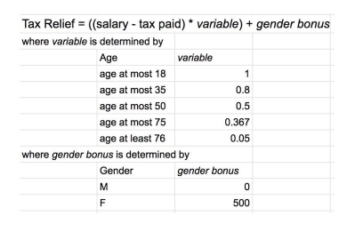

1. If tax relief is less than $50 ( $0.00 - $ 50.00 ), the final amount should be $50
2. The final amount should be truncated at the second decimal place and then subjected to normal rounding rule.

|  |  |  |  |  |  |
| --- | --- | --- | --- | --- | --- |
| **Tesecase S/N** | **Test Steps** | **Expected Result** | **Actual Result** | **Pass / Fail** | **Remark** |
| **Clerk Login** |  |  |  |  |  |
| 2 Sign in as Bookkeeper | Launch the browser with the url: http://localhost:8080/ | The page is launched successfully |  |  |  |
|  | * 1. Sign in with Bookkeeper account Bookkeeper_01 | Able to sign in as Bookkeeper |  |  |  |
|  | * 1. Search the tax relief amount using natid & name, and with the rest information as gentle, age, salary | Able to search the tax relief using name and natid (Natid will be masked from the 5th characters onward with $ )and display the rest of information as gentle, age, salary |  |  |  |
|  | * 1. Enter the Gender, Birthday, Salary and Tax paid to re-calculate the tax relief | When enter the gender, system will display the gender bonus as default.  When enter the birthday, the system will display the age and variable value as default. |  |  |  |
|  | * 1. Final amount display | Final amount will be displayed after the calculated amount,  When tax relief is less than $50 ($0.00 - $ 50.00), the final amount should be $50.  Final amount should be truncated at the second decimal place and then subjected to normal rounding rule. |  |  | If tax relief is $ 0.01 or $49, the final amount will be $50  If tax relief is 12.56678, then the final amount will be $12.57  If tax relief is $12.56234, then the final amount will be $12.56 |

For Governor,

1. Able to search the amount of tax relief using natid & name, and with the rest of information as gentle, birthday, salary
2. Able to click and dispense.

|  |  |  |  |  |  |
| --- | --- | --- | --- | --- | --- |
| **Tesecase S/N** | **Test Steps** | **Expected Result** | **Actual Result** | **Pass / Fail** | **Remark** |
| **Clerk Login** |  |  |  |  |  |
| 3 Sign in as Governor | Launch the browser with the url: http://localhost:8080/ | The page is launched successfully |  |  |  |
|  | * 1. Sign in with Governor account Governor _01 | Able to sign in as Governor |  |  |  |
|  | * 1. Able to Search class hero details with class natid or name | Able to get the correct record with displayed Natural Id(natid), Name, Gender, Birthday, Salary and Tax paid |  |  |  |
|  | * 1. Able to click the “Dispense Now” button to dispense | The button is red colour. The text on the button must be exactly “Dispense Now”  After clicking on the button, it should direct me to a page with a text that says “Cash dispensed” |  |  |  |

For Class hero:

1. Able to search the amount of tax relief using natid & name, and with the rest of information as gentle, birthday, salary
2. Able to enter these required information to the formula and re-calculate the tax relief.

|  |  |  |  |  |  |
| --- | --- | --- | --- | --- | --- |
| **Tesecase S/N** | **Test Steps** | **Expected Result** | **Actual Result** | **Pass / Fail** | **Remark** |
| **Clerk Login** |  |  |  |  |  |
| 4 Sign in as Class hero | Launch the browser with the url: http://localhost:8080/ | The page is launched successfully |  |  |  |
|  | * 1. Sign in with Governor account Class_hero _01 | Able to sign in as Class hero |  |  |  |
|  | * 1. Able to Search class hero details with class natid or name | Able to get the correct record with displayed Natural Id(natid), Name, Gender, Birthday, Salary and Tax paid |  |  |  |
|  | * 1. Enter the Gender, Birthday, Salary and Tax paid to re-calculate the tax relief | When enter the gender, system will display the gender bonus as default.  When enter the birthday, the system will display the age and variable value as default |  |  |  |
|  | * 1. Final amount display | Final amount will be displayed after the calculated amount,  When tax relief is less than $50 ($0.00 - $ 50.00), the final amount should be $50.  Final amount should be truncated at the second decimal place and then subjected to normal rounding rule. |  |  | If tax relief is $ 0.01 or $49, the final amount will be $50  If tax relief is 12.56678, then the final amount will be $12.57  If tax relief is $12.56234, then the final amount will be $12.56 |

For testing execution

API testing: Use Postman to test all endpoints from API document. But seems the server side got error… always response 500…

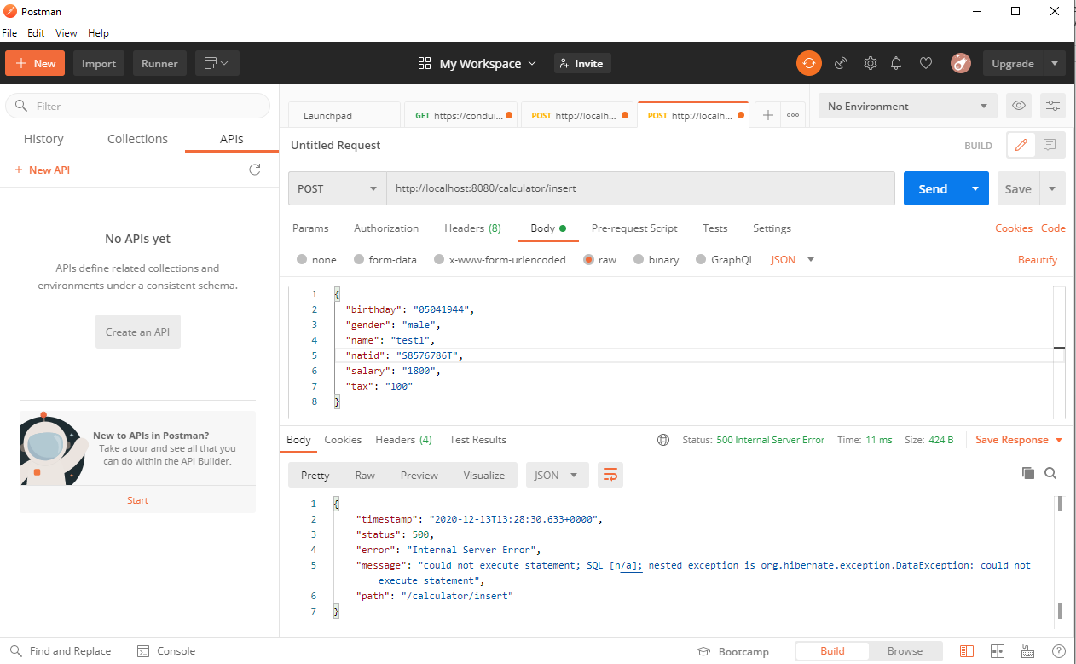

For UI testing, it’s not able to upload the csv file.



The only working function is testcase 3.3, able to click the Red button “Dispense Now” and it will direct the page with text “Cash dispensed”





For non-function testing, we can use Jmeter to test the API (or UI if implemented) performance as show in below, but as mentioned before, it’s not working due to server error.

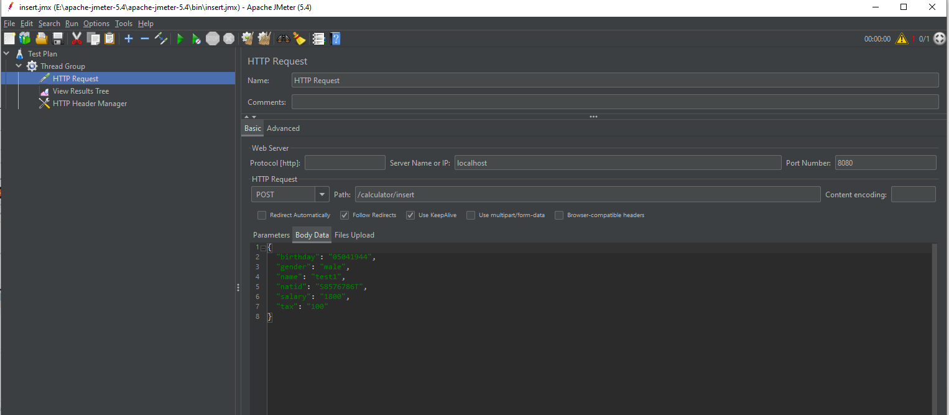

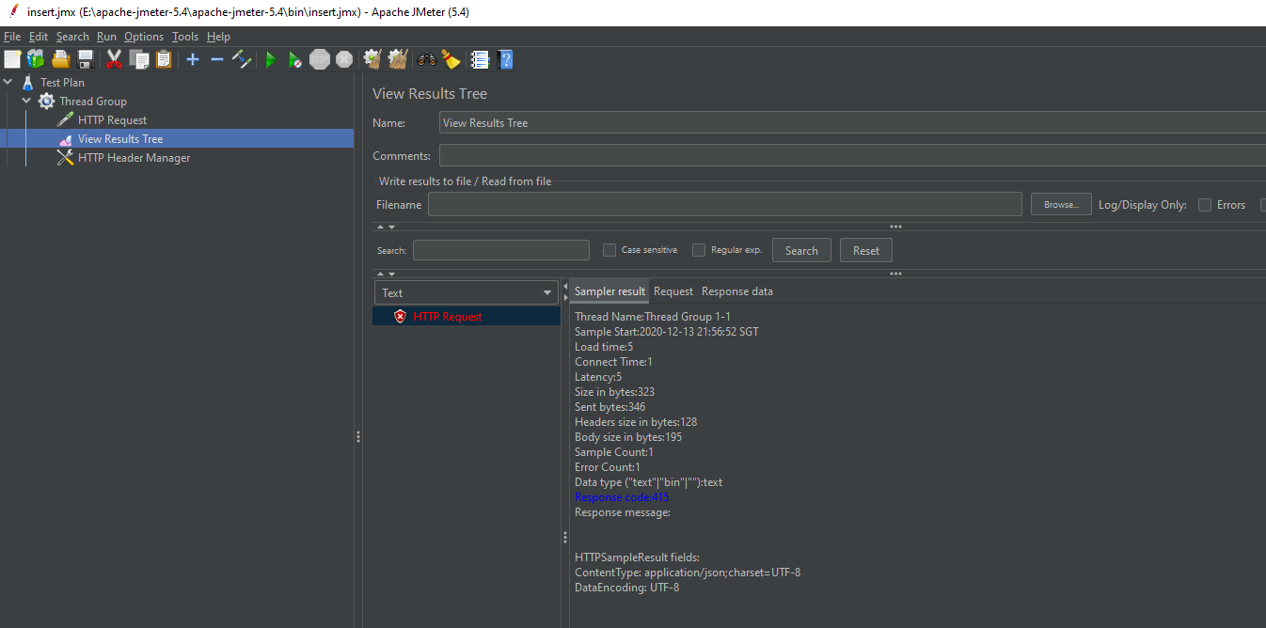

Regression testing: Assume all the UIs are implemented and server are working as expect, the system is stable, we can transfer the user based testcase to automation script using selenium python. Here’s the example to upload the .csv file

from selenium import webdriver

from selenium.webdriver.common.keys import Keys

import unittest

from selenium.webdriver.support.ui import Select

import HtmlTestRunner

import os

import sys

from selenium.webdriver.common.by import By

from selenium.webdriver.support.ui import WebDriverWait

from selenium.webdriver.support.wait import WebDriverWait

from selenium.webdriver.support import expected_conditions as EC

import time

from pynput.keyboard import Key, Controller

# driver = webdriver.Chrome("C:\Program Files (x86)\chromedriver\chromedriver.exe")

class Assignment(unittest.TestCase):

    driver = webdriver.Chrome("C:\Program Files (x86)\chromedriver\chromedriver.exe")

    def uploading(self, file_path):

         self.driver.get("http:\\localhost:8080\\”)

# click upload file

        self.driver.find_element_by_xpath('//*[@id="contents"]/div[1]/div[2]/input').send_keys(file_path)

def test1(self):

      self.uploading ("E:\\Sample\\test2.csv")