Forking a Repo

If you’ve cloned the 2019-CS109A repo you might have run into merge conflicts when trying to pull down new course content. Forking the repo is an alternative to cloning that allows you to modify files locally, like lab files or lecture notes, and still pull down course content.

This tutorial is a condensed version of Github’s tutorials [Fork a repo](https://help.github.com/en/articles/fork-a-repo) and [Syncing a fork](https://help.github.com/en/articles/syncing-a-fork). If you’d like to learn more, definitely take the time to read through their tutorials.

# How to Fork

1. Go to <https://github.com/Harvard-IACS/2022-CS109B>
2. Click on the “Fork” button and create a fork of the repo

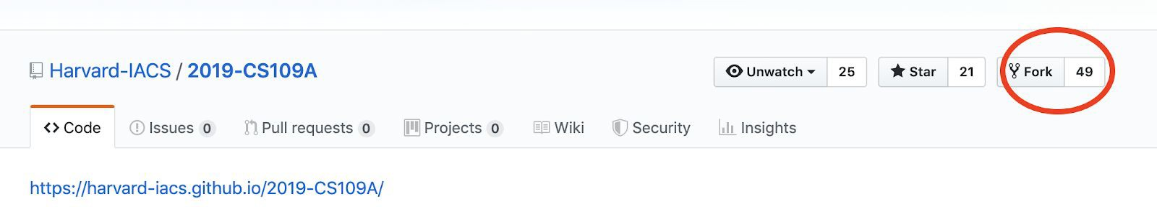

1. Navigate to your fork (https://github.com/zhonglizhang/2022-CS109B)
2. Clone your fork to your desktop. You can either do this by copying the repo URL and running

git clone <https://zhonglizhang/2022-CS109B.git> or by using github desktop

Now you have a copy of your forked repo on the desktop. If you run git remote -v you should see the URL that you cloned as the origin of the repo. This is where you’ll push all of your local changes. However, we still haven’t told our fork where to pull new content from.

1. Enter your forked repository from the command line and run

git remote add upstream <https://github.com/Harvard-IACS/2022-CS109B.git>

if you want to remove an incorrect upstream, run:

git remote rm upstream

1. Now running git remote -v should show both an origin and an upstream branch.

Now your branch is connected!

# Pushing Changes

If you make any changes to your forked repo, you might want to commit them to store them! What’s great about your fork is you don’t have to worry about your changes being pushed to the master CS109A branch.

1. Stay inside the /2022-CS109B/ folder on your local computer
2. Run git add -A to add your changes to your next commit
3. Run git commit -m “Your message here” to create the commit
4. Run git push to push your changes to your fork. Github knows to push to the origin (your branch) and rather than the upstream branch so your changes won’t affect anyone else’s repo;

# Getting Updates from the Upstream Branch

If new lecture slides are published, you’ll want to update your branch so that you have the latest slides. To sync your branch, do the following (assuming you’re on your master branch (stay inside the /2022-CS109B/ folder):

git fetch upstream

git merge upstream/main