修改如下：

pc：样式和public.js替换
Css文件修改如下：
modified: bbcyw/pages/css/delivery.css
modified: bbcyw/pages/css/download.css
modified: bbcyw/pages/css/feedback.css
modified: bbcyw/pages/css/index.css
modified: bbcyw/pages/css/list_details.css
modified: bbcyw/pages/css/login.css
modified: bbcyw/pages/css/person.css
modified: bbcyw/pages/css/personal.css
modified: bbcyw/pages/css/public.css
modified: bbcyw/pages/css/release.css
modified: bbcyw/pages/css/resodetails.css
modified: bbcyw/pages/css/service.css
modified: bbcyw/pages/css/taskhelp.css
modified: bbcyw/pages/css/topicdetails.css
modified: bbcyw/pages/css/topicmore.css
modified: bbcyw/pages/css/topicthum.css
modified: bbcyw/pages/css/upload_document.css
modified: bbcyw/pages/css/upload_game.css

- 首页修改more切换
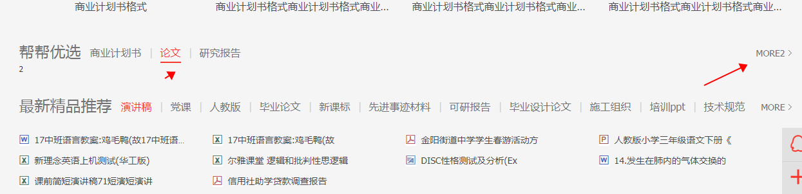
2、首页、列表滚动头部固定
