Dear, Mr interviewer

By reading the coding exam, I think I understand 90% of tasks. Forgive my unprofessional input samples by not reading inputs from file. Because I just want to write a simple demo to demonstrate the major idea instead of writing pseudo code to save my time.

Task-1: (ExchangeCenter)

Using B+ Tree to do the merge Algorithm (I didn’t write B+ Tree by myself, so it takes times to implement aggressive ASK/BID logic, because I have to read through the B+ Tree code to add range search function)

Here the result set by matching the Price exactly, I commented in the code, it’s not hard to read, The most important part is to calculate remaining quantity.

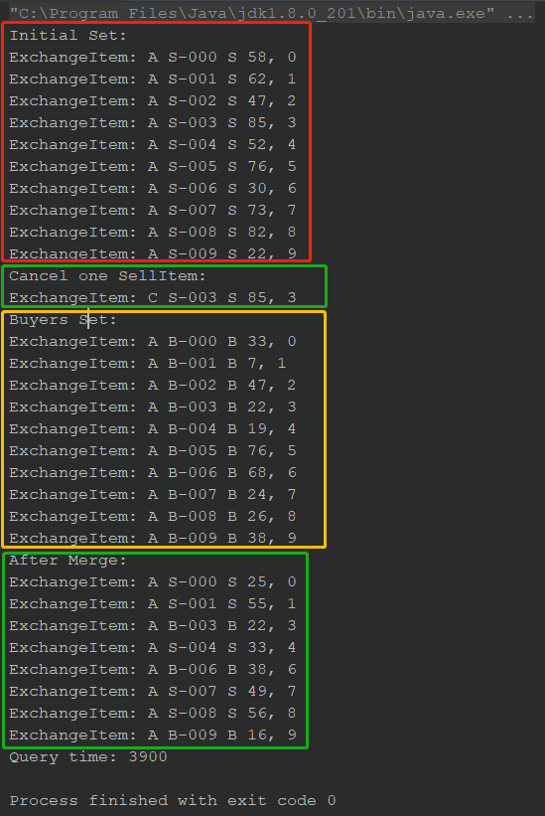

Task 2: (Trader)

Use two LinkedHashMap to organize Price into a key slot, and use cursors to iterate both map concurrently, resolve M, A, C login inside the iteration.

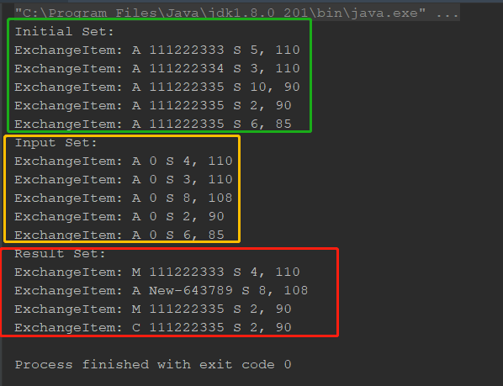

Regards

Zhongwen