The UI contains two options to choose on the left:

**Bin Tracking**

* Linked Bins Histogram (see Figure 1, Figure 2)
  + X axis labeled as “Attenuation Window”
  + Y axis labeled as “Frequency”
* Unlinked Bins Summary (see Figure 3)
  + Not useful (-51 to -1000)
  + Pushed by operator (-1 to -50)
  + *Linking bins (0 to 150) not show in this histogram*
  + Slipping on belt (151 to 200)
  + Not useful (201+)
* Summary Pie Chart with information label (see Figure 4)
  + Linked Bins /Unlinked Bins show in pie chart
  + Summary Label contains:
    - Total Bins:
    - Total Linked Bins:
    - Total Unlinked Bins:
    - Percent of Unlinked Bins:
    - Slipping Bins:
    - Percent of Slipping Bins:
    - Pushed Bins:
    - Percent of Pushed Bins:
  + Unlinked Bin information:
    - Cut/oversized object:
    - Percentage (unlinked):
    - Percentage (total):

*\*Error handling when data is not ready (1. Show empty chart; 2. Show “data not ready” message.)*

**Simulation**

* Distribution Histogram (stop time) (see Figure 5)
* Occurrence Histogram (stop time) (see Figure 6)
* Summary before/after (stop/run time) (see Figure 7, Figure 8)

*\*Error handling when data is not ready (1. Show empty chart; 2. Show “data not ready” message.)*

*\*\*Error handling when corresponding file is not generated yet (1. Show empty chart; 2. Show “data not ready” message.)*

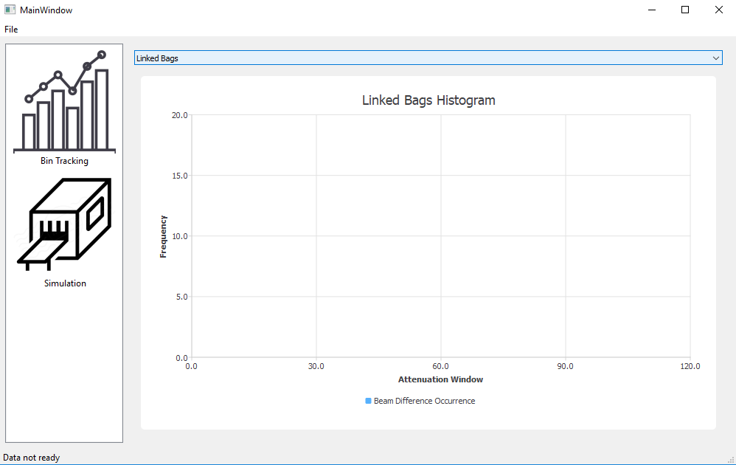

Figure 1. Empty Linked Bins Histogram (no data)

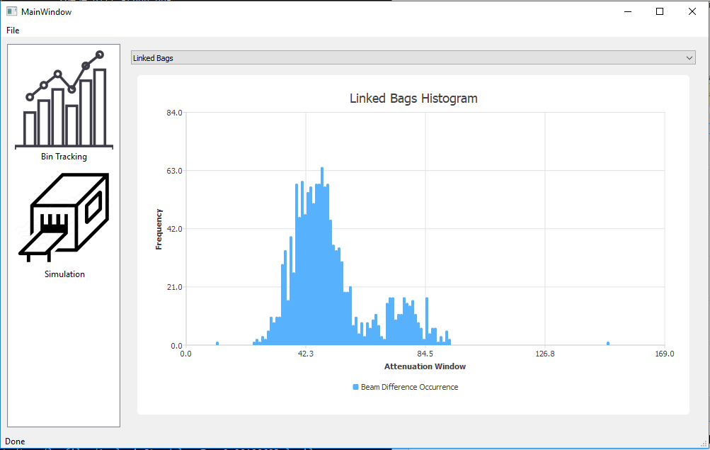

Figure 2. Linked Bins Histogram with data

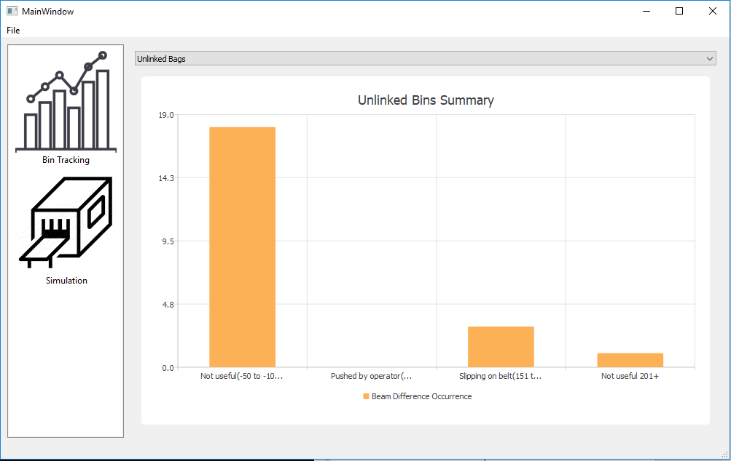

Figure 3. Unlinked Bins Histogram with data

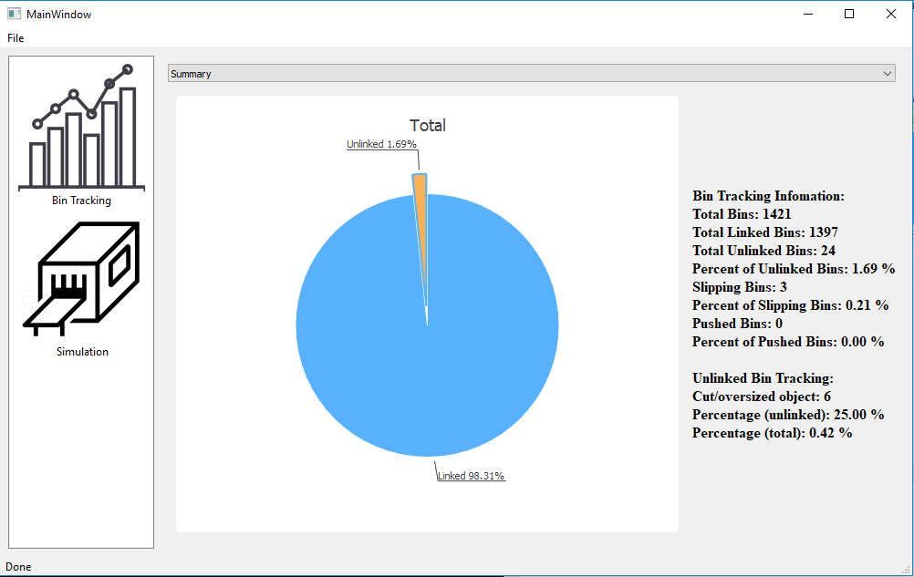

Figure 4. Summary pie chart with information label

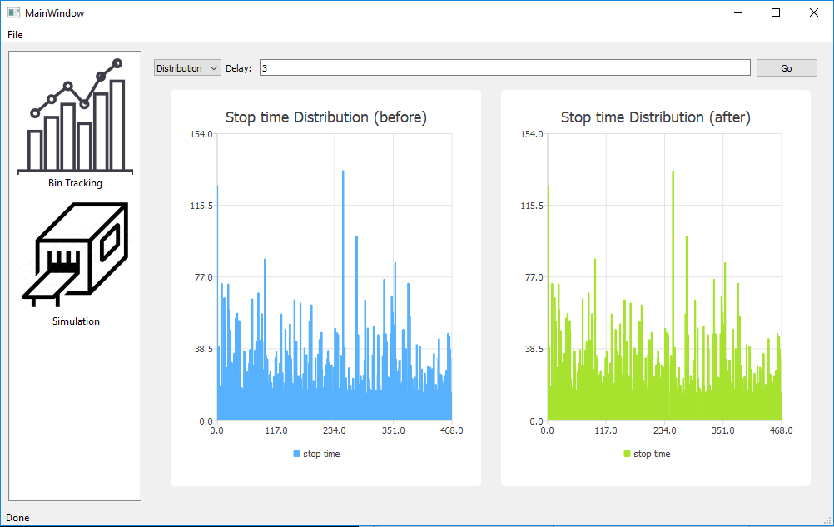

Figure 5. Stop time distribution before/after delay

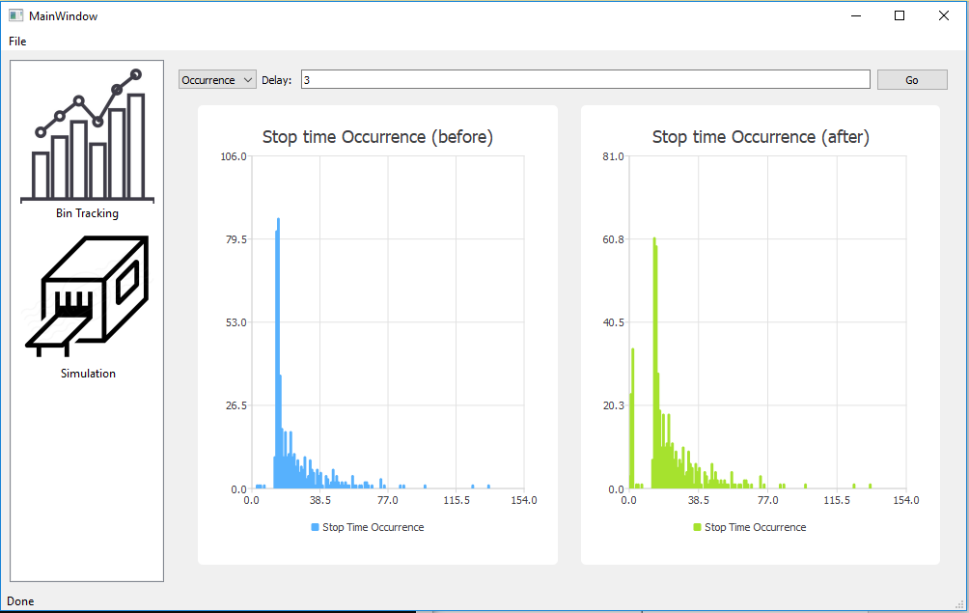

Figure 6. Stop time occurrence before/after delay

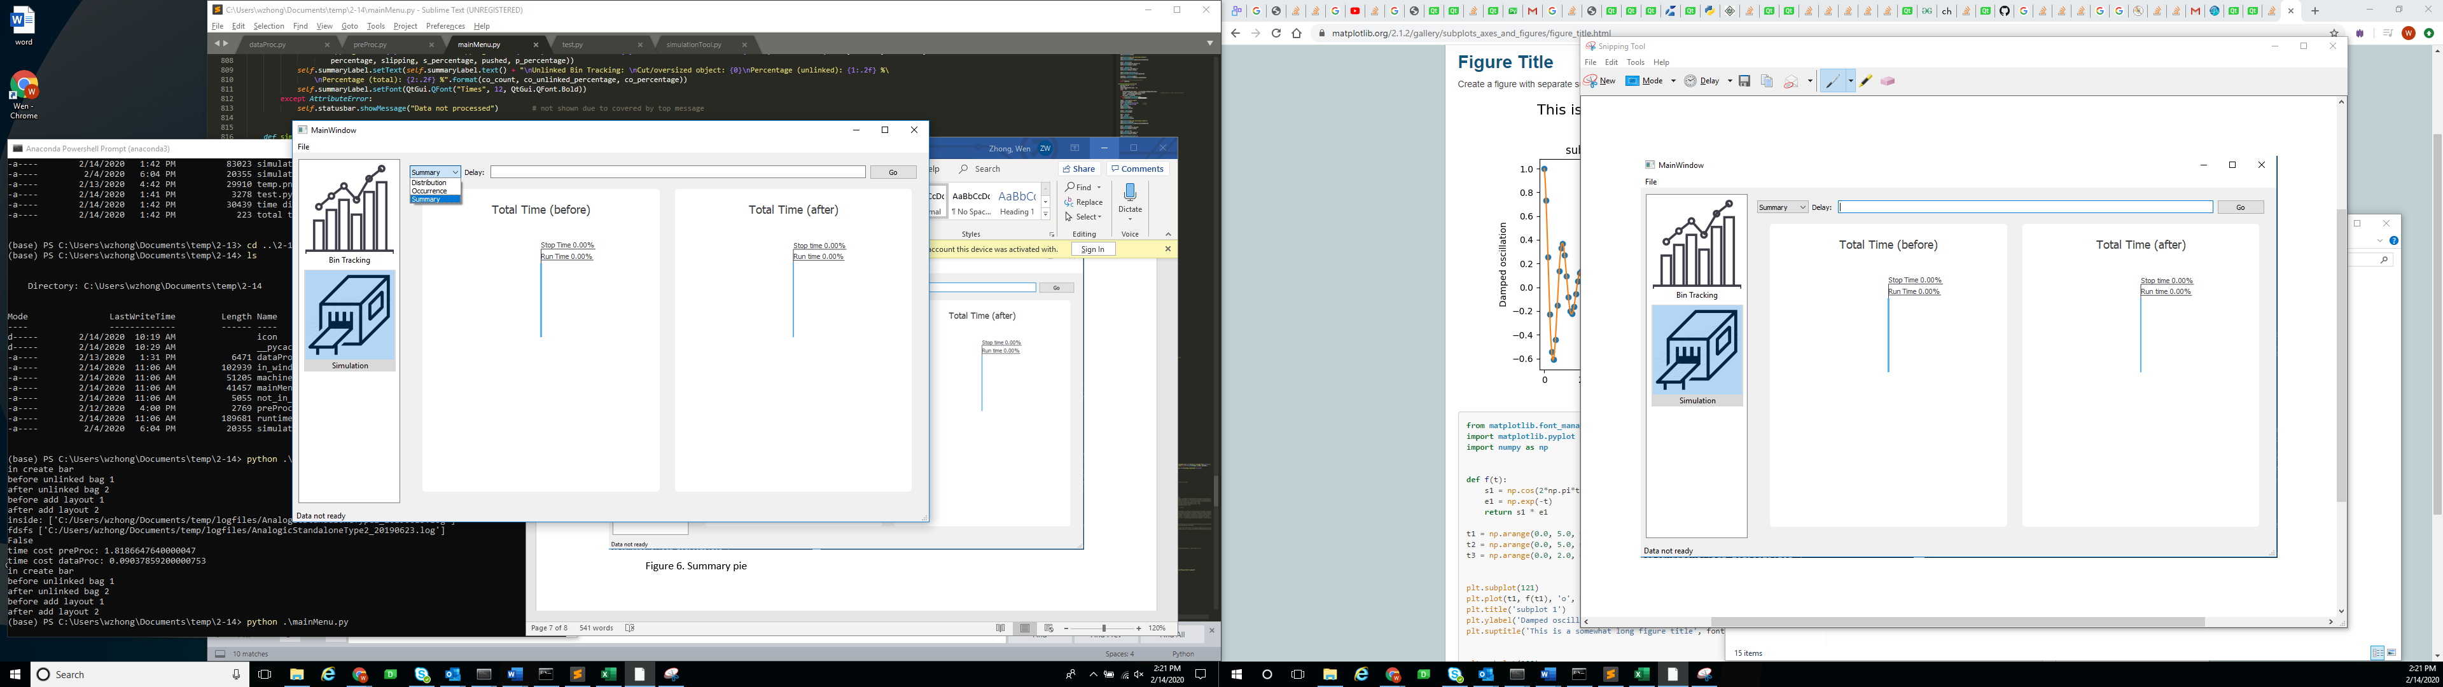

Figure 7. Different Chart to Choose and Empty Summary Pie Chart

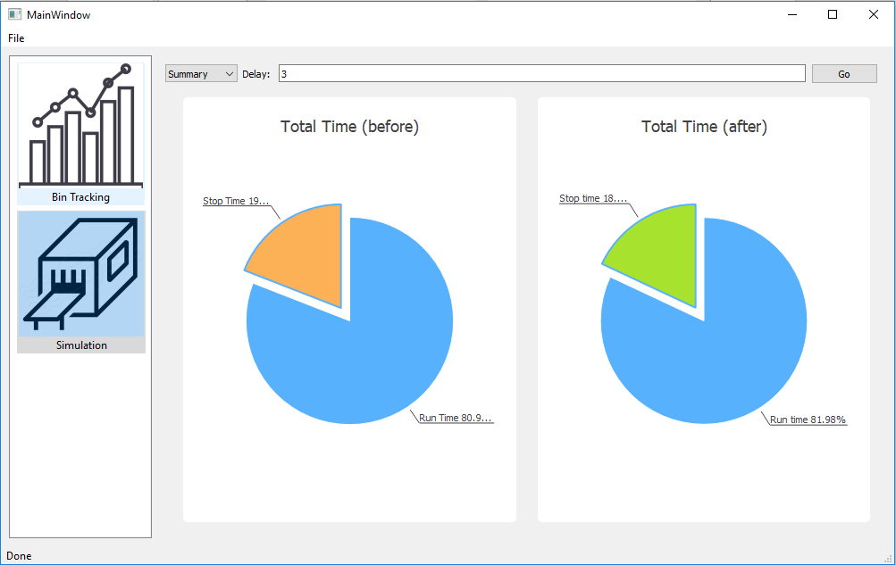

Figure 8. Summary pie chart on time before/after delay

**Appendix:** (To choose the best delay time)

Below shows the simulation total running time after delays:

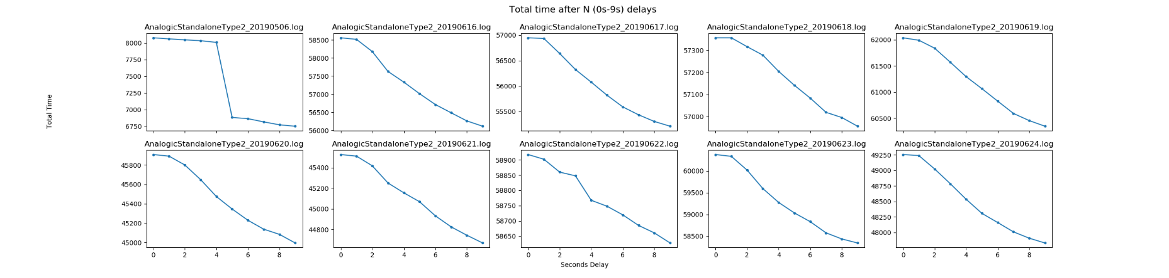

Figure 1. Total time after N delays (N = 0s - 9s)

Figure 1 shows the total time after N seconds delay, it decreases as the delay seconds goes up. The best delay number is indicated by calculating the difference between total time after delay. By observing the largest gap, which means save the huge amount of time on the process.

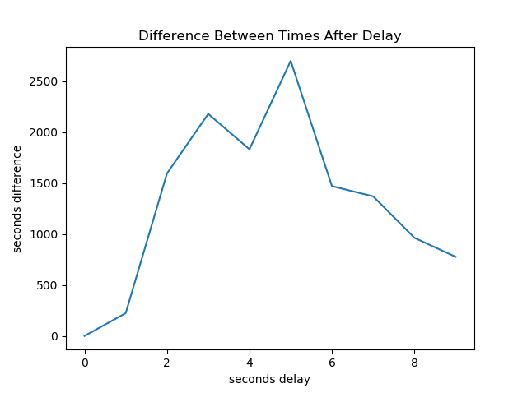

Figure 2. Difference between times after delay

In the Figure 2 (also can refer to Chart 1), the two peaks at 3 seconds and 5 seconds means relatively increases a lot compares to the previous delay (1 second earlier). This result given by 10 log files show that the 3s and 5s have the best performance after delay.

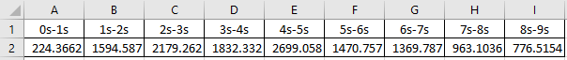

Chart 1. Time Difference among 10 log files