**Conformer Filtration (v4.0.0)**

*Break Change: not compatible with early version ~v3.3.0*

Contents

Conformers 2

System and Fragment 2

Connections 3

All vs Par 5

Userinputs 5

Tolerance 6

File Type Explanation 6

Dynamic vs Static 7

Dynamic Filtration 8

Static Filtration 11

Plot 12

Plot on Probability Data Files 13

Plot on Backup Files 14

Examples 15

Help Usages 15

Filtration in mode: dynamic/all 16

Filtration in mode: dynamic/separate 17

Filtration in mode: static/lowest-bit 17

Filtration in mode: static/random 18

Filtration in mode: static with anchoring value 18

Plot on Probability Data Files 19

Plot on Backup Files 19

Code Execution Efficiency 20

Some Useful Codes Options:

acon 4

atol 6

bcon 3

borandom 12

btol 6

dynamic 8

file-format-explanations 6

fragments 3

lowest-bit 10

nmlist 14

oball & oaall 5

obpar & oapar 5

plot 14

separate 11

static 11

userinputs 5

vndx 12

# Conformers

We define conformers as the molecules varying at their atomic relative positions, which include variation in bonds and angles. Conformer is used as a symbol name to differentiate the same type molecules changing at atomic relative positions due to bonds length variations and single bond rotations.

For example, bond length changes;

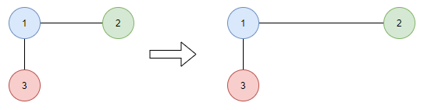

Figure : Molecules Vary in Bonds

Angle varying;

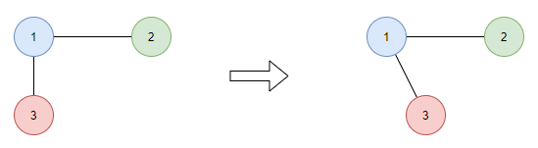

Figure : Molecules Vary in Angles

# System and Fragment

Filtration is based on system, which is a single molecule used for defining bond/angle connections. Thus, it is a broad name to descript the inner connection information but not refer to any specific molecules.

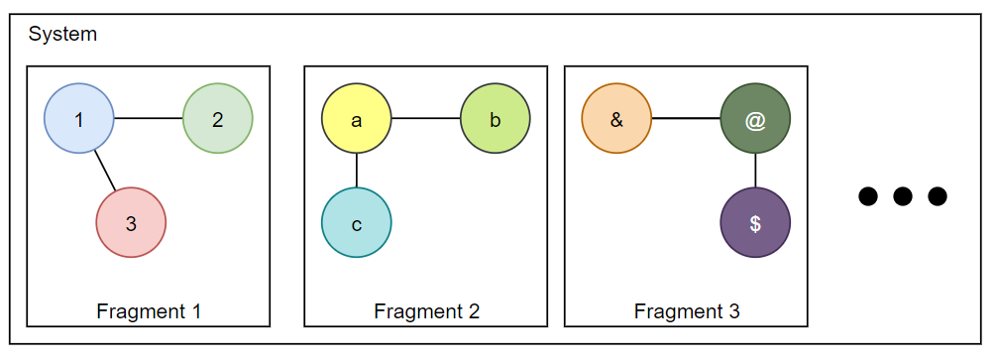

Figure : System and Fragments

From above figure, the system may be "split" into many different pieces, and we define them as fragments. Apparently, fragments have no bonded connections with each other.

# Connections

In Figure 3, we can get their inner connection is; for bonds:

Fragment 1: 1-2, 1-3

Fragment 2: a-b, a-c

Fragment 3: &-@, @-$

Connection in angles will be got in similar way.

As a notice, the filtration is based on the input connections, thus different connections will cause different filtration results even for the same set data inputs.

So, it comes to the question, how can we find the optimal connection?

Here are some assumptions.

If BOSS (Biochemical and Organic Simulation System, invented by Dr. Jorgensen) is used for the generations of input data set, since it can only make atomic variations in every Monte Carlo step, so the filtration is performed on the summary of overall changes for the input connections.

For simulation packages, they are built with powerful constraint algorithms, e.g., LINCS for GROMACS; SHAKE for AMBER; SETTLE for water models. They are all served to one common purpose, to hold the "integrity" of the input system, mainly to avoid two extreme artifacts, e.g., broking into pieces or flying ice problem, the former makes system exploded, while the latter causes system to be frozen into rigid body.

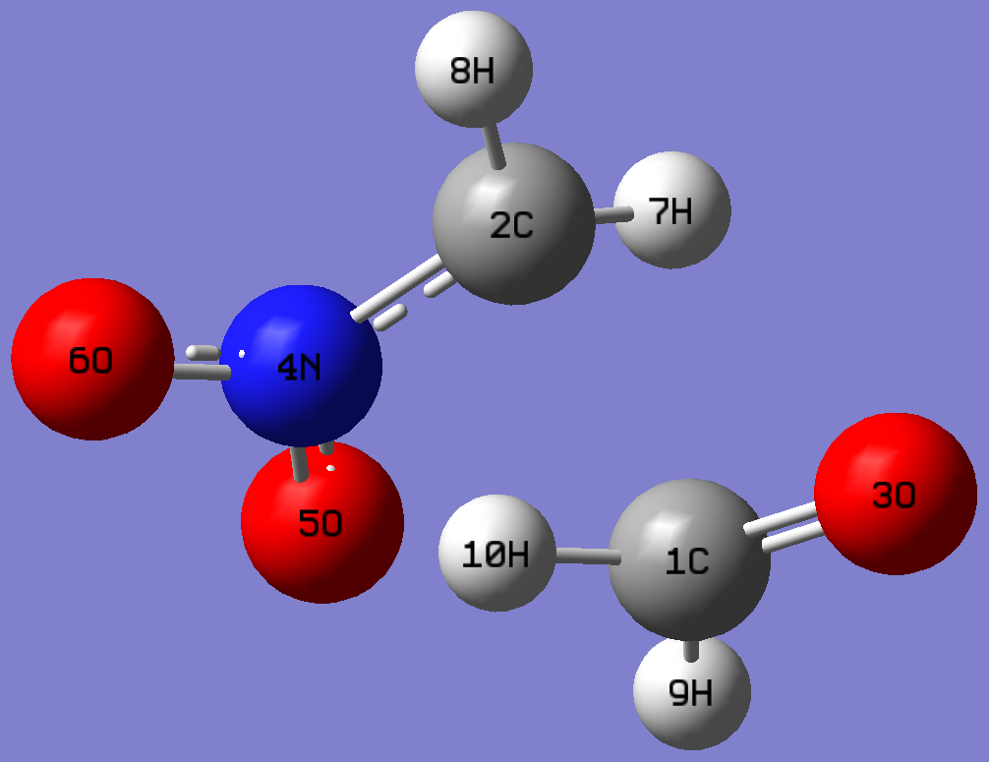

Figure : Fragments in Henry reaction

Therefore, if we trust their simulation results, as shown in Figure 4, there is no meaning to do calculation in bond connections 2-7, 2-8, 2-4, 4-5, .., etc., or angle connections 7-2-8, 7-2-4, 8-2-4, …, etc.

The focus is paid on the connection among cross-fragments. Thus the suggested bond connections in setting to choose are, 2-1, 2-3, …, 7-1, 7-3, …, etc.

Because single bond rotation will change the relative positions of its "connected atomic groups", for example, the rotation for group 2,7,8 in single bond 2-4 will change angle for 7-2-5, 7-2-6, …

However, those changes can be represented by the bond connections, 7-5, 7-6, …

In conclusion, you should use your best judgement to set up those connections. Please bearing in mind that using the bonds connections is always suggested, due to its faster computation than angle's.

From codes view, to ignore bonds connections calculation: -bcon [], similarly, to ignore angles connections calculation, -acon []. Any number of square-bracket can be used.

# All vs Par

If we have the connection settings:

bonds: 1-2, 1-4, 1-5, 1-6

angles: 1-3-2, 1-3-4, 1-3-5

We can either perform calculation in all of them or in separately. They are three modes provided:

overall: combine bonds and angles

all: bonds or angles connections

par: individual bonds or angles

The detail implementations will be discussed in Dynamic vs Static. For setting all, which means we conclude either all bonds or either all angles into their own considerations, thus only two probability analyses results will be got after filtration is done.

However, if the par is chosen, the probability analyses results will be printed out based on your input connection settings. For example, we can analyze the bond par 1-2, or angle par 1-3-4 probability results.

Because par calculations are very time-consuming, they are only executed when you explicitly specify the Boolean option, -obpar, -oapar.

# Userinputs

We human prefer counting things starting from 1, however, it is not the truth for most computer languages, e.g., Python, SHELL, C, the list will go on, they are starting from 0.

So from the codes view, there is a Boolean value userinputs to indicate whether the connections are starting from 1 (True), or starting from 0 (False).

# Tolerance

Filtration is performed on tolerances: bond (in Angstrom), and angle (in degree).

We define that the conformers whose changes smaller than the setting tolerance will be filtered out. Here is an example by illustrating in bond variation.

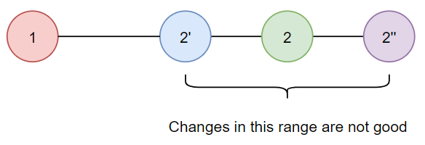

Figure : Illustration filtration on bond tolerance

If there are two atoms, by changing position of atom 2, new molecules will be made. For filtration, if we have,

Abs(Distance1-2 – Distance1-2') < btol

Abs(Distance1-2 – Distance1-2'') < btol

The molecules 1,2', and 1-2'' are not good, they are called repeats and will be removed.

Showing in plot, it is like the atomic position variation is not allowed in certain range along axis, see Figure 5. If it is shown in 3D space, the range will be a sphere. Any new molecules generated in those ranges will be thought as repeats.

For angle, if shown in similar way, it will be a cone in 3D space, corresponding to setting atol.

# File Type Explanation

Currently, only following file formats are supported. The file type is determined by extension.

For txt file:

molecules are separated by new line, line starts with char '#' will be ignored,

if any errors happen, the whole set will be skipped.

note: energy info has to be at the end of the first line, equal sign, =, can be used.

[ # x x x [=] energy

| atom-1 x y z

mol | atom-2 x y z

| atom-3 x y z

| ...

[ <new line>

For xsf file:

molecules are separated by '#', keyword 'ATOMS' is important,

case sensitive, if any errors happen, the whole set will be skipped.

note: energy info has to be at the end of the first line, equal sign, =, can be used.

[ # x x x [=] energy

|

| ATOMS

mol | atom-1 x y z else

| atom-2 x y z else

| atom-3 x y z else

[ ...

For xyz file:

molecules are separated by new line, line starts with char '#' will

be ignored, if any errors happen, the whole set will be skipped.

note: energy info has to be at the end of the first line, equal sign, =, can be used.

[ # x x x [=] energy

| atom-1 x y z else

mol | atom-2 x y z else

| atom-3 x y z else

[ ...

Those information can be printed by option: -p or --file-format-explanations.

# Dynamic vs Static

There are two modes can be selected, dynamic and static mode, where,

dynamic: filtration is based on the inputs, changes on the inputs may cause different results

static: filtration is only related with starting index and input tolerance

Given a dataset, on the basis of different tolerances and connections, the molecules inside it can be split into many small groups, they can be represented in histograms, and we call them "bins". Molecules inside the same histograms are thought as the "similarities", the actual meaning of "repeats".

To be unified, we will use bins and repeats in the following contents instead.

For the different type of connections, they can be concluded into "complexity", a high level dimensional representation. Thus, we can get a plot like;

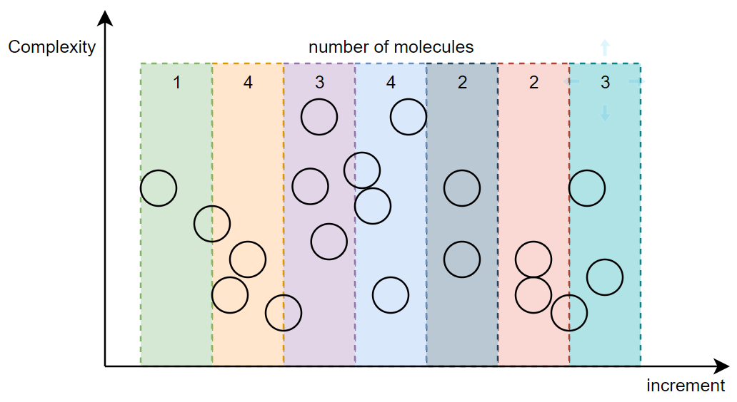

Figure : Illustration on Categorizing Molecules

In above figure, there are in total 19 molecules. For the input increment, like complexity, which is a summary term of bonds and angles tolerances, total dataset can be split into 7 bins, the number of molecules in each bin are shown in the top.

To filter them out, only one molecule will be left in every bin.

## Dynamic Filtration

Assume there is an edge molecule, the "edge molecule" means the molecule happens to fall on the boundary of the next increment.

During the dynamic filtration, if this type of molecule is happened to be added (by adding more BOSS generated Backup files) or removed (by using index file, the early processed file), the bins will be dramatically changed, please see graph in below.

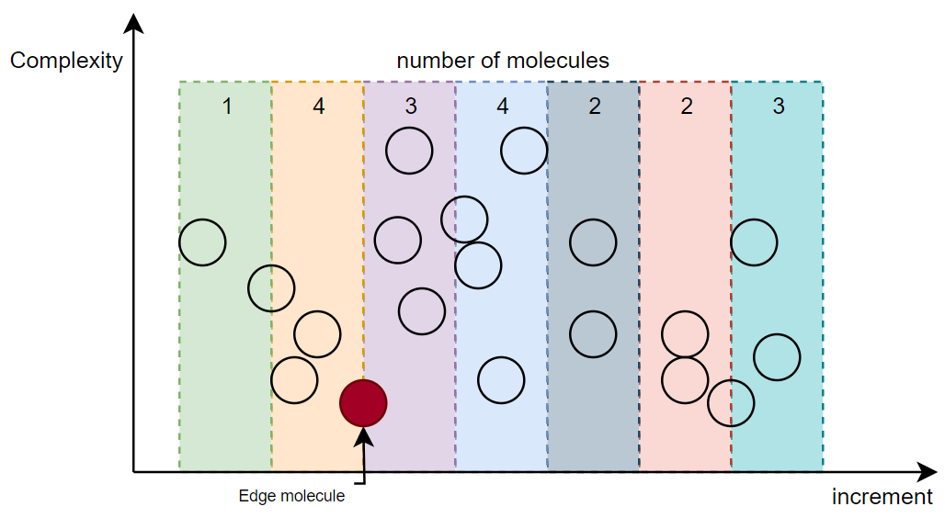

Figure : Illustration of Edge Molecule

By removing the edge molecule, it may have "gap" created between two adjacent bins. As a result, all the following bins will be accordingly changed.

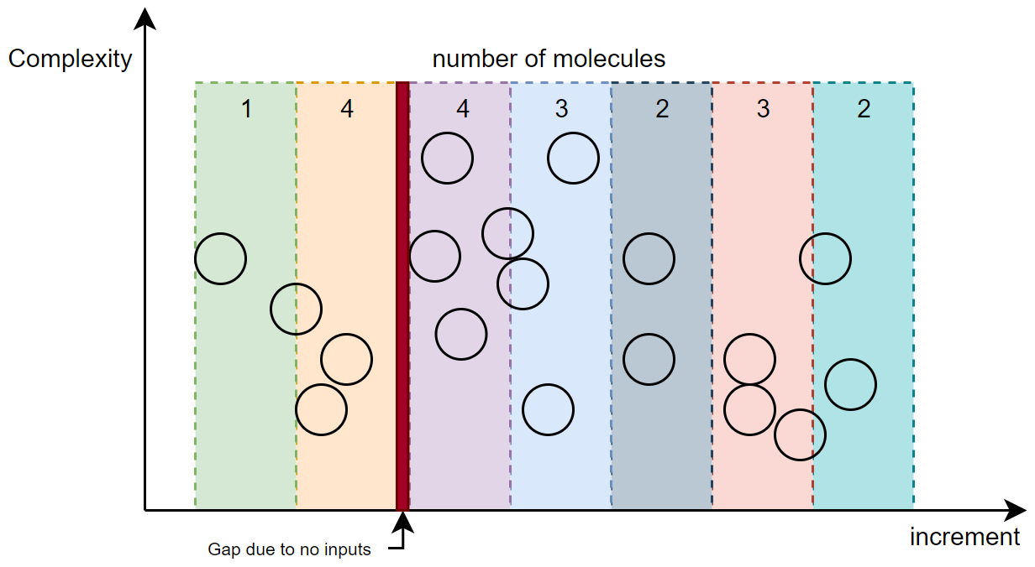

Figure : Effects on Removing of Edge Molecule

Since we have understood that by changing the edge molecule will cause the modification of bins, how can it influence the final filtration result? The answer is in the lowest-bit filtration.

Molecule in lowest-bit means the molecule close to the left edge of the bin and in the smallest complexity. To help your understanding, here is a plot;

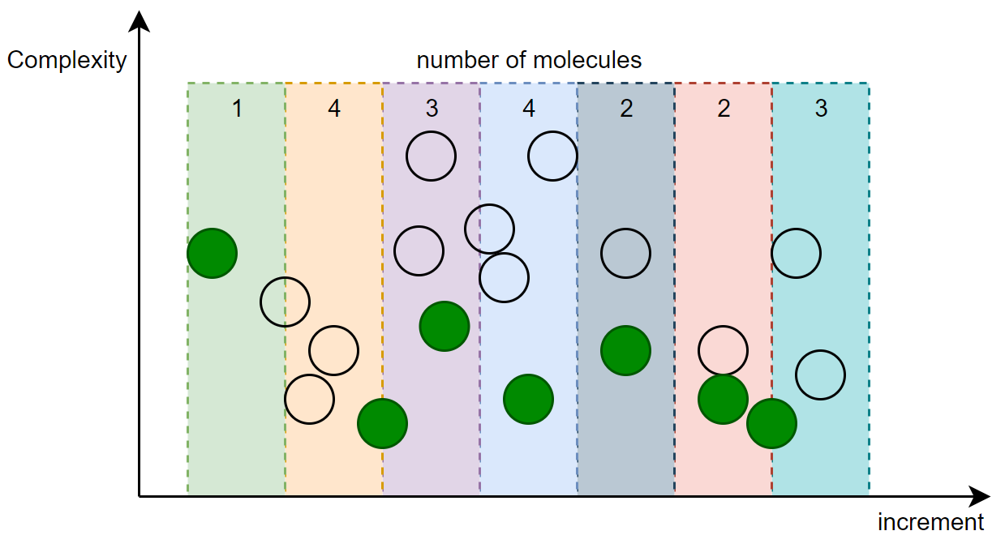

Figure : Illustration of Molecules in Lowest-bit (In blue)

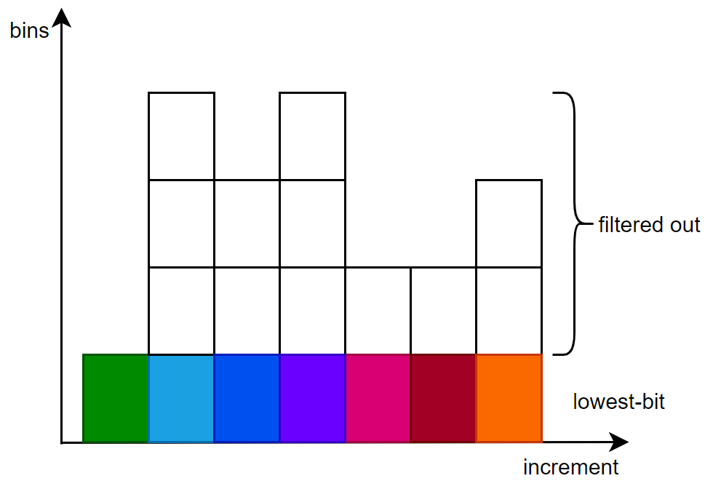

Figure : Filtration in Lowest-bit

All molecules in each bin except the molecules in lowest-bit will be removed during dynamic filtration. Therefore, we say its result is based on the input files and call it "dynamic".

In dynamic mode, there are two types calculations are provided, whether in all or in separate.

all: bonds changes + angles changes >= bonds tolerance + angle tolerance

separate: bonds changes >= bond tolerance or angles changes > angle tolerance

It is easy to be understood. The separate mode can be turned on by option --separate.

## Static Filtration

On the contrary of dynamic mode filtration, there is the static mode filtration.

In static filtration, there are no edge molecules labelled, the bins are kept in continuous, and no gaps will be allowed. Thus, one of this main feature is that it allows zero-bin exists.

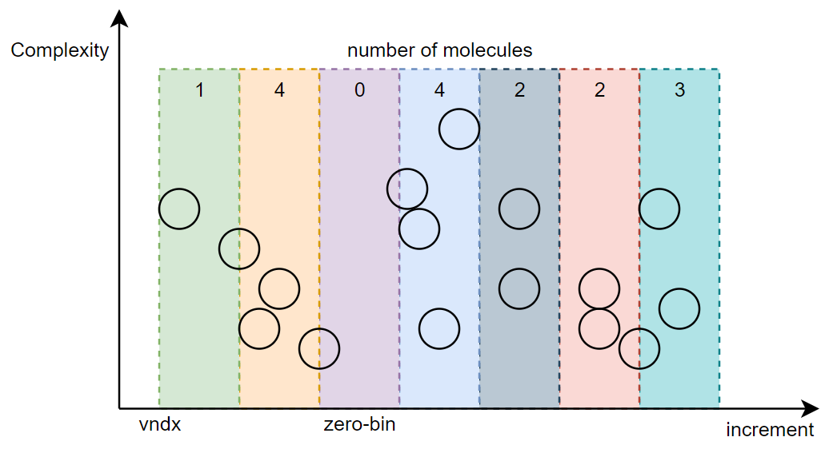

Figure : Illustration of Static Filtration

Addition parameter can be provided, --vndx, which is a number where to anchor filtration. This value can be any number, if not provided, the smaller lowest-bit molecule will be used instead.

Besides, apart from lowest-bit filtration, the random filtration is also provided.

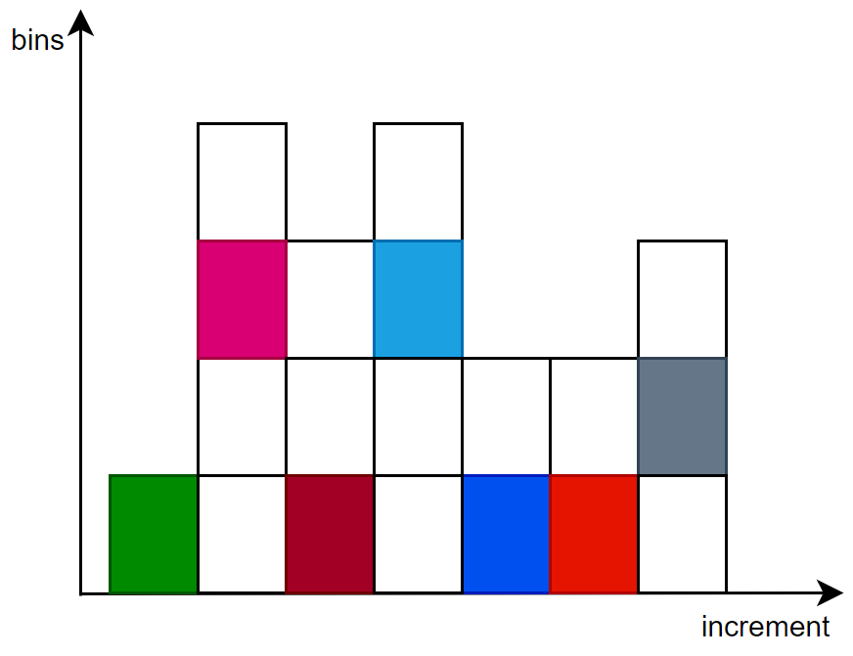

Figure : Illustration of Static Random Filtration

If the random filtration is turned on, all molecules in blank in each bin will be filtered out, the correspondent option is --borandom, which can be reproduced by --seed.

In static mode filtration, the filtration is based on all changes (discussed in above), because there is no valid way to deal with the difference of magnitudes

# Plot

To help visualize the filtration results, a subcommand plot is integrated.

There are two types of inputs can be specified.

## Plot on Probability Data Files

After the filtration is done, a new text file named as bulk-probability-data-num.txt will be generated. This file contains inner probability data for plots.

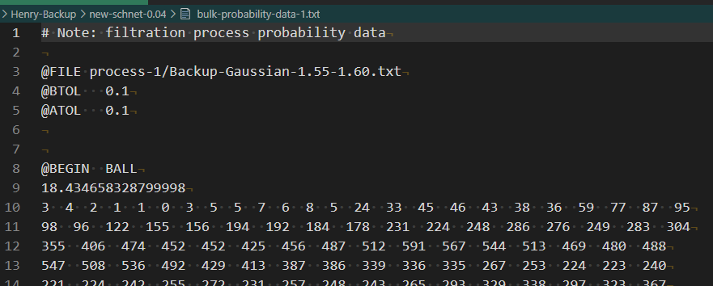

Figure : Illustration of Probability Data File

Each integer value represents number of molecules inside bins. So the goal should be to make them be single digits (i.e., less than 10) after the favorable settings of filtration.

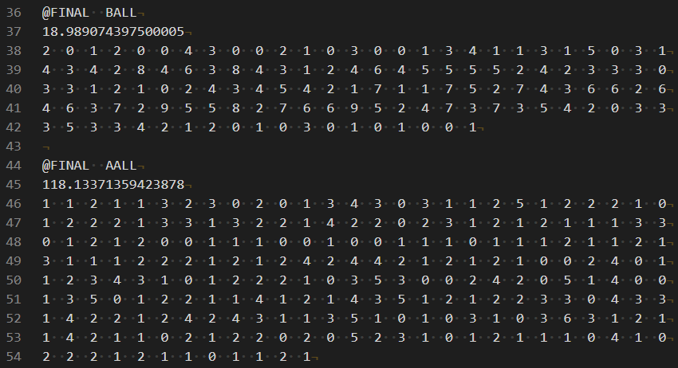

Figure : Probability Data after Filtration

The inputs of those data files can be called by -bf or --probdatafilelist.

## Plot on Backup Files

Subcommand plot shares the options with top-level filtration command.

It has two different ways to make those selections.

1) Option -nl or --nmlist is used to select number of molecules. For example, if we want to compare 5 samples of input conformers, say 10000, 20000, 30000, 40000, 50000, declaring them, the plot will be accordingly generated. You can visualize any number of samples in any number of molecules(no bigger than your inputs) in a way before and after filtration.

Due to the selection is in randomly, to reproduce, please specify --seed.

This option is used to generate non-equal length of samples, and it is in the highest priority.

2) On the contrary, the "equal" length of samples can be generated in the combined options.

For example, if we simplifying the dataset into 1D axis;

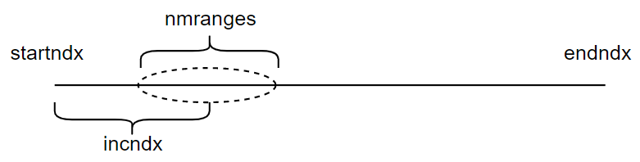

Figure : Parameters in Plot Subcommand

By combining those options, we can choose certain range from --startndx and --endndx in the given increment --incndx to generate samples. The length of generated samples will be equal, unless a random range --nmranges is specified, still it can be reproduced by --seed.

# Examples

## Help Usages

1. Overall usage, by executing any one of those three;

[python3] ./filter.py -h

[python3] ./filter.py

[python3] ./filter.py --help

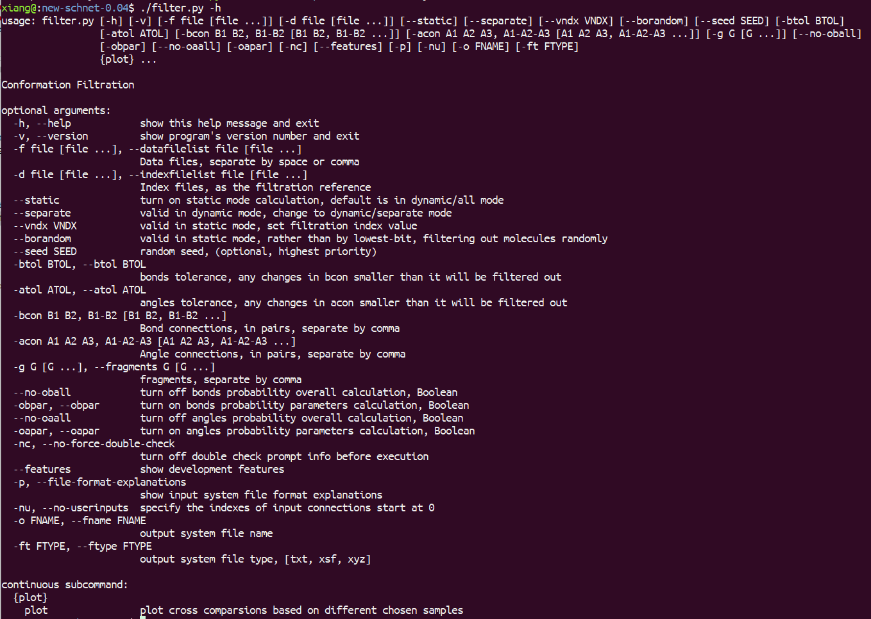

Figure : Overall Help Usage of Filtration Script

1. Subcommand plot usage,

[python3] ./filter.py plot -h

[python3] ./filter.py plot --help

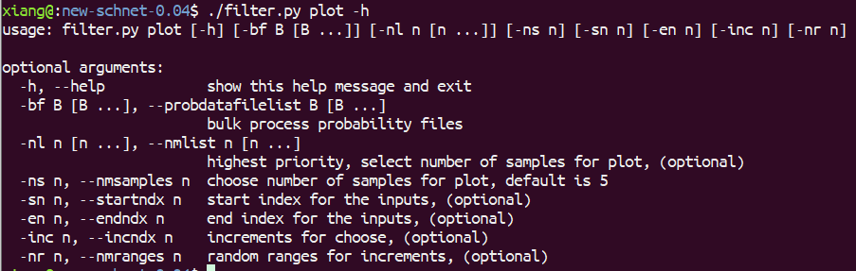

Figure : Subcommand-plot Help Usage of Filtration Script

## Filtration in mode: dynamic/all

Note: connections are separated by comma, thus white space and hyphen can be used.

The default calculation type is dynamic/all, so we only need to input the options that we want;

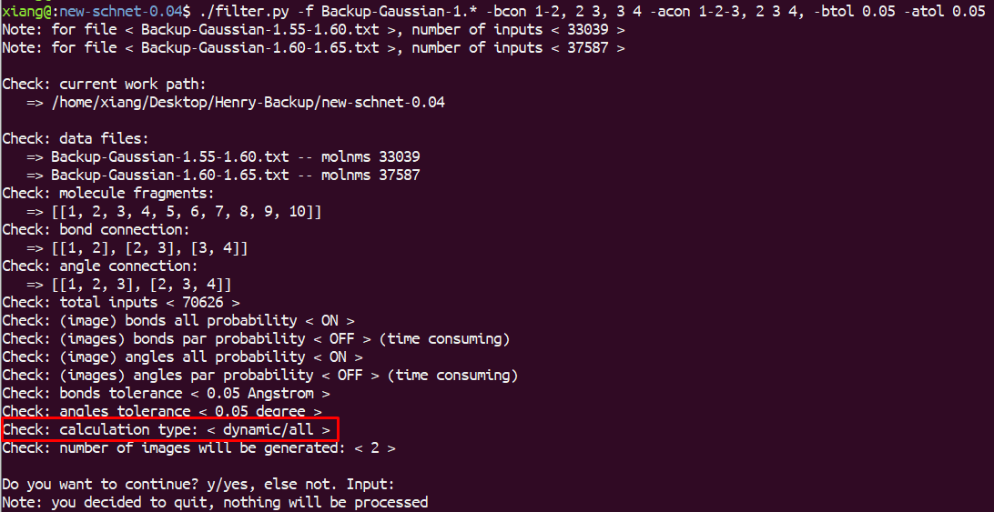

Figure : Example of Calculation Type dynamic/all

## Filtration in mode: dynamic/separate

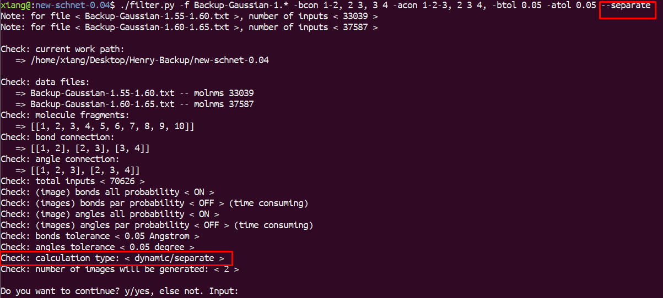

Figure : Example of Calculation Type dynamic/separate

## Filtration in mode: static/lowest-bit

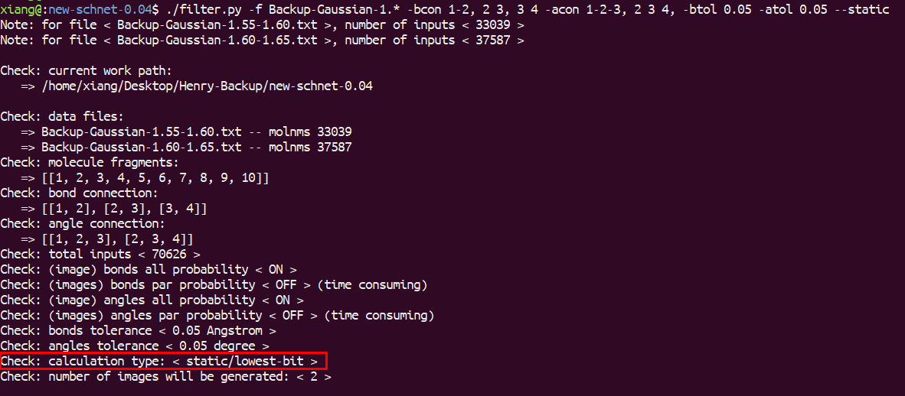

Figure : Example of Calculation Type static/lowest-bit

## Filtration in mode: static/random

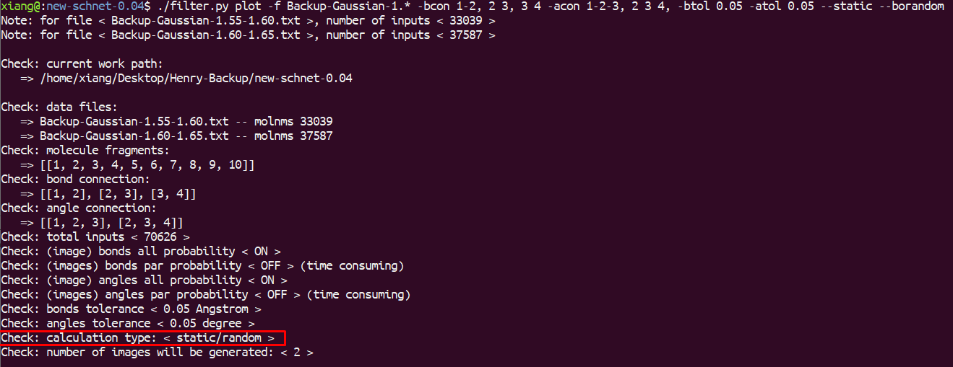

Figure : Example of Calculation Type static/random

## Filtration in mode: static with anchoring value

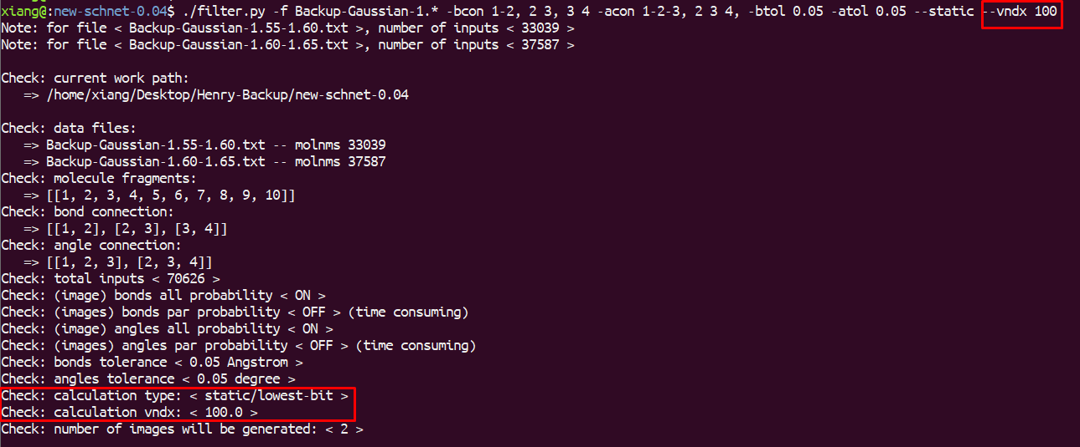

Figure : Example of Calculation Type static/lowest-bit with Anchoring Value

## Plot on Probability Data Files

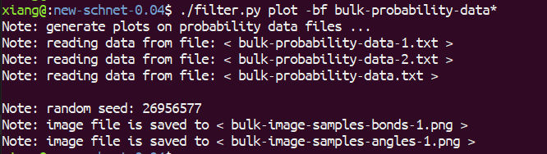

Figure : Example of Subcommand-plot on Probability Data Files

## Plot on Backup Files

1. Specify number of molecules in each sample



Figure : Example of Subcommand-plot on Backup Files with Selected Number of Samples

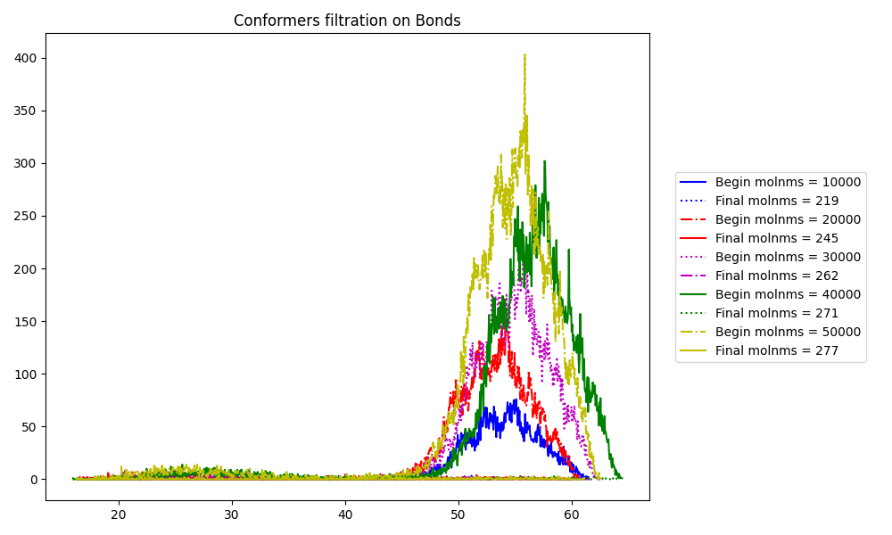

Figure : Example of Bonds Plot in Different Samples

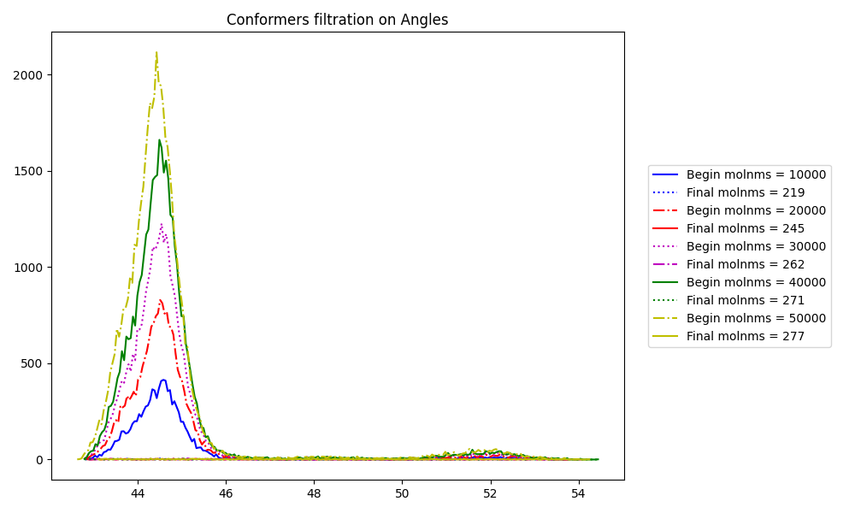

Figure : Example of Angles Plot in Different Samples

Note: due to fewer connections were defined, the number of molecules after filtration are very smaller than original inputs. It is just an example though.

1. Plot on equal consecutive number of samples



Figure : Example of Subcommand-plot on Equal Consecutive Number of Samples

1. Plot on equal split number of samples



Figure : Example of Subcommand-plot on Equal Split Number of Samples

Please use it with help of Figure 15.

# Code Execution Efficiency

Consider ~1.8 million 10-atomic molecules, number of bonds connections is 8, number of angles connections is 7, in calculation type dynamic/all, time cost is less than 40 minutes.