Molecule’s Size

In general, here two different type definitions of molecule’s size are proposed, three different ways are used to calculate molecule’s size.

**Method 1**

For a given molecule’s, usually its size is defined as the longest distance of its two atoms, which is also named as the First-Dimension (1D) maximum distance.

Besides, it has another definition in Open Source free software MOPAC, the Second-Dimension (2D) distance, which is the maximum distance in the plane perpendicular to the first dimension between any pair of atoms.

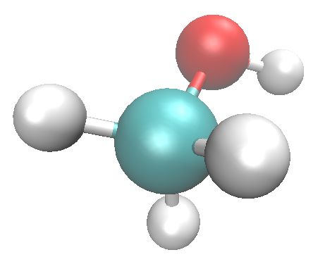

**2**

**1**

**3**

**4**

**1**

**4**

**2**

**3**

**Figure 1**. The molecule’s distance; **1D** distance, the longest distance between atom 1 and atom 2; For line 1-2, find two parallel planars, which are perpendicular this line but each contains atom (atom 3 or atom 4) of this molecule, the **2D** distance is the largest distance among those paired planars.

**Method 2.**

Use Gaussian software do the calculation, the basis_set: **# B3LYP/6-311++G(d) Volume** is used, the result consider in here consider the molecule’s conformation changes, thus the distance is an average of all the Monte Carlo (MC) simulation results.

**Method 3**

SESA: Solvent Exclusive Surface Area

SASA: Solvent Access Surface Area

|  |  |  |  |  |  |  |
| --- | --- | --- | --- | --- | --- | --- |
| Software | Note | Unit | Galactose_ideal | Galactose_model | Glucose | Lactose |
| MOPAC | **1D distance** | Å | 7.745 | 8.059 | 7.972 | 10.838 |
|  | **2D distance** | Å | 5.675 | 6.602 | 4.498 | 6.923 |
|  |  |  |  |  |  |  |
| Gaussian | **MC** | Å | 4.58 | 4.71 | 4.35 | 5.36 |
|  |  |  |  |  |  |  |
|  | **SESA** | Å2 | 161.585 | 161.762 | 157.815 | 275.813 |
|  | **SASA** | Å2 | 330.314 | 331.873 | 321.814 | 499.673 |