Fall 2023
Trip: 08/28/2023 -12/22/2023
I started the 01/11/2024 (within time frame).
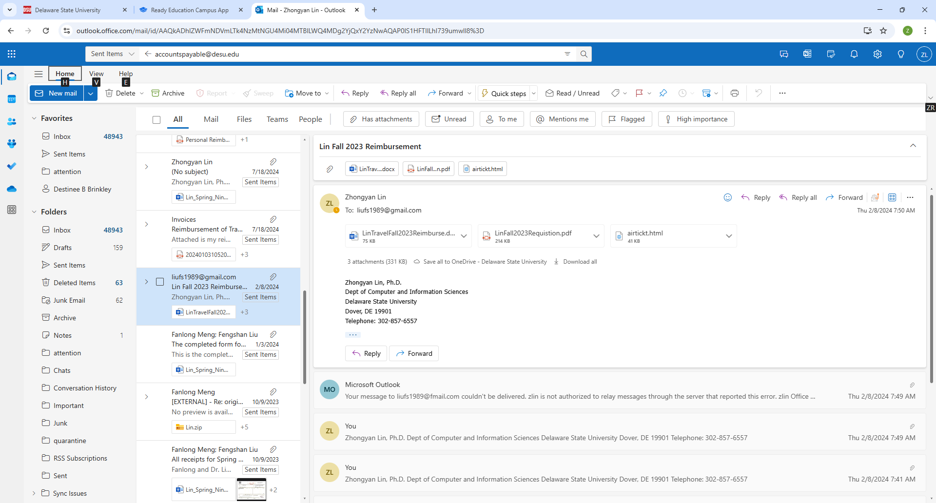
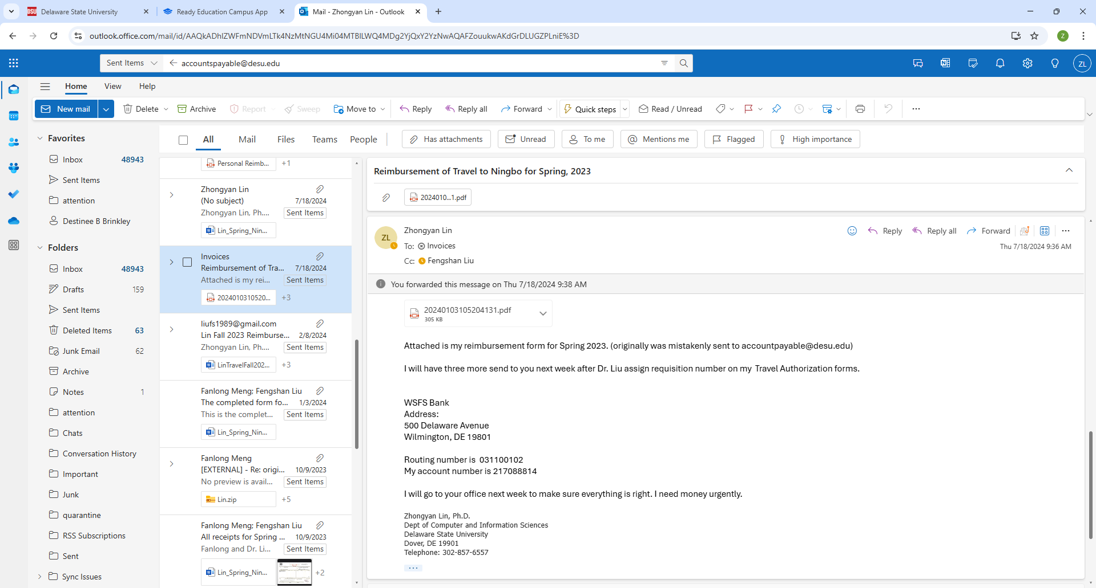
I sent reimbursement form to invoices@desu.edu on 07/18

