Fall 2023

Trip: 08/28/2023 -12/22/2023

I started the 01/11/2024 (within time frame).

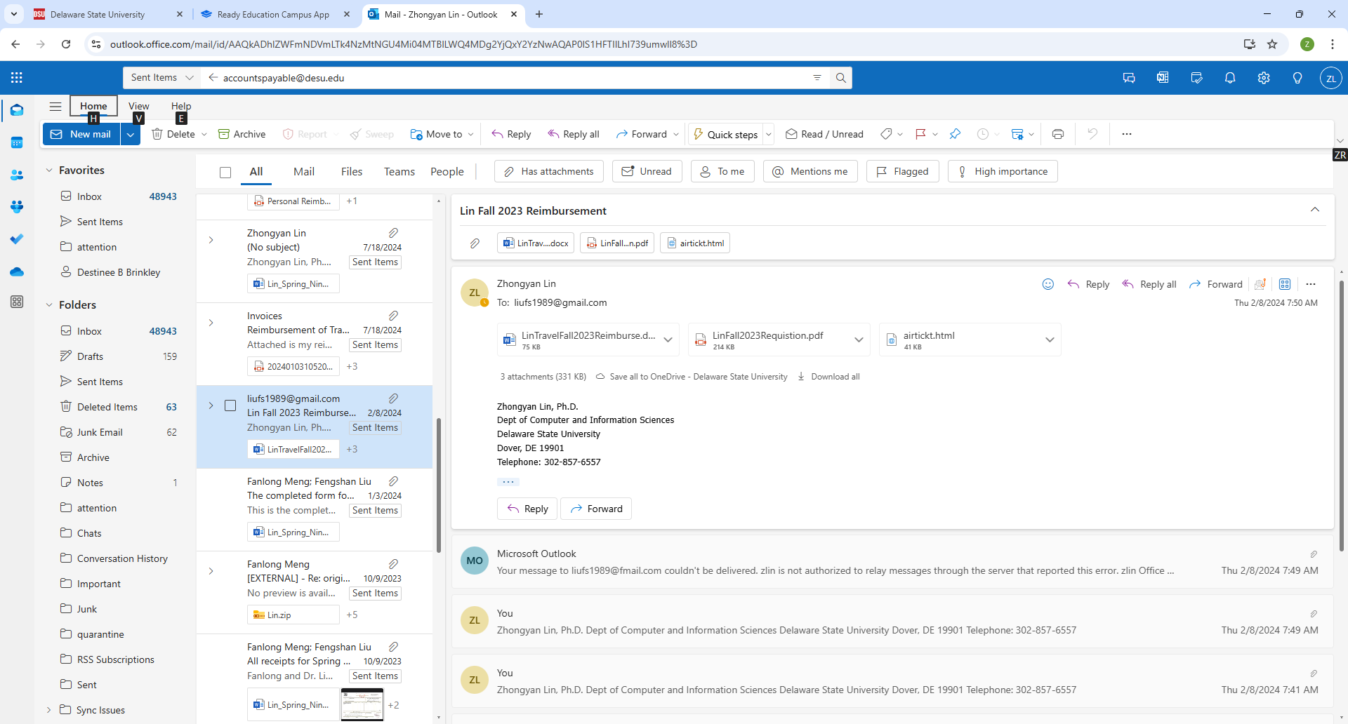

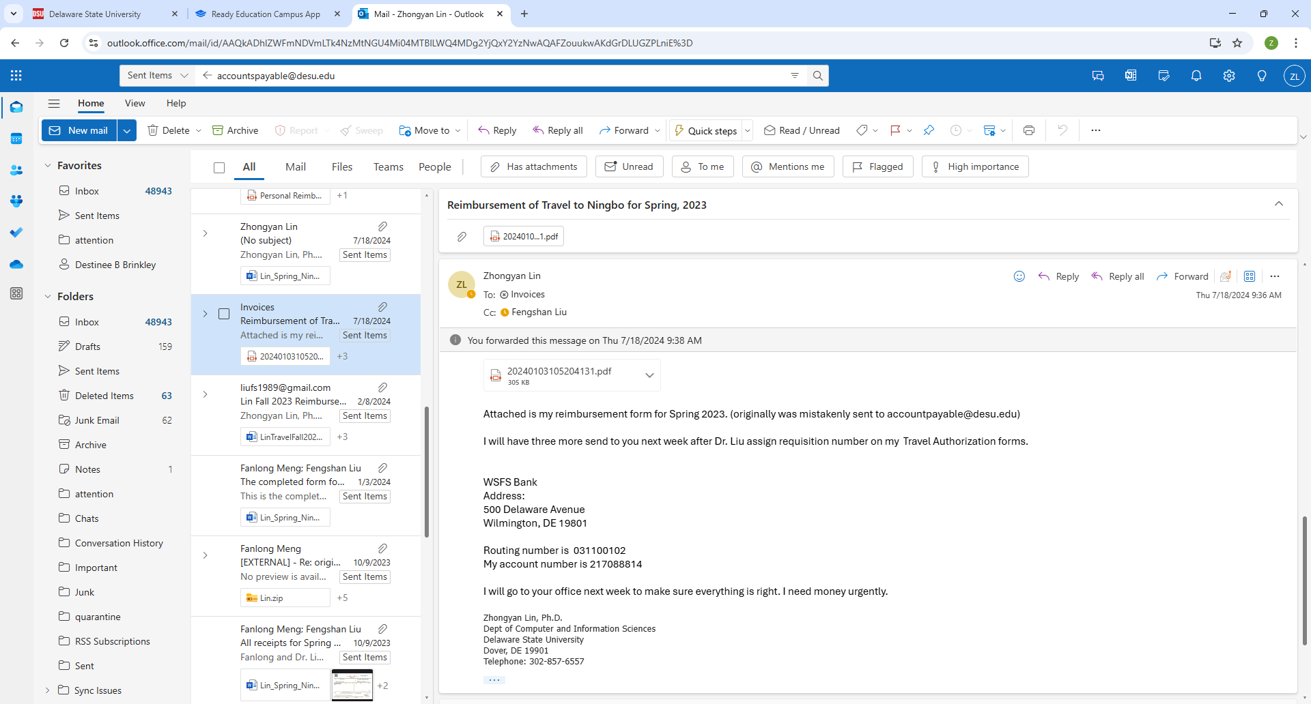

I sent reimbursement form to [invoices@desu.edu](mailto:invoices@desu.edu) on 07/18