软体动物生殖发育过程DNA甲基化研究进展
DNA甲基化调控软体动物生殖可塑性的分子机制作为表观遗传调控的核心机制（图2），通过动态调控基因时空表达模式，在环境适应与表型可塑性中发挥枢纽作用。软体动物因其复杂的生活史策略（如阶段性生殖投入、环境依赖性性别决定）及表观基因组可塑性特征，成为解析“环境-表观遗传-生殖表型”三元互作关系的理想模型^{[33]}。近年来，基于多组学技术（全基因组甲基化测序、单细胞表观组分析）与模式物种（长牡蛎、皱纹盘鲍Haliotis discus hannai）的研究体系。软体动物生殖发育表观调控网络逐步明晰^{[34-35]}，其核心发现包括：1）配子发生中的甲基化重编程机制：在长牡蛎中通过TET双加氧酶介导的5mC氧化（5hmC/5fC/5caC）卵母细胞主动去甲基化，全局甲基化水平下降42.7±5.3%（vs.精母细胞8.2±3.1%），该过程可清除转座子区异常修饰（LINE元件甲基化清除率76.4%），维持胚胎基因组稳定性^{[36]}。2）性腺分化过程存在性别特异性差异甲基化区域（DMRs）：皱纹盘鲍精巢发育关键基因SOX9与DMRT1的启动子区甲基化水平在雌性个体中升高1.9-2.4倍（RRBS验证），表现为启动子甲基化-基因表达负调控，通过抑制Wnt/β-catenin通路调控性别分化^{[35, 37]}；而且长牡蛎性腺中鉴定到温度响应型DMRs 274个，其中86.5%位于配子发生相关基因（如Vasa、Boule）调控区，提示表观遗传调控在环境-生殖轴中的桥梁作用^{[38]}。3）环境胁迫的跨代表观遗传效应：长牡蛎温度暴露组（ΔT≥5℃）F₁代配子保留12.7%的母代DMRs，其子代（F₂）在高温胁迫（30℃）下的存活率提升23.4%（vs. 对照组），证实表观遗传记忆的环境适应性，可跨代记忆形成^{[39]}。因此，胁迫诱导DNA甲基化可形成跨代表观遗传“记忆”，通过生殖系细胞传递增强子代环境适应性。上述机制表明，环境驱动的表观遗传修饰可能是软体动物生殖可塑性的重要调控枢纽。
作为软体动物中表观遗传研究的薄弱类群，头足类近期研究取得重要突破：Díaz-Freije等采用甲基化敏感扩增多态性技术（MSAP）揭示真蛸早期幼体呈现高胞苷甲基化特征（全基因组平均甲基化水平58.3±4.7%），其中Hox基因簇异常高甲基化（Δβ=0.41，FDR<0.01）导致发育相关基因（如HoxA3表达量下降3.8倍）沉默，显著提高早期死亡率（高甲基化组存活率23.1% vs. 正常组67.4%）^{[39]}。比较表观基因组学显示，头足类全基因组甲基化水平显著高于双壳类：金乌贼（Sepia esculenta）性腺组织甲基化率为42.46±3.1%，短蛸（Octopus ocellatus）外套膜组织为23.97±2.8%（BS-seq数据），而大珠母贝（Pinctada maxima）对应组织仅15.48~19.61%，提示头足类可能通过表观基因组可塑性增强环境适应性^{[39-41]}。玛雅章鱼（Octopus maya）胚胎暴露于高温胁迫（30℃）时，生殖细胞8-羟基-2’-脱氧鸟苷（8-OHdG）水平升高7.2倍（LC-MS/MS检测），其通过空间位阻效应抑制DNMT3B甲基转移酶活性（酶活降低64%），导致全局甲基化水平下降18.3%，最终引发胚胎孵化率降低至41.5±6.3%（vs. 对照组82.7±5.1%）^{[42]}。上述研究表明，头足类短生命周期物种的跨代遗传在一定程度上依赖DNA甲基化稳定性。虎斑乌贼作为典型r-策略物种、一年两代繁殖，其全人工繁育面临受精率低（<35%）、幼乌贼存活率差（<20%）等产业瓶颈^{[43-45]}。本课题组前期已完成：1）染色体水平基因组构建（contig N50=0.83 Mb，scaffold N50=104.3 Mb，BUSCO完整度97.8%），注释ER信号通路基因27个；2）鉴定ER相关差异甲基化区域（DMRs）27个（|Δβ|≥0.3，FDR<0.05），其中12个位于vtg、GnRHR等生殖基因启动子区。因此，本课题拟解决核心科学问题：环境胁迫如何通过ER信号通路介导的生殖细胞表观遗传重编程，调控虎斑乌贼繁殖效能的跨代可塑性？基于此，本研究拟开展以下工作：1）构建“DNA甲基化组-转录组”多组学关联网络，系统解析ER信号通路相关DMRs的动态特征，通过CRISPR/Cas9介导的靶向甲基化编辑技术进行功能验证；2）建立温度梯度胁迫模型，结合单细胞甲基化测序（scMethyl-Seq）追踪生殖细胞表观遗传记忆的跨代传递规律，构建“环境胁迫-表观重编程-子代转录响应”的定量关联模型。
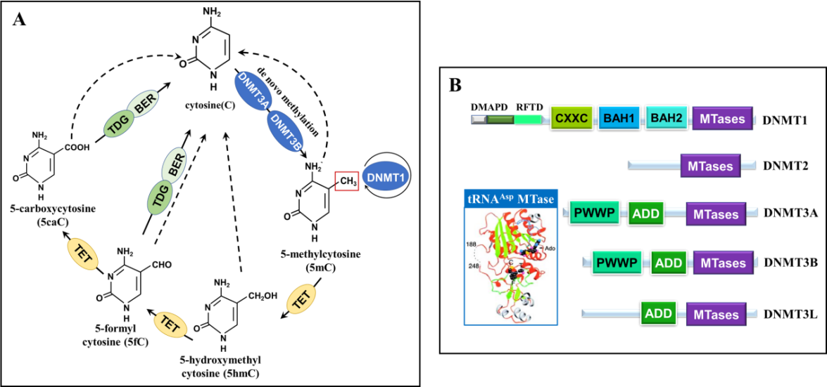
图2. DNA甲基化机制及DNMT结构示意图（引自Goll et al. 2006. Science ^{[43]}）
（A）DNA甲基化过程；（B）DNMTs分子结构

（3）温度胁迫ER通路关键基因DNA甲基化动态响应与表达调控偶联机制
针对养殖水体温度波动导致生殖衰退的现象，解析“温度胁迫-DNA甲基化-基因表达”的因果调控链。设计可控实验，模拟养殖中剧烈温度波动（ΔT≥7 ℃），设置不同温度梯度胁迫处理（对照处理、ΔT≤3 ℃、ΔT≥7 ℃），对性腺发育关键时期雌性个体进行全基因组亚硫酸氢盐测序（WGBS）与转录组测序（RNA-seq）联合分析，鉴定ER、GnRHR、vtg等关键基因调控区的温度响应型差异甲基化区域（DMRs）。筛选并鉴定响应热胁迫的差异甲基化区域（DMRs），分析CpG位点甲基化水平与基因表达量的相关性。进一步，利用荧光素酶报告载体甲基化修饰技术，在细胞水平验证关键DMRs甲基化状态改变对转录因子结合及基因转录活性的直接影响。从而验证“温度波动→特定DMRs甲基化改变→ER/GnRHR/Vtg表达失调”这一核心假设环节。
（4）ER通路相关表观遗传印记的跨代传递及其对生殖表型影响验证
本研究在明确环境诱导表观修饰机制基础上，深入探究表观记忆的遗传稳定性，解答“环境诱导的甲基化印记能否跨代传递并影响子代生殖表型”的关键问题。建立温度胁迫的跨代实验体系（F₀母代处理-F₁子代-F₂孙代），通过WGBS追踪ER通路关键基因DMRs在卵母细胞、受精卵及早期胚胎中的动态变化，鉴定能够逃逸受精后表观重编程的稳定遗传标记。其次，通过测定不同世代的孵化率、性腺发育指数、ER通路基因表达及E₂水平，量化评估表观遗传变异对生殖表型的跨代影响效应。进一步，比较F₀代体细胞、F₁代生殖细胞及F₂代性腺的甲基化模式，阐明这些胁迫诱导的修饰是部分重编程还是稳定遗传，从而揭示环境胁迫通过ER通路介导的表观遗传变异影响子代繁殖效能的跨代机制，阐明环境胁迫导致养殖群体“生殖效能衰退”的表观遗传本质，最终构建完整的“环境胁迫→表观遗传重塑→亲本生殖性能下降→印记跨代传递→子代适应/损伤”理论模型。

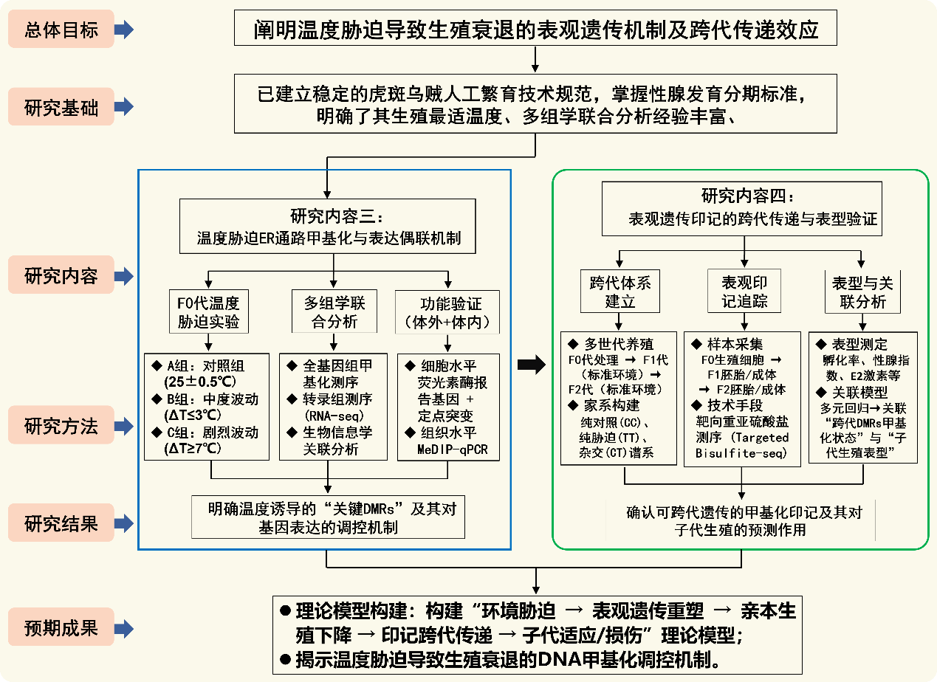
图4. 虎斑乌贼ER通路温度胁迫表观遗传调控与跨代传递研究技术路线图

参考文献：
- Sun, D., Yu, H., Li, Q. Examination of the roles of Foxl2 and Dmrt1 in sex differentiation and gonadal development of oysters by using RNA interference[J]. Aquaculture. 2022, 548:737732.
- 姚汶励, 姜鹏, 白俊杰. 17α-甲基睾酮对草鱼性腺发育及性类固醇激素水平的影响[J].水产学报,2019,43(4):801-808.
- Kazeto, Y., Tosaka, R., Matsubara, H. et al. Ovarian steroidogenesis and the role of sex steroid hormones on ovarian growth and maturation of the Japanese eel[J]. J. Steroid Biochem. Mol. Biol. 2011, 127(3):149-154.
- Aham, E.C., Ravikumar, A., Okoye, C.O. et al. A comprehensive review of paper-based analytical devices for 17β-estradiol detection: Current status and future perspectives[J]. Microchem. J. 2024:111486.
- Keay, J., Bridgham, J.T., Thornton, J.W. The Octopus vulgaris estrogen receptor is a constitutive transcriptional activator: evolutionary and functional implications[J]. Endocrinology. 2006, 147(8):3861-3869.
- Nagasawa, K., Treen, N., Kondo, R. et al. Molecular characterization of an estrogen receptor and estrogen-related receptor and their autoregulatory capabilities in two Mytilus species[J]. Gene. 2015, 564(2):153-159.
- Kajiwara, M., Kuraku, S., Kurokawa, T. et al. Tissue preferential expression of estrogen receptor gene in the marine snail, Thais clavigera[J]. Gen. Comp. Endocr. 2006, 148(3):315-326.
- Castro, L.F.C., Melo, C., Guillot, R. et al. The estrogen receptor of the gastropod Nucella lapillus: Modulation following exposure to an estrogenic effluent[J]? Aquat. Toxicol. 2007, 84:465-468.
- Yang, Y., Zhou, Y., Pan, L. et al. Benzo [a] pyrene exposure induced reproductive endocrine-disrupting effects via the steroidogenic pathway and estrogen signaling pathway in female scallop Chlamys farreri[J]. Sci. Total. Environ. 2020, 726:138585.
- De Lisa, E., Paolucci, M., Di, Cosmo, A. Conservative nature of estradiol signalling pathways in the brain lobes of Octopus vulgaris involved in reproduction, learning and motor coordination[J]. J. Neuroendocrinol. 2012, 24(2):275-284.
- Zohar, Y., Muñoz-Cueto, J.A., Elizur, A. et al. Neuroendocrinology of reproduction in teleost fish[J]. Gen. Comp. Endocrinol. 2010, 165(3):438-455.
- Nelson, E.R., Habibi, H.R. Functional significance of nuclear estrogen receptor subtypes in the liver of goldfish[J]. Endocrinology. 2010, 151(4):1668-1676.
- Moon, J.S., Choi, Y.H. Role of the insulin-like growth factor system in gonad sexual maturation in Pacific oyster Crassostrea gigas[J]. Fishier. Aquatic. Sci. 2020, 23:1-8.
- 刘婉.曼氏无针乌贼雌激素受体基因的克隆、表达及生殖调控功能初探[D].浙江海洋大学, 2016.
- Jiang, M.W., Han, Q.X., Xu, L.T. et al. Comparative transcriptomic analysis of the different developmental stages of ovary in the cuttlefish Sepia pharaonis[J]. BMC Genomics. 2024, 25(1):1-16.
- Stamatiades, G.A., Kaiser, U.B. Gonadotropin regulation by pulsatile GnRH: Signaling and gene expression[J]. Mol. Cell. Endocrinol. 2018, 463:131-141.
- Kitahashi, T., Ogawa, S., Parhar, I.S. Cloning and expression of kiss2 in the zebrafish and medaka[J]. Endocrinology. 2009, 150(2):821-831.
- Ohga, H., Selvaraj, S., Adachi, H. et al. Functional analysis of kisspeptin peptides in adult immature chub mackerel (Scomber japonicus) using an intracerebroventricular administration method[J]. Neurosci. Lett. 2014, 561:203-207.
- 刘建业. Gpr173介导Phoenixin调控的金钱鱼生殖功能的研究[D]. 广东海洋大学, 2020.
- Wang, C., Croll, R.P. Effects of sex steroids on spawning in the sea scallop, Placopecten magellanicus[J]. Aquaculture. 2006, 256:423-432.
- Zhu, X., Guo, C., Lin, C. et al. Estradiol-17β and testosterone levels during the annual reproductive cycle of in Mytilus coruscus[J]. Anim. Reprod. Sci. 2018, 196:35-42.
- Ciocan, C.M., Cubero-Leon, E., Puinean, A.M. et al. Effects of estrogen exposure in mussels, Mytilus edulis, at different stages of gametogenesis[J]. Environ. Pollut. 2010, 158:2977-2984.
- Muriach, B., Carrillo, M., Zanuy, S. et al. Distribution of estrogen receptor 2 mRNAs (Esr2a) in the brain and pituitary of the sea bass (Dicentrarchus labrax) [J]. Brain. Res. 2008, 121:126-141.
- Kazeto, Y., Tosaka, R., Matsubara, H. et al. Ovarian steroidogenesis and the role of sex steroid hormones on ovarian growth and maturation of the Japanese eel[J]. J. Steroid Biochem. Mol. Biol. 2011, 127:149-154.
- Gu, W., Thitiphuree, T., Otoki, Y. et al. Expression and functional analyses for estrogen receptor and estrogen related receptor of Yesso scallop, Patinopecten yessoensis[J]. J. Steroid Biochem. Mol. Biol. 2023, 231:106302.
- Khan, M.Z.I, Uzair, M., Nazli, A. et al. An overview on estrogen receptors signaling and its ligands in breast cancer[J]. Eur. J. Med. Chem. 2022,241:114658.
- Arterburn, J.B., Prossnitz, E.R. G protein–coupled estrogen receptor GPER: molecular pharmacology and therapeutic applications[J]. Annu. Rev. Pharmacol. 2023, 63(1):295-320.
- Soloperto, S., Nihoul, F., Olivier, S. et al. Effects of 17α-Ethinylestradiol (EE2) exposure during early life development on the gonadotropic axis ontogenesis of the European sea bass, Dicentrarchus labrax[J]. Comp. Biochem. Phys. A. 2022, 271: 111260.
- Tsai, P.S., Sanders, K.N., Dai, X. et al. Authentication of a lophotrochozoan adipokinetic hormone receptor in a Gastropod, Aplysia californica[J]. Gen. Comp. Endocr. 2024, 345:114393.
- June, K., Bridgham, J.T., Thornton, J.W. The Octopus vulgaris estrogen receptor is a constitutive transcriptional activator: evolutionary and functional implications[J]. Endocrinology. 2006, 147(8):3861-9.
- 王昊泽, 王秀利. DNA甲基化及其在水产养殖动物中的应用研究进展[J].河北渔业,2017,(8):48-53.
- Haidar, L., Georgescu, M., Drăghici, G.A. et al. DNA Methylation Machinery in Gastropod Mollusks[J]. Life. 2024, 14(4):1-21.
- Zhang, X.J., Han, B.B., Shao, Z.Y. et al. Auto-suppression of Tet dioxygenases protects the mouse oocyte genome from oxidative demethylation[J]. Nat. Struct. Mol. Biol. 2024, 31(1):42-53.
- Zhang, X., Li, Q., Kong, L. et al. DNA methylation changes detected by methylation-sensitive amplified polymorphism in the Pacific oyster (Crassostrea gigas) in response to salinity stress[J]. Genes. Genom. 2017, 39:1173-1181.
- Sarkies, P. Molecular mechanisms of epigenetic inheritance: Possible evolutionary implications[J]. Semin. Cell. Dev. Biol. 2020, 97:106-115.
- Zhang, Q., Fu, Y., Zhang, Y. et al. Genome-wide identification and expression profiling of the Wnt gene family in three abalone species[J]. Genes. Genom. 2024: 1-12.
- Díaz-Freije, E., Gestal, C., Castellanos-Martínez, S. et al. The role of DNA methylation on Octopus vulgaris development and their perspectives[J]. Front. Physiol. 2014, 5:62-68.
- 何暮春, 张金勇, 刘长琳等. 金乌贼生长期DNA甲基化水平和模式[J]. 渔业科学进展, 2018, 39(4):46-55.
- Macchi, F., Edsinger, E., Sadler, K.C. Epigenetic machinery is functionally conserved in cephalopods[J]. BMC Biol. 2022, 20(1):1-23.
- Jiang, M.W., Peng, R.B., Wang, S.J., Zhou, S.N., Chen, Q.C., Han, Q.X., Jiang, X.M*. Growth performance and nutritional composition of Sepia pharaonis under artificial culturing conditions[J]. Aquacult. Res. 2018, 49(8):2788-2798.
- 蒋霞敏, 彭瑞冰, 韩庆喜, 江茂旺, 陶震, 宋微微.虎斑乌贼的生物学及养殖技术[M]. 北京:海洋出版社. 2019:1-300.
- Zhang, Z.H., Chen, Q.C., Jiang, X.M, Han, Q.X., Peng, R.B., Pan, H.L., Jiang, M.W*. Histological analysis of oogenesis and ovarian development of the pharaoh cuttlefish, Sepia pharaonis[J]. Invertebr. Biol. 2023, 142(2):1-14.
- Goll, M.G., Kirpekar, F., Maggert, K.A. et al. Methylation of tRNAAsp by the DNA methyltransferase homolog Dnmt2[J]. Science. 2006, 311(5759):395-398.

