# Assignment 1

This assignment is about the exploration of non-parametric methods for density estimation, including histogram method, kernel density estimation and k nearest neighbor method.

## 0. Overview

### 0.1 Structure

* source python file
  + source.py
* solution files
  + histogram.py: implementation of histogram method
  + kernel.py: implementation of kernel density estimation
  + knn.py: implementation of k nearest neighbor
* other file
  + plot.py: my wrapper of the gm1d plot function for showing gm1d in each subplot

### 0.2 Packages

* Packages including numpy, matplotlib, scipy are used for implementing algorithms.
* In addition, argparse is used for organizing the program, which can be installed via:
* pip install argparse

### 0.3 Usage

* There are example usages in the following context
* Show the help message via:
* python source.py -h

### 0.4 Parameters

* n: the amount of sample data
* b: the amount of bins in histogram method
* h: the parameter h in Gaussian kernel
* k: the amount of nearest neighbors

## 1. histogram method

### 1.1 Implementation

* This can be easily implemented with hist function in matplotlib.pyplot.
* Example usage (replace 200 and 25 with desired values of n and b):
* python source.py --algorithm histogram_method --n 200 --b 25

### 1.2 Vary num_data

* By increasing n in the usage above, the result histogram **gets less spiky, captures more underlying features and gets closer to the original distribution**.
* As n grows, b can be increased for a certain amount which makes the histogram better without making the histogram spiky.

### 1.3 Vary the number of bins

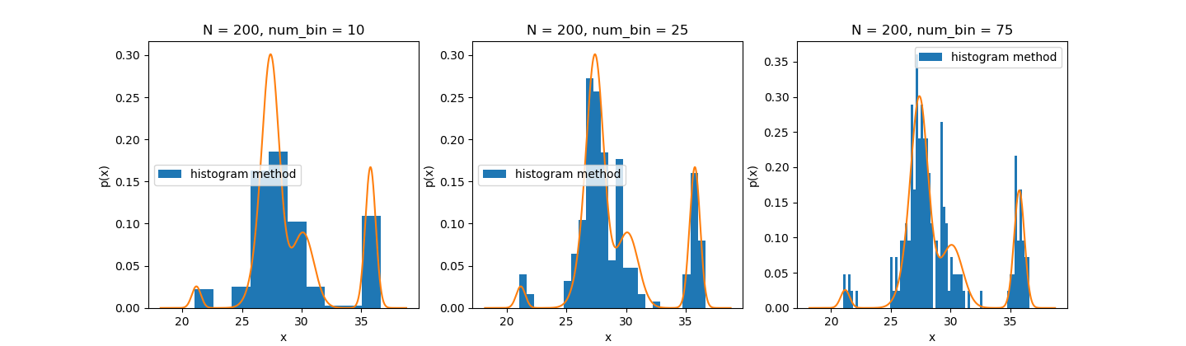

* This is the result of N = 200 and b = 10 or 25 or 75, which can be obtained with the following command:
* python source.py --algorithm histogram_result
* The effect of b:
  + If b is too small as shown on the left, the histogram is **too smooth** and **captures little details** of the original distribution (orange curve).
  + If b is too large as shown on the right, the histogram gets **too spiky** with **a lot of structures that are not presented** in the original distribution.
  + The best b is some intermediate value as shown in the middle, which **captures the details without being spiky**.

### 1.4 Find the optimal number of bins

This is achieved with Shimazaki and Shinomoto's choice.

#### Implementaion

* generate an array of bin widths
* calculate the cost of each bin width with this formula:
$$C\left(∆\right)= \frac{2k-v}{∆^{2}}, where k is mean, v is variance and ∆ is bin width$$

* The bin width that achieves the lowest cost is the best bin width

#### Usage

* The following usage finds the best b with a given n:
* python source.py --algorithm optimal_bin --n 200

#### Result

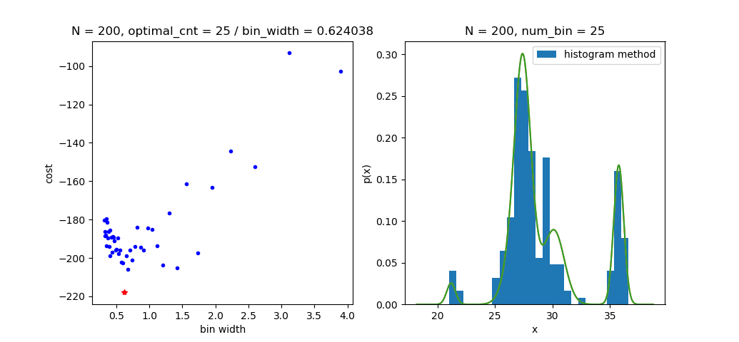

If n = 200, b = 25 is the best result, which is shown above: + [4, 5, 6, ..., 50] number of bins are tested + on the left, the cost of each bin width is shown in the scatter plot . The histogram with the optimal bin width is shown on the right

### 1.5 Other methods for finding the optimal amount

* Square-root choice
$$b= \left\lceil \sqrt{n}\right\rceil$$

* Sturges' formula
$$b= \left\lceil \sqrt{\log_{2}{n}}\right\rceil +1$$

* Rice Rule

$$b= \left\lceil 2n^{\frac{1}{3}}\right\rceil$$

## 2. kernel density estimate

### 2.1 Implementation

* Implemented with numpy operation based on Gaussian kernel
* Example usage (replace 200 and 0.35 with desired values of n and h):
* python source.py --algorithm kernel_density_estimate --n 200 --h 0.35

### 2.2 Vary num_data

By increasing n in the usage above, the result curve **captures more underlying features and gets closer to the original distribution**.

### 2.3 Vary h

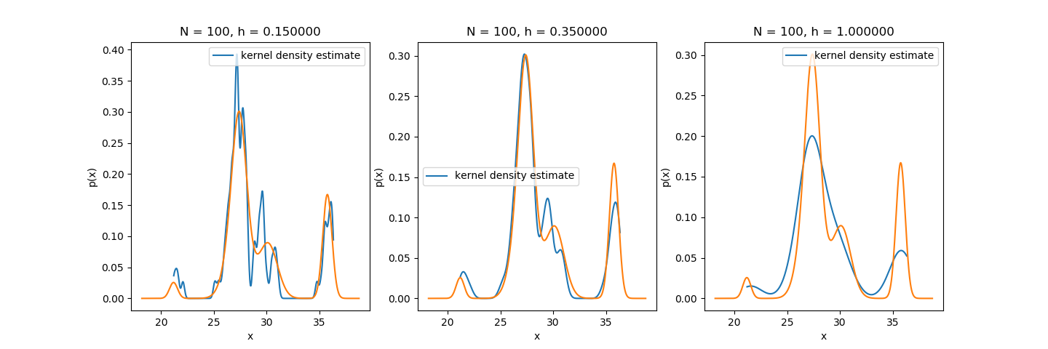

* This is the result of N = 100 and h = 0.15 or 0.35 or 1, which can be obtained with the following command:
* python source.py --algorithm kde_result
* The effect of h:
  + If h is too small as shown on the left, the curve gets **too spiky** with **a lot of structures that are not presented** in the original distribution.
  + If h is too large as shown on the right, the curve is **too smooth** and **captures little details** of the original distribution.
  + The best h is some intermediate value as shown in the middle, which **captures the details without being spiky or too smooth**.

### 2.4 Find the optimal h

This is achieved with the idea of maximum likelihood.

#### Implementation

* Test different value of h to achieve the highest probability:
$$L\left(h\right)= \prod_{i=1}^{m}{\frac{1}{N}\sum_{n=1, n !=i}^{N}{\frac{1}{{(2πh^{2})}^{\frac{1}{2}}}e^{-\frac{{(x_{i}-x_{n})}^{2}}{2h^{2}}}}}$$

* This can be achieved easily with minimize in scipy.optimize

#### Usage

* The following usage finds the best h with a given n:
* python source.py --algorithm optimal_h --n 200

#### Result

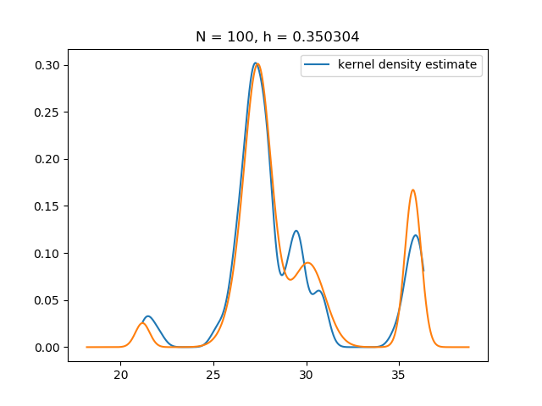

If n = 100, h = 0.35 is the best result, which is shown above.

## 3. k nearest neighbor method (kNN)

### 3.1 Implementation

kNN is implemented with the following 3 methods: * Naive approach: + sort sample data and test data + set a window with fixed width k on sample data + for each test data, slide the window to include the k nearest neighbors + get V with the following formula

* Matrix operation approach:
  + implemented with numpy
* KD tree:
  + implemented with KDTree in scipy.spatial

### 3.2 Usage

Example usage (replace 200 and 14 with desired values of n and k):

python source.py --algorithm kNN_kdtree --n 200 --k 14

### 3.3 Vary num_data

By increasing k in the usage above, the result curve **captures more underlying features and gets closer to the original distribution**.

### 3.4 Vary k

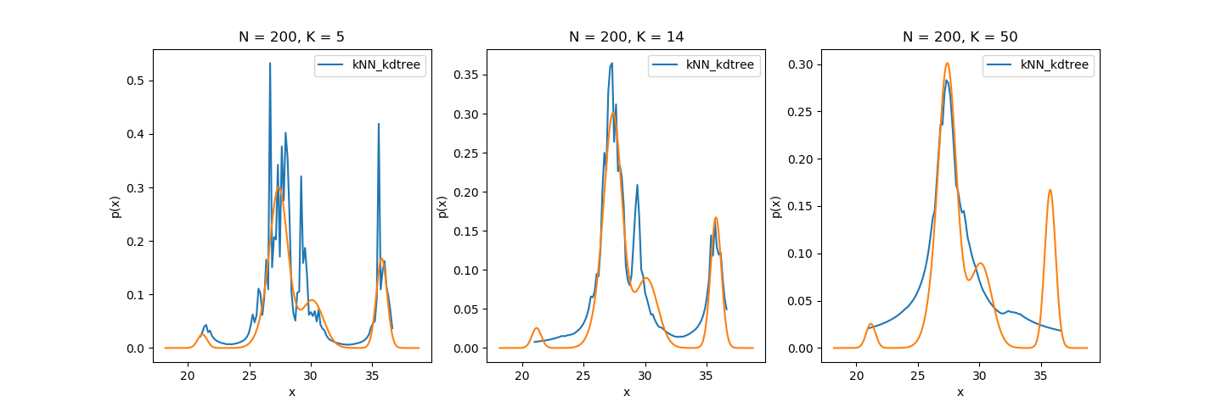

* This is the result of N = 100 and k = 5 or 14 or 50, which can be obtained with the following command:
* python source.py --algorithm kNN_result
* The effect of k:
  + If k is too small as shown on the left, the curve gets **noisy decision boundaries** with **a lot of structures that are not presented** in the original distribution.
  + If k is too large as shown on the right, the curve gets **over-smoothed boundaries** and **captures little details** of the original distribution.
  + The best k is some intermediate value as shown in the middle, which is **large enough to minimize error rate** and __small enough to only include nearby samples.

### 3.5 Find the optimal k

This is achieved with the rule of thumb.

#### Implementation

* Get the best k simply with:

$$k= √n$$

#### Usage

* The following usage finds the best k with a given n:
* python source.py --algorithm optimal_K --n 200

#### Result

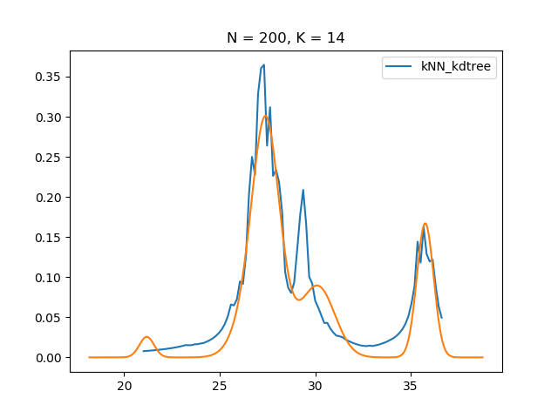

If n = 100, k = 14 is the best result, which is shown above.

### 3.6

Assume {x1, x2, … xn} is the sample data, if the test data x > xn, the sum of probability mass over all the space won’t converge to 1 as this is O(lnx).