# **Pay-android**

###### **Pay Framework for android**

A sdk implemented in merchant app to collect consumer's credit/debit card information

1 Inject a credit form to collect consumer’s credit/debit card information:

card number, holder name, expiry date, CVV/CVC

Or ACH payment

Checking/saving, holder name, routing number, accout number

2 provide tokenize, purchase methods

## **Step 1: Install**

(1) copy PayAndroidCredit-release.aar to app/libs

(2) app/bild.gradle

repositories {

flatDir {

dirs 'libs'

}

} ...

dependencies {

...

compile(name:'PayAndroidCredit-release',ext:'aar')

...

}

## **Step 2: Setup View**

Inject Pay credit form into a ViewGroup in your app.

CardInfoView(ViewGroup viewGroup, **int** creditCardStyle, **int** payType)

payType:

PayConstants.***Card***.**label**

PayConstants.Ach.**label**

creditCardStyle:

PayConstants.***SingleLine***.**label**

PayConstants.TripleLine.**label**

Triple Lines:

(int)PayConstants.TripleLine.label

Credit/Debit ACH

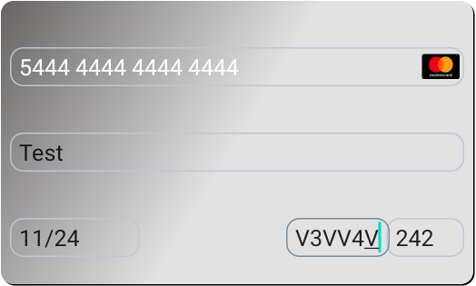or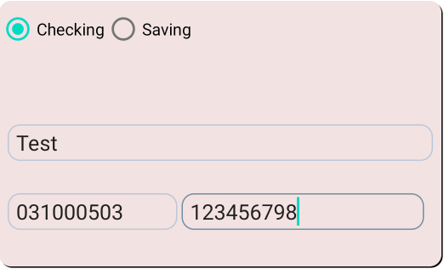

Single Line:

(int)PayConstants.SingleLine.label

Credit/Debit ACH

or 

example:

CardInfoView CardInfoView;

...

CardInfoView = pay.androidcredit.business.PayService.*CardInfoView*(findViewById(R.id.***tripleLine***),(**int**) pay.androidcredit.util.PayConstants.***TripleLine***.**label**,(**int**) pay.androidcredit.util.PayConstants.***Card***.**label**);

## **Step 3: Send the Request**

PayService.sendRequest(String secureId, pay.androidcredit.widgets.CardInfoView creditForm, PayCallback PayCallback)

;

Example:

(2.1) purchase:

//Make sure secureID for payment has been retrieved from context

try{

PayService.sendRequest(secureId, CardInfoView,new PayCallback(){

public void onResultPay(String result) {

//please process result in your own way, ex: showMsg("Payment Result:" + result);

}

});

}catch (Exception e){

//showMsg("Error:" + e.getMessage());

}

(2.2) Tokenize: binding a card or bank account to an token

//Make sure secureID for tokenization has been retrieved from context

try{

PayService.sendRequest(secureId,CardInfoView,new PayCallback(){

public void onResultPay(String result) { //result

//please process result in your own way, ex: showMsg("Payment Result:" + result);

}

});

}catch (Exception e){

//showMsg("Error:" + e.getMessage());

}