EECS 3311 Project Report
Fall 2018-19

NAME | LOGIN
Xi Zhang | zhangxi0
Ziyin Zhong | james98
Zijie Liang | chaptere

Submitting account: james98

1.1. BON1_relationships
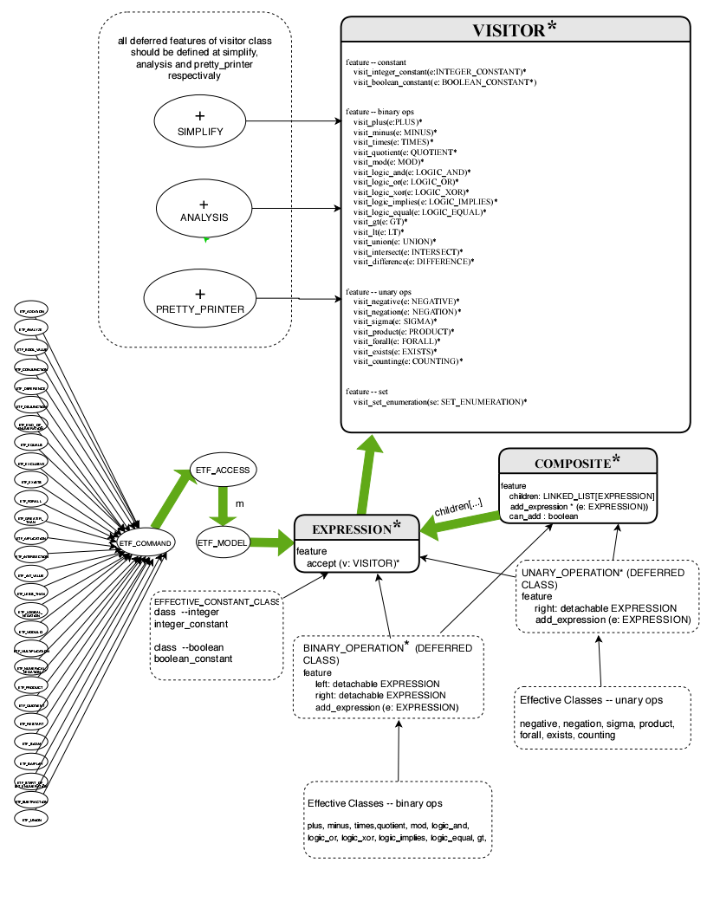
1.2. BON2_language_structure
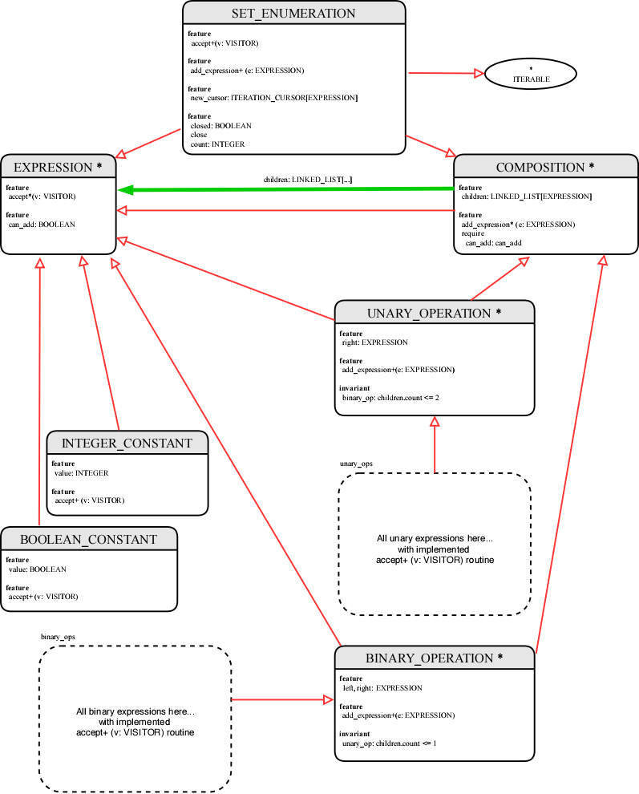
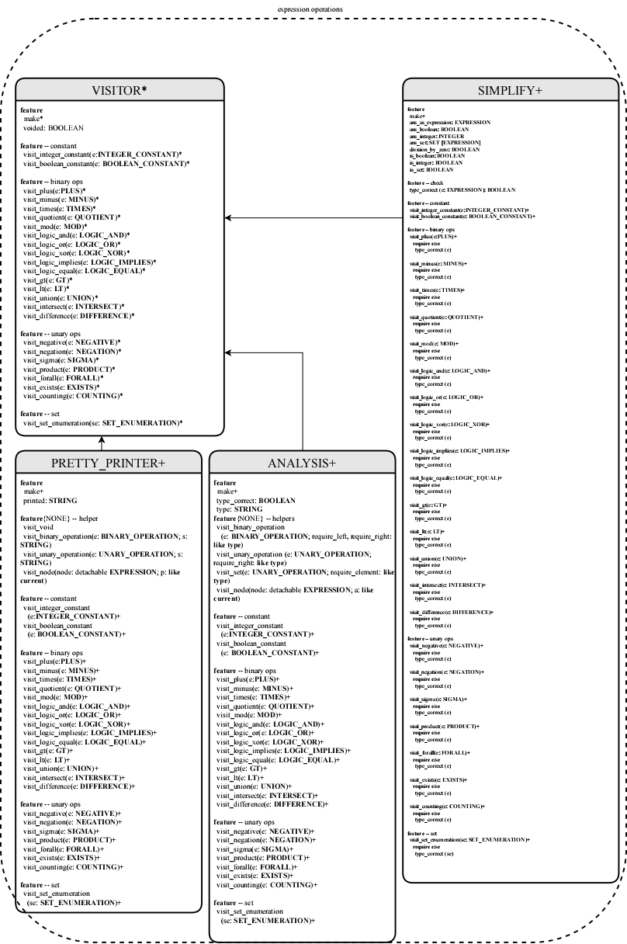
1.3. BON3_expression_operations
2. Report

2.1. DESIGN PATTERNS

In this project, we need to design an expression language which supports a few operations.

This project makes use of several design patterns: the visitor design pattern, the composite design pattern, the singleton design pattern and a little bit of iterator design pattern (to make SET_ENUMERATION iterable).

The expression language tree is given in project instruction. We made BINARY_OPERATION, UNARY_OPERATION and SET_ENUMERATION inherit both EXPRESSION and COMPOSITE, and COMPOSITE itself inherits EXPRESSION.

For convenient, the operation to add an expression to the structure is written in the side of expression language, while other operations (pretty print, simplify and analysis) are encapsulated in visitors. I made this design decision because I believe that the expression structure itself should be able to add new expression, instead of using a visitor to add expression.

To add an expression to the tree, we first check if there’s any space left in the tree. If there is, we know that the root of the tree must be a COMPOSITE, so we call the add_expression routine of the root, and let polymorphism handle the rest.

To do an operation on the language structure, we check if the expression tree’s root is void. If it isn’t, we let it accept the corresponding visitor of the operation, and let polymorphism handle the rest.

2.2. DESIGN_PRINCIPLES

UNIFORM ACCESS PRINCIPLE
There’s an interface between user and model. Any user input has to go through this interface. If there is a change inside the model, the user interface can match the user input to the new implementation in the model. For example, if we decide to make operation “simplify” no longer implemented as a visitor but as procedures written in the expression language, the user needs no worry: he/she just calls simplify.
On the last day of project, I unfortunately had to rewrite the whole ANALYSIS class, and thanks to sticking with uniform access principle, all I needed to change on other classes is a renamed attribute (answer → type_correct).

SINGLE CHOICE PRINCIPLE
This principle is about code reuse. When I implement the PRETTY_PRINTER class, I notice that when visiting the binary operations, the codes are very similar, and the only difference is the operation to be printed. So I made a private helper method visit_binary_operation that takes a string. Same for visit_unary_operation and for other visitors.

OPEN-CLOSE PRINCIPLE
In this project, the structure of expression language is not likely to be changed, while we want to preserve the ability to add new operations to the language structure. Thus, we decided to use the visitor pattern which makes the operations opened and the expression language closed.

INFORMATION HIDING
All attributes and commands in ETF_MODEL are only opened to ETF_COMMAND (and all its subclasses), except the ETF generated “reset” routine. Queries are opened to all classes.
All attributes in COMPOSITION (and all its subclasses) are only opened to VISITOR (and all its subclasses). All commands in COMPOSITION are opened to ETF_MODEL and COMPOSITION.

COMMAND-QUERY SEPARATION
In our project, there exists no routine that both changes the state of an object and returns a value.

