## 2021春季工程实践创新项目III

## 设计文件



作品名称：智能阳台

小组编号：20210316

小组成员1：刘正浩（2019270103005）

小组成员2：李仁轩（2019270103011）

小组成员3：唐晨烨（2019270103003）

2021年 7月 11日

# 1系统方案

## 1.1 硬件平台模块的论证与选择

我们选择了软硬件开发难度最低,适用范围更广的ESP32平台。它拥有13个GPIO，两个按键，一个彩色屏幕，同时支持USB TYPE-C口与外接电池口进行供电。我们选用的这块开发板上还集成了Wifi和蓝牙模块，WiFi支持三种模式：AP，STA和AP + STA -支持Windows系统（cygwin和msys32）和Linux系统。它支持使用Arduino-ide, ESP-IDF, Micropython多种开发环境进行开发，同时支持Lua程序。

# 2系统理论分析与计算

## 2.1 功耗的分析

依据ESP32的数据手册，ESP32的静态功耗可以控制在实验室功率计忽略的量级，约3 $μW$。而瞬态功耗可以达到200mA的漏电流。

对于步进电机，在本模型中最大电流约为100mA，共计300mA，需要5V供电。

对于风扇，本模型采用12V风扇驱动，最大电流约为100mA，但无需通过电源芯片。

对于加热模块，本模型使用小灯泡代替其功能，最大电流约为300mA，同样无需通过电源芯片。

对于74AHCT08逻辑门，最大电流约0.8mA，考虑到远小于步进电机和风扇的功耗，故可忽略不计

综上，可采用12V锂电池供电、7805提供5V的方案。

# 3 电路、程序与结构设计

## 3.1 电路的设计

原理图如下：

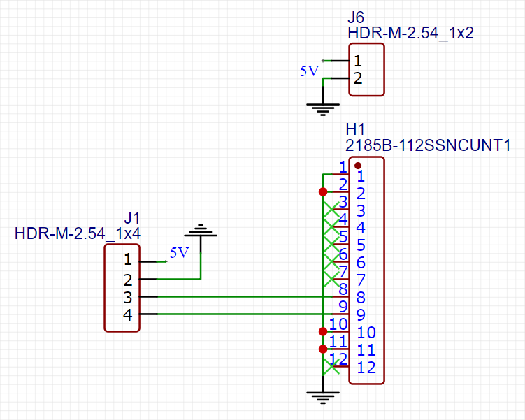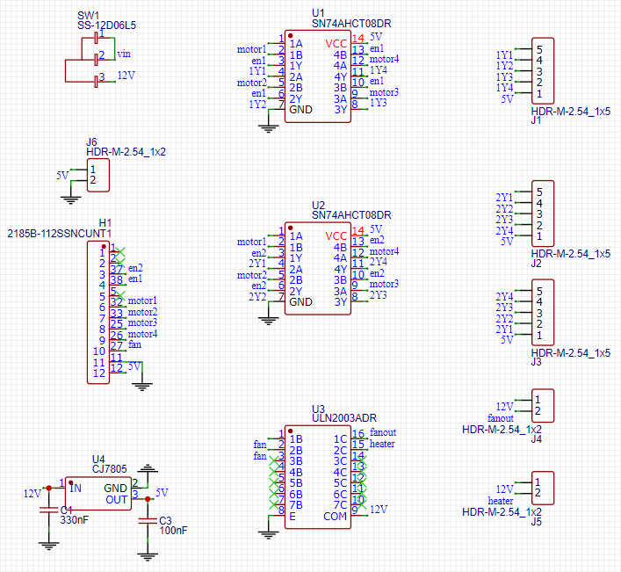

单片机接口

雨水检测器接口

风扇、加热器接口

电机驱动板接口

单片机接口

## 3.2 程序的设计

在程序中主要包含几个部分：单片机与服务器连接、开关状态记忆、电机驱动、风扇以及加热器驱动。下面是完整代码：

#define BLINKER_WIFI

#include <Blinker.h>

char auth[] = "43ad3f693cf7"; //设备编号

char ssid[] = "test_wifi"; //ssid

char pswd[] = "88888888"; //密码

int n = 0; //记录衣架状态

int m = 0; //记录风扇、加热器状态

// 新建组件对象，注意两个按键均为开关型按键

BlinkerButton Button1("Yijia");

BlinkerButton Button2("fengshan");

// 按下衣架按键即会执行该函数

void button1_callback(const String & state) {

BLINKER_LOG("get button1 state: ", state);

if (state=="off") {

n = 1;

// 反馈开关状态

Button1.print("off");

} else if(state=="on"){

n = 2;

// 反馈开关状态

Button1.print("on");

}

}

// 按下风扇、加热器按键即会执行该函数

void button2_callback(const String & state) {

BLINKER_LOG ("get button2 state: ",state);

if (state=="off") {

m = 0;

Button2.print("off");

} else if(state=="on"){

m = 1;

Button2.print("on");

}

}

void setup() {

// 初始化串口，并开启调试信息

Serial.begin(115200);

BLINKER_DEBUG.stream(Serial);

// 初始化有LED的IO

pinMode(37, OUTPUT);

pinMode(38, OUTPUT);

pinMode(32, OUTPUT);

pinMode(33, OUTPUT);

pinMode(25, OUTPUT);

pinMode(26, OUTPUT);

pinMode(27, OUTPUT);

// 初始化blinker

Blinker.begin(auth, ssid, pswd);

Button1.attach(button1_callback);

Button2.attach(button2_callback);

}

void loop() {

Blinker.run();

digitalWrite(38, HIGH);

digitalWrite(37, HIGH);

//控制衣架进出

if(n == 1)

{

digitalWrite(38, HIGH); //选择电机1

//开始转动

digitalWrite(32, HIGH);

delay(100);

digitalWrite(32, LOW);

digitalWrite(33, HIGH);

delay(100);

digitalWrite(33, LOW);

digitalWrite(25, HIGH);

delay(100);

digitalWrite(25, LOW);

digitalWrite(26, HIGH);

delay(100);

digitalWrite(26, LOW);////////////

digitalWrite(32, HIGH);

delay(100);

digitalWrite(32, LOW);

digitalWrite(33, HIGH);

delay(100);

digitalWrite(33, LOW);

digitalWrite(25, HIGH);

delay(100);

digitalWrite(25, LOW);

digitalWrite(26, HIGH);

delay(100);

digitalWrite(26, LOW);/////////////

digitalWrite(32, HIGH);

delay(100);

digitalWrite(32, LOW);

digitalWrite(33, HIGH);

delay(100);

digitalWrite(33, LOW);

digitalWrite(25, HIGH);

delay(100);

digitalWrite(25, LOW);

digitalWrite(26, HIGH);

delay(100);

digitalWrite(26, LOW);////////////

digitalWrite(32, HIGH);

delay(100);

digitalWrite(32, LOW);

digitalWrite(33, HIGH);

delay(100);

digitalWrite(33, LOW);

digitalWrite(25, HIGH);

delay(100);

digitalWrite(25, LOW);

digitalWrite(26, HIGH);

delay(100);

digitalWrite(26, LOW);///////////////////

digitalWrite(32, HIGH);

delay(100);

digitalWrite(32, LOW);

digitalWrite(33, HIGH);

delay(100);

digitalWrite(33, LOW);

digitalWrite(25, HIGH);

delay(100);

digitalWrite(25, LOW);

digitalWrite(26, HIGH);

delay(100);

digitalWrite(26, LOW);///////////////

digitalWrite(32, HIGH);

delay(100);

digitalWrite(32, LOW);

digitalWrite(33, HIGH);

delay(100);

digitalWrite(33, LOW);

digitalWrite(25, HIGH);

delay(100);

digitalWrite(25, LOW);

digitalWrite(26, HIGH);

delay(100);

digitalWrite(26, LOW);///////////////

digitalWrite(32, HIGH);

delay(100);

digitalWrite(32, LOW);

digitalWrite(33, HIGH);

delay(100);

digitalWrite(33, LOW);

digitalWrite(25, HIGH);

delay(100);

digitalWrite(25, LOW);

digitalWrite(26, HIGH);

delay(100);

digitalWrite(26, LOW);///////////////

digitalWrite(32, HIGH);

delay(100);

digitalWrite(32, LOW);

digitalWrite(33, HIGH);

delay(100);

digitalWrite(33, LOW);

digitalWrite(25, HIGH);

delay(100);

digitalWrite(25, LOW);

digitalWrite(26, HIGH);

delay(100);

digitalWrite(26, LOW);

// digitalWrite(38, LOW); //取消选择

delay(100);

digitalWrite(37, HIGH); //选择电机2

//开始转动

digitalWrite(32, HIGH);

delay(100);

digitalWrite(32, LOW);

digitalWrite(33, HIGH);

delay(100);

digitalWrite(33, LOW);

digitalWrite(25, HIGH);

delay(100);

digitalWrite(25, LOW);

// digitalWrite(37, LOW); //取消选择

delay(100);

}

else if (n == 2)

{

digitalWrite(37, HIGH); //选择电机2

//开始转动

digitalWrite(33, HIGH);

delay(100);

digitalWrite(33, LOW);

digitalWrite(32, HIGH);

delay(100);

digitalWrite(32, LOW);

digitalWrite(26, HIGH);

delay(100);

digitalWrite(26, LOW);

// digitalWrite(37, LOW); //取消选择

delay(250);

digitalWrite(38, HIGH); //选择电机1

//开始转动

digitalWrite(33, HIGH);

delay(100);

digitalWrite(33, LOW);

digitalWrite(32, HIGH);

delay(100);

digitalWrite(32, LOW);

digitalWrite(26, HIGH);

delay(100);

digitalWrite(26, LOW);

digitalWrite(25, HIGH);

delay(100);

digitalWrite(25, LOW);/////////////////

digitalWrite(33, HIGH);

delay(100);

digitalWrite(33, LOW);

digitalWrite(32, HIGH);

delay(100);

digitalWrite(32, LOW);

digitalWrite(26, HIGH);

delay(100);

digitalWrite(26, LOW);

digitalWrite(25, HIGH);

delay(100);

digitalWrite(25, LOW);////////////////

digitalWrite(33, HIGH);

delay(100);

digitalWrite(33, LOW);

digitalWrite(32, HIGH);

delay(100);

digitalWrite(32, LOW);

digitalWrite(26, HIGH);

delay(100);

digitalWrite(26, LOW);

digitalWrite(25, HIGH);

delay(100);

digitalWrite(25, LOW);//////////////////////

digitalWrite(33, HIGH);

delay(100);

digitalWrite(33, LOW);

digitalWrite(32, HIGH);

delay(100);

digitalWrite(32, LOW);

digitalWrite(26, HIGH);

delay(100);

digitalWrite(26, LOW);

digitalWrite(25, HIGH);

delay(100);

digitalWrite(25, LOW);/////////////////////

digitalWrite(33, HIGH);

delay(100);

digitalWrite(33, LOW);

digitalWrite(32, HIGH);

delay(100);

digitalWrite(32, LOW);

digitalWrite(26, HIGH);

delay(100);

digitalWrite(26, LOW);

digitalWrite(25, HIGH);

delay(100);

digitalWrite(25, LOW);////////////////////

digitalWrite(33, HIGH);

delay(100);

digitalWrite(33, LOW);

digitalWrite(32, HIGH);

delay(100);

digitalWrite(32, LOW);

digitalWrite(26, HIGH);

delay(100);

digitalWrite(26, LOW);

digitalWrite(25, HIGH);

delay(100);

digitalWrite(25, LOW);//////////////////

digitalWrite(33, HIGH);

delay(100);

digitalWrite(33, LOW);

digitalWrite(32, HIGH);

delay(100);

digitalWrite(32, LOW);

digitalWrite(26, HIGH);

delay(100);

digitalWrite(26, LOW);

digitalWrite(25, HIGH);

delay(100);

digitalWrite(25, LOW);/////////////////////

digitalWrite(33, HIGH);

delay(100);

digitalWrite(33, LOW);

digitalWrite(32, HIGH);

delay(100);

digitalWrite(32, LOW);

digitalWrite(26, HIGH);

delay(100);

digitalWrite(26, LOW);

digitalWrite(25, HIGH);

delay(100);

digitalWrite(25, LOW);

// digitalWrite(38, LOW); //取消选择

delay(100);

}

else if (n == 0){

}

//控制风扇、加热器

if(m == 1) //风扇、加热器打开

{

digitalWrite(27, HIGH);

}else if(m == 0){

digitalWrite(27, LOW);

}

}

## 3.3 结构的设计

3D图如下：

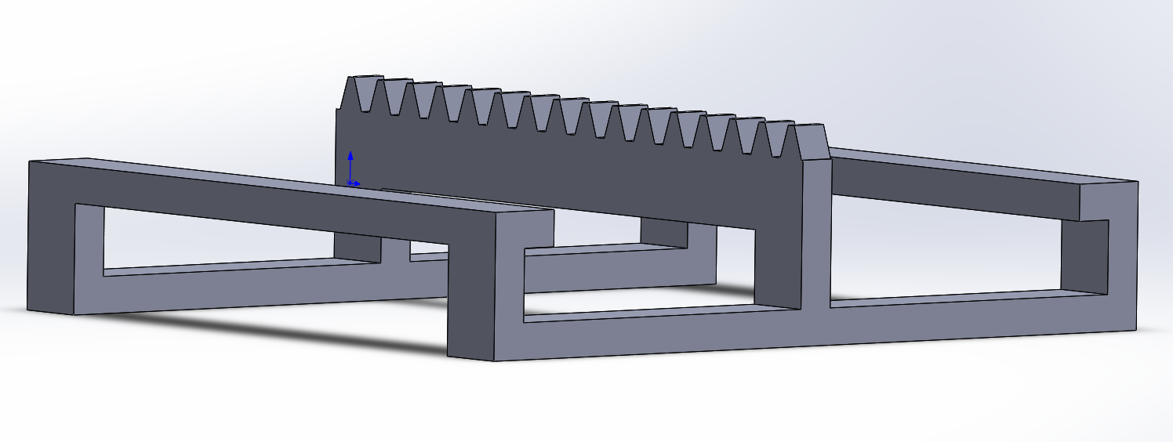

图 1 晾衣杆

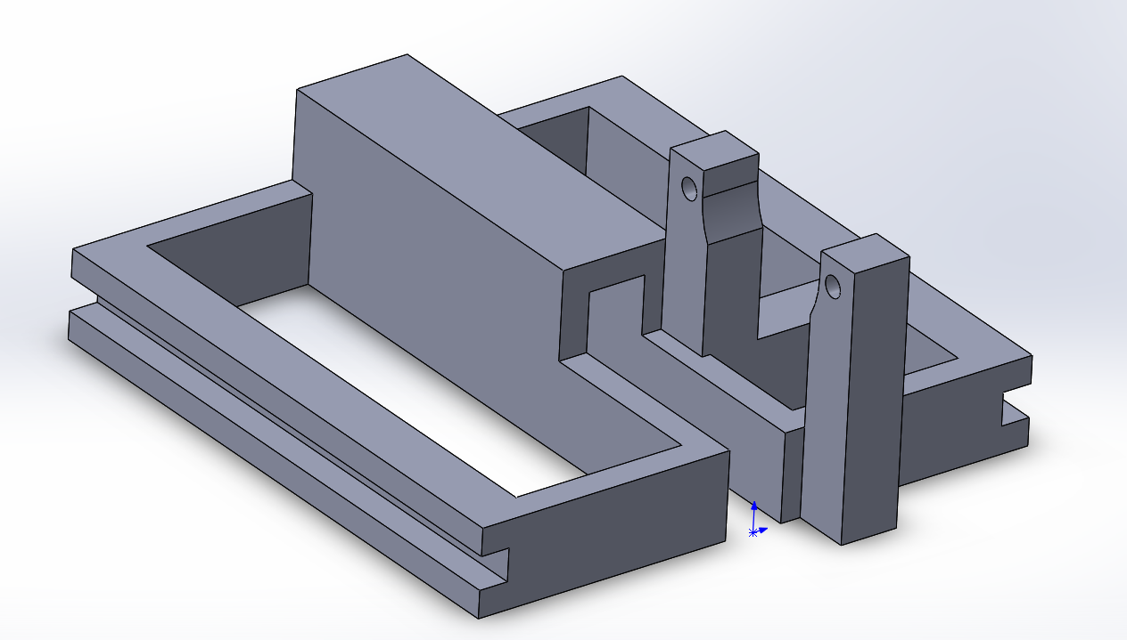

图 2 晾衣杆滑轨及电机支架

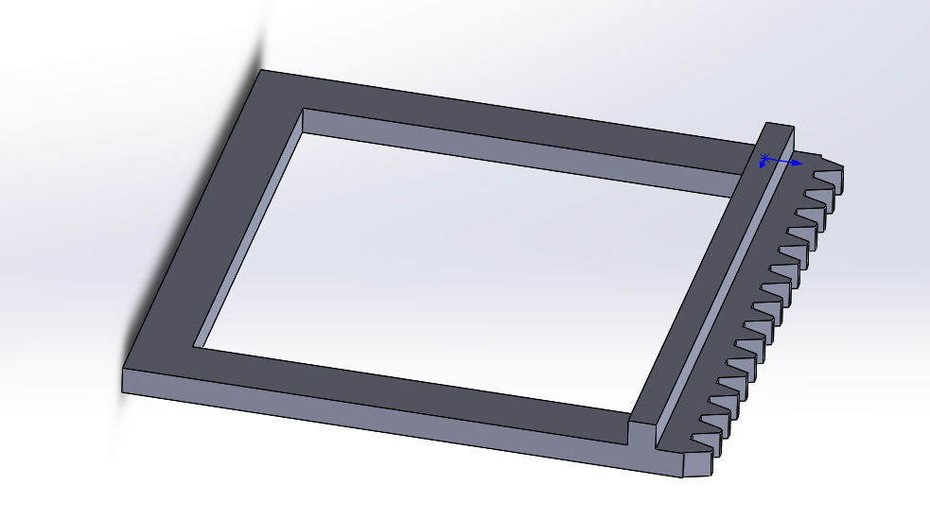

图 3 窗户框架

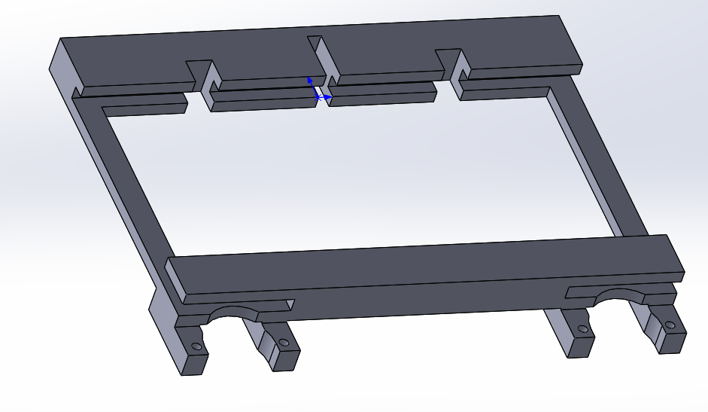

图 4 窗户支架及电机支架

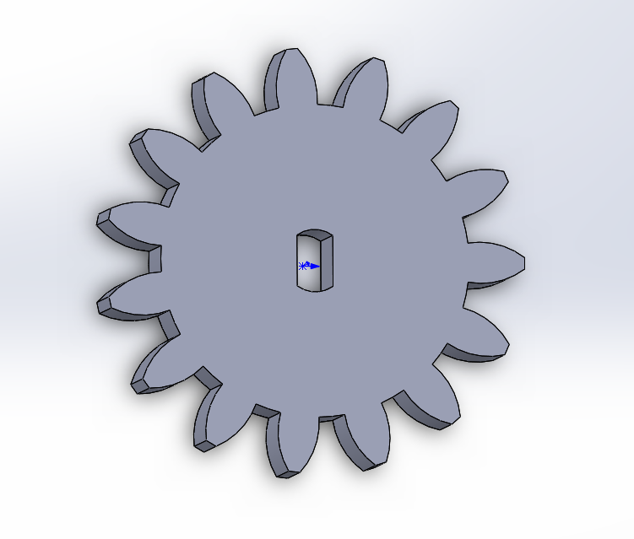

图 5 齿轮

# 4测试方案与测试结果

## 4.1测试方案

1、硬件测试

功耗测试:使用学生电源供电,测试线性稳压电路和锂电池能否支持功耗。

2、软件测试

烧入程序，测试电路信号是否正常。

3、硬件软件联调

烧入程序，安装锂电池，测试各组件是否正常工作，能否与手机正常通信。

## 4.2 测试条件与仪器

测试条件：原型机,学生电源,万用表，小米9SE手机。

## 4.3 测试结果及分析

经测试，电路最大功耗不超过7W，其中仅有不到2.5W需要5V供电，故可以采用锂电池供电，7805降压。

步进电机可以较好地带动机械结构运转，风扇工作正常，雨水监测器潮湿时可向手机报告并自动启动收回程序。