|  | Very Busy Expressions |
| --- | --- |
| Domain | b-a; a-b (sets of expressions) |
| Direction | forward :  OUT[b] = fb(IN[B])  In[b] = ∧ OUT[pred(b)] |
| Transfer function | fb(x) = GEN[B] ∪ (IN[B] - KILL[B]) |
| Meet Operation (∧) | ∩ |
| Boundary Condition | OUT [entry] = 0 |
| Initial interior points | OUT [b] = 0 |

**Tabella :**

**Gen() Kill()**

**BB2 0 0**

**BB3 b-a 0**

**BB4 a-b 0**

**BB5 b-a 0**

**BB6 0 b-a**

**BB7 a-b 0**

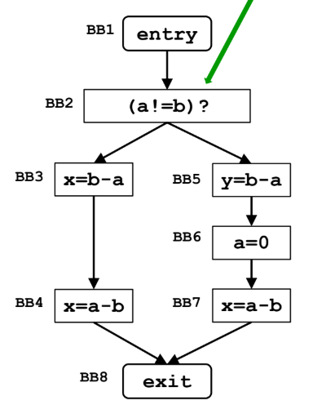

**Primo giro :**

**OUT [ BB1 ] =0**

**IN [ BB2 ] = 0**

**OUT [ BB2 ] = 0**

**IN [ BB3 ] = 0**

**OUT [ BB3 ] = b-a U 0 = { b-a }**

**IN [ BB4 ] = OUT [ BB3 ] = { b-a }**

**OUT [ BB4 ] = a-b U { b-a } = { a-b, b-a }**

**IN [ BB5 ] = 0**

**OUT [ BB5 ] = b-a U 0 = { b-a }**

**IN [ BB6 ] = { b-a }**

**OUT [ BB6 ] = 0 U ( { b-a } - kill { b-a } ) = 0**

**IN [ BB7 ] = 0**

**OUT [ BB7 ] = { a-b } U 0 = { a-b }**

**IN [ BB8 ] = OUT [ BB4 ] = { a-b, b-a }** ∧ **OUT [ BB7 ] = { a-b }**

**OUT [ BB8 ] = 0 U { a-b } = { a-b }**

**→ solo ‘a-b’ è very busy, perchè ‘a’ di ‘b-a’ è stato cambiato (con a = 0, nel secondo branch)**

**################################################**

Dominator Analysis

|  | Dominator Analysis |
| --- | --- |
| Domain | Sets of nodes |
| Direction | forward:  out[b] = fb(in[b])  in[b] = ^ out[pred(b)] |
| Transfer function | fb(x)= def(b) U (∧ OUT[pred(b)]) |
| Meet Operation (∧) | ∩ |
| Boundary Condition | out[entry] = 0 |
| Initial interior points | out[b] = 0 |

| Blocco | IN[B] | OUT[B] (= DOM[B]) |
| --- | --- | --- |
| A | 0 | A |
| B | A | {A, B} |
| C | A | {A, C} |
| D | {A, C} | {A, C, D} |
| E | {A, C} | {A, C, E} |
| F | {A, C, D} ∧ {A, C, E} =  = {A, C} | F U {A, C} = {A, C, F} |
| G | {A, B} ∧ {A, C, F} = A | {A, G} |

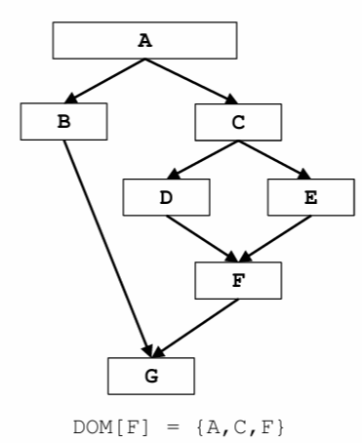

DOM[ A ] = { A }

DOM[ B ] = { A, B }

DOM[ C ] = { A, C }

DOM[ D ] = { A, C, D }

DOM[ E ] = { A, C, E }

DOM[ F ] = { A, C, F }

DOM[ G ] = { A, G }

**#####################################**

*Constant propagation*

|  | Constant propagation |
| --- | --- |
| Domain | Sets of Variables |
| Direction | forward :  OUT[b] = fb(IN[B])  In[b] = ∧ OUT[pred(b)] |
| Transfer function | OUT[B] = Use[B] ∪ ( (^IN[B]) - KILL[B]) |
| Meet Operation (∧) | ∩ |
| Boundary Condition | OUT [entry] = 0 |
| Initial interior points | OUT [b] = 0 |

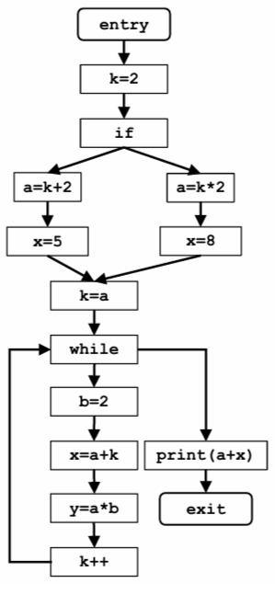

|  | Iterazione1 | | Iterazione 2 | |
| --- | --- | --- | --- | --- |
|  | IN(B) | OUT(B) |  |  |
| BB1 ( k=2 ) | 0 | k=2 | * - | * - |
| BB2 ( a=k+2) | k=2 | k=2, a=2+2=4 | * - | * - |
| BB3 ( x=5 ) | k=2, a=4 | k=2, x=5, a=4 | * - | * - |
| BB4 ( a=k*2 ) | k=2 | k=2, a=2*2=4 | * - | * - |
| BB5 ( x=8 ) | k=2, a=4 | k=2, x=8, a=4 | * - | * - |
| BB6 ( k=a ) | k=2, a=4, {x = 5, x = 8} | k=4, a=4, {x = 5, x = 8} | * - | * - |
| BB7 ( b=2 ) | k=4, a=4, {x = 5, x = 8} | k=4, a=4, b=2, {x = 5, x = 8} | k=5, a=4, b=2, x=8,  y=8 | k=5, a=4, b=2, x=8,  y=8 |
| BB8 ( x=a+k ) | k=4, a=4, b=2,{x = 5, x = 8} | k=4, a=4, b=2, x=8 | k=5, a=4, b=2, x=8,  y=8 | k=5, a=4, b=2, x=4+5=9,  y=8 |
| BB9 ( y=a*b ) | k=4, a=4, b=2, x=8 | k=4, a=4, b=2, x=8  y=4*2=8 | k=5, a=4, b=2, x=9,  y=8 | k=5, a=4, b=2, x=9,  y=8 |
| BB10 (k++) | k=4, a=4, b=2, x=8,  y=8 | k=5, a=4, b=2, x=8,  y=8 | k=5, a=4, b=2, x=9,  y=8 | k=5+1=6, a=4, b=2, x=9,  y=8 |