# 数据库设计小组报告

### 实验题目

基于Web网页的公司人力资源管理系统

### 实验要求

1、利用学习的数据库设计的方法和步骤﹐为选择的应用设计数据库，编写应用程序。

2、根据实训要求以及实际情况，设计合理的数据库，建立表格并为其分配字段，建立合理的主键和外键

### 设计思想

##### 设计目的

建立这个系统的目的是为了实现对公司人力资源的管理﹐其中包括了职工基本信息、职工详情信息，部门、职位、岗位、奖赏、合同、考勤、人员调动，登录权限，人员身份等。该系统为不同的用户设置了不同的权限﹐分为admin最高权限，为管理员身份﹐普通员工只有员工身份﹐通过外键实现了表与表之间的级联。

##### 开发平台

在windows平台下﹐建立一个公司人力资源管理系统的Web网站﹐使用eclipse开发工具进行开发。数据库选用的开发程序是Navicat 15

##### 数据字典

考勤管理表=编号+员工工号+员工姓名+考勤类别+开始时间+结束时间+持续时长+备注  
合同管理表=合同编号+合同名称+签约机构+签订日期+合同有效时间+签约人+电话  
部门表=部门编号+部门名称  
部门人员性质表=部门名称+部门人员性质

教育表=编号+教育编号+姓名+教育等级

员工详细信息表=职工编号+姓名+入职日期+工龄+性别+出生日期+身份招募+年龄+最后学历+专业+毕业时间+学位证书+民族+政治面貌+电话+QQ号码+电子邮箱

职位表=职位编号+职位名称

岗位表=岗位编号+岗位类别

奖惩管理表=序号+奖惩条目编号+姓名+警告次数+记过次数+嘉奖次数 +立功次数

权限表=编号+名字+权限

员工调动管理与薪酬管理表=职工编号+姓名+职位+工龄+在职状态+警告次数+记过次数+嘉奖次数+立功次数+薪酬

员工基本信息表=编号+职工编号+姓名+部门编号+职位编号+岗位编号+教育等级+专业+状态+薪水  
系统注册人员管理表=编号+用户名+密码+用户性质+备注

##### E-R图

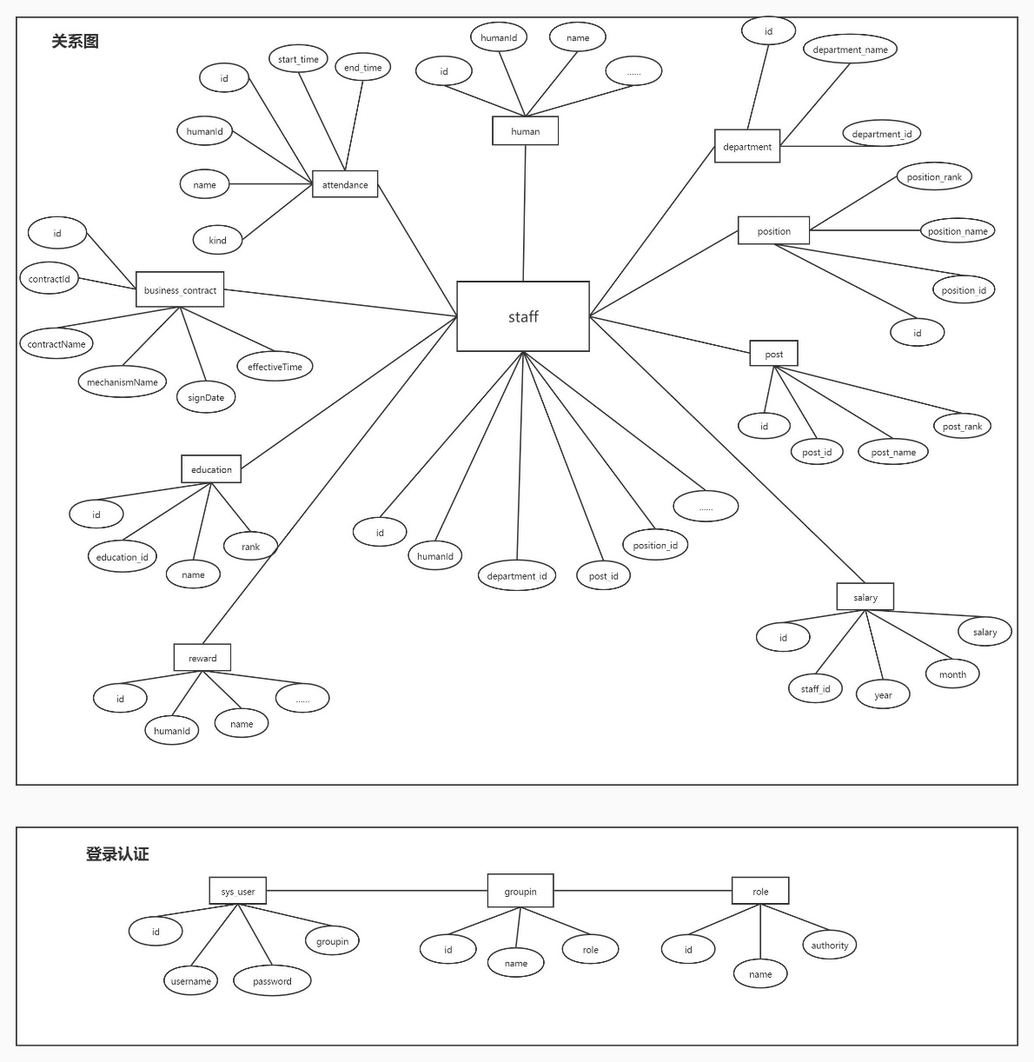

##### 数据结构（表结构）

###### a.信息类表

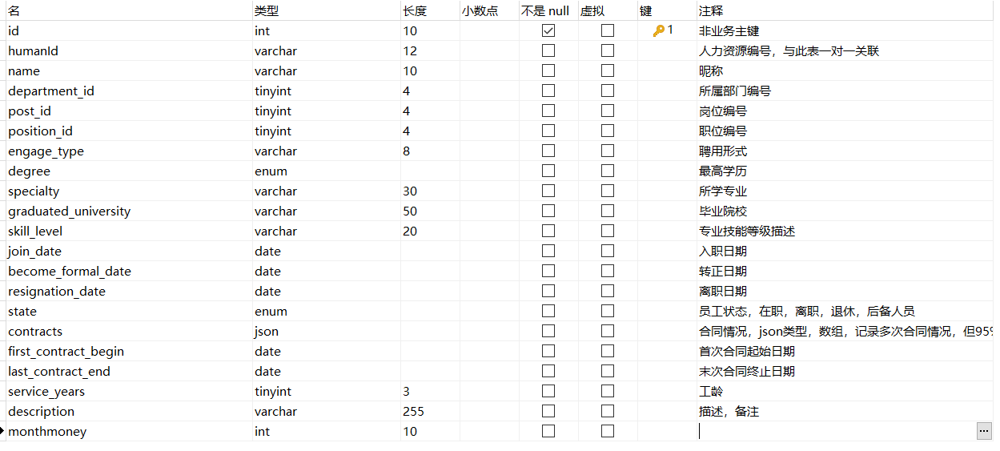

Staff表（基本信息表）

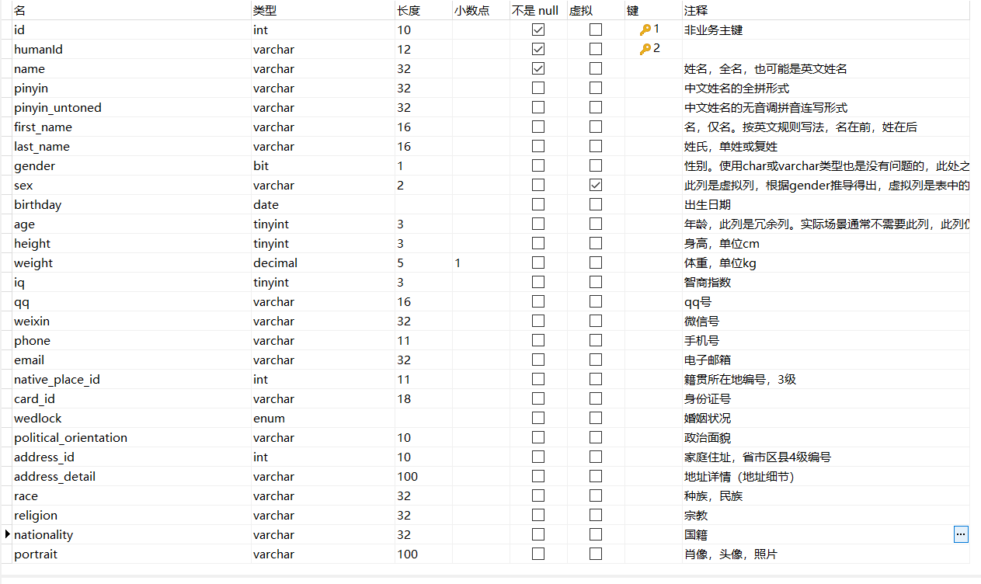

Human表（详细信息表）



Department表



Post表

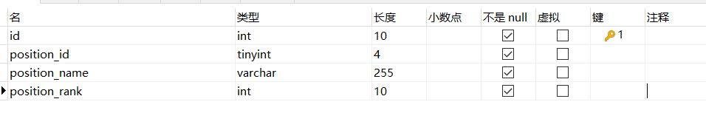

Position表

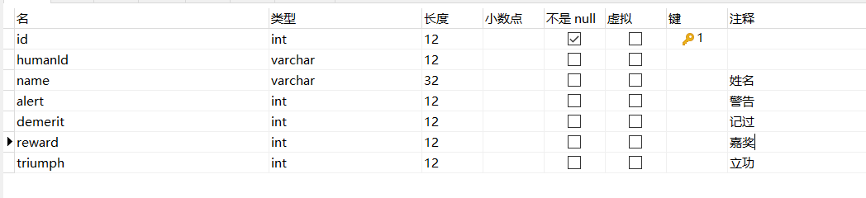reward表（奖赏表）

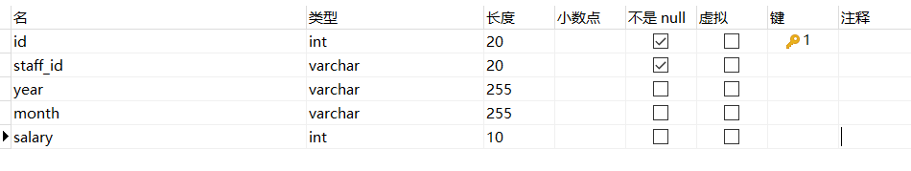salary表（薪水表）

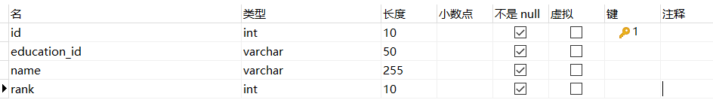

Education表（教育等级表）

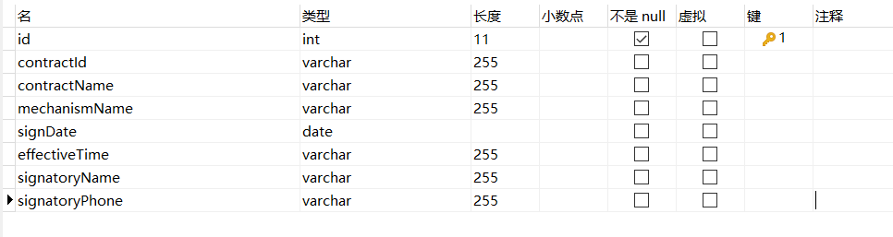

business_contract表（合同表）

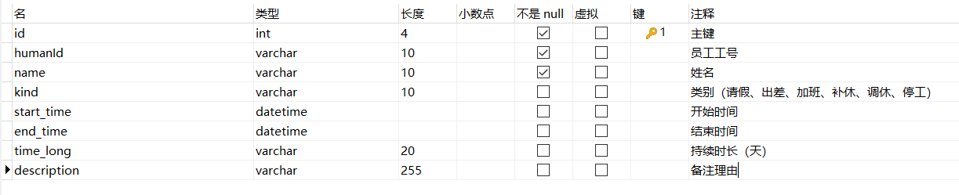

Attendance表（考勤表）

###### b.身份权限类表

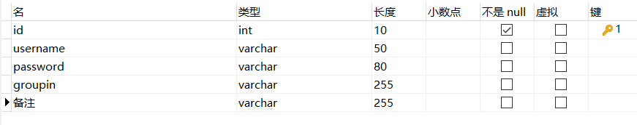

Sys_user表（账号密码表，有身份信息）

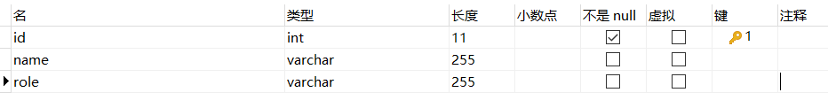

Groupin表（分组，内有角色）

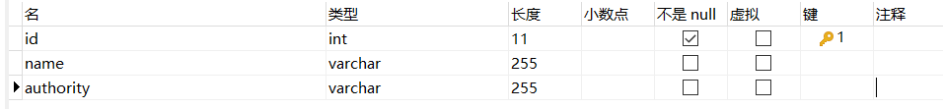

Role表（具体权限表）

### 数据库表的创建代码

SET NAMES utf8mb4;

SET FOREIGN_KEY_CHECKS = 0;

DROP TABLE IF EXISTS `attendance`;

CREATE TABLE `attendance` (

`id` int(4) NOT NULL COMMENT '主键',

`humanId` varchar(10) CHARACTER SET utf8 COLLATE utf8_general_ci NOT NULL COMMENT '员工工号',

`name` varchar(10) CHARACTER SET utf8 COLLATE utf8_general_ci NOT NULL COMMENT '姓名',

`kind` varchar(10) CHARACTER SET utf8 COLLATE utf8_general_ci NULL DEFAULT NULL COMMENT '类别（请假、出差、加班、补休、调休、停工）',

`start_time` datetime NULL DEFAULT NULL COMMENT '开始时间',

`end_time` datetime NULL DEFAULT NULL COMMENT '结束时间',

`time_long` varchar(20) CHARACTER SET utf8 COLLATE utf8_general_ci NULL DEFAULT NULL COMMENT '持续时长（天）',

`description` varchar(255) CHARACTER SET utf8 COLLATE utf8_general_ci NULL DEFAULT NULL COMMENT '备注理由',

PRIMARY KEY (`id`) USING BTREE

) ENGINE = InnoDB CHARACTER SET = utf8 COLLATE = utf8_general_ci ROW_FORMAT = DYNAMIC;

DROP TABLE IF EXISTS `business_contract`;

CREATE TABLE `business_contract` (

`id` int(11) NOT NULL AUTO_INCREMENT,

`contractId` varchar(255) CHARACTER SET utf8 COLLATE utf8_general_ci NULL DEFAULT NULL,

`contractName` varchar(255) CHARACTER SET utf8 COLLATE utf8_general_ci NULL DEFAULT NULL,

`mechanismName` varchar(255) CHARACTER SET utf8 COLLATE utf8_general_ci NULL DEFAULT NULL,

`signDate` date NULL DEFAULT NULL,

`effectiveTime` varchar(255) CHARACTER SET utf8 COLLATE utf8_general_ci NULL DEFAULT NULL,

`signatoryName` varchar(255) CHARACTER SET utf8 COLLATE utf8_general_ci NULL DEFAULT NULL,

`signatoryPhone` varchar(255) CHARACTER SET utf8 COLLATE utf8_general_ci NULL DEFAULT NULL,

PRIMARY KEY (`id`) USING BTREE

) ENGINE = InnoDB AUTO_INCREMENT = 111 CHARACTER SET = utf8 COLLATE = utf8_general_ci ROW_FORMAT = DYNAMIC;

DROP TABLE IF EXISTS `department`;

CREATE TABLE `department` (

`id` int(10) NOT NULL AUTO_INCREMENT,

`department_id` tinyint(4) NOT NULL,

`department_name` varchar(255) CHARACTER SET utf8 COLLATE utf8_general_ci NOT NULL,

PRIMARY KEY (`id`) USING BTREE,

UNIQUE INDEX `department_id`(`department_id`) USING BTREE

) ENGINE = InnoDB AUTO_INCREMENT = 8 CHARACTER SET = utf8 COLLATE = utf8_general_ci ROW_FORMAT = DYNAMIC;

DROP TABLE IF EXISTS `education`;

CREATE TABLE `education` (

`id` int(10) NOT NULL AUTO_INCREMENT,

`education_id` varchar(50) CHARACTER SET utf8 COLLATE utf8_general_ci NOT NULL,

`name` varchar(255) CHARACTER SET utf8 COLLATE utf8_general_ci NOT NULL,

`rank` int(10) NOT NULL,

PRIMARY KEY (`id`) USING BTREE,

INDEX `education_id`(`education_id`) USING BTREE

) ENGINE = InnoDB AUTO_INCREMENT = 1 CHARACTER SET = utf8 COLLATE = utf8_general_ci ROW_FORMAT = DYNAMIC;

DROP TABLE IF EXISTS `groupin`;

CREATE TABLE `groupin` (

`id` int(11) NOT NULL AUTO_INCREMENT,

`name` varchar(255) CHARACTER SET utf8 COLLATE utf8_general_ci NULL DEFAULT NULL,

`role` varchar(255) CHARACTER SET utf8 COLLATE utf8_general_ci NULL DEFAULT NULL,

PRIMARY KEY (`id`) USING BTREE

) ENGINE = InnoDB AUTO_INCREMENT = 8 CHARACTER SET = utf8 COLLATE = utf8_general_ci ROW_FORMAT = DYNAMIC;

-- ----------------------------

-- Table structure for human

-- ----------------------------

DROP TABLE IF EXISTS `human`;

CREATE TABLE `human` (

`id` int(10) UNSIGNED NOT NULL AUTO_INCREMENT COMMENT '非业务主键',

`humanId` varchar(12) CHARACTER SET utf8 COLLATE utf8_general_ci NOT NULL,

`name` varchar(32) CHARACTER SET utf8 COLLATE utf8_general_ci NOT NULL COMMENT '姓名，全名，也可能是英文姓名',

`pinyin` varchar(32) CHARACTER SET utf8 COLLATE utf8_general_ci NULL DEFAULT NULL COMMENT '中文姓名的全拼形式',

`pinyin_untoned` varchar(32) CHARACTER SET utf8 COLLATE utf8_general_ci NULL DEFAULT NULL COMMENT '中文姓名的无音调拼音连写形式',

`first_name` varchar(16) CHARACTER SET utf8 COLLATE utf8_general_ci NULL DEFAULT NULL COMMENT '名，仅名。按英文规则写法，名在前，姓在后',

`last_name` varchar(16) CHARACTER SET utf8 COLLATE utf8_general_ci NULL DEFAULT NULL COMMENT '姓氏，单姓或复姓',

`gender` bit(1) NULL DEFAULT NULL COMMENT '性别。使用char或varchar类型也是没有问题的，此处之所以使用bit仅是为了演示数据类型，及jdbc下，bit与boolean之间的转换。注意：长度是列显示长度',

`sex` varchar(2) CHARACTER SET utf8 COLLATE utf8_general_ci GENERATED ALWAYS AS (if((`gender` = 1),_utf8mb4'男',_utf8mb4'女')) VIRTUAL COMMENT '此列是虚拟列，根据gender推导得出，虚拟列是表中的真实对象，可以设置索引，不同于仅作用于当前查询中的计算列' NULL,

`birthday` date NULL DEFAULT NULL COMMENT '出生日期',

`age` tinyint(3) UNSIGNED NULL DEFAULT NULL COMMENT '年龄，此列是冗余列。实际场景通常不需要此列，此列仅用于在教学场景中演示数据库范式及触发器。此列也可用于演示虚拟列。但要注意，虚拟列不能使用动态取值函数，如now()等。',

`height` tinyint(3) UNSIGNED NULL DEFAULT NULL COMMENT '身高，单位cm',

`weight` decimal(5, 1) UNSIGNED NULL DEFAULT NULL COMMENT '体重，单位kg',

`iq` tinyint(3) UNSIGNED NULL DEFAULT NULL COMMENT '智商指数',

`qq` varchar(16) CHARACTER SET utf8 COLLATE utf8_general_ci NULL DEFAULT NULL COMMENT 'qq号',

`weixin` varchar(32) CHARACTER SET utf8 COLLATE utf8_general_ci NULL DEFAULT NULL COMMENT '微信号',

`phone` varchar(11) CHARACTER SET utf8 COLLATE utf8_general_ci NULL DEFAULT NULL COMMENT '手机号',

`email` varchar(32) CHARACTER SET utf8 COLLATE utf8_general_ci NULL DEFAULT NULL COMMENT '电子邮箱',

`native_place_id` int(11) NULL DEFAULT NULL COMMENT '籍贯所在地编号，3级',

`card_id` varchar(18) CHARACTER SET utf8 COLLATE utf8_general_ci NULL DEFAULT NULL COMMENT '身份证号',

`wedlock` enum('已婚','未婚','离异') CHARACTER SET utf8 COLLATE utf8_general_ci NULL DEFAULT NULL COMMENT '婚姻状况',

`political_orientation` varchar(10) CHARACTER SET utf8 COLLATE utf8_general_ci NULL DEFAULT NULL COMMENT '政治面貌',

`address_id` int(10) UNSIGNED NULL DEFAULT NULL COMMENT '家庭住址，省市区县4级编号',

`address_detail` varchar(100) CHARACTER SET utf8 COLLATE utf8_general_ci NULL DEFAULT NULL COMMENT '地址详情（地址细节）',

`race` varchar(32) CHARACTER SET utf8 COLLATE utf8_general_ci NULL DEFAULT '汉' COMMENT '种族，民族',

`religion` varchar(32) CHARACTER SET utf8 COLLATE utf8_general_ci NULL DEFAULT NULL COMMENT '宗教',

`nationality` varchar(32) CHARACTER SET utf8 COLLATE utf8_general_ci NULL DEFAULT '中国' COMMENT '国籍',

`portrait` varchar(100) CHARACTER SET utf8 COLLATE utf8_general_ci NULL DEFAULT NULL COMMENT '肖像，头像，照片',

`description` text CHARACTER SET utf8 COLLATE utf8_general_ci NULL COMMENT '备注，使用text字段可演示大字段存储，如使用富文本编辑器进行大容量文本数据存储',

`extra_info` text CHARACTER SET utf8 COLLATE utf8_general_ci NULL COMMENT '额外的用户信息，可以进行灵活处理',

`created_time` datetime NULL DEFAULT NULL COMMENT '此记录创建时间',

`created_by` varchar(32) CHARACTER SET utf8 COLLATE utf8_general_ci NULL DEFAULT NULL COMMENT '此记录创建人',

`last_modified_time` datetime NULL DEFAULT NULL COMMENT '此记录的最后一次修改时间',

`last_modified_by` varchar(32) CHARACTER SET utf8 COLLATE utf8_general_ci NULL DEFAULT NULL COMMENT '此记录的最后一次修改人',

`version` int(10) UNSIGNED NOT NULL DEFAULT 1 COMMENT '此记录修改版本号',

PRIMARY KEY (`id`, `humanId`) USING BTREE

) ENGINE = InnoDB AUTO_INCREMENT = 1000 CHARACTER SET = utf8 COLLATE = utf8_general_ci COMMENT = '人力资源信息表，作为员工的基础信息表，与员工信息表一对一关联' ROW_FORMAT = DYNAMIC;

DROP TABLE IF EXISTS `position`;

CREATE TABLE `position` (

`id` int(10) NOT NULL AUTO_INCREMENT,

`position_id` tinyint(4) NOT NULL,

`position_name` varchar(255) CHARACTER SET utf8 COLLATE utf8_general_ci NOT NULL,

`position_rank` int(10) NOT NULL,

PRIMARY KEY (`id`) USING BTREE,

UNIQUE INDEX `position_id`(`position_id`) USING BTREE

) ENGINE = InnoDB AUTO_INCREMENT = 6 CHARACTER SET = utf8 COLLATE = utf8_general_ci ROW_FORMAT = DYNAMIC;

DROP TABLE IF EXISTS `post`;

CREATE TABLE `post` (

`id` int(10) NOT NULL AUTO_INCREMENT,

`post_id` tinyint(4) NOT NULL,

`post_name` varchar(255) CHARACTER SET utf8 COLLATE utf8_general_ci NOT NULL,

`post_rank` int(10) NOT NULL,

PRIMARY KEY (`id`) USING BTREE,

UNIQUE INDEX `post_id`(`post_id`) USING BTREE

) ENGINE = InnoDB AUTO_INCREMENT = 3 CHARACTER SET = utf8 COLLATE = utf8_general_ci ROW_FORMAT = DYNAMIC;

DROP TABLE IF EXISTS `reward`;

CREATE TABLE `reward` (

`id` int(12) NOT NULL,

`humanId` varchar(12) CHARACTER SET utf8 COLLATE utf8_general_ci NULL DEFAULT NULL,

`name` varchar(32) CHARACTER SET utf8 COLLATE utf8_general_ci NULL DEFAULT NULL COMMENT '姓名',

`alert` int(12) NULL DEFAULT NULL COMMENT '警告',

`demerit` int(12) NULL DEFAULT NULL COMMENT '记过',

`reward` int(12) NULL DEFAULT NULL COMMENT '嘉奖',

`triumph` int(12) NULL DEFAULT NULL COMMENT '立功',

PRIMARY KEY (`id`) USING BTREE

) ENGINE = InnoDB CHARACTER SET = utf8 COLLATE = utf8_general_ci ROW_FORMAT = DYNAMIC;

DROP TABLE IF EXISTS `role`;

CREATE TABLE `role` (

`id` int(11) NOT NULL AUTO_INCREMENT,

`name` varchar(255) CHARACTER SET utf8 COLLATE utf8_general_ci NULL DEFAULT NULL,

`authority` varchar(255) CHARACTER SET utf8 COLLATE utf8_general_ci NULL DEFAULT NULL,

PRIMARY KEY (`id`) USING BTREE

) ENGINE = InnoDB AUTO_INCREMENT = 18 CHARACTER SET = utf8 COLLATE = utf8_general_ci ROW_FORMAT = DYNAMIC;

DROP TABLE IF EXISTS `salary`;

CREATE TABLE `salary` (

`id` int(20) NOT NULL AUTO_INCREMENT,

`staff_id` varchar(20) CHARACTER SET utf8 COLLATE utf8_general_ci NOT NULL,

`year` varchar(255) CHARACTER SET utf8 COLLATE utf8_general_ci NULL DEFAULT NULL,

`month` varchar(255) CHARACTER SET utf8 COLLATE utf8_general_ci NULL DEFAULT NULL,

`salary` int(10) NULL DEFAULT NULL,

PRIMARY KEY (`id`) USING BTREE

) ENGINE = InnoDB AUTO_INCREMENT = 2 CHARACTER SET = utf8 COLLATE = utf8_general_ci ROW_FORMAT = DYNAMIC;

INSERT INTO `salary` VALUES (1, '201901060233', '2021', '10', 1000);

INSERT INTO `salary` VALUES (2, '201901060233', '2021', '11', 2000);

DROP TABLE IF EXISTS `staff`;

CREATE TABLE `staff` (

`id` int(10) UNSIGNED NOT NULL AUTO_INCREMENT COMMENT '非业务主键',

`humanId` varchar(12) CHARACTER SET utf8 COLLATE utf8_general_ci NULL DEFAULT NULL COMMENT '人力资源编号，与此表一对一关联',

`name` varchar(10) CHARACTER SET utf8 COLLATE utf8_general_ci NULL DEFAULT NULL COMMENT '昵称',

`department_id` tinyint(4) UNSIGNED NULL DEFAULT NULL COMMENT '所属部门编号',

`post_id` tinyint(4) NULL DEFAULT NULL COMMENT '岗位编号',

`position_id` tinyint(4) UNSIGNED NULL DEFAULT NULL COMMENT '职位编号',

`engage_type` varchar(8) CHARACTER SET utf8 COLLATE utf8_general_ci NULL DEFAULT NULL COMMENT '聘用形式',

`degree` enum('博士','硕士','本科','大专','高中','初中','小学','其他') CHARACTER SET utf8 COLLATE utf8_general_ci NULL DEFAULT NULL COMMENT '最高学历',

`specialty` varchar(30) CHARACTER SET utf8 COLLATE utf8_general_ci NULL DEFAULT NULL COMMENT '所学专业',

`graduated_university` varchar(50) CHARACTER SET utf8 COLLATE utf8_general_ci NULL DEFAULT NULL COMMENT '毕业院校',

`skill_level` varchar(20) CHARACTER SET utf8 COLLATE utf8_general_ci NULL DEFAULT NULL COMMENT '专业技能等级描述',

`join_date` date NULL DEFAULT NULL COMMENT '入职日期',

`become_formal_date` date NULL DEFAULT NULL COMMENT '转正日期',

`resignation_date` date NULL DEFAULT NULL COMMENT '离职日期',

`state` enum('在职','离职','退休','后备人员') CHARACTER SET utf8 COLLATE utf8_general_ci NULL DEFAULT '在职' COMMENT '员工状态，在职，离职，退休，后备人员',

`contracts` json NULL COMMENT '合同情况，json类型，数组，记录多次合同情况，但95%以上只会有一次合同记录。合同记录，要包括合同起始日期，合同终止日期，合同期限，合同签订日期，操作员，备注。其中合同期限不算冗余字段，基于法律上的考虑。',

`first_contract_begin` date NULL DEFAULT NULL COMMENT '首次合同起始日期',

`last_contract_end` date NULL DEFAULT NULL COMMENT '末次合同终止日期',

`service_years` tinyint(3) UNSIGNED NULL DEFAULT NULL COMMENT '工龄',

`description` varchar(255) CHARACTER SET utf8 COLLATE utf8_general_ci NULL DEFAULT NULL COMMENT '描述，备注',

`monthmoney` int(10) NULL DEFAULT NULL,

PRIMARY KEY (`id`) USING BTREE,

INDEX `departmentId`(`department_id`) USING BTREE,

INDEX `jobLevelId`(`post_id`) USING BTREE,

INDEX `posId`(`position_id`) USING BTREE

) ENGINE = InnoDB AUTO_INCREMENT = 1000 CHARACTER SET = utf8 COLLATE = utf8_general_ci

DROP TABLE IF EXISTS `sys_user`;

CREATE TABLE `sys_user` (

`id` int(10) NOT NULL AUTO_INCREMENT,

`username` varchar(50) CHARACTER SET utf8 COLLATE utf8_general_ci NULL DEFAULT NULL,

`password` varchar(80) CHARACTER SET utf8 COLLATE utf8_general_ci NULL DEFAULT NULL,

`groupin` varchar(255) CHARACTER SET utf8 COLLATE utf8_general_ci NULL DEFAULT NULL,

`备注` varchar(255) CHARACTER SET utf8 COLLATE utf8_general_ci NULL DEFAULT NULL,

PRIMARY KEY (`id`) USING BTREE

) ENGINE = InnoDB AUTO_INCREMENT = 10 CHARACTER SET = utf8 COLLATE = utf8_general_ci ROW_FORMAT = DYNAMIC;

SET FOREIGN_KEY_CHECKS = 1;