**Figure 1. Annual Maize Production, Maize Yield and Maize Stocks from 1990-2015**



**Figure 2. Average FRA Purchase by District from 2002/03 to 2009/10**

A picture containing text, map

Description generated with very high confidence

**Figure 3. Map of Major District Markets in Zambia**

A picture containing text, map

Description generated with very high confidence

**Figure 4. Monthly Shares of FRA Purchase and Sales**

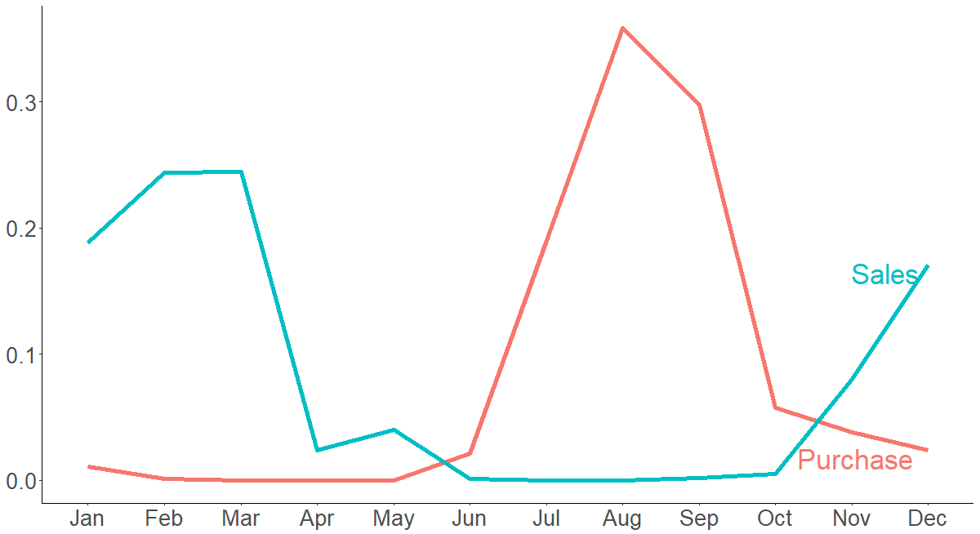

**Figure 5. Average Price Distribution by District in Lean Season and Harvest Season**

A close up of a map

Description generated with high confidence

A picture containing text, map

Description generated with very high confidence**Figure 6.** **Map of Predicted FRA Purchase and Sales**

**A close up of text on a white background

Description generated with high confidenceFigure 7. Historical and Simulated Price in Production and Consumption Region**