Importing and processing market price data

1. price data received by email from [bsegula@yahoo.com](mailto:bsegula@yahoo.com) or [Luis.AmayaOrtiz@fao.org](mailto:Luis.AmayaOrtiz@fao.org)

The data come as an .xls spreadsheet.

I cannot find anywhere that these data are posted on the Malawi statistical office webpage nor on the ministry of ag webpage

1. The monthly data files include a lot of information – additional crops, comparison prices from the year before by market, additional spreadsheets – and are currently transposed by hand to a spreadsheet in a new .xls file with the following features:
   1. .xls file has standard naming “Malawipricesyearmonth.xls”. For example: “Malawiprices2015dec.xls”
   2. a spreadsheet in that .xls file called “Maize_transpose” that only includes the date in the first column and then each market in additional columns.

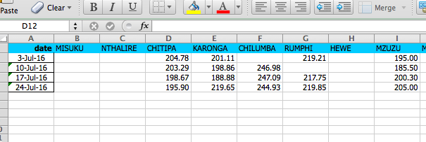

1. currently the file WeeklyPrices_update.do combines these files by importing the transposed spreadsheet, saving them as .dta files, and appending them to a file called “WeeklyPricesMaize_join.xlsx” which includes the price data going back to Dec 2007. The .do file then generates a month, and yearmonth (“yearmo”) variable and saves the output as

“WeeklyPriceMaize_updated.dta”

To update with a new price .xls file currently, the steps are as follows:

1. look in the file “/Users/hopecm/Dropbox/Caleb and Erin IPC analysis/new

price data” for new price data

2. create a new .xls file following the naming convention above

3. transpose the maize data by hand into a new spreadsheet in the new .xls file. Thr

spreadsheet should be called “Maize_transpose”

1. add code to the .do file to import and then append these files to the existing file
2. move the price data files you started with from “/Users/hopecm/Dropbox/Caleb

and Erin IPC analysis/new price data” to the “processed” sub-folder