**FIGURES AND TABLES**

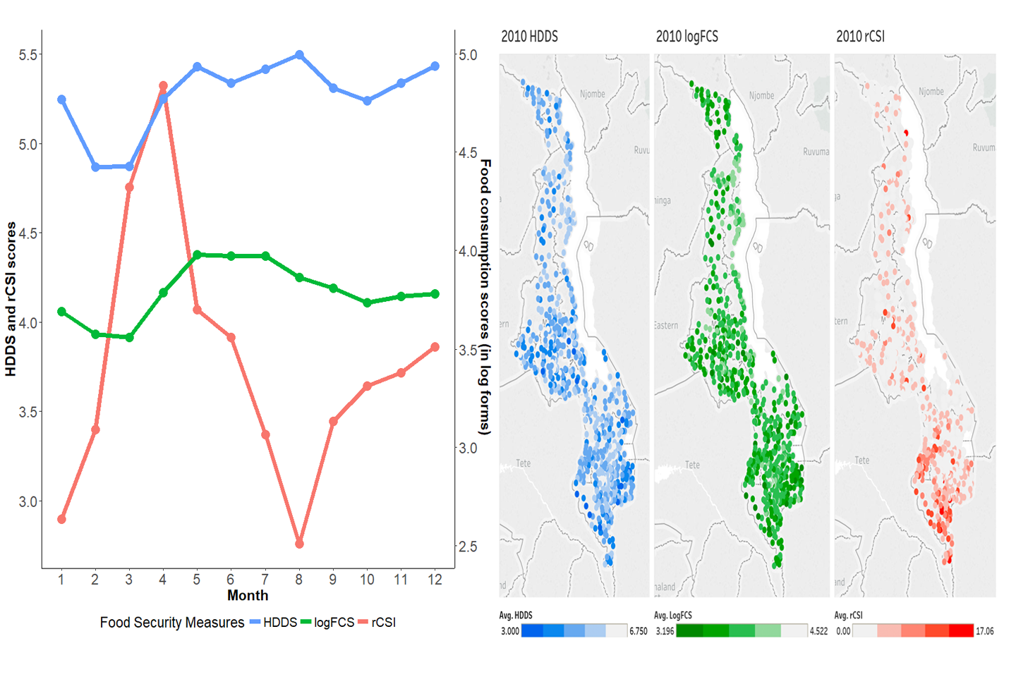

**A**  **B**

**Fig. 1.** **Food security measures vary across space and time.** **(A)** Average food security measures by month for 2010 vary by season. January = 1. Read rCSI (reduced coping strategies index) and HDDS (Household Dietary Diversity Score) against the left axis and FCS (Food Consumption Score) against the right axis. A high rCSI indicates the use of more coping strategies, thus low food security, whereas a high HDDS or FCS indicates high food security. **(B)** Darker shades of cluster-level average food security measures in Malawi 2010-11 LSMS data indicate lower regional food security. Specifically, for the household dietary diversity score (HDDS, left panel) and log food consumption score (logFCS, central panel), darker shades indicate lower dietary quality. For the reduced coping strategies index (rCSI, right panel), a darker shade indicates that on average households in the cluster are employing more coping strategies.

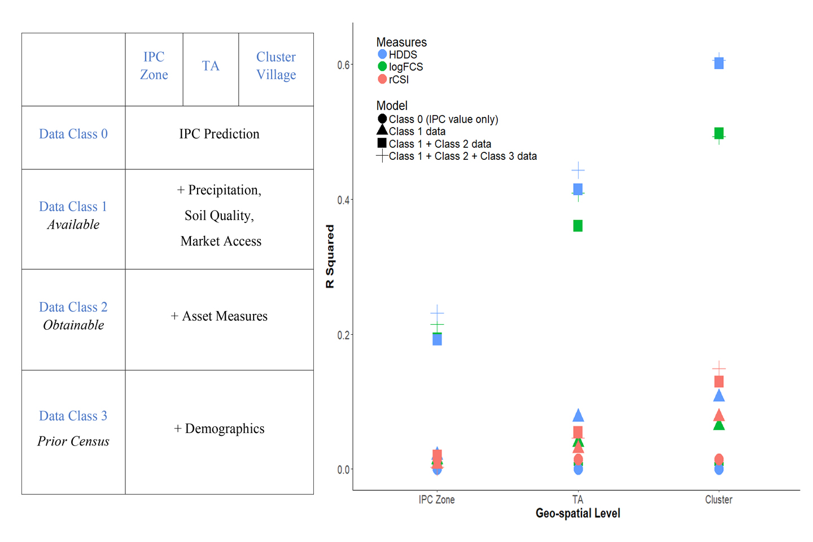

**A B**

**Fig. 2.** **The share of variation in out-of-sample cluster-level food security predicted by our models improves with greater spatial granularity and richer data.** **(A)** We predict food security outcomes using three levels of spatial granularity and 4 classes of models. Class 0 data include the IPC early warning value only. Class 1 data contains: past IPC values, precipitation, market prices, market access measures, and soil quality. Class 2 data contains: share of households owing cellular phone and share of dwellings with metal versus thatch roof. Class 3 data contains: household demographics and assets. **(B)** The explanatory power of the models, measured as R-squared, increases with the Classes of data and the spatial granularity of data used. Our best model explains 62% of the variation in cluster-averages of household dietary diversity (HDDS). However, at the most spatially disaggregated level, the cluster level, additional household and demographic variables add little additional information.

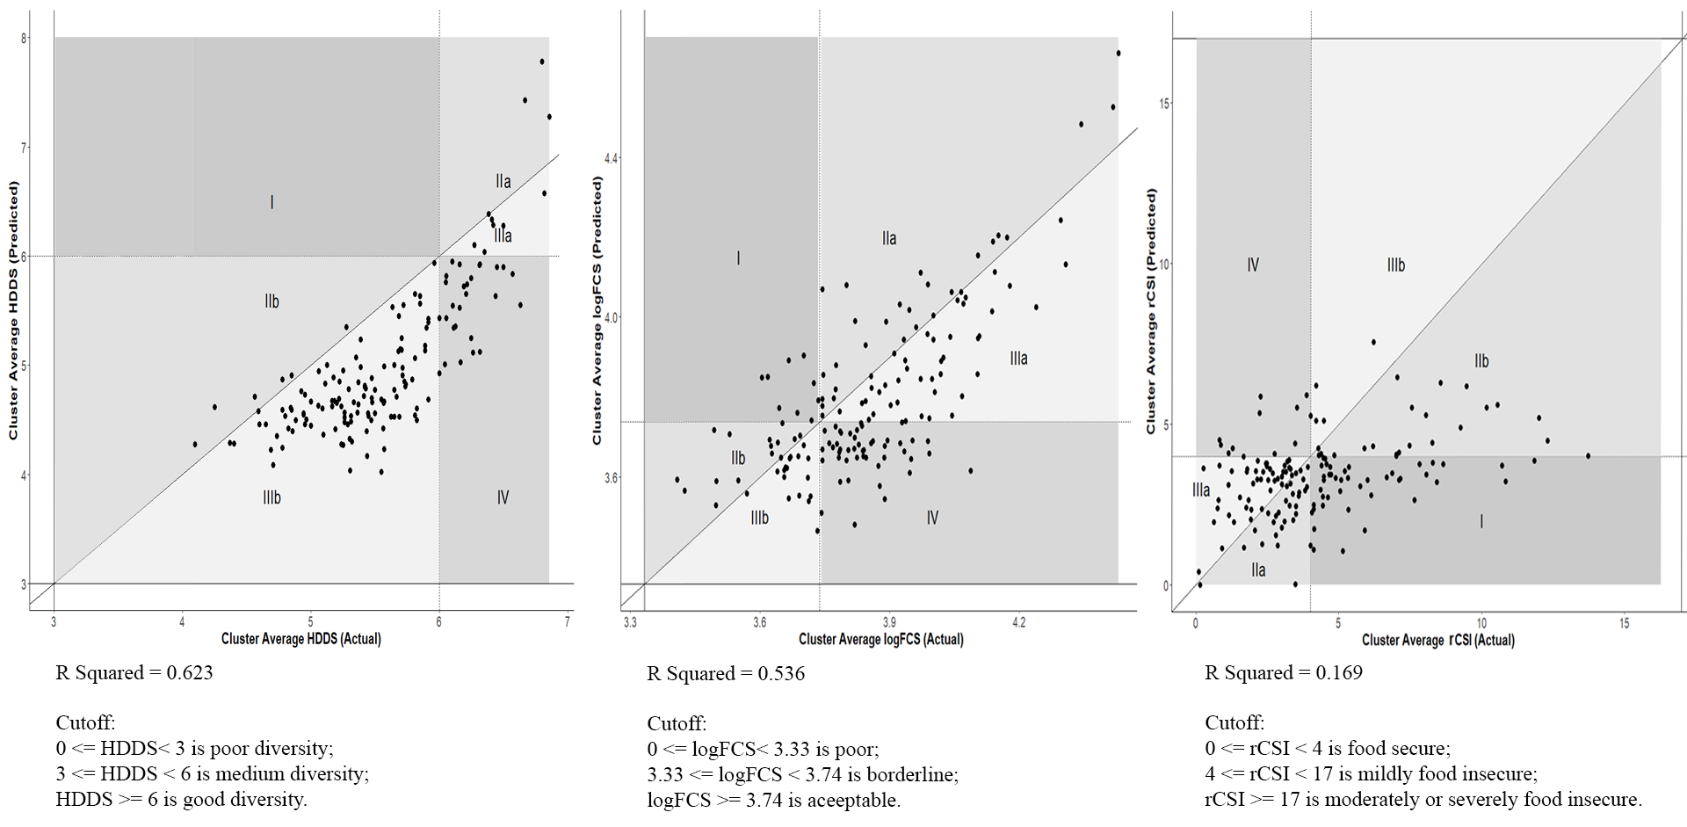

**A B C**

**Fig. 3.** **Actual versus predicted out-of-sample cluster food security estimates, with errors of exclusion and inclusion, where errors of exclusion may be of more concern to relief agencies.** Across all three panels, Area I shows areas in which the model under predicts food insecurity status (errors of exclusion) and Area IV shows areas in which the model over predicts food insecurity (errors of inclusion). Areas IIa, IIb, IIIa and IIIb are more nuanced. Areas IIa and IIIa show: clusters where the model correctly predicted that households were food secure but under or over predicted the continuous measure, respectively. Area IIb and area IIIb show: clusters where categorical status was correctly predicted to be food insecure but continuous measures were under and over predicted, respectively. **(A)** Our model correctly classifies 87% of the household dietary diversity scores. **(B)** Our model correctly predicts 62% of the log food consumption score categories. **(C )** Our model correctly predicts 65% of reduced coping strategies index categories.

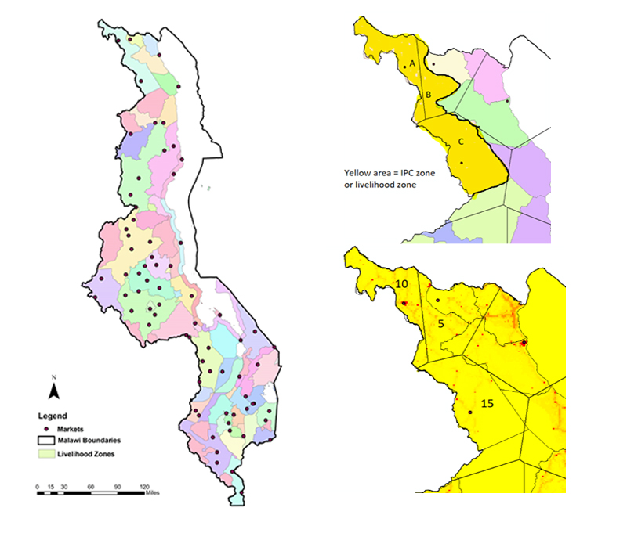

A B

**Fig. S1: Demonstration of application of our protocol for matching data at different spatial scales.** (A) The map shows the delineation of IPC zones, with 72 markets indicated as dots. Some markets are close to one another (e.g., urban markets in Blantyre or Lilongwe) and therefore do not appear as distinct dots. (B) To match residents in an IPC zone to a market, Theissen polygons are drawn around each market. We weight the Thiessen polygons that fall within a livelihood zone by population where the dot within each polygon is the closest market. For example, suppose Zone A included a population of 10 people; Zone B included a population of 5 people; and Zone C included a population of 15 people. We compute the total population for the livelihood zone as the following: Zone A (10) + Zone B (5) + Zone C (15) = 30 people.

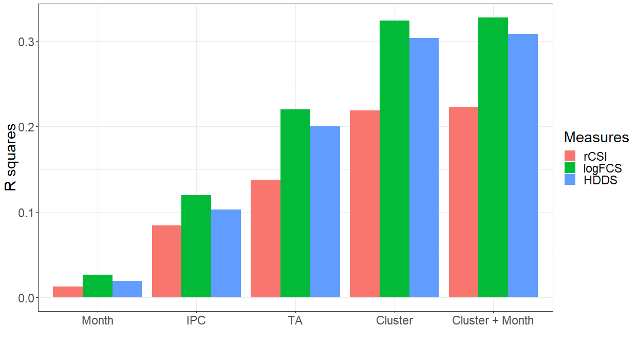

**Fig. S2: A series of fixed effect models show that spatial level and temporal frequency influence food security status.** Bars present the share of variation of each of the 2010 HH Food Security measures explained by month and or geographic identifier.

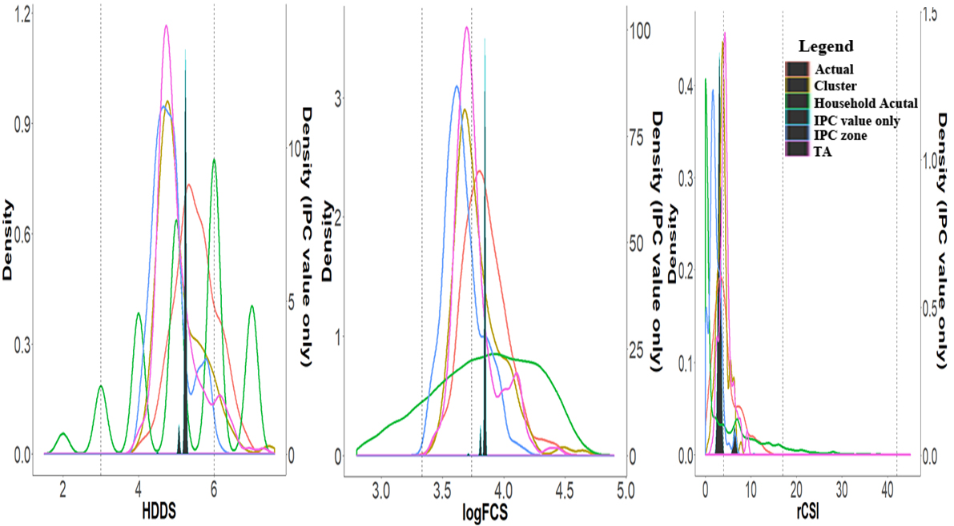

**(A) (B) (C)**

**Fig S3: As the level of spatial granularity increases, explanatory power increases and the distribution of the predicated values moves towards the actual distribution both in the center and the spread of the distributions.** Panels show, from left to right, Density plots of actual and predicted value of HDDS at different spatial levels (A) Density plots of actual and predicted value of logFCS at different spatial levels (B) Density plots of actual and predicted value of rCSI at different spatial levels (C). The cluster level food security measure averages obtained from the household surveys are shown in red (labeled as “Actual”) as a comparison for our model predictions. Predicted values using variables at the IPC zone, TA and cluster level are shown in blue, purple, and yellow respectively. Prediction values using only the IPC value are shown in dark green and are mostly clustered around the mean of the distribution. This prediction would leave out the clusters at the two extremes of the distribution.

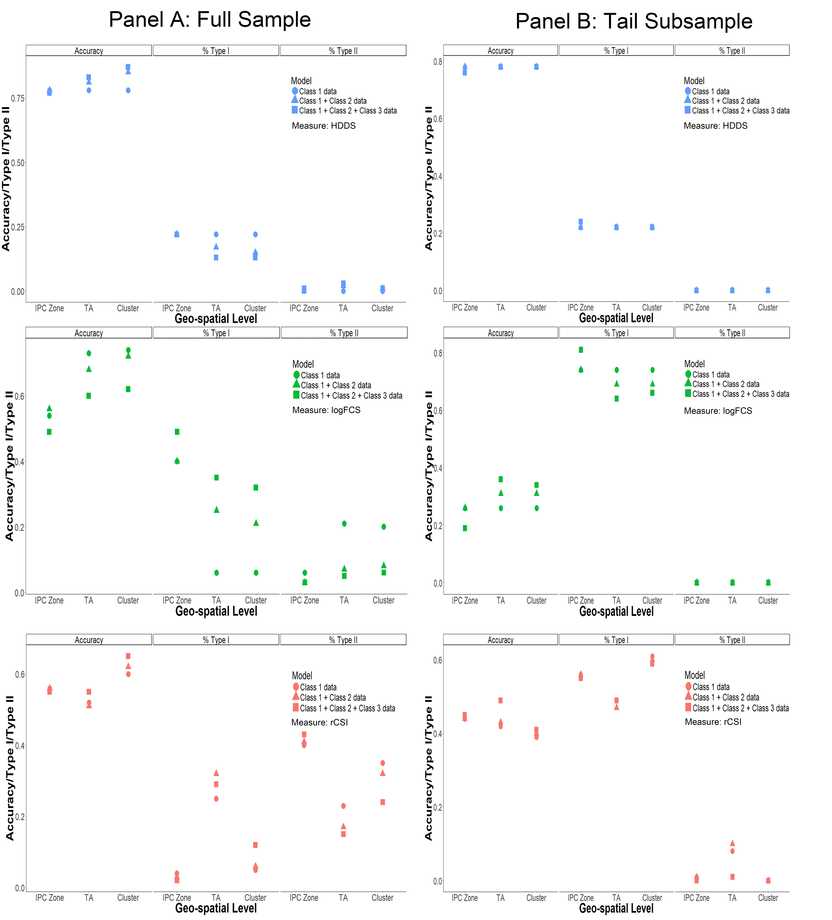

**Fig S4: We predict 2013 food security using only 2010 data, limiting both sample(s) to the most food insecure households and confirm that factors that affect food security do not substantially differ for the subset of the most insecure households.** The “tail” is defined by excluding the households that fall in the most food secure category of each food secure measures: rCSI greater than 4, logFCS smaller than 1.623 and HDDS smaller than 6. The cluster average tail food security measures are based on the cluster average of the remaining households at the tail. The signs and significance of the coefficients on the variables included in the tails-only models closely match estimates from the full distribution. When estimating just the tails of the distribution, the length of dry spells largely negatively affects food security but other measures are consistent between the full distribution and the tails-only distribution. Results of categorical prediction for models including both full-samples and tail subsamples indicate the full sample’s accuracy is more sensitive to spatial scale and data class than tail subsample. The accuracy in categorical predictions is similar between model 1 to model 3 for the same food security measure because the predicted values tend to fall into the same category. The same holds for the percent of type I and type II errors.