Result_writeup

1. summary stats (pooled data of 2010 and 2013)
2. FS by month plot

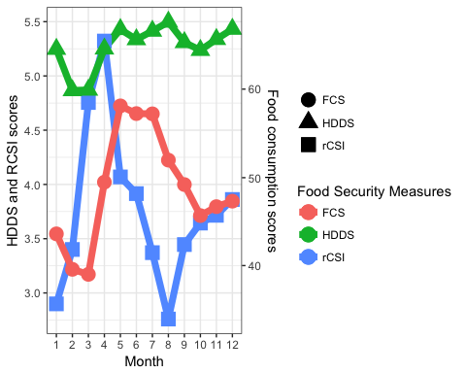

1. bar chart of variation
2. Result of 2013 prediction
3. Scatter plots (predict vs. actual) 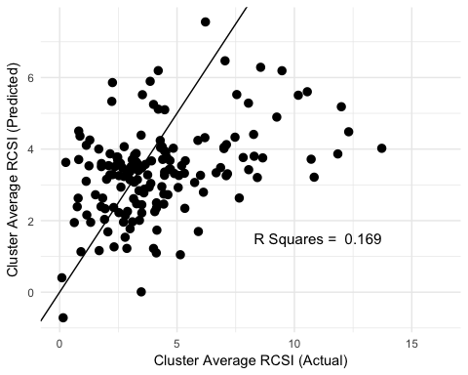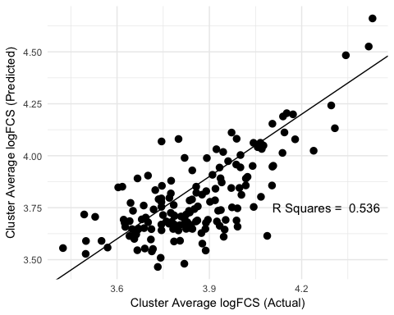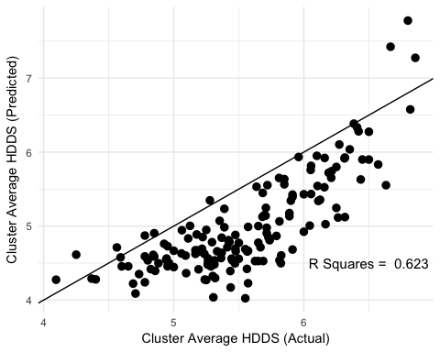
4. Density plot (predication using different scales + household)
   1. Unexplored variation of household level
5. R squares of 2013 predication
   1. (with/without fixed effect)
6. only what matters for 2010 is the tables (coefficients and variables)
7. Discussion of classification
8. hit and miss tables (for the predications)
   1. one is cluster to actual cluster outcomes
   2. one is cluster predication to actual household level outcomes
   3. how bad it can be to just target the
   4. put it in SI ?
   5. 2010 data
9. regression results
10. discussion on the coefficients

# library("ggpubr")  
# ggscatter(logFCS_pair, x = "actual", y = "predict",  
# add = "reg.line", conf.int = TRUE,   
# cor.coef = FALSE, cor.method = "pearson",  
# xlab = "actual", ylab = "predict")  
#   
# ggsave("logFCS_scatter.png", plot = last_plot(),device = "png",path = "output/figures/",  
# dpi = 1000, limitsize = TRUE)  
#   
# ggscatter(d, x ="RCSI_cluster" , y = "RCSI_pred",  
# add = "reg.line", conf.int = TRUE,   
# cor.coef = TRUE, cor.method = "pearson",  
# xlab = "actual", ylab = "predict")  
#   
# ggsave("RCSI_scatter.png", plot = last_plot(),device = "png",path = "output/figures/",  
# dpi = 1000, limitsize = TRUE)  
#   
# ggscatter(d, x ="HDDS_cluster" , y = "HDDS_pred",  
# add = "reg.line", conf.int = TRUE,   
# cor.coef = FALSE, cor.method = "pearson",  
# xlab = "actual", ylab = "predict")  
#   
# ggsave("HDDS_scatter.png", plot = last_plot(),device = "png",path = "output/figures/",  
# dpi = 1000, limitsize = TRUE)