Result_writeup

Get this done by this Sunday morning so Kathy can get the writing done on Sunday

1. summary stats (pooled data of 2010 and 2013)
2. FS by month plot
3. bar chart of variation
4. Result of 2013 prediction
5. Fixed effects (cluster, month)
   1. Increase in the
   2. Do we highlight it?
   3. Spit out the regression tables with a full set of fixed effects added in
6. Scatter plots (predict vs. actual)
7. Density plot (predication using different scales + household)
   1. Unexplored variation of household level
8. R squares of 2013 predication
   1. (with/without fixed effect)
9. only what matters for 2010 is the tables (coefficients and variables)
10. Discussion of
11. hit and miss tables (for the predications)
    1. one is cluster to actual cluster outcomes
    2. one is cluster predication to actual household level outcomes
    3. how bad it can be to just target the
    4. put it in SI ?
    5. 2010 data
12. regression results
13. discussion on the coefficients

summary(cars)

## speed dist   
## Min. : 4.0 Min. : 2.00   
## 1st Qu.:12.0 1st Qu.: 26.00   
## Median :15.0 Median : 36.00   
## Mean :15.4 Mean : 42.98   
## 3rd Qu.:19.0 3rd Qu.: 56.00   
## Max. :25.0 Max. :120.00

## Including Plots

You can also embed plots, for example:

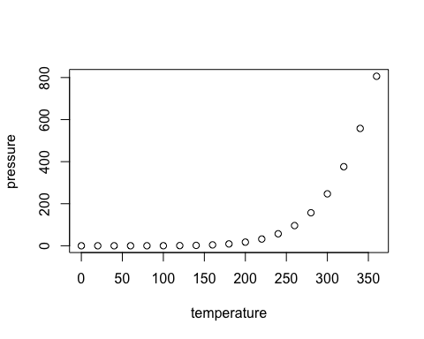

Note that the echo = FALSE parameter was added to the code chunk to prevent printing of the R code that generated the plot.