CA Weather

Yujun Zhou

May 2, 2018

plot(zmw_ward)

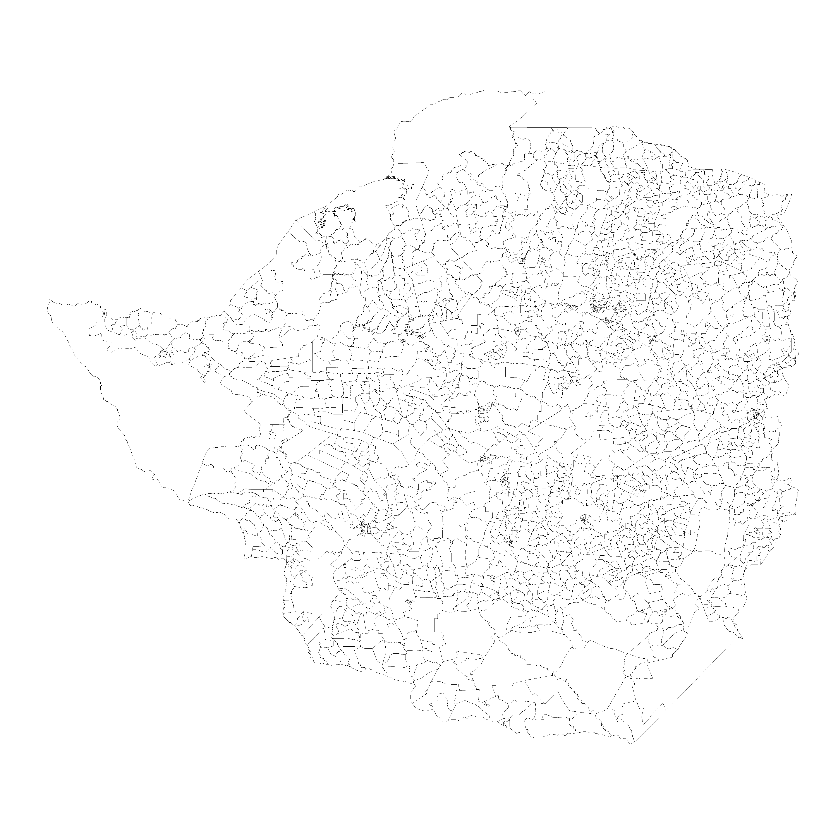 ## Daily temperature (min and max) for each ward (1970/01/01- 2018/04/28)

Dataset extracted from African Drought Monitor (using extract_afm.R), see temp_min.csv and temp_max.csv

## Daily rainfall for each ward (1981/01/01- 2018/04/28)

Dataset extracted from CHIRPS (using daily_rain_zmw.R), see daily_rain.csv

## daily temperatures for each ward for the growing season (October to June) starting in October 2007 and ending in June 2011.

## 4 Rainfall Maps (CHIRPS daily rainfall data for the entire country, calculate cumulative seasonal rainfall )

1. October 2007 – June 2008
2. October 2008 – June 2009
3. October 2009 – June 2010
4. October 201 – June 2011

## Warning: package 'readxl' was built under R version 3.3.3

create a “heat” map for cumulative season rainfall, lay over the outlines of the surveyed wards on the “heat” map.

## 4 Temperature Maps (Gdd and mean temperature)

create a “heat” map for cumulative season rainfall, lay over the outlines of the surveyed wards on the “heat” map.