Update March 25

(1) See if data can be cleaned up to remove missing variables from 2009-13 and so increase sample size.

The observations increased from 1142 to 2687 after adding in missing sunflower acreage and weather information.

Illustration of method in North and South Dakota:

The light-yellow dots are where sunflowers are growing, and grey dots are where the apiaries are (with 2 miles buffer).

We are considering the yellow dots that fall in the gray dots, but not the ones that are further away.

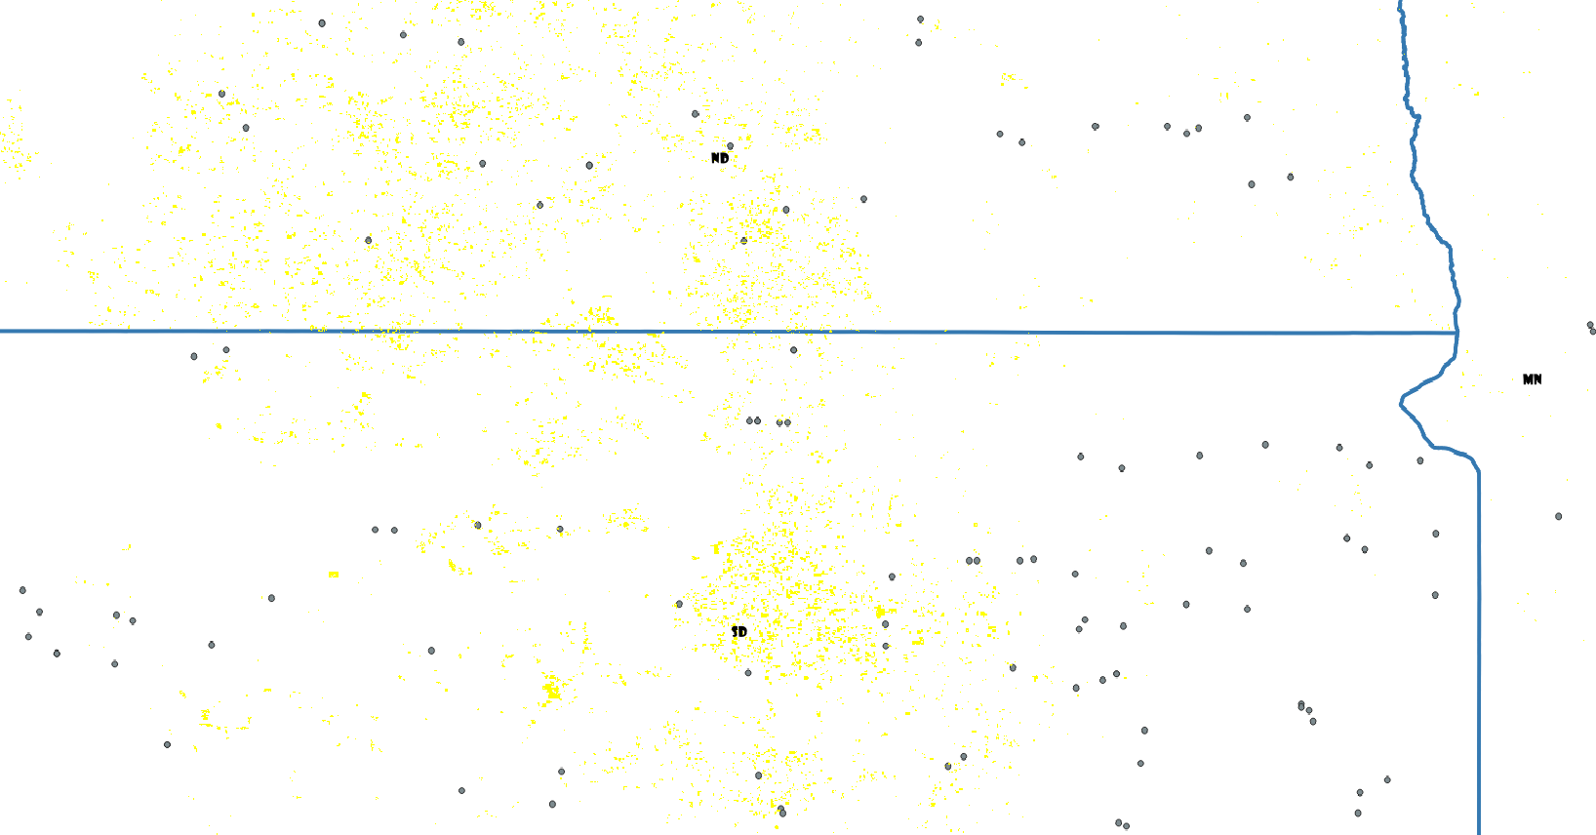

(2) Do analyses once for all years (both Aug/Sept analysis, and analysis of all months with interaction term), remove either ‘month’ or ‘bloom dummy’.

**Table 2.1. Mite regression limited to Aug/Sept (2010-2015)**

(observation increase from 443 to 1034)

===============================================================

Dependent variable:

-------------------------------

mites

(1) (2) (3)

---------------------------------------------------------------

Sunflower acreage -1.051***

(log form) (0.355)

sunflower>0.2 acres -10.449***

(4.028)

sunflower> 1 acres -11.830***

(4.480)

average_mintemp -0.402 -0.377 -0.385

(0.324) (0.324) (0.324)

average_precip -0.053*** -0.052*** -0.053***

(0.019) (0.019) (0.019)

September 5.879** 5.971** 5.762**

(2.396) (2.398) (2.401)

Constant 26.302*** 25.627*** 25.829***

(5.399) (5.388) (5.400)

---------------------------------------------------------------

Observations 1,034 1,034 1,034

R2 0.028 0.026 0.026

Adjusted R2 0.024 0.022 0.022

Residual Std. Error (df = 1029) 35.383 35.418 35.413

F Statistic (df = 4; 1029) 7.388*** 6.866*** 6.928***

===============================================================

Note: *p<0.1; **p<0.05; ***p<0.01

=============================================================

|  |
| --- |
| **Table 2.2 Nosema regression limited to Aug/Sept (2010-2015)**  =============================================================  Dependent variable:  -----------------------------  Nosema  (1) (2) (3)  -------------------------------------------------------------  Sunflower acreage -0.0004  (log form) (0.004)    sunflower>0.2 acres 0.012  (0.047)    sunflower> 1 acres 0.020  (0.053)    average_mintemp -0.011*** -0.011*** -0.011***  (0.004) (0.004) (0.004)    average_precip 0.001** 0.001** 0.001**  (0.0002) (0.0002) (0.0002)    September -0.098*** -0.098*** -0.098***  (0.028) (0.028) (0.028)    Constant 0.314*** 0.308*** 0.306***  (0.064) (0.063) (0.064)    -------------------------------------------------------------  Observations 1,031 1,031 1,031  R2 0.018 0.018 0.018  Adjusted R2 0.014 0.014 0.014  Residual Std. Error (df = 1026) 0.417 0.417 0.417  F Statistic (df = 4; 1026) 4.576*** 4.590*** 4.611***  =============================================================  Note: *p<0.1; **p<0.05; ***p<0.01 |
|  |
| |  | | --- | |  | |

**Table 2.3 Mite regression all month (2010-2015), with bloom dummy (month 8 or 9)**

(observation increase from 1007 to 2686)

=============================================================

Dependent variable:

-----------------------------

mites

(1) (2) (3)

-------------------------------------------------------------

log(sunflower acres)*bloom_dummy -0.464

(0.390)

sunflower>0.2 acres*bloom_dummy -3.591

(4.372)

sunflower>1 acres*bloom_dummy -3.056

(4.891)

log(sunflower acres) -0.465**

(0.232)

sunflower>0.2 acres -5.548**

(2.553)

sunflower>1 acres -7.552***

(2.898)

bloom_dummy 7.897*** 7.708*** 7.637***

(1.480) (1.469) (1.454)

average_mintemp -0.291** -0.291** -0.292**

(0.129) (0.129) (0.129)

average_precip -0.016 -0.015 -0.016

(0.010) (0.010) (0.010)

Constant 16.760*** 16.737*** 16.798***

(1.614) (1.612) (1.603)

-------------------------------------------------------------

Observations 2,686 2,686 2,686

R2 0.017 0.016 0.017

Adjusted R2 0.015 0.014 0.015

Residual Std. Error (df = 2680) 31.782 31.790 31.775

F Statistic (df = 5; 2680) 9.061*** 8.763*** 9.302***

=============================================================

Note: *p<0.1; **p<0.05; ***p<0.01

**Table 2.4 Nosema regression all month (2010-2015), with bloom dummy (month 8 or 9)**

=============================================================

Dependent variable:

-----------------------------

nosema

(1) (2) (3)

-------------------------------------------------------------

log(sunflower acres)*bloom_dummy -0.026**

(0.010)

sunflower>0.2 acres*bloom_dummy -0.281**

(0.113)

sunflower>1 acres*bloom_dummy -0.244*

(0.126)

log(sunflower acres) 0.025***

(0.006)

sunflower>0.2 acres 0.283***

(0.066)

sunflower>1 acres 0.257***

(0.075)

bloom_dummy -0.182*** -0.186*** -0.196***

(0.038) (0.038) (0.038)

average_mintemp -0.010*** -0.010*** -0.010***

(0.003) (0.003) (0.003)

average_precip 0.0002 0.0002 0.0002

(0.0003) (0.0003) (0.0003)

Constant 0.455*** 0.454*** 0.465***

(0.042) (0.042) (0.041)

-------------------------------------------------------------

Observations 2,681 2,681 2,681

R2 0.033 0.034 0.031

Adjusted R2 0.031 0.032 0.029

Residual Std. Error (df = 2675) 0.819 0.819 0.820

F Statistic (df = 5; 2675) 18.294*** 18.639*** 17.267***

=============================================================

Note: *p<0.1; **p<0.05; ***p<0.01

(3) do again for only 2014-15, including apiary size as a covariate.

**Table 3.1. Mite regression limited to Aug/Sept (2014-2015), controlling for apiary size**

=============================================================

Dependent variable:

------------------------------

mites

(1) (2) (3)

-------------------------------------------------------------

log(sunflower acres) -3.038***

(1.076)

sunflower>0.2 acres -31.276**

(12.189)

sunflower>1 acres -36.817***

(13.002)

average_mintemp -1.713 -1.646 -1.627

(1.057) (1.063) (1.047)

average_precip -0.050 -0.055 -0.051

(0.068) (0.068) (0.068)

colonysize -0.008* -0.008* -0.008*

(0.005) (0.005) (0.005)

Constant 81.831*** 80.854*** 80.251***

(15.038) (15.138) (14.833)

-------------------------------------------------------------

Observations 291 291 291

R2 0.041 0.037 0.041

Adjusted R2 0.028 0.023 0.028

Residual Std. Error (df = 286) 54.546 54.676 54.542

F Statistic (df = 4; 286) 3.066** 2.712** 3.076**

=============================================================

Note: *p<0.1; **p<0.05; ***p<0.01

**Table 3.2. Nosema regression limited to Aug/Sept (2014-2015), controlling for apiary size**

============================================================

Dependent variable:

-----------------------------

nosema

(1) (2) (3)

------------------------------------------------------------

log(sunflower acres) 0.009*

(0.005)

sunflower>0.2 acres 0.131**

(0.056)

sunflower>1 acres 0.103*

(0.060)

average_mintemp 0.004 0.005 0.003

(0.005) (0.005) (0.005)

average_precip 0.0002 0.0002 0.0002

(0.0003) (0.0003) (0.0003)

colonysize -0.00000 0.00000 -0.00000

(0.00002) (0.00002) (0.00002)

Constant -0.006 -0.022 -0.001

(0.078) (0.078) (0.077)

------------------------------------------------------------

Observations 291 291 291

R2 0.019 0.028 0.019

Adjusted R2 0.002 0.011 0.002

Residual Std. Error (df = 285) 0.251 0.249 0.251

F Statistic (df = 5; 285) 1.114 1.623 1.091

============================================================

Note: *p<0.1; **p<0.05; ***p<0.01

**Table 3.3. Mite regression all month (2014-2015), with bloom dummy (month 8 or 9)** **and** **controlling for apiary size**

============================================================

Dependent variable:

-----------------------------

mites

(1) (2) (3)

------------------------------------------------------------

log(sunflower acres)*bloom_dummy -2.044

(1.367)

sunflower>0.2 acres*bloom_dummy -18.342

(14.820)

sunflower>1 acres*bloom_dummy -14.618

(17.578)

log(sunflower acres -0.844

(0.965)

sunflower>0.2 acres -11.274

(10.003)

sunflower>1 acres -21.046

(13.082)

bloom_dummy 21.893*** 21.412*** 21.469***

(4.523) (4.504) (4.449)

average_mintemp -1.302*** -1.300*** -1.332***

(0.406) (0.407) (0.406)

average_precip -0.004 -0.006 -0.006

(0.034) (0.034) (0.034)

colonysize -0.006** -0.006** -0.006**

(0.002) (0.002) (0.002)

Constant 50.109*** 50.294*** 50.761***

(5.452) (5.435) (5.411)

------------------------------------------------------------

Observations 710 710 710

R2 0.052 0.051 0.055

Adjusted R2 0.044 0.043 0.047

Residual Std. Error (df = 703) 52.318 52.355 52.244

F Statistic (df = 6; 703) 6.456*** 6.280*** 6.804***

============================================================

Note: *p<0.1; **p<0.05; ***p<0.01

**Table 3.4. Nosema regression all month (2014-2015), with bloom dummy (month 8 or 9)** **and** **controlling for apiary size**

============================================================

Dependent variable:

-----------------------------

nosema

(1) (2) (3)

------------------------------------------------------------

log(sunflower acres)*bloom_dummy -0.010

(0.015)

sunflower>0.2 acres*bloom_dummy 0.078

(0.162)

sunflower>1 acres*bloom_dummy 0.031

(0.192)

log(sunflower acres) 0.016

(0.011)

sunflower>0.2 acres 0.022

(0.109)

sunflower>1 acres 0.044

(0.143)

bloom_dummy -0.114** -0.127** -0.123**

(0.049) (0.049) (0.049)

average_mintemp -0.005 -0.005 -0.005

(0.004) (0.004) (0.004)

average_precip 0.0003 0.0003 0.0003

(0.0004) (0.0004) (0.0004)

colonysize 0.00001 0.00001 0.00001

(0.00003) (0.00003) (0.00003)

Constant 0.246*** 0.264*** 0.264***

(0.060) (0.059) (0.059)

------------------------------------------------------------

Observations 710 710 710

R2 0.022 0.019 0.019

Adjusted R2 0.013 0.011 0.010

Residual Std. Error (df = 703) 0.571 0.572 0.572

F Statistic (df = 6; 703) 2.592** 2.268** 2.217**

============================================================

Note: *p<0.1; **p<0.05; ***p<0.01