1. Check how well model fits the data (lots of zeroes; mites are count data) and try using models with distributions that fit the data (zero-inflated, Poisson, negative binomial?); assess model fit to ensure we are using appropriate models. Kathy also suggested log-transforming mites (and Nosema?) as a possible fix.
2. Limiting to blooming month



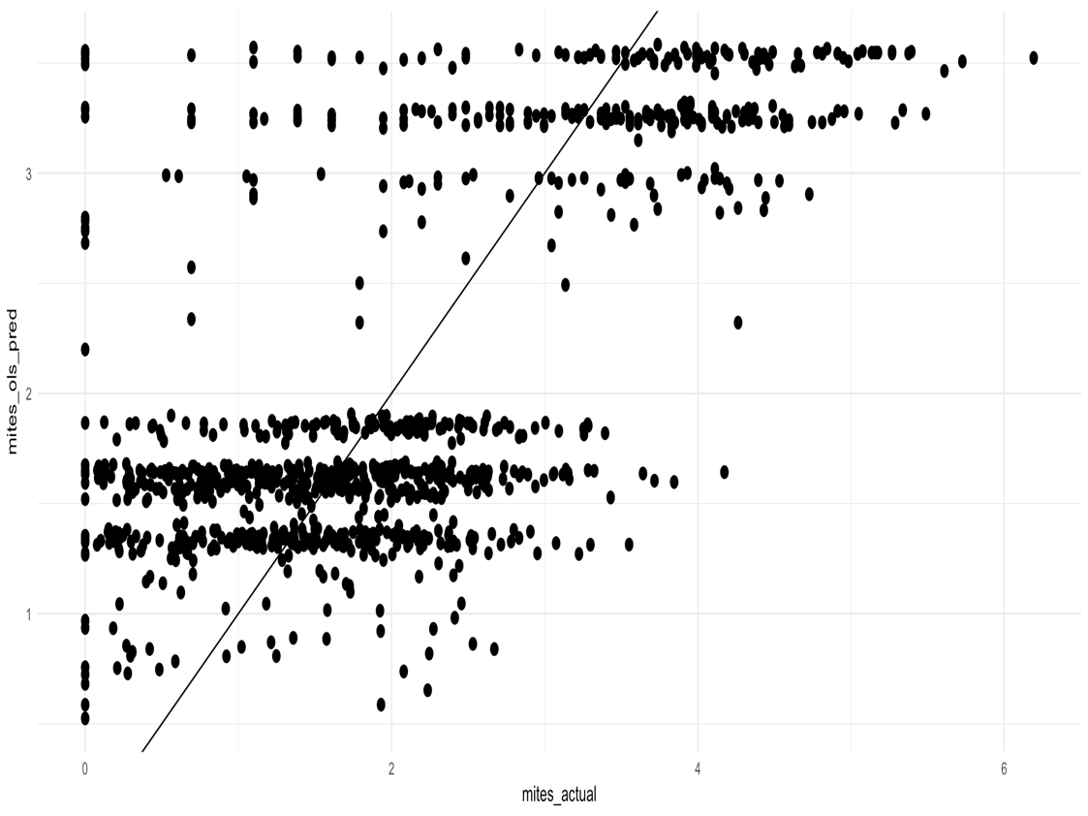 OLS

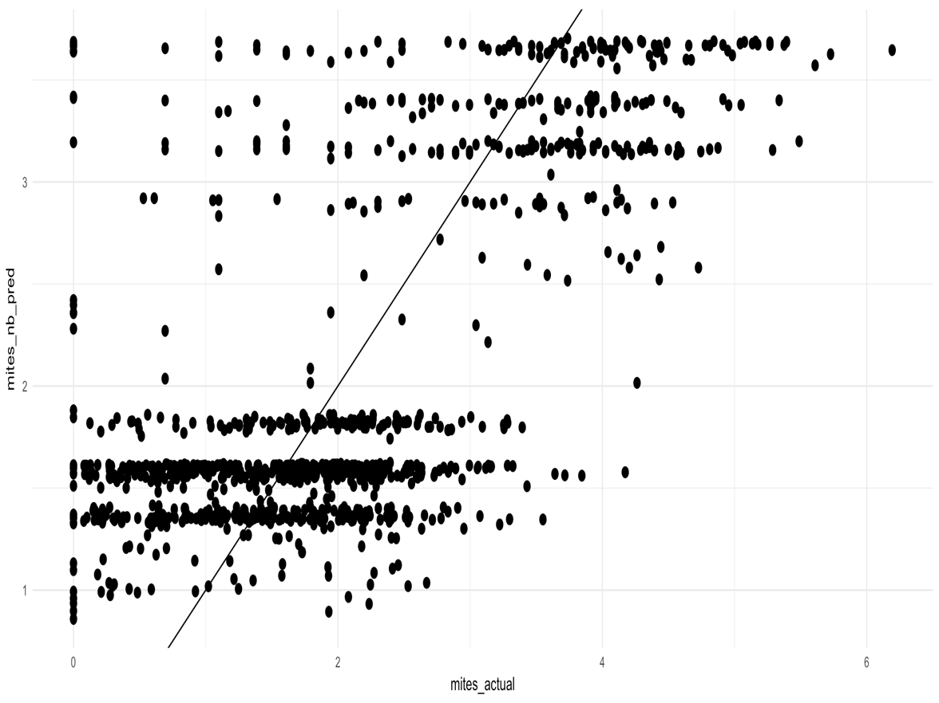

Negative binomial

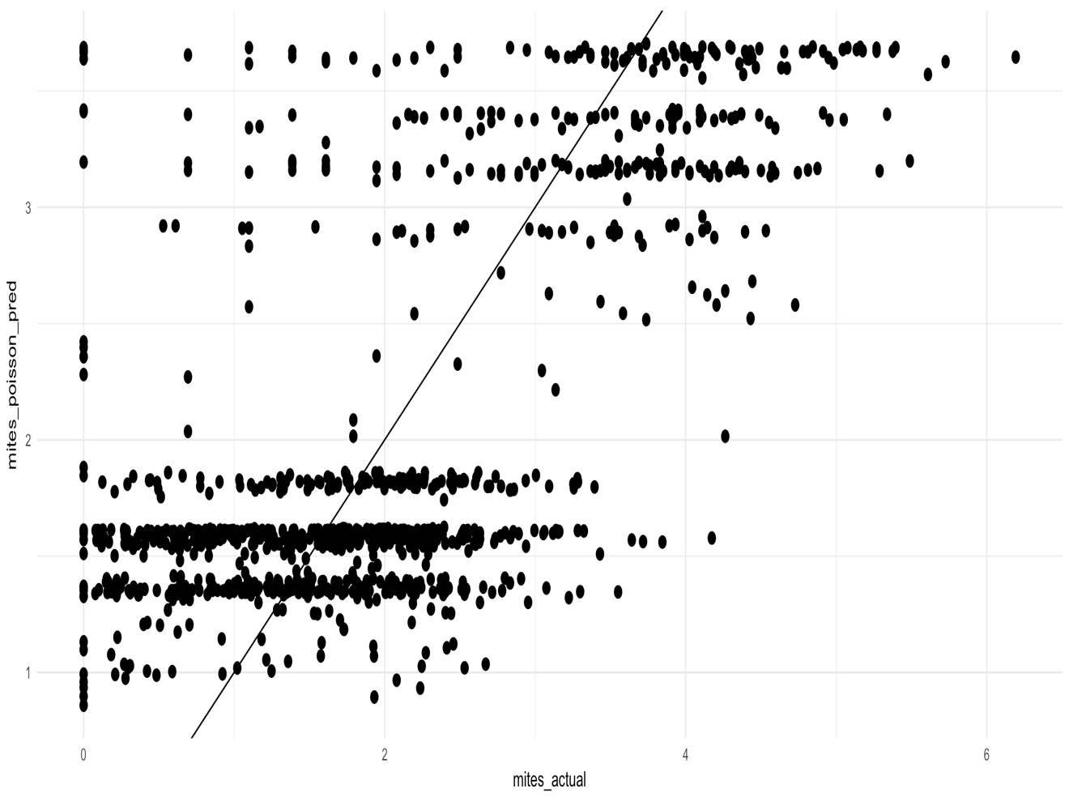

Poisson

1. All month results



2. Restricting analysis to only states that grow sunflower (above some minimum bar of acreage for the state), now that we have a larger sample size.

1. Trying a 4 mile instead of 2-mile radius.

need more time for the geoprocessing to work out.

1. Kathy suggested including year as a fixed effect.

added

5. Given that results seem similar whether sunflower is used as a continuous or categorical predictor, for the sake of efficiency I suggest using as continuous (sunflower acreage).