姓名： 周良康 | 专业：信息管理与信息系统 | 班级：20181171 | 学号：2018117129
科目： Android应用与开发 |  | 实验日期：2021-06-19
实验题目： 实验一：创建第一个项目
【实验目的】
创建一个HelloWorld项目

【实验内容】
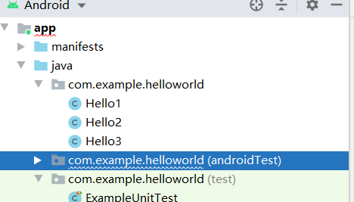

Hello1：
package com.example.helloworld;
import org.junit.Test;
import static org.junit.Assert.*;
/**
* Example local unit test, which will execute on the development machine (host).
*
* @see <a href="http://d.android.com/tools/testing">Testing documentation</a>
*/
public class ExampleUnitTest {
@Test
public void addition_isCorrect() throws Exception {
assertEquals(4, 2 + 2);
}
}
Hello2：
package com.example.helloworld;
import android.content.Intent;
import android.os.Bundle;
import android.support.v7.app.AppCompatActivity;
import android.util.Log;
import android.view.View;
import android.widget.Button;
public class Hello2 extends AppCompatActivity implements View.OnClickListener {
private final static String TAG = "Hello2";
@Override
protected void onCreate(Bundle savedInstanceState) {
super.onCreate(savedInstanceState);
setContentView(R.layout.activity_hello2);
Log.d(TAG, "onCreate execute");
setTitle("Hello2");
settupButtons();
}
@Override
protected void onStart() {
super.onStart();
Log.d(TAG, "onStart");
}
@Override
protected void onResume() {
super.onResume();
Log.d(TAG, "onResume");
}
@Override
protected void onPostResume() {
super.onPostResume();
Log.d(TAG, "onPostResume");
}
@Override
protected void onPause() {
super.onPause();
Log.d(TAG, "onPause");
}
@Override
protected void onStop() {
super.onStop();
Log.d(TAG, "onStop");
}
@Override
protected void onDestroy() {
super.onDestroy();
Log.d(TAG, "onDestroy");
}
@Override
public void onClick(View v) {
if (v.getId() == R.id.btToHello1) {
Intent intent;
intent = new Intent(this, Hello1.class);
startActivity(intent);
}
if (v.getId() == R.id.btToHello2) {
Intent intent;
intent = new Intent(this, Hello2.class);
startActivity(intent);
}
if (v.getId() == R.id.btToHello3) {
Intent intent;
intent = new Intent(this, Hello3.class);
startActivity(intent);
}
}
private void settupButtons() {
Button b;
b = (Button) findViewById(R.id.btToHello1);
b.setOnClickListener(this);
b = (Button) findViewById(R.id.btToHello2);
b.setOnClickListener(this);
b = (Button) findViewById(R.id.btToHello3);
b.setOnClickListener(this);
}
}

Hello3：
package com.example.helloworld;
import android.content.Intent;
import android.os.Bundle;
import android.support.v7.app.AppCompatActivity;
import android.util.Log;
import android.view.View;
import android.widget.Button;
public class Hello3 extends AppCompatActivity implements View.OnClickListener {
private final static String TAG = "Hello3";
@Override
protected void onCreate(Bundle savedInstanceState) {
super.onCreate(savedInstanceState);
setContentView(R.layout.activity_hello3);
Log.d(TAG, "onCreate execute");
setTitle("Hello3");
settupButtons();
Intent intent = this.getIntent();
if (intent == null) {
Log.d("test tag", "This activity is invoked without an intent");
}
}
@Override
protected void onStart() {
super.onStart();
Log.d(TAG, "onStart");
}
@Override
protected void onResume() {
super.onResume();
Log.d(TAG, "onResume");
}
@Override
protected void onPostResume() {
super.onPostResume();
Log.d(TAG, "onPostResume");
}
@Override
protected void onPause() {
super.onPause();
Log.d(TAG, "onPause");
}
@Override
protected void onStop() {
super.onStop();
Log.d(TAG, "onStop");
}
@Override
protected void onDestroy() {
super.onDestroy();
Log.d(TAG, "onDestroy");
}
@Override
public void onClick(View v) {
if (v.getId() == R.id.btToHello1) {
Intent intent;
intent = new Intent(this, Hello1.class);
startActivity(intent);
}
if (v.getId() == R.id.btToHello2) {
Intent intent;
intent = new Intent(this, Hello2.class);
startActivity(intent);
}
if (v.getId() == R.id.btToHello3) {
Intent intent;
intent = new Intent(this, Hello3.class);
startActivity(intent);
}
}
private void settupButtons() {
Button b;
b = (Button) findViewById(R.id.btToHello1);
b.setOnClickListener(this);
b = (Button) findViewById(R.id.btToHello2);
b.setOnClickListener(this);
b = (Button) findViewById(R.id.btToHello3);
b.setOnClickListener(this);
}
}

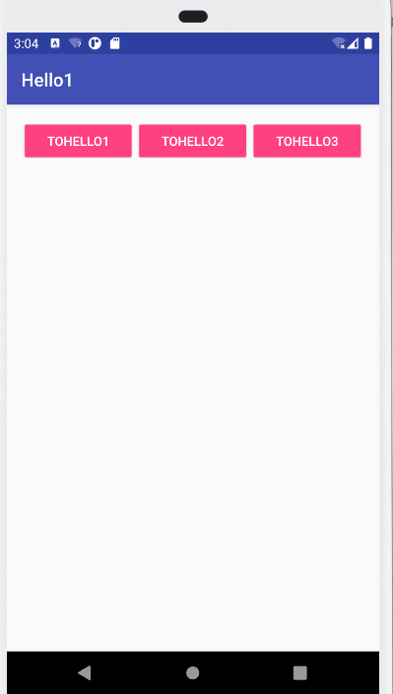

【教师评语和成绩】

成绩： 指导教师： 日期：

