姓名： 周良康 | 专业：信息管理与信息系统 | 班级：20181171 | 学号：2018117129
科目： Android应用与开发 |  | 实验日期：2021-06-19
实验题目： 实验二：探究Activity
【实验目的】
认识并使用Activity

【实验内容】

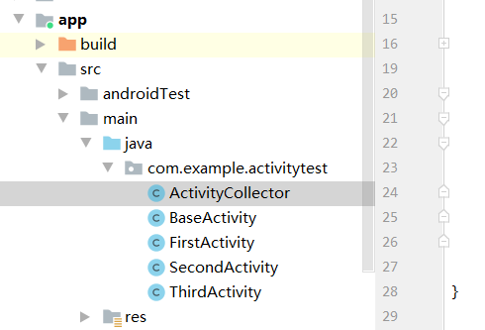

ActivityCollector：
package com.example.activitytest;
import android.app.Activity;
import java.util.ArrayList;
import java.util.List;
public class ActivityCollector {
public static List<Activity> activities = new ArrayList<>();
public static void addActivity(Activity activity) {
activities.add(activity);
}
public static void removeActivity(Activity activity) {
activities.remove(activity);
}
public static void finishAll() {
for (Activity activity : activities) {
if (!activity.isFinishing()) {
activity.finish();
}
}
}
}

BaseActivity：
package com.example.activitytest;
import android.os.Bundle;
import android.support.annotation.Nullable;
import android.support.v7.app.AppCompatActivity;
import android.util.Log;
public class BaseActivity extends AppCompatActivity {
@Override
protected void onCreate(Bundle savedInstanceState) {
super.onCreate(savedInstanceState);
Log.d("BaseActivity", getClass().getSimpleName());
ActivityCollector.addActivity(this);
}
@Override
protected void onDestroy() {
super.onDestroy();
ActivityCollector.removeActivity(this);
}
}

FirstActivity：
package com.example.activitytest;
import android.content.Intent;
import android.net.Uri;
import android.support.v7.app.AppCompatActivity;
import android.os.Bundle;
import android.util.Log;
import android.view.Menu;
import android.view.MenuItem;
import android.view.View;
import android.widget.Button;
import android.widget.Toast;
public class FirstActivity extends BaseActivity {
@Override
protected void onCreate(Bundle savedInstanceState) {
super.onCreate(savedInstanceState);
Log.d("FirstActivity", "Task id is " + getTaskId());
setContentView(R.layout.first_layout);
Button button1 = (Button) findViewById(R.id.button_1);
button1.setOnClickListener(new View.OnClickListener() {
@Override
public void onClick(View v) {
// Intent intent = new Intent(FirstActivity.this, SecondActivity.class);
// startActivity(intent);
SecondActivity.actionStart(FirstActivity.this, "data1", "data2");
}
});
}
@Override
protected void onRestart() {
super.onRestart();
Log.d("FirstActivity", "onRestart");
}
@Override
public boolean onCreateOptionsMenu(Menu menu) {
getMenuInflater().inflate(R.menu.main, menu);
return true;
}
@Override
public boolean onOptionsItemSelected(MenuItem item) {
switch (item.getItemId()) {
case R.id.add_item:
Toast.makeText(this, "You clicked Add", Toast.LENGTH_SHORT).show();
break;
case R.id.remove_item:
Toast.makeText(this, "You clicked Remove", Toast.LENGTH_SHORT).show();
break;
default:
}
return true;
}
@Override
protected void onActivityResult(int requestCode, int resultCode, Intent data) {
switch (requestCode) {
case 1:
if (resultCode == RESULT_OK) {
String returnedData = data.getStringExtra("data_return");
Log.d("FirstActivity", returnedData);
}
break;
default:
}
}
}

SecondActivity：package com.example.activitytest;
import android.content.Context;
import android.content.Intent;
import android.support.v7.app.AppCompatActivity;
import android.os.Bundle;
import android.util.Log;
import android.view.View;
import android.widget.Button;
import android.widget.Toast;
public class SecondActivity extends BaseActivity {
public static void actionStart(Context context, String data1, String data2) {
Intent intent = new Intent(context, SecondActivity.class);
intent.putExtra("param1", data1);
intent.putExtra("param2", data2);
context.startActivity(intent);
}
@Override
protected void onCreate(Bundle savedInstanceState) {
super.onCreate(savedInstanceState);
Log.d("SecondActivity", "Task id is " + getTaskId());
setContentView(R.layout.second_layout);
Button button2 = (Button) findViewById(R.id.button_2);
button2.setOnClickListener(new View.OnClickListener() {
@Override
public void onClick(View v) {
Intent intent = new Intent(SecondActivity.this, ThirdActivity.class);
startActivity(intent);
}
});
}
@Override
protected void onDestroy() {
super.onDestroy();
Log.d("SecondActivity", "onDestroy");
}
@Override
public void onBackPressed() {
Intent intent = new Intent();
intent.putExtra("data_return", "Hello FirstActivity");
setResult(RESULT_OK, intent);
finish();
}
}

ThirdActivity：
package com.example.activitytest;
import android.support.v7.app.AppCompatActivity;
import android.os.Bundle;
import android.util.Log;
import android.view.View;
import android.widget.Button;
public class ThirdActivity extends BaseActivity {
@Override
protected void onCreate(Bundle savedInstanceState) {
super.onCreate(savedInstanceState);
Log.d("ThirdActivity", "Task id is " + getTaskId());
setContentView(R.layout.third_layout);
Button button3 = (Button) findViewById(R.id.button_3);
button3.setOnClickListener(new View.OnClickListener() {
@Override
public void onClick(View v) {
ActivityCollector.finishAll();
android.os.Process.killProcess(android.os.Process.myPid());
}
});
}
}

运行截图：

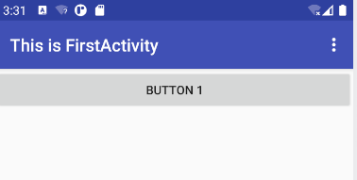
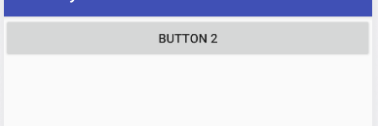
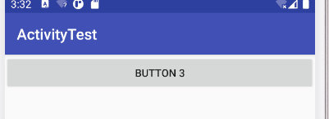
【教师评语和成绩】

成绩： 指导教师： 日期：

