忽略文件

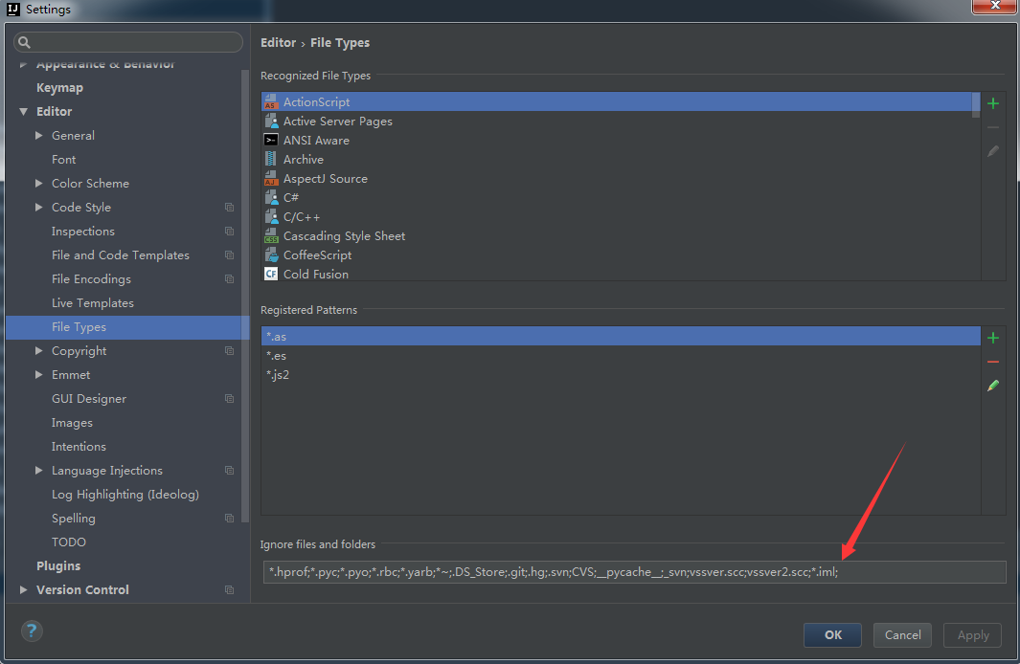

svn

上传分组

添加分组，可以将不上传的文件放到分组

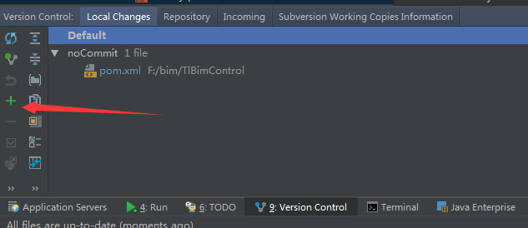

代码自动更新tomcat

tomcat虚拟机参数

-Dfile.encoding=UTF-8设置

这里加一句



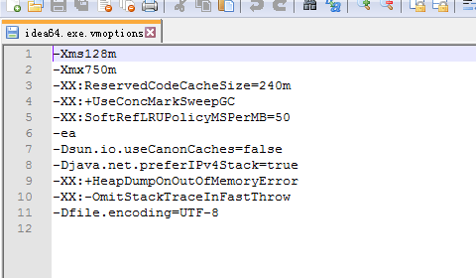

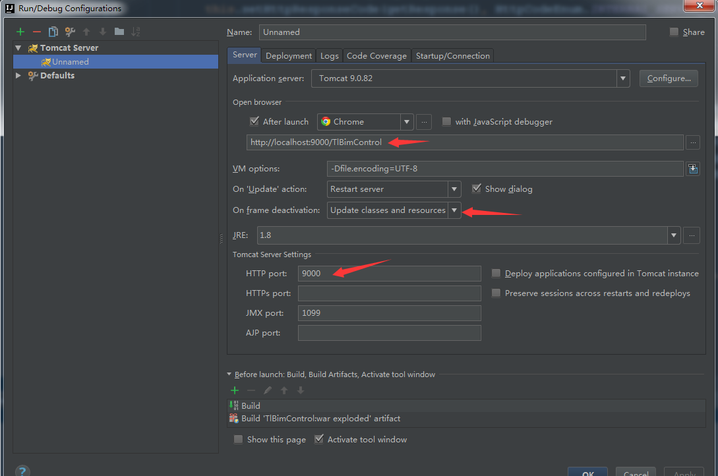

tomcat路径

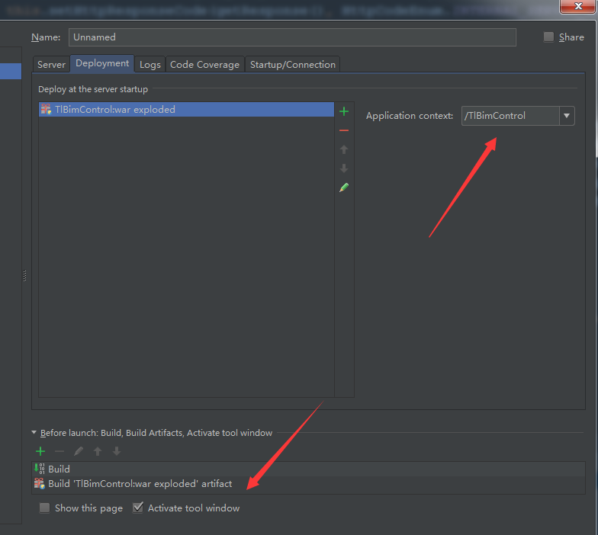

设置JavaScript版本

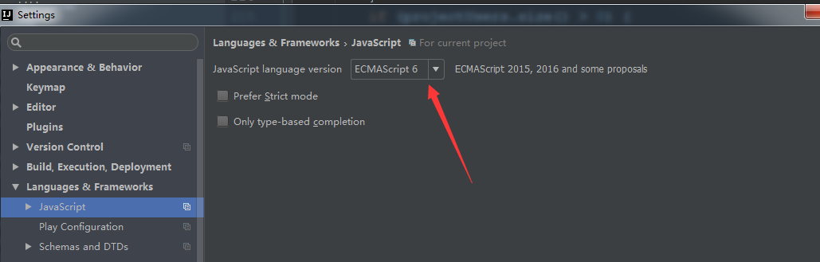

设置文件编码

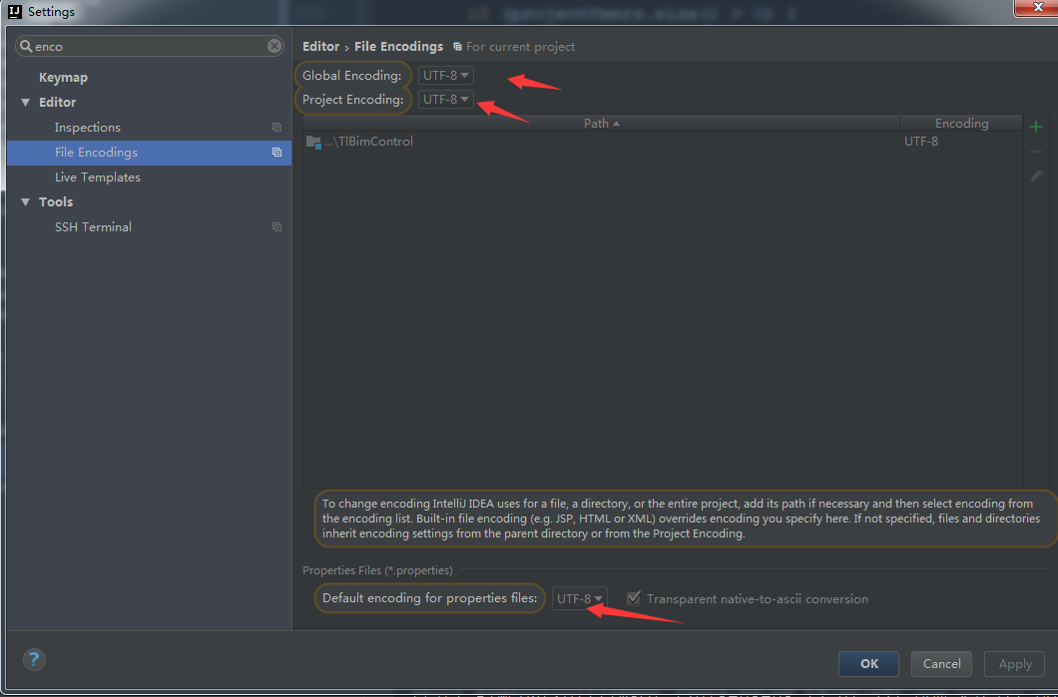

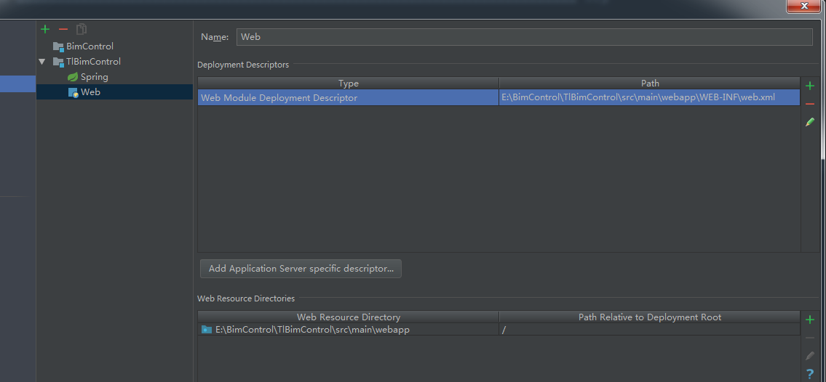

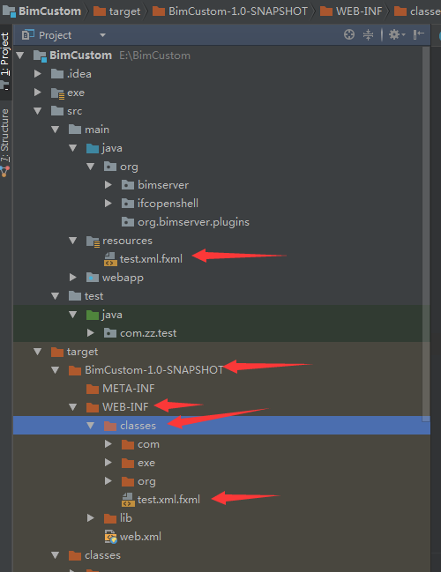

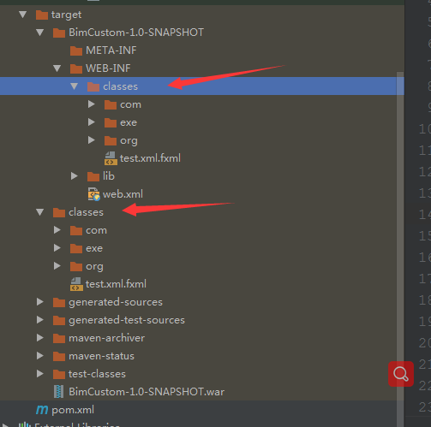

<?xml version="1.0" encoding="UTF-8"?>  
<project xmlns="http://maven.apache.org/POM/4.0.0"  
 xmlns:xsi="http://www.w3.org/2001/XMLSchema-instance"  
 xsi:schemaLocation="http://maven.apache.org/POM/4.0.0 http://maven.apache.org/xsd/maven-4.0.0.xsd">  
 <modelVersion>4.0.0</modelVersion>  
  
 <groupId>com.zz</groupId>  
 <artifactId>BimCustom</artifactId>  
 <packaging>war</packaging>  
 <version>1.0-SNAPSHOT</version>  
  
  
  
 <build>  
 <!-- java源文件目录 -->  
 <sourceDirectory>src/main/java</sourceDirectory>  
 <!-- java源文件编译目录 -->  
 <outputDirectory>target/classes</outputDirectory>  
  
 <!-- java 测试 源文件目录 -->  
 <testSourceDirectory>src/test/java</testSourceDirectory>  
 <!-- java 测试 源文件编译目录 -->  
 <testOutputDirectory>target/test-classes</testOutputDirectory>  
  
  
 <resources>  
 <resource>  
 <!-- java配置文件目录 -->  
 <directory>src/main/resources</directory>  
 <!--<targetPath>不设置会默认输出到classes下</targetPath>-->  
 </resource>  
 <resource>  
 <directory>exe</directory>  
 <!--<targetPath>设置会默认输出到classes/exe下</targetPath>-->  
 <targetPath>exe</targetPath>  
 </resource>  
 </resources>  
  
 <plugins>  
 <!--JDK版本 -->  
 <plugin>  
 <groupId>org.apache.maven.plugins</groupId>  
 <artifactId>maven-compiler-plugin</artifactId>  
 <version>3.7.0</version>  
 <configuration>  
 <source>1.8</source>  
 <target>1.8</target>  
 <encoding>UTF-8</encoding>  
 <showWarnings>true</showWarnings>  
 </configuration>  
 </plugin>  
 </plugins>  
 </build>  
 <dependencies>  
 <dependency>  
 <groupId>org.slf4j</groupId>  
 <artifactId>slf4j-api</artifactId>  
 <version>1.7.13</version>  
 </dependency>  
 <dependency>  
 <groupId>org.apache.httpcomponents</groupId>  
 <artifactId>httpclient</artifactId>  
 <version>4.5.1</version>  
 </dependency>  
 <dependency>  
 <groupId>org.apache.httpcomponents</groupId>  
 <artifactId>httpmime</artifactId>  
 <version>4.5.1</version>  
 </dependency>  
 <dependency>  
 <groupId>org.eclipse.aether</groupId>  
 <artifactId>aether-api</artifactId>  
 <version>1.0.2.v20150114</version>  
 </dependency>  
 <dependency>  
 <groupId>org.eclipse.aether</groupId>  
 <artifactId>aether-transport-file</artifactId>  
 <version>1.0.2.v20150114</version>  
 </dependency>  
 <dependency>  
 <groupId>org.eclipse.aether</groupId>  
 <artifactId>aether-transport-http</artifactId>  
 <version>1.0.2.v20150114</version>  
 <exclusions>  
 <exclusion>  
 <artifactId>httpclient</artifactId>  
 <groupId>org.apache.httpcomponents</groupId>  
 </exclusion>  
 </exclusions>  
 </dependency>  
 <dependency>  
 <groupId>org.eclipse.aether</groupId>  
 <artifactId>aether-spi</artifactId>  
 <version>1.0.2.v20150114</version>  
 </dependency>  
 <dependency>  
 <groupId>org.eclipse.aether</groupId>  
 <artifactId>aether-connector-basic</artifactId>  
 <version>1.0.2.v20150114</version>  
 </dependency>  
 <dependency>  
 <groupId>org.eclipse.aether</groupId>  
 <artifactId>aether-impl</artifactId>  
 <version>1.0.2.v20150114</version>  
 </dependency>  
 <dependency>  
 <groupId>org.apache.maven</groupId>  
 <artifactId>maven-repository-metadata</artifactId>  
 <version>3.3.9</version>  
 </dependency>  
 <dependency>  
 <groupId>org.apache.maven</groupId>  
 <artifactId>maven-aether-provider</artifactId>  
 <version>3.3.9</version>  
 </dependency>  
 <dependency>  
 <groupId>com.google.guava</groupId>  
 <artifactId>guava</artifactId>  
 <version>19.0</version>  
 </dependency>  
 <dependency>  
 <groupId>com.fasterxml.jackson.core</groupId>  
 <artifactId>jackson-core</artifactId>  
 <version>2.9.1</version>  
 </dependency>  
 <dependency>  
 <groupId>com.fasterxml.jackson.core</groupId>  
 <artifactId>jackson-databind</artifactId>  
 <version>2.9.1</version>  
 </dependency>  
 <dependency>  
 <groupId>org.slf4j</groupId>  
 <artifactId>slf4j-api</artifactId>  
 <version>1.7.13</version>  
 </dependency>  
 <dependency>  
 <groupId>commons-io</groupId>  
 <artifactId>commons-io</artifactId>  
 <version>2.4</version>  
 </dependency>  
 <dependency>  
 <groupId>com.google.code.gson</groupId>  
 <artifactId>gson</artifactId>  
 <version>2.5</version>  
 </dependency>  
 <dependency>  
 <groupId>commons-codec</groupId>  
 <artifactId>commons-codec</artifactId>  
 <version>1.9</version>  
 </dependency>  
 <dependency>  
 <groupId>org.eclipse.tycho</groupId>  
 <artifactId>org.eclipse.jdt.core</artifactId>  
 <version>3.9.1.v20130905-0837</version>  
 </dependency>  
 <dependency>  
 <groupId>org.eclipse.core</groupId>  
 <artifactId>runtime</artifactId>  
 <version>3.9.100-v20131218-1515</version>  
 </dependency>  
 <dependency>  
 <groupId>org.eclipse.emf</groupId>  
 <artifactId>org.eclipse.emf.common</artifactId>  
 <version>2.11.0-v20150805-0538</version>  
 </dependency>  
 <dependency>  
 <groupId>org.eclipse.emf</groupId>  
 <artifactId>org.eclipse.emf.ecore</artifactId>  
 <version>2.11.1-v20150805-0538</version>  
 </dependency>  
 <dependency>  
 <groupId>org.eclipse.emf</groupId>  
 <artifactId>org.eclipse.emf.ecore.xmi</artifactId>  
 <version>2.11.1-v20150805-0538</version>  
 </dependency>  
 <dependency>  
 <groupId>org.eclipse.emf</groupId>  
 <artifactId>org.eclipse.emf.codegen</artifactId>  
 <version>2.11.0-v20150806-0404</version>  
 </dependency>  
 <dependency>  
 <groupId>org.eclipse.emf</groupId>  
 <artifactId>org.eclipse.emf.codegen.ecore</artifactId>  
 <version>2.11.0-v20150806-0404</version>  
 </dependency>  
 <dependency>  
 <groupId>org.eclipse.birt.runtime</groupId>  
 <artifactId>org.eclipse.core.resources</artifactId>  
 <version>3.8.101.v20130717-0806</version>  
 </dependency>  
 <dependency>  
 <groupId>org.opensourcebim</groupId>  
 <artifactId>buildingsmartlibrary</artifactId>  
 <version>1.0.11</version>  
 </dependency>  
 <dependency>  
 <groupId>org.glassfish</groupId>  
 <artifactId>javax.json</artifactId>  
 <version>1.0.4</version>  
 </dependency>  
 </dependencies>  
  
</project>