使用swagger步骤：
- 在pom.xml 文件中引入相关包：
<!-- 配置 swagger -->
<dependency>
<groupId>io.springfox</groupId>
<artifactId>springfox-swagger2</artifactId>
<version>2.6.1</version>
</dependency>
<dependency>
<groupId>io.springfox</groupId>
<artifactId>springfox-swagger-ui</artifactId>
<version>2.6.1</version>
</dependency>

- 创建配置类对 swagger进行基本的配置
package com.springboot.vue;
import org.springframework.context.annotation.ComponentScan;
import org.springframework.context.annotation.Configuration;
import org.springframework.web.servlet.config.annotation.ResourceHandlerRegistry;
import org.springframework.web.servlet.config.annotation.WebMvcConfigurerAdapter;
import springfox.documentation.builders.ApiInfoBuilder;
import springfox.documentation.builders.PathSelectors;
import springfox.documentation.builders.RequestHandlerSelectors;
import springfox.documentation.service.ApiInfo;
import springfox.documentation.spi.DocumentationType;
import springfox.documentation.spring.web.plugins.Docket;
import springfox.documentation.swagger2.annotations.EnableSwagger2;
@EnableSwagger2
@ComponentScan( basePackages = {"com.springboot.vue.controller"})
@Configuration
public class Swagger2 extends WebMvcConfigurerAdapter {
@Override
public void addResourceHandlers(ResourceHandlerRegistry registry) {
registry.addResourceHandler("swagger-ui.html")
.addResourceLocations("classpath:/META-INF/resources/");
registry.addResourceHandler("/webjars*")
.addResourceLocations("classpath:/META-INF/resources/webjars/");
}
public Docket createRestApi(){
return new Docket(DocumentationType.SWAGGER_2)
.apiInfo(apiInfo())
.select()
.apis(RequestHandlerSelectors.any())
.paths(PathSelectors.any())
.build();
}
private ApiInfo apiInfo(){
return new ApiInfoBuilder()
.title("test")
.description("测试")
.version("1.0")
.build();
}
}

- 在启动类中启使用 @EnableSwagger2注解来启用Swagger2Configuration
package com.springboot.vue;
import org.mybatis.spring.annotation.MapperScan;
import org.springframework.boot.SpringApplication;
import org.springframework.boot.autoconfigure.SpringBootApplication;
import springfox.documentation.swagger2.annotations.EnableSwagger2;
@SpringBootApplication
@EnableSwagger2
@MapperScan( basePackages = {"com.springboot.vue.mapper","com.springboot.vue.controller"})
public class Application {
public static void main(String[] args) {
SpringApplication.run(Application.class, args);
}
}

启动application 并访问http://localhost:端口号/swagger-ui.html
Swagger2常用注解类：
- @Api()用于类；
表示标识这个类是swagger的资源
- @ApiOperation()用于方法；
表示一个http请求的操作
- @ApiParam()用于方法，参数，字段说明；
表示对参数的添加元数据（说明或是否必填等）
- @ApiModel()用于类
表示对类进行说明，用于参数用实体类接收
- @ApiModelProperty()用于方法，字段
表示对model属性的说明或者数据操作更改
- @ApiIgnore()用于类，方法，方法参数
表示这个方法或者类被忽略
- @ApiImplicitParam() 用于方法
表示单独的请求参数
- @ApiImplicitParams() 用于方法，包含多个 @ApiImplicitParam

-------------------------------------------------------------------------------------------------------------------------------------------
package com.springboot.vue.controller;
import java.util.List;
import io.swagger.annotations.*;
import org.springframework.beans.factory.annotation.Autowired;
import org.springframework.stereotype.Controller;
import org.springframework.web.bind.annotation.RequestBody;
import org.springframework.web.bind.annotation.RequestMapping;
import org.springframework.web.bind.annotation.RequestMethod;
import org.springframework.web.bind.annotation.RestController;
import com.springboot.vue.pojo.Users;
import com.springboot.vue.service.UserService;
@RestController
@RequestMapping("/users")
@Api(value = "UsersController",description = "用户测试")
public class UsersController {
@Autowired
private UserService userService;
@RequestMapping(value = "/findUsers",method = RequestMethod.GET)
@ApiOperation(value = "获取所用户信息",notes = "返回所有的学生信息")
public List<Users> findUsers() {
List<Users> findUser = null;
try {
findUser = userService.findUser();
} catch (Exception e) {
e.printStackTrace();
}
return findUser;
}
@RequestMapping(value = "/findUserByUid",method = RequestMethod.GET)
@ApiOperation(value ="获取用户信息",notes ="根据用户ID 获取用户信息" )
@ApiImplicitParams({@ApiImplicitParam(paramType = "form",name = "uid",value = "用户ID")})
public Users findUserByUid(@ApiParam(name="uid",value = "用户ID",required = false) int uid) {
Users user = null;
try {
user = userService.findUserByUid(uid);
} catch (Exception e) {
e.printStackTrace();
}
return user;
}
@RequestMapping(value = "/updateUser",method = RequestMethod.POST)
public boolean updateUser(@RequestBody Users users) {
try {
if(userService.updateUser(users) == 1) {
return true;
}
} catch (Exception e) {
e.printStackTrace();
}
return false;
}
@RequestMapping(value = "/deleteUser",method = RequestMethod.GET)
public boolean deleteUser(int uid) {
try {
if(userService.deleteUser(uid) == 1) {
return true;
}
} catch (Exception e) {
e.printStackTrace();
}
return false;
}
@RequestMapping("/insertUser")
public Users insertUser(@RequestBody Users users) {
try {
userService.insertUser(users);
return users;
} catch (Exception e) {
e.printStackTrace();
}
return null;
}
}

通过swagger测试后台数据是否正确获取：
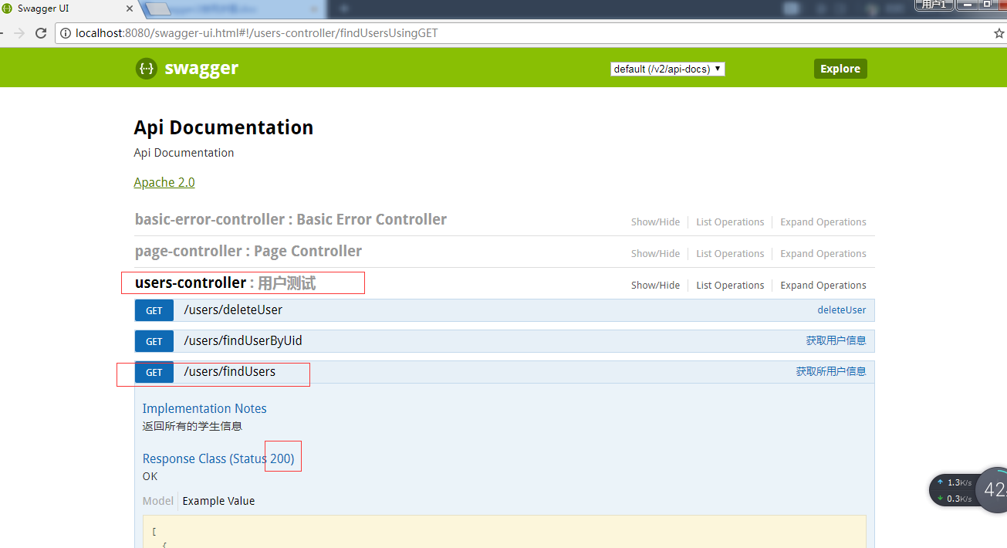
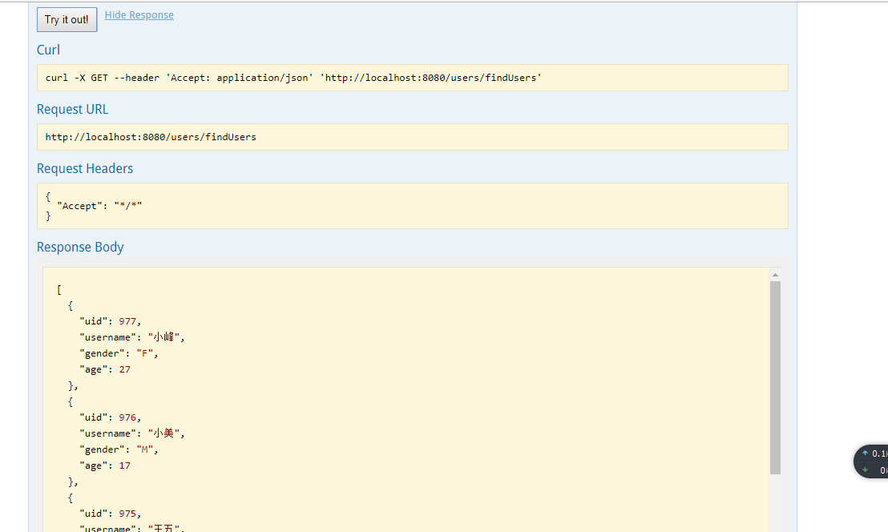

获取数据与数据库一致：
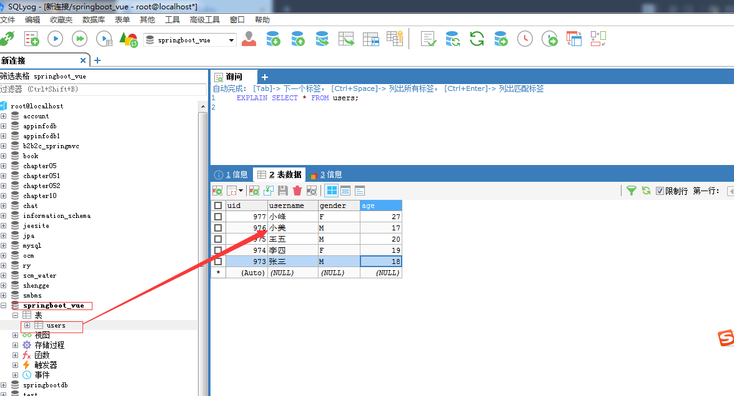

前端使用vue，页面显示数据也一致：
