# Chapter 4. Router advanced

### ***This chapter covers***

* Guarding routes
* Creating components that have multiple router outlets
* Lazy-loading modules

This chapter covers some advanced router features. You’ll learn how to use router guards that allow you to restrict access to certain routes, warn the user about unsaved changes, and ensure that important data is retrieved before allowing the user to navigate to a route.

We’ll then show you how to create components that have more than one router outlet. Finally, you’ll see how to load modules *lazily*—meaning only when the user decides to navigate to certain routes.

This chapter doesn’t include the hands-on section for ngAuction. If you’re eager to switch from dealing with routing to learning other Angular features, you can skip this chapter and come back to it at a later time.

### 4.1. Guarding routes

Angular offers several *guard interfaces* that give you a way to mediate navigation to and from a route. Let’s say you have a route that only authenticated users can visit. In other words, you want to guard (protect) the route. [Figure 4.1](https://livebook.manning.com/book/angular-development-with-typescript-second-edition/chapter-4/ch04fig01) shows a workflow illustrating how a login guard can protect a route that can be visited only by authenticated users. If the user isn’t logged in, the app will render a login view.

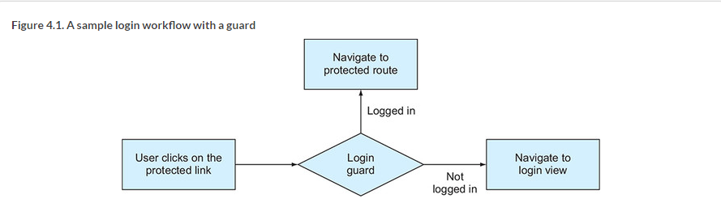

Here are some other scenarios where guards can help:

* Open the route only if the user is authenticated and authorized to do so.
* Display a multipart form that consists of several components, and the user is allowed to navigate to the next section of the form only if the data entered in the current section is valid.
* Remind the user about unsaved changes if they try to navigate from the route.
* Allow navigation to the route only after a certain data structure is populated.

These are the guard interfaces:

* CanActivate allows or disallows navigation to a route.
* CanActivateChild mediates navigation to a child route.
* CanDeactivate allows or disallows navigating away from the current route.
* Resolve ensures that the required data is retrieved before navigating to a route.
* CanLoad allows or disallows lazy-loading modules.

[Section 3.3](https://livebook.manning.com/book/angular-development-with-typescript-second-edition/chapter-4/13#!/book/angular-development-with-typescript-second-edition/chapter-3/ch03lev1sec3) of [chapter 3](https://livebook.manning.com/book/angular-development-with-typescript-second-edition/chapter-4/13#!/book/angular-development-with-typescript-second-edition/chapter-3/ch03) mentions that the Routes type is an array of items that conforms to the Route interface. So far, you’ve used such properties as path and component in configuring routes. Now, you’ll see how to mediate navigation to or from a route and ensure that certain data is retrieved before navigating to the route. Let’s start with adding a guard that’ll work when the user wants to navigate to a route.

#### 4.1.1. Implementing the CanActivate guard

Imagine a component with a link that only logged-in users can navigate to. To guard this route, you need to create a new class (for example, LoginGuard) that implements the CanActivate interface, which declares one method, canActivate(). In this method, you implement the validating logic that will return either true or false. If canActivate() of the guard returns true, the user can navigate to the route. You need to assign this guard to the property canActivate, as in the following listing.

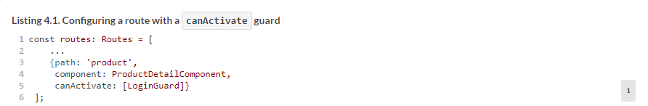

Because canActivate properties of Route accept an array as a value, you can assign multiple guards if you need to check more than one condition to allow or forbid the navigation.

Let’s create a simple app to illustrate how you can protect the product route from users who aren’t logged in. To keep the example simple, you won’t use an authentication service but will generate the login status randomly. The following class implements the CanActivate interface. The canActivate() function will contain code that returns true or false. If the function returns false (the user isn’t logged in), the application won’t navigate to the route, will show a warning, and will navigate the user to the login view.

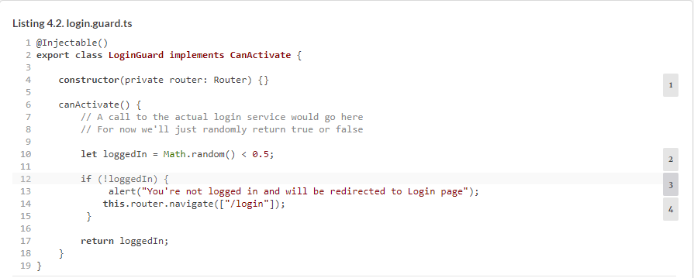

This implementation of the canActivate() function will randomly return true or false, emulating the user’s logged-in status.

The next step is to use this guard in the router configuration. The following listing shows how the routes could be configured for an app that has home and product-detail routes. The latter is protected by LoginGuard.

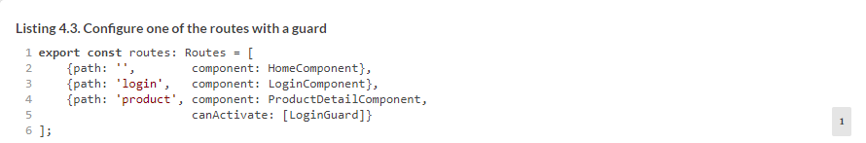

Your LoginComponent will be pretty simple—it will show the text “Please login here,” as shown in the following listing.

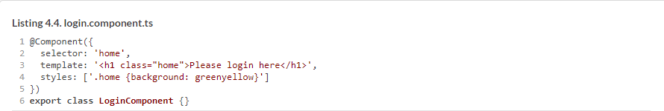

Angular will instantiate the LoginGuard class using its DI mechanism, but you have to mention this class in the list of providers that are needed for injection to work. Add the name LoginGuard to the list of providers in @NgModule().

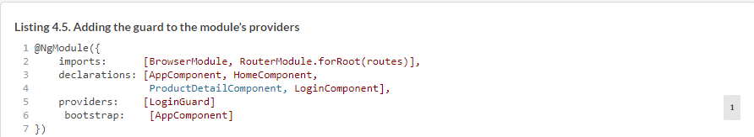

The template of your root component will look like the following listing.

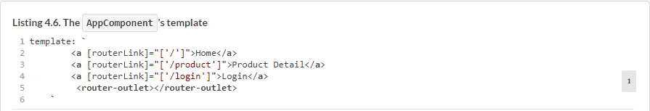

To see this app in action, run the following command:



[Figure 4.2](https://livebook.manning.com/book/angular-development-with-typescript-second-edition/chapter-4/35#!/book/angular-development-with-typescript-second-edition/chapter-4/ch04fig02) shows what happens after the user clicks the Product Detail link, but the LoginGuard decides the user isn’t logged in.

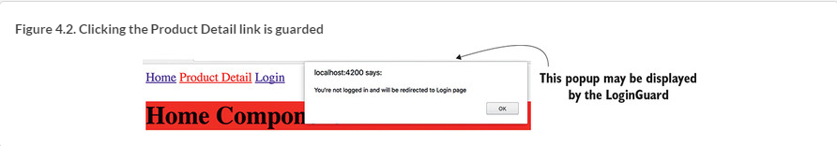



Clicking OK closes the pop-up window with the warning and navigates to the /login route. In [figure 4.2](https://livebook.manning.com/book/angular-development-with-typescript-second-edition/chapter-4/41#!/book/angular-development-with-typescript-second-edition/chapter-4/ch04fig02), you implement the canActivate() method without providing any arguments to it. But this method can be used with optional parameters:



The values of ActivatedRouteSnapshot and RouterStateSnapshot will be injected by Angular automatically, and this may be quite handy if you want to analyze the current state of the router. For example, if you’d like to know the name of the route the user tried to navigate to, this is how you can do it:

The CanActivate guard controls who gets in, but how you can control whether a user should be allowed to navigate *from* the route? Why do you even need this?

#### 4.1.2. Implementing the CanDeactivate guard

The CanDeactivate interface mediates the process of navigating from a route. This guard is quite handy in cases when you want to warn the user that there are some unsaved changes in the view. To illustrate this, you’ll update the app from the previous section and add an input field to the ProductDetailComponent. If the user enters something in this field and then tries to navigate from this route, your CanDeactivate guard will show the “Do you want to save changes” warning, as shown in the following listing.

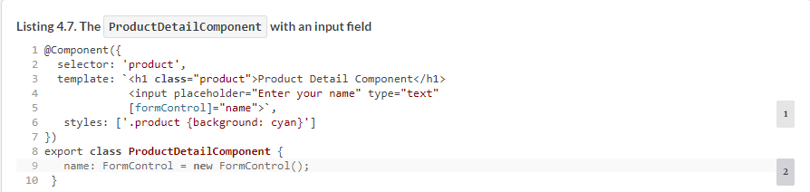

[Listing 4.7](https://livebook.manning.com/book/angular-development-with-typescript-second-edition/chapter-4/49#!/book/angular-development-with-typescript-second-edition/chapter-4/ch04ex07) uses the Forms API, which is covered in [chapters 10](https://livebook.manning.com/book/angular-development-with-typescript-second-edition/chapter-4/49#!/book/angular-development-with-typescript-second-edition/chapter-10/ch10) and [11](https://livebook.manning.com/book/angular-development-with-typescript-second-edition/chapter-4/49#!/book/angular-development-with-typescript-second-edition/chapter-11/ch11). At this point, it suffices to know that you create an instance of the FormControl class and bind it to the <input> element. In your guard, you’ll use the FormControl.dirty property to know if the user entered anything in the input field. The following listing creates a UnsavedChangesGuard class that implements the CanDeactivate interface.

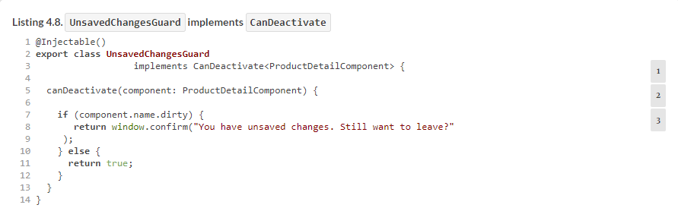

The CanDeactivate interface uses a parameterized type, which you specified using TypeScript generics syntax: <ProductDetailComponent>. The method canDeactivate() can be used with several arguments (see <https://angular.io/api/router/CanDeactivate>), but you’ll just use one: the component to guard.

If the user entered any value in the input field—if (component.name.dirty)—you’ll show a pop-up window with a warning. You need to make a couple more additions to the app from the previous section. First, add the CanDeactivate guard to the routes configuration.

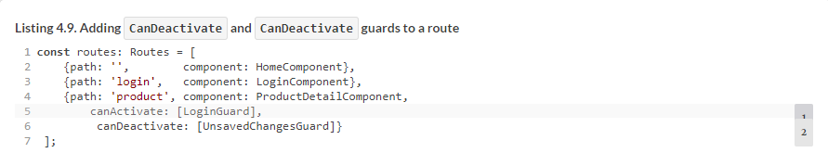

The next listing includes the new guard in the providers list in the module.

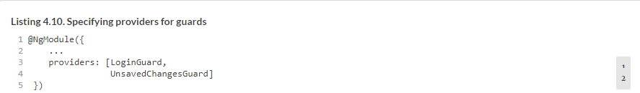

Run this app (ng serve --app guards -o), visit the /product route, and enter something in the input field. Then, try to click another link in the app or the browser’s back button. You’ll see the message shown in [figure 4.3](https://livebook.manning.com/book/angular-development-with-typescript-second-edition/chapter-4/54#!/book/angular-development-with-typescript-second-edition/chapter-4/ch04fig03).

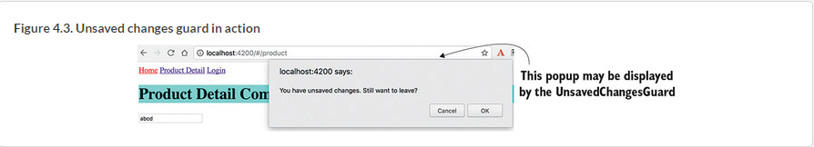

Now you know how to control the navigation to and from a route. The next thing is to ensure that the user doesn’t navigate to a route too soon, when the data required by the route isn’t ready yet.

#### 4.1.3. Implementing the Resolve guard

Let’s say you navigate to a product-detail component that makes an HTTP request to retrieve data. The connection is slow, and it takes two seconds to retrieve the data. This means that the user will look at the empty component for two seconds, and then the data will be displayed. That’s not a good user experience. What if the server request returns an error? The user will look at the empty component to see the error message after that. That’s why it may be a good idea to not even render the component until the required data arrives.

If you want to make sure that by the time the user navigates to a route some data structures are populated, create a Resolve guard that allows getting the data *before* the route is activated. A *resolver* is a class that implements the Resolve interface. The code in its resolve() method loads the required data, and only after the data arrives does the router navigate to the route.

Let’s review an app that will have two links: Home and Data. When the user clicks the Data link, it has to render the DataComponent, which requires a large chunk of data to be loaded before the user sees this view. To preload the data (a 48 MB JSON file), you’ll create a DataResolver class that implements the Resolve interface. The routes are configured in the following listing.

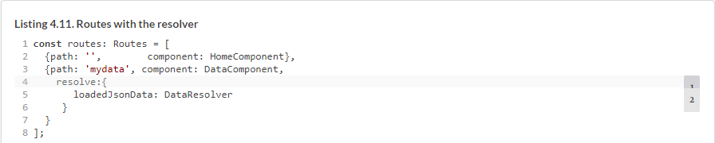

Note that the HomeComponent has no guards. You’ve configured the DataResolver only for the route that renders DataComponent. Angular will invoke its resolve() method every time the user navigates to the mydata route. Because you named the property of the resolve object loadedJsonData, you’ll be able to access preloaded data in the DataComponent using the ActivatedRoute object, as follows:



The code of your resolver is shown next. In this code, you use some of the syntax elements that haven’t been covered yet, such as @Injectable() (explained in [chapter 5](https://livebook.manning.com/book/angular-development-with-typescript-second-edition/chapter-4/65#!/book/angular-development-with-typescript-second-edition/chapter-5/ch05)), HttpClient ([chapter 12](https://livebook.manning.com/book/angular-development-with-typescript-second-edition/chapter-4/65#!/book/angular-development-with-typescript-second-edition/chapter-12/ch12)), and Observable ([appendix D](https://livebook.manning.com/book/angular-development-with-typescript-second-edition/chapter-4/65#!/book/angular-development-with-typescript-second-edition/appendix-d/app04) and [chapter 6](https://livebook.manning.com/book/angular-development-with-typescript-second-edition/chapter-4/65#!/book/angular-development-with-typescript-second-edition/chapter-6/ch06)), but we still want to review this code sample because it’s about the router.

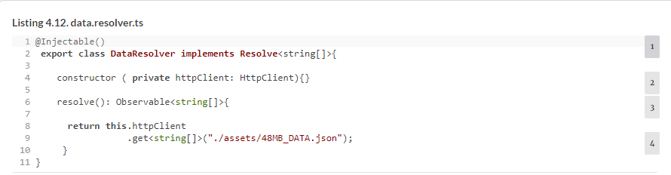

Your resolver class is an injectable service that implements the Resolve interface, which requires implementing a single resolve() method that can return an Observable, a Promise, or any arbitrary object.

##### TIP

Because a resolver is a service, you need to declare its *provider* (covered in [section 5.2](https://livebook.manning.com/book/angular-development-with-typescript-second-edition/chapter-4/68#!/book/angular-development-with-typescript-second-edition/chapter-5/ch05lev1sec2) of [chapter 5](https://livebook.manning.com/book/angular-development-with-typescript-second-edition/chapter-4/68#!/book/angular-development-with-typescript-second-edition/chapter-5/ch05)) in the @NgModule() decorator.

Here, you use the HttpClient service to read the file that contains an array of 360,000 records of random data. The HttpClient.get() method returns an Observable, and so does your resolve() method. Angular generates the code for resolvers that auto subscribes to the observable and stores the emitted data in the ActivatedRoute object.

In the constructor of the DataComponent, you extract the data loaded by the resolver and store it in the variable. In this case, you don’t display or process the data, because your goal is to show that the resolver loads the data before DataComponent is rendered. [Figure 4.4](https://livebook.manning.com/book/angular-development-with-typescript-second-edition/chapter-4/68#!/book/angular-development-with-typescript-second-edition/chapter-4/ch04fig04) shows the debugger at the breakpoint in the constructor. Note that the data was loaded and is available in the constructor of the DataComponent. The UI will be rendered after the code in your constructor completes.

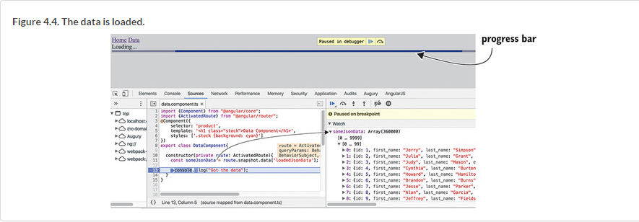

The source code of this app is located in the directory resolver, and you can see it in action by running ng serve --app resolver -o.

Every time you navigate to the mydata route, the file will be reloaded and the user will see a progress bar (mat-progress-bar) from the Angular Material library of UI components. You’ll be introduced to this library in [section 5.6](https://livebook.manning.com/book/angular-development-with-typescript-second-edition/chapter-4/74#!/book/angular-development-with-typescript-second-edition/chapter-5/ch05lev1sec6) of [chapter 5](https://livebook.manning.com/book/angular-development-with-typescript-second-edition/chapter-4/74#!/book/angular-development-with-typescript-second-edition/chapter-5/ch05).

The progress bar is used in the template of the AppComponent, but how does AppComponent know when to start showing the progress bar and when to remove it from the UI? The router triggers events during navigation, such as NavigationStart, NavigationEnd, and some others. Your AppComponent subscribes to these events, and when NavigationStart is triggered, the progress bar is displayed, and on NavigationEnd it’s removed, as shown in the following listing.

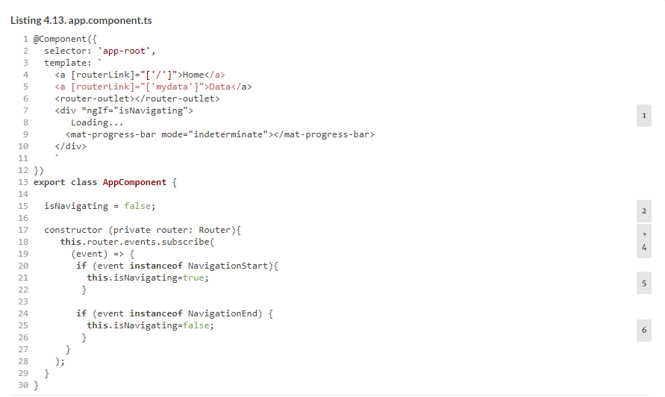

##### TIP

To avoid reading such a large file over and over again, you can cache the data in memory after the first read. If you’re interested in seeing how to do this, review the code of another version of the resolver located in the data.resolver2.ts file. That resolver uses an injectable service from data.service.ts, so on subsequent clicks, instead of the file being read, the data is retrieved from the memory cache. Since the data service is a singleton, it’ll survive creations and destructions of the DataComponent and cached data remains available.

##### RELOADING THE ACTIVE ROUTE

You can reload the route that’s already active and rerun its guards and resolvers using the configuration runGuardsAndResolvers and onSameUrlNavigation options.

Say the user visits the mydata route and after some time wants to reload the data *in the same route* by clicking the Data link again. The routes configuration in the following listing does this by reapplying the guards and resolvers:

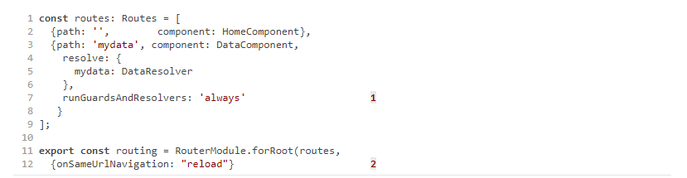

* *1***Runs guards and resolvers always**
* *2***Reloads the component when the user navigates to the same route**

You can read about the other guards in the product documentation at <https://angular.io/guide/router#milestone-5-route-guards>.

Now, we’ll move on to covering another subject: how to create a view that has more than one <router-outlet>.

### 4.2. Developing an SPA with multiple router outlets

The directory ngAuction contains the code of ngAuction that implements the functionality described in [chapter 3](https://livebook.manning.com/book/angular-development-with-typescript-second-edition/chapter-4/88#!/book/angular-development-with-typescript-second-edition/chapter-3/ch03)’s hands-on section.

So far, in all routing code samples you’ve used components that have a single tag, <router-outlet>, where Angular renders views based on the configured routes. Now, you’ll see how to configure and render views in sibling routes located in the same component. Let’s consider a couple of use cases for multi-outlet views:

* Imagine a dashboard-like SPA that has several dedicated areas (outlets), and each area can render more than one component (one at a time). Outlet A can display your stock portfolio, either as a table or as a chart, while outlet B shows either the latest news or an advertisement.
* Say you want to add a chat area to an SPA so the user can communicate with a customer service representative while keeping the current route active as well. You want to add an independent chat route allowing the user to use both routes at the same time and be able to switch from one route to another.

In Angular, you can implement either of those scenarios by having not only a *primary* outlet, but also named *secondary* outlets, which are displayed at the same time as the primary one.

To separate the rendering of components for primary and secondary outlets, you’ll need to add yet another <router-outlet> tag, but this outlet must have a name. For example, the following code snippet defines primary and chat outlets:



[Figure 4.5](https://livebook.manning.com/book/angular-development-with-typescript-second-edition/chapter-4/93#!/book/angular-development-with-typescript-second-edition/chapter-4/ch04fig05) shows an app with two routes opened at the same time after the user clicks the Home link and then the Open Chat link. The left side shows the rendering of HomeComponent in the primary outlet, and the right side shows ChatComponent rendered in a named outlet. Clicking the Close Chat link will remove the content of the named outlet (you add an HTML <input> field to HomeComponent and a <textarea> to ChatComponent so it’s easier to see which component has focus when the user switches between the home and chat routes).

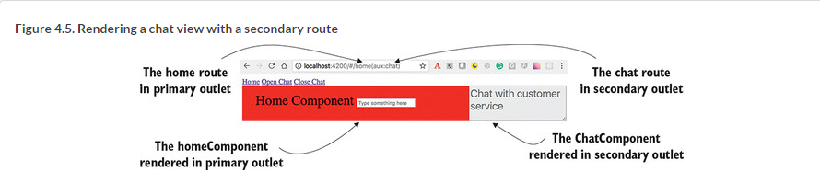

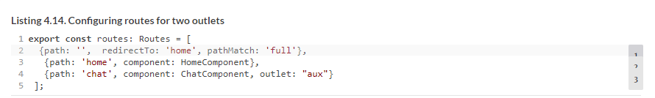

Note the parentheses in the URL of the auxiliary route, http://localhost:4200/#home(aux:chat). Whereas a child route is separated from the parent using the forward slash, an auxiliary route is represented as a URL segment in parentheses. This URL tells you that home and chat are sibling routes.

The configuration for the chat route specifies the name of the outlet where the ChatComponent has to be rendered, shown in the following listing.

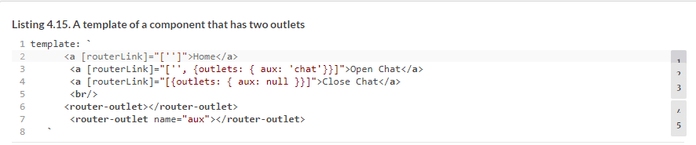

Note that you have two outlets here: one primary (unnamed) and one secondary (named). When the user clicks the Open Chat link, you instruct Angular to render the component configured for chat in the outlet named aux. To close a secondary outlet, assign null instead of a route name.

If you want to navigate to (or close) the named outlets programmatically, use the Router.navigate() method:



To see this app with two router outlets in action, run the following command in the router-samples project:



There’s one more problem the router can help you with. To make the app more responsive, you want to minimize the amount of code that the browser loads to display the landing page of your app. Do you really need to load all the code for each route on application startup?

#### 4.2.1. Lazy-loading modules

Some time ago, one of your authors was working on a website for a European car manufacturer. There was a menu item called “European Delivery” for US citizens, who could fly to the car factory in Europe, pick up their new car there, and spend two weeks driving their own car and enjoying everything that Europe has to offer. After that, the car would be shipped to the United States. Such a trip would cost several thousand dollars, and as you can imagine, not many website visitors would be interested in exploring this option. Then why include the code supporting the menu European Delivery into the landing page of this site, increasing the initial page size?

A better solution would be to create a separate European Delivery module that would be downloaded only if the user clicked the menu item, right? In general, the landing page of a web app should include only the minimal core functionality that must be present when a user visits the site.

Any mid-size or large app should be split into several modules, where each module implements certain functionality (billing, shipping, and so on) and is *lazy-loaded* on demand. In [chapter 2](https://livebook.manning.com/book/angular-development-with-typescript-second-edition/chapter-4/110#!/book/angular-development-with-typescript-second-edition/chapter-2/ch02), [section 2.5.1](https://livebook.manning.com/book/angular-development-with-typescript-second-edition/chapter-4/110#!/book/angular-development-with-typescript-second-edition/chapter-2/ch02lev2sec1), you saw an app split into two modules, but both modules were loaded on application startup. In this section, we’ll show you how a module can be lazy loaded.

Let’s create an app with three links: Home, Product Details, and Luxury Items. Imagine that luxury items have to be processed differently than regular products, and you want to separate this functionality into a feature module called LuxuryModule, which will have one component named LuxuryComponent. Most users of the app have modest incomes and will rarely click the Luxury Items link, so there’s no reason to load the code of the luxury module on application startup. You’ll load it *lazily*—only if the user clicks the Luxury Items link. This way of doing things is especially important for mobile apps when they’re used in a poor connection area—the code of the root module has to contain only the core functionality. The code of LuxuryModule is shown in the following listing.

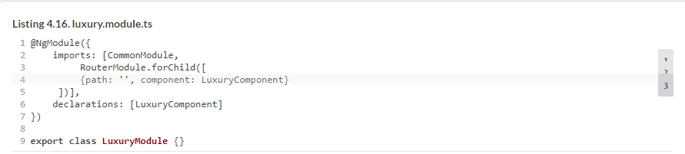

In the next listing, the code of LuxuryComponent just displays the text “Luxury Component” on a yellow (suggesting gold) background.

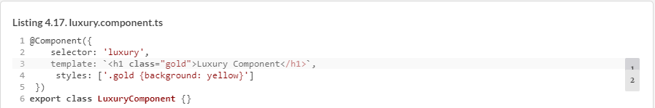

The code of the root module is shown in the following listing.

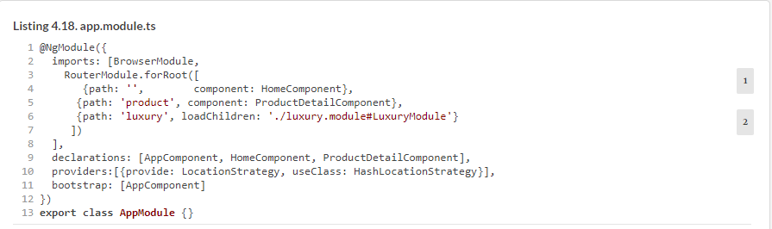

Note that the imports section only includes BrowserModule and RouterModule. The feature module LuxuryModule isn’t listed here. Also, the root module doesn’t mention LuxuryComponent in its declarations section, because this component isn’t a part of the root module. When the router parses the routes configuration from both root and feature modules, it’ll properly map the luxury path to the LuxuryComponent that’s declared in the LuxuryModule.

Instead of mapping the path to a component, you use the loadChildren property, providing the path and the name of the module to be loaded. Note that the value of loadChildren isn’t a typed module name, but a string. The root module doesn’t know about the LuxuryModule type; but when the user clicks the Luxury Items link, the loader module will parse this string and load LuxuryModule from the luxury .module.ts file shown earlier.

To ensure that the code supporting LuxuryModule isn’t loaded on app startup, Angular CLI places its code in a separate bundle. In your project router-samples, this app is configured under the name lazy in .angular-cli.json. You can build the bundles by running the following command:



The Terminal window will print the information about the bundles, as shown in the following listing.

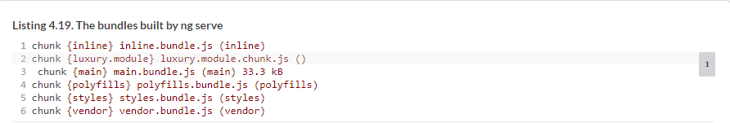

The second line shows that your luxury module was placed in a separate bundle named luxury.module.chunk.js.

##### NOTE

When you run ng build --prod, the names of the bundles for lazy modules are numbers, not names. In the code sample, the default name of the bundle for the luxury module would be zero followed by a generated hash code, something like 0.0797fe80dbf6edcb363f.chunk.js. If your app had two lazy modules, they would be placed in the bundles with the names starting with 0 and 1, respectively.

If you open the browser at localhost:4200 and check the network tab in dev tools, you won’t see this module there. See [figure 4.6](https://livebook.manning.com/book/angular-development-with-typescript-second-edition/chapter-4/126#!/book/angular-development-with-typescript-second-edition/chapter-4/ch04fig06).

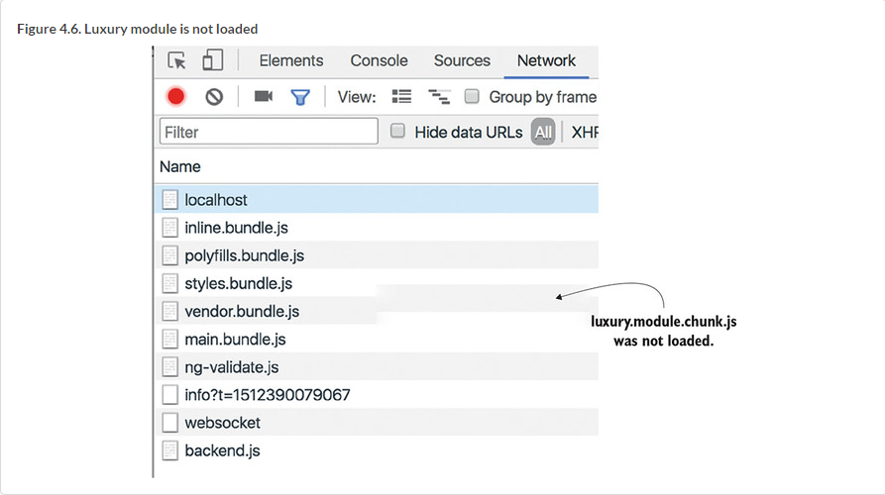

Click the Luxury Items link, and you’ll see that the browser made an additional request and downloaded the code of the LuxuryModule, as seen at the bottom of [figure 4.7](https://livebook.manning.com/book/angular-development-with-typescript-second-edition/chapter-4/131#!/book/angular-development-with-typescript-second-edition/chapter-4/ch04fig07). The luxury module has been loaded, and the LuxuryComponent has been rendered in the router outlet.

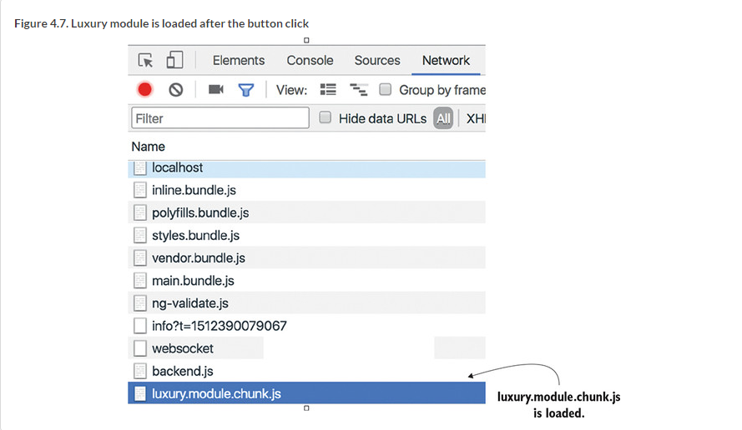

This simple example didn’t substantially reduce the size of the initial download. But architecting large applications using lazy-loading techniques can lower the initial size of the downloadable code by hundreds of kilobytes or more, improving the perceived performance of your application. *Perceived performance* is what the user *thinks* of the performance of your application, and improving it is important, especially when the app is being loaded from a mobile device on a slow network.

Dn von vl tvh zzur stropejc, grk ganemar saedtt rspr odr ignanld hzdx lk rkd nwlye ddpeloeev owd hbs bzu er gzfk yignlablz lasr. Mo asked, “Hkw zzlr?” Hv nzkr cd s fjon er zmxx dhs: “Bz zlrs az dcrj nvk.” Mv woleflod kyr jvfn hnc dnuof c lnieyc tesdly owu skqq jgwr z nvqm tpnedesre as xtpl eglar ruqssea. Bjqz hcuv yju vfuc ygizlalnb lrzz. Bvlrt igcklcni ncq lk kbr suserqa, rj kver tvme rcnq 10 ocsdens klt grv ceeedstl oumdel vr go gccf oedald. Xjau jc perceived performance nj iacont.

##### TIP

Make the root module of your app as small as possible. Split the rest of your app into lazy-loaded modules, and users will praise the performance of your app.

#### 4.2.2. Preloaders

Let’s say that after implementing lazy loading, you saved one second on the initial app startup. But when the user clicks the Luxury Items link, they still need to wait this second for the browser to load your luxury module. It would be nice if the user didn’t need to wait for that second. With Angular *preloaders*, you can kill two birds with one stone: reduce the initial download time *and* get immediate response while working with lazy-loaded routes.

With Angular preloaders, you can do the following:

* Preload all lazy modules in the background while the user is interacting with your app
* Specify the preloading strategy in the routes configuration
* Implement a custom preloading strategy by creating a class that implements the PreloadingStrategy interface

Angular offers a preloading strategy called PreloadAllModules, which means that right after your app is loaded, Angular loads all bundles with lazy modules in the background. This doesn’t block the application, and the user can continue working with the app without any delays. Adding this preloading strategy as a second argument of forRoot() is all it takes, as shown in the following listing.

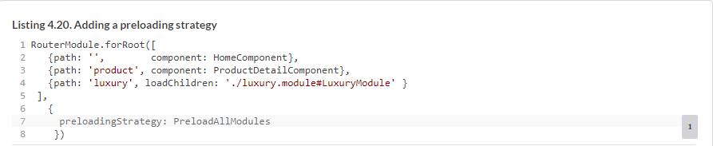

After this code change, the network tab will show that luxury.module.chunk.js was also loaded. Large apps may consist of dozens of lazy modules, and you may want to come up with some custom strategy defining which lazy modules should be preloaded and which shouldn’t.

Say you have two lazy modules, LuxuryModule and SuperLuxuryModule, and you want to preload only the first. You can add some Boolean variable (for example, preloadme: true) to the configuration of the luxury path:



Your custom preloader may look like the following listing.

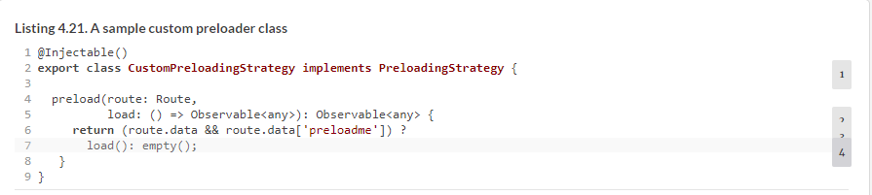

Because CustomPreloadingStrategy is an injectable service, you need to add it to the providers property of the root module in the @NgModule decorator. Don’t forget to specify the name of your custom preloader as an argument in the forRoot() method.

### Summary

* Mediate client-side navigation using guards.
* Create more than one <router-outlet> tag in the same component if need be.
* Minimize the initial size of your app by implementing lazy-loading techniques.