# mybatis 的简单实现原理解析

### 简介：

##### 一.整体架构

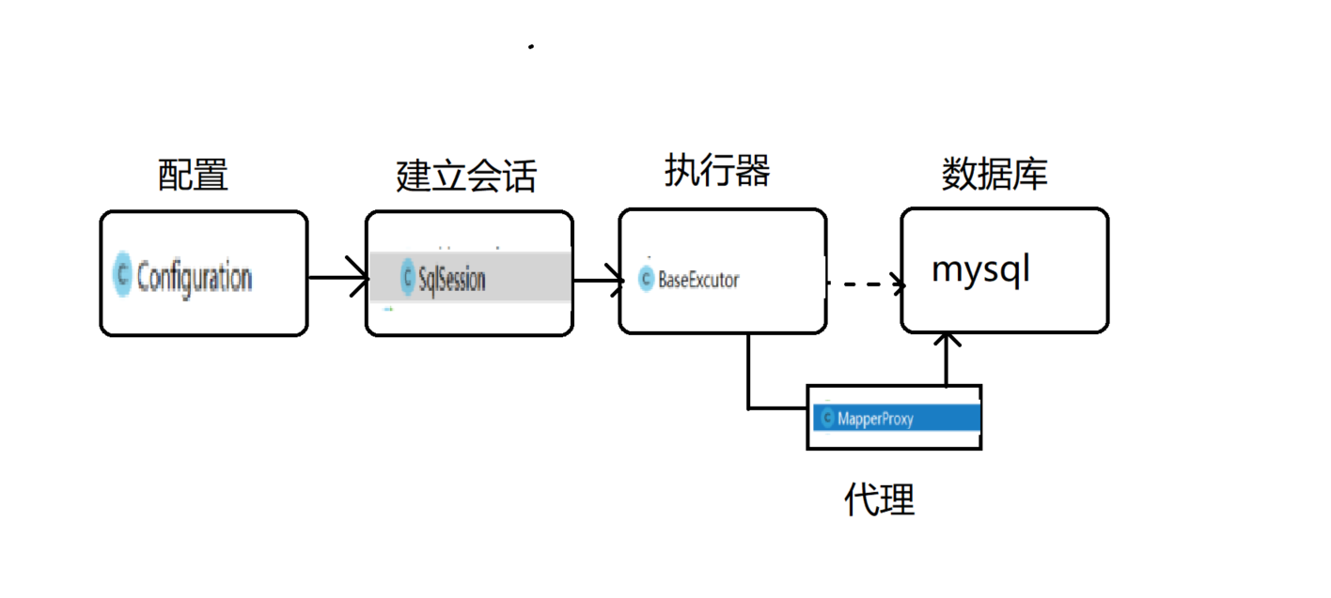

##### 二.工程目录

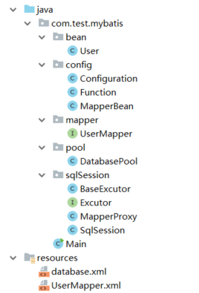

##### 三.主要实现

###### 1.使用动态代理将接口动态代理到xml的id和接口方法名相同的sql上，执行sql返回值

###### 2.使用dom4j读取配置文件

##### 四.代码实现

###### 1.Configuration(读取配置文件类,包括数据库配置文件，以及*Mapper.xml文件的实现，并封装成一个对象)

/**  
 * @author 老肥猪  
 * @since 2019/3/7  
 */  
public class Configuration {  
 private static ClassLoader loader = ClassLoader.getSystemClassLoader();  
  
 /**  
 * 资源读取以及构建  
 *  
 * @param resources  
 * @return  
 */  
 public static Connection build(String resources) {  
 try {  
 InputStream inputStream = loader.getResourceAsStream(resources);  
 SAXReader reader = new SAXReader();  
 Document document = reader.read(inputStream);  
 Element root = document.getRootElement();  
 return evalDataSource(root);  
 } catch (DocumentException e) {  
 throw new RuntimeException("xml read error");  
 } catch (ClassNotFoundException e) {  
 throw new RuntimeException("not found driver");  
 }  
 }  
  
 /**  
 * 获取数据库的连接  
 * <database>  
 * <property name="driverClassName">com.mysql.jdbc.Driver</property>  
 * <property name="url">jdbc:mysql://localhost:3306/test?useUnicode=true&amp;characterEncoding=utf8&amp;tinyInt1isBit=false&amp;useSSL=false</property>  
 * <property name="username">root</property>  
 * <property name="password">88105156</property>  
 * </database>  
 * @param node xml的节点  
 * @return  
 * @throws ClassNotFoundException  
 */  
 private static Connection evalDataSource(Element node) throws ClassNotFoundException {  
 if (!node.getName().equals("database")) {  
 throw new RuntimeException("root shuold be database");  
 }  
 String driver = null;  
 String url = null;  
 String username = null;  
 String password = null;  
 for (Object item : node.elements("property")) {  
 Element element = (Element) item;  
 String value = getValue(element);  
 String name = element.attributeValue("name");  
 if (name == null || value == null) {  
 throw new RuntimeException("the database's value or database's name is not null");  
 }  
 switch (name) {  
 case "url":  
 url = value;  
 break;  
 case "username":  
 username = value;  
 break;  
 case "driverClassName":  
 driver = value;  
 break;  
 case "password":  
 password = value;  
 break;  
 default:  
 throw new RuntimeException("not found name is " + name);  
 }  
 }  
 Class.forName(driver);  
 Connection connection = null;  
 try {  
 connection = DriverManager.getConnection(url, username, password);  
 } catch (SQLException e) {  
 e.printStackTrace();  
 }  
 return connection;  
 }  
  
 /**  
 * 获得值  
 *  
 * @param element  
 * @return  
 */  
 private static String getValue(Element element) {  
 /**  
 * 中间是否有值，有的话去找中间的，没有的话去找属性为value的值  
 */  
 return element.hasContent() ? element.getText() : element.attributeValue("value");  
 }  
  
 /**  
 * 读取mapper的xml  
 * <mapper namespace="com.test.mybatis.mapper.UserMapper">  
 * <select id="getUserById" resultType ="com.test.mybatis.bean.User">  
 * select * from user where id = ? (element.getText())  
 * </select>  
 * </mapper>  
 * @param path 位置  
 * @return  
 */  
 public static MapperBean readMapper(String path) {  
 MapperBean mapperBean = new MapperBean();  
 /**  
 * 获得读取流  
 */  
 InputStream stream = loader.getResourceAsStream(path);  
 SAXReader reader = new SAXReader();  
 Document document = null;  
 try {  
 /**  
 * 读取xml文档  
 */  
 document = reader.read(stream);  
 } catch (DocumentException e) {  
 throw new RuntimeException("read xml error");  
 }  
 /**  
 * 获得xml文档根元素  
 */  
 Element root = document.getRootElement();  
 if (root == null) {  
 throw new RuntimeException("not found root element");  
 }  
 if (!root.getName().equals("mapper")) {  
 throw new RuntimeException("root element should be mapper");  
 }  
 String namespace = root.attributeValue("namespace");  
 if (namespace == null || "".equals(namespace)) {  
 throw new RuntimeException("root element should be mapper");  
 }  
 /**  
 * 设置扫描的类  
 */  
 mapperBean.setNamespace(namespace);  
 List<Function> list = new ArrayList<>();  
 root.elements().forEach(o -> {  
 Function function = new Function();  
 Element element = (Element) o;  
 //设置类别 update || select || delete  
 function.setSqlType(element.getName().trim());  
 String funcName = element.attributeValue("id");  
 if (funcName == null || "".equals(funcName)) {  
 throw new RuntimeException("id is not be null");  
 }  
 function.setFuncName(funcName.trim());  
 String resultType = element.attributeValue("resultType");  
 if (resultType == null || "".equals(resultType)) {  
 throw new RuntimeException("resultType is not be null");  
 }  
 resultType = resultType.trim();  
 if (!element.hasContent()) {  
 throw new RuntimeException("element's mid is not be null");  
 }  
 /**  
 * 获得中间的sql  
 */  
 String sql = element.getText();  
 function.setSql(sql);  
 Object instance = null;  
 try {  
 instance = Class.forName(resultType).newInstance();  
 } catch (ClassNotFoundException e) {  
 e.printStackTrace();  
 } catch (IllegalAccessException e) {  
 e.printStackTrace();  
 } catch (InstantiationException e) {  
 e.printStackTrace();  
 }  
 function.setResultType(instance);  
 list.add(function);  
 });  
 mapperBean.setList(list);  
 return mapperBean;  
 }  
}

##### 2.DatabasePool（数据库连接池）

/**  
 * @author 老肥猪  
 * @since 2019/3/7  
 */  
public class DatabasePool {  
 /**  
 * 初始化连接数  
 */  
 private static final int INIT_LINK = 5;  
  
 private static final int MAX_LINK = 20;  
  
 private AtomicBoolean atomicBoolean = new AtomicBoolean(false);  
  
  
 /**  
 * 连接池队列  
 */  
 private static ArrayBlockingQueue<Connection> arrayBlockingQueue;  
  
 static {  
 arrayBlockingQueue = new ArrayBlockingQueue<>(INIT_LINK);  
 for (int i = 0; i < INIT_LINK; i++) {  
 arrayBlockingQueue.offer(Configuration.build("database.xml"));  
 }  
 }  
  
 private synchronized void extend() {  
 if (arrayBlockingQueue.size() <= 20) {  
 int extendNum = INIT_LINK;  
 if (arrayBlockingQueue.size() > MAX_LINK - INIT_LINK) {  
 extendNum = MAX_LINK - INIT_LINK;  
 }  
 for (int i = 0; i < extendNum; i++) {  
 arrayBlockingQueue.offer(Configuration.build("database.xml"));  
 }  
 }  
 }  
  
 /**  
 * 内部类实现单例  
 */  
 private static class SingletonHolder {  
 private static final DatabasePool INSTANCE = new DatabasePool();  
 }  
  
 /**  
 * 获得一个数据库连接池  
 *  
 * @return  
 */  
 public static DatabasePool getDatabasePool() {  
 return SingletonHolder.INSTANCE;  
 }  
  
 /**  
 * 获得实例  
 * @return  
 * @throws InterruptedException  
 */  
 public synchronized Connection getConnection() throws InterruptedException {  
 if (arrayBlockingQueue.isEmpty()) {  
 if (arrayBlockingQueue.size() <= MAX_LINK) {  
 extend();  
 return arrayBlockingQueue.poll();  
 } else {  
 atomicBoolean.set(true);  
 while (atomicBoolean.get()) {  
 this.wait();  
 }  
 return arrayBlockingQueue.poll();  
 }  
 } else {  
 return arrayBlockingQueue.poll();  
 }  
 }  
  
 /**  
 * 回收  
 * @param connection  
 * @return  
 */  
 public synchronized void recycle(Connection connection) {  
 if(arrayBlockingQueue.size()>=MAX_LINK) {  
 atomicBoolean.set(false);  
 this.notifyAll();  
 } else {  
 arrayBlockingQueue.offer(connection);  
 }  
 }  
  
}

##### 3.MapperBean（存放配置包名，及配置的sql方法）

/**  
 * @author 老肥猪  
 * @since 2019/3/7  
 */  
@Data  
public class MapperBean {  
 private String namespace;  
 private List<Function> list;  
}

##### 4.Function(存放xml里的sql方法，包括，sql，以及返回值，以及查询类别，以及方法名)

/**  
 * @author 老肥猪  
 * @since 2019/3/7  
 */  
@Data  
public class Function {  
 private String sqlType;  
 private String funcName;  
 private String sql;  
 private Object resultType;  
 private String parameterType;  
}

##### 5.Excutor(执行器的抽象方法)

/**  
 * @author 老肥猪  
 * @since 2019/3/7  
 */  
public abstract class Excutor {  
 /**  
 * 查询  
 * @param sql  
 * @param parameter  
 * @param <T>  
 * @return  
 */  
 public abstract <T> T queryOne(String sql,Object object,Object parameter);  
 protected Connection connection() {  
 try {  
 return DatabasePool.getDatabasePool().getConnection();  
 } catch (InterruptedException e) {  
 throw new RuntimeException("get conn is error");  
 }  
 }  
  
 protected String letFirstLetter2Up(String string) {  
 if (string != null && !"".equals(string)) {  
 String up = string.substring(0, 1);  
 if (string.length() == 1) {  
 return up;  
 } else {  
 String latter = string.substring(1);  
 return up.toUpperCase() + latter;  
 }  
 } else {  
 throw new RuntimeException("string is not be null");  
 }  
 }  
  
 /**  
 * 回收  
 *  
 * @param pre  
 * @param conn  
 * @param resultSet  
 */  
 protected void closeAll(PreparedStatement pre, Connection conn, ResultSet resultSet) {  
 try {  
 if (resultSet != null) {  
 resultSet.close();  
 }  
 if (pre != null) {  
 pre.close();  
 }  
 if (conn != null) {  
 DatabasePool.getDatabasePool().recycle(conn);  
 }  
 } catch (SQLException e) {  
 e.printStackTrace();  
 }  
 }  
}

##### 6.BaseExcutor (基础的执行器实现)

/**  
 * @author 老肥猪  
 * @since 2019/3/7  
 */  
public class BaseExcutor<T> extends Excutor {  
 @Override  
 public <T> T queryOne(String sql, Object object, Object parameter) {  
 Field[] fields = object.getClass().getDeclaredFields();  
 PreparedStatement pre = null;  
 ResultSet set = null;  
 Connection conn = connection();  
 try {  
 pre = conn.prepareCall(sql);  
 String id = parameter.toString();  
 pre.setString(1, id);  
 set = pre.executeQuery();  
// set.next();  
 if (set.next()) {  
 ResultSetMetaData metaData = set.getMetaData();  
 int columnCount = metaData.getColumnCount();  
 for (int i = 0; i < columnCount; i++) {  
 Object o = set.getObject(i + 1);  
 String columnName = metaData.getColumnName(i + 1);  
 for (int j = 0; j < fields.length; j++) {  
 if (fields[j].getName().equals(columnName)) {  
 Method method;  
 if(fields[j].getType().getSimpleName().equals("String")) {  
 method = object.getClass().getMethod("set" + letFirstLetter2Up(columnName),String.class);  
 method.invoke(object,(String)o);  
 } else if(fields[j].getType().getSimpleName().equals("Integer")  
 || fields[j].getType().getSimpleName().equals("int")) {  
 method = object.getClass().getMethod("set" + letFirstLetter2Up(columnName),Integer.class);  
 method.invoke(object, Integer.parseInt(o.toString()));  
 } else if(fields[j].getType().getSimpleName().equals("Double")  
 || fields[j].getType().getSimpleName().equals("double")) {  
 method = object.getClass().getMethod("set" + letFirstLetter2Up(columnName),Double.class);  
 method.invoke(object, Double.parseDouble(o.toString()));  
 } else {  
 throw new RuntimeException("this type conversion is not supported");  
 }  
 }  
 }  
 }  
 }  
 } catch (SQLException e) {  
 e.printStackTrace();  
 } catch (NoSuchMethodException e) {  
 e.printStackTrace();  
 } catch (IllegalAccessException e) {  
 e.printStackTrace();  
 } catch (InvocationTargetException e) {  
 e.printStackTrace();  
 } finally {  
 closeAll(pre, conn, set);  
 }  
 return (T) object;  
 }  
  
}

##### 7.SqlSession(建立会话，将客户端与代理方法串联起来)

/**  
 * @author 老肥猪  
 * @since 2019/3/7  
 */  
public class SqlSession {  
  
 private Excutor excutor= new BaseExcutor();  
 private String mapperName=null;  
 public <T> T selectOne(String sql, Object parameter , Object object) {  
 return excutor.queryOne(sql,object,parameter);  
 }  
  
 public <T> T getMapper(Class<T> clazz) {  
 this.mapperName=clazz.getSimpleName()+".xml";  
 return (T) Proxy.newProxyInstance(clazz.getClassLoader(),new Class[]{clazz},new MapperProxy(this));  
 }  
  
 public String getMapperName() {  
 return mapperName;  
 }  
}

##### 8.MapperProxy(代理对象，将接口做动态代理，使其执行指定sql，这里由于是代理接口，会导致具体的对象是拿不到的，所以使用method获取对象名称)

/**  
 * @author 老肥猪  
 * @since 2019/3/7  
 */  
public class MapperProxy implements InvocationHandler {  
  
 private SqlSession sqlSession;  
  
 public MapperProxy(SqlSession sqlSession) {  
 this.sqlSession = sqlSession;  
 }  
  
 @Override  
 public Object invoke(Object proxy, Method method, Object[] args) throws Throwable {  
 MapperBean bean = Configuration.readMapper(sqlSession.getMapperName());  
 if(method.getDeclaringClass().getName().equals(bean.getNamespace()) ) {  
 List<Function> list = bean.getList();  
 if(list!=null && list.size()>0) {  
 for (Function function: list) {  
 /**  
 * 如果方法名匹配上就执行  
 */  
 if(method.getName().equals(function.getFuncName())) {  
 return sqlSession.selectOne(function.getSql(),args[0],function.getResultType());  
 }  
 }  
 }  
 }  
 return null;  
 }  
}

##### 9.测试

/**  
 * @author 老肥猪  
 * @since 2019/3/7  
 */  
public class Main {  
  
 public static void main(String[] args) {  
 SqlSession sqlSession = new SqlSession();  
 UserMapper userMapper = sqlSession.getMapper(UserMapper.class);  
 User user = userMapper.getUserById(1);  
 System.out.println(user);  
 }  
}

##### 五.总结

这样我们通过5步就实现了一个简单的mybatis，通过这个小demo，可以看出其实mybatis的实现并不困难，主要就是要想到利用代理的方式来实现我们的sql执行，其他的也没有什么特别难实现的点，若写的有什么错误，请通过issue提交你的问题