Topic: Research on the Experience Design of Interactive Serious Games for Preschool Children
- Take the eye care course as an example

pick want

Nowadays , the rapid development of technology has gradually broadened the ways of games and education . For today's preschool children, electronic products have become popular and common, and ordinary teaching methods can no longer satisfy and stimulate their interest needs. With the past education methods, it may be difficult for children to adapt to the future world, but digital interactive equipment and technology can better stimulate their fun of exploring the world and play an important role in guiding them to the future .
my country is paying more and more attention to children's eye health issues. On June 17, 2021, the national organization formulated the "Specifications for Eye Care and Vision Examination Services for Children Aged 0-6 (Trial)". And continue to strengthen the eye care and vision inspection services for children aged 0-6 . Therefore, this project takes children's eye care services as the starting point, and takes preschool children aged 3-6 as the research object to conduct an experience research design of interactive serious games. In order to cope with the diversified learning experience, the research on users and presentation methods is carried out through literature research, user interviews and other forms, so as to try to deliver effective eye care information in the form of serious games, and cooperate with the teaching of interactive courses to create a more An interesting educational game experience, a series of designs to give the user group a higher sense of substitution and participation.
Keywords: experience design preschool children serious game device interaction

head record
1. Introduction 3
1.1 Topic selection basis 3
1.1.1 Research Background 3
1.1.2 Research purpose and significance 3
1.2. Research method 4
1.3 Research object and content framework 5
1.3.1 Research object 5
1.3.1 Content Framework 5
1.4 Innovation Point 7
2. Analysis of characteristics and needs of preschool children 7
2.1 Characteristics of physical and psychological development of preschool children 7
2.2 Investigation and Research on the Cognitive Characteristics of Preschool Children 9
2.3 Targeted investigation and research on the behavior habits of preschool children 10
2.4 Analysis of Survey and Research Results 11
3. Research on the interaction between serious games and physical devices 12
3.1 Serious games part 12
3.1.1 Serious Game Concept 12
3.1.2 Research and Analysis of Characteristics and Advantages of Serious Games 12
3.2 Introduction to Physical Devices 15
3.3 User Experience Research 15
3.4 Analysis of interactive environment 16
4. Design Practice 17
4.1 Design concept 17
4.2 Design ideas and schemes 17
4.2.1 Design ideas: 17
4.2.2 Design Scheme 19
4.3 Prototype interface design 25
4.3 User Experience Design 26
V. Summary and improvement points 28
Reference 30

1. Introduction

1.1 Basis for topic selection

1.1.1 Research Background
Preschool is the enlightenment stage of children's growth and learning , and its educational issues have always been the focus of society and parents . A good preschool education is of great help to children's growth, and in today's and future societies, electronic information products occupy Most of the space in our lives, familiarizing them with the skills of this method in the enlightenment education is of great benefit to children's cognitive enlightenment .
Nowadays, the eyesight problems of preschool children are becoming more and more serious. Our country has been paying close attention to children's eyesight problems and has formulated a series of protection plans. By 2020, the coverage of children's eye care and vision examinations will have covered almost all preschool children.
Preschool children have complex characteristics, special needs, and the rapid development of science and technology. For preschool children , simple mobile phones, tablets and other electronic devices are the only way to learn and teach. After investigation, there is a shortage of related products for eye -vision interactive serious game design research. According to the analysis of international literature, since 2011, more and more scientific research focus has shifted to physical interaction for the development of children's entertainment and educational products. The interactive serious game designed in this research is also a kind of physical interaction. The combination of virtual serious game and interactive electronic whiteboard will make children's learning and game process more immersive.

1.1.2 Research purpose and significance
Although the country has formulated relevant eye care policies for children aged 0-6, at present, not only preschool children, but even many parents and teachers lack relevant eye care knowledge, so they cannot correctly and effectively teach children to do eye care. Popular science study of knowledge. Through the design and research of this topic, the author will integrate scientific and professional eye care related knowledge into serious games to ensure the correctness of knowledge acquired by children and help further expand the scope of eye care knowledge.
At the same time, the design and research of this topic realizes teaching with fun, so that children can better cooperate with eye examinations, clearly understand how to protect their eyes correctly, and promote preschool children's learning and absorption of boring scientific knowledge. To solve the problem of how to guide preschool children to receive memorized knowledge more efficiently, quickly, and in a way that they are more interested in when they are just enlightened and not yet literate, so as to give them a better learning experience and have Effectively improve the independent learning ability of preschool children. Preschool is a critical period for children's growth. Appropriate learning methods can make them cognitive, psychological, physical, etc.
In addition, from a development point of view, this research on the design of serious games for preschool children's eye care will fill in the lack of interactive serious games related to children's eye care in the market, and make the concept of serious games better. The promotion of the game has enabled more people in China to understand this form of entertaining and entertaining, and promoted the development of serious domestic games in more fields.

1. 2. Research methods
The main research methods used in this study are user survey method, literature analysis method, practice analysis method and other research methods.
(1) Document analysis method
According to the research direction of the thesis, in the early stage of the research, a large amount of relevant literature on preschool children, serious game design, physical interaction research, user experience, etc. was collected and sorted out on various authoritative academic platforms , laying a large amount of knowledge reserves for subsequent research. Analyze and refine from it, extract useful theories and research for this design research, and help yourself clarify the ideas of stimulating thesis and design research.
(2) Practical analysis method
Taking the serious game of eye care for preschool children as the main research design and application content, it is comprehensively analyzed, summarized and tested. Collect good data for integration and sorting, and combine the knowledge of user experience in the later stage of design to optimize and adjust the overall design of serious game experience.
(3) Case analysis method
Through the investigation and analysis of the serious games currently on the market, collect and sort out and study the cases in a targeted manner, and combine the analysis and research of the cases to design and adjust your own serious games and experience construction. This method is mainly used in mid-term build design for serious games.
(4) Interdisciplinary research method
In this research design, when constructing serious games in the early stage, considering that the user group is preschool children, in order to understand the knowledge of eye care knowledge of preschool children and their points of interest and needs, children's cognitive development psychology, education In-depth research has been carried out on relevant knowledge such as computer science; and in order to better integrate the interaction between serious games and electronic devices, it also explores the fields of electronic interaction technology, and extracts demand information from them to design the research project. When designing and planning for serious games in the later stage, we should think deeply about the fields of game thinking and user experience research.

1.3 Research object and content framework

1.3.1 Research object _
In this investigation, the author defines preschool children as children aged 3 to 6. [ 11] Children in this age group have just left the infant stage, and most of them have not yet entered the school-age stage where they can learn systematic knowledge, but they already have the ability to receive basic enlightenment knowledge, which is the best stage for education, correct Good education methods and good thinking training will play an important role in children's imagination and creativity. However, children in this period of time are often relatively passive when learning, and need correct guidance from the surrounding environment.
At present, the teaching mode of preschool children's education is very lacking and single in China. According to the investigation, most of the modes are based on playing animation or the teacher directly lectures and teaches, and the teacher takes the children to play and learn. The teaching interaction is carried out in a more traditional way. .

1.3.1 Content framework _
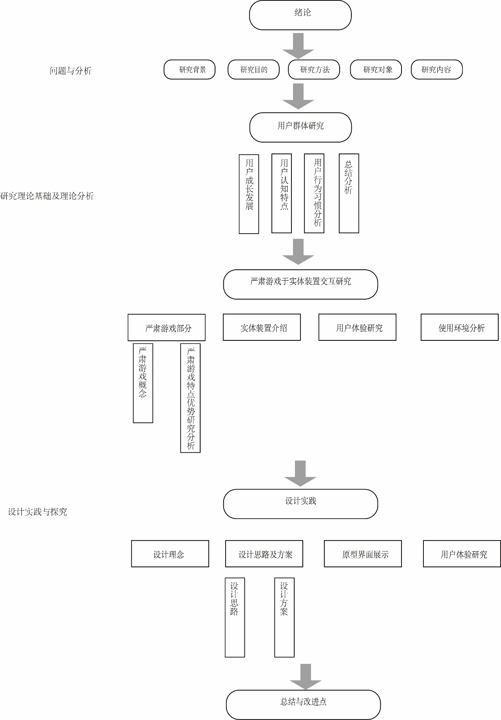
The content structure of this project research is shown in Figure 1-2 below. The main process is: starting from the perspective of user groups, taking the research of user groups as the primary entry point, analyzing their characteristics and needs, and combining serious games and interactive devices. Based on the characteristics and advantages, build the overall interface framework with the idea of interaction design, supplement the content in the framework with the thinking of game design, and then use its feedback and incentive mechanisms in sound, shape and color, etc. Method construction, enriching user experience, in order to help preschool children solve the main purpose of how to realize the education of eye health science knowledge , and make them have the willingness to learn independently.

Content structure diagram 1-2

1.4 Innovation points
First of all, conduct interdisciplinary key research on preschool children, analyze and summarize their cognitive characteristics, behavior habits and needs, and conduct inductive analysis of user experience theory to find the best interactive serious game user experience for preschool children method. Secondly, the research on the combination of serious games and physical interaction for children's education in my country is still in an emerging and just starting stage. Based on the understanding of the user characteristics of preschool children, the author carried out the design of physical interactive serious games, using the interactive electronic whiteboard as the carrier, serious games as the medium, and then integrated them with the theoretical knowledge of user experience design. Through the design of serious games, it uses its special advantages to make up for the lack of immersion of the interactive electronic whiteboard, and uses the interactive electronic whiteboard to give serious games more interactivity. The design of this research will use interactive games that are more in line with preschool children's cognition to improve their learning interest and willingness to learn, stimulate their independent learning ability, and make teaching fun to achieve the required teaching effect.

2. Analysis of characteristics and needs of preschool children

2.1 Characteristics of physical and psychological development of preschool children

Preschool is a critical period for children's development and enlightenment. Their growth is not only the growth and development of physiology, but also the rapid growth of psychology. In terms of physiology, compared with infancy, the growth rate of the body at the preschool age will be slower ^{[ 15]} , and their brain functions will be further developed. Before the age of 5, the brain can grow to 80% of an adult's ^{[ 17 ]} , and the large muscles have been developed, and the small muscle groups develop later than the large muscles, so the flexibility and coordination of the limbs have been developed and improved. Although there is still a lack of stability, they can already control the body to make some movements. Simple body gestures such as walking, swinging arms. ^{[ 1]} And the control of both hands has gradually become proficient, and I can already do simple actions such as picking up and putting down objects, and scribbling simple patterns. Multisensory perception is also being developed further. Visually, at the age of 3, children's vision is relatively sharp, and they can recognize basic colors. At the age of 4, they can already recognize the direction of patterns and notice some differences in hue. Preschool children's preference for colors has not yet There is a certain gender difference[ 19] , and the further development of vision at the age of 4-6 can help them grasp the objects in front of them more accurately . In terms of hearing, children have completed hearing development within one year of age after birth, and the hearing function in the preschool age will gradually stabilize. The language ability developed with hearing and vision can already enable children to use some basic vocabulary and communicate consciously. In terms of tactile senses, the development of the tactile sense has been relatively complete, and children can feel objects through touch. [ 18]
Regarding the development of psychological characteristics of children at this age, the author has read a lot of literature and actually interviewed some parents of preschool children to confirm. Based on the literature survey, it is known that children at this age are in the best period for shaping their developmental abilities, that is, the sensitive period. Children at this stage are full of curiosity about the world and have a strong desire for knowledge. Both culture and space are very sensitive. In the sensitive period, in terms of language, the words and sentences they can master will increase significantly. By listening to the communication of people around or watching TV, preschool children can quickly absorb and learn language knowledge, master the structure of sentences, and accurately use adjectives and adverbs to form complete sentences to express their feelings and ideas. In terms of order, they can show a certain sensitivity to regular things, the order of time and space, etc., for example, they will perceive the rhythm changes of music, the regularity and changes of color lines, etc. In terms of perception, through physiological development, preschool children will perceive the surrounding things and the environment, and will produce certain feedback on the perceived things and environment according to their own preferences, thereby triggering their psychological activities and further Improve your senses. In terms of social culture, they will start to pay attention to the relationship between people or things, such as making friends, sharing things with people who have a good impression, and willing to participate in group activities. In terms of space, children at this stage will extensively use their physical senses for comprehensive perception, thus establishing a three- dimensional consciousness [ 16] . Therefore, the way of cultivating children at this age will have a huge impact on the physical and psychological development of children in the future. Therefore, we need to build a suitable and interesting game form to make children focus on knowledge learning, and enhance fun and interaction through a series of methods such as visual guidance and interactive experience, so as to satisfy children's desire to explore new things and the game brings Train their thinking ability while enjoying the pleasure.

2. 2 Investigation and Research on the Cognitive Characteristics of Today 's Preschool Children
For preschool children, most parents will let them enter kindergartens to receive preschool enlightenment education. Usually, these educations are planned and implemented purposefully, and most of them will revolve around how to stimulate their creativity, desire for exploration, and exercise. Concentration, observation and other aspects of ability to develop. Kindergarten is different from home. They will come into contact with more identities such as teachers, classmates, etc., and people of more age groups. The environment will be created by the kindergarten to be more suitable for preschool children to learn, and these changes in the environment It will also greatly promote the cognitive development of children. The cognitive development of children at this age has the characteristics of continuity and stages. [ 23]
From the perspective of language cognition, they have been able to understand and construct complete sentences and phrases, and the reserves of words and sentences are gradually increasing with age and rich experience. And when they are doing one thing, they will consciously pay attention to the feedback from the people or the environment around them. The voice of positive feedback such as joy, praise, encouragement, etc. will greatly encourage the child and let him understand that in similar situations The behavior made in the situation is correct, so as to learn and develop. [ 12]
by Clements et al. (Clements, Swaninathan , Hannibal, Sstsma , 1999) proved that preschool children's cognition of things is judged based on two types of features [ 2] , one is visual features, and they have been able to grasp roughly The second is the attribute characteristics. Preschool children can perceive and understand the attribute characteristics of objects in a multi-sensory way . For example, when an object enters their field of vision, they will first perceive the characteristics of the object . Color and general shape; then touch the object to understand the texture of the surface of the object; understand the hardness and taste of the object after biting; then pick up the object to feel its weight, etc., and use multi-sensory behavior patterns to understand this The attributes of similar things produce corresponding concepts in cognition.
Compared with the ignorant and ignorant infancy, the thinking of preschool children has already developed initially. They gradually have the concept of quantity[ 3] , and can organize objects according to their characteristics, and can gradually carry out classification reasoning based on analogy and induction. And with the further development of brain function, children's ability to recognize and remember is gradually improved, and the memory time is gradually extended. Usually we divide memory into three categories: instant memory, short-term memory and long-term memory. The time of instant memory is about 0.25-2 seconds; the retention time of short-term memory is about one minute; and the retention time of long-term memory is one minute. The above is even stored for life. For preschool children, when they receive the information, they immediately repeat the received information again, and the memory retention time of this information tends to be longer than the memory of the information that has only been received once. [ 24] During the preschool period, children's memory of graphics is stronger than memory of language vocabulary, And their cognitive memory is usually not a memory that is carried out by their own consciousness, but a memory that is naturally produced unconsciously. Therefore, generally speaking, the learning of preschool children is closely related to games, and entertaining is the best way for children of this age to learn.

2.3 A Targeted Survey of Preschool Children's Behavior Habits
Children aged 3-6 have their unique age-psychological characteristics, physical development level and behavior. Although children growing up in different environments have begun to have different behavioral differences, the author here summarizes the characteristics that are common to most preschool children. behavioral characteristics. The following are the characteristics of children's behavior and learning in this age group:
They love and habitually learn to imitate the people or things they see. They have been able to repeat the words of others in language, and they have further developed their physiology. Their limbs have been able to perform some basic movements accurately and quickly, such as Use a spoon, doodle, dress yourself, do simple crafts, etc. [ 13]
They are very exploratory, energetic, active, and love games. The things in their eyes have the characteristics of explorability and playability, and they will actively use their own senses to conduct in-depth exploration and cognition of things. Learning is very fast, and sometimes even some destructive behaviors, such as taking apart toys for observation, but at the same time their concentration is not high, if a more novel and exciting thing appears, their desire to explore 1. Curiosity will soon be attracted by more novel things.
Because children at this age are in a socially sensitive period[ 16], they will pay special attention to the relationship between people, and they are very eager for the attention and love of others. They cannot control their emotions well, and their emotional ups and downs are easily affected by the environment. In order to make corresponding behaviors, such as crying after being criticized by the teacher, etc., so they also attach great importance to experience in the game.
The attention span of preschool children is generally maintained at 5-15 minutes according to different situations [ 18 ] . Children at this age subconsciously observe their environment. They will produce the following two behaviors: one is to further improve the cognition and ability that they have already formed. The second is to learn and imitate the surrounding environment in the continuous interaction with the environment, so as to strengthen the awareness of one's own behavior and gradually form one's own personality characteristics. [ 14 ] To sum up, at this age, children are in a state of rapid growth. They absorb a lot of knowledge brought by the surrounding environment, and grow rapidly from ignorant babies to those with basic social cognition. A person who acts out of self-awareness.
Play is an important way for preschoolers to learn. Neurophysiological studies have found that the limbic system between the cerebral cortex and thalamus is the center in charge of games in mammals (including humans). "The limbic system is the brain's function of participating in play and caring for offspring. . . . Rooted in the limbic system, playfulness among children is typical across cultures and promotes the emotions of pleasure and joy. " [ 25 ] Brain science research has found that there is a dedicated circuit in the brain for gaming. Games are as important to humans as a series of necessary intake activities such as eating and sleeping. For children at this age, games are their learning , which is a process of making assumptions and verifying them, just like scientific cognition [ 22] . Different games can help them better carry out The development of various abilities.

2.4 Analysis of Survey and Research Results
For the above analysis and research, the following aspects of the user group of preschool children are summarized, which pave the way for the follow-up interactive and serious game design about preschool children's eye care:
(1) Preschool children also have the characteristics of strong curiosity about unknown things, and for them, it is easier for them to attract their attention to fresh, moving and brightly colored things, and at the same time their concentration Very short attention span, very short attention span, easily distracted by other things. Therefore, when designing the game, it is necessary to increase the playability and explorability of the game. The interface ui should conform to the aesthetic characteristics of preschool children, stimulate children with multiple senses, and prolong their concentration time as much as possible, so as to cultivate children's concentration .
(2) Preschool children have weak observation and perception of complex details. It is difficult for them to distinguish and understand complex and multi-layered things, so they should try to simplify and clarify as much as possible when doing information guidance. However, children at this stage learn very quickly about things, and they often learn, recognize and think unconsciously. The design needs to balance these two factors, and further serve to cultivate children's thinking cognition, logical reasoning, language ability, memory ability, perception ability and independent learning ability.
( 3 ) For preschool children, it is more about exploring the world through body and behavior, and classifying and constructing things, and preschool children can already master some simple interactive gestures, such as click, double click, drag and drop wait. The design also needs to better promote their physical development such as hand-eye coordination, hand flexibility, sensory perception, etc. , so that they can better develop brain functions and control the body.
( 4 ) Preschool children have mastered the basic language vocabulary and used them, are sensitive to the emotional perception of sounds, movements, etc., like to be praised and praised, and like to receive positive feedback. However, preschool children are already in kindergarten and need to be in contact with more people. Therefore, their emotions during games need to be considered in the design. At the same time, they need to develop their sociality, cultivate their emotional perception, and their own emotions. Social skills such as control and empathy.

3. Research on the interaction between serious games and physical devices

3.1 Serious game part

3.1.1 Serious Game Concept
The content of serious games includes: imparting knowledge and skills, providing professional training and simulation. Its purpose is not to entertain, but to achieve the learning goals that they need to achieve while the learners obtain a new learning experience that is entertaining, interactive, personalized and immersive through entertaining and educational games. It is mainly used in aviation, medical and health, education, training and other non-entertainment fields. [ 4]

3.1.2 Research and Analysis on the Characteristics and Advantages of Serious Games
Serious games have been contributing to the development of education, training, medicine and other fields. The information and data recorded by them can also be used as important reference data to help related industries develop better and make boring knowledge more interesting. People will also be more willing to engage in learning inquiry. Moreover, the development of serious games has also blurred the boundary between reality and virtual world.
Figure 3-1 " Vocabicar " This game was developed in cooperation with the middle school textbook publisher Westermann. This is a serious game specially designed for children aged 8-12. The player chooses a car, controls it through the virtual space, and collects and memorizes words while driving fast. Compared with the traditional word memorizing software, such as the well-known "scallop word" as shown in Figure 3-3 , first of all, the "word car" has richer colors on the screen, and the dynamic picture can better attract children's attention At the same time, it can improve children's artistic accomplishment. Secondly, the playfulness and interactivity of serious games are beyond the reach of traditional word memorizing software. The immersion it brings can make children immersed in the novelty and stimulation brought by the game and unconsciously memorize words. , while playing the game, help the vocabulary to expand rapidly, achieve the effect of learning and entertainment, and achieve the teaching purpose of expanding children's vocabulary. Compared with boring word memorization and reciting, the subjective learning brought by serious games Will will be stronger.
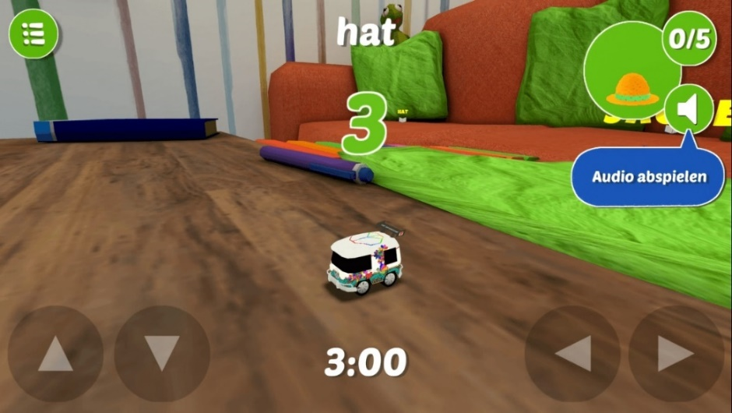
Word Car Game Figure 3-2
Scallop Words 3 -3

After market research, the author found that the field of eye care for preschool children still lacks this kind of interactive and serious game design practice. It is difficult for preschool teachers and doctors to give very vivid and interesting lectures on serious eye health science popularization. The great scientist Einstein once said: "Interest makes the best teacher." It is the same as memorizing words. Compared with listening to the boring lectures of teachers and doctors, Children are mostly more interested in fun games.
To sum up, for children at this stage of preschool age, the advantages of serious games over other teaching methods are very obvious:
First, serious games can bring higher interactivity and immersion: due to the way games are designed, they always use various feedback systems such as reward mechanisms to motivate players to continue playing the game . For preschool children, a better immersive learning environment is created . Moreover, children's cognitive learning of things at the preschool stage is often unconscious, and it is a very efficient learning method for them to instill knowledge purposefully through serious games.
Second, serious play can give children a safe space for experimentation and trial and error : In the real world, some incorrect actions have consequences, which sometimes lead to material or self-injury damage . Serious games, on the other hand, create a safe virtual environment where players can experiment without fear of getting hurt or destroying their belongings .
Third, the positive emotions brought about by combining education with serious games are very beneficial to children's growth and development. In this regard, a study [ 5] made by researchers at the University of Warwick showed that students who use games to learn will experience more positive emotions. This improves the learning experience compared to traditional and video learning methods.

3.2 Introduction to Physical Devices
The interactive device for this research topic is an electronic interactive whiteboard. We will project the projection onto the electronic interactive whiteboard. The touch screen is surrounded by infrared receiving tubes and infrared emitting tubes. These infrared tubes are arranged on the surface of the touch screen in a one-to-one correspondence. position relationship, thus forming an optical network composed of infrared rays, which is organized into a fixed-point relationship by infrared rays. When an object (it can be a finger, a gloved hand or any touching object) enters the infrared optical network to block a certain When the infrared ray is transmitted and received at this point, the intensity of the infrared rays received by the receiving infrared tubes in the horizontal and vertical directions of this point will change, and the touch position is determined according to the intensity change of the infrared ray to transmit interactive information. [ 6]
First of all, with the popularity of mobile phones, tablet computers and other devices, traditional blackboards and projectors are gradually unable to meet the curious needs of some preschool children. Electronic interactive whiteboards increase interactivity, fun and immersion, while interactive electronic whiteboards are difficult. The degree of ease is just right for preschool children to be enlightened on the use of science and technology.
VR devices on the market, electronic interactive whiteboards have their own advantages, although they lack immersion. (1) It has the advantages of ease of use, which is convenient for preschool teachers to debug, and can be clicked and dragged on the screen without memorizing complicated gestures, etc., which is more suitable for independent learning of preschool children (2) The interaction on the market now Compared with VR equipment and other equipment, the electronic whiteboard does not need to be worn, and the cost is lower when it is used by multiple people. (3) Children are energetic, active by nature, and prone to destructive behaviors. Therefore, compared with other carrying equipment, electronic interactive whiteboards are safer and have a relatively high space utilization rate, and are more suitable for preschool kindergartens. environment.

3.3 User experience research
Bernd Schmitt (Bernd Schmitt) through the "human brain module analysis" and the research of social psychology, put forward five systems of user experience: sensory experience, emotional experience, thinking experience, behavioral experience, related experience[ 7] . The sensory body is a person's experience, perception and understanding of a thing through his own five senses. Emotional experience embodies the inner emotional emotions generated by users when they use the product. Thinking experience is the product designed to make users think, stimulate users' sense of freshness, and create a certain degree of cognition for users. Behavioral experience refers to the feeling that users take from the actions of this product. The relevant experience here is the relevant cognitive experience of other things after using this product. Therefore, according to the actual situation of preschool children, this article will discuss this interactive serious game from the five aspects of children's "sensory experience", "emotional experience", "behavioral experience", "thinking experience" and "associated experience". User experience design.
Entity interaction [ 7] connects the real physical world and the virtual digital world through interactive design methods, and is a combination of tangible and real products with virtual and digital products. This study is based on the electronic interactive whiteboard as a carrier for the physical interaction research and design of touch interactive serious games. Combined with the characteristics of serious games and electronic interactive whiteboards, through these characteristics, the sensory experience, emotional experience, behavioral experience, thinking experience, and related experience of preschool children are driven to carry out efficient and immersive learning of eye care knowledge. Serious games are designed to make up for the lack of immersion of the interactive electronic whiteboard compared with other physical interactive devices.

4. Design practice

4.1 Design Concept
In the design practice of this chapter, the author thinks and designs for the purpose of learning eye care knowledge, so that preschool children can be more efficient through serious games when they have not yet learned a lot of words, and quickly and effectively receive memorization of boring eye care science. knowledge information.

4.2 Design Ideas and Schemes

4.2.1 Design idea:
Although serious games serve various industries such as education, medicine, and politics, they are still designed based on games. Colleen Macklin and John Sharp mentioned a theory of game design in their game design textbook "Games, Design and Play: A detailed approach to iterative game design" [ 10] , that is, the six basic elements of game design, namely: Actions (action) Rules (rules) Goals (game goals) Objects (game objects) Playspace (game space) Players (players). Design around these six basic elements.
First of all, the player is the person who participates in the game and the target audience: preschoolers. The game space is the place where the game is played. Because it is an interactive and serious game, according to the analysis of the environment above, there will be two game spaces in this study , one is the real game space, and the other is the game space. In the virtual space, the author sets the number of players in the game to 1-4 , which makes the electronic interactive whiteboard need to be divided into four answering areas, and the answers in each area will not interfere with each other. As shown in Figure 4-1 below , it shows the simple use space.
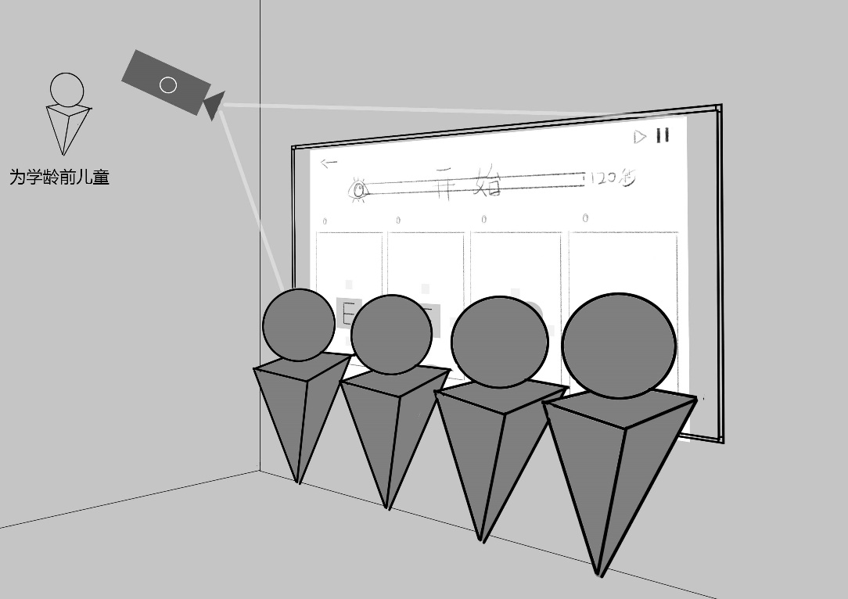
Use space display Figure 4-1
GameObjects are objects that the player interacts with in the game.
The goal is what the player needs to achieve in the game, and here is also the learning goal in this serious game. Actions are what the player does in the game. The rules determine whether the player's operations in the game can be triggered, not triggered , correct or wrong, etc. Here the author summarizes actions and rules as function settings. Through a series of investigation and analysis of users above, the author made the following table 4-2-1 , which is the idea of interaction design:
Form 4-2-1
Interaction design ideas for interactive serious games for preschool children
type | Specific requirements | Design ideas | design reason
Organizational structure of the interface | Clear organizational structure | The composition of the hierarchical structure is simple and clear | Children this age have difficulty understanding multi-layered complexities
 | clear layout | Screen layout should be as simple and clear as possible
 | multiplayer partition | Divided into four answering areas for four-player play | Can be used by multiple children Stimulate children's desire to learn so that children are not alone Now
interface ui | Information Graphics | Replace text with graphics, video, voice and sound effects | preschoolers are illiterate, and
 | bright and rich colors | colorful bright colors | Brightly colored and dynamic objects will attract children 's attention more easily, and children's perception of details is weak at this stage
 | Graphical cartoonization | UI interface style
 | animation effect | Make ordinary single graphics dynamic
Interactive experience of the game | easy to use | Simple operation, not too complicated, mainly click and drag. | Preschool children can master some simple interactive gestures such as single click, double click, drag and drop
 | Timely feedback | Visible feedback for every operation and judgment | Increase children's immersion, let children understand right and wrong
 | Incentives | Get positive feedback for correct answers, increase points, medals and other reward mechanisms | Stimulate children's game enthusiasm, good people's desire to explore, and attract children to continue learning games
 | gradual increase in difficulty | After a certain number of correct answers, the difficulty of the game will increase to a certain extent
 | The sound effect is cute | The sound effect is lively, cheerful and lovely | Considering the age of preschool children, the sound effects that are audibly cute are more likely to welcome their attention

4.2.2 Design scheme
In order to let preschool children learn as much knowledge about eye care as possible, the author made a classification and summary based on the consultation survey of children's ophthalmologists, and set five major themes, and formulated two games for each theme. The theme of the first part is how the vision of popular science people develops and grows. The two games are mainly for training. The second theme is to understand the composition of the eyes and their differences. From the simplest foundation, gradually increase the difficulty and advance, so as to achieve step-by-step exercise. The purpose of children's mind growth. According to the understanding of the above, according to the author's arrangement of game interaction design ideas above, considering the particularity of the user group, the interface architecture needs to be not too complicated, but clear enough. The author first thinks about the overall architecture, as follows Figure 4-2 shows the information architecture design of the main interface.
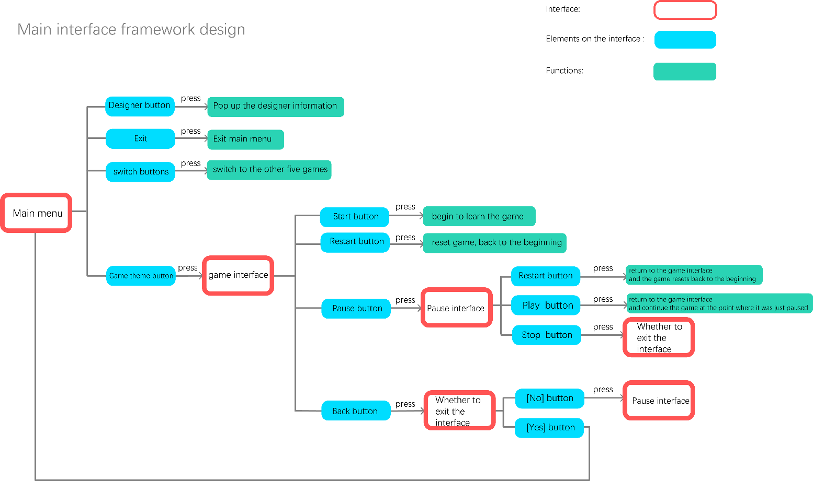
Main interface architecture design diagram 4-2
Then, the same interaction 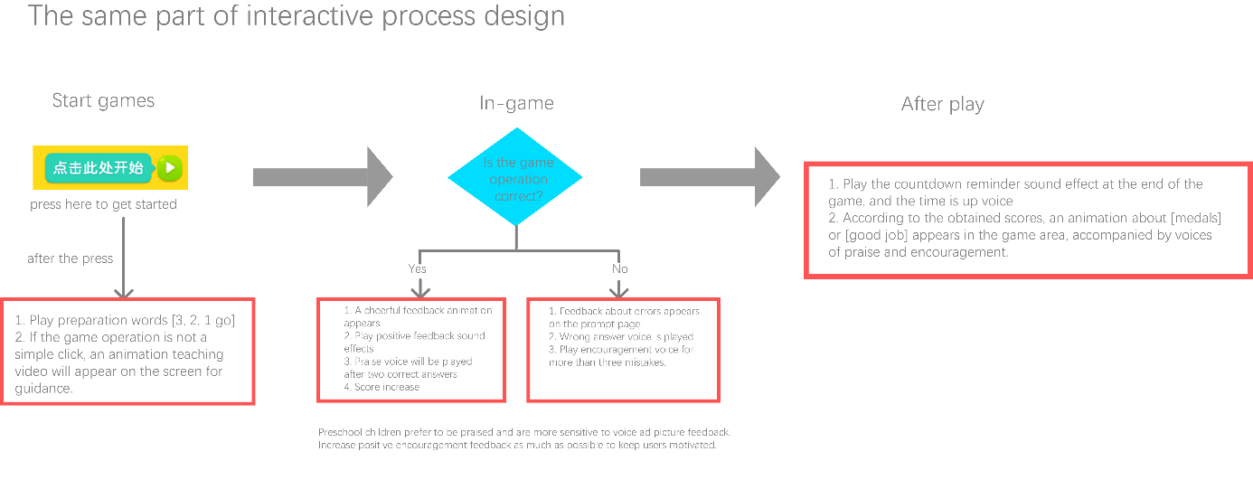process and functions in all games are summarized, as shown in Figure 4-3
4-3 of the same part of the interactive process design
And considering the characteristics that preschool children's attention span will not last too long, and in order to better maintain their freshness in game learning, the author sets the game duration to 120 s . The following are the specific planning plans and analysis of each game:

Game 1. Slide to the Gap
Game goal: For children who are not proficient in distinguishing up, down, left, and right, let them learn to identify the opening direction of the eye chart by sliding the direction of their fingers , so that they can cooperate with the doctor to do a vision test . Train children to distinguish up, down, left, and right, and exercise their simple graphic cognitive ability, memory ability and hands-on operation ability.
Game Object: Eye Chart Optotype Symbol
Gameplay: The player drags the vision symbol to slide up, down, left , and right according to the opening direction of the vision symbol, and the correct sliding rewards the score, and finally presses the score to get the corresponding medal.
Specific functions: (1) Children drag the eyesight symbol according to the opening direction of the eyesight symbol to slide up, down, left , and right. If the slide is correct, a correct feedback will appear, and if the slide is wrong, an error reminder will appear, so as to inform children of right and wrong. (2) Every time children slide three times Vision symbols, vision symbols are reduced once, and the difficulty is slightly increased, which can stimulate children's desire to explore and enthusiasm for learning. 4. Scores and medals: To stimulate the exploration and competitiveness of preschool children . Basic points: 10 points for each correct answer. Additional points: for one correct answer in a row, in addition to the basic 10 points, extra points will be added. (3) Medals: 50 points for a bronze medal, 3 bronze medals for a silver medal, 3 silver medals for a gold medal.

Game 2. Distinguish between up, down , left , and right
Game goal: Let children learn to correctly identify the opening direction of the eye chart , and cooperate with the eye examination , train children to distinguish up, down, left, and right, and exercise their simple graphic cognition and memory skills.
Game Object: Eye Chart Optotype Symbol
Gameplay: Players select the correct direction button in the lower button area according to the opening direction of the highlighted vision symbol in the picture , score according to the correct number, and rank according to the score.
Specific functions: (1) Vision symbols in the same row have the same size, and each next row of vision symbols is smaller than the previous row to a certain extent (1.25 times smaller). (2) As shown in Figure 4-4 , three lines are for the first level (the black box), and one line is moved down for the second level, and so on . In the official game, in consideration of allowing children to learn better, the up and down of the visual symbols Left and right are irregular.
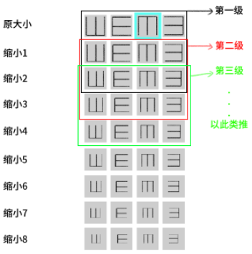Game Difficulty Grading Chart 4 -4
(3) Highlighted symbols randomly appear in the visual symbols of the first level. Children press the keys on the keypad and enter the next level after being correct three times. (4) If you reach the last level within the specified time, play at the last level until the time ends. (5) One point will be awarded for each correct score, and gold, silver and bronze medals will be awarded according to the score, and the ranking will not be based on the score.

Game 3 : Get to know our eyes
Objectives of the game: Let children know the basic structure of the eye, expose them to different types of eye structures, and improve their aesthetic ability.
Game objects: eyelashes, eyelids, iris, eyelashes
Gameplay: Let the children choose their favorite eye structure from the patterns at the bottom of the screen and drag it to the top to form eyes.
Specific functions: (1) Each person's area will be divided into a question area and an answer area. The answer area will give different styles of eyebrows, eyelids, irises and eyelashes for children to choose. Give children more choices and cultivate children's aesthetics. (2) If the child is satisfied, click the submit button above, after the submission is completed If the eye structure is complete, a smiling face will pop up; if there is a missing eye structure, a sad face will pop up after submission, and a red box will remind the missing structure module. Let the children know what parts are missing in their spelling eyes

Game 4. How to instill eye drops correctly
Game goal: let children learn the correct way to instill eye drops, and cooperate with parents to instill eye drops . Practice through trial and error, and exercise children's hands-on ability and thinking ability through interactive and immersive game experience.
Game object: left eye or right eye
play: The system randomly displays the left and right eyes, and the children can complete the operation by following the correct steps (1. Open the eyelids, 2. Inject eye drops at the correct position, 3. Press and hold the corner of the eye for 5 seconds)
Specific functions: (1) Four split screens randomly display the medicine bottle and one of the left or right eyes. (2) Sound effects and animation feedback on whether the player's actions are correct or not in each step. Let the children know whether their actions in this step are correct. (3) Follow the correct steps to complete all successes + 1 point and there will be positive feedback, and switch to the next eye. In this way, children are encouraged to continue learning and become proficient again and again.

Game 5. Eyeballs are like cameras
Purpose of the game: Let children know the important eyeball structure, pay attention to eye protection , exercise children's graphic recognition ability and hand-eye coordination ability.
Game object: eyeball structure
Gameplay: Select the correct pattern from the given eye structure patterns and drag it into the correct corresponding position. (drag icon)
Specific functions: (1) The screen initially displays the eyeball outline background, the parts that need to be spliced and all optional eye structures (2) Considering that the user group is relatively young, the pattern to be spelled for each question is set to be full in color when setting In reality, there are already patterns that do not need to be dragged to be set as gray silhouettes. (3) After spelling out a complete eyeball, you get 1 point and an encouraging picture appears. If you drag it to the wrong place, negative feedback will appear, and the dragged part will return to the original position to remind children that they have made mistakes and need to rethink. This is how children learn.
Test results: very good for children

Game 6. Why the eyes can’t see clearly
Purpose of the game: Let children know that when something happens , the eyes may be nearsighted (or hyperopia, or astigmatism), and they need to respond to their parents or teachers in time.
Game object: the picture you see when you are nearsighted, farsighted or astigmatism
Gameplay: Judge and choose whether the symptoms shown in the picture are myopia, hyperopia or astigmatism according to the icon randomly displayed on the screen within the time limit.
Specific functions: (1) Different symptom icons are randomly displayed in the screen icon area, and the player clicks on the corresponding answer in the selection area. (2) If the judgment is correct, a correct prompt icon will pop up and switch to the next question at the same time; if the judgment is wrong, an error prompt icon will pop up and switch to the next question at the same time. ( 3) Time limit for each small question: 1 2 s, allowing players to have enough time to think and at the same time feel the tension and excitement brought by the game.

Game 7. Why wear glasses
Purpose of the game: Let children correctly understand the role of glasses, correctly accept themselves wearing glasses , accept classmates wearing glasses , and further exercise children's simple logic ability .
Game object: the picture you see when you are nearsighted, farsighted or astigmatism
play: According to the symptoms shown in the pictures in the icon area above , click on the correct glasses icon in the answer selection area below to wear them.
Specific functions: (1) Different symptom icons are randomly displayed in the icon area of the screen. Children click the icon of the glasses that need to be worn in the answer selection area according to the icons. (2) Click the icon of glasses, and the corresponding glasses fly out and cover the picture . If the judgment is correct, the image will become clear, and a prompt icon for choosing the correct one will pop up; if the judgment is wrong, the image will become blurred, the lens will return to the original position and the picture will not be switched to the next question until the correct lens is selected. Get the correct answer and memorize it.

Game 8. How to use glasses correctly
Purpose of the game: Let children learn how to wear and maintain glasses correctly , and improve children's thinking and cognition.
Game Object: Behavior Animation
Gameplay: Randomly play an animation of the behavior of wearing or maintaining glasses in the question bank, and the children judge whether the behavior is correct
Specific functions: (1) An animation of wearing or maintaining glasses is randomly displayed in the icon area of the screen, and the child clicks on the correct or incorrect answer selection area. (2) If the judgment is correct, the button turns green and switches to the next question after 0.5 seconds; If the judgment is wrong, the button turns red and switches to the next question after 0.5 seconds

Game 9. Prevent accidental injury
Purpose of the game: Let children learn how to prevent accidental injuries, understand the basic common sense of correct handling of accidental injuries , and exercise preschool children's logical thinking ability and language ability
Game objects: action pictures and voice
play: random pictures in the question bank and play the corresponding voice, the children judge whether this behavior is correct
Specific functions: (1) Random animations are displayed in the icon area of the screen, and children click the correct or wrong icon in the answer selection area. (2) After the judgment is completed, the right or wrong icon will be hidden immediately, and the extra points will be judged; if the answer is overdue, it will be judged as an error . (3) After answering the question, the prompt of correct answer or wrong answer pops up, and the answer is immediately hidden. Prevent plagiarism from each other ( 4) Situation 1 , when 0≦time limit≦7s, if all four people have completed the answer, a countdown 321 will appear, and a crying or smiling face will appear on the panel according to the judgment of right or wrong, and then jump to Next question; case 2, when 7<time limit≦10s, there are still children who have not answered the question, a countdown 321 will appear, and the panel will display a smiling face and a crying face according to the right or wrong, and the unanswered question will judge the crying face, and skip to the next question after 2 seconds

Game 10. Protect your eyes and prevent myopia
Purpose of the game: Let children learn the correct habit of using eyes, protect their eyes, prevent myopia , exercise children's hand-eye coordination ability , and help train children's concentration.
Game Objects: Behavior Images with Eyes
play: Different eye-use pictures are randomly dropped at the bottom of the screen. Children click on the eye-use picture that they think is correct. Points will be added for correctness and deductions for mistakes. Finally, they will be ranked according to the accumulated points.
Specific functions: (1) Icons drop randomly from the top (similar to Tetris), and children click to choose (2) Click the correct icon to add the corresponding score; click the wrong icon to subtract the corresponding score; the wrong icon falls to the bottom and it is considered correct if you do not click , add the corresponding score (3) after ten correct, speed up the falling speed to increase the difficulty.

4.3 Prototyping interface design
Through the thinking of the interface ui presentation part of the interaction design idea mentioned above , the information graphics are extracted, the colors need to be bright and rich, and the interface icons are cartoonized. The three main requirements of the prototype design are used for prototype design, as shown in Figure 4 - 5 shows the prototype interface.
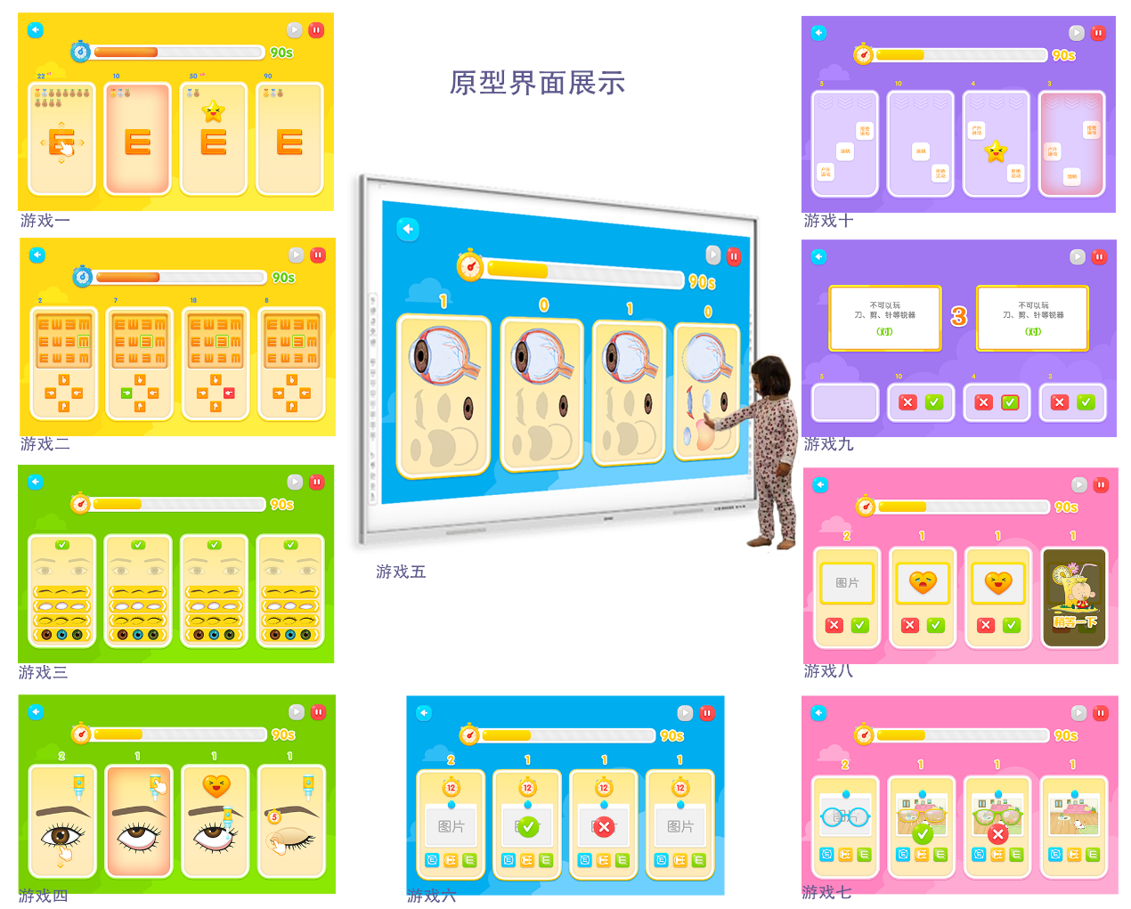
Prototype interface display Figure 4-5

4.3 User Experience Design
For a good user experience, on the basis of the rule framework, the user experience is further designed, tested and optimized according to the summary of the interaction design ideas. According to the above research on user experience, here we analyze and think about the five experience aspects of senses, emotions, thinking, behavior, and association.
Sensory experience: (1) On the screen, cartoon elements, rich and vivid colors and various dynamic screen feedback, such as button feedback, correct and wrong operation feedback in the game, etc., can attract children's attention and increase the fun of the game At the same time, tell the children whether the judgment is correct. (2) In terms of sound effects, in terms of dubbing and production selection of sound effects, it is more inclined to the lively, cheerful and lovely type suitable for the age characteristics of preschool children. It is endowed with rich feedback voice sound effects and animations. When preschool children touch the screen, Receiving visual and tactile responses is also auditory, multi-sensory feedback, enhancing their overall perception.
Emotional experience: (1) Random samples have been added to the sound effect, giving the game more and richer emotional feedback. (2) Due to the above survey and analysis, preschool children are sensitive to emotional perception of sounds, movements, etc., and like to be praised and praised, and like to receive positive feedback. Therefore, at the same time as the basic positive feedback and negative feedback, a random sample of praise voice is played after a certain number of correct answers in a row, and a random sample of encouragement voice is played after a certain number of wrong answers in a row, so as to add more positive feedback to enhance The joy of user success and the frustration of user failure can be adjusted to improve the user's enthusiasm for playing games. (3) The author designed the final settlement to lower the threshold for getting the best result rewards as much as possible, making it easier for children to get the best rewards, such as "gold medal" and "great", to satisfy preschool children's desire to get positive results. Feedback psychological needs, in order to mobilize their enthusiasm.
Thinking experience: Combined with the previous investigation and research on the cognitive characteristics of preschool children, it is known that although preschool children have certain reasoning and logical abilities, they can only produce general feelings or descriptions of multi-level things or things, and it is difficult to It produces deeper thinking, so although the user's thinking experience this time is the memorization and learning of eye care knowledge, it is actually an enlightenment and exercise for children. After playing ten serious games, the memory, cognition, imagination and logical reasoning abilities are exercised.
Behavioral experience: The set operations are simple click, drag, and a teaching demonstration will be played for more complex operations, telling children how to change the operation, and improving the playability of the game. Children love the novel way of playing and learning, and the form of graphic animation enables children to understand faster and have a better playing experience.
Relevant experience analysis: After playing ten interactive serious games about eye care, children's enthusiasm for learning eye care popular science knowledge will be stimulated in the form of serious games, so that children will not reject the learning of boring popular science knowledge.

4.3 Testing and Feedback
After completing the game construction, we conducted a preliminary test with a few preschool children, and all ten games in the test could achieve the expected goals. Game 1 "slide to the gap" and game 2 "distinguish up, down, left, and right" have achieved the effect of repeated training to improve memory and proficient recognition of eye vision icons after children play. The medals and rich animation feedback obtained in game 1 It also stimulates children's enthusiasm for learning and desire to win; but the game effect of game 2 is slightly inferior to that of game 1. Simple selection and click and similar graphics, compared to game 1 , the effect feedback is only the right and wrong icons. Variations occur, the novelty is lost after the child has tried many times, attention becomes less focused compared to game one . In Game 3 "Knowing Our Eyes " , children can choose to piece together their own eyes with different aesthetics, and basically can complete the choice of eye structure well, but there is only one chance to choose, and children are not given enough room for trial and error , need to be improved later. The test effect of game 4 "How to instill eye drops correctly " is better. By operating a whole set of eye drops process, there will be corresponding reminders at each step. Children learn by trial and error repeatedly under rich feedback, and can learn well. How to instill eye drops correctly to achieve the desired effect. Game 6 "Why I Can't See Clearly" Game 7 "Why Wear Glasses" allows trial and error training to achieve the basic learning purpose, but in comparison with Game 7 , the corresponding type of glasses will fly out after choosing the right one. The picture becomes clearer, and the effect of choosing the wrong picture will make children feel more immersed and better understand right from wrong. The combination of voice and animation in Game 9 "Preventing Accidental Injury" also helps children learn how to avoid accidental injury while subtly exercising their language skills. Direct selection, still need to continue to improve.

5. Summary and improvement points
In this study, because the user group is preschool children, this age group is relatively special, and the author has little contact with it, so a large number of investigations, research and analysis on the cognitive characteristics and behavioral characteristics of this user group have been carried out. In the early stage of the article, a large amount of analysis and research on the user group of preschool children was carried out. After a thorough understanding, the needs of the user group were summarized for the output design of this research, and it was believed that the combination of serious games and electronic interactive whiteboards would be more in line with The characteristics of the needs of preschool children, followed by a further elaboration and analysis of the advantages of the presentation form of this research design. Next, according to the above investigation and analysis, the research and design of the interactive system is carried out, and its information, interface level, main style, etc. are analyzed and structured. The investigation and analysis of users and interaction methods are fully reflected in the research design, giving in-depth thinking on user experience and shaping the design. At the present stage, a lot of research has been done on the user group of preschool children, knowledge related to eye care, serious games, and experience design in terms of repeated literature surveys. Based on the research, the framework has been built, and the high-fidelity interface has been produced. The game function is developed and perfected under the condition that the design has a knowledge base.

In the game test, bright and vivid colors, cartoon graphics and dynamic graphics can attract children's attention and improve children's aesthetics. The part of voice and sound effects can make children understand the game better. Children bring positive emotional guidance. At the same time, in the game content, color animation and sound effects can give preschool children a sense of immersion, which greatly improves children's learning enthusiasm and helps children to cultivate children's concentration. The effect of comprehension. In addition to achieving the effect of learning popular science knowledge about eye care, the ten games can also help children train basic thinking logic ability, graphic cognition ability and language ability. "Slide to the gap", "Know our eyes", "How to drop eye drops correctly", "Eyeballs are like cameras", "Protect eyes and prevent myopia". Several games also exercise children's hand-eye coordination ability by dragging and clicking. The simple operation of moving and clicking also reduces the burden of learning complex operations for preschool children while playing games.
At the same time, there are also some problems that need to be balanced and repaired later. During the game, there will still be some preschool children who are too naughty and impatient. For example, in the game "Preventing Accidental Injury " , they directly make choices and judgments before watching the animation or pictures, which leads to the situation that the learning content is not well absorbed. , needs to be further optimized and tested later to further improve and reduce the occurrence of problems.

Improvement points: Due to the limitations of the epidemic, we can only find a few preschool children and their parents around us to conduct simple surveys through online channels, and there are certain limitations in subsequent test optimization. There is a certain lack. After this research, it is necessary to contact more user groups, let more users test and further test and optimize the game, improve those problems in the research, so that preschool children can have a better game learning experience. In the future, technology will become more and more intelligent. In the follow-up research and development, the author will conduct more in-depth research on physical interaction, add more physical interaction to the research design, and further optimize and improve the immersive experience of game learning.

references
[1] Hou Tao. Analysis of children's entertainment product design from the perspective of development [D]. Beijing Institute of Technology, 2014.
[ 2 ] Hong Xinhui. Exploring the optimal design of preschool children's toys from the perspective of educational psychology [DJ. Jiangnan University, 2008 (5).
[ 3 ] Yao Wenji. Research on mid-children's furniture design based on developmental psychology [D]. Zhejiang Sci-Tech University, 2010(3).
[ 4 ] Deng Daping, Huang Renpeng, Chen Gan. Research and practice of embedding serious games into classroom teaching in colleges and universities [J]. Education and Teaching Forum, 2020(27): 15-17.
[ 5] Allcoat , Devon & Von Muhlenen , Adrian. (2018). Learning in virtual reality: Effects on performance, emotion and engagement. Research in Learning Technology. 26. 10.25304/ rlt.v 26.2140.
[ 6] Virtual reality intelligent projection gesture interactive all-in-one machine CN205028239U
[ 7 ] Liu Yuan. Research on Entity Interaction Application Design Based on User Experience of Preschool Children [D]. Nanjing University of Science and Technology, 2019. DOI: 10.27241/d.cnki.gnjgu .2019.001922.
[ 8 ] Han Jing. Measures to improve the teaching quality of preschool education in the ubiquitous learning environment [J]. Wisdom, 2017 (01): 76.
[ 9 ] Xu Yafen, Gu Hanjie . Research on the Construction of Smart Learning Environment Based on Serious Games [J]. China Information Technology Education, 2018(05):87-90.
[ 10] Colleen Macklin, John Sharp. Games , Design and Play: A detailed approach to iterative game design [M]. America; Addison -Wesley Professional; 2016.
[ 11] Sun Fanfei . Research on Children's Room Space Utilization and Home Design Based on Children's Behavioral Characteristics [D]. Jiangnan University, 2017.
[ 12] Chang Shenglong. Do you know the cognitive characteristics of preschool children [J]. Shanghai Education, 2018 (09): 64.
[1 3 ] Wei Min. Inclusive Design of Kindergarten Activity Space Based on Behavior Characteristics of Preschool Children[J]. Industrial Design, 2022(01):90-92.
[ 14] Sun Xiaoye. Entertaining and entertaining - research on interactive design of picture books for preschool children [D]. Nanjing University of the Arts, 2018.
[1 5 ] Zhou Xueqing . Research on furniture design based on the growth of preschool children [D]. Shanghai Normal University, 2020. DOI: 10.27312/d.cnki.gshsu .2020.001448.
[1 6 ] Xu Xuan. Research on User Psychological Evaluation and Interesting Design of Campus Furniture for Preschool Children [D]. Nanjing University of Science and Technology, 2015.
[ 17 ] Wang Ping. Preschool Child Care [ M ]. Beijing: Tsinghua University Press, 2015: 5 .
[1 8 ] Zhou Xi, Huang Xinyuan. Interaction Design of Educational Game Characters for Preschool Children [J]. Packaging Engineering, 2022,43(06): 243-251.DOI:10.19554/j.cnki .1001-3563.2022.06.032.
[1 9 ] Zhao Li. Strategies for Cultivating Preschool Children's Energy- Level Visual Thinking[J]. Shanghai Educational Research, 2012(02): 94-96. DOI: 10.16194/j.cnki .31-1059/g4.2012.02 .002.
[ 20 ] He Jin'e, Liu Zhimin, Gao Chunyan. Relationship between preschool children's psychological behavior problems and family environment [J]. Contemporary Medicine, 2015, 21(17): 163-164.
[21 ] Li Lu. Research on the Design of Preschool Education APP [D]. Huazhong University of Science and Technology, 2019. DOI: 10.27157/d.cnki.ghzku .2019.003785.
[ 22 ] Wang Zhenyu. Realizing the Unification of Game Means and Purposes——Rediscussing Game Curriculum [J]. Early Childhood Education, 2019 (Z3): 3-7.
[ 23 ] Zhu Jihong, Zhao Yuechao. Research on Interaction Design of APP Interface of Preschool Children Based on Children's Cognitive Development [J]. Packaging Engineering, 2020, 41(10): 42-48. DOI: 10.19554/j.cnki .1001-3563.2020 .10.008.
[ 24 ] Zhao Zhibo. Design and research on interactive preschool children's popular science digital books [D]. Shandong Institute of Arts and Crafts, 2019.
[ 25] G Valiente. Spiritual Evolution: The Composition of a Better Life [M]. Zhang Qingzong, Zhou Qiong, translated. Shanghai: East China Normal University Press, 2018: 157-158.

